
Programme: MSc Public Health and Social Care in Practice
Module name: Social Epidemiology And Public Health Development
Module ID: LCHS7000

Lecturer’s name: Jolly Nwankwo

Disability And Health Inequalities, Focusing on the Adults in the UK Facing Diverse Kinds of Disabilities

Student Name : Darshan Bipinbhai Sarvaiya
Student ID: 2436889

Table of Contents
Task 1: Social Epidemiological Analysis 3
1.1 Introduction 3
1.2 Contextual background and underlying factor 3
1.3 National response to reduce health inequalities 5
1.4 UK organisations that support the chosen group 5
1.5 Conclusion 6
Task 2: Epidemiological Analysis 7
2.1 Introduction 7
2.2 Public health measures 7
2.3 The key risk factors for obesity 8
2.4 Main public approaches to monitor the incidence of childhood obesity 9
2.5 Plan and use epidemiology to determine public health impact 9
2.6 Appropriate health interventions for childhood obesity 11
2.7 Strengths and Weaknesses of the Epidemiological Approach 11
References 12

Task 1: Social Epidemiological Analysis

1.1 Introduction
This report has chosen disability and health inequalities. Disability and health inequalities are connected as health imbalances originate from one-sided states shared via individuals with disability, such as deprivation, exclusion, intolerance and stigma from occupation, instruction and health system impediments (WHO, 2023).
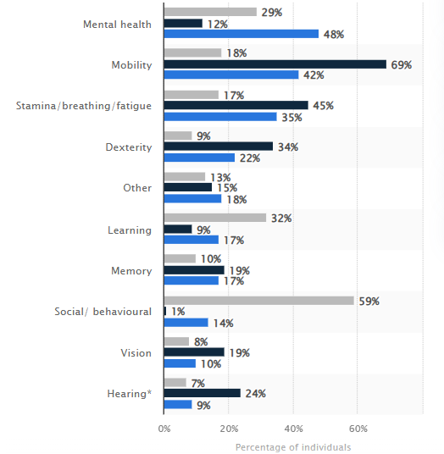
Figure 1: Share of disabled persons in the UK
(Source: Minhas, 2025)
In the UK, due to the variety of social and structural obstacles, individuals face unreasonable barriers to healthcare and other essential services, such as those related to chronic diseases, unemployment, and poverty (Ferrie et al, 2002). Minhas (2025) opined that, as of 2023-24, approximately 42% of working-age adults were found to have a mobility disability, and 69% of adults were at the pension age stage. This report chooses the adult population of the UK between the 30-65 age group who have a disability and experience health inequalities in the UK. Such health issues are not just caused by the fitness disabilities, but the outer elements such as lack of understanding, prejudice, ableism and others lead them to undergo health imbalances.

1.2 Contextual background and underlying factor
Health inequalities come from several unfair conditions that are experienced by individuals with disabilities, such as
Social determinants of health
Poverty, exclusion from employment and education and poor living conditions increase the risk of health issues. Having gaps in the formal support mechanisms for the disabled people not only disadvantages them in getting a diagnosis for certain health isues but also the caregivers mostly stay careless to engage in healthcare activities (WHO, 2023). Mobility is the most commonly reported impairment type that affects 69% of disabled adults. In the stage of pension age, elderly adults have reported finding stamina, fatigue impairment and breathing issues (Kirk-Wade et al., 2024).
Health systems
Adults with cognitive disabilities may experience barriers in all aspects of health systems (Kuh et al. 1997). Lack of knowledge about certain chronic health issues, high rates of mental illness, mortality rates, discrimination and negative attitudes among healthcare workers contribute to health inequalities for this group (WHO, 2023). Hackett et al. (2020) opined that in healthcare, approximately 46.6% of people with physical disabilities reported discrimination, and another 65% with unspecified disabilities reported that they experienced discrimination from healthcare staff.
Risk factors
Adults with cognitive disabilities mostly experienced risk factors for non-communicable diseases such as alcohol consumption, smoking, lack of physical activity and poor diet issues (WHO, 2023). Because of these harmful practices, they are often left out of public healthcare interventions.
Structural factors
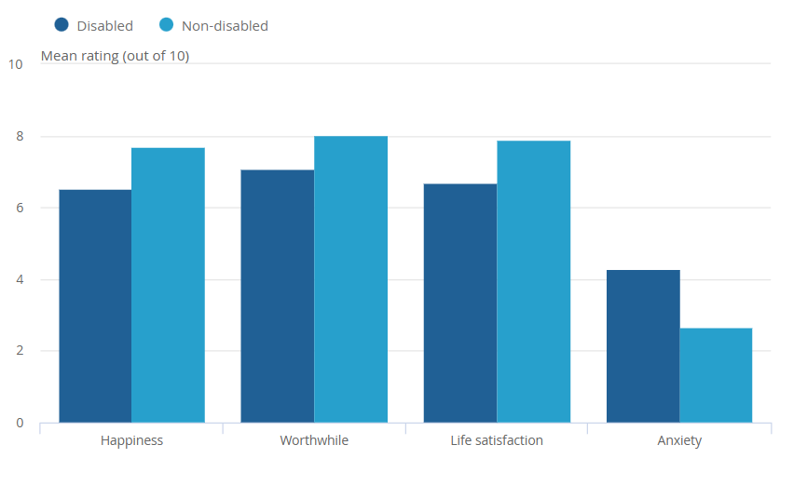
Figure 2: Average well-being ratings for disabled people
(Source: Jones, 2019)
Individuals with disabilities face discrimination, stigma and abuse in all stages of life that impact their mental health (WHO, 2023). Disabled adults have lower ratings in mental well-being than non-disabled people, as 6.68 out of 10 people found life satisfaction, and 4.27 out of 10 disabled persons have experienced anxiety compared to non-disabled people (Jones, 2019).

1.3 National response to reduce health inequalities
The NHS provided a national healthcare inequalities improvement programme aimed to reduce health inequalities (NHS, 2021). In the NHS long-term plan 2019, it addresses several actions that can help to reduce health inequalities for people with disabilities, such as
- Stronger accountability and leadership
- Ensure a preventive programme for all groups of people with disabilities
- Restoring the inclusive service of the NHS (NHS, 2021)
- Resolve digital exclusion-related issues (NHS, 2021).
These policies are important to protect social determinants such as housing, education and deprivation, which are important for disabled people and ensure proper health service intervention, including tobacco control, social prescribing and others. Hence, such radical push and preventive measures are relevant to understanding and reducing the health inequalities for people with various disabilities.
In addition, the Disability Action Plan 2024 is a successful government initiative to address social justice for disabled adults in the UK (GOV.UK, 2024). This legislation aims to give accessibility to public services by fulfilling the needs of disabled people through emergency planning. Hence, the government is supporting the disabled populations of the U.K. through social inclusion methods. This legislation supports disabled persons and improves their accessibility in playgrounds, public offices and others.

1.4 UK organisations that support the chosen group
Mencap is a UK learning charity that works for people with disabilities and helps them to gain opportunities in learning and careers (Mencap, 2023). The vision of the company is to develop an inclusive, kinder and fairer society for disabled people, hence, they can get support from other people and an excess of needed healthcare services... The key objectives of this organisation are to support people in their personal growth, campaigning for needed changes and help communities to become more inclusive for those people who are experiencing diverse disabilities, hence, they can improve care practices and reduce health inequalities.
The core goals of it are
- By listening to the learning disabled people to support them in fighting for their rights
- By campaigning with learning disabled persons to make society fairer and to make sure their voice is heard (Mencap, 2023).
On the other hand, the national autistic society is a charity that works to promote the rights of people with autism and ensures that their families can get proper medical and quality services to their needs (Nationalautisticsociety, 2019). The goal of it is
- Change people's attitude. Create workplaces for autistic people (Nationalautisticsociety, 2019)
- Transform lives for people with autism disabilities
By promoting significant services such as residential care and school care, it offers support and guidance for the families and aims to develop more autism friendly workplaces and services. Hence, it supports the experiences and voices of people with autism disabilities and reduces healthcare inequalities.

1.5 Conclusion
In conclusion, disability is part of the human body, and it is critical to human experiences. Persons with disabilities are a diverse group, and their economic situations negatively impact their daily life experiences and critical healthcare needs. Hence, to support their effective health services, healthcare professionals and the government need to
- facilitate proper collection and dissemination of disability based information (WHO, 2023)
- Promote strategies to ensure that disabled people are knowledgeable about their health conditions and get personal healthcare support from local healthcare settings
- Develop abilities among service providers and health policymakers (WHO, 2023)
- Develop diverse normative equipment, such as guidelines to strengthen disability inclusion in the UK health industry (WHO, 2023).

Task 2: Epidemiological Analysis

2.1 Introduction
Obesity, which is classified as a noncommunicable disease (NCD), is a major public health problem (WHO, 2025). It is a growing health issue for the young populations in the UK, which comes from excessive body fat. The epidemiological process begins from an imbalance of diet and energy expenditure. However, in most cases, psycho-social factors, genetic variations, and obesogenic environments are other situations that become responsible for it (WHO, 2025). In addition, the lack of an effective health system to address excess fat gain and weight development in early stages of people is the primary reason for the development of obesity.
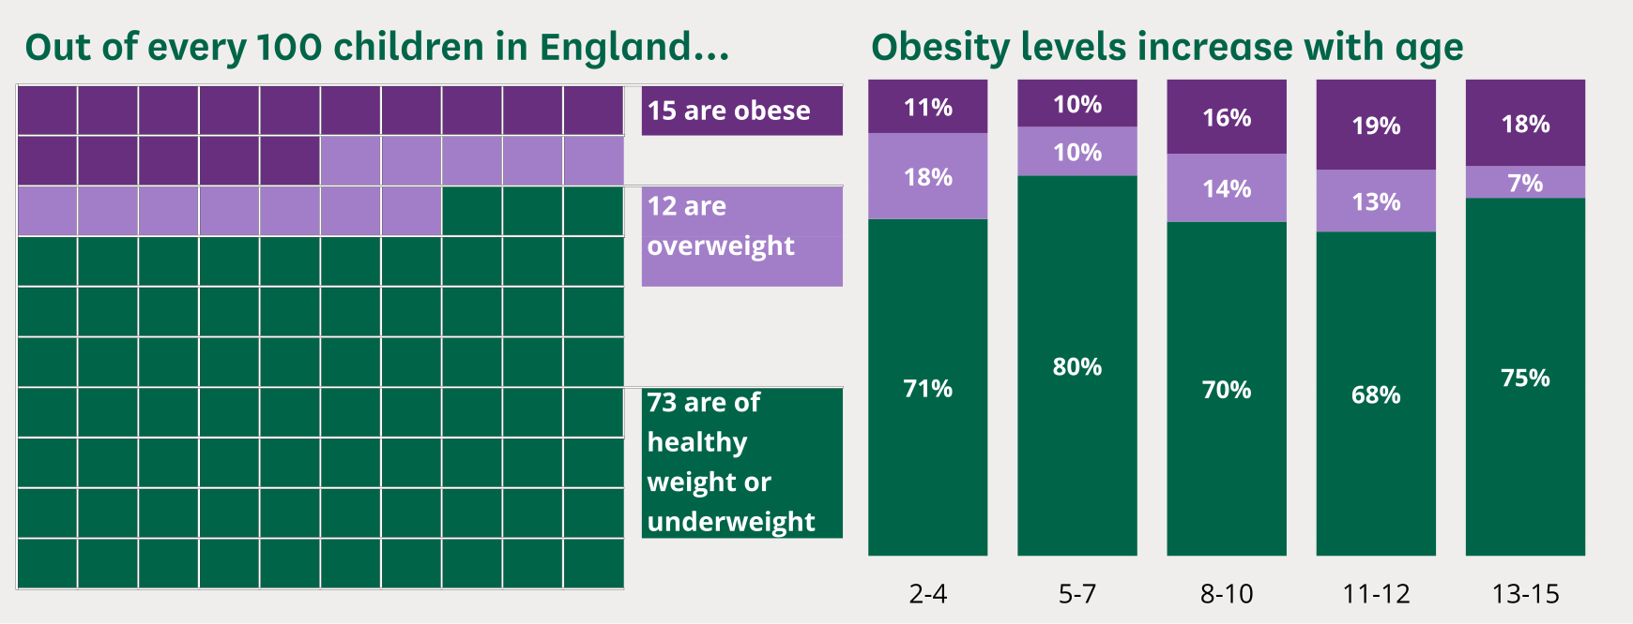
Figure 3: Child obesity rate in the UK
(Source: Stiebahl, 2025)
Mostly, children who come from middle-income and low-income regions are exposed to intake of high sugar, fat and energy-dense foods that tend to develop obesity (Agha and Agha, 2017). The core preventive measures from the obesity indicators support behaviours of healthy eating for children, facilitate physical activity, the needed amount of sleep and limit consumption of sugar-related foods (Stiebahl, 2025). This report targeted child obesity in the UK, as 9.6% of children in England experienced obesity in 2023-24. From the ages of 10 to 11, 22.1% of children are obese, and 13.8% of them experienced overweight-related issues. In 2022, the number was high as 26.8% of children aged 0-15 were found to face overweight-related issues (Stiebahl, 2025). In both of these ages, boys' numbers are primarily higher compared to obesity.

2.2 Public health measures
Public health measures designed for children aged 5-11 years by applying the 3 Ps
People
- Targeted family programmes such as MEND can offer group discussion, behaviour changes expertise, fun activities through learning about the risks of obesity.
- Under the guidance of the national child measurement programme (NCMP), give training to early overweight children, understand them about the risks of obesity through school visits, GPs and help from school nurses and help children to know the risks of obesity (Harding et al., 2007).
Place
- In the school, through nursery approaches, active play environments and knowing the differences between junk food and healthy food, parents and teachers can prevent the excessive consumption of junk foods (Agha and Agha, 2017). Maintaining restrictions on sugary drinks and allowing regular physical activity will bring improvements in the learning of obesity related issues in children.
Policy
- Restrictions on the marketing of sugary drinks to children, bringing improvements in the standards of school foods and imposing a sugar tax on drinks can ensure healthy snacks and lunches for children (NHS, 2023). In addition, arranging community programs, promoting obesity prevention programs and offering free meals in school can help children focus on their diet and allow them to consume healthy meals.

2.3 The key risk factors for obesity
Lack of physical activity
The lack of physical activity is the core reason for the development of obesity in children (Mohamed et al., 2022). It raises a high body mass index and develops excessive fat in different areas of the body, which is a core reason for being overweight among children.
Unhealthy eating habits
According to Haase et al. (2020), daily consumption of high added sugar in the diet helps to develop obesity among children. According to the Dietary Guidelines for Americans, the amount of saturated fat in regular food must not be more than 10% of the total calories of a person (NIH, 2022). Maintaining such calories in the diet can help manage obesity among children.
Not getting enough sleep.
Not getting a quality sleep of 8 hours develops a high BMI. Regularly sleeping less than 8 hours can develop hormonal imbalances that can cause hunger urges (NIH, 2022).
Health conditions
Taking long-term stress may impact how the brain works and allow the body to make hormones, including cortisol, that raise hunger urges and energy imbalances (Mohamed et al., 2022). Hence, these changes in hormones may cause children to consume more and store more fat in their bodies.
Symptoms in children who are affected by obesity
As opined by XU and XUE (2015), the core symptoms of obesity among children include breathing issues and the development of chronic obstructive pulmonary disease and certain types of cancers, such as uterine disease among girls and bowel disease among men. In addition, depression, gastro-oesophageal reflux diseases, liver issues, and type 2 diabetes can be noticed among children (d’Errico et al., 2021). After 2010, among 6-11-year-old children, the rate of obesity grew by 7% (XU and XUE, 2015).

2.4 Main public approaches to monitor the incidence of childhood obesity
Focusing on children who are from 5 to 11 years, the main public health approaches that are applied to monitor the incidence of obesity are
- Passive surveillance, where the healthcare professionals report the recent cases of child obesity to local healthcare authorities (NHS, 2023). It is a low-cost method that offers a limited impact on the inspection of the child obesity rate
- Active surveillance indicates the process of gathering complete information about a certain child's obesity incident. This process is more effective, and it gives positive data accuracy through targeting epidemiological examinations by the health officer.
- Connecting laboratory information and epidemiologic aspects across health information, integrated disease surveillance and response (IDSR) process, detracts, response and report regarding obesity (WHO, 2010)
- Syndromic surveillance process that monitors symptoms of obesity and provides primary warnings about outbreaks, and shows high responses to emerging health threats among children.

2.5 Plan and use epidemiology to determine public health impact
Using epidemiology to determine the public health impact of children aged 5-11 years regarding obesity in the UK has diverse short and long-term consequences.
Prevalances
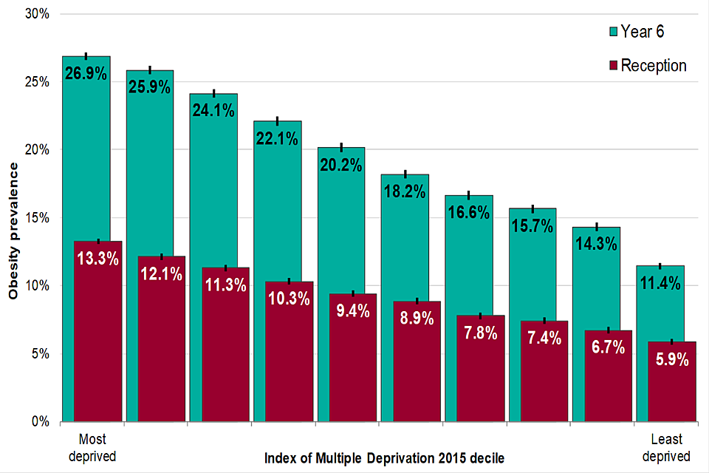
Figure 4: Obesity prevalence in 6-year-old children
(Source: GOV.UK, 2022)
In the government report of the UK, from 2018 to 2019, approximately 76.5% of children between 4-5 years and 64.3% of children from 10-11 years experienced obesity (GOV.UK, 2022). Children with obesity in the UK are more likely to become adults living with obesity. Therefore, such actions raise the risk of obesity among children in their future lives. Haase et al. (2020) stated that the low level of physical exercise and poor diet are the critical reasons for the development of such excessive fat in the body. Consuming sugar drinks of 17% children aged 11-18 years and 6% of children aged 4 years is the core reason behind the development of early obesity issues (GOV.UK, 2023).
Incidence
Gregory (2025) finds that the number of children who are experiencing obesity will worsen by 90% in England by 2035. Most obesity cases raise the risk of cardiovascular diseases, cancer and type 2 diabetes in the long term. The global data forecasts that in the UK, childhood obesity cases will increase from 12.76 million in 2025 to 13.09 million in 2031 (Clinicaltrialsarena, 2025). For the long term, childhood obesity may develop diverse diseases such as Crohn's disease, type 1 diabetes, arthritis and others.
Mortality and morbidity
Marcus et al. (2022) mentioned that for the long term, childhood obesity can raise the risks of premature mortality before 30 years of age. During treatment of type 2 diabetes in children and young people, the morbidity rate becomes higher compared to type 1 diabetes (Marcus et al., 2022).

2.6 Appropriate health interventions for childhood obesity

Factors | Intent | Examples | Process
Primary | Immediate measures to reduce obesity | Consume healthy school meals, focus on daily exercise, and avoid junk food consumption (Holmes, 2021) | Changes in food priority, promotion of health education
Secondary | Preliminary detection of obesity and prevention strategies (GOV.UK, 2019) | BMI scanning in schools, focus on daily healthy food consumption (Holmes, 2021) | Support for prevention systems
Tertiary | Monitor the development of the obesity rate | Weight management programs and behavioural therapy | Clinical diagnosis, lifestyle changes and regular check-up through healthcare experts (GOV.UK, 2019)
Table 1; Intervention strategies

2.7 Strengths and Weaknesses of the Epidemiological Approach
The entire epidemiological approach based on childhood obesity shows diverse strengths, such as factors to address obesity risks and its symptoms. Short and long-term consequences, and others. However, the weaknesses found in this approach are bias from self-reported information, isolating socio-economic factors and avoiding multifactorial reasons for developing childhood obesity. Future studies need to focus on the longitudinal information and measurement methods to increase accuracy in the epidemiological approach.

References
Agha, M. and Agha, R. (2017) ‘The rising prevalence of obesity’. International Journal of Surgery Oncology 2(7), p. e17. Available at: https://www.ncbi.nlm.nih.gov/pmc/articles/PMC5673154/ (Accessed: 2 December 2025).
Clinicaltrialsarena (2025) Obesity in children will rise rapidly in England. Available at: https://www.clinicaltrialsarena.com/analyst-comment/obesity-rise-children-england/ (Accessed: 2 December 2025).
d’Errico, M., Pavlova, M. and Spandonaro, F. (2021) ‘The economic burden of obesity in Italy: a cost-of-illness study’. The European Journal of Health Economics 23(2). Available at: https://link.springer.com/article/10.1007/s10198-021-01358-1 (Accessed: 2 December 2025).
Ferrie et al (2002). Effects of chronic job insecurity and change in job security on self-reported health, minor psychiatric morbidity, physiological measures and health-related behaviours in British Civil Servants: The Whitehall II Study, Journal of epidemiology and community health, 56, pp.450-454.
GOV.UK (2019) Childhood Obesity: A Plan for Action. Available at: https://www.gov.uk/government/publications/childhood-obesity-a-plan-for-action/childhood-obesity-a-plan-for-action (Accessed: 2 December 2025).
GOV.UK (2022) Childhood obesity: applying All Our Health. Available at: https://www.gov.uk/government/publications/childhood-obesity-applying-all-our-health/childhood-obesity-applying-all-our-health (Accessed: 2 December 2025).
GOV.UK (2023) NDNS: results from years 9 to 11 (2016 to 2017 and 2018 to 2019). Available at: https://www.gov.uk/government/statistics/ndns-results-from-years-9-to-11-2016-to-2017-and-2018-to-2019?msclkid=19f6da7ab4ab11ec918b4fafeff5e733 (Accessed: 2 December 2025).
GOV.UK (2024) Disability Action Plan 2023 to 2024: consultation document. Available at: https://www.gov.uk/government/consultations/disability-action-plan-2023-to-2024/disability-action-plan-2023-to-2024-consultation-document (Accessed: 2 December 2025).
Gregory, A. (2025) Majority of children will be overweight or obese in nine areas of England by 2035, study shows. Available at: https://www.theguardian.com/society/2025/jun/23/majority-children-overweight-obese-nine-areas-england-by-2035-study (Accessed: 2 December 2025).
Haase, C.L., Eriksen, K.T., Lopes, S., Satylganova, A., Schnecke, V. and McEwan, P. (2020) ‘Body mass index and risk of obesity‐related conditions in a cohort of 2.9 million people: Evidence from a UK primary care database’. Obesity Science & Practice 7(2). Available at: https://pmc.ncbi.nlm.nih.gov/articles/PMC8019280/ (Accessed: 2 December 2025).
Hackett, R.A., Steptoe, A., Lang, R.P. and Jackson, S.E. (2020) ‘Disability Discrimination and well-being in the United Kingdom: a Prospective Cohort Study’. BMJ Open 10(3). Available at: https://bmjopen.bmj.com/content/10/3/e035714.abstract (Accessed: 2 December 2025).
Harding, S., Maynard, M.J., Cruickshank, K. and Teyhan, A. (2007) ‘Overweight, obesity and high blood pressure in an ethnically diverse sample of adolescents in Britain: the Medical Research Council DASH study’. International Journal of Obesity 32(1), pp. 82–90. Available at: https://www.nature.com/articles/0803662 (Accessed: 2 December 2025).
Holmes, J. (2021) Tackling Obesity the Role of the NHS in a whole-system Approach. The King’s Fund., pp. 1–38. Available at: https://assets.kingsfund.org.uk/f/256914/x/cead3911f6/tackling_obesity_role_nhs_whole_system_approach_2021.pdf (Accessed: 2 December 2025).
Jones, J. (2019). Disability, well-being and loneliness, UK - Office for National Statistics. Available at: https://www.ons.gov.uk/peoplepopulationandcommunity/healthandsocialcare/disability/bulletins/disabilitywellbeingandlonelinessuk/2019 (Accessed: 2 December 2025).
Kirk-Wade, E., Wong, H. and Stiebahl, S. (2024). UK Disability statistics: Prevalence and Life Experiences. Available at: https://commonslibrary.parliament.uk/research-briefings/cbp-9602/ (Accessed: 2 December 2025).
Kuh, D. and Ben-Shlomo, Y., eds. (1997). A Life-course Approach to Chronic Disease Epidemiology eds. Oxford: Oxford University Press.
Marcus, C., Danielsson, P. and Hagman, E. (2022) ‘Pediatric obesity—Long‐term consequences and effect of weight loss’. Journal of Internal Medicine 292(6), pp. 870–891. Available at: https://onlinelibrary.wiley.com/doi/full/10.1111/joim.13547 (Accessed: 2 December 2025).
Mencap (2023) What we do. Available at: https://www.mencap.org.uk/what-we-do (Accessed: 2 December 2025).
Minhas, A. (2025) Disability prevalence by impairment 2018/19. Available at: https://www.statista.com/statistics/860984/disability-prevalence-impairment-united-kingdom-uk-by-age-group/ (Accessed: 2 December 2025).
Mohamed, M.A.S. et al. (2022) ‘Risk Factors, Clinical Consequences, Prevention, and Treatment of Childhood Obesity’. Children 9(12), p. 1975. Available at: https://www.mdpi.com/2227-9067/9/12/1975 (Accessed: 2 December 2025).
Nationalautisticsoceity (2019) Vision to Reality strategy. Available at: https://www.autism.org.uk/what-we-do/who-we-are/vision-to-reality-strategy (Accessed: 2 December 2025).
NHS (2021) National Healthcare Inequalities Improvement Programme. Available at: https://www.england.nhs.uk/about/equality/equality-hub/national-healthcare-inequalities-improvement-programme/ (Accessed: 2 December 2025).
NHS (2023) Obesity causes and treatments. Available at: https://www.nhsinform.scot/illnesses-and-conditions/nutritional/obesity/ (Accessed: 2 December 2025).
NIH (2022) Overweight and obesity - causes and risk factors. Available at: https://www.nhlbi.nih.gov/health/overweight-and-obesity/causes (Accessed: 2 December 2025).
Stiebahl, S. (2025) ‘Obesity Statistics’. House of Commons Library 1(3336). Available at: https://commonslibrary.parliament.uk/research-briefings/sn03336/ (Accessed: 2 December 2025).
WHO (2010) INTEGRATED DISEASE SURVEILLANCE AND RESPONSE IN THE AFRICAN REGION., pp. 1–418. Available at: https://www.afro.who.int/sites/default/files/2017-06/IDSR-Technical-Guidelines_Final_2010_0.pdf (Accessed: 2 December 2025).
WHO (2023) Disability. Available at: https://www.who.int/news-room/fact-sheets/detail/disability-and-health (Accessed: 2 December 2025).
WHO (2025) Obesity and Overweight. Available at: https://www.who.int/news-room/fact-sheets/detail/obesity-and-overweight (Accessed: 2 December 2025).
XU, S. and XUE, Y. (2015) ‘Pediatric obesity: Causes, symptoms, prevention and treatment’. Experimental and Therapeutic Medicine 11(1), pp. 15–20. Available at: https://www.ncbi.nlm.nih.gov/pmc/articles/PMC4726862/ (Accessed: 2 December 2025).

