
Assignment 2:
Operating Systems
CertHE Computing Skills for Workplace

Computer Architecture and Operating Systems. ACCA4022_LON
DR. Redhwan Al-Amri (Lecturer)
University of Wales Trinity Saint David
(London Campus)
Student Name: Hifza Nasir
Student Number: 2524550
Date: 08-08-2026
Lecturer: Dr Anum Paracha

Table of Contents
1. Introduction 3
2. Key Functions of General Operating Systems 4
2.2. Process and Processor Management 4
2.3. Memory Management 5
2.4. File System Management 5
2.5. Security and Protection 6
3. Use of Windows OS CLI Commands 7
4. Use of Linux OS CLI Commands 13
5. Use of Windows OS Scripts 15
5.1. Script 1: System Health Check 16
5.2. Script 2: Sum Calculator 16
6. Use of Linux OS Scripts 18
6.1. Script 1: Log File Analyzer 18
6.2. String and Number Variables with IF Condition 19
Output 20
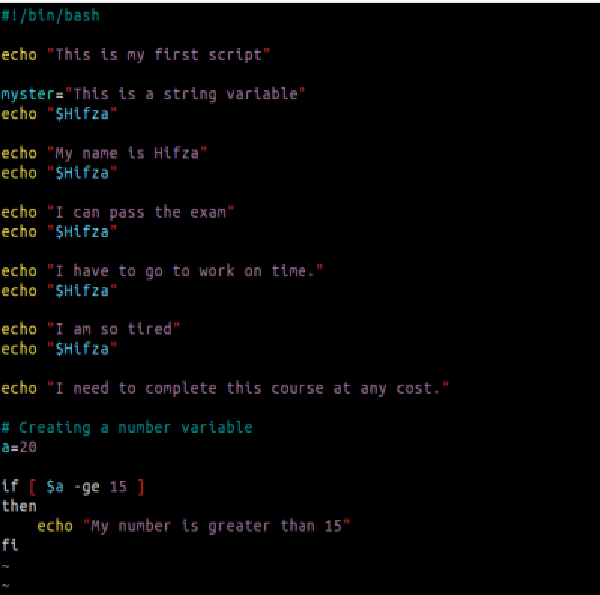 20
Key Features Demonstrated 20
Conclusion 20
References 21
Appendices 22
Appendix (A) 22
Cisco Networking Academy Course Evidence 22

- Introduction
Operating systems (OS) are vital software that controls computer hardware and software resources and offer a platform for applications to run effectively. This report delves into the major roles of operating systems such as process management, memory management, file system management, etc., and security management. It also shows how to use some of the common commands in the Windows Command Prompt and Linux Bash for system administration. The report also features Windows Batch and Linux Bash scripts, showcasing the advantages of using the command line to automate typical admin tasks. The concepts mentioned in the report are backed up with examples and screenshots throughout the report to show a clear understanding of the basics of operating systems.

Task 1
- Key Functions of General Operating Systems
A general-purpose operating system (OS) controls computer hardware and software resources and provides an environment for running applications efficiently. It has the following primary functions: process management, memory management, file system management, and security management. These functions enhance the performance, stability, and reliability of the system on various operating systems like Windows, Linux and macOS [1], [2].

2.2. Process and Processor Management
Process Management controls the creation, scheduling and termination of programs and ensures that CPU resources are shared fairly among the programs running. Pre-emptive multitasking is the way Windows works, which involves rapidly switching processor time between processes by a process of context switching. This is important because this way, one application does not use up all the processor, and several applications may run at the same time. For instance, if a user is surfing the Web as he works on a report, he can hear music without any interruption. Figure 1 is an illustration of the Windows Task Manager program showing the CPU usage, background processes, and active programs. The utilization of the processors appears low, suggesting that the processor is getting its resources used efficiently by Windows. Pre-emptive scheduling is also used in Linux and macOS, but Linux affords more flexibility for server administration [1], [2].
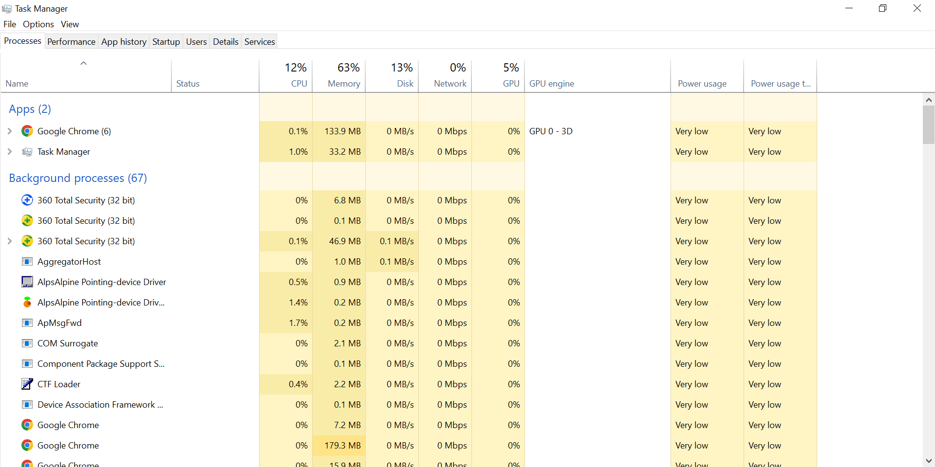
Figure 1: Windows Task Manager window with the list of applications currently running along with their usage of the processor.

2.3. Memory Management
Memory Management ensures running applications receive sufficient RAM while preventing conflicts between the processes. Virtual memory is allocated dynamically by Windows and is used when a computer's RAM is full, ensuring the computer remains efficient. As shown in Figure 2, the system has RAM, with a portion currently in use and the remaining memory available for additional tasks. It shows that Windows is successfully allocating memory resources to support multitasking while maintaining overall system performance or stability [2], [3].
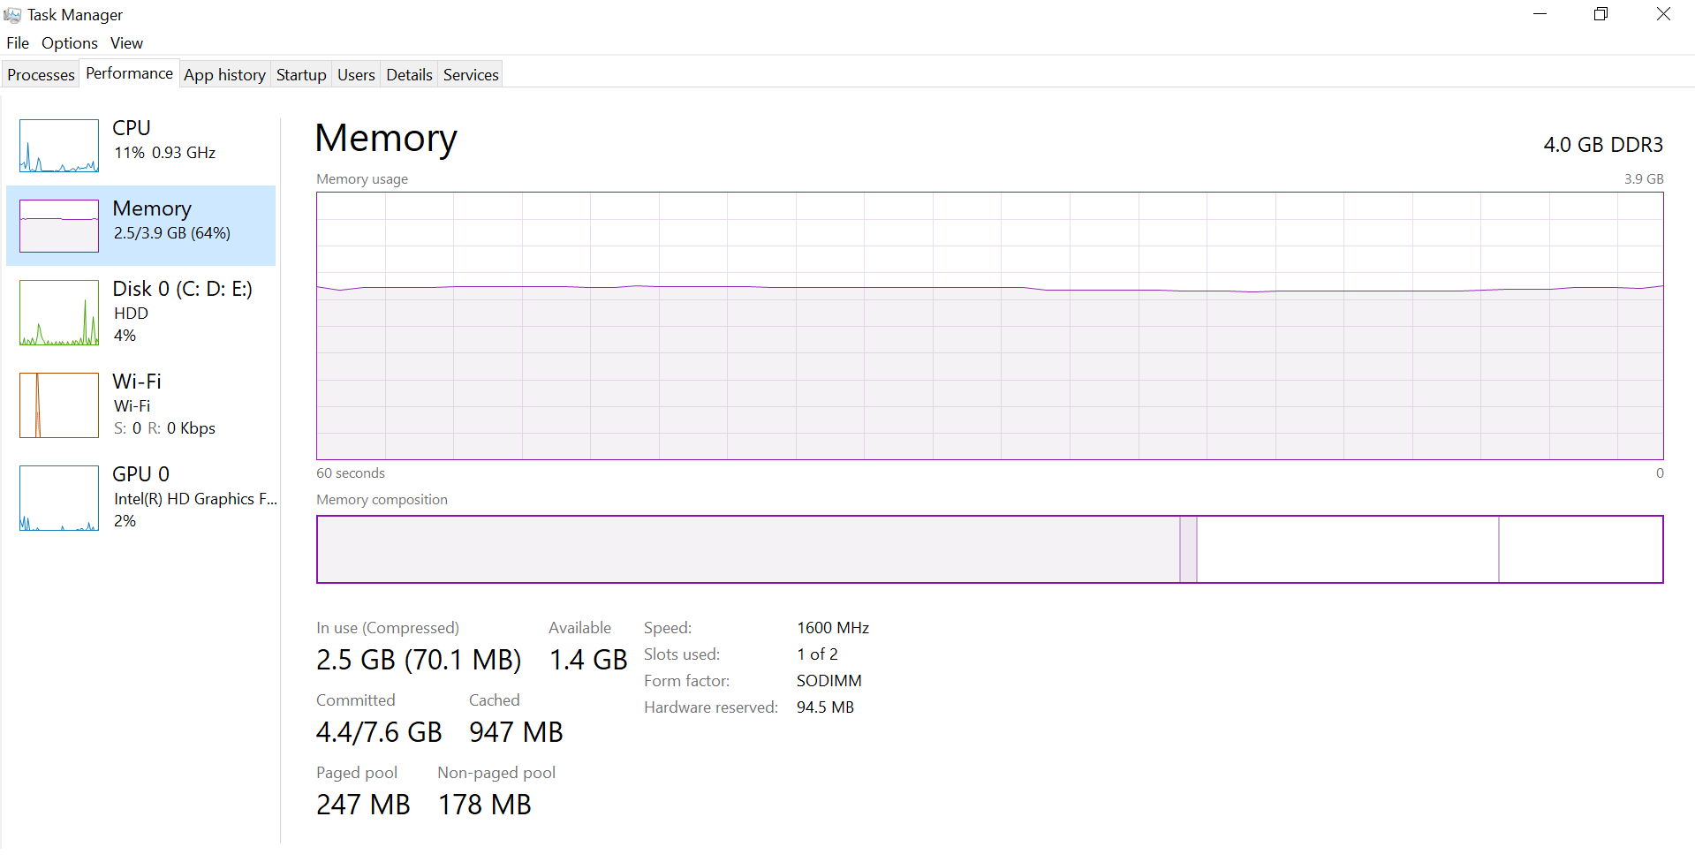
Figure 2: Memory Usage and Performance in Windows Task Manager

2.4. File System Management
File System Management organizes, stores, accesses and retrieves data and files from storage devices. It is used to create, rename, copy, move and delete files and folders, and to manage file permissions. For instance, Figure 3 displays Windows File Explorer, whereby people can gain access to files, folders and storage drives. A typical file system for Linux is ext4, and for Windows, it is NTFS, which are efficient ways to manage storage [1], [4].
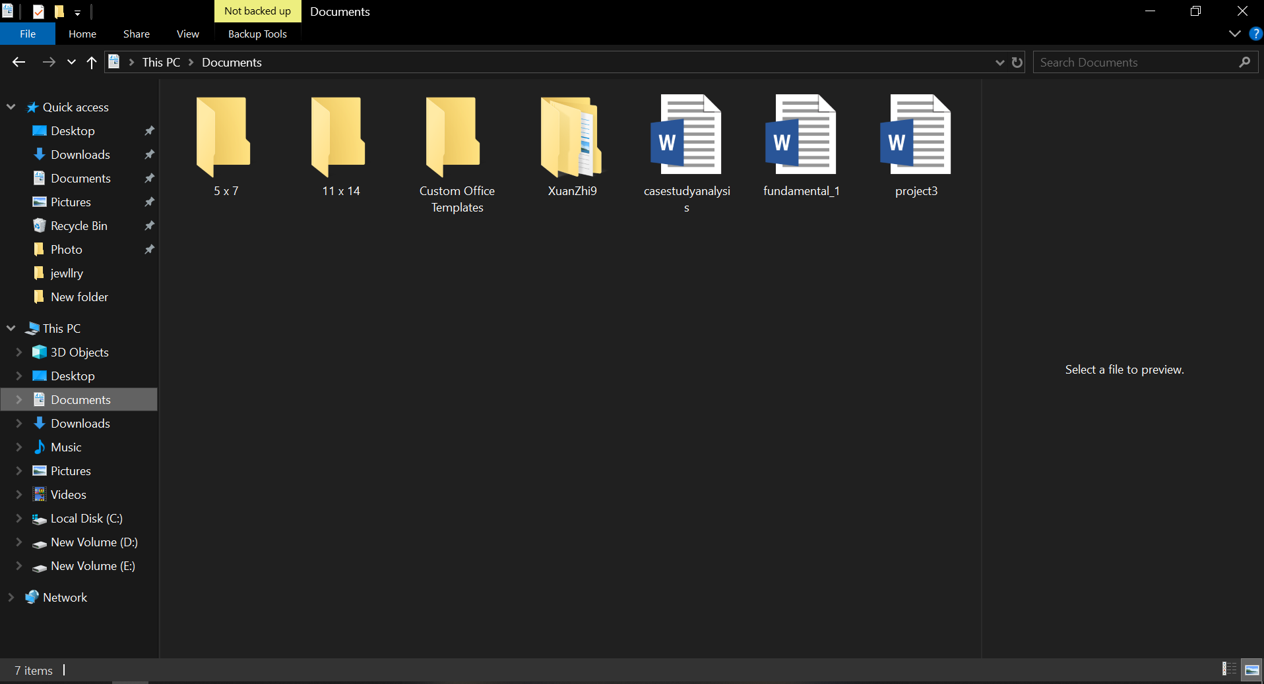
Figure 3: Windows File Explorer displaying folders, files and storage drives.

2.5. Security and Protection
Security management ensures that the operating system is secured from unauthorized access, malware and software vulnerabilities. Windows' security is enabled via user authentication, Microsoft Defender, firewall security and regular security updates. These features combat cyber risks, boost stability, and safeguard delicate information. The Windows security interface is illustrated in figure 4, updates are used to fix vulnerabilities and enhance system protection. Linux makes extensive use of user permissions and repository-based updates, macOS uses UNIX permissions with built-in security technologies to protect user information [1], [3], [5].
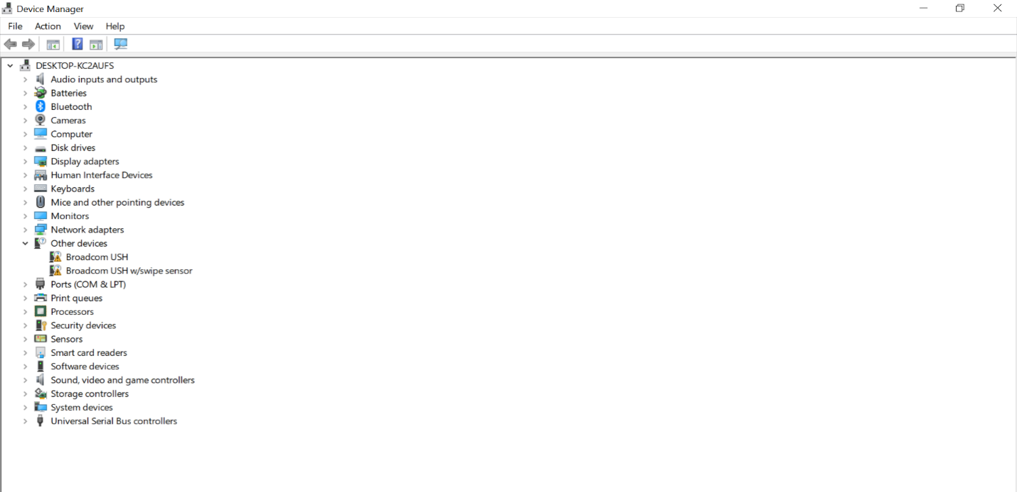
Figure 4: Windows Device Manager showing system hardware txtand devices.

Task 2

Use of Windows OS CLI Commands
The Windows Command Prompt (CMD) is a command-line interface that allows you to run administrative commands, troubleshoot system problems, and manage Windows resources efficiently. Admins can perform tasks faster and automate repetitive tasks using CMD as compared to graphical tools [1].
Process Management
Command: tasklist
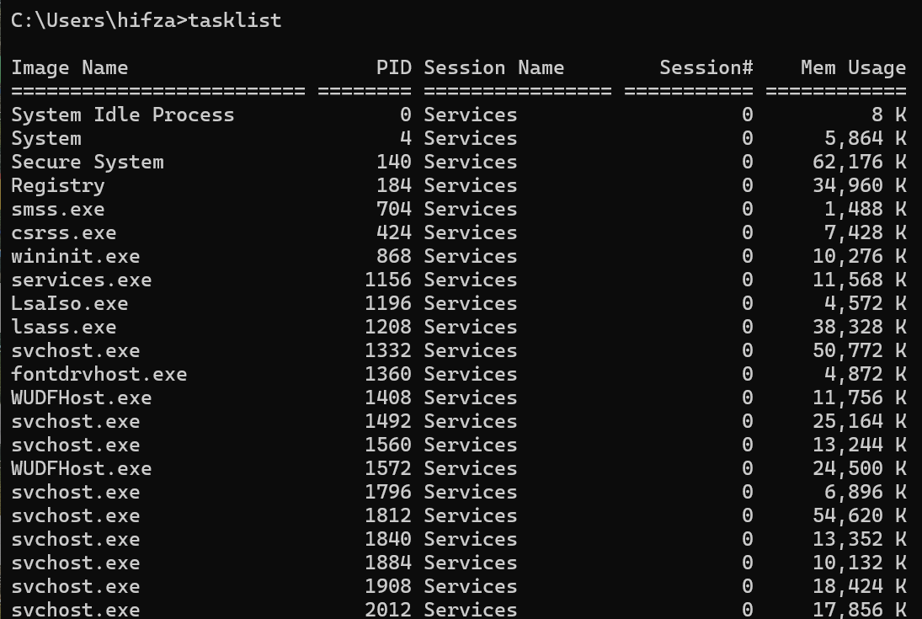
All running processes are listed, with each displaying Process IDs (PIDs) and memory usage with the task list command. It can help determine if an application is using too many resources. The screenshot output will list active processes, allowing administrators to keep track of system performance and to diagnose problems [1].
Command: task kill /PID 11972 /F
The task kill /PID 11972 /F command will kill a process by the PID. The /PID switch is used to designate the process to terminate, and /F will make the application terminate if it does not respond. This will improve system responsiveness without rebooting the computer [1].
File and Directory Management
Command: dir
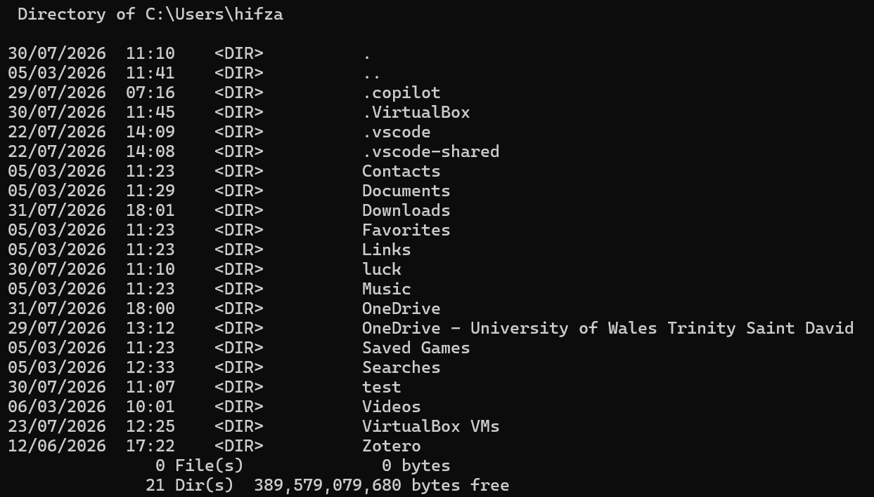
The dir. command lists files and folders in the current directory and assists users in confirming file locations before operations. The output shows the file name, size and modification time [2].
Command: mkdir Test Folder
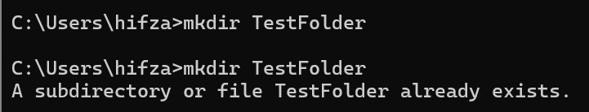
The Test Folder directory will be created with the mkdir command, and the current working directory will change to Test Folder with the cd command. These commands make file management easy and make administration more efficient [2], [6].
Command: cd Test Folder
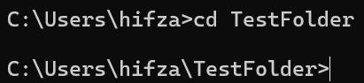
The CD command is used to set the current working directory. It enables us to navigate between folders as well as run commands from other areas of the file system [2].
Network Testing and Monitoring
Command: ipconfig /all
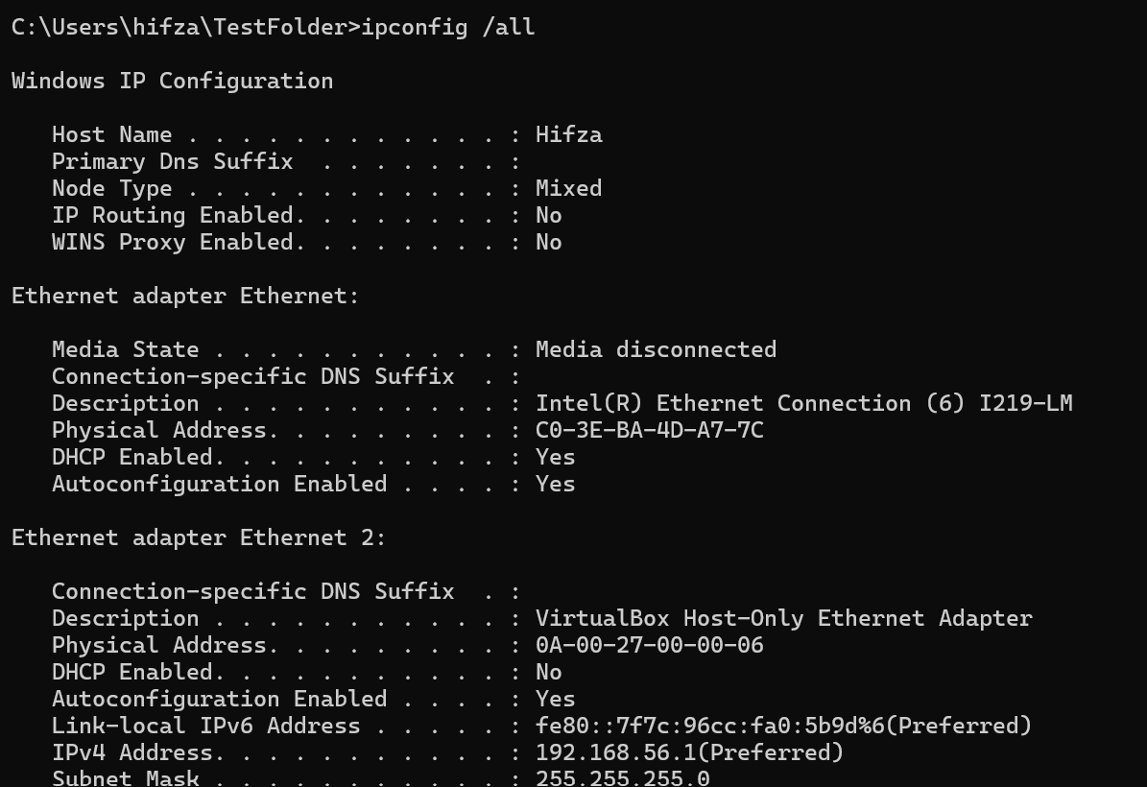
The ipconfig /all command will show detailed network configuration, such as the IP address, DNS servers and adapter information. The /all switch gives you all the configuration information that can help troubleshoot connectivity issues. The screenshot shows that the network configuration is set properly [1].
Command: ping google.com
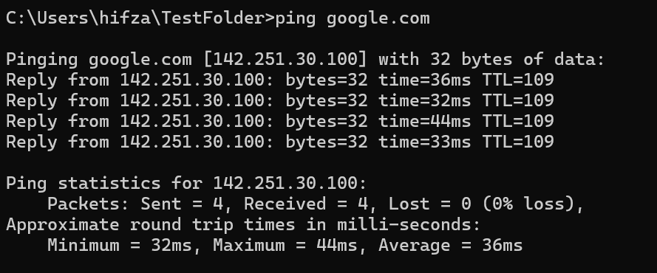
The ping google.com command sends out ICMP echo requests to test the network. Successful responses indicate a system's ability to communicate with remote systems. The netstat -an command can be used to identify suspicious network activity and lists active connections and listening ports, -a lists all connections and -n shows numerical addresses [1].
Command: netstat –an
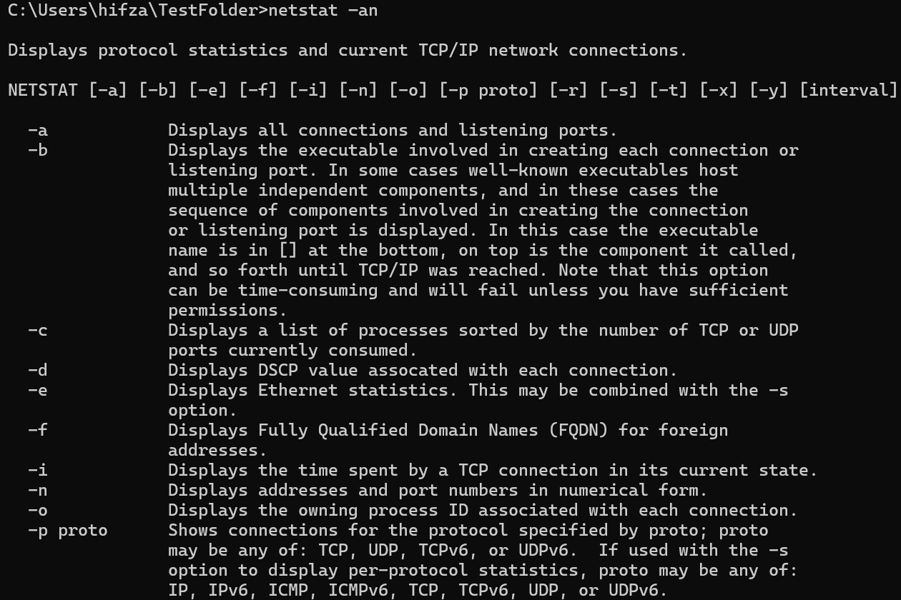
The netstat -an command shows the active network connections and listening ports in numeric form. It is used to keep users updated on the activity in the network and to find out if the computer is communicating with remote systems [2].
User Management
Command: whoami
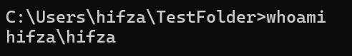
The whoami command will return the name of the account that you are currently logged on as. It can be useful to verify a user's identity and to ensure that commands are being executed under the proper user's account [1].
Task Scheduling
Command: schtasks /query
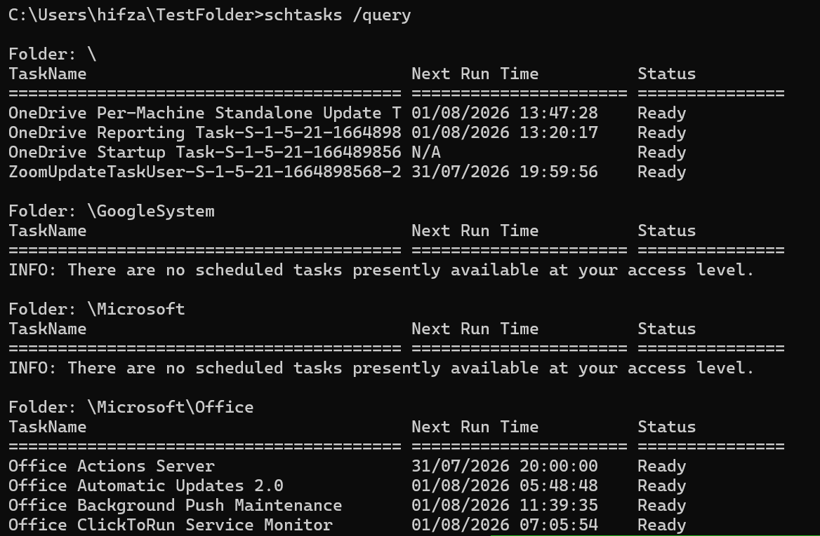
Scheduled tasks that are configured on the system are displayed, along with their status and the time they will run next, by using the schtasks /query command. It assists the users to track automated tasks and ensure that the tasks scheduled are running correctly [2].

Task 3
- Use of Linux OS CLI Commands
The Linux Command Line Interface (CLI) offers an effective means of handling files and directories and system resources. Here are some examples of basic Linux operations using the Terminal in Ubuntu for moving around, creating files, and manipulating directories.
- pwd:
The pwd command shows the current working directory, which is useful for ensuring that a user is in the correct directory before attempting to operate on files or directories [7].
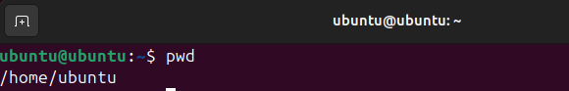
- ls –l
The command ls -l lists the information of files in detail (the -l option displays the permission, owner, size, and time they are modified) [8].
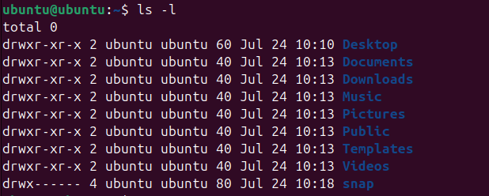
- mkdir TestFolder
The mkdir command is used to make a new directory. For this example, a folder called TestFolder was created successfully that will be used for storing and organizing files [8].
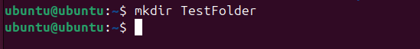
- cd Test Folder
The mkdir TestFolder command creates a new directory, and the cd Test Folder command switches to this directory to manage files [8].
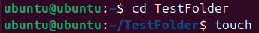
- touch test.text
The touch test.txt command will create an empty file and the command cat test.text will display the contents of the file [8].
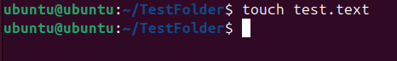
- ls –l
The command ls -l was used once more to ensure that the file test.text was created successfully. Successful creation of the file is confirmed by the output that shows its permissions, ownership, size and creation time [8].
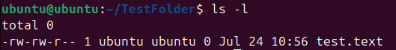
- cat test.text
The cat command can be used to print out a file's contents. The command was executed successfully but test.text contained no text, so no text was displayed [8].
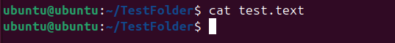
- whoami
The whoami command log will show you the name of the user you are logged in as and the ps command will list processes running [8].
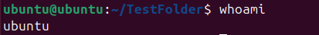
- ps
The Ps command shows the running processes within the current terminal session. It is useful to get a user aware of running tasks and basic process information [8].
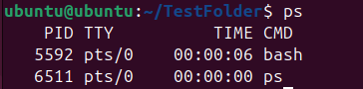
- ping –c 4 google.com
Lastly, ping -c 4 google.com sends 4 ICMP packets to google.com, and the -c 4 option is used to limit the number of requests. Successful responses indicate that there is an Internet connection in the system and it can interact with remote servers [8].
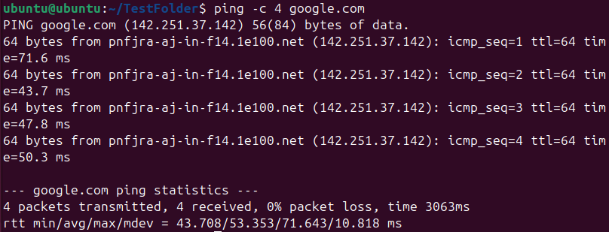

Task 4
- Use of Windows OS Scripts
Batch scripting is about using Command Prompt commands to automate repetitive tasks. There are two batch scripts in the Microsoft Windows system that are used to show how to display information about the system and to perform some basic arithmetic [9].
  - Script 1: System Health Check
System information is displayed by the systeminfo.bat script, which are based on the environment variables %COMPUTERNAME%, %USERNAME%, %DATE%, and %TIME%. The pause command will run until a key is pressed, and the echo command will display the formatted output. [9].
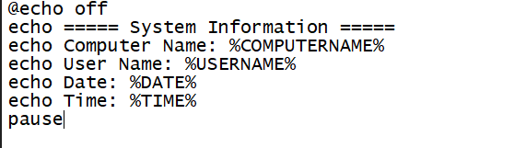
Figure 1: Contents of a systeminfo.bat batch script
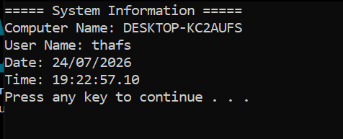
Figure 2: Output of the systeminfo.bat script
Successful execution is indicated in Figure 2 with the computer name, logged-in user, date and time. It's a good script for a quick query of system information as part of troubleshooting [9].
  - Key Features Demonstrated
- Displays system information using echo.
- Displays the current date and time.
- Uses environment variables.
- Formats output for readability.
Script 2: Sum Calculator
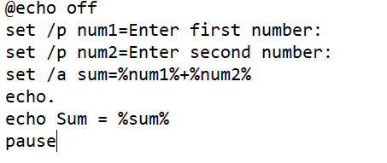
Figure 3: Contents of calculator.bat batch script
The calculator.bat script shows how to use variables, input from the user, and arithmetic. The two user inputs are entered by the set command, and the addition is performed by the set /a command and the result is displayed [9].
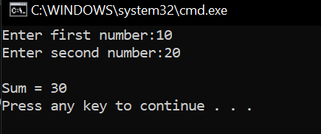
Figure 4: Output of calculator.bat script
Figure 4 shows that the script is correct in calculating the total. The examples of Windows batch files in these scripts demonstrate automated and repetitive tasks, minimize human error, and serve as the basis for more complex batch scripts [9].

Task 5
- Use of Linux OS Scripts
  - Script 1: Log File Analyzer
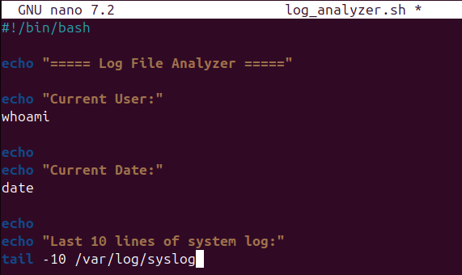
The log_analyzer.sh shell script prints the system's last 10 lines of the system log and prints other useful information such as the current user and the current date and time. It automates log inspection with built-in Linux commands like whoami, date and tail. This script shows how shell scripting can make repetitive administration tasks easier and how it can be helpful in efficiently keeping track of system activities and troubleshooting them [10], [11].
Output
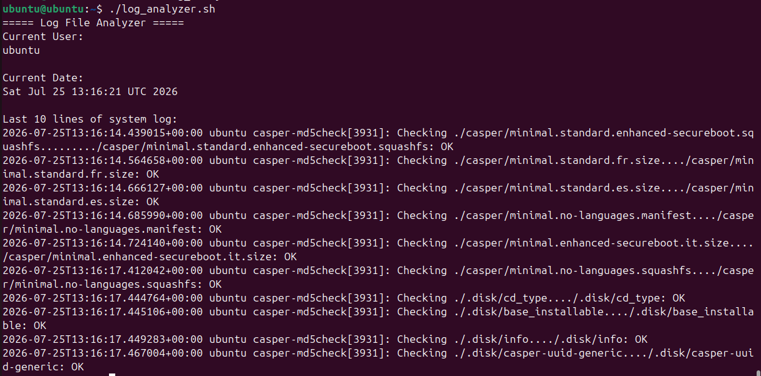
The output shows that the script ran successfully as it prints out the current logged on user, the current date and time of the system and the last entries of the system log. This proves that the shell package can automatically collect and provide valuable system information, thus saving users from executing multiple commands manually, and making it more efficient in regular Linux system maintenance operations [10], [11].
  - Key Features Demonstrated
- Uses a shell script to automate tasks on Linux.
- Uses whoami to get the current logged on user.
- Prints the current date and time – date.
- Reads the last ten lines of a log file using tail.
- Shows some knowledge of shell scripts and command automation.
Script 2: String and Number Variables with IF Condition
The Bash script shows how to use string variables, number variables and an IF condition it Stores text in a variable and uses echo to display it. It also prints a variable number and asks whether its value is greater than 15. Shows simple use of variables and decision making in Bash scripting.
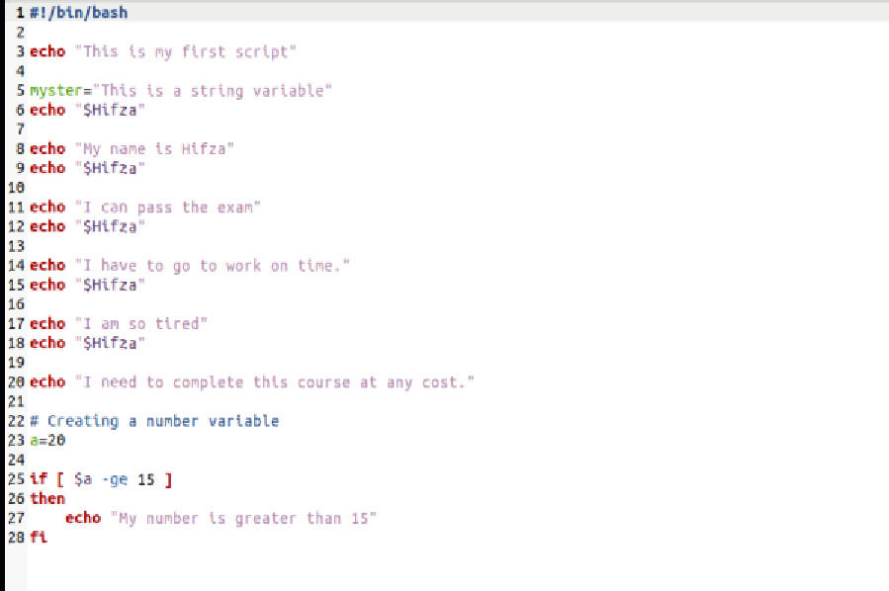

Output
The results indicate that the script can print the string values and messages stored in the string variable. It also checks the number variable with the IF condition and outputs “My number is greater than 15” with the value assigned to the number variable being 20. This demonstrates that variables can be used in the script and decisions can be made depending on a set condition.

Key Features Demonstrated
- Knows and can use string variables to hold and show text.
- Prints values of variables and messages using echo.
- Defines a number variable that has a value of 20.
- Compares the number to 15 using the IF condition.
- Know basic bash scripting and decision making.

Conclusion
This report helped to enhance both theoretical knowledge and practical knowledge related to operating systems. It introduced various core OS concepts such as process and memory management, file system management, security management, and showed how to use the Windows CMD commands and Linux CLI commands to administer an OS. The use of Windows batch scripting also showcased the benefits of automation in repetitive tasks and increasing efficiency. In general, the activities have demonstrated the value of using operating systems and command-line tools to maintain computer systems properly and to facilitate productive and dependable day-to-day administrative tasks.

References
fi
[1] | M. Learn, "Windows documentation," Microsoft, 2025.
[2] | M. Learn, "Windows architecture and memory management," Microsoft, 2024.
[3] | M. Learn, "Windows Security documentation," Microsoft, 2025.
[4] | R. Hat, "What is the Linux command line?," 2024.
[5] | NIST, "Computer Security Resource Center," 2024. [Online]. Available: https://csrc.nist.gov/.
[6] | C. N. Academy, "Operating Systems Basics," 2025.
[7] | U. Documentation, "Ubuntu Server and Desktop Command Line Guide.," 2024. [Online].
[8] | U. Documentation, "Ubuntu Server and Desktop Command Line Guide.," 2024. [Online].
[9] | M. Learn, "Windows Command-Line and Batch Files Documentation.," 2024. [Online].
[10] | A. G. P. B. &. G. G. Silberschatz, Operating System Concepts (10th ed.). Wiley., 2020.
[11] | C. Ltd., "Ubuntu Documentation.," 2024. [Online]. Available: https://ubuntu.com/tutorials.
[12] | T. L. Foundation, "Linux Documentation," 2025.
[13] | O. Foundation, "OWASP Top 10: The Web Application Security Risks," 2024. [Online]. Available: https://owasp.org/www-project-top-ten/.
[14] | D. Inc., "Docker Documentation," 2025. [Online]. Available: https://docs.docker.com/.
[15] | G. Project, "GNU Bash Reference Manual," 2025. [Online]. Available: https://www.gnu.org/software/bash/manual/.
[16] | G. G. a. P. B. G. A. Silberschatz, Operating System Concepts, 10th ed. Hoboken, NJ: John Wiley & Sons, 2018.

Appendices

Appendix (A)

Cisco Networking Academy Course Evidence

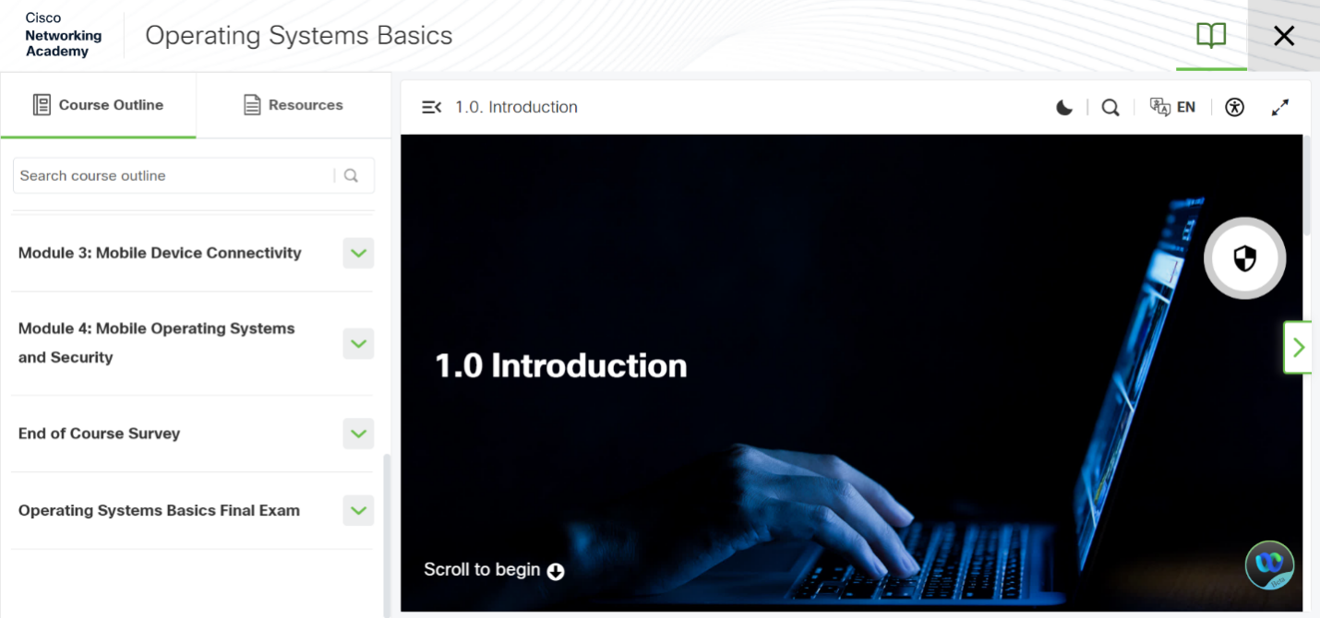

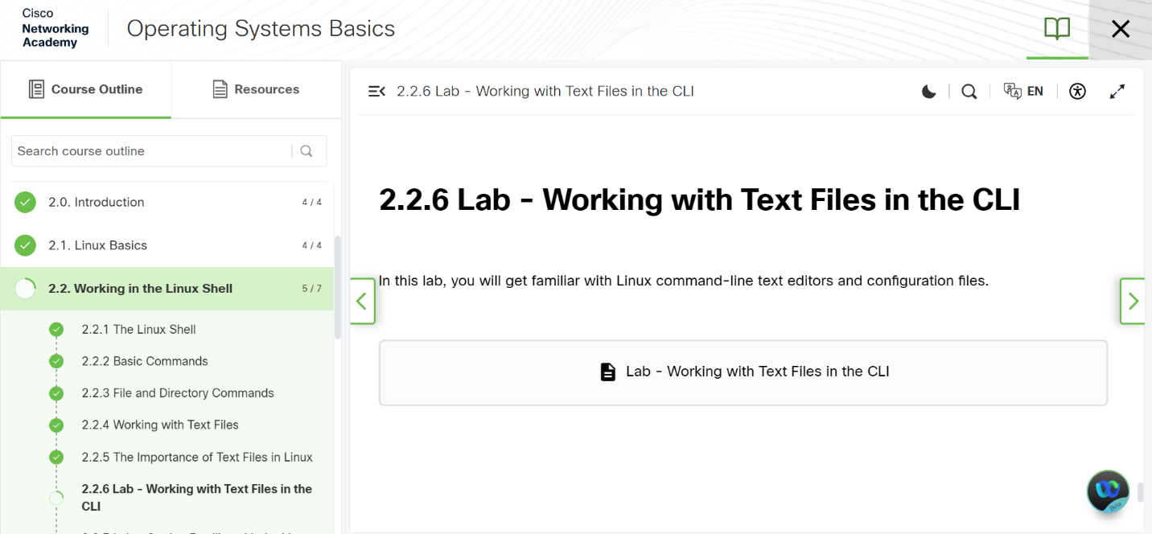
Appendix (B)
Lecture Notes and Learning Evidence

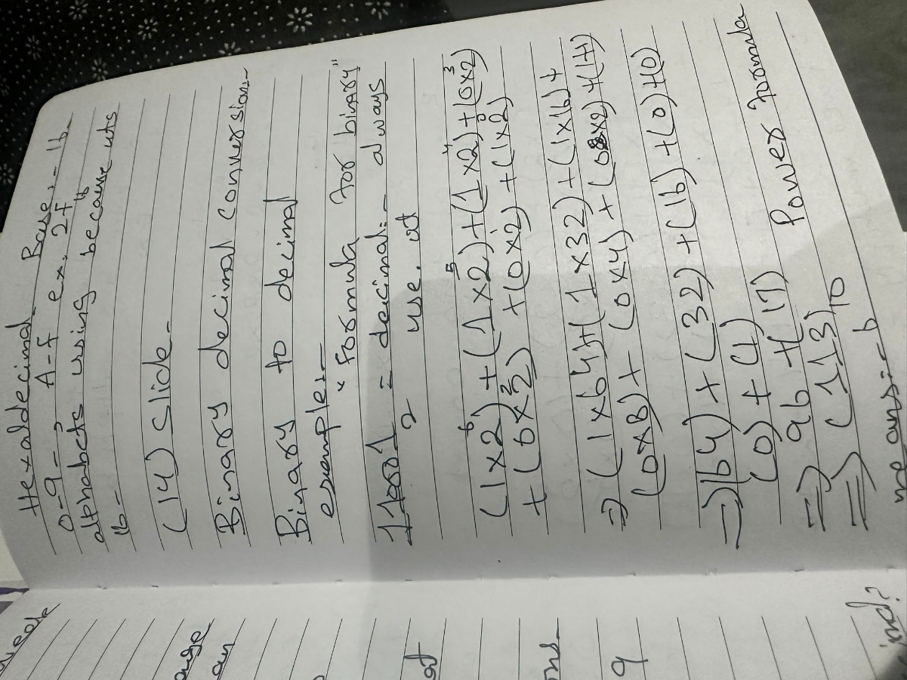

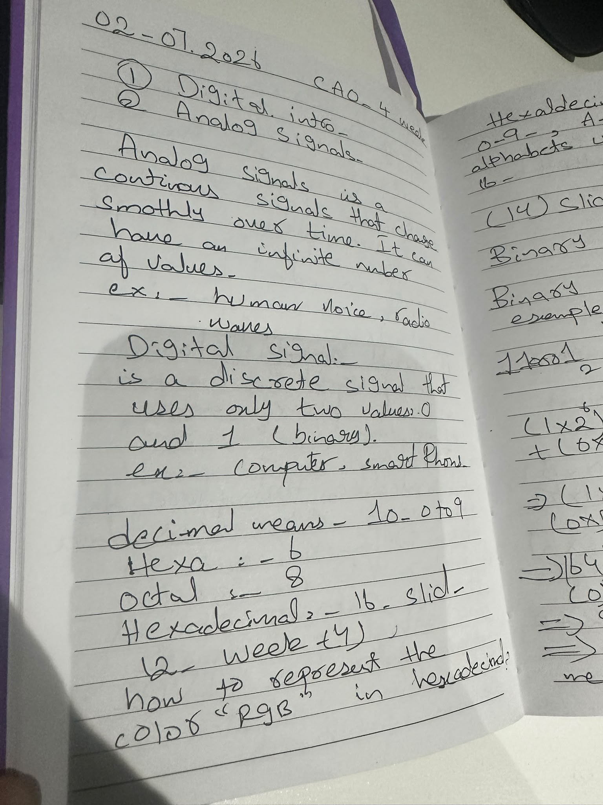
Appendix (C)
Course Completion Evidence



