2. Within a given time period, select examples of what could be considered high and low cultural artefacts. Discuss these, taking into consideration the surrounding social, political and historical context.
Name: Georgia Cole
P number: 1700663
Course: BA Graphic design
Word count: 1907
Course tutors: Sarah Tombs and Louise Burston

In this essay I will be discussing artefacts that could be considered high and low culture between the 1960s-1980s, with reference to Pop Art and Graffiti. The term “Culture” first appeared in the 18th century, “to connote a process of cultivation or improvement, as in agriculture or horticulture” However, in the 19th century, the term later developed to “first to the betterment of refinement of the individual, especially through education, and then to the fulfilment of national aspirations or ideals.” Scientists also used the term “culture” to “refer to a universal human capacity.” (Lumen, 2018)

High and low cultures are considered sub cultures, which is a cultural group within a culture. Due to globalization and digital culture, the terms high and low Culture have become increasingly difficult to define, as the barriers between them both have essentially collapsed. ‘High culture’ is defined as “the providence of an elite aristocracy or intelligentsia” (Cram 101 Textbook review, 2016)
Whereas, ‘low culture’ refers to “that of the less well-educated or the masses, encompassing such things as gossip magazines, reality television, popular music, yellow journalism, escapist fiction, and camp.” Boundless (2018.) Raymond Williams once stated the definition of high culture in his book:

What does “high culture” mean? Its most plausible use is to describe the great body of cultural skills and the great works which embody and represent them. There would be argument about which skills to include or exclude, but in common usage the skills of organized thought, writing, music, the visual arts and architecture would certainly be included. (Williams, R. 1974)

Firstly, I will be discussing Pop art artefacts. Pop art is an art movement that began in the 1950’s within both the United Kingdom and the united states. It reached it’s peak in the 1960’s due to artists such as Andy Warhol, Roy Lichtenstein and many others, taking inspiration from sources in popular and commercial culture, then creating them into masterpieces. At this time young artists “felt that what they were taught at art school and what they saw in museums did not have anything to do with their lives or the things that they saw around them” thus leading to artists with the likes of Warhol and Lichtenstein, using everyday products such as packaging, house hold items, comic strips, Hollywood movies and pop music within their work. Which showed off the lower art style and attracted a lot more people. Bell, N (2017)

Before the Pop art movement began, you could argue that art in general was aimed at people with a higher culture background. However, the Pop art movement blurred the lines between high and low culture in the 1960’s. Therefore, in my opinion Pop art is considered both high and low culture. An English artist, Richard Hamilton once stated in a letter written to his friends in 1957 “Pop Art is: Popular (designed for a mass audience), Transient (short term solution), Expendable (easily forgotten), Low Cost, Mass Produced, Young (aimed at youth), Witty, Sexy, Gimmicky, Glamorous, Big business” (Kaizen, 2000.)
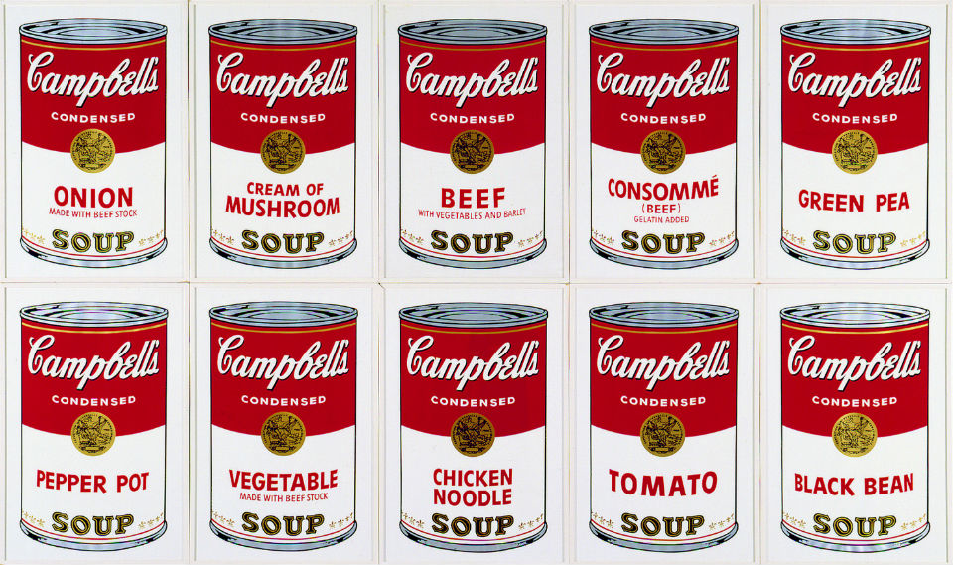
Warhol, A (1968) Campbell’s Soup.
One of the defining creations of the Pop Art Movement was Andy Warhol’s Campbell’s soup cans. During the early 1960’s, Warhol’s work undermined the realm of high culture and commercial art. During 1962, Warhol began his transition from hand-painted to photo-transferred art. For example, the Campbell’s soup cans that he painted. A friend of Warhol’s suggested that he should paint something that everybody would recognize “like Campbell’s soup.” Warhol, A (2015.) All the productions were hand painted, although he later reinterpreted these works into screen-prints, which again achieved the highly finished mechanised look he desired to make a name for himself. The Campbell’s soup cans became one of the most iconic images of Warhol’s career.
Warhol claimed the Campbell’s Soup Cans were his favourite works and said that he “should have just done the Campbell’s Soups and kept on doing them ... because everybody only does one painting anyway.” Warhol, A (2015) The fact the original screen-prints, and paintings were mechanically reproduced, while the originals were selling for Millions in galleries and museums, indicates that his work is High culture dwelling on low culture. Warhol also discussed in his book:

“in the late post- Abstract expressionist days, the days right before Pop, there were only a few people in the art world who knew who was good, and the people who were good knew who else was good. It was all like private information; the art public hadn’t picked up on it yet. One incident especially brought home to me how low the general art world awareness was.” Warhol, A (2015)

Roy Lichtenstein was an American pop artist in the 1960’s alongside Andy Warhol. He was influenced by advertising and the comic strip, thus leading him to becoming a leading figure in the new Pop art movement. Lichtenstein actually upstaged Warhol when the Pop art movement began. However, at “some point in the years that followed the tables had seemed to have turned” and Warhol had “emerged as the emblematic pop artist for the public at large, particularly because of his highly visible public persona” Lobel, M (2002)

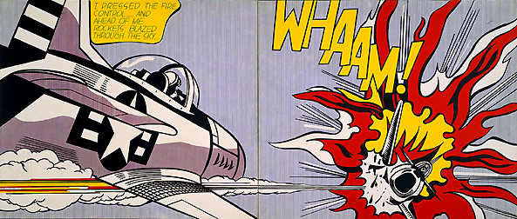

Lichtenstein, R (1963) Whaam!

One of the defining creations of the Pop Art Movement for Lichtenstein was his ‘Whaam!’ work in 1963. Lichtenstein mainly drew on commercial art such as comic images. Lichtenstein had a three-year period in which he proceeded with pop and stated “I was doing only abstract work. At that time, I began putting hidden comic images into those paintings.” Lobel, M (2002) ‘Whaam!’ was based on an image from the DC comic, All American Men of War, published in 1962. Lichtenstein wanted to depict a “highly emotional subject matter relating to love or war in a cool, impersonal way” Tate (1963.) Lichtenstein stated in a book that:

The heroes depicted in comic books are fascist types, but I don't take them seriously in these paintings - maybe there is a point in not taking them seriously, a political point. I use them for purely formal reasons, and that's not what those heroes were invented for ... Pop Art has very immediate and of-the-moment meanings which will vanish ... Pop takes advantage of this "meaning", which is not supposed to last, to divert you from its formal content. I think the formal statement in my work will become clearer in time. Selz P, Stiles, K (2012)
To conclude, Both Warhol and Lichtenstein achieved a name for themselves during the 1960’s, due to the fact they had both managed to blur the lines between high and low culture, they had changed the way people view art as a whole. Both of their work ended up in galleries and exhibitions selling for millions.
Graffiti art has had an extraordinary effect on high and low culture, what started as an illegal pastime, grew into an art movement more wide-ranging than anyone could have imagined. Graffiti goes back to ancient Rome, if we define it as any type of writing or image making on walls. However, the style of urban graffiti that most people know about, such as using spray paint, all started in Philadelphia on the turn of the 60's with writers like “Cornbread”, Darryl McCray and Jean-Michel Basquiat.

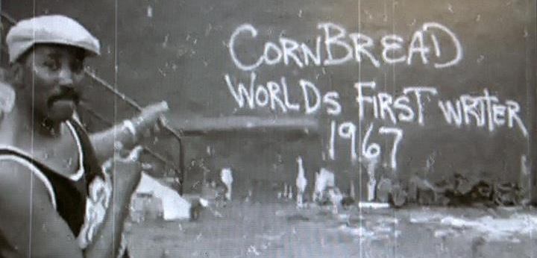
Cornbread (1967) Worlds first writer

In 1965, Darryl “Cornbread” McCray, was a young mischief maker housed at Philadelphia’s Youth Development Centre. He is now considered the world’s first modern graffiti artist. The name “Cornbread” came from the fact that McCray loved cornbread and liked to eat it with his grandmother. He used this name and marked it all around Philadelphia to make himself known to the public. As Nancy McDonald explains in The Graffiti Subculture, graffiti artists would start off “making a name” for themselves by choosing a pseudonym, they would place the signature up in as many places around they’re local area, to make themselves known Macdonald, N (2001). Two Sociologists Ernest Abel and Barbara Buckley profess that graffiti markings have historically been ‘announcements of one's identity, a kind of personal testimonial to one's existence … scratched, carved, or painted onto some surface seemingly for the purpose of leaving one's mark.” Abel, E.L and Buckley, B.E (1977)

Cornbread used his graffiti “as a means of protesting social inequities and police brutally in minority communities.” White, A (2018) This suggests that graffiti was once considered low culture but is now considered higher cultured due to the fact it is being used to raise awareness of social issues.

Jean-Michael Basquiat is an artist best known for neo expressionism. However, was also a successful graffiti artist in the late 1970’s, he was also known to be part of the duo “SAMO”, a pseudonym that first caught the public’s attention. Basquiat came from a middle-class family and also grew up “exposed to different languages, diverse literature and culture.” Gallery, K (2013) The reason for his graffiti being so successful is because of the strong messages and opinions conveyed to the public within his work.
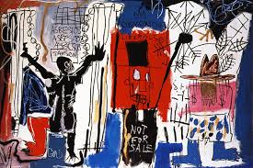Basquiat, J.M (1982) Obnoxious Liberals
An example of this would be his “obnoxious liberals”, where he conveys series of pictures representing capitalism and it’s victims. In an interview, his friend Al Diaz who was part of the SAMO duo, states that the graffiti “would very quickly develop into a vehicle for voicing opinions on the world around us as we observed it. We were creating an entirely new style of graffiti. It was literate and message-based.” The fact that the work had a strong cultural influence within society, is also the reason that Basquiat’s work ended up selling for millions in galleries and museums. Which suggests that his work started off as lower culture art but became higher cultured throughout his career and still continues to have an impact on society today. Gregory Snyder states in his book ““while the reaction [to graffiti] from the public [is] often positive, the reaction from City Hall [is] not” Snyder, G. J. (2009) this is a perfect example of how Graffiti is viewed by the government and the higher class. However, it has become more acceptable and higher cultured since the 60’s until now.

As an artist, Basquiat took inspiration from Andy Warhol throughout his career and Basquiat himself was also an influence for Banksy’s work. Banksy, an anonymous English street artist who was born in the 1970’s, is another artist that conveys strong messages through graffiti. Most of his work is low culture but his stencils have been used to convey important messages, have become high culture in museums and galleries, and are now selling for millions.

In conclusion, my research on high and low culture within Pop art and graffiti conveys that between the 1960s, up untill the 21st century, all the artists that I have discussed have all had an impact on each other. I have also found that there has been a significant culture change through the Pop art and graffiti movement between the 1960s-1980s. Overall, I think that all the artists’ work is difficult to define as either high culture or low culture. However, I do think a lot of Pop and graffiti artists started off as low culture, due to their backgrounds and then all of them ended up selling their work, and still continue to sell, for millions in galleries. Which in my opinion is now high culture art. However, the fact that the art work can be mass produced and copied, also makes it low culture.

Bibliography:
- Abel, E.L and Buckley, B.E (1977) The Handwriting on the Wall: Toward a Sociology and Psychology of Graffiti. Westport, CT: Greenwood Press.
- Banksy (2006) Wall and Piece [New] ed. London: Century
- Bell, N (2017) Progression Week FMP: Description of Three Ideas [online]https://nicolebellfilmtv16.wordpress.com/2017/03/27/progression-week-fmp/
- Boundless (2018) High and Low Culture. [online] http://oer2go.org/mods/en-boundless/www.boundless.com/sociology/concepts/high-and-low-culture-0-5619/index.html
- Cornbread (1967) Worlds first writer

Cram 101Textbook review (2016) An Introduction to Women’s Studies, Gender in a Transnational World.
- Dillon. B (2011) Ruins: Documents of Contemporary Art. Whitechapel Gallery, Cambridge, Mass: MIT Press
- Farr, I (2012) Memory: Documents of Contemporary Art. Whitechapel Gallery, Cambridge, Mass: MIT Press.

Gallery, K (2013) Jean- Michel Basquiat [online] https://www.kukjegallery.com/db_img/press/d_Jean_Michel_Basquiat_en.pdf
- Hickey, D (2005) Air Guitar: Essays on Art and Democracy. Los Angeles: Art Issues.
- Inglis, D (2005) Culture and Everyday Life. London, Routledge.
- Kaizen, WR 2000. Richard Hamilton’s tubular image. Vol. 94, The Independent Group
- Lichtenstein, R (1963) Whaam!

Lobel, M (2002) Image Duplicator: Roy Lichtenstein and the Emergence of Pop Art. Yale Publications in the History of Art
- Lumenlearning.com, (2018) Culture and Adaption: boundless sociology [online]https://courses.lumenlearning.com/boundless-sociology/chapter/culture-and-adaptation/
- Macdonald, N (2001) The Graffiti Subculture: Youth, Masculinity, and Identity in London and New York. Basingstoke, U.K
- Manco, T (2002) Stencil Graffiti. London: Thames & Hudson
- Manco, T (2004) Street logos. London: Thames & Hudson
- Posener, J (1982) Spray it loud. London: Routledge & Kegan Paul.

Selz P, Stiles, K (2012) Theories and Documents of Contemporary Art: A Sourcebook of ArtistsÕ
- Snyder, G. J. (2009) Graffiti Lives: Beyond the Tag in New York's Urban Underground. New York
- Storey, J ( 2003) Inventing Popular Culture: From Folklore to Globalization. Blackwell Publishing.
- Tate (1963) Roy Lichtenstein: Whaam! [online] https://www.tate.org.uk/art/artworks/lichtenstein-whaam-t00897
- Varnedoe, K (1990) High and Low: Modern Art, Popular Culture. Museum of Modern Art, N.Y.
- Warhol, A (2015) Hackett, P(ed) POPism: The Warhol Sixties. New York
- Warhol, A (1968) Campbell’s Soup
- White, A (2018) From primitive to integral: the evolution of graffiti art. Vol. 11 : Iss. 11, Article 1. [online] https://digitalcommons.ciis.edu/cejournal/vol11/iss11/1
- Whiting, C (1997) A Taste for Pop: Pop Art, Gender and Consumer Culture. Cambridge University Press.
- Williams, G (2016) On and By Andy Warhol. Whitechapel Gallery, Cambridge, Mass: MIT Press
- Williams, R (1974) On high and popular culture. New Republic
- York: New York UP, Print.)

