1.C - Constraints

There are a variety of constraints that are imposed on developing this new Riverside Health Centre in Port Talbot, it’s imperative to recognise and navigate through these constraints that ultimately will shape the project. These will be explored in detail below outlining a variety of factors from a multitude of challenges and considerations that must be made. In this comprehensive overview, we will look at the planning constraints, environmental implications, logistical intricacies that will be responsible for managing the highway network surrounding the site, the parking arrangements and all utility implications and restrictions. This section will also explore the how restrictions will affect construction activities with the surrounding communities, whilst adhering to client-imposed deadlines and budgetary constraints. Sustainable drainage approvals, construction phasing and establishments of site compound restrictions that require strategic planning to ensure the project is successful. By navigating these constraints with diligence and foresight the construction project will not only meet all regulatory requirements but also ensure responsible development and community stewardship.
Planning Constraints
Obtaining planning consent has been a critical step in the development process to ensure we comply with local regulations and policies. The Health and Wellness centre’s planning consent has been approved and no planning restrictions have been imposed onto the project.
The presence of listed buildings near the site, such as a grade 2 listed Bethany Chapel, necessitates careful consideration to avoid adverse impact on these heritage structures, this information will be disseminated to all contractors to make them aware of this. While the new health centre is unlikely to directly affect this building due to being around 200m away from the site and there are other buildings between this and our site, adherence to planning policies and regulations is imperative to avoid any potential risks imposed by our project. Figure 1 shows the location of Bethany Chapel. There are no areas of importance listed nearby relating to CADW. There are no implications to consider as there is no conservation area, no hedgerow preservation. No TPO (Tree Preservation Orders) in place however, we have been granted approval from NPTCBC to work to nearby to trees, all trees will be protected, and no plant, machinery or materials will be stored in the nearby vicinity of the trees.

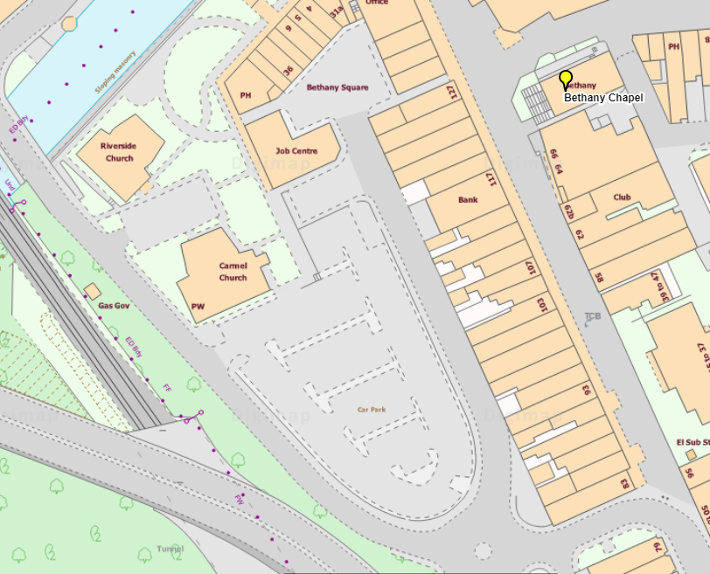
Figure 1 – Bethany Chapel Location

Public Right of Way Restriction
There are no public rights of way restrictions on site. There is one highlighted public walkway crossing highlighted in figure 2 as orange, there is also a public road highlighted in blue that is adjacent to our site. For the duration of the works, it will be subject to Traffic Management during road construction and realignment works the road will remain open for the duration of the works, but restrictions may apply from the Traffic management plan, this will allow for the successful removal or roundabout and new outdoor area in front of the health centre. Tyre washing facilities will also be available when leaving site to ensure minimal dust and dirt is spread and therefore have minimal impact on road users and pedestrians.

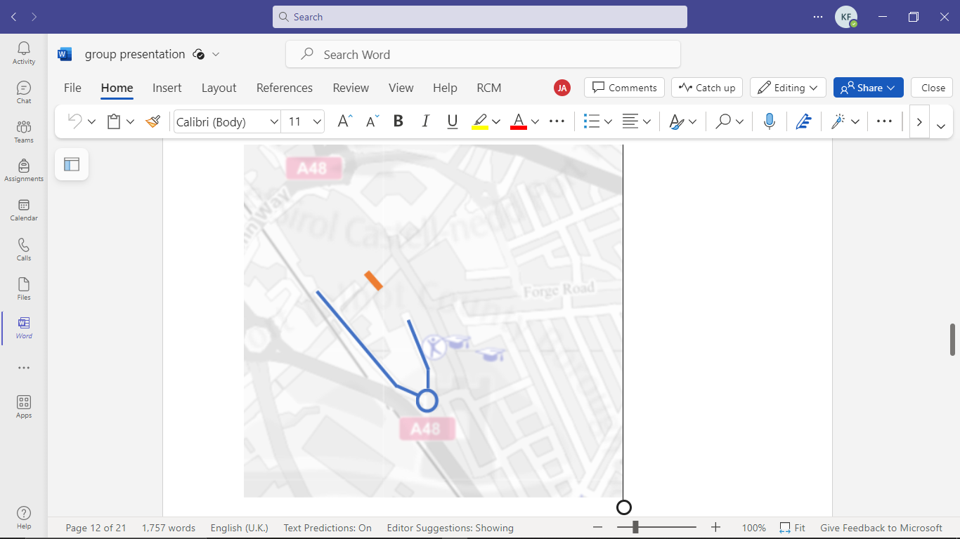
Figure 2 – Public Road (Highlighted Blue) & Public Bridge (Orange)

Flood Constraints
Upon analysing the flood risk surrounding our site, it is evident that the immediate vicinity exhibits a low risk of flooding. However, the main risks associated are identified from the nearby River Afan. The higher risk zone heightens the potential impact on our site during periods of spate, necessitating diligent mitigation measures to safeguard against any flood -related consequences. Figure 3 below shows the flood risk zones (Natural Resources Wales, 2023), in our site and the surrounding area. The area is considered low risk.
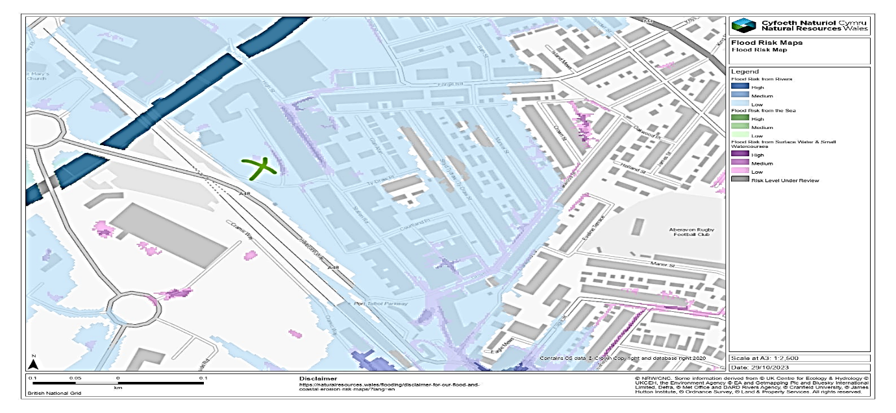
Figure 3 – Flood Risk Zones – Port Talbot (Natural Resources Wales, 2023)

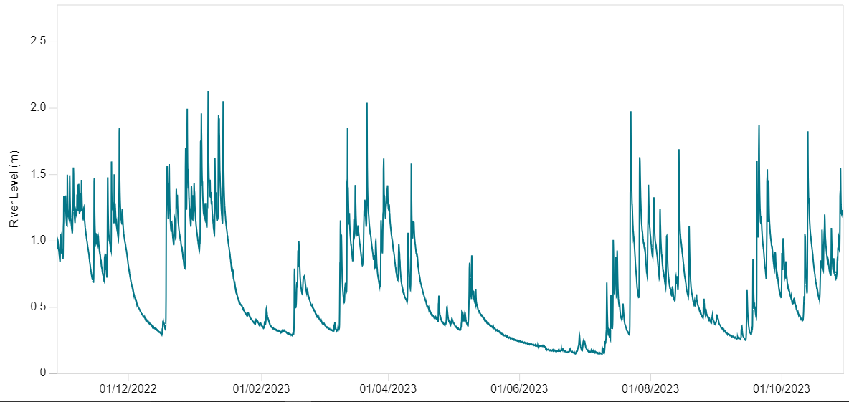
It is worth noting that figure 4 shows the highest river levels in the last year with levels not exceeding 2.2m on January 7th 2023 and did not result in flooding of the surrounding areas. The river level stands at on average 1.2m throughout the year. Natural Resources Wales have also not issued any flood warning alerts the last year. Therefore at current no major flood risks protection measures are considered at current.
Figure 4 – River Afan river levels 2022-23 (Natural Resources Wales, 2023)

Natural Resources Wales also have not issued any flood or severe flood warnings in the area in the last 5 years. Figure 5 shows the flood risk map for surface water and small watercourses in the area.
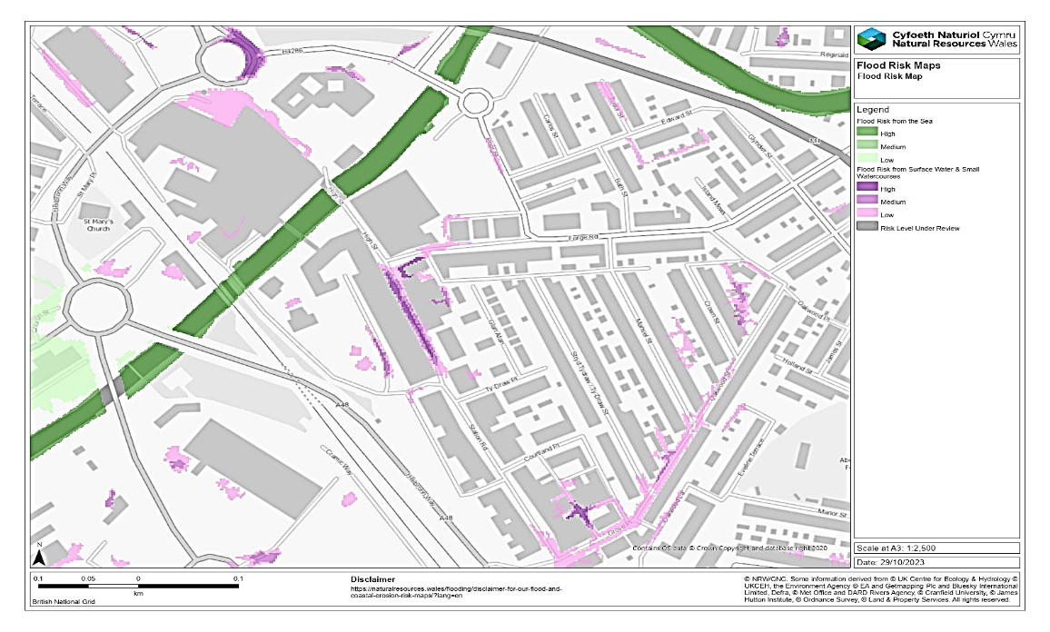
Figure 5– Flood Risk map for surface water and small watercourses(Natural Resources Wales, 2023)

This overall risk for our site is categorised as low to medium with localised areas susceptible to flooding due to potential inadequate drainage infrastructure that may result in flooding this will result in a constraint for the project as these issues need to be properly addressed.
Considering the findings, we deem a Flood Consequence Assessment not warranted, but the project will carry out proactive measures to help mitigate any potential flood-related risks effectively. The highest risk posed on the project is that from surface water flooding and therefore a management strategy has been proposed and approved to the council to help mitigate these concerns. The project will upgrade the drainage infrastructure and implement sustainable drainage systems (SUDS) that have been approved.
By proactively addressing these flood risks we aim to ensure the longevity and resilience of the health and wellness centre from the resultant factors.
Environmental Protection Constraints
The Health and Wellness centre has undergone stringent environmental protection requirements, planning and implementation of mitigation measures to safeguard against any environmental risks. The site in feasibility study highlighted the sites historical use as an old railway line and raised concerns of contamination such as asbestos remnants from prior housing developments. To ensure the health and safety of all persons on site comprehensive site assessments and investigations are being undertaken and remediation undertaken as required to remove any substances hazardous to health following the COSHH (Control of substances hazardous to health) protocol.
Research has also identified the high potential for heavy metal contamination in the soils on site, therefore correct PPE and removal of waste will be done by trained professionals when excavating topsoil during foundation works. If asbestos is found the removal procedures will ensure compliance with the ‘Control of Asbestos Regulations 2012’, with any waste disposed at licenced facilities and RAMS will follow all control measures to minimize exposure risks. Protection against radon and methane is also considered, although methane has not been identified, ongoing monitoring will be carried out to ensure proactive risk management.
The project also lies on the boundary between ‘high radon’ with levels being between 10-30% and ‘low radon’ levels being less than 1%. Therefore, although the Health & Wellness centre falls within the lower category as it is next to the higher levels, we have taken action to monitor and measure radon levels and a radon barrier installed. All staff as part of the risk assessment and method statements will wear protective equipment to eliminate potential health risks associated with elevated radon concentrations while groundworks and barrier is installed. Figure 6 highlights the areas of radon’s concerned with the project.

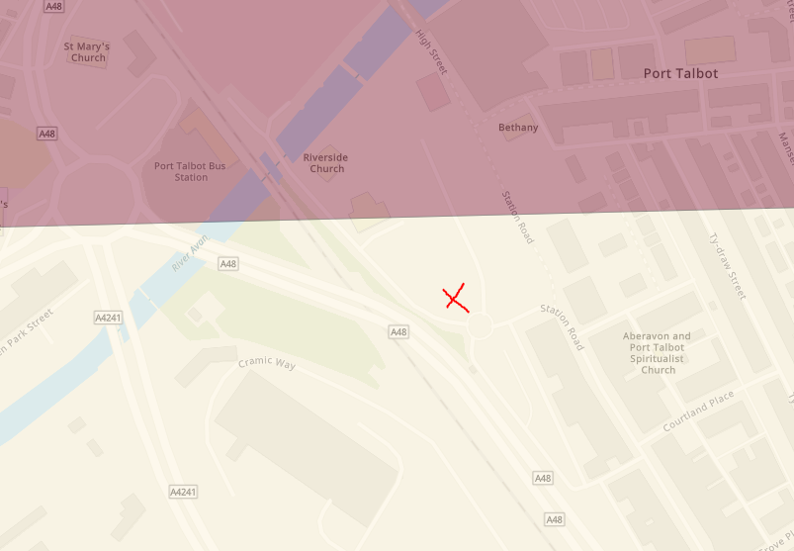
Figure 6 –Radon levels at Riverside Health & Wellness centre (UKradon.org, 2024).

Through these remediation measures a proactive role has been taken to mitigate risk and ensure compliance of the project with health and safety regulations. It will safeguard the workforce and all relevant stakeholders while works are constructed and mitigate environmental impacts.

Highway Constraints
There are a significant number of highway constraints that have been considered and developed for this project these include highways design via a Transport Impact Assessment (TIA), Parking provision and modifications, highway access and restrictions imposed for cars and pedestrians. These will be summarised below.
Transport Impact Assessment (TIA) & Highways Design
The health and wellness centre is subject to various highway implications and to achieve a successful project assessments and mitigation measures have been imposed to ensure that there is minimal disruption to the town of Port Talbot and traffic still flows and deliveries are not disrupted to the surrounding businesses.
The new facility will mean a change in road layout at the front of the leisure centre to remove an existing roundabout means that a TIA has been produced that has evaluated to the impact on traffic circulation and accessibility it has also covered all highway conditions with planning policy context and transport implementation The TIA has meant that any adverse transport impacts have been mitigated through our design process. Amendments made have been approved by NPTCBC planning department. A Road safety audit stages 1-4 has also been completed to enhance road safety measures in the vicinity of the building to ensure safety to the travelling public.
Parking & Modifications
The current carpark where our site is located is being removed for the new development of the array of buildings in the vicinity including the health and wellness centre, therefore modification to the carpark to the south of the site is essential to accommodate new capacity and usage. This will include for Disabled driver parking, provision for electric vehicles and associated infrastructure. The proposal has also looked at any incorporations for active travel to the site, considering the town centre location and the potential to reduce overall parking requirements a bicycle rack will also be installed in the carpark south of site.
Highway Access and Restrictions
Access to the site is currently via a 20mph asphalt road leading from the A48 at Heilbron way that intersects a roundabout adjacent to Port-Talbot Bus Station. This then joins Station Road which is a highlight pedestrianised area with a significant number of shops and restaurants that have deliveries daily. Careful consideration has been made for delivery drivers and site workers accessing the site outside peak periods. For success in the programme access roads to surrounding properties and car parks, churches are crucial to avoid disruption and delays. NPTCBC have been notified of our works to put an embargo on any other site works being carried out for the duration of our programme unless an emergency occurs i.e. burst pipe etc.
Several parking restrictions on access roads such as the one along side our site to Bethany Square have been addressed and suspended certain parking restrictions and the implementation of new traffic orders carried out to prevent congestion and ensure smooth traffic flows to site and prevent delivery delays.
Pedestrian Management & Site Compounds
Given the significant footfall from pedestrians in the vicinity, management of this has been essential to ensuring safety to the workforce and public. Traffic management plans have been produced to divert footfall away from the construction areas, also the erection of fencing and site compound will ensure separation between the two. Adequate lighting and signage of the area has also been implemented to ensure high visibility and safety.
Summary
Overall, the special considerations made will help to minimise disruption to commercial, pedestrian and residential properties. This has been achieved by comprehensive TM plans that will help mitigate impacts and ensure smooth operations throughout and after the construction period. By addressing needed restrictions proactively we will ensure efficient construction, minimise delays while also achieving high safety and inconvenience to the local community of Port Talbot.
Service Constraints
Several service constraints have been identified through direct contact with the statutory undertakers, these have been approved to be relocated on site.
Welsh Water
A VC (Vitrified Clat) 305mm Sewer rising main has been identified that will be relocated and new pipes installed to ensure capacity of building is met in line with Welsh water. No Surface water shall connect directly or indirectly and sustainable drainage systems (SUDS) shall be used. A working drawing plan will be issued to Welsh water to ensure planning is met.
WPD
An underground LV cable has been identified that has been identified should be sufficient for capacity for the building, the pipe will however, be relocated alongside the site to ensure that foundations do not damage any existing pipes.
WWU
A low pressure (LP – 21mbar to 75mbar) pipe has been identified runs through the site. This is to be relocated as part of the works and new connections installed as a recommendation and subsequently will have sufficient capacity these drawings will be supplied to local planning authority and WWU.

BT
BT connections run alongside the site and will be easily accessed for connection onto the site and do not have a major impact to the delivery of the programme and will have sufficient capacity for high-speed internet. There are no other plans relating to utilities of the site at this current time.

Client Imposed Constraints
There is only one client imposed constrain for a delivery window from October 2023 to August 2025. This, however, will not be met due to restrictions identified in the feasibility study with a new deliverable date of 21.01.26. This does not include for defect period.

