HEALTH AND SOCIAL CARE
BMHP5003
INTRODUCTION TO PHYSIOLOGY

Health assessment report



Lecturer- Mumtaz Ghoolam
Nageena Ahmed - 1808213

Contents page

Introduction ………………………………………………………. Page 3

Case Study ………………………………………………………… Page 4/5

Assessment Report ……………………………………………….Page 5/6

Recommendations ………………………………………………... Page 7

Conclusion …………………………………………………………. Page 8

References ………………………………………………………… Page 9/10

Appendix …………………………………………………………… Page 11/12/13

Introduction
This report is based on findings of a lifestyle questionnaire conducted on Mr T to help the practice focus on health promotion activities for patients. A questionnaire is a beneficial source of research it is a cheap, quick, and efficient way of collecting large amounts of data. This can help the practice make unbiased decisions and offer targeted health promotion activities to benefit patients (Mcleod,2018).
When personal information is collected for research the General Data Protection Regulation applies (GDPR) making provision to safeguard all information collected, this information is also protected under the Data Protection Act 2018 (GOV.UK, 2020). Informed consent is an ethical requirement which was taken from Mr T to use the health questionnaire to produce this report (Added to appendix 2).
This report will look at the findings from the health questionnaire and analyse how his lifestyle is affecting Mr Ts health. The results will help to investigate how his daily habits and routine is having an impact on his physiological conditions, recommendations will be made to propose a healthier lifestyle change for Mr T.

Case Study
After conducting a health questionnaire (Questionnaire added to appendix 1) on Mr T who is a 42-year-old male, other relevant health information was looked at and it come to surface that Mr T suffers from chronic Asthma.
The findings from the health questionnaire suggest Mr T is a smoker and smokes up to 19 cigarettes a day. Evidence from the European Respiratory Journal indicates smoking causes severe symptoms in asthmatic people accelerating decline in lung function. Smoke inhaled from cigarettes increases already inflamed airways making it difficult to breathe. (N.C. Thomson, R. Chaudhuri, E. Livingston). Mr T should consider quitting smoking for the betterment of his health. Smoking remains one of the main causes of ill health and premature death this can be prevented if Mr T quits smoking (West R, 2017)
Mr T’s blood pressure is in the normal range of 120/80mmHg however asthma can trigger changes in blood pressure. Blood pressure is a major factor related to asthma, low blood pressure is an indicator that an asthma attack is coming on whilst high blood pressure can be caused from narrowed airways, with not enough air going into the lungs the heart will work harder to try and deliver blood to the body, causing a rise in blood pressure (Asthma symptoms, n.d).
From the health questionnaire we come to know that Mr T’s father suffered a heart attack above the age of 60 and there is a family history of high cholesterol, Mr T is a smoker and also suffers from chronic asthma putting him at high risk of developing a heart disease he is also vulnerable to high cholesterol. High cholesterol builds up in the blood vessels forming plaque, over time the plaque deposits begin to clog up arteries causing heart attack, heart disease and stroke. Smoking lack of exercise and poor diet can all put him at risk of developing heart disease (Osborn, 2020).
Looking at Mr T’s height and weight, his BMI was calculated, and results show Mr T is overweight. Obesity is a major health problem and is associated with poor asthma control. Review from the journal Asthma and Allergy found weight loss has a significant impact on asthma symptoms and improvements in asthma control. This study found how weight loss improves asthma, reduces medication intake and has seen decrease in numbers of hospitalisation due to asthma. Furthermore, improvements in lung function and airways add to the benefits of weight loss (Juel CT, Ali Z, Nilas L, Ulrik CS, 2012).
Results from the lifestyle questionnaire reveal Mr T has an inactive lifestyle his job involves him driving up to 15 hours a day with very limited physical activity involved, the government recommends an adult to include 150 min of exercise a week in their lifestyle, inactivity is described by the department of health as a silent killer (NHS, n.d). A study programme for twelve adults who suffer from asthma showed positive results these adults exercised for twelve weeks and improved their asthma symptoms and control, the findings indicate that a structured exercise regime can have a positive impact on asthma (S. Dogra J.L. Kuk, J. Baker, v Jamnik, 2011)
Mr T’s diet also signifies change is required to lead a healthier lifestyle, he is consuming chips and fried food on a regular basis which will have an adverse effect on his health and asthma. There is not enough study or research out their which suggests diet can reverse the effects of asthma. Mr T may benefit from eating a well-balanced diet including plenty of fresh fruit and vegetables (McDermott, 2019). Mr T does not consume alcohol which is beneficial to his health.

Assessment report
The Data collected found Mr T suffers from the following abnormal physiological conditions, Asthma, Obesity and being at high risk of developing cholesterol.
Asthma is a common disease which affects a person’s respiratory system. Asthma causes the airways to become inflamed or swollen, the tiny muscles around the airways tighten making it difficult to breath when having an asthma attack. Airways are small tubes that carry air in and out of the lungs.
The main symptoms of asthma are shortness of breath, tightness of the chest, coughing which varies over time in intensity and wheezing, some people’s asthma will trigger due to dust, viruses, and allergies.
The main treatment for asthma is daily use of inhalers or lifestyle changes to help stop symptoms (Quirt J, Hildebrand KJ, Mazza J, Noya F, Kim H).
A normal functioning respiratory system will breathe in air through the mouth or nose and down the trachea or windpipe and into the lungs. The trachea divides into two tubes called bronchial and these enter the lungs as they pass through the lungs they further divide into smaller airways called bronchioles each airway holds a tiny air sac called alveoli that fills up with air each time we breathe in, breathing in oxygen and exhaling carbon dioxide helps keep our body healthy (AAFA, 2019).
A normal respiratory rate is 12 to 20 breaths per minute breathing should not even be noticed ( Cannizzaro, 2018) respiratory rate in asthma sufferers when an asthma attack s coming on is 20 to 30 breaths per minute this is an indicator action must be taken (Am Fam, 2013)
(Diagram of a normal and abnormal lung added in appendix 3)
Mr T is overweight, and this puts him at risk of developing many physiological illnesses including the following, Heart disease, High cholesterol, Type 2 diabetes, cancer and stroke (CDC, n.d). Lack of exercise leads to obesity and we can see from the questionnaire that Mr T’s lifestyle lacks physical activity, consuming more calories and not burning enough leads to weight gain. Obesity is a major factor for causing high cholesterol Mr T has a family history of high cholesterol and looking at his lifestyle he is at high risk of being diagnosed with this disease unless he makes significant changes to his lifestyle. High cholesterol also increases his chances of cardiovascular illnesses because increase lipids in the blood clog up arteries putting one at risk of heart attack and stroke (Heart UK, n.d).
(Diagram of cholesterol build up in the arteries added in appendix 4 – Harvard medical school, 2019)

Recommendations
A person-centred care (PCC) approach would best suit Mr T, PCC meets the standards of the Care Quality Commission who regulate Health and Social care in England. PCC involves delivering the care and service the person needs tailored to suit them, respecting their views and priorities in life (Burton, 2018).To lead a healthy lifestyle first and foremost Mr T needs to give up smoking as this is affecting his asthma, Mr T can get help from his GP to help him quit by using nicotine patches or other products available to help him quit, he can also consider counselling sessions to help quit, cognitive behavioural therapy has proved to be effective in quitting smoking (Good Therapy 2020).
Diet and nutrition is an important factor in promoting healthy lifestyle change, Mr T needs to cut down on saturated fat as this raises the cholesterol in the blood, adding more fibre to his diet and eating more fruits and vegetables will help reduce his weight. Mr T can have a daily diet chart where he knows what he will be eating throughout the day this will help him to make sensible choices when he is working as he will have prepped his meals and snacks, he will avoid stopping to have quick takeaways (NHS, n.d). The NHS offers support through a 12-week diet plan to help people lose weight by making healthy choices and setting weekly challenges this app could help motivate Mr T (NHS, 2019). There are many programmes available in different parts of the country to help people lose weight through weekly meetings to discuss food and nutrition and weigh in sessions these groups are available on a monthly subscription fee.
Mr T’s lifestyle leaves him with little time to have an exercise routine he also lacks motivation, Mr T can find an activity he enjoys doing such as walking, cycling, running and start this just once a week then gradually increase it to 3 times a week. Mr T can start doing gardening or join a swimming class exercise doesn’t have to be going to the gym if he includes physical activities in his daily routine it will help increase his energy levels he will feel refreshed and alert. Walking is an enjoyable form of exercise you can go with a friend, using a pedometer or step count watch can keep one motivated.
The research and data collected can help the practice introduce some health activities to help people like Mr T who need help with quitting smoking and make changes to their diet and adding exercise into their routine. These activities can include, motivational workshops, Group meetings with a nutritionist and workout classes at local community centres. These activities should be funded by the government. A healthy lifestyle will have less burden on the NHS, a healthy lifestyle has many long- term benefits (NHS, 2015).

Conclusion
All evidence from this report suggests Mr T requires professional help to gain a better quality of life and better manage his chronic asthma. Healthy lifestyle changes will benefit Mr T improve his asthma and prevent him from developing cholesterol and other serious heart conditions which he is vulnerable to. A person-centred care approach will help him take small steps towards his goals and with professional help Mr T can possibly quit smoking this alone will be a huge benefit to his health. With age everyone is at risk of developing health conditions and if your lifestyle lacks a heathy diet and exercise, you are a smoker and drink alcohol then you are at a higher risk of developing serious health conditions like heart disease and cancers.
This report has helped me reflect on how the physiology and anatomy of the body works and how important it is to stay healthy. If an illness is identified there is always a way to manage the symptoms to avoid serious illnesses developing.
Mr T has made me realise that people need to be informed and educated about their health and lifestyle choices to make better decisions. Generally, we have a more health conscious population who will lead a better quality of life because they will make the right decisions according to their lifestyle choices, this will have a positive impact on their health and living standards.

References
Cannizzaro T, (2018) For those with asthma what is normal breathing, Available at, https://asthma.net/living/normal-breathing/#:~:text=Response%20from%20Theresa%20Cannizzarro%2C%20Respiratory,12%2D20%20breaths%20per%20minute. Accessed on (3rd December 2020)
Am Fam Physician, (2013) Acute asthma and other recurrent wheezing disorders in children, 15;88(2):130-131. Available at, https://www.aafp.org/afp/2013/0715/p130.html Accessed on (3rd December 2020)
NHS FIFE, (2015) The benefits of maintaining a healthy lifestyle, Available at, https://www.moodcafe.co.uk/media/30656/The%20benefits%20of%20maintaining%20a%20healthier%20lifestyle%20-%20moodcafe%20format.pdf Accessed on ( 3rd December 2020)
Good therapy, (2020) Smoking Cessation, Available at, https://www.goodtherapy.org/learn-about-therapy/issues/smoking-cessation Accessed on (2nd December 2020)

Singleton P. Wadsworth M, (2016) Consent for the use of personal medical data in research, BMJ. 2006;333(7561):255-258. doi:10.1136/bmj.333.7561.255, Available at, https://www.ncbi.nlm.nih.gov/pmc/articles/PMC1523480/ Accessed on (26th November 2020)

Quirt J, Hildebrand KJ, Mazza J, Noya F, Kim H. Asthma. Allergy Asthma Clin Immunol. 2018;14(Suppl 2):50. Published 2018 Sep 12. doi:10.1186/s13223-018-0279-0, Available at, https://www.ncbi.nlm.nih.gov/pmc/articles/PMC6157154/ Accessed on (27th November 2020)

N.C. Thomson, R. Chaudhuri, E. Livingston European Respiratory Journal 2004 24: 822-833; DOI: 10.1183/09031936.04.00039004, Available at, https://erj.ersjournals.com/content/24/5/822#:~:text=Cigarette%20smoking%20may%20modify%20inflammation,compared%20with%20nonsmokers%20with%20asthma. Accessed on (27th November 2020)

Asthma symptoms, (n.d) Blood pressure issues, A major Asthma problem. Available at, https://www.asthmasymptoms.org/blood-pressure.html Accessed on (27th November 2020)

Corrine K, (2020) Healthline, What you should know about Hyperlipidemia, Available at, https://www.healthline.com/health/hyperlipidemia, Accessed on (29th November 2020)

Juel CT, Ali Z, Nilas L, Ulrik CS. (2012) Asthma and obesity: does weight loss improve asthma control? a systematic review. J Asthma Allergy. 2012;5:21-26. doi:10.2147/JAA.S32232, Available at, https://www.ncbi.nlm.nih.gov/pmc/articles/PMC3392696/ Accessed on ( 29th November 2020)
West R. (2017)Tobacco smoking: Health impact, prevalence, correlates and interventions. Psychol Health. 2017;32(8):1018-1036. doi:10.1080/08870446.2017.1325890, Available at, https://www.ncbi.nlm.nih.gov/pmc/articles/PMC5490618/ Accessed on (29th November 2020)
NHS, (n.d) Benefits of exercise, Available at, https://www.nhs.uk/live-well/exercise/exercise-health-benefits/ Accessed on (29th November 2020)
S. Dogra, J.L. Kuk, J. Baker, V. Jamnik, (2011) European Respiratory Journal 37: 318-323; DOI: 10.1183/09031936.00182209, Available at, https://erj.ersjournals.com/content/37/2/318, Accessed on (29th November 2020)

McDermott, (2019) Asthma and your diet, what to eat and what to avoid, Available at, https://www.healthline.com/health/asthma/asthma-diet#:~:text=At%20the%20same%20time%2C%20eating,asthma%20cases%20in%20recent%20decades. Accessed on ( 29th November 2020)

Nursing times, (2020) Respiratory rat 2: Anatomy and physiology of breathing, Available at, https://www.nursingtimes.net/clinical-archive/respiratory-clinical-archive/respiratory-rate-2-anatomy-and-physiology-of-breathing-31-05-2018/ Accessed on (30th November 2020)
AAFA, (2019) Asthma and allergy foundation of America, What happens in your airways when you have asthma, Available at, https://community.aafa.org/blog/what-happens-in-your-airways-when-you-have-asthma Accessed on (1st December 2020)
CDC, (n.d) The health effects of overweight and obesity, Available at, https://www.cdc.gov/healthyweight/effects/index.html Accessed on (1st December 2020)
Heart UK, (n.d) What is high cholesterol, Available at, https://www.heartuk.org.uk/cholesterol/what-is-high-cholesterol Accessed on, (1st January 2020)
Harvard Health Publishing, (2019) High Cholesterol, Available at, https://www.health.harvard.edu/a_to_z/high-cholesterol-hypercholesterolemia-a-to-z Accessed on (1st December 2020)
Burton L, (2018) What is person centred care and why is it important?) Available at, https://www.highspeedtraining.co.uk/hub/what-is-person-centred-care/ Accessed on ( 1st December 2020)
NHS, (n.d) Lower your cholesterol, Available at, https://www.nhs.uk/live-well/healthy-body/lower-your-cholesterol/ Accessed on (2nd December 2020)
NHS, (2019) Start the NHS weight loss plan, Available at, https://www.nhs.uk/live-well/healthy-weight/start-the-nhs-weight-loss-plan/ Accessed on (2nd December 2020)
McLeod, S. A. (2018). Questionnaire: definition, examples, design and types. Simply Psychology. Available at, https://www.simplypsychology.org/questionnaires.html#:~:text=Questionnaires%20provide%20a%20relatively%20cheap,a%20large%20sample%20of%20people.&text=Data%20can%20be%20collected%20relatively,when%20the%20questionnaires%20were%20completed. Accessed on (3rd December 2020)
GOV.UK,(2020) Data protection, Available at, https://www.gov.uk/data-protection#:~:text=The%20Data%20Protection%20Act%202018,Data%20Protection%20Regulation%20(GDPR).&text=They%20must%20make%20sure%20the,used%20fairly%2C%20lawfully%20and%20transparently Accessed on, (3rd December 2020)
Appendix
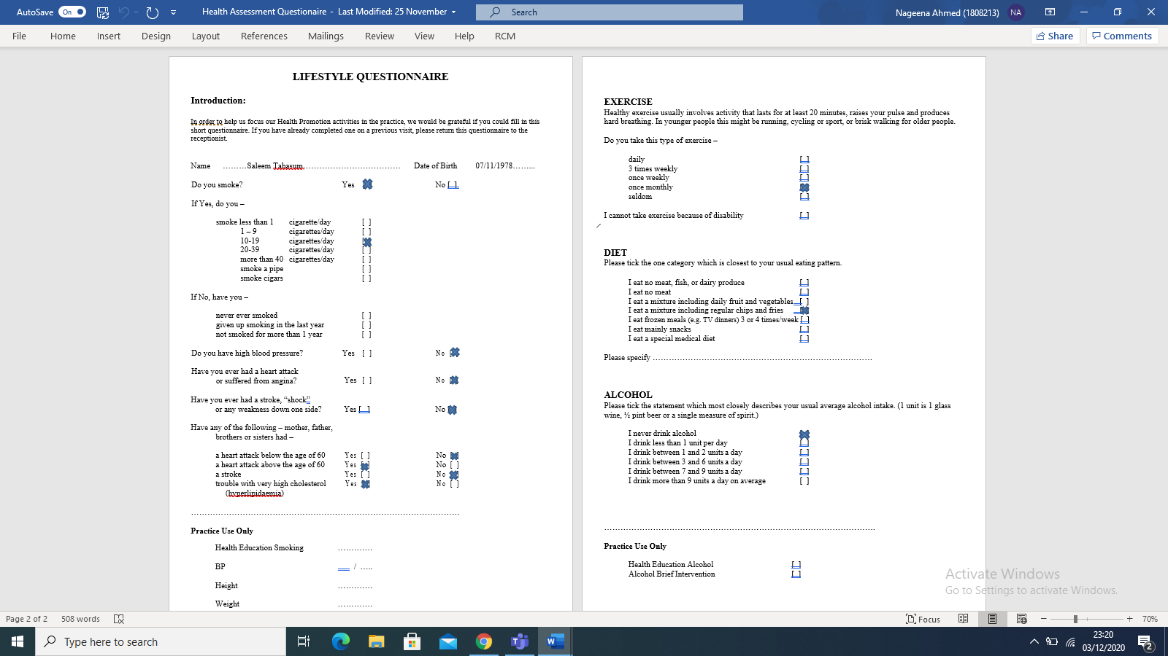
Appendix 1

Appendix 2



Appendix 3
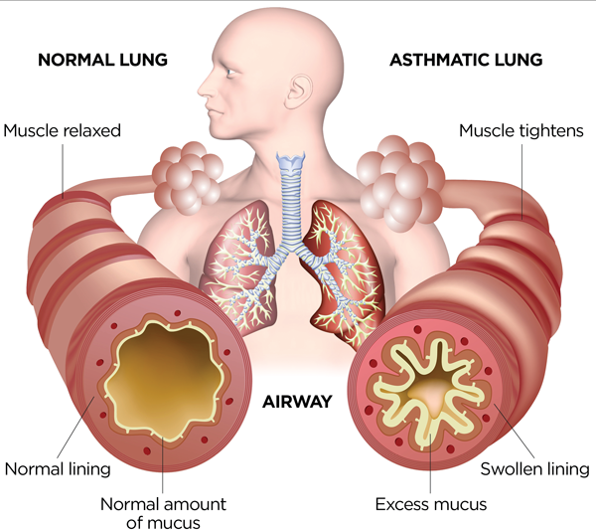

Appendix 4



