Network Operating Systems Worksheet 2
By Steven Moon (1904741)

Table of Contents
1.0 Task 1 Page 3
1.1.1 NTFS Share Page 3
1.1.2 SMB Network Share Page 4
1.2 Group Policy Management Page 5
1.2.1 Moderating Control Panel Access Page 6
1.2.2 Removing Command Prompt Access Page 6
1.2.3 Removable Storage Devices Page 7
1.2.4 Restricting Software Installs Page 8
2.0 Task 2 Page 10
2.1 Creating an FTP Server Page 10
2.2 Remote Access Services Page 11
2.3 IP Packet Filtering Page 12
2.3.1 Stopping PrivateNet1 from Pinging Router Firewall Page 12
2.3.2 FTP Access Restriction Page 13
3.0 Task 3 Page 15
3.1 Password Policy Page 15
3.2 Failover Clustering Page 15
3.2.1 Windows Server Failover Clustering Page 16
3.3 Draft Network Policy Page 17
3.3.1 Topology Page 17
3.3.2 Network Access Page 18
3.3.3 Security Page 18
3.3.4 Mitigation of Risks Page 19
4.0 References Page 20

1.0 Task 1
1.1.1 NTFS Share
As part of the worksheet it was required to create a shared folder on the local client machine that only admin users have access to. In order to achieve this the below security settings were applied to the created folder to allow admin access without regular users having permissions to edit.
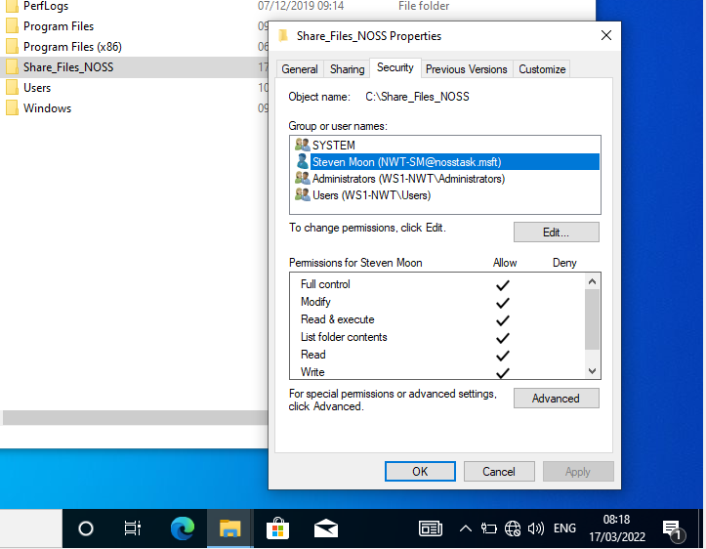
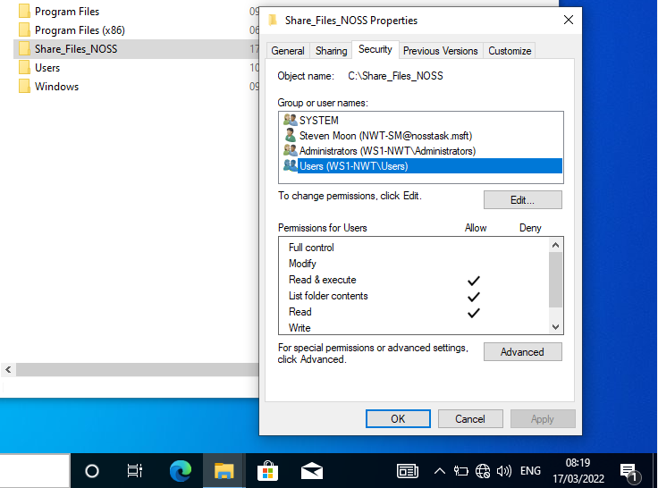
This was then tested by logging into the machine as a regular user and attempting to edit a simple text document.
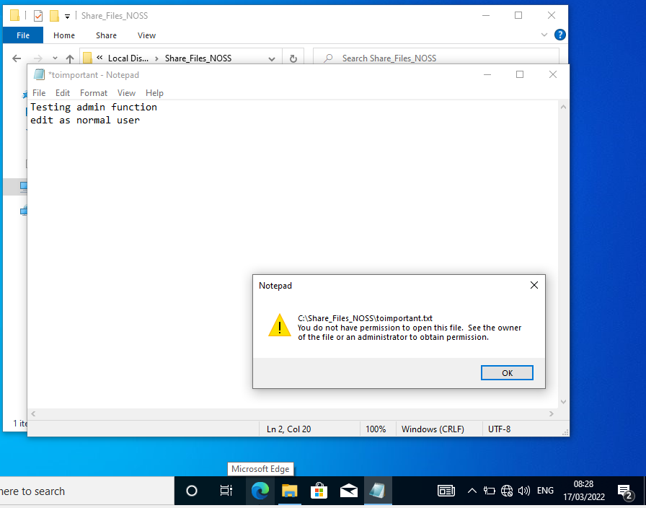

1.1.2 SMB Network Share
To allow for a networked method for accessing storage there is an option to create an SMB share on a network server and create a mapped drive on each client machine. Within the task a network share named “Share_File_NOSS$”. Below is the configured SMB share present on Server one and the subsequent mapping from Client one.
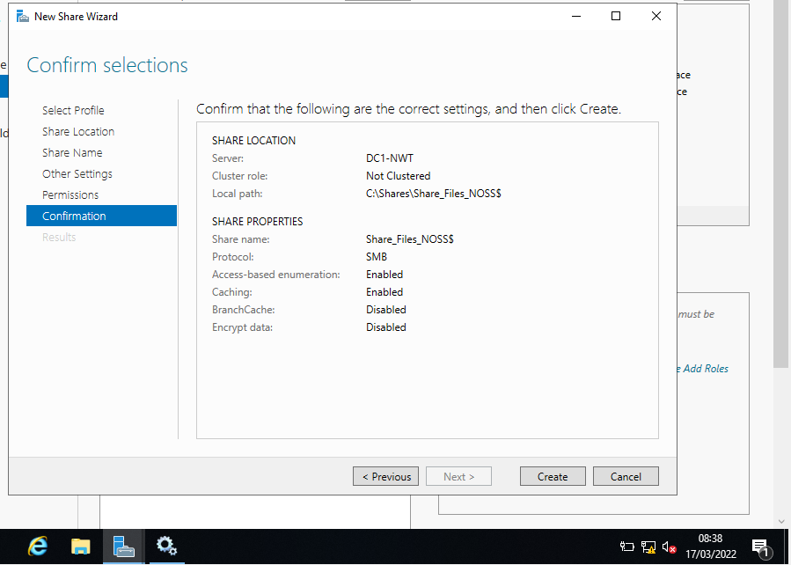
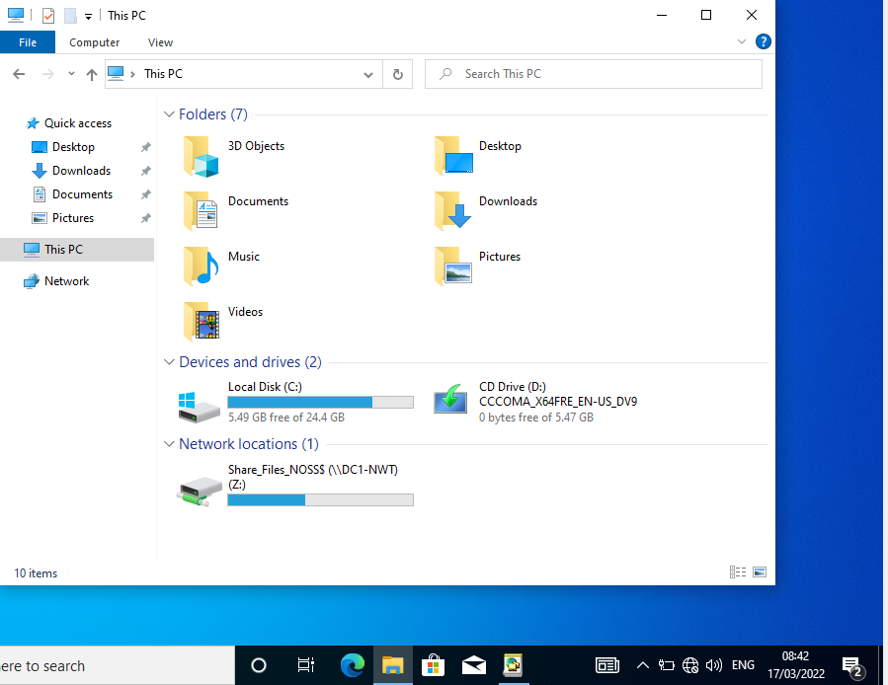
1.2 Group Policy Management
A major part of enterprise management is the use of group policies to manage a huge number of different operating system functions from a single server or server pool. Below are five examples of where group policies can be used to increase security and remove potential security flaws from the enterprise.
1.2.1 Moderating Control Panel Access
To create a group policy it needs to be assigned to an OU which contains either user accounts or machine accounts. In this example a GPO is configured to remove non-admin access to the control panel, this is then tested by logging into a client machine as a non-admin user and attempting to access the control panel.
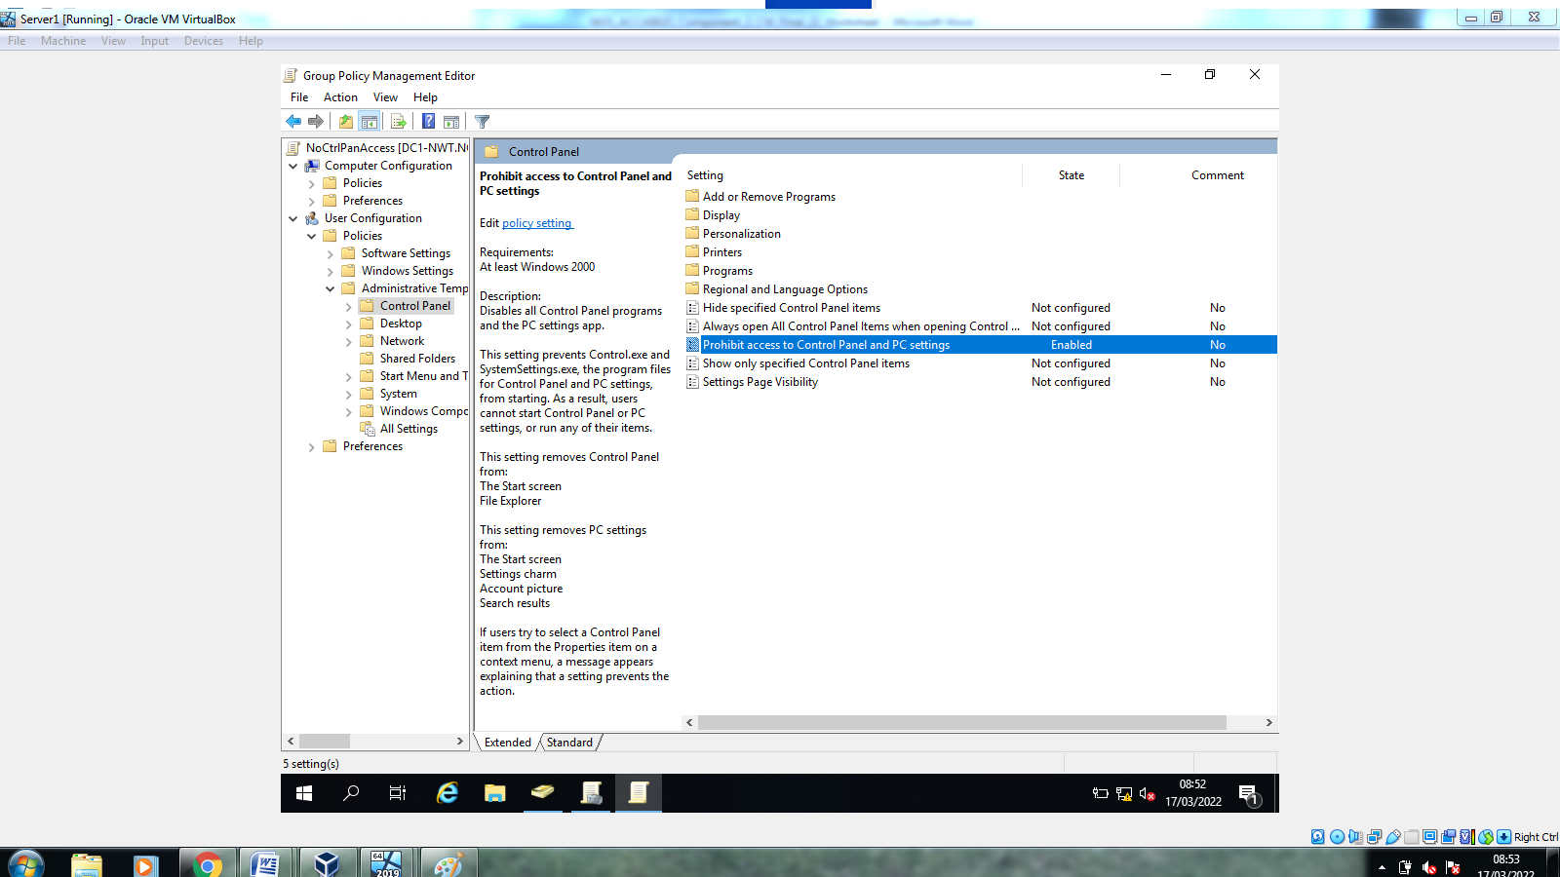
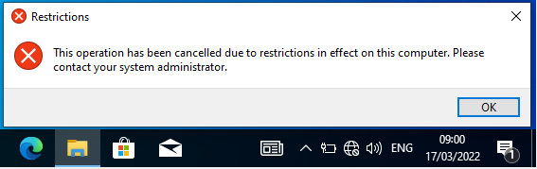
1.2.2 Removing Command Prompt Access
The next example show another GPO affecting user account assigned to a specific OU which removes the ability to access the command prompt which can be used by malicious attackers to gain greater access to the system. This is also tested once configured to ensure GPO is applying correctly.
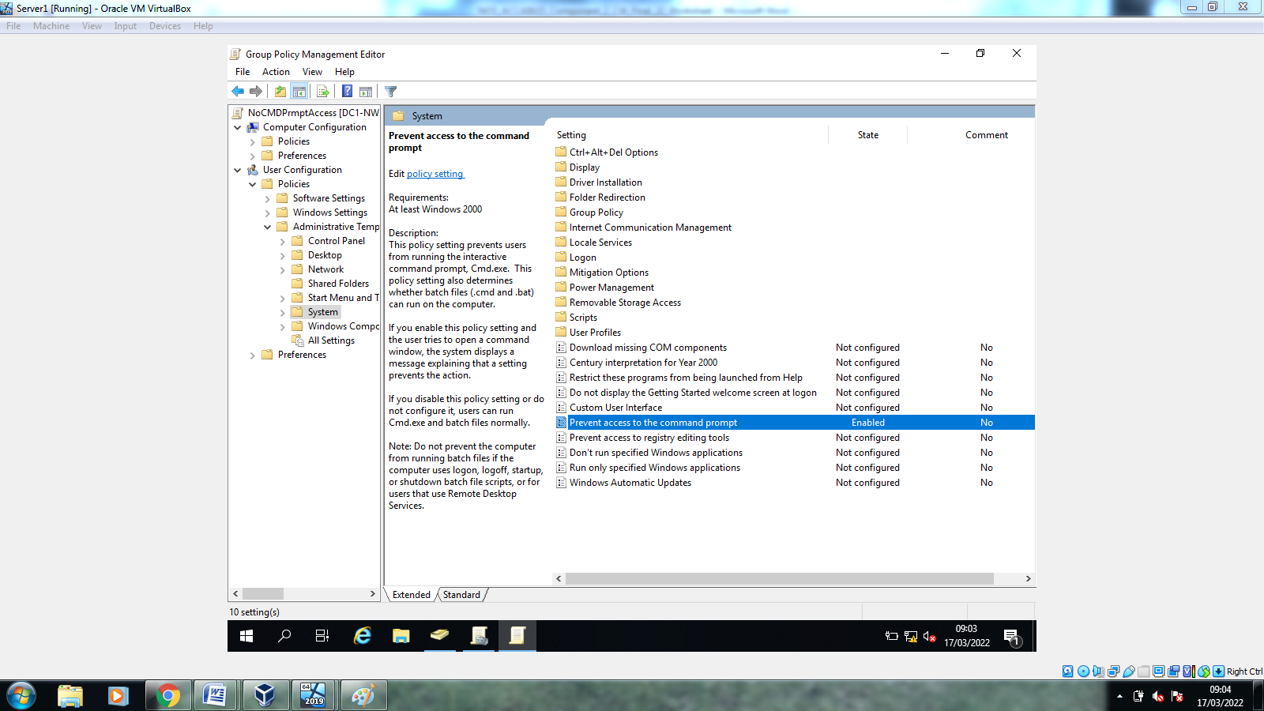
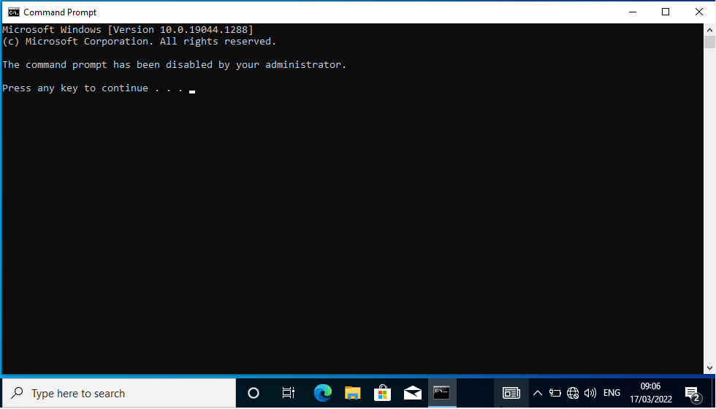
1.2.3 Removable Storage Devices
Another key component of security is to limit the ability to move data from outside the corporate network into the secure environment. The easiest way to help this is to remove the ability of users to access external media on the corporate machines, this GPO is configured to remove this right from all users that are not domain admins.
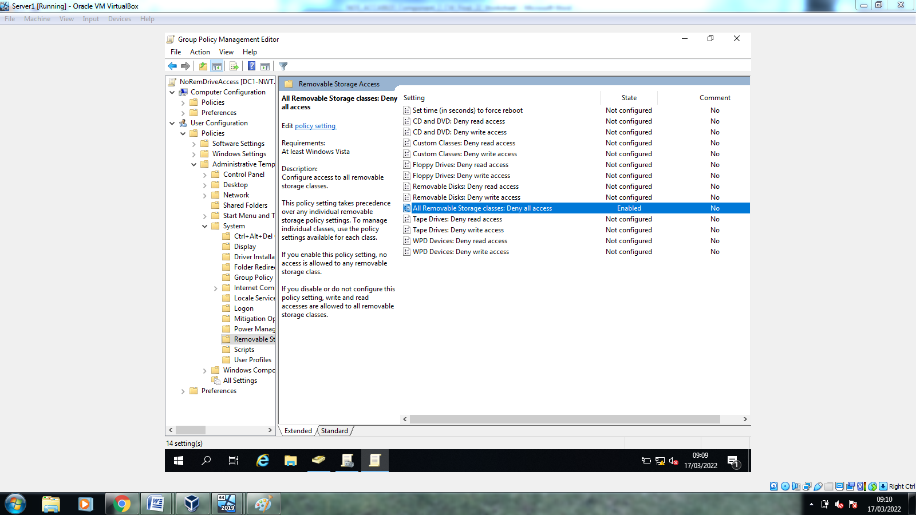
This example was not tested and verified due to local issue of passing through a USB device to the type two hypervisor (OracleBox) program being used.
1.2.4 Restricting Software Installs
Another possible source of attack on a network is the use of malicious code and software being installed onto machines. For this to be affective the GPO is applied to an OU containing the client machines rather than user accounts, this GPO was created but was unable to test due to an environment issue with the hypervisor not passing through an internet connection to the virtual machines.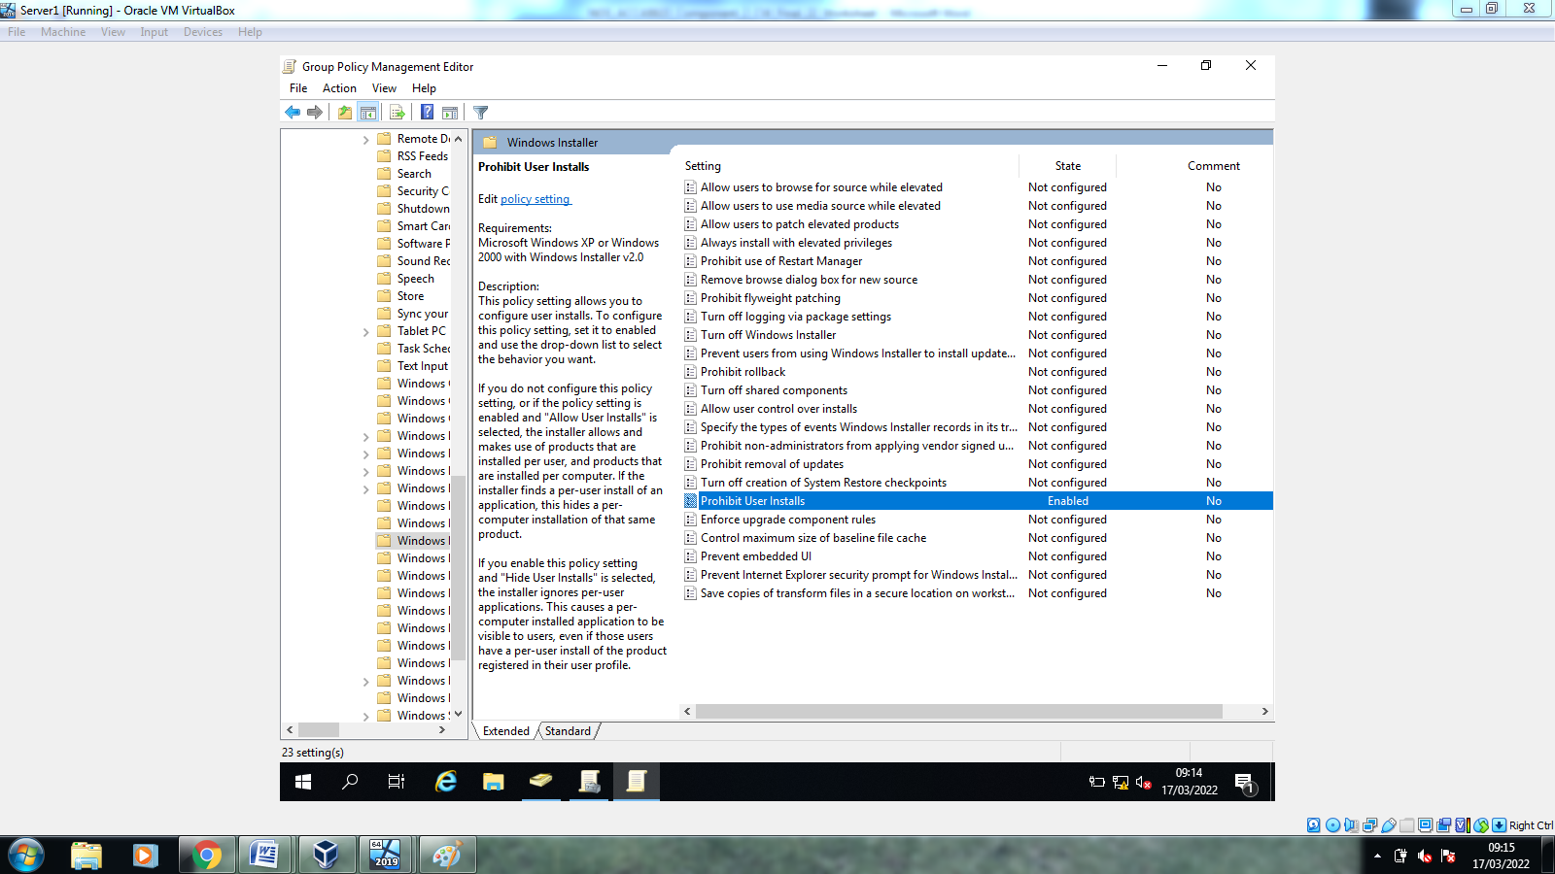
1.2.5 Enforcing Password Policy on Domain
The final GPO being created in this worksheet is to enforce a password policy at the domain level for user accounts. This is to ensure passwords are difficult to guess and poses a significant challenge to any un-authorised users to gain access to the corporate machines. In this example the policy enforces the use of a password at least 8 characters long and needs to be changed each 10 days.
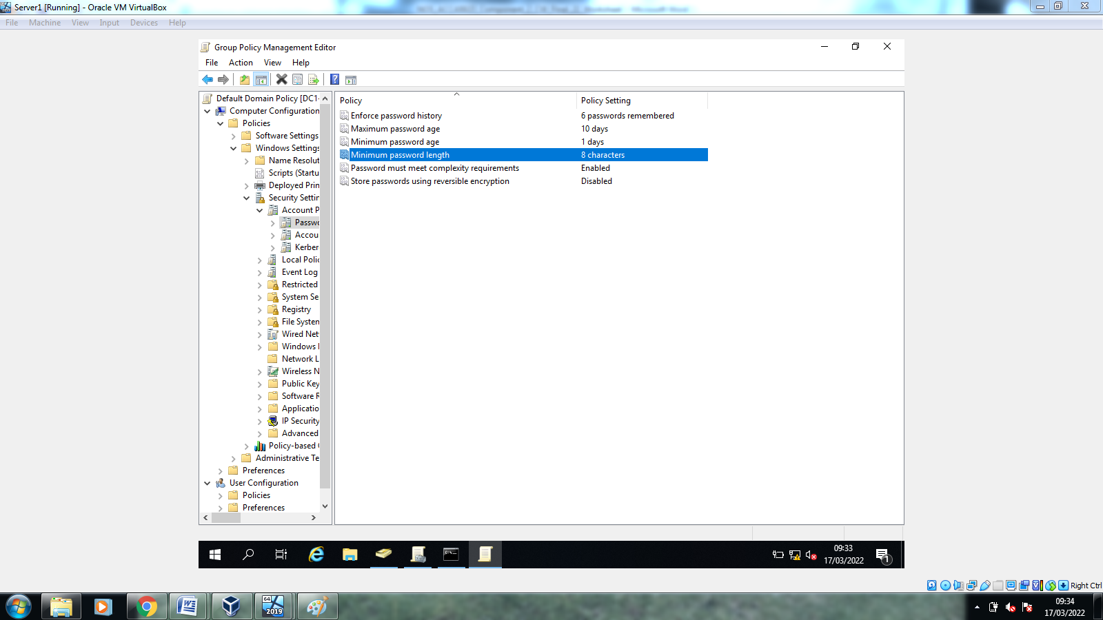
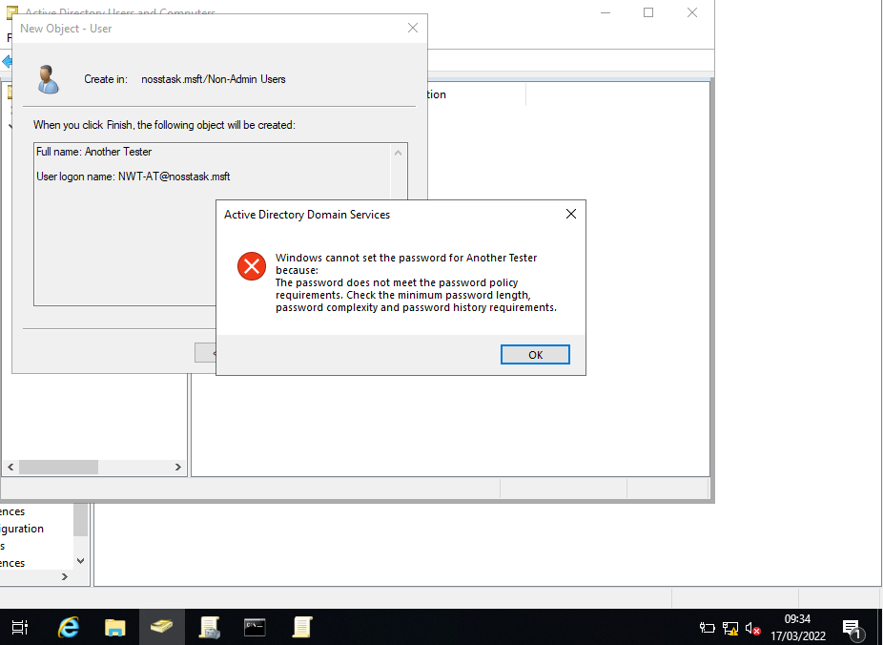

2.0 Task 2
2.1 Creating an FTP Server
For moving large objects between network machines and often employed approach is to configure an FTP server where authorised users are able to upload files for others with permission can then use the relevant connection details to download. For this worksheet an FTP service was configured on Server 2 with an account then provisioned for access.
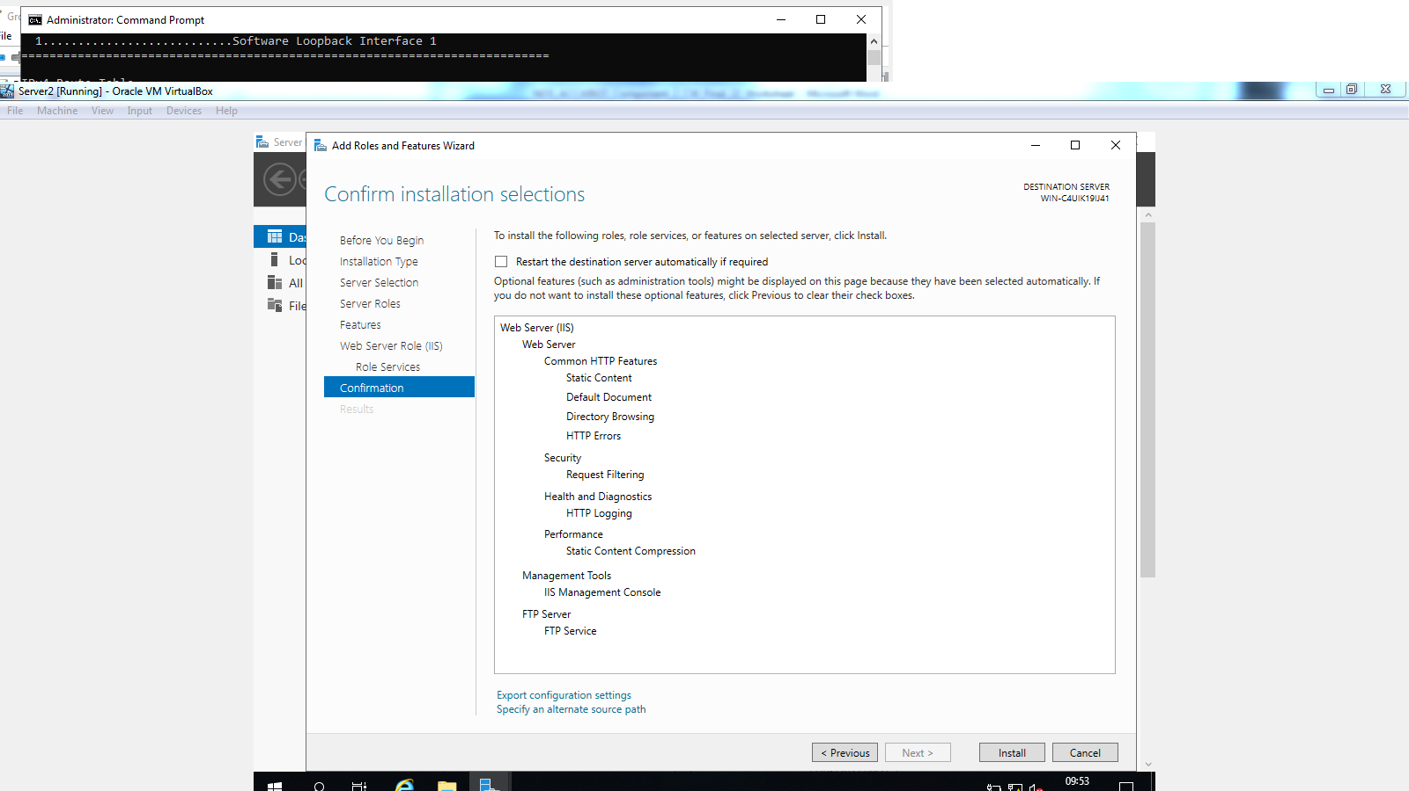
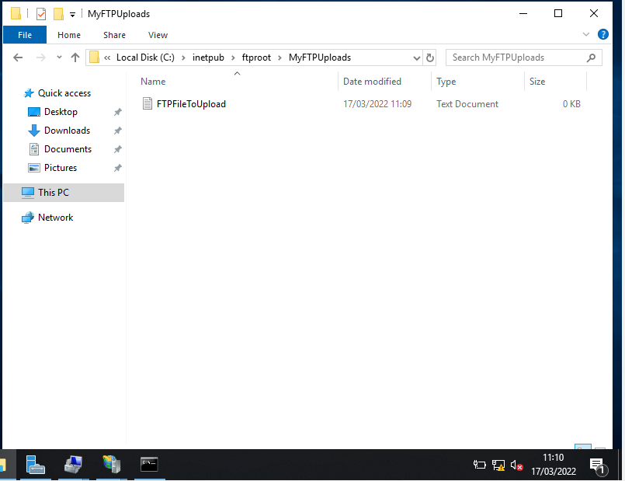
As demonstrated above after correct configuration a file was then able to be uploaded to the FTP server from client 2 on the privatenet2 LAN.
2.2 Remote Access Service
In order for communication to be passed between the two private LAN environments the remote access service needs to be configured on the two server machines that have access to the publicnet network. This is part of the windows server roles and was configured on both servers as below.
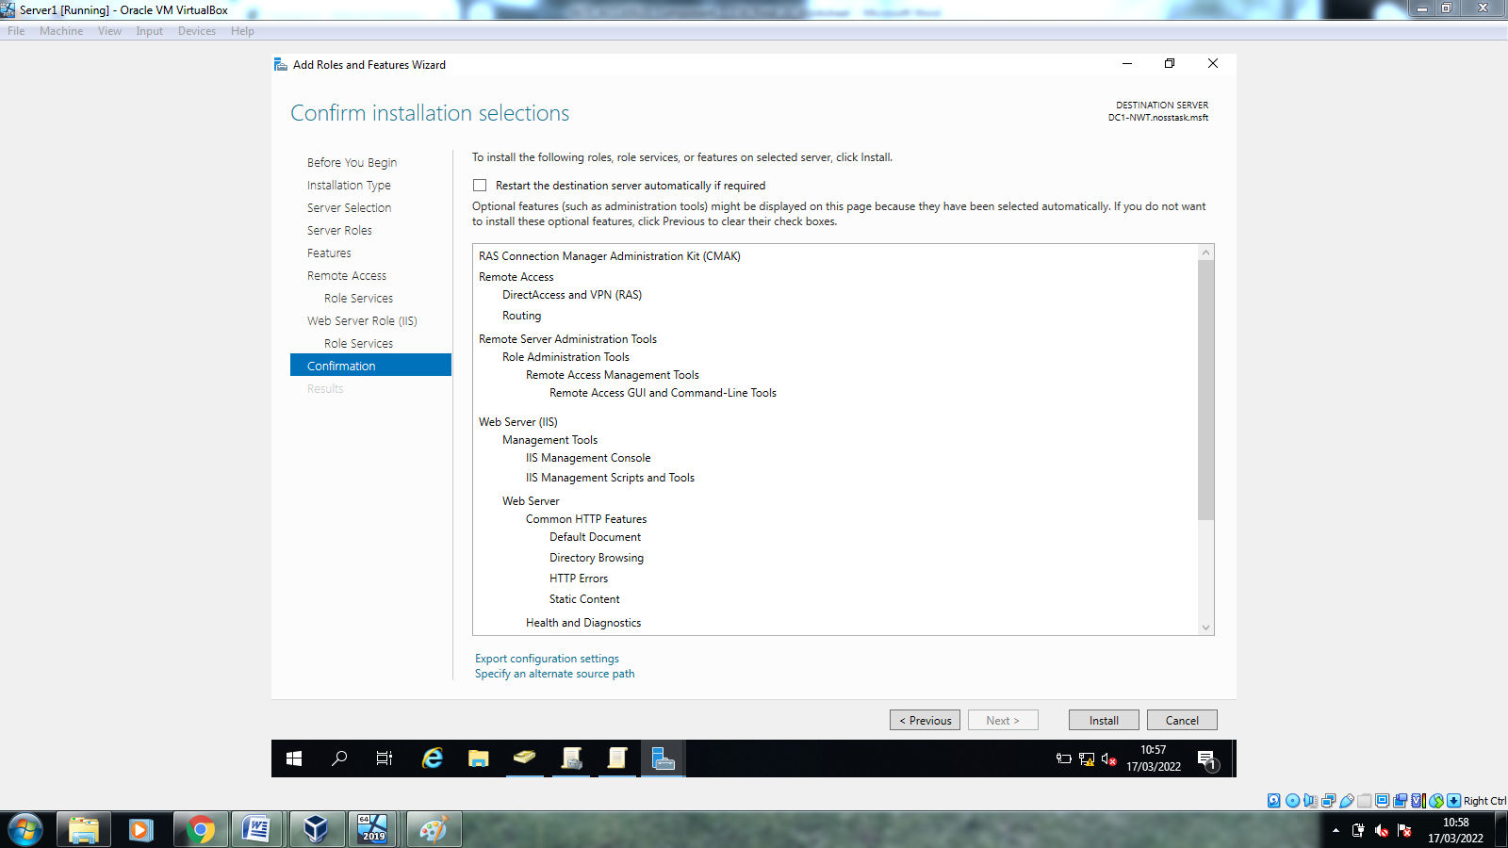
To allow for the client machines to communicate with other clients across the publicnet the machines need to be made aware of where there default gateway is to allow for the traffic to be routed correctly. In this example client one has a default gateway of 192.168.1.1 which is the IP address of sever one on its privatenet.
The connectivity is then tested to prove connectivity between clients.
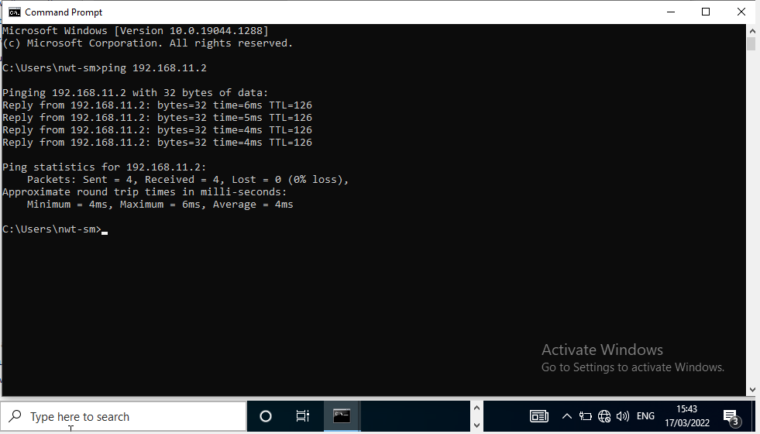
2.3 IP Packet Filtering
2.3.1 Stopping PrivateNet1 from Pinging Router Firewall
Another feature that can be implemented into a network is the use of packet filtering which can stop certain traffic from being sent or received between specific IP addresses or groups of addresses. In the first example a filter was implemented that stop any clients from PrivateNEt1 from being able to ping the router firewall on 192.168.1.1.
The configuration of the packet filtering for this is shown below alongside the testing of this rule.
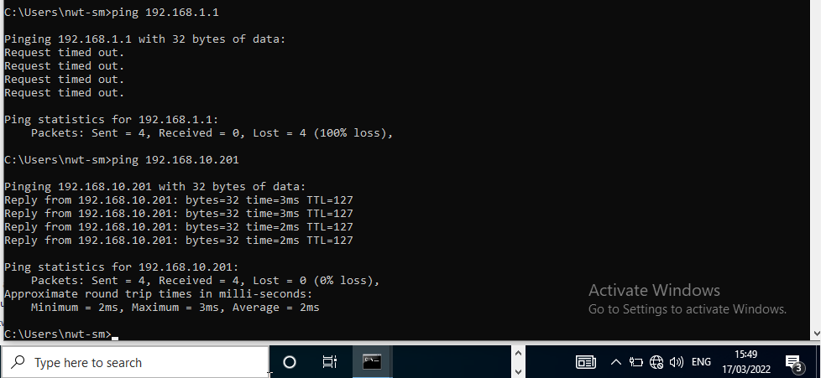
2.3.2 FTP Access Restriction
Another reason to configure packet filtering rules is to restrict access to key network resources such as the FTP server that was configured in the earlier section of this work book. This was achieved by using the configuration shown below.
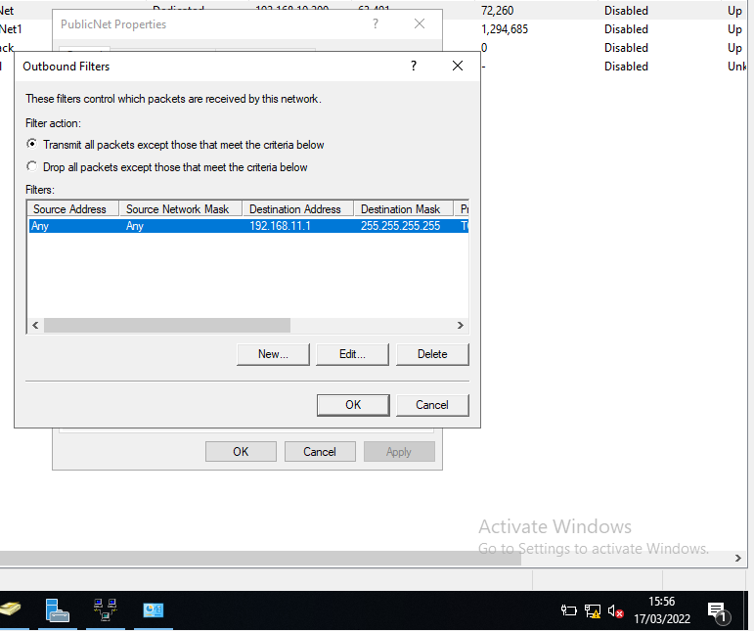
The above stops access to the FTP from any machine not already on the PrivateNet2, it is possible to go one step further and only allow access from one machine IP address, the below shows a rule that only allows client one to access the FTP server.
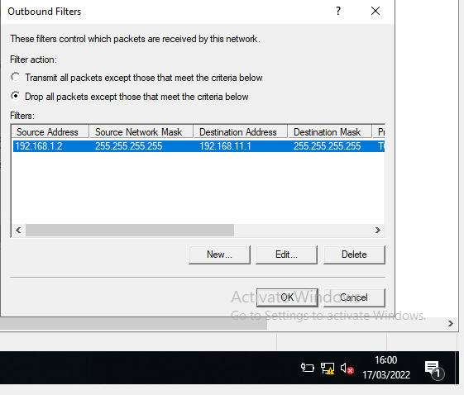
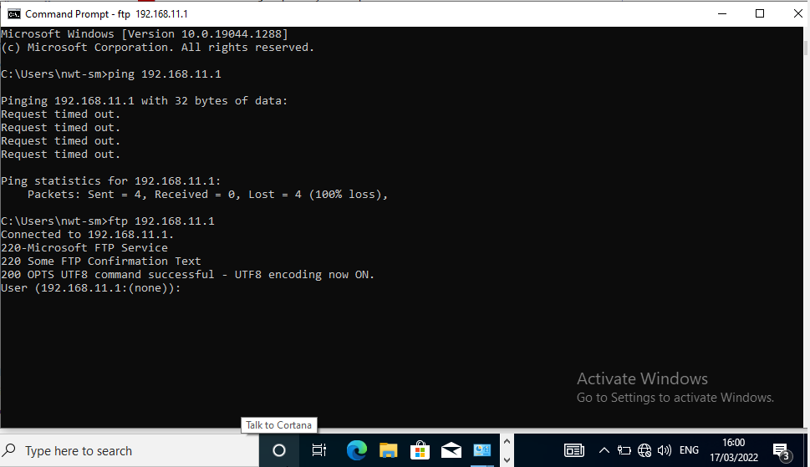

3.0 Task 3
3.1 Password Principles
When considering the use of any networked device a lot of consideration needs to be given to passwords and the policy that surround their usage and creation. The need for a complex password is paramount when not using another security method such as two factor authentication which relies on something that you know such as a more simple password and something you have such as a code generated by an application on a mobile device.
When discussing sound password policies the below are generally considered to be good practices;
- Mix of upper and lower case characters
- Include alpha and numeric characters
- Use of special characters such as *,$ etc
- Minimum length of 8 total characters
- Password is changed on a regular basis
Following the above guidance gives a network the best opportunity to remain safe from certain attacks such as brute force or from malicious attackers gaining access from use of key information gained from social media accounts or other personal knowledge of the user.
Another consideration for people in a modern network setting is not to use a combination of publicy known information such as email address, information shared on social media or name. This again limits the ability of malicious attackers to gain access to the device of the user.
3.2 Failover Clustering
In a modern network environment having consistent access to key applications and services is vital to the functioning of the entire system. This concept has led to a number of technologies being developed to support the high availability of key business applications. This paper will discuss some of these technologies but it is also worth understanding the applications/services that can take advantage of failover technologies these include but are not limited to; [1]
Database Server
Windows Distributed File System (NFS) Namespace Server
File Server
Hyper-V
Microsoft Exchange Server
Microsoft SQL Server
Namespace Server
Windows Internet Name Server
There are additional key requirements to consider before looking at WSFC for a high availability network such as redundant network connectivity to the network resource, this may take the form of either multiple operators of mobile data such as EE, Vodafone etc or the use of multiple physical paths taken by the data in the case of connectivity loss. An example of this type or routing can be seen below [2]
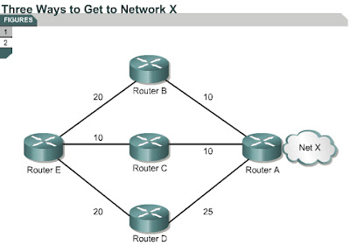
This image shows that if a single path is down then the information required can take an alternative but in most instances a slower route to its destination allowing for the application or service to remain functioning. Additionally the use of additional datacentres or physical locations for the service to exist is also a viable solution to combat against physical issues such as energy supply or natural disasters such as fire or floods.
3.2.1 Windows Server Failover Clustering
WSFC is the proprietary technology used when deploying a failover cluster within a windows environment and there are a number of considerations to make before implementing this service to allow for it to function correctly and provide the high availability of the application or service.
In order to use this technology there is a need to understand how it functions and what is required for it to operate before deploying it to use on applications such as SQL or a distributed file system that is available from multiple sources. The basis of failover is to have a number of nodes or physical servers that operate in a logical pool together so that when a single or multiple nodes are not online for any reason then the remaining are able to take over and provide the service to the end user. A key technology in enabling this in WSFC is the use of quorum and voting to understand when a node is offline and where the service is going to provided from, this means that the nodes need to be configured as a member of quorate and if a smaller number of machines in the cluster then a witness is configured as a tie break to enable a decision on if the service is stopped or moved to another location. [1]
Another consideration to make when deploying WSFC is the storage being used to service the application or where the database is stored for services such as AD. This means that the storage needs to be available to the cluster nodes wherever the physical nodes are, this means that the storage needs to be attached using storage direct or shared via SMB 3.0 in the network environment. [3] A generally accepted practice when using networked storage would be to also configure a RAID array to allow for drive loss without affecting data integrity or causing data losses, most enterprise applications are going to either be a RAID 1 or RAID 5 array to allow for some drive loss without data loss or in the case of RAID 1 it is effectively able to lose half its total drives before any loss occurs.
The management of clusters is done via the “Failover Cluster Manager” in a windows server environment, from here the administrator is able to configure options such as roles, storage, nodes and other key criteria for a functional cluster. Below is how this management console looks without any configuration taking place; [4]
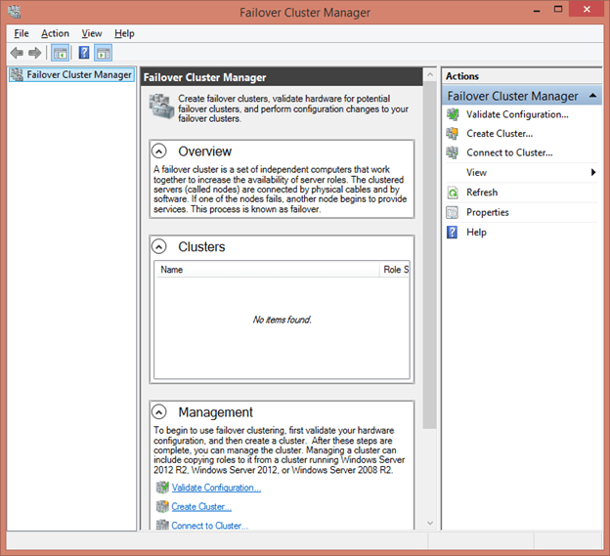
3.3 Draft Network Policy
When considering the challenges faced by a network administrator a number of different aspects need to be considered, the below demonstrates some of those aspects and systems put in place to mitigate the risks.
3.3.1 Topology
The network will be developed and deployed in such a way that allows for key applications to be available at all times and without delay. This means that there will be multiple servers configured in failover clusters for the key services such as file shares, SQL DBs and active directory. Whilst this topology requires a large amount of resource to maintain it provides the most seamless use for the user and also most up time possible for the enterprise. The below shows an example of a parallel topology that would be used versus a serial network [5]
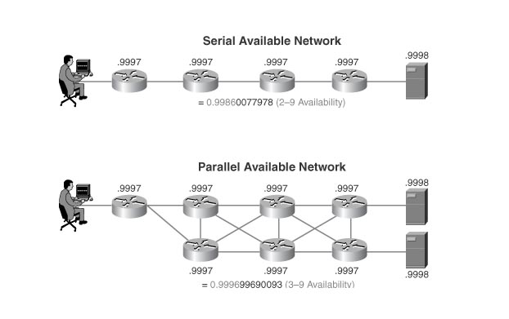
In order to maintain this high availability within the enterprise all changes being made to configuration would be tested on a mirrored test environment based in a hosted services such as AWS to ensure the live service is not compromised. Tested in a hosted platform allows for the quick provision of additional servers and services without the need to maintain additional hardware within the data centre structures internally. This reduces costs for the organisation and limits the number of different point of entry for malicious attacks.
3.3.2 Network Access
Access to the corporate network and resources will be defined using role based access utilising Microsoft active directory [6] to allow the administrative team to effectively manage the enterprise environment. This mean only staff employed within the network team of the organisation will have privileges to make changes on any networked server or service such a domain controllers or print management services. This is achieved by using a designated OU within the AD forest to manage user accounts for admin users and a number of distinct OU’s for the remaining staff within the organisation based on needs. An assumption made in this policy is that the individual service areas will be managed by the lead of that area and is able to understand the implications of allowing any staff member access to their files or folders.
Access to corporate services will be restricted to only users or computers that are registered within the active directory structure and this will allow for the network to have less points of attack from malicious users.
3.3.3 Security
A minimum level of security is assumed when using a corporate device and this starts with a secure password that meets the minimum level of complexity outset by Microsoft which ensures there are 159,238,157,238,528 different options for passwords at the minimum [7]. This is to combat the risk of easily guessed password exposing large areas of the network as passwords that only contain alphanumeric are more likely to be broken by a malicious user.
To increase security a number of different group policies will be implemented to limit general user access to a number of applications or functions within the windows operating system. Those being implemented as a minimum will be the restriction of the command prompt, control panel and program installation to only those within the administrator OU of active directory. This is to limit the options an attacker would be able to leverage if they were able to gain access to a end user device.
3.3.4 Mitigation of Risks
In order to mitigate a number of the most basic risks to the organisation the above policies for passwords and the overall topology of the network will allow for continued availability of network resources in the event of failure.
An additional mitigation that is required is the use of firewalls within the organisation to limit the traffic that is sent or received into the environment which will reduce the likelihood that a malicious attacker is able to gain access. This could then be further refined to the use of packet filtering to the key services and servers within the domain.
The use of a management tool will also help with the mitigation of risk and also allow the admin team to pro-actively manage any potential breaches or issues within the network. For this example a software such as that provided Solarwinds [8] can be leveraged to monitor incoming and outgoing traffic to quickly identify issues and potential DDoS [9] attacks can be managed and shut down.
4.0 References

[1] | G. Wright, "Windows Server Failover Clustering (WSFC)," 03 2022. [Online]. Available: https://www.techtarget.com/searchwindowsserver/definition/Windows-Server-failover-clustering. [Accessed 31 03 2022].
[2] | A. Haider, "Load balancing across multiple paths," 13 08 2011. [Online]. Available: http://basicitnetworking.blogspot.com/2011/08/load-balancing-across-multiple-paths.html. [Accessed 31 03 2022].
[3] | Microsoft, 29 03 2022. [Online]. Available: https://docs.microsoft.com/en-us/windows-server/failover-clustering/clustering-requirements. [Accessed 31 03 2022].
[4] | Altaro, "How to set up and manage a Hyper-V Failover Cluster, Step by step," [Online]. Available: https://www.altaro.com/hyper-v/failover-cluster-manager/. [Accessed 31 03 2022].
[5] | Cisco, "CCDP Self-Study: Designing High-Availability Services," 18 03 2005. [Online]. Available: https://www.ciscopress.com/articles/article.asp?p=375501&seqNum=2. [Accessed 31 03 2022].
[6] | Microsoft, "Active Directory Domain Services Overview," 11 01 2022. [Online]. Available: https://docs.microsoft.com/en-us/windows-server/identity/ad-ds/get-started/virtual-dc/active-directory-domain-services-overview. [Accessed 31 03 2022].
[7] | Microsoft, "Password must meet complexity requirements," 08 03 2022. [Online]. Available: https://docs.microsoft.com/en-us/windows/security/threat-protection/security-policy-settings/password-must-meet-complexity-requirements#:~:text=Set%20Passwords%20must%20meet%20complexity,difficult%2C%20but%20still%20not%20impossible.. [Accessed 31 03 2022].
[8] | Solarwinds, "Solarwinds," [Online]. Available: https://www.solarwinds.com/homepage-3c?CMP=KNC-TAD-GGL-SW_UK_X_PP_CPC_LD_EN_BRDE_TIN-X-972701961~56758950868_g_c_solarwinds-e~505639313262~~p53926918897&s_kwcid=AL!11508!3!505639313262!e!!g!!solarwinds&ds_cid=71700000067700820&ds_agid=58700005886239084&ne. [Accessed 31 03 2022].
[9] | Cloudflare, "What is a DDoS Attack," [Online]. Available: https://www.cloudflare.com/en-gb/learning/ddos/what-is-a-ddos-attack/. [Accessed 31 03 2022].

