1710331

PROJECT PLANNING AND
ShahIda Miah
20th December 2019
MANAGEMENT IN WORKPLACE

Contents

Introduction……………………………………………………………………………………………………………… 3
Initiation Stage…………………………………………………………………………………………………………. 4
Planning Stage………………………………………………………………………………………………………….. 5
Executing Stage………………………………………………………………………………………………………… 6
Monitoring and Control……………………………………………………………………………………………. 7
Evaluation………………………………………………………………………………………………………………… 9
Conclusion……………………………………………………………………………………………………………… 11

Introduction
Project planning and management in the workplace was introduced to the students giving the opportunity of placements. According to The Big Choice (2019), employers seek candidates with experience as well as academic achievements. Placements develop teamwork and interpersonal skills leading to job opportunities.
The chosen project was to market, fundraise and deliver a workshop for Cardiff Muslim School which is an independent and no financial aid from the government. The schools thrives to give a balanced education and Islamic education to benefit the community and society (CMS, 2019).
The main focus for direction was the project life cycle consisting of five characteristics displaying the phases a project goes through which are, initiating, planning, execution, control and monitor and evaluation. Each stage is determined by the leader providing a basic foundation for the actions in the project (Invensis, 2019).
Project management is effective when applying skills, knowledge, experience and different methods to achieve goals. Application of tools and techniques can help a project be more methodical, organised, scheduled, track progress, maintain and manage budget, documents, resources and control risks (APM, 2019).

Initiation Stage
The projects life cycles initiation stage identifies the objectives and values of the project stated The Office Timeline (2019), team members are briefed and assigned goals. The project manager builds support for team members. However, the issue with this phase is insufficient alignment of interest and concerns between members which can be handled by the PM by setting rules regarding transparency communication.
The CMS project team attended meetings with Deputy, highlighting requirements, purpose and goals expected, the funds where for the school, latch Wales and Islamic Relief. The team created a Quad chart to summarise the project as according to U.S Department of Veterans Affairs (2016), this tool provides a concise informative description of progression, invention and innovation used for planning and communication viewed by all members involved in the project. However, Quora (2019) stated, Quad chart does not give importance to any aspects which may cause misunderstanding.
The Quad chart for CMS project displayed the aim which is to create a school profile, through various activities such as, fundraising and events. There are few stakeholders involved that could benefit the school and community such as; parents and teachers. One of the main desired goals was to raise £4000. An aspects of the secondary benefits are; high profile in the community and increasing self-esteem as this can aid the school for future development and confidence to fundriase in the future. The measures of success is by raising awareness with the local businesses and educating children on leadership skills so the school can benefit from both internally and externally. The project was aligned to personal values as according to Caprino (2016), personal values and ethics should align with a project as this can make members more professional and satisfied, otherwise can be very miserable with devastating results. Sketch Bubble (2019) stated, the Quad chart helped the team members to make decisions and communication process. (Tool available below). this was created by all team members and disseminated to remind members what the project is all about. APM. (2019) stated, a Gantt chart that aid initial stage of a project, strategy and scheduling can simplify project and manage timeline can also be used alternatively at this stage.
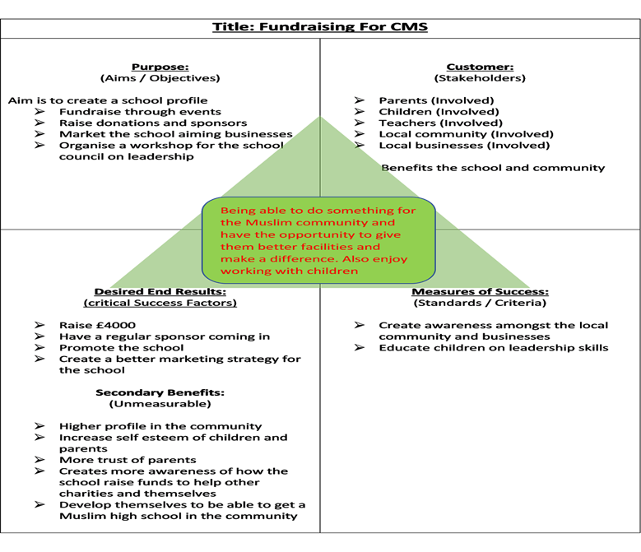

To evaluate the positive and negative factors of a project that can either lead to success or failure, the SWOT and PESTLE analysis can aid for decision making during the initiating stage. SWOT analysis is a powerful tool aiding strong strategies to grow a project looking at four aspects. Pestle looks at the environment outside (Seidul and Woodruff, 2019).
PESTLE: The Political factor is, Muslim schools, members and children face religious discrimination outside the school.
The Legal factor is, complying with OFSTED is compulsory that many Muslim school fail to follow this regulation.
Identifying the potential threats and political factors, the CMS team can use these information to also focus on marketing the school to the non-Muslim community and businesses. According to Gilmour Academy (2019), individuals attending these schools have a strong sense of community, stability, help shape morale and an improved academic achievement which can be useful to the society. Now that the team has established the main goals and potential threats, the team can go onto the planning stage.

Planning Stage
The project lifecycle planning phase is the next step to further develop the project by having objectives strategies. The resources, equipments, materials and labor are budgeted which is monitored and controlled, roles are defined by the PM ensuring team members are clear of responsibilities avoiding time being wasted. Once the objectives are identified S.M.A.R.T goals are set to make project achievable (Office Timeline, 2019).
The CMS team created a stakeholders analysis, according to Thompson (2019), this tool identifies individuals with power, influence and impact on the project. The analysis can help define a project by taking opinions of the stakeholders and build a understanding and plan actions. The analysis identifies the stakeholders and works out the power, influence and interest to improve focus, recognising key stakeholders can aid better support.
However, 12Manage (2019) argued, although the benefits of a stakeholder analysis may help retrieve a better relationship highlighting the significance of the stakeholder, the disadvantage are the analysis should regularly be updated as the power of stakeholders may change. Achieving stakeholders demands may also be difficult which leaves managers reconciling all interest.
The project analysis displayed four stakeholders with high priority such as parents and children, the perception ranged from investing in school fees to simply going to school. Action found was the stakeholders can spread awareness and bring more funding as Hall (2019) stated, this meant the team can focus on the priority stakeholders and be kept engaged by talking, listening, manage expectations and work together. (analysis available below).
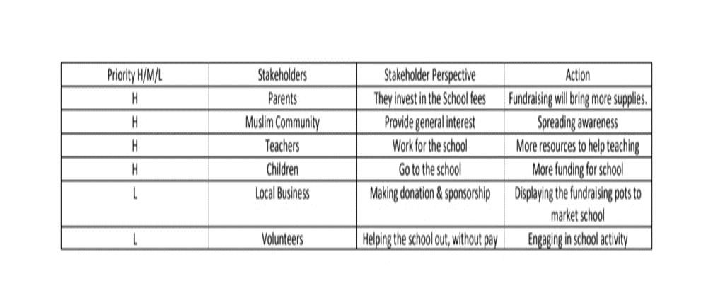
Furthermore, some organisations implement the McKinsey 7-S framework, which analyses current situations, examines future effects and changes in a project. There are three hard elements which are easy to identify, Strategy: a project plan, Structure: how organised and System: procedures team use. The four soft elements which are hard to identify are, Shared Value: core values of a organisation, Style: style of leadership, Staff: team members capabilities and Skills: skills of employees (Mind Tool, 2019). However, MSG (2019) argued, the framework ignores the external environment, only concentrates within an organisation. CMS team can look at each aspects to see which element needs to be realigned to improve performances, the team maintained alignment and was not in need of restructuring. Now that all the vital stakeholders are identified, systematic tools can go on to implement the activities in the execution stage.
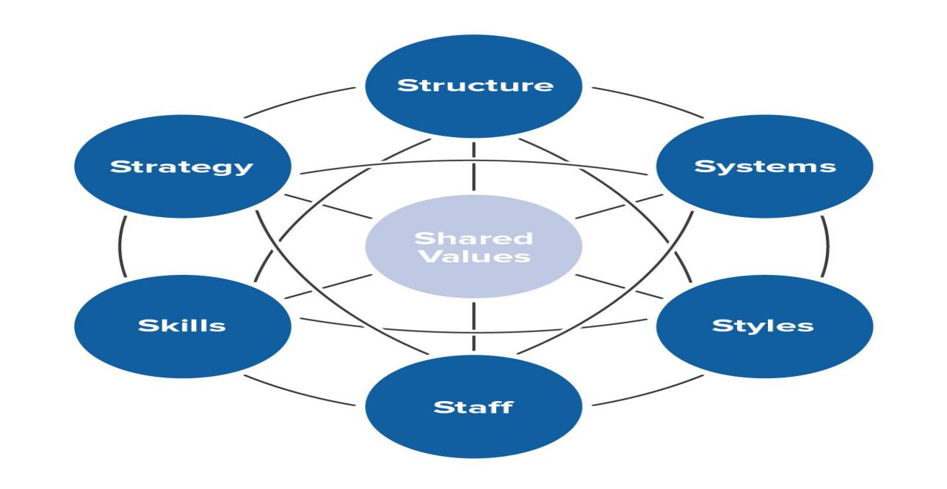

Execution Stage
The lifecycle execution phase is when project activities take place, PM will be required to leverage soft and management skills to keep the team motivated, stop unnecessary distractions, manage morale, solve conflicts and guide under-performers (Office Timeline, 2019).
A Work Breakdown Structure (WBS) in project management breaks down the deliverables into sub-deliverables making complex activities more manageable aiding projects to be accomplished faster and efficiently. Team members work is done simultaneously to good team productivity (Wrike, 2019). According to Workbreakdownstructure.com (2019), the structure can help allocate time, cost and potential risk along with referring back to the WBS for projects that are falling behind to identify the deliverables affected. However, according to Mathis (2019), a detailed WBS can lead the PM to micromanage the project slowing progress down.
There are two main approaches for the WBS, the top-down strategy is when the structure is completed and managed from the top and task are distributed with a time frame, However, this approach may be common in project management but can leave the team demoralised and demotivated as very little control is given (Makar, 2018). According to Bachar (2016), the bottom-up strategy involves PM and team members to brainstorm how project goals can be met. Project timeline is finalised by the team leading to a realistic schedule. However, teams may be engaged using this approach but the project can take longer to initiate as PM needs incorporation from stakeholders.

TOP-DOWN:
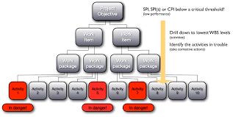

BOTTOM-UP:

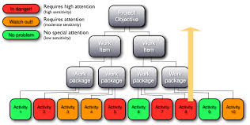

The CMS project team created a WBS using the bottom-up approach, the reason for this is the team will be more involved in the brainstorming process, be motivated to reach goals as the team would feel ownership (Codella, 2018). The teams WBS consist of five groups with the deliverables of Volunteering with the most sub-deliverables giving clear directions of dividing members to each activity to manage time and work efficiency. (tool available below). Each event is strategically scheduled but need to be controlled and monitored to maintain efficiency.
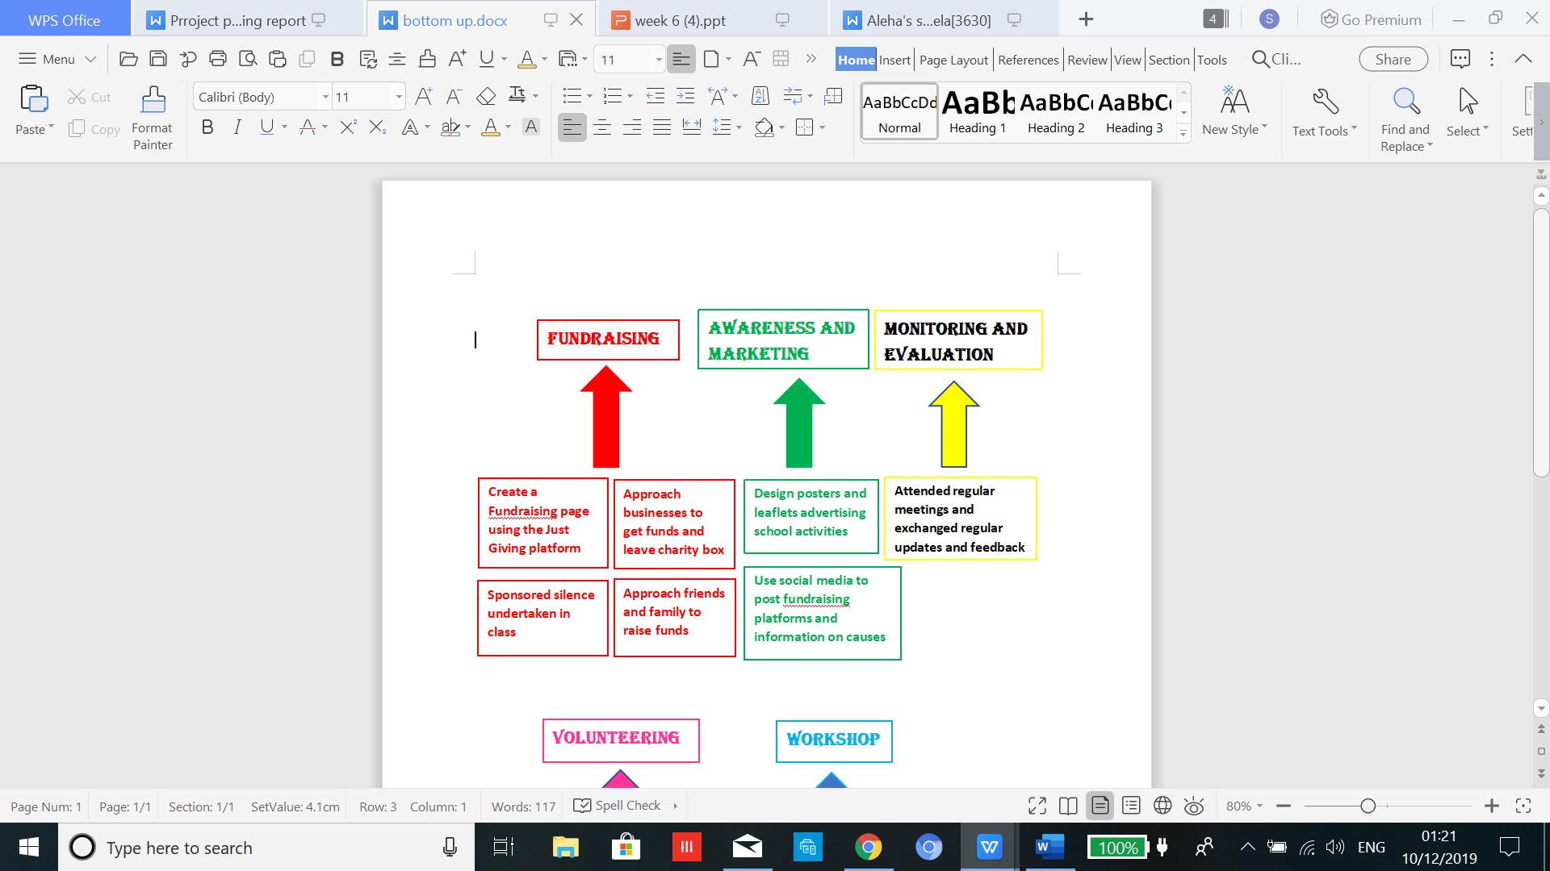
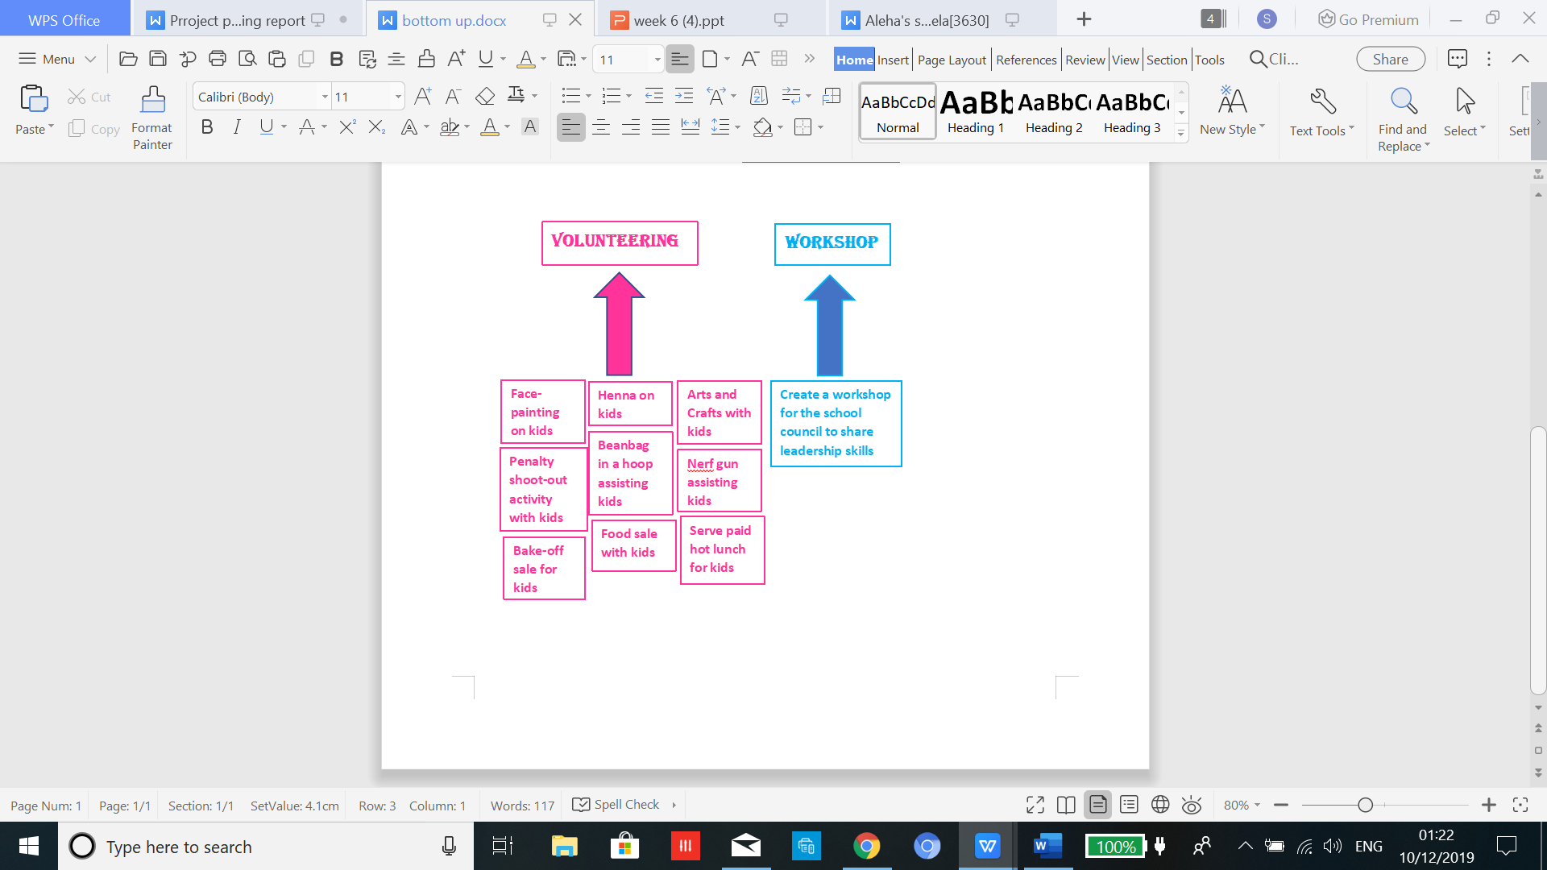

Monitoring and Control Stage
Monitoring and control is often implemented during the execution phase as the PM monitors and controls task, updating shareholders, optimise performances, comparing cost and ensuring its S.M.A.R.T (Office Timeline, 2019).
A risk assessment addresses factors that may have effect on the project such as, control measures, natural disasters, injuries and hazards (Bonnie, 2018). WorkSmart (2019) stated, it is the PM duty to perform a risk assessment and liaise with the team of hazards faced. A risk assessment examines aspects of, cause of harm or injury, can it be eliminated and the control measures that should be in place. Implementing the five steps identifies, potential risk, decide individuals at risk evaluate risk and precautions, record and implement, finally, review the risk assessment and update. According to Duggan (2019), although a risk assessment may be mandatory covering threats that may effect a project, however, risk assessment involve data which can be costly and not reliable.
CMS project teams risk assessment identified five risk with less likelihood of happening, if the risk identified did take place then the project would be impacted quite high. However, the mitigating actions in place meant the team was prepared with a back-up strategy to deal with any risk that did arise. According to Mitre (2019), risk mitigation plan develop options, enhance opportunities and reduce threats. (Assessment available below).
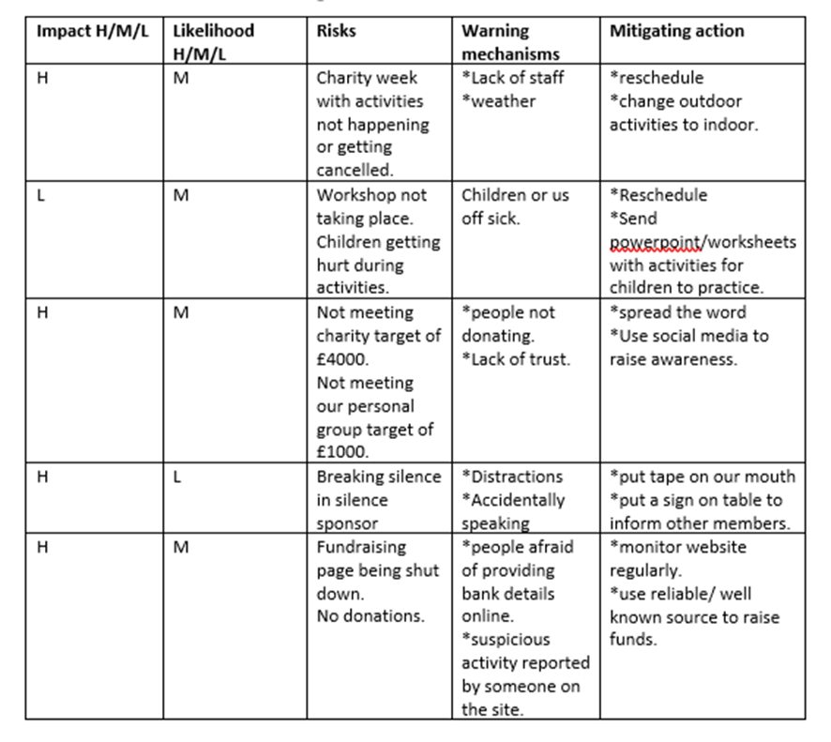
The Iron Triangle has triple constraint of time, cost and quality which aid to operate a project, each points are connected which means being focusing on one point, changes the other two points (Stakeholder Map, 2018). Implementing the iron triangle on CMS exposed the constraints effected, designs were printed that involved cost to improve quality but time was effected as this accumulated a que due to children selection process. Other than that, the team used all tools and techniques to plan and collaborate information to balance all three constraint. Once the project has come to the closing stage, it is vital to evaluate what has been a success or failure for future projects.

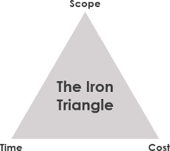

Evaluating Stage
This is the final stage when a project task are delivered, all resources are released and communication with stakeholders are completed. At this stage the PM evaluates performance highlighting strengths and weaknesses, taking these information to improve on the next project (Office Timeline, 2019).
The Gantt chart can be used to view progress, if all task managed within the timeline, all activities are formatted in a Gantt template that converts task into horizontal bars, stating the start and end date, displays the stages of each task achieved and what member was responsible. The Gantt chart allocated responsibilities, resources, made adjustments, communicate with stakeholders, display key activities and identified problems (APM, 2019). Project Management.com (2018) stated, the disadvantages of a Gantt chart is the length of the bars do not indicate the work achieved and needs constant updating. However, according to Wrike (2019), a Network diagram can be used as an alternative to a Gantt, the diagram track progress using boxes and arrows which is only done by the PM and status is the shared. This diagram captures every stage displaying the scope of the project. The CMS team created a Gantt available below display all the activities with each task delegated accordingly and achieved in expected time frame.
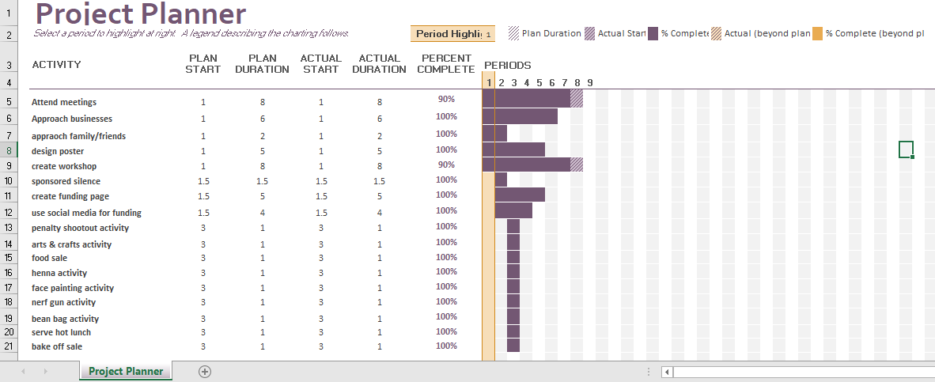

According to The University of Edinburgh (2019), the Gibbs reflection cycle help the team to reflect on performances, CMS team strengths are how the team collaborated well with one another, each task was accomplished with passion which led to a positive email from the CMS deputy, the results for each task performed led to success and attaining hard skill by raising the amount of £4825.63 and the team being certified for this achievement. As a team the weakness found was limited time to perform the workshop which meant aspects were incomplete. Certain activities where after school it was not possible for team members to attend due to personal commitment. The soft skills the team established was good interpersonal skills after the workshop a feedback sheet was distributed where the school council displayed good understanding of what leadership skills are and how vital it is.


Conclusion
The CMS project was completed after achieving over the anticipated amount of £4825.63, the guidance of the tools aided the project to success. As U.S Department of Veterans Affairs (2016) explained, the Quad chart gave vital information of aspects of goals and stakeholders involved during the initiating stage. The Stakeholder analysis helped recognise the key stakeholders with powerful impact on the project stated Thompson (2019). Wrike (2019) stated, how the WBS help to break down complex activities to get better results. Bonnie (2018) explained, risk assessment was performed to have a mitigating action in place in the case of anything going wrong. Finally, Gantt chart gave a detailed progression of each stage and time frame.
The team did very well, reflecting back using Gibbs many strengths and weaknesses was recognised however, in future projects it is recommended to allow more time for activities and ensure more notice is given before an activity is due to make arrangements for personal commitments.

Reference List

12Manage. (2019), Stakeholders Analysis, [Online]. Available: https://www.12manage.com/methods_stakeholder_analysis.html. [Accessed 8th December 2019].
APM. (2019), What is a Gantts Chart, [Online]. Available: https://www.apm.org.uk/resources/find-a-resource/gantt-chart/. [Accessed 12th December 2019].
APM. (2019), Using Project Management Software, [Online]. Available: https://www.apm.org.uk/blog/using-project-management-software-tools/. [Accessed 16th December 2019].
APM. (2019), Definition, [Online]. Available: https://www.apm.org.uk/resources/what-is-project-management/. [Accessed 16th December 2019].
Bachar, H. (2016), Top-Down vs Bottom-Up Approaches: Which is Right for you, [Online]. Available: https://www.clarizen.com/top-down-vs-bottom-up-approaches-which-is-right-for-you/. [Accessed 8th December 2019].
Bonnie, E. (2018), Project Risk Assessment, [Online]. Available: https://www.wrike.com/blog/ultimate-guide-to-project-risk-part-1-risk-assessment/. [Accessed 10th December 2019].
Caprino, K. (2016), If your Values Clash with How you’re Working, [Online]. Available: https://www.forbes.com/sites/kathycaprino/2016/08/04/if-your-values-clash-with-how-youre-working-youll-suffer-heres-how-to-fix-that/. [Accessed 9th December 2019].
Cardiff Muslim. (2019), Head Teachers Message, [Online]. Available: https://cmpswales.org/About-Us/Head-Teacher-s-Message/. [Accessed 6th December 2019].
Codella, D. (2018), Top-Down and Bottom-Up Project Management: Leveraging the Advantages of the Two Approaches, [Online]. Available: https://www.wrike.com/blog/top-down-and-bottom-up-project-management-leveraging-the-advantages-of-the-two-approaches/. [Accessed 9th December 2019].
Duggan, T. (2019), Find All the Limitations of Risk Assessment Analysis Listed Here, [online]. Available: https://www.brighthubpm.com/risk-management/91362-the-limitations-of-risk-assessment-analysis/. [Accessed 11th December 2019}.
Gilmour Academy. (2019), Benefits of a Religious School, [Online]. Available: https://www.gilmour.org/faith/benefits-of-a-religious-school. [Accessed 16th December 2019].
Hall, H. (2019), 10 Ways to Engage Project Stakeholders, [Online]. Available: https://projectriskcoach.com/engage-project-stakeholders/. [Accessed 9th December 2019].
Hseni. (2019), Risk Assessment, [Online]. Available: https://www.hseni.gov.uk/articles/risk-assessment. [Accessed 10th December 2019].
Invensis. (2018), What is Project Lifecycle and its Main Characteristics, [Online]. Available: https://www.invensislearning.com/resources/pmp/what-is-project-life-cycle-and-its-main-characteristics. [Accessed 6th December 2019].
Makar, A. (2018), Top-Down vs Bottom-Up Project Management Strategies, [Online]. Available: https://www.liquidplanner.com/blog/how-long-is-that-going-to-take-top-down-vs-bottom-up-strategies/. [Accessed 9th December 2019].
Mathis, M. (2019), Work Breakdown Structure (WBS) Purpose, Process and Pitfall, [Online]. Available: https://www.projectsmart.co.uk/work-breakdown-structure-purpose-process-pitfalls.php. [Accessed 8th December 2019].
Mind Tool. (2019), McKinsey 7-S Framework, [Online]. Available: https://www.mindtools.com/pages/article/newSTR_91.htm. [Accessed 10th December 2019].
Mitre. (2019), Risk Mitigation Planning, Implementation and Progress Monitoring, [Online]. Available: https://www.mitre.org/publications/systems-engineering-guide/acquisition-systems-engineering/risk-management/risk-mitigation-planning-implementation-and-progress-monitoring. [Accessed 11th December 2019}.
MSG. (2019), McKinsey 7-S Change, [Online]. Available: https://www.managementstudyguide.com/mckinsey-7s-change-model.htm. [Accessed 10th December 2019].
Parson, N. (2018), What is a SWOT analysis, [Online]. Available: https://www.liveplan.com/blog/what-is-a-swot-analysis-and-how-to-do-it-right-with-examples/. [Accessed 12th December 2019].
Project Management.com. (2018), Advantages and Disadvantages of a Gantt Chart, [Online]. Available: https://project-management.com/advantages-and-disadvantages-of-gantt-charts/. [Accessed 12th December 2019].
Quora. (2019), What is a Quad Chart? [Online]. Available: https://www.quora.com/What-is-a-quad-chart. [Accessed 11th December 2019].
Sketch Bubble. (2019), Quad Chart, [Online. Available: https://www.sketchbubble.com/en/presentation-quad-chart.html. [Accessed 7th December 2019].
Stakeholder Map. (2018), Project Management, Project Planning, Templates and Advice, [Online]. Available: https://www.stakeholdermap.com/project-management/project-triangle.html#the-iron-triangle-of-time-cost-and-scope-or-quality. [Accessed 11th December 2019].
The Big Choice. (2019), Benefits of a Workplace, [Online]. Available: https://www.thebigchoice.com/work-placements/careers-advice/benefits-of-a-work-placement. [Accessed 6th December 2019].
The Office Timeline. (2017), The Project Planning and Gantt Chart Blog, [Online]. Available: https://www.officetimeline.com/blog/conquer-the-5-phases-of-the-project-management-life-cycle. [Accessed 7th December 2019].
The University of Edinburgh. (2019), Gibbs Reflection Cycle, [Online]. Available: https://www.ed.ac.uk/reflection/reflectors-toolkit/reflecting-on-experience/gibbs-reflective-cycle. [Accessed 12th December 2019].
Thompson, R. (2019), Stakeholder Analysis, [Online]. Available: https://www.mindtools.com/pages/article/newPPM_07.htm. [Accessed 8th December 2019].
U.S Department of Veterans Affairs. (2016), Project and Award Quad Chart Guidelines, [Online]. Available: https://www.hsrd.research.va.gov/funding/quad_charts.cfm. [Accessed: 7th December 2019].
Workbreakdownstructure.com. (2019), Work Breakdown Structure (WBS), [Online]. Available: https://www.workbreakdownstructure.com/. [Accessed 8th December 2019].
WorkSmart. (2019), What is a Risk Assessment, [Online]. Available: https://worksmart.org.uk/health-advice/health-and-safety/hazards-and-risks/what-risk-assessment. [Accessed 10th December 2019].
Wrike. (2019), Project Management Guide, [Online]. Available: https://www.wrike.com/project-management-guide/faq/what-is-work-breakdown-structure-in-project-management/. [Accessed 8th December 2019].
Wrike. (2019), What is a Network Diagram in Project Management, [Online]. Available: https://www.wrike.com/project-management-guide/faq/what-is-a-network-diagram-in-project-management/. [Accessed 12th December 2019].

Appendix

