



BSc (Hons) Applied Computing

2024/25

An Investigation into Developing a Usable Desktop Application for Academic Referencing

Joachim Manlongat / 119187
NPTC Group of Colleges
BSc (Hons) Applied Computing
2024/25

For Declaration Form and Form of Consent (See Appendix 6)

Abstract
Software has become advanced alongside computers and relatable devices over the past generation. [80] Available tools on the internet in the form of software or applications have become exceptional with the availability to anyone who has access to it. [81] There is not a significant lack of area for the referencing tool however, there is an abundance of reference tools to choose from as with any other utilities may come across online. People who spend time researching would use these tools to efficiently produce their work with the assistance of what these tools provide to help finish their work before deadline. The guidance of these tools output consistency and accuracy, providing less amounts of labour and more organisation with references that can be stored in one place systematically. [47] Every software surrounding referencing has a distinctive feature although they are similar to one another. [23] An application to provide a direct approach with good usability to help users finish their work with a faster, direct approach as opposed to the features and premium offers that available tools provide.

Contents
Abstract 4
1. Project Introduction 9
1.1 Introduction 9
1.2 Problem Statement 10
2. Literature Review 11
2.1 History of Academic Referencing 11
2.1.1 Nature of Academic Referencing 11
2.1.2 Plagiarism 11
2.1.3 Integrity 11
2.2 Academic Referencing Styles 12
2.2.1 Vancouver Style 12
2.2.1.1 IEEE Style 12
2.2.2 Harvard Style 12
2.2.3 MLA Style 12
2.2.4 APA Style 12
2.2.5 Chicago Style 13
2.2.5.1 Various Styles 13
2.3 Referencing Tools 14
2.3.1 Current Referencing Tools 14
2.3.2 Referencing Application Issues 15
2.3.2.1 Issues with Current Referencing Tools (Online) 15
2.3.2.2 Issues with Referencing (By Hand) 15
2.4 Technology Platforms 16
2.4.1 Desktop 16
2.4.2 Website 16
2.4.3 Portable (Mobile) 16
2.5 Programming Languages and Environment 17
2.5.1 C# 17
2.5.1.1 Object-Oriented Programming Paradigm 17
2.5.1.2 .NET Framework 17
2.5.3 Google Books API 18
2.6 Data Stores / Databases 19
2.6.1 JSON 19
2.6.1.1 Serialisation 19
2.6.1.2 Deserialisation 20
2.6.2 Newtonsoft. JSON 20
2.6.3 NoSQL 21
2.6.3.1 Document Database 21
2.6.3.2 Search Database 21
2.6.4 NoSQL: LiteDB 21
2.7 Scrapped Proposal Ideas 22
2.7.1 LiteDB 22
2.7.2 Google Books API 22
2.8.3 Conclusion 22
3. Research Methodologies 23
3.1 Aim 23
3.2 Objectives 23
3.2.1 Work Breakdown Structure 23
3.3 Research Methodology 24
3.3.1 Philosophy 24
3.3.1.1 Phenomenology 24
3.3.2 Approach 24
3.3.2.1 Inductive 24
3.3.3 Strategy 25
3.3.3.1 Action Research 25
3.3.4 Choice 25
3.3.4.1 Multi Method 25
3.3.5 Time Horizon 26
3.3.5.1 Cross-Sectional 26
3.3.6 Data Collection 26
3.3.6.1 Non-Numerical 26
3.3.6.2 Questionnaire Sampling 26
3.4 Ethics 27
3.4.1 Data Protection Act 2018 27
4. Resources 28
5. Design and Implementation 29
5.1 Design 29
5.1.1 Usability 29
5.1.2 Human-Computer Interaction (HCI) 30
5.1.3 Wireframing 31
5.1.4 Project Requirements 32
5.1.5 Flowcharts 33
5.1.5.1 User Flow Diagram (UFD) 33
5.1.5.2 Hierarchal Task Analysis (HTA) 34
5.1.5.3 Procedural Flow Diagram (PFD) 34
5.2 Implementation 35
5.2.1 User Interfaces 35
5.2.2 Software Testing 37
6. Evaluation 38
6.1 Expectations 38
6.2 Reality and Outcome 38
6.3 Was it Successful? 39
6.3.1 Suggestions for Future Development 40
7. Conclusion 40
7.1 Final Thoughts 41
8. References 42
8.1 List of Figures 48
9. Appendices 49
9.1 Appendix 1: Ethics Form 49
9.2 Appendix 2: Wireframe 53
9.3 Appendix 3: Usability Testing 54
9.4 Appendix 4: User Acceptance Testing 56
9.5 Appendix 5: Questionnaire for Client 57
9.6 Appendix 6: Declaration Form and Form of Consent 59
9.7 Appendix 7: Demonstration Video 60

Project Introduction

1.1 Introduction
The computer has become a powerful tool alongside technology, it continues to proceed extravagantly, and with it, has people from across the world to innovate. [80] Passed on from time, an assortment of available software with different use-cases has gone and developed to become efficient, robust and more accessible. [81]
Technology has changed dramatically over the past generation and so has the change in academic writing. From what was once able to be written by hand is now automated with profound efficiency on the computer with a few adjustments such as the assistance of tools while the same tradition remain, except it is with a keyboard rather than a pen.
Many others who have studied have been familiar with academic writing, and so too with referencing. [15] With the use of available tools online and with the full utilisation of Microsoft Word for writing their research, the software itself can support the user with replacing words, spell and grammar checking. [37] When it comes to writing a reference sheet along with citations of each word that is sourced, it’s a separate thing from Microsoft Word.
This research project will be about surrounding the investigation of the nature of academic referencing and its use of management applications. Research is obliged with the availability of tools for referencing found online. For this project, a referencing application is required that also meets the usability, functionality and expectations which shall be a counter that causes other infrastructures for a development requirement.
There is an assortment of reference tools found on the web that are used as tools for configuring references neatly and presently for mainly academic purposes. [1] Since there is a different format for each type of referencing, users must reassure while making the reference list applicable. The problem of unclear citing concepts, make the referencing task appear complicated. Thus, users must consider that in order to make a reference list, it requires consistency and format accuracies. [2]

1.2 Problem Statement
This research project will investigate the nature of academic referencing and its management applications. The research will adopt the position that these include a wealth of functionality which can be seen bewildering to some users and that this might be improved by concentrating on a single citation standard. [2] The project involves a client who has requested a referencing application suited for their needs. With the availability of tools for referencing applications found available online, there has yet to be a referencing application that meets the expectations which is causing deficit infrastructure for a development requirement. When it comes to choosing the right software, it is either met with a premium or issues that all other available tools seem to have. The area of referencing tools should be investigated.
Inspecting references and adjusting them is often labouring, as this applies to supporting academics in writing. It is vital to reference what is found to back the claims in writing. [7] Referencing after long stretches of writing can be tedious, in a worst-case scenario, it could become overwhelming if the source turned out to be an issue. This can be a concern to poor notetaking or the link to the reference has expired. [8]
A prerequisite of implementing solutions to provide alternative approach for a reasonable referencing tool for a direct approach and less working towards. Further study, development and time is required to identify the referencing styles to create an outcome. [15] This may refer to existing sources, research and publications whilst such discussions have yet to illustrate any useful solutions to the problem that needs to be addressed.
Primary research results are based on the questionnaire (see appendix 5), which was completed by the client, they also contributed to testing and as motivation to undergo. The push for this project came from a questionnaire with the client where dissatisfaction with the current range of academic reference tools have been expressed. Their issue is with the dissatisfaction of submitting and saving their referencing progression. This would often result in manually submitting a referencing instead of using a tool that is supposedly providing a faster way of making a reference list. [28]

2. Literature Review

2.1 History of Academic Referencing
In History, has for years employed endnotes to ensure that references to archives which has an assortment of referencing formats that are not always easy to cite, but could be accommodated and also preventing plagiarism. [3] [4] [37] However, this lost some of the immediacy of being able to identify authors or archives directly in text while reading the article.

2.1.1 Nature of Academic Referencing
Referencing is how you acknowledge the source of the information you have used based on how it is referred in your work. This helps to make clear adjustments to the reader on how referencing has applied to the work of others to develop own ideas and arguments in an intuitive manner. [5]

2.1.2 Plagiarism
In academic writing, plagiarism is submitting work that others have produced and claiming it as your own effort. [8] Plagiarism involves using words, concepts, ideas, or information from a source regardless of value without referencing it appropriately. [7] Plagiarism can be seen as intentional, as it is an act or a form of theft to cut corners by taking ideas or context from others. [9] It may also be found unintentionally which may be caused by poor academic writing and misunderstanding. This also includes inaccuracies of referencing or short notetaking. [8]
Should the person be held accountable for the academic misconduct? They would face the consequence of having their status revoked and their information falsified. [9] It is advised that institutions give the guidance on avoiding the misconduct of plagiarism. It is also advised that learning about plagiarism is a good practice that start to begin in schools. [6]

2.1.3 Integrity
In academic writing, integrity is by means the acting in a way that is fair, honest, impartial, respectful and responsible in your research and effort in work. [11] It also means applying these values and when engaging with the work and towards the contributions of others. These values are expected even if you are a student or a teacher. [10]
Students are expected to research and reference the experts who have previously made the research. [12] To produce original work, ideas and words are taken inspiration from gathered research, as this is to ensure that the research is broad and about how the works of other scholars have influenced understanding. Undergraduates, for instance, often base their assignments on selecting, ordering, summarising and interpreting what others have said to support their own academic arguments. Therefore, it is important to learn how to reference well, that is, how to consciously and clearly acknowledge the sources you have used in your work so that your own contribution can be clearly identified and appreciated. [9]

2.2 Academic Referencing Styles
Referencing styles are preferred by academic disciplines because they work better with the kind of texts that are most used in that discipline. [12] [22] Various referencing styles has its origins but are widely adopted in certain academics of different sectors as its use cases. [15]

2.2.1 Vancouver Style
Vancouver is a numeric style with each given a number which corresponds to the order in which it appear in the text. [12] If the same source is referred to again in the text, the same number is used. At every point in the text where a particular work is referred to by quoting or paraphrasing, references are numbered, the reference list comprises a single numbered list of citations with full details.

2.2.1.1 IEEE Style
The IEEE has its own take on a referencing style. While both IEEE and Vancouver uses the notable, square brackets with numbers to list which indicates it’s feature in a top-down approach, both styles are different to one another. [21]

2.2.2 Harvard Style
Harvard referencing uses an author-date system. The author-date style offers an efficient and clear method of providing citations of published sources, which appear in a reference list at the end of the chapter or book. The method works well when the citations are to published books or journal articles. It does not however, provide compatibility if the citations are from unauthored sources. [14]

2.2.3 MLA Style
The Modern Language Association (MLA) is a referencing style predominantly used in arts and humanities that uses the author’s last name and the page number from which the context of quotation is taken. [15] The MLA style bears the resemblance of Harvard, while the MLA style is depicted by the name, it is predominantly used in the academic field of arts and humanities.

2.2.4 APA Style
The APA referencing style is another variant on Harvard. Many of the conventions are similar, with the author-date system used that directs readers to a full reference list entry. This reference is recommended by the American Psychological Association (APA) and is used in many social sciences. [16]

2.2.5 Chicago Style
The Chicago referencing style is an ‘author-date’ format, with the citation in the form of text that consist of the author(s) name, year of publication and pages that are rounded in brackets. [17] Originating from the University of Chicago and is used in humanities. When referencing, no distinction is made between various sources such as books, journals or websites and other formats. In this case, the user could use the paragraph number and if available, with the abbreviation paragraph. [14]

2.2.5.1 Various Styles
There are a variety of styles chosen that are used for specific fields of study. [15] These styles are designed to encourage the consistency and to guide the reader to find the necessary information effectively in such format. [22] These can often be used alternatively for humanities and history research [20], mathematics and law [19] or similarities of using square brackets under a different use case. [18] [21]

2.3 Referencing Tools
A detailed review discussing the various tools available that are used for referencing and the use case for it. This outlines where the development of the applications fits in when considering the functionalities and usability. [82]
Referencing tools are a convenient set of tools to generate a list of references. They can be found at most, as websites and other alternative such as a software for desktop that produces a structure. [23] This is all to save time in academic writing.

2.3.1 Current Referencing Tools
It is also understood that these available tools found online generates a format in accurately making references in various, popular styles to support users by incorporating them into academic writing. [23]
To gain a wider understanding of currently available referencing tools and to identify a potential solution for the library, an investigation has been conducted of these referencing tools. As expected, each result was in full swing as varying cases for each website offer features that have similar desires for the user to interact with. Referencing tools are software that records any reference that you input and linked to a wording process, allowing you to add citations and formatting them. [24]

2.3.2 Referencing Application Issues
The issue with the current tools is the inaccuracies of the referencing style. After trying out and testing a range of available tools, the result often involves reorganising the referencing by hand. To consider, we will take the idea of the quick input of referencing and saving it for future management.

2.3.2.1 Issues with Current Referencing Tools (Online)
These applications have the basic idea all settled out, which help keep track of what you have read and allows organisation of research. Current reference tools found online such as Scribbr [25], Mendeley [27] and MyBib [26]. These applications have similar usability for quick formatting a reference in contrast to service. Overall, what was found out about these tools are settled out, which helps keep track of what you have read and allows effective research. [28] There are issues addressed from the proposal that still hold up, when synthesing the selected tools, with the similarities as for the following:
- Premium service (Often subscription based. Pay to use further services.)
- Inconsistent selected referencing styles. With other referencing styles such as Harvard are the focus whilst Vancouver is either not available or in other tools.
- AI assisted
- Proprietary software
With the word from the client, they have pointed out a few that must be made to make a referencing application usable:
- Interactive imagery for ISBN and URL
- Less manual labour for entering a reference.
- Attention to detail without making it less complicated.
(For the questionnaire see Appendix 5)

2.3.2.2 Issues with Referencing (By Hand)
Traditionally, referencing by hand is a way of keeping and tracking note of the sources found in physical copies of books, papers, journals and articles. [28] Practically speaking, most referencing these days are done virtually and typed out.
Additional to adjusting references manually, if a reference selected has turned out to be false, by reasons of losing the page, mismatches or a broken link, it can lead to an issue. The habit of writing a reference by hand is often a poor researching habit as it shown that, recording what is acknowledged must be tracked and as a result, can be more time consuming than having it done on the computer and losing consistency by mismatching the format. [29]

2.4 Technology Platforms
To produce a solution that is effective and meets the requirements of the client it is important to first consider the range of platforms and technologies currently available to design, develop and produce the solutions they require.

2.4.1 Desktop
A desktop application is a type of program designed to run on a specific hardware, such as a desktop or laptop. It is an application that runs locally on the user's computer, as opposed to a web application that runs in a web browser. [30]
With the ability to integrate with browsers and offline access, they remain indispensable. This allows users to work offline. For users who need access to data regardless of network availability, desktop applications may suit a better choice. The choice between desktop and web applications depends on the specific needs. [31] It is worth mentioning that desktop applications still have a lot to offer, especially when data and performance is necessary.
Although desktop apps allow offline work, the installation process on the other hand must be manual which involves re-installing. If it were the case of a cloud and using a web app, this would not be the case as it requires a login and no further installation.

2.4.2 Website
A web application is a software that runs in the browser. Which require internet to connect with clients for convenience. If the application is run on the web, it can be enabled for any device that requires internet. Traditionally, there is no need for downloading, the availability of interactions with the content provided including functionalities in data, user authentication and updates. [31]

2.4.3 Portable (Mobile)
Mobiles are a popular device used commonly for applications. As a result, demand is often high, portability is a major factor in using tools wherever you go. [32] As for mobile, it is a popular choice in comparison to stationary, available software and tools can be downloaded and used anywhere, allowing greater accessibility that can provide convenience with quick access. [32] [30] There are two operating systems that outshine: iOS and Android.

2.5 Programming Languages and Environment
Programming allows the possibility of the application build project to happen. Programming languages are a set of rules written and developed by a programmer to deliver instructions to the computer to accomplish a task. [34] This set of instructions is usually viewed as incomprehensible, with each programming language having similar concept and vocabulary. The code is structured by following a syntax of a programming language to form and organise computer instructions. [33]

2.5.1 C#
C# is a general-purpose programming language created by Microsoft in 2000. Its joint alongside the ASP.NET ecosystem and runs primarily on the .NET Framework that can be used to develop web, desktop and mobile applications. [35] In brief, C# relates to the C-family of programming languages alongside C and C++. C# benefits the simplicity while utilising similar syntax from the rest.
As C# is part of the .NET language, it works well with a Windows application. Although it can be cross-platformed to port C# language application into Linux as an example, its best use case is on a Windows environment. [36]
C# was used as the researcher for the project is more leaned towards it. This is more likely to produce better results as opposed to other languages. As an added benefit, the language itself has the library provided for the desktop application as language itself is integrated to the .NET platform.

2.5.1.1 Object-Oriented Programming Paradigm
While using objects in C#, it can be managed without interacting with their inner attributes, describing object behaviour and functions through a declaration of classes. Applications that use OOP can be made simpler to test and read, enable response to any occurring issues, and generally a leaner approach to programming. [37]

2.5.1.2 .NET Framework
As C# was used as it is the language suitable for the project, for the framework, .NET is the available platform with tools and libraries for C#. The benefit for .NET is that it also supports running websites, services, desktop apps, that are oriented towards Windows. [38]

2.5.3 Google Books API
The “Application Programming Interface” (API) are applications that allow desktop applications to communication with a server-sided application. [40] If the reference application were to feature the Google API, this would enable two sides of communication with each application (desktop to internet) using a set of protocols to retrieve data from a database. [39]
According to Google, the Google Books API allows the application to perform additional full-text searches and retrieve book information and virtually. [41] This can be beneficial for interacting with the application as it can be used to trace information about the chosen book to be inspected and saved into a file. [40]

2.6 Data Stores / Databases

2.6.1 JSON
JavaScript Object Notation or (JSON) is a standard text-based format for representing structured data based originally for the JavaScript object syntax. JSON can be used extensively and universally as it is not dependent on any language. It is directly translatable to generate and parse. [42] JSON is commonly used for transmitting data in web or desktop applications.
File formats in general determine how data can be used. [42] As this application is a database that contains string to be converted into a file, it is important to decide what use of file formats to use for data collection, data processing, archiving, and long-term preservation. Applying JSON is a better choice for APIs, applications, and data storage. JSON is a popular file format that was picked for the application as it's much more versatile than plain text because it keeps everything neat and structured and easily readable by both computers and humans. [43]

2.6.1.1 Serialisation
Serialisation is the process of converting the state of an object, that is, the values of its properties, into a form that can be stored or transmitted. [43] 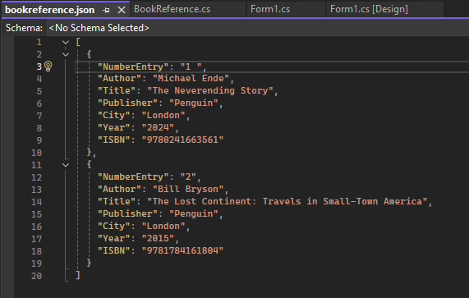
(Figure 1: Serialisation)
With serialisation shown in (Figure 1), it makes storing objects in a file or in a database which can be retrieved for later use from deserialisation. This simple approach makes it easy to implement persistent storage in applications. [44]

2.6.1.2 Deserialisation
Deserialisation is just the reverse process of serialisation, where the data file is put back into an object. [44] During this process, the serialized data is read and used to reconstruct the objects’ state, including their fields and object values.
With the data (as an object) stored in a format such as JSON being used for the application as an example, it becomes usable in memory or stored as JSON as shown in (Figure 2). This technique is commonly used in applications for data transmission or saving objects to files. [45]
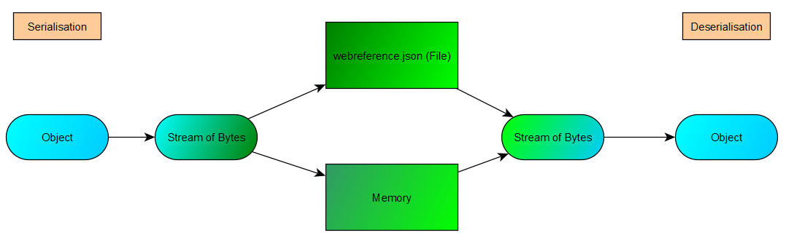
(Figure 2: Serialisation-Deserialisation)

2.6.2 Newtonsoft. JSON
Newtonsoft. JSON is a package that was acknowledged and used as a library for applying and handling JSON files in NET. The package itself has a wide array of features and settings allows for properties of data control over the serialisation and deserialisation process. [46] As this application used JSON as the file format to store data shown in (Figure 13), is suitable for the specific use case as save/load application for using data. [47]
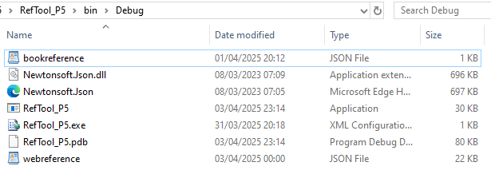
(Figure 13: File Location)

2.6.3 NoSQL
NoSQL is a type of database design as an alternative to a traditional RDBMS. NoSQL can copy and store data on various servers, which can either be remotely or locally. This ensures availability and reliability of data. If some of the data goes offline, the rest of the database can continue to run. [50] With NoSQL, databases can store data with a singular file format such as JSON.
NoSQL databases are purpose-built for non-relational data models and have flexible schemas for building modern applications. They are widely recognised for its ease of development, functionality, and performance at scale. [50] Exploiting NoSQL has it’s benefit as it is more flexible and does not necessarily require a schema, offering scalability to handle small to large datasets. [49]
Applying NoSQL would offer different types of data and offer flexibility, allowing unstructured or semi-structured to adapt into requirements. [48]

2.6.3.1 Document Database
As this application features a load/save function, it is mainly storing information as logical documents such as JSON. Due to the flexible nature of JSON provides a dynamic to document databases that prefer JSON when building data-driven applications. [49]

2.6.3.2 Search Database
Adopting NoSQL would allow the ability to query semi-structured or unstructured data such as applying JSON to save documents and make use out of. With the application together with being document database, it’s use case would have been deemed appropriate for this issue as not only it could save documents, but it would also search for what the reference is for example, the data for an ISBN code to search for specific book rather than just using Google. [49]

2.6.4 NoSQL: LiteDB
Derived from NoSQL, LiteDB as a design, is a simple and lightweight embedded .NET document database. LiteDB is another design for C# and .NET oriented exclusively. [52] LiteDB was inspired by the MongoDB database and its API is very similar to MongoDB’s official .NET API. LiteDB is a document store and serverless database that works well for small projects and mobile applications. [53]
As the application is written in C# for the entirety of the project, the main benefit of LiteDB is that it is a serverless database (NoSQL derivative). Unlike traditional servers, serverless databases don't require installation, provisioning, or any other type of maintenance. [51]

2.7 Scrapped Proposal Ideas

2.7.1 LiteDB
As a NoSQL alternative, LiteDB was initially designed for researching massive amounts of disorganized, stored data, collected from multiple sources. [51] [52]
The idea of applying LiteDB into the application was with the intention of the .NET Framework. Should the development of LiteDB have carried forward? It would have been a far suitable learning experience to understand about databases without the traditional SQL service whilst also storing data from various sources while using different file formats.

2.7.2 Google Books API
The plan to use the API was to claim the benefit of using the service to search and collate books into reference. To apply the API in the application is to require a HTTP request and URL in the application as a query parameter. This will be able to fetch the data which can then be added to the search tool and filter through the chosen book for data. The idea of the API would link to the client’s needs and such plan was considered. However, it was scrapped due to the complexity of the API when it meshed with the application itself.
Ideally, the use of the API would allow ISBN searches to automate whenever the number of has been entered into its Textbox to retrieve further information about the book. The feature would be useful as not only the application itself would store data about a certain source, but it would also grant access to a digital library (Google Books Database). [41]

2.8.3 Conclusion
The scrapped ideas have left a mark of how the development could have gone. To involve and apply the utilisation of alternative databases such as LiteDB or even NoSQL, to the Google Books APIs that can make the application more revealing and more tailored to the client’s wishes. To acknowledge this outcome, it can be an experience to learn more while still developing and researching the project. Should planning be more adjusted to balance a priority for these additional features? Setting the stage of the environment of programming in C# and the research about academic referencing can provide the developer additional learning experience that can change the outcome of the project and dissertation.

3. Research Methodologies

3.1 Aim
The aim is to develop a referencing application as a means to provide an alternative towards the issues that exist with the currently available reference tools. A singular referencing style (Vancouver) is recommended for the project, with the requirement to provide a concrete demonstration of a desktop application.

3.2 Objectives
- Develop a prototype
- Evaluate the nature of the references, types and capabilities of application
- Investigate how client expectations are influencing the application
- To discuss the client experience and expectations and make recommendations to develop an application

3.2.1 Work Breakdown Structure
Follow up used from the GANTT chart to illustrate a diagram of the project proposal and project development. As shown in (Figure 3), the research dissertation has been re-arranged to add more definition for the project and application itself.
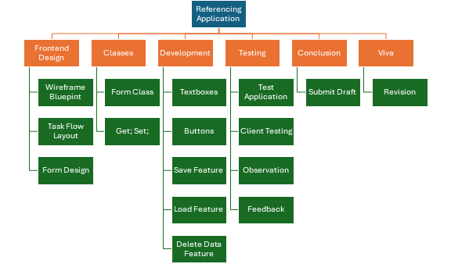
(Figure 3: WBS for Dissertation)

3.3 Research Methodology
Since the objective of this project is to develop a referencing application, the core objectives of this study were to develop the application using C# as the absolute chosen language with LiteDB as the chosen database and Google Books API as an extra tool.
To break down the methodology into description, Saunder’s research onion was holistically taken into account as a useful tool and guide about the methodology of the project. [54]

3.3.1 Philosophy
Research Philosophy is related to a set of beliefs on the nature of the investigation of reality. Often studied in the context of epistemology and ontology. [55] The selection of a philosophical stance may have an impact.

3.3.1.1 Phenomenology
This project to an extent, had adopted phenomenology as it was development concerns, with the prior experience. [56] Adopting phenomenology brought out the term, meaning and value what that experience was. When developing the application, the existing knowledge of using C# and other design methods such as wireframing, testing an assortment of tools provided intuitive understanding of handling the project.

3.3.2 Approach
Approaches are the broader understanding of what is provided for the research of the project. This is to inform the decision-making taken in terms of how data was collected, with the span of steps from decision-making to detailing the methodology of analysing the collected data and interpretation.

3.3.2.1 Inductive
Inductive was the approach taken as reasoning tests were existing and then taken into research to find what’s needed for the project. Taking a research approach are the steps from broad assumptions to detailed methods of data collection, analysis, and interpretation. [55] By analysing from interviewing and observation though feedback by means of creating an application that suits or fulfils client need.

3.3.3 Strategy
Taking into consideration, the aims and objectives of the research in a broader perspective and how it was conducted. The strategy here would determine the path of which the project itself underwent alongside the level of understanding aims and objectives. [56]

3.3.3.1 Action Research
Due to the nature of this project, action research was conducted practically in different locations whether it was at home or in a classroom. Applying action research would heavily involve the client. [57] Unfortunately, this was not the case that went according to plan. With action research, its aim is to investigate a problem and solving issues together with the client. The client would initially receive a prototype of the project for feedback to see how the application is fairing. In addition to the initial point, the process would be repeated. As reality went, the plan for checking in with the client was cut for self-reflection and was handed out to them late into the development of the project.

3.3.4 Choice
Choices were stood firm in deciding which data type was used for the research and development. [58] One data type was used for limitations before the project was undertaken and with only a client was needed, a qualitative approach was the only choice needed. That same choice was used as there was no further need to expand the approach.

3.3.4.1 Multi Method
The multi method used quantitative and qualitative research as data gathering for the project which only provided the client experiences, views and opinions of referencing tools. [58] Arguably, this selected choice with the scalability of the project being shorter than expected. The experience is still sufficient for the client to provide their information for which a solution is carried forward. [55]

3.3.5 Time Horizon
Planning a fixated time during the course at which point development process were made that evaluate the level of production to make ends meet. It is a timeframe over which the developer and client would stay invested in making the application a possibility.

3.3.5.1 Cross-Sectional
The nature of this project and with the aim and objectives, the cross-sectional time horizon was realistically appropriate given that data collected was split to see how far the progress of the project development went and conducted thereafter. [55]
Applying a WBS organised a definition of scope necessary to structure sections into smaller, manageable sections. Adjustments would be made clearer provided that over a short period are made followed by a GANTT for scheduling and monitoring to ease congestion of productivity to project fulfilment.

3.3.6 Data Collection
After breaking down the research onion as a guide to understanding the project holistically, adopting the layers chosen prior, to ensure that these decisions made at each layer would align with the aim and objectives. [55]

3.3.6.1 Non-Numerical
Collection methods such as non-numerical for this project included the collection of non-numerical data such as questionnaires to gather insight to undergo research. In qualitative research, it gave the client to brief out the nature of their experiences and perspectives to enable an understanding of phenomena. [59]

3.3.6.2 Questionnaire Sampling
Initially, questions were to be provided for an interview of the client which would ask about the referencing tools available and their experiences of it, followed up by what they would like the application to their current situation of dealing. The insight is the data provided to produce an application based on what the client wants and how it will be used effectively. [60] Instead of an interview that would never come into fruition. Instead, a simple questionnaire was sent through an e-mail detailing a short series of questions by which the client would respond at their own pace. The data they provided collected necessarily for what the project would bring.
(For the questionnaire see appendix 5)

3.4 Ethics
An ethics form was provided and approved by the Neath College and Trinity Saint David beforehand for the development of the project of the referencing application was undertaken. The client, who is also the participant for the application were informed in person through consent and notified through email prior to completion form, regarding the application, their anonymity would be kept confidential and that they were free to withdraw from the project at any time. In addition to email, a questionnaire was handed to the client with open and closed questions debriefing about the situation with the current referencing tools used at their disposal and what the new referencing application should be. [61]

3.4.1 Data Protection Act 2018
Acknowledging DPA 2018 requires the understanding of data and its sensitivity. To ensure that data is secure and to remain impartial, the developer needs take accountability by informing the clients what data is being stored and what it is used for. For this case, the questionnaire before development and after development for user/usability testing, their answers are used for the purpose of the creating, designing and implementing the application. [62]

4. Resources
Tools used to fulfil the project:
- Desktop Computer
  - Personal
  - Lab
- Laptop
  - Personal
Software used:
- Visual Studio 2022
  - C# Form (.NET Framework)
  - NuGet Package: NewtonSoft. JSON
- yED
- GIMP
Sources available:
- Books
- Articles
- Blogs
- Websites
- Videos
Qualitative (For client):
- Questionnaire
- User/Usability Testing

5. Design and Implementation

5.1 Design
With designing, the process of the overall structure of the project is met with requirements and goals. [67] With plans, it is with these concepts that follow a process which could then be passed on to the development process as a structured guide. In the design stage of the project, the requirements and specifications are necessary for software development. It sets a standard that can be guided out to eliminate or warrant errors or changes of the project. [68]
In various real-world situations and practices that are dependent on applications of different use cases such as mobile, web and desktop. The user's overall experience is taken into consideration to make things less complicated. The design for the application is made to be simple, sustained and understood. [82]

5.1.1 Usability
Usability testing is a method of testing the functionality of a website, app, or product by observing real users as they attempt to complete tasks on it.
The purpose of applying usability testing is to identify and reveal areas of improvement for the client to use the application. These highlights shown in (Figure 12) overall user experience by seeking the functionality of the application. Followed by observation, the user may test the application while they are being observed followed by queries and follow-ups through conservation. [70]
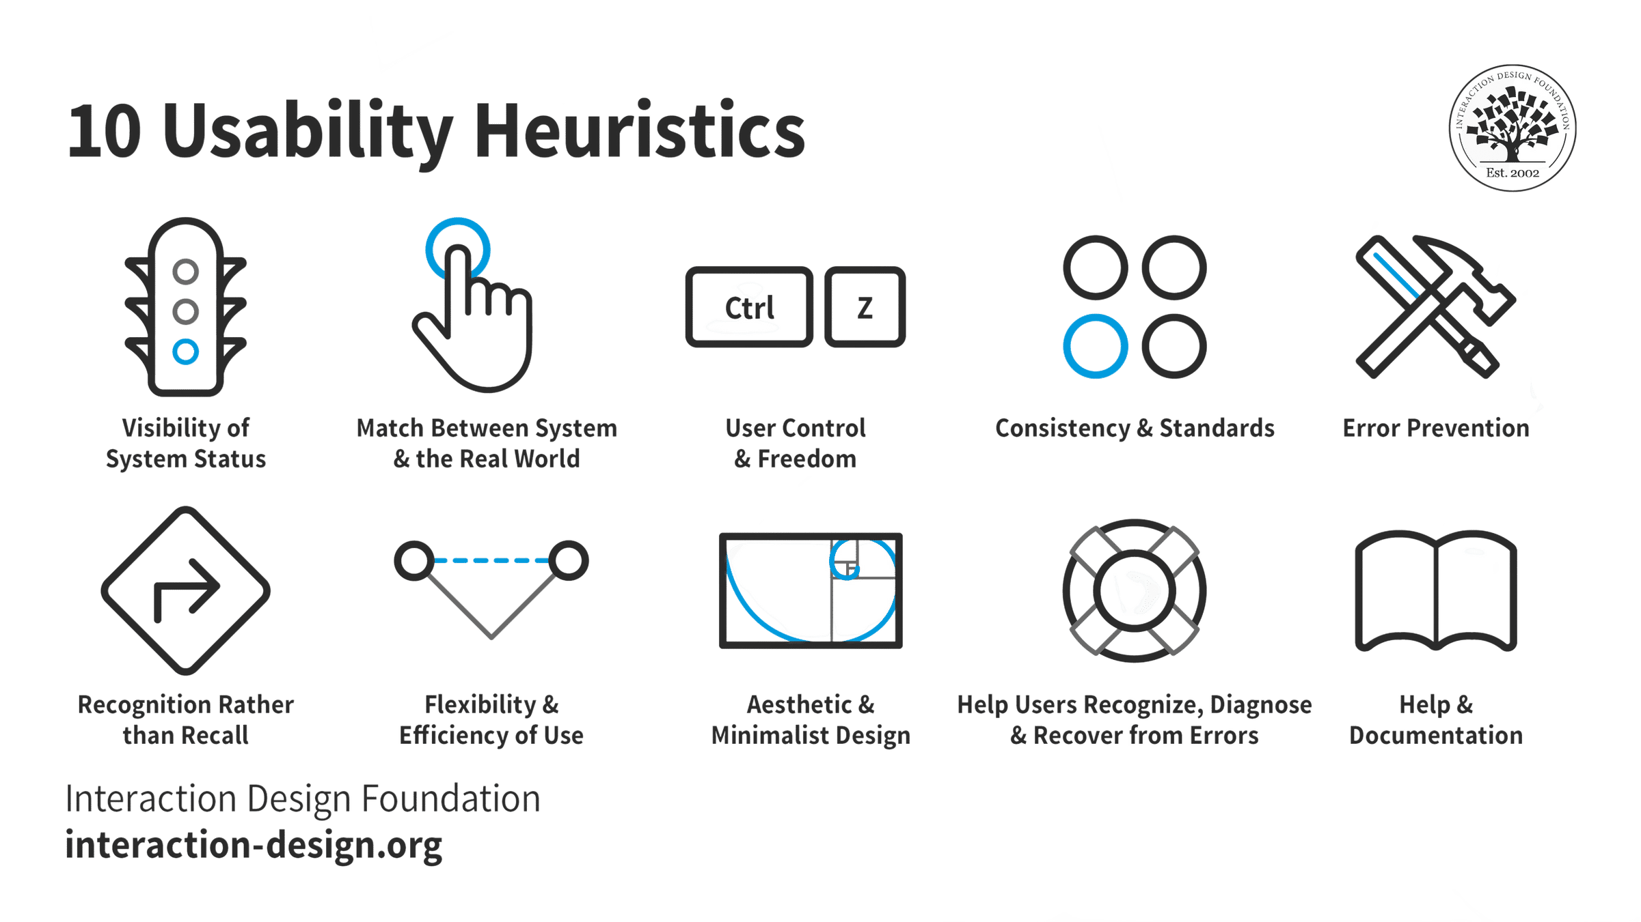
(Figure 12: Nielsen’s 10 Heuristics)
Applying Nielsen’s Heuristics as a guide about the principles of UI/UX design. To following the process to ensure that the application made for the user is easy to remember and apply, and they can be used for any type of interface or system. [83] As a guidance to adapt varying scenarios on how users typically think and behave.

5.1.2 Human-Computer Interaction (HCI)
HCI is the observation of the way us humans engage with technology, such as a computer. [87] Applying HCI can apply towards anyone who isn’t as computer literate even without the user realising it. [85] HCI provides an in-depth concept of empirical understandings about the user especially in ergonomics, with achieving and ensuring the goals within the limitations, personalisation and constraints of interface design. [86]
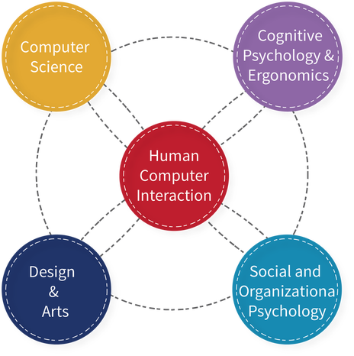
(Figure 14: HCI Diagram)
The importance in the concepts of HCI as a goal for acknowledging UX instead of just designing for the UI, by allowing the user to develop a pattern for referencing quickly and efficiently to be engaging while the user becomes more task efficient with their situation and become familiar with them. [85] Provided, that the usability can be similar to a trend of various applications or software where for example, the user expects the buttons and textboxes as shown in (Figure 9 and 10) to be close or similar to one another. As shown in (Figure 14), by converting the previous knowledge of what was applied by taking control of other interfaces that users experienced before it can be applied to the application form. [86]
The application form should not be complicated or overwhelming but rather, it should be about the focus or consistency of the UI/UX between human and computer while enhancing productivity, accessibility with an intuitive interface. [87]

5.1.3 Wireframing
Used as a layout of getting into terms to establish a structure of an application before the development is passed on. [64] The wireframe shown in (Figure 4), is to define a rough sketched layout is made simple to understand and encourages feedback of every iteration. [63] By acknowledging heuristics [83] and the usability approach [84], requiring knowledge beforehand about user interaction design patterns and accessibility to ensure that the interface is user-friendly. [82] [85] The UI included a few elements of an application that allow for user experience. [84] [87] This includes buttons, text, form (in textbox), save, delete, upload and exit that allow anyone to input and view output by the user from the application.
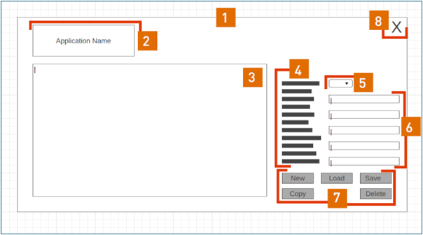
(Figure 4: Annotated Wireframe) (For the wireframe in clearer detail see Appendix 2)
No. | Annotations
1 | Graphical User Interface (GUI)
2 | Logo
3 | ListView
4 | Properties
5 | ComboBox
6 | TextBox
7 | Utility Buttons
8 | Exit Button

5.1.4 Project Requirements
The requirement for the project is to identify what the application is, what is it supposed to and what it should be. Project requirements give everyone involved a framework to work toward and determine the various goals and boundaries to fulfil. [69]

5.1.4.1 Requirements
No. | Requirements
1 | The application can run independently.
2 | The application can select either a Book or Website reference under the Vancouver Style.
3 | The application can accept information under the guise of reference.
4 | Allow users to copy by formatting information correctly as a Vancouver reference.
5 | Allow users to save entry.
6 | Allow users to overwrite entry.
7 | Allow users to delete entry.
8 | Allow users to delete file.
9 | Allow users to retry an entry.
10 | The application can save an entry as a JSON.
11 | The application is pre-loaded.

5.1.4.2 Risks
No. | Risks
1 | Data privacy and security concerns as any entry can be submitted.
2 | No login requirements
3 | Data breaches as the application can be accessed unauthorised.
4 | Any unsaved changes can be lost.
5 | JSON files can be corrupted or lost entirely if it isn’t backed up properly.

5.1.4.3 Constraints
No. | Constraints
1 | Desktop exclusive application.
2 | Lack of options for referencing. (Only 2 available
3 | Development time to produce a more polished product
4 | Any unsaved changes can be lost.
5 | Desktop exclusive application.
6 | Lack of additional features such as imagery and API for books.
7 | Lack of appearance. (Basic UI)
8 | Average usability.

5.1.5 Flowcharts
Designing a prototype provides a basic idea of how the application looks and what it can do. [66] With a sequence of process that the user must or should follow the steps in order to understand the application. [65]
When designing and planning a process by following a applying a flowchart, it helps anyone identify the steps and offers the full particulars of the process in the application. [65] [66] From a developer’s perspective, the application is set and standard however, if it is under a different view such as users then there will be issues.

5.1.5.1 User Flow Diagram (UFD)
The UFD provides a breakdown of the steps needed to follow up the application process. To provide a better understanding of the form, a visual representation of the UFD shown in (Figure 5), is a path of the application that a user would take to complete a task in as few steps possible. [76]
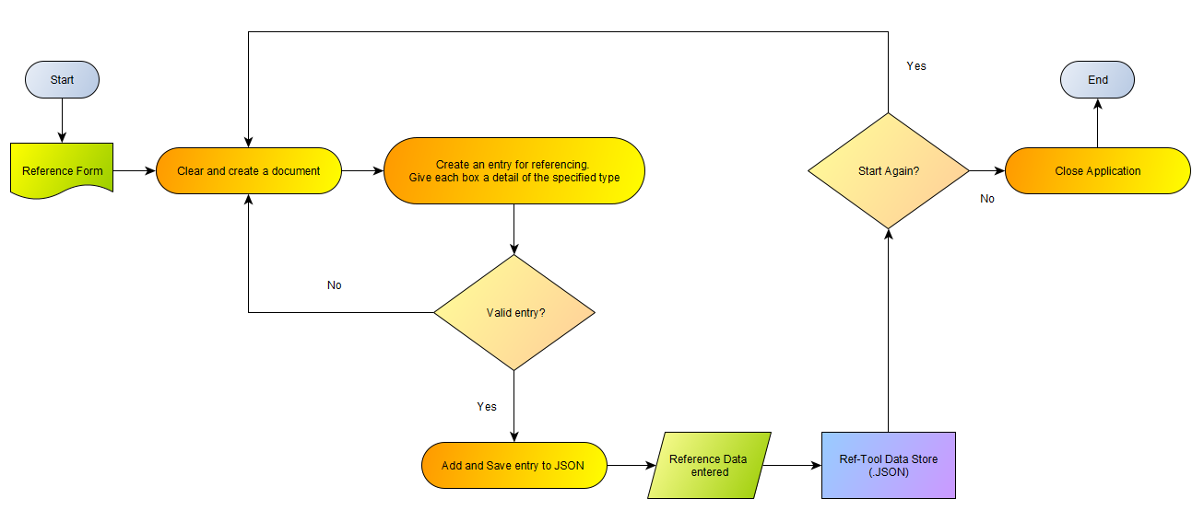(Figure 5: User Flow Diagram)

5.1.5.2 Hierarchal Task Analysis (HTA)
The HTA structures in (Figure 6), provides an activity defined in simple terms of specific goals that a user could follow. [77] Here they could start up the application and select ‘Book’ as an example. As they access the form, they should follow the steps necessary to complete the task that is associated with the application by understanding the process.
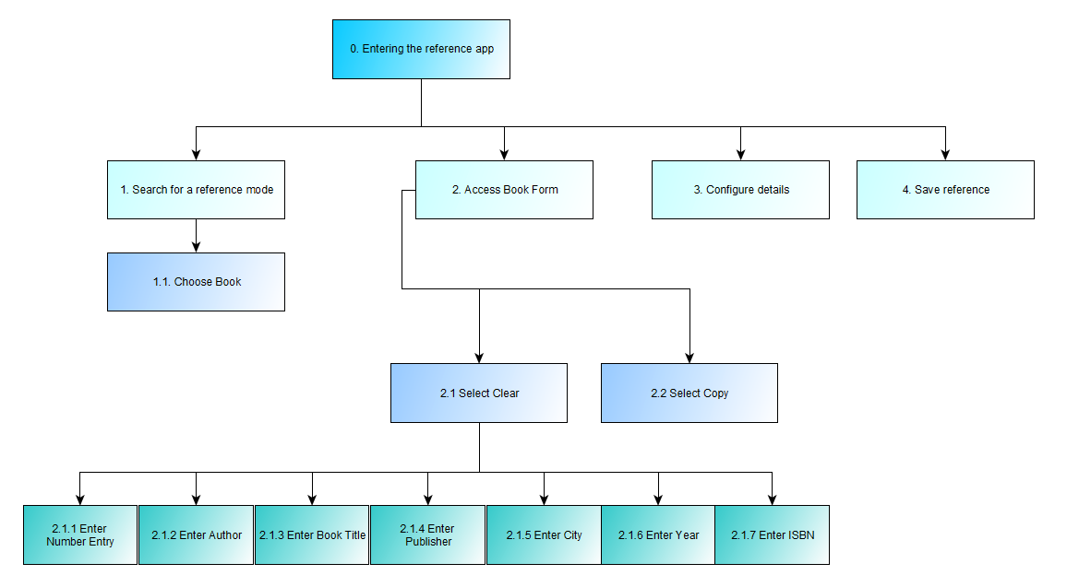
(Figure 6: Hierarchal Task Analysis)

5.1.5.3 Procedural Flow Diagram (PFD)
The PFD is used to process a streamline of illustrating the steps of a workflow for the user to work towards in a more technical approach. [79] In these cases, given that the task for the application is fundamentally simple as shown in (Figure 7), it does however provide a standard for efficiency and repeatability. [78]
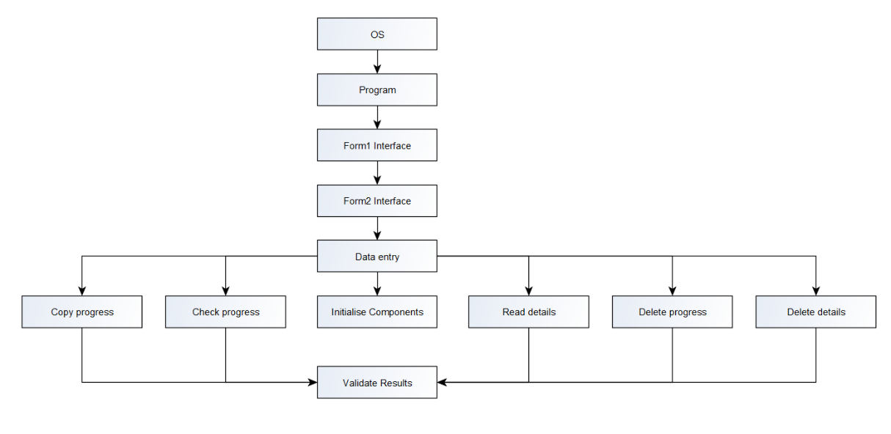
(Figure 7: Procedural Flow Diagram)

5.2 Implementation

5.2.1 User Interfaces
The UI as shown, is a usable and simple design. The ‘Start Menu’ form in (Figure 8) is a small box with two buttons as modes to select, ‘Book’ or ‘Web’. This form acts as a gateway if the user chooses one of the modes selected, they will be sent to another form with each matching name as shown in (Figure 9 and 10), respectively.

5.2.1.1 Start Menu
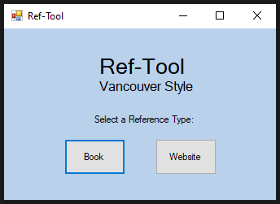
(Figure 8: Start Menu)

5.2.1.2 Book Referencing Mode UI
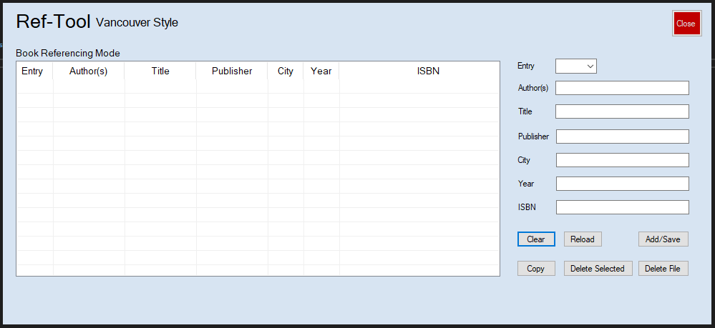
(Figure 9: Book Referencing Mode UI)
With a suitable UI, this allows users to interact and perform tasks with the software by using buttons and search boxes. There are also buttons appropriately located as that would provide features of what the application is capable of.

5.2.1.3 Website Referencing Mode UI
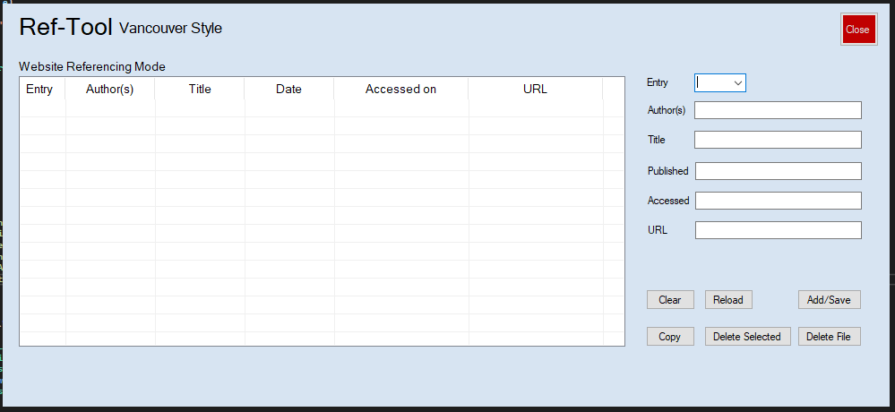
(Figure 10: Website Referencing Mode UI)

5.2.2 Software Testing

5.2.2.1 Usability Testing
Usability testing is analysing user experience by allowing them to test the functionalities of the application. This is done by moderately observing the client as they attempt to complete a task on it. [70] The client was able to start the application and chose the ‘Website’ button which would take them to a separate form. Before the testing, they were asked to reveal and identify areas followed by questions.
(For the usability testing, see appendix 3)
Another case of issue was closing the application. When closing the application, it should, ideally lead you back to the menu form. Instead, it shuts down the application entirely. This was noticed and agreed upon that it should be considered for improvement. Overall, there were also issues with how many clicks it would take to fulfil a task, as discussed, there can be improvements made to combat the issue by making certain buttons be organised or removed entirely for example, the ‘Reload’ button.
As this usability testing is to seek the functionality of the application, the client was able to navigate through the application quickly while identifying issues that were spotted but weren’t a big issue as they had addressed. [70] A good UI design would save time reservation by navigating the development process and interpretation providing a better UX. [85] Benefitting the simple design can also reduce the time spent on development of the application followed by the efficiency of production of making the application usable. [84]

5.2.2.2 User Acceptance Testing (UAT)
UAT is about evaluating whether the application has met business and user requirements, including functional and non-functional requirements. As this testing is for the client; this test was prioritised less compared to others as development was pushed further. [71] [72] When the development was ‘done’, provided it was functional and met most of the requirements, the client was sent an email for a meeting to try out the prototype application.
When the meeting happened, the client was overall satisfied with the application. They even tested out the application itself by entering details into the boxes before saving the item into a JSON file to exiting the application with a saved file at hand.
(For the acceptance testing see Appendix 4)
After testing with the client, some questions about the application itself were asked. With notes provided for a qualitative analysis, these included ideas such as what they would have liked more about the application or what the issues were. The included additional features such as the use of imagery when hovering the ISBN for example or, better usability with a cleaner UI design with changeable colours. Other issues were addressed such as exiting the application back to the menu and the UI with less functionalities to make things quicker.

6. Evaluation

6.1 Expectations
Expectations are beliefs that something will happen or be the case in which the application is expected to have a save/load function and having an interface with acceptable usability. [73] With expectations, the project provided more opportunities to succeed as this can be made accurate when development is building up the requirements to design plan for the application. [65] What was to be expected was to meet the requirements from the client needs, design plans and development processes. [86]

6.2 Reality and Outcome
The application had become functional with a save/load feature as the main approach, ability to enter objects in the form of details and saving them as a file was made a possibility. However, the whole application is practically not as usable as intended after applying heuristics and HCI as a guide than a principle. [83] [84] [85]
Upon realisation, communicating with the client could have solved issues sooner than relying on last minute changes. The e-mail towards the client for testing came out late. Ideally, by acknowledging the time horizon the result may vary, however, that was changed due to how the process of the whole project went, which was expected. Negotiating with the client and what ideas they came up with could become a feature that is implemented to updating the application. However, it can also result in changes to the already setbacks to take account for custom redesign, further development, and testing. [70] Regardless, the outcome from the client were the tests provided (UAT and Usability) with a report on evaluating what the application brought to them has summed what’s necessary or what’s recommended in the future.
With expectations, to ensure that the application is working as intended is to reiterate the plan to make it possible. The outcome is the result of a finished application with a room to learn and reflect upon. The application is functional and was able to enter information and saving or loading an object from JSON to balance things. As the developer and researcher for this project, it can be a mix of satisfaction due to the project working while also frustrating due to the development of making classes in a program to work and semi-successfully meeting the requirements to fulfil. The contrast between what is anticipated or hoping that it will work would happen in the end. When the application came into fruition, the disparity from expectations often lead to a product that was left ‘unfinished’ or more to fulfil regardless, the whole application worked as it should.

6.3 Was it Successful?
In a sense, yes it was successful. The application itself produced a load and save function by using JSON as a file format to contain and balance data as shown in (Figure 11) of deserialisation needed for the purpose of the application. [43] [44]
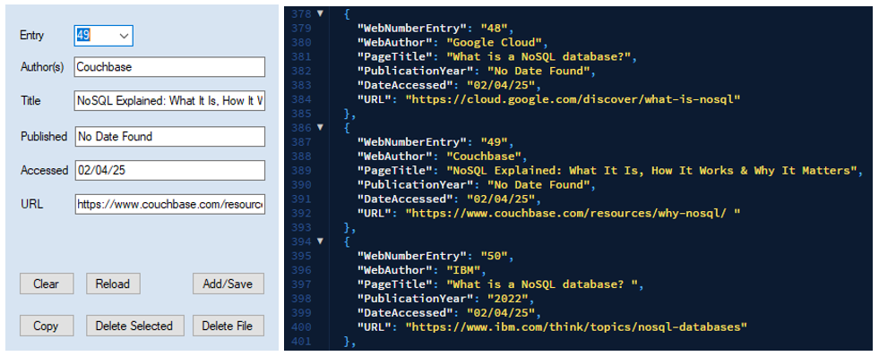
(Figure 11: Deserialisation of an Object)
To further acknowledge the application, with the use of C# and applying OOP to organise classes to create an instance of objects after assigning constructors. [35] [37] The development of the entire project itself rather than just the application. Applying principles, tools and guides by setting goals to keep aligning with the development of the application. [74]
Design tools such as wireframing, HTA and flowcharts were applied to provide breakdowns of steps to solve a problem for both developer and client. [76] [77] It was made readable to identify steps and offer a broad perspective of what the process of the application is to offer. [75] Time management tools were an asset for organising and defining the scope of the project by splitting it down into manageable sections.
The client was overall satisfied with the prototype application and even acknowledged that there could be changes or additions made after their evaluation and discussion. The client was also pleased with how the referencing could be formatted from the ‘Copy’ button and that it was pasted in the appropriate format for Vancouver, both in book and website.
Applying HCI [85], usability [73] and heuristics [83] would also set a structure of planning the design the project itself. Applying the framework of planning as to alleviate the struggle of software development. [74]

6.3.1 Suggestions for Future Development
As stated, the project is far from what has envisioned from expectations. The current application can save, load, copy and delete objects for referencing however, there is still issues with the main application itself. This has been addressed previously, that if there is more time and more to learn about the use of C#, API tools and databases to its extent, the results would make a huge difference especially for acknowledging Google Books and LiteDB prior initially. [41] [53] Aside from programming the application, design in usability and UI has also played a major factor, and to provide familiarity for the user, it should be examined at a high regard. [82] [84]
Without planning and designing, the project itself would down spiral into more loss of delivery, less productivity, quality and control. [82] [87] Applying tools of guiding the project has reduced problems expectedly. To ensure that the application is working as the developer intends it to be, there is more planning and responsibility for making that possible.
In summary, learning what was lost during the development of the project can be passed on as a suggestion to make use out of by learning to also honing the skills that were already applied to the project and dissertation. Communication and more collaboration with clients are also crucial to further establish expectations and understanding their needs and goals more clearly.

7. Conclusion
The development of the referencing application, ‘Ref-Tool’, was a time-consuming and challenging yet eventful learning experience. The development of the application made the researcher understand by exploring the abilities of referencing styles, tools and exploration of the referencing topic as for most of the project. [4] [5] In addition to researching about referencing, it is with at most, the exploration of the programming aspect with the use of C# .NET, JSON and existing resources to find and solve problems throughout. [36] [38] This has further developed and promoted a sense of critical thinking, problem solving and investigating the program for this project.
The implementation of project planning proved to be a huge asset to allow time-management as guidance, visual representations such as flowcharts and task analysis to provide a process and WBS to split work into more manageable tasks. [75] All this considered, followed by complying with requirements and able to communicate with the client even if it was cut back, this cannot be ignored as they are also contributors.
Communication with the client by providing tests is crucial to achieve an outcome that the developer may not entirely see and has been proven from the report of both tests (UAT and Usability). The client’s contribution during the proposal stage of the project and even during the project had offered a platform of insights or ideas that would construct a better outcome for the application. The benefits of communication applied to the tests done by the client in both usability and UAT would create a result to share with the developer by spotting to mitigate errors, solve design problems and increasing user satisfaction. [71] [72]

7.1 Final Thoughts
The application itself is far from perfect, most of which was the developer’s liability to delve into the project while handling other projects at hand. Nonetheless, as a learning experience, the application is functional and could be used as an example to be made as an improvement and foundation to provide better usability and design in the future.

8. References
[1] J Caulfield. Citation Styles Guide | Examples for All Major Styles. 2024. [Accessed on 02/04/25]. Available from: https://www.scribbr.com/citing-sources/citation-styles/
[2] UCL. References, citations and avoiding plagiarism. No Date Found. [Accessed on 02/04/25]. Available from: https://library-guides.ucl.ac.uk/referencing-plagiarism/referencing-styles
[3] S Page et al. Change of referencing style. 2017. [Accessed on 02/04/25]. Available from: https://www.tandfonline.com/doi/full/10.1080/00076791.2017.1386762
[4] Fiona Gardiner. The Importance of Citations and Referencing for Students. 2023. [Accessed on 02/04/25]. Available from: https://www.universitylibrarian.com/blog/the-importance-of-citations-and-referencing-for-students
[5] NCL. What is referencing? No Date Found. [Accessed on 02/04/25]. Available from: https://www.ncl.ac.uk/academic-skills-kit/good-academic-practice/referencing/
[6] University of Oxford. Plagiarism. No Date Found. [Accessed on 02/04/25]. Available from: https://www.ox.ac.uk/students/academic/guidance/skills/plagiarism
[7] Scribbr. What Is Plagiarism? | Definition & Examples. No Date Found. [Accessed on 02/04/25]. Available from: https://www.scribbr.com/category/plagiarism/
[8] University of Kent. What is Plagiarism?. 2022. [Accessed on 02/04/25]. Available from: https://www.kent.ac.uk/education/academic-integrity/guide-for-students/what-is-plagiarism
[9] UNSW. What is Plagiarism?. 2024. [Accessed on 02/04/25]. Available from: https://www.student.unsw.edu.au/what-plagiarism
[10] Monash University. What is academic integrity and why is it important? . No Date Found. [Accessed on 02/04/25]. Available from: https://www.monash.edu/student-academic-success/maintain-academic-integrity/what-is-academic-integrity-and-why-is-it-important
[11] Swansea University. Academic Integrity and Academic Misconduct. No Date Found. [Accessed on 02/04/25]. Available from: https://myuni.swansea.ac.uk/academic-life/academic-misconduct/
[12] University of Reading. Citing references. No Date Found. [Accessed on 02/04/25]. Available from: https://libguides.reading.ac.uk/citing-references/referencingstyles
[13] Kate W and Mary D. Referencing and Understanding Plagiarism. 2nd Edition. London. Bloomsbury; 2017
[14] Oxford Academic. Referencing Styles. No Date Found. [Accessed on 02/04/25]. Available from: https://academic.oup.com/pages/authoring/books/preparing-your-manuscript/referencing-styles
[15] C Vijai et al. Citation Tools and Reference Management Software for Academic Writing. 2020. [Accessed on 02/04/25]. Available from: https://papers.ssrn.com/sol3/papers.cfm?abstract_id=3514498
[16] University of Toledo. WHAT IS APA'S STYLE OF REFERENCE CITATION?. 2008. [Accessed on 02/04/25]. Available from: https://www.utoledo.edu/library/help/guides/docs/apastyle.pdf
[17] Murdoch University. Chicago Author-Date (previously Chicago) - Referencing Guide. 2025. [Accessed on 02/04/25]. Available from: https://libguides.murdoch.edu.au/Chicago
[18] University of York. AMS/LMS referencing style. 2025. [Accessed on 02/04/25]. Available from: https://subjectguides.york.ac.uk/referencing-style-guides/ams-lms
[19] Swansea University. OSCOLA referencing guide. 2024. [Accessed on 02/04/25]. Available from: https://libguides.swansea.ac.uk/oscola/basics
[20] University of York. MHRA referencing style. 2025. [Accessed on 02/04/25]. Available from: https://subjectguides.york.ac.uk/referencing-style-guides/mhra
[21] University of Cantebury. IEEE Reference style guide. No Date Found. [Accessed on 02/04/25]. Available from: https://www.canterbury.ac.nz/study/study-support-info/citations-and-referencing/ieee-style
[22] idebroy. Why There Are Different Citation Styles. 2019. [Accessed on 02/04/25]. Available from: https://www.thecleancopy.com/453/
[23] University of Washington. What are CItation Tools?. 2025. [Accessed on 02/04/25]. Available from: https://guides.lib.uw.edu/research/citations/tools
[24] University of South Wales. Referencing tools. 2024. [Accessed on 02/04/25]. Available from: https://libguides.southwales.ac.uk/ref-tools#s-lg-box-16085778
[25] Scribbr. A Quick Guide to Referencing | Cite Your Sources Correctly. No Date Found. [Accessed on 02/04/25]. Available from: https://www.scribbr.co.uk/category/referencing/
[26] South Hadley High School. Citations Guide: MyBib. 2024. [Accessed on 02/04/25]. Available from: https://shhs-southhadleyschools.libguides.com/c.php?g=1285988&p=9442860
[27] Simon. Why you should not use Mendeley as a reference manager. 2016. [Accessed on 02/04/25]. Available from: https://gagarine.medium.com/3-reasons-you-shouldn-t-use-mendeley-8f00d609bd12
[28] Newcastle University. Top Tips for Referencing. No Date Found.. [Accessed on 02/04/25]. Available from: https://www.ncl.ac.uk/mediav8/academic-skills-kit/file-downloads/Referencing%20Checklist.pdf
[29] J Bailey. 3 Reasons Students May Struggle With Citation. 2019. [Accessed on 02/04/25]. Available from: https://www.turnitin.com/blog/3-reasons-students-may-struggle-with-citation
[30] V Kremenchuck. Desktop vs. mobile design: which one to focus on?. 2023. [Accessed on 02/04/25]. Available from: https://beetrootacademy.com/blog/desktop-vs-mobile-design-which-one-to-focus-on
[31] J Gomez. Web Apps Vs. Desktop Apps: Understanding the Differences. 2024. [Accessed on 02/04/25]. Available from: https://www.koombea.com/blog/web-apps-vs-desktop-apps/
[32] A Bharadwaj. The Difference: Mobile Product Management vs Desktop Product Management. 2023. [Accessed on 02/04/25]. Available from: https://productschool.com/blog/career-development/mobile-product-management-vs-desktop-product-management
[33] D O Tuama. What Is A Programming Language? 2022. [Accessed on 02/04/25]. Available from: https://codeinstitute.net/blog/what-is-a-programming-language/
[34] Chakray. Programming Languages: Types and Features. No Date Found. [Accessed on 02/04/25]. Available from: https://chakray.com/programming-languages-types-and-features/
[35] M Watson. What is C# used for?. 2023. [Accessed on 02/04/25]. Available from: https://stackify.com/what-is-c-used-for/
[36] Y Shiotsu. C# vs. C++: Which Language is Best for Your Project?. 2024. [Accessed on 02/04/25]. Available from: https://www.upwork.com/resources/c-sharp-vs-c-plus-plus
[37] M H Alvi. A Manual for Referencing Styles in Research. 2016. [Accessed on 02/04/25]. Available from: https://www.researchgate.net/profile/Mohsin-Alvi/publication/308786787_A_Manual_for_Referencing_Styles_in_Research/links/57f14ed008ae8da3ce4ec234/A-Manual-for-Referencing-Styles-in-Research.pdf
[38] Microsoft. What is .NET Framework?. No Date Found.. [Accessed on 02/04/25]. Available from: https://dotnet.microsoft.com/en-us/learn/dotnet/what-is-dotnet-framework
[39] D Fateh. What is an API? How APIs work, simply explained. 2025. [Accessed on 02/04/25]. Available from: https://www.contentful.com/api/
[40] K Casey. What is an API?. 2020. [Accessed on 02/04/25]. Available from: https://www.okta.com/blog/2020/10/api-application-programming-interface/
[41] Google Developers. Using the API. 2024. [Accessed on 02/04/25]. Available from: https://developers.google.com/books/docs/v1/using
[42] Developer Mozilla. Working with JSON. 2025. [Accessed on 02/04/25]. Available from: https://developer.mozilla.org/en-US/docs/Learn_web_development/Core/Scripting/JSON
[43] Microsoft Learn. JSON serialization and deserialization in .NET - overview. 2025. [Accessed on 02/04/25]. Available from: https://learn.microsoft.com/en-us/dotnet/standard/serialization/system-text-json/overview
[44] Shiksa Online. What is Serialization in Java?. 2023. [Accessed on 02/04/25]. Available from: https://www.shiksha.com/online-courses/articles/understanding-serialization-in-java/
[45] Imperva. Deserialization. No Date Found. [Accessed on 02/04/25]. Available from: https://www.imperva.com/learn/application-security/deserialization/
[46] Microsoft Learn. Migrate from Newtonsoft.Json to System.Text.Json. 2025. [Accessed on 02/04/25]. Available from: https://learn.microsoft.com/en-us/dotnet/standard/serialization/system-text-json/migrate-from-newtonsoft?pivots=dotnet-9-0
[47] I E Polat. Comprehensive Guide to Using JSON and Newtonsoft.Json in .NET. 2024. [Accessed on 02/04/25]. Available from: https://medium.com/@ieplt/comprehensive-guide-to-using-json-and-newtonsoft-json-in-net-ac67b7963e35
[48] Google Cloud. What is a NoSQL database?. No Date Found. [Accessed on 02/04/25]. Available from: https://cloud.google.com/discover/what-is-nosql
[49] Couchbase. NoSQL Explained: What It Is, How It Works & Why It Matters. No Date Found. [Accessed on 02/04/25]. Available from: https://www.couchbase.com/resources/why-nosql/
[50] IBM. What is a NoSQL database? 2022. [Accessed on 02/04/25]. Available from: https://www.ibm.com/think/topics/nosql-databases
[51] J Ellingwood. Traditional databases vs serverless databases. No Date Found. [Accessed on 02/04/25]. Available from: https://www.prisma.io/dataguide/serverless/traditional-vs-serverless-databases
[52] LiteDB. LiteDB. No Date Found. [Accessed on 02/04/25]. Available from: https://www.litedb.org/
[53] S Giesel. LiteDB - A .NET embedded NoSQL database. 2022. [Accessed on 02/04/25]. Available from: https://steven-giesel.com/blogPost/d376a46c-ec5b-4e37-81b3-23772c47ed85
[54] UK Academic Help. Saunders Research Onion Explained By Experts. 2024. [Accessed on 02/04/25]. Available from: https://ukacademichelp.co.uk/saunders-research-onion-explained-by-experts/
[55] Thesismind. Analysis of Saunders Research Onion. 2019. [Accessed on 02/04/25]. Available from: https://thesismind.com/analysis-of-saunders-research-onion/
[56] J Emiliussen et al. We are all in it!: Phenomenological Qualitative Research and Embeddedness. 2021. [Accessed on 02/04/25]. Available from: https://journals.sagepub.com/doi/full/10.1177/1609406921995304
[57] F Willegas. Action Research: What it is, Types, Stages & Examples. No Date Found. [Accessed on 02/04/25]. Available from: https://www.questionpro.com/blog/action-research/
[58] I Vizcarguenaga-Aguirre and J R Lopez-Robles. Mono, mixed or multiple strategy approach: a descriptive study of Project Management. 2020. [Accessed on 02/04/25]. Available from: http://eprints.rclis.org/40506/1/2020_Vizcarguenaga-Aguirre_et_al_Researches_REPM2020.pdf
[59] L Busetto et al. How to use and assess qualitative research methods. 2020. [Accessed on 02/04/25]. Available from: https://neurolrespract.biomedcentral.com/articles/10.1186/s42466-020-00059-z
[60] C Vijai et al. Citation Tools and Reference Management Software for Academic Writing. 2019. [Accessed on 02/04/25]. Available from: https://papers.ssrn.com/sol3/papers.cfm?abstract_id=3514498
[61] B Nancholas. Ethical challenges in computer science. 2024. [Accessed on 02/04/25]. Available from: https://online.keele.ac.uk/ethical-challenges-in-computer-science/
[62] Redscan. Data Protection Act 2018. No Date Found. [Accessed on 02/04/25]. Available from: https://www.redscan.com/services/data-protection-act-2018/
[63] Experience UX. What is wireframing? No Date Found.. [Accessed on 02/04/25]. Available from: https://www.experienceux.co.uk/faqs/what-is-wireframing/
[64] P Guilizzoni. What are wireframes and why are they used?. No Date Found. [Accessed on 02/04/25]. Available from: https://balsamiq.com/learn/articles/what-are-wireframes/
[65] Team Kissflow. Application Development Lifecycle: Phases and Steps Explained. 2025. [Accessed on 02/04/25]. Available from: https://kissflow.com/application-development/application-development-lifecycle/
[66] Lucidchart. What is a Flowchart - What do you want to do with flowcharts?. No Date Found. [Accessed on 02/04/25]. Available from: https://www.lucidchart.com/pages/what-is-a-flowchart-tutorial
[67] Swimm Team. System Design: Complete Guide with Patterns, Examples, and Techniques. No Date Found. [Accessed on 02/04/25]. Available from: https://swimm.io/learn/system-design/system-design-complete-guide-with-patterns-examples-and-techniques
[68] D Jonson. What is Software Development and Implementation?. 2025. [Accessed on 02/04/25]. Available from: https://graphicdesigneye.com/what-is-software-development-and-implementation/
[69] S Cleary. How to thoroughly document your project requirements. 2021. [Accessed on 02/04/25]. Available from: https://www.teamwork.com/blog/project-requirements/
[70] Content Square. Usability Testing: what it is, its benefits, and why it matters. 2024. [Accessed on 02/04/25]. Available from: https://contentsquare.com/guides/usability-testing/
[71] Testsigma. Acceptance Testing: What, Why, Types & How to Do?. No Date Found.. [Accessed on 02/04/25]. Available from: https://testsigma.com/guides/acceptance-testing/
[72] R W Rice. What is User Acceptance Testing? A Concise Guide to UAT Planning and Design. 2024. [Accessed on 02/04/25]. Available from: https://www.practitest.com/resource-center/article/what-is-uat-testing/
[73] HumanPsychology. Expectations – the real happiness killer. No Date Found. [Accessed on 02/04/25]. Available from: https://humanpsychology.com.au/expectations-the-real-hapiness-killer/
[74] L Rila. What is the significance of a flowchart?. 2021. [Accessed on 02/04/25]. Available from: What is the significance of a flowchart?
[75] Atlassian. Work breakdown structure (WBS) in project management. No Date Found. [Accessed on 02/04/25]. Available from: https://www.atlassian.com/work-management/project-management/work-breakdown-structure
[76] ProductPlan. User Flow. No Date Found. [Accessed on 03/04/25]. Available from: https://www.productplan.com/glossary/user-flow/
[77] human reliability. How do you conduct a Hierarchical Task Analysis? No Date Found. [Accessed on 03/04/25]. Available from: https://www.humanreliability.com/human-factors/hierarchical-task-analysis-hta/
[78] LucidChart. What is a Process Flow Diagram. No Date Found. [Accessed on 03/04/25]. Available from: https://www.lucidchart.com/pages/process-flow-diagrams
[79] SolveXia. Understanding and Using a Process Flowchart. 2024. [Accessed on 03/04/25]. Available from: https://www.solvexia.com/blog/what-is-a-process-flowchart-and-how-to-use-it
[80] M Hillyer. How has technology changed - and changed us - in the past 20 years? 2020. [Accessed on 04/04/25]. Available from: https://www.weforum.org/stories/2020/11/heres-how-technology-has-changed-and-changed-us-over-the-past-20-years/
[81] L S Asaram. Technology Advancements: The Pros and Cons. 2023. [Accessed on 04/04/24]. Available from: https://www.eit.edu.au/technology-advancements-the-pros-and-cons/
[82] UsablityBOK. Principles for Usable Design. No Date Found. [Accessed on 04/04/25]. Available from: https://www.usabilitybok.org/principles-for-usable-design
[83] Jakob Nielsen. 10 Usability Heuristics for User Interface Design. 2024. [Accessed on 04/04/25]. Available from: https://www.nngroup.com/articles/ten-usability-heuristics/
[84] M Soegaard. Usability: A part of the User Experience. 2021. [Accessed on 04/04/25] Available from: https://www.interaction-design.org/literature/article/usability-a-part-of-the-user-experience
[85] IxDF. Human-Computer Interaction (HCI). No Date Found. [Accessed on 04/04/25]. Available from: https://www.interaction-design.org/literature/topics/human-computer-interaction
[86] E. Atlas. Human Computer Interaction Definition & Examples | What is HCI? 2023. [Accessed on 04/04/25]. Available from: https://study.com/academy/lesson/hci-definition-examples.html
[87] What is human-computer interaction (HCI)? No Date Found. [Accessed on 04/04/25]. Available from: https://www.figma.com/resource-library/human-computer-interaction/

8.1 List of Figures
Figure 1: Serialisation
Figure 2: Serialisation-Deserialisation
Figure 3: WBS for Dissertation
Figure 4: Annotated Wireframe
Figure 5: User Flow Diagram
Figure 6: Hierarchal Task Analysis
Figure 7: Procedural Flow Diagram
Figure 8: Start Menu
Figure 9: Book Referencing Mode UI
Figure 10: Website Referencing Mode UI
Figure 11: Deserialisation of an Object
Figure 12: Nielsen’s 10 Heuristics - Interaction Design Foundation - IxDF. [Accessed on 03/04/25]. Available from: https://www.interaction-design.org/literature/topics/heuristic-evaluation
Figure 13: File Location
Figure 14: HCI Diagram -
HUMAN COMPUTER INTERACTION (HCI) – And how it influences UI & UX Design – Arun. [Accessed on 04/04/25]. Available from: https://theuxlab.weebly.com/blog/human-computer-interaction-hci-and-how-it-influences-ui-ux-design

9. Appendices

9.1 Appendix 1: Ethics Form

Ethics Approval Form

Before you complete this form, please take time to carefully consider the following questions:

Have you considered yet whether there are any problematic ethical issues in your proposed research project? If you have not you should talk to your Course Tutor or Supervisor.

Have you already completed an Ethics Approval Form? Yes – then you do not need to complete this form

No – please complete this form in as much detail as you can

Name: | Joachim Manlongat
Project/Research Title: | A Quick Referencing Application
Name of Supervisor: | Andrew Green
School/Dept. | NPTC Group
Faculty: | School of IT
Proposed Start Date: |  | End Date: | 18/12/24

1. Summary of planned research (please indicate below the purpose of your planned project/research, together with your aims, main research questions and research design – you should continue onto a separate sheet if necessary)
The purpose of this planned project is to design and develop a referencing application alternative for a client.
The aim is to design a referencing application as a solution towards the issues that exist with the currently available reference tools. A singular referencing style (Vancouver) is recommended for the project, with the requirement to provide a concrete demonstration of a desktop application.
Objectives
- Develop a prototype
- Evaluate the nature of the references, types and capabilities of application
- Investigate how client expectations are influencing the application
- To discuss the client experience and expectations and make recommendations to develop an application

2. Methodology (You need to be clear about the methodology you intend to use in your study; this could include any number of methods, so either tick those shown below (where appropriate) or put the details in the box marked *)

 | Interviews |  | Participant Observation |  | Use of personal data
 | Focus groups | / | Questionnaire |  | Literature Review
 | Performance |  | Presentation |  | Other (state below)*

3. Participants - Does your proposed project/research involve human participants?

/ | 1. Yes, as a primary source* |  | 2. Yes, as a secondary source* |  | No- go to section 4

*If you have ticked yes, it is likely you will need an Advanced CRB check before undertaking your study

If yes, indicate who your participants are:

 | Early years/Pre-School children | / | Adults - give details below
 | School age children |  | Vulnerable people - give details below
 | Young People aged 17-18 | Employees of NPTC Group – Neath College
 | Unknown at this stage

4. Ethical issues - you should tick all that apply

 | Administration of drugs incl. alcohol |  | Deprivation
 | Unpleasant stimuli in any manner or form |  | Active deception or withholding information
 | Collection of highly personal information |  | Payment

5. Are there any ethical concerns other than those listed above? (Continue onto a separate sheet if necessary)

N/A

6. If there are any ethical concerns, please state how you intend to minimise any risk of harm or distress that could be caused (continue onto a separate sheet if necessary)

N/A

You should enclose any materials (e.g. questionnaire, interview schedule), plus the Consent Form, and the Debriefing Sheet when submitting the Ethics Approval Form to your supervisor.

Student Signature: J.Manlongat Date: 18/12/2024

**********************************************************************************
 | Advanced CRB check required |  | CRB confirmation received - Date:_______________
 | Recommendation of approval given at Faculty Level
 | Approval not given at Faculty level – forwarded for discussion at the next meeting of the University Ethics Committee
Comments:

Signature: (Assistant Dean/Head of School): Andrew Green Date: 18/12/2024

Faculty recommendation endorsed by the Ethics Committee | Chair’s Initials |  | Date

9.2 Appendix 2: Wireframe
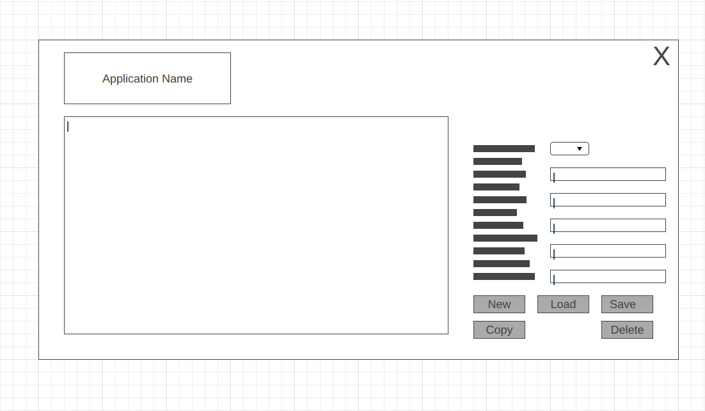

9.3 Appendix 3: Usability Testing
Test | Type | Description | Expectation | Reality | (P/F)
1.0 |  | The "Close" or "Exit" button. By clicking it will close the application. | This button should close the application form and sent back to menu | After press, a MessageBox will appear to warn the user that any unsaved changes will be lost. Once accepted, the application shuts down. | F
2.0 |  | The ‘Copy’ button allows a selected entry to be held on a clipboard. | This button should provide a template of a Vancouver style format | This button will be able to print an exact reference of a book entry of a Vancouver style format.  [1] Michael Ende. The Neverending Story. Penguin. London. 2024. 9780241663561 | P
3.0 |  | The ‘Clear’ button allows a selected entry to be wiped. | This button should provide wipe existing entry. | After press, the entry is wiped, and the user may start a new entry | P
4.0 |  | The ‘Reload’ button would function by allowing the interface to refresh. | This button should reload a save file of where it left off. | After press, then the interface will log back into the first entry of reference. | P
5.0 |  | The ‘Add/Save’ button to add and save data entry to refresh. It also functions as an overwrite tool. | This button should save file then clear out the entry for a new input. | After press, a MessageBox will appear that the entry has been saved to JSON and a new entry is ready to be entered. | P
6.0 |  | The ‘Delete’ button allows the entire entry to be erased from the JSON. This can be useful for starting a fresh entry. | Delete button should wipe away the objects in the JSON file. | After press, a MessageBox will appear warning the user that all data will be erased. After accepting, the entry is wiped, and the user may start from scratch. | P
7.0 |  | Similar to the ‘Clear’ Button, the ‘Delete Selected’ button would instead allow the current entry to be erased from the JSON. | Add/Save button should save file then clear out the entry for a new input. | After press, a MessageBox will appear warning the user that the current entry will be erased. After accepting, the entry is wiped, and the user may start from scratch. | P
8.0 |  | Similar to the ‘Clear’ Button, the ‘Delete Selected’ button would instead allow the current entry to be erased from the JSON. | Add/Save button should save file then clear out the entry for a new input. | After press, a MessageBox will appear warning the user that the current entry will be erased. After accepting, the entry is wiped, and the user may start from scratch. | P

9.4 Appendix 4: User Acceptance Testing
Test | Scenario | Steps | Expectation | Reality | P/F
1 | Enter a reference about a book | - Open Application  - Select ‘Book’  - Enter Valid details of a book  - Click Add/Save Button | User is met with a message that the entry has been saved. Saved to JSON. | Same as expected | P
2 | Enter a reference about a website | - Open Application  - Select ‘Website’  - Enter Valid details of a book  - Click Add/Save Button | User is met with a message that the entry has been saved. Saved to JSON. | Same as expected | P
3 | Exiting application form to menu | - Open Application  - Select ‘Book’  - Click ‘Close’ button  - Accept message | Form closes and user is sent back to the menu. | Application stopped. | F
4 | Deleting a selected entry | - Open Application  - Select ‘Book’  - Select entry in ComboBox  - Click ‘Delete Selected’  - Accept Message | Message Appears to delete selected entry. | Same as expected | P
5 | Deleting an entire JSON | - Open Application  - Select ‘Book’  - Select entry in ComboBox  - Click ‘Delete’  - Accept Message | Message Appears to delete entire JSON. | Same as expected | P
6 | Copying a selected entry | - Open Application  - Select ‘Website’  - Select entry in ComboBox  - Click ‘Copy’  - Paste into a notepad | Pasted from a clipboard into a structured referencing style. | Same as expected | P

9.5 Appendix 5: Questionnaire for Client

Q1. What appears to be the with the current referencing apps available online?
_________________________________________________________________________________
_________________________________________________________________________________
_________________________________________________________________________________
_________________________________________________________________________________
_________________________________________________________________________________

Q2. How do you handle with this issue regarding referencing?
_________________________________________________________________________________
_________________________________________________________________________________
_________________________________________________________________________________
_________________________________________________________________________________
_________________________________________________________________________________

Q3. What are your expectations for the upcoming referencing app?
_________________________________________________________________________________
_________________________________________________________________________________
_________________________________________________________________________________
_________________________________________________________________________________
_________________________________________________________________________________

Q4. What would you like to do with the referencing app?
_________________________________________________________________________________
_________________________________________________________________________________
_________________________________________________________________________________
_________________________________________________________________________________
_________________________________________________________________________________

Q5. Is there anything you expect/like added for the referencing app?
_________________________________________________________________________________
_________________________________________________________________________________
_________________________________________________________________________________
_________________________________________________________________________________
_________________________________________________________________________________

Q6. Do you have and questions for me?
_________________________________________________________________________________
_________________________________________________________________________________
_________________________________________________________________________________
_________________________________________________________________________________
_________________________________________________________________________________

9.6 Appendix 6: Declaration Form and Form of Consent

DECLARATION

I, Joachim Name declare that I am the sole author of this Project; that all references cited have been consulted; that I have conducted all work of which this is a record, and that the finished work lies within the prescribed word limits.

This work has not previously been accepted as part of any other degree submission.

Signed: Joachim Manlongat

Date: 04-04-2025

FORM OF CONSENT

I Students Joachim hereby consent that my Project, submitted in candidature for the B.Sc. Applied Computing degree, if successful, may be made available for inter-library loan or photocopying (subject to the law of copyright), and that the title and abstract may be made available to outside organisations.

Signed: Joachim Manlongat

Date : 04-04-2025

9.7 Appendix 7: Demonstration Video

Video: | https://youtu.be/SGvNGCNdw4M

End

