Contents

Appendix 1 | Ethics form
Appendix 2 | Consent form – Headteacher
Appendix 3 | Cover letter to Parents and Teachers
Appendix 4 | Consent form – Parents and Teachers
Appendix 5 | Elective Report
Appendix 6 | Questions and Responses – Internet Bug Café
Appendix 7 | Questions and Responses – Breakfast Club
Appendix 8 | Images of the Cwtch
Appendix 9 | Interview Questions – Key Stage 2

Appendix 1
APPLICATION FOR ETHICAL APPROVAL

In order for research to result in benefit and minimise risk of harm, it must be conducted ethically. A researcher may not be covered by the University’s insurance if ethical approval has not been obtained prior to commencement.

The University follows the OECD Frascati manual definition of research activity: “creative work undertaken on a systematic basis in order to increase the stock of knowledge, including knowledge of man, culture and society, and the use of this stock of knowledge to devise new applications”. As such this covers activities undertaken by members of staff, postgraduate research students, and both taught postgraduate and undergraduate students working on dissertations/projects.

The individual undertaking the research activity is known as the “principal researcher”.

Ethical approval is not required for routine audits, performance reviews, quality assurance studies, testing within normal educational requirements, and literary or artistic criticism.

Please read the notes for guidance before completing ALL sections of the form.

This form must be completed and approved prior to undertaking any research activity. Please see Checklist for details of process for different categories of application.

Delete the Guidance Notes at the end of the form BEFORE submitting your application

SECTION A: About You (Principal Researcher)
Full Name: |  | Sarah Bawden
Tick all boxes which apply: |  | Member of staff: | ☐ | Honorary research fellow: | ☐
Undergraduate Student | ☒ | Taught Postgraduate Student | ☐ | Postgraduate Research Student | ☐

Faculty/School/Centre: | ITE: Yr Athrofa, UWTSD
Campus: | Carmarthen
E-mail address: | 1600411@student.uwtsd.ac.uk
Contact Telephone Number: | 07800512846
For students:
Student Number: | 1600411
Programme of Study: | BA Primary Education (QTS)
Director of Studies/Supervisor: | Dr Sioned Hughes

SECTION B: Approval for Research Activity
Has the research activity received approval in principle?  (please check the Guidance Notes as to the appropriate approval process for different levels of research by different categories of individual) |  | YES | ☒ | NO | ☐
 |  |  |  | Date
If Yes, please indicate source of approval (and date where known): Approval in principle must be obtained from the relevant source prior to seeking ethical approval | Research Degrees Committee |  | ☐
 | Faculty Research Committee |  | ☐
 | Other - Module Lead |  | ☒ | 06.02.2020

SECTION C: Internal and External Ethical Guidance Materials
Please list the core ethical guidance documents that have been referred to during the completion of this form (including any discipline-specific codes of research ethics, and also any specific ethical guidance relating to the proposed methodology). Please tick to confirm that your research proposal adheres to these codes and guidelines.
UWTSD Research Ethics & Integrity Code of Practice | ☒
UWTSD Research Data Management Policy | ☒
BERA (British Educational Research Association) guidelines – Ethical Guidelines for Educational Research, (2018) | ☒
The research is within the bounds of the normal classroom and in accordance with the ATHROFA guidelines for parental consent as per ATHROFA letter. | X
Education Workforce Council (EWC) Research and Ethics Guidelines (2019) | X

SECTION D: External Collaborative Research Activity
Does the research activity involve collaborators outside of the University? |  | YES | ☐ | NO | ☒
If Yes, please provide the name of the external organisation and name and contact details for the main contact person and confirmation this person has consented to their personal data being shared.as part of this collaboration.
Institution
Contact person name
Contact person e-mail address

Has this individual consented to sharing their details on this form? |  | YES | ☐ | NO |  |  | ☒
Are you in receipt of a KESS scholarship? |  | YES | ☐ | NO |  |  | ☒
Is your research externally funded |  | YES | ☐ | NO |  |  | ☒
Are you specifically employed to undertake this research in either a paid or voluntary capacity? | Voluntary | YES | ☐ | NO |  | ☒
 | Employed | YES | ☐ | NO |  | ☒
Is the research being undertaken within an existing UWTSD Athrofa Professional Learning Partnership (APLP) | If YES then the permission question below does not need to be answered. | YES | ☒ | NO |  |  | ☐
Permission to undertake the research has been provided by the partner organisation | (If YES attach copy)  If NO the application cannot continue | YES | ☐ | NO |  |  | ☐

Where research activity is carried out in collaboration with an external organisation
Does this organisation have its own ethics approval system? | YES | ☐ | NO | ☒
If Yes, please attach a copy of any final approval (or interim approval) from the organisation

SECTION E: Details of Research Activity
Indicative title: | An exploration into the barriers of parental engagement: Strategies that are currently being used to overcome it and their effectiveness.
Proposed start date: | 10/02/2020 | Proposed end date: | 01/07/2020
Introduction to the Research (maximum 300 words)
Ensure that you write for a Non-Specialist Audience when outlining your response to the three points below:
- Purpose of Research Activity
- Proposed Research Question
- Aims of Research Activity
- Objectives of Research Activity
Demonstrate, briefly, how Existing Research has informed the proposed activity and explain
- What the research activity will add to the body of knowledge
- How it addresses an area of importance.
Purpose of Research Activity
- To explore the barriers of parental engagement
- To explore whether the strategies that are currently in place to overcome the barriers in parental engagement are effective
- To further develop professional knowledge and understanding and future practice
(this box should expand as you type)
Research Question
An exploration into the barriers of parental engagement: Strategies that are currently being used to overcome it and their effectiveness.

(this box should expand as you type)
Aims of Research Activity
- The research aims to identify the barriers of parental engagement and capture the views of practitioners, pupils and parents to contribute to an informed dissertation regarding the effectiveness of strategies that are being used to overcome it. Existing research such as that by the Department for Education and Skills (2003) suggest that positive parental engagement can have more impact over a child’s education than the quality of the school that they attend, thus the need to ensure barriers are overcome.
- The primary research that I wish to undertake will provide an insight into whether parents and teachers feel the strategies that are currently in place are effective and what improvements can be made to improve professional practice.

(this box should expand as you type)
Objectives of Research Activity
- To explore the barriers of parental engagement.
- To explore and observe the strategies currently in place to overcome barriers.
- To disperse questionnaires to parents and teachers to capture their view on parental engagement and whether the strategies used are effective or not.
- To interview teachers to capture their view on the importance of parental engagement and what they view as barriers to parental engagement.
- To critically reflect on findings and consider how I can use this to improve and transform my professional practice.

(this box should expand as you type)
Proposed methods (maximum 600 words)
Provide a brief summary of all the methods that may be used in the research activity, making it clear what specific techniques may be used. If methods other than those listed in this section are deemed appropriate later, additional ethical approval for those methods will be needed.
Interviews – A group of children from both key stages with be involved in a semi-structured interview where they will be encouraged to respond to questions. For example, do you feel like your parents are involved in school? Do they help you with your learning at home? Do they come to shows/ fates/ parents’ evenings? Does it make you feel happy when your parents are involved with school and your work? The children will be in an informal setting where I will make notes of their answers. The children will not be made to participate and if a child does not wish to respond to a question it will be respected. Exit: All children will be asked if they are willing to take part and the traffic light circles will be used if they wish to leave or withdraw at any point. I will check regularly on how the children are feeling and no names will be used in the writing of the findings.
Teachers and other members of staff from each phase will be interviewed using semi-structured interviews including senior members of staff to gain insight into their feelings on parental engagement and what they feel some of the barriers are and how it can be overcome in the 21st century.

Questionnaire – I hope to be able to distribute a questionnaire to parents from both key stages to gain their perspective on parental engagement. Throughout the creation of the questionnaire, I will adhere to and follow the training provided by the university during my second year of study when the design and distribution of a questionnaire was necessary for a specific module. The questionnaire will include questions that will result in both qualitative and quantitative data. The questionnaire will not ask participants to list their name or personal information however, they may be asked as to whether their child in in the foundation phase or key stage 2.
A cover letter will accompany the questionnaire which will explain to the participant the reason for and nature of the research questionnaire. The questionnaire will be distributed via physical means placed within the response pool for analysis. The questions asked within the questionnaire will give the participant several ways in which they can give their response. Exit: Before the participant submits their questionnaire, they have a right to retain their response. However, once I receive the participants response and it is added to the pool there will be no fair means of identifying their response in order to return it to them. This will be explained in the cover letter.

Observations/Field notes – I will observe and make notes of a variety of strategies used to encourage parental engagement. Throughout my observations, I will note the level of engagement by parents and children. At times, I may focus on the engagement of the teacher and other member of staff and the way in which they implement the strategy.
Observations will be made in a personal handbook; no names shall be mentioned in the notes. To further enhance the research, I may discuss my noted with a teacher or parent to gather a more detailed perspective. EXIT: I will make participants aware of their involvement in the observation and ask for consent to use the data collected. If consent is not given the data will be destroyed and not used in the research.

Learning walk – To support my research I may conduct a learning walk. This learning walk will allow me to observe displays and provisions that are put in place for parental engagement. The learning walk may be self-directed or assisted by a member of staff or pupils. Prior to conducting the learning walk EXIT: I will obtain consent from a member of staff. Before evidencing the walk (by means of written or photographic method) I will ask the participant who accompanied me on the walk for their consent to use the information in the research.

Video or Audio Taping – I will use video or audio taping to take the notes (possibly photographic) from observations and interviews that are conducted. I will ask the participants for consent to the video or audio taping and if consent is not given then the method will not be used.

Examples of pupils’ work – Where I feel examples of pupils’ work would support my research, I may request samples. EXIT: Prior to gathering samples of work, I will ensure that I have the class teacher’s consent and the consent of the pupil to which the work belongs. Upon gathering samples, I will take responsibility of the work and ensure that confidentiality and security is upheld.

(this box should expand as you type)

Location of research activity
Identify all locations where research activity will take place.
The proposed research/study activity will be conducted in a Primary School within the Athrofa.
(this box should expand as you type)
Research activity outside of the UK
If research activity will take place overseas, you are responsible for ensuring that local ethical considerations are complied with and that the relevant permissions are sought. Specify any local guidelines (e.g. from local professional associations/learned societies/universities) that exist and whether these involve any ethical stipulations beyond those usual in the UK (provide details of any licenses or permissions required). Also specify whether there are any specific ethical issues raised by the local context in which the research activity is taking place, for example, particular cultural and/or legal sensitivities or vulnerabilities of participants.
N/A

(this box should expand as you type)
Use of documentation not in the public domain: Are any documents NOT publicly available? | NO | ☒
 | YES | ☐
If Yes, please provide details here of how you will gain access to specific documentation that is not in the public domain and that this is in accordance with prevailing data protection law of the country in question and England and Wales.

(this box should expand as you type)

SECTION F: Scope of Research Activity
Will the research activity include: | YES | NO
Use of a questionnaire or similar research instrument? | ☒ | ☐
Use of interviews? | ☒ | ☐
Use of diaries? | ☒ | ☐
Participant observation with their knowledge? | ☒ | ☐
Participant observation without their knowledge? | ☐ | ☒
Use of video or audio recording? (Interviews) | ☒ | ☐
Access to personal or confidential information without the participants’ specific consent? | ☐ | ☒
Administration of any questions, test stimuli, presentation that may be experienced as physically, mentally or emotionally harmful / offensive? | ☐ | ☒
Performance of any acts which may cause embarrassment or affect self-esteem? | ☐ | ☒
Investigation of participants involved in illegal activities? | ☐ | ☒
Use of procedures that involve deception? | ☐ | ☒
Administration of any substance, agent or placebo? | ☐ | ☒
Working with live vertebrate animals? | ☐ | ☒
Other primary data collection methods, please explain in this box  For example, ‘focus groups’. Please indicate the type of data collection method(s) in this box and tick the accompany box. | ☒ | ☐
Details of any other primary data collection method:  Learning walk  Examples of work  Field notes  (this box should expand as you type) | ☒ | ☐
If NO to every question, then the research activity is (ethically) low risk and may be exempt from some of the following sections (please refer to Guidance Notes).

If YES to any question, then no research activity should be undertaken until full ethical approval has been obtained.

SECTION G: Intended Participants
Who are the intended participants: | YES | NO
Students or staff at the University? | ☐ | ☒
Adults (over the age of 18 and competent to give consent)? | ☒ | ☐
Vulnerable adults? | ☐ | ☒
Children and Young People under the age of 8? (Consent from Parent, Carer or Guardian will be required) | ☒ | ☐
Prisoners? | ☐ | ☒
Young offenders? | ☐ | ☒
Those who could be considered to have a particularly dependent relationship with the investigator or a gatekeeper? | ☐ | ☒
People engaged in illegal activities? | ☐ | ☒
Others (please identify specifically any group who may be unable to give consent) please indicate here and tick the appropriate box. | ☒ | ☐
Other – please indicate here:  Children 8+  (this box should expand as you type) | ☒ | ☐

Participant numbers and source
Provide an estimate of the expected number of participants. How will you identify participants and how will they be recruited?
How many participants are expected? | Approximately 400 participants in school however not all will be direct participants  (this box should expand as you type)
Who will the participants be? | Teachers, other staff members, pupils and parents  (this box should expand as you type)
How will you identify the participants? | Prior to conducting the research, I will discuss and seek advice from a senior mentor in the school setting.  (this box should expand as you type)

Information for participants: | YES | NO | N/A
Will you describe the main research procedures to participants in advance, so that they are informed about what to expect? | ☒ | ☐ | ☐
Will you tell participants that their participation is voluntary? | ☒ | ☐ | ☐
Will you obtain written consent for participation? | ☒ | ☐ | ☐
Will you explain to participants that refusal to participate in the research will not affect their treatment or education (if relevant)? | ☒ | ☐ | ☐
If the research is observational, will you ask participants for their consent to being observed? | ☒ | ☐ | ☐
Will you tell participants that they may withdraw from the research at any time and for any reason? | ☒ | ☐ | ☐
With questionnaires, will you give participants the option of omitting questions they do not want to answer? | ☒ | ☐ | ☐
Will you tell participants that their data will be treated with full confidentiality and that, if published, it will not be identifiable as theirs? | ☒ | ☐ | ☐
Will you debrief participants at the end of their participation, in a way appropriate to the type of research undertaken? | ☒ | ☐ | ☐
If NO to any of above questions, please give an explanation
(this box should expand as you type)

Information for participants: | YES | NO | N/A
Will participants be paid? | ☐ | ☒ | ☐
Is specialist electrical or other equipment to be used with participants? | ☐ | ☒ | ☐
Are there any financial or other interests to the investigator or University arising from this study? | ☐ | ☒ | ☐
Will the research activity involve deliberately misleading participants in any way, or the partial or full concealment of the specific study aims? | ☐ | ☒ | ☐
If YES to any question, please provide full details
(this box should expand as you type)

SECTION H: Anticipated Risks

Outline any anticipated risks that may adversely affect any of the participants, the researchers and/or the University, and the steps that will be taken to address them.

If you have completed a full risk assessment (for example as required by a laboratory, or external research collaborator) you may append that to this form.
Full risk assessment completed and appended? |  | Yes | ☐
 |  | No | ☒
Risks to participants
For example: emotional distress, financial disclosure, physical harm, transfer of personal data, sensitive organisational information
Risk to Participant:  - May affect self-esteem through not being chosen as a participant in the research  - Pupils, teachers, parents and other members of staff may feel under pressure to give the ‘correct’ answer to the questions  - Safeguarding issues could arise during the research  - Anonymity  (this box should expand as you type) | How will you mitigate the Risk to Participant  - All potential participants will give in consent forms. Pupils will be told that there will be a selection of children chosen at random.  - Pupils, teachers, parents and other members of staff will be told that there is no consequence for anything that they say. I will make it clear that we want open and honest answers. I will make it clear that the answers the pupils give will affect their education in no way. I will inform each participant that there will be no repercussions for their actions and answers in regards to the research.  - If any safeguarding issues arise during the research, I will inform the safeguarding officer at the school, immediately.  - Pupils, parents, teachers and other members of staff will be made aware that all the data will be anonymised and will remain confidential. They will be aware that no one will be able to be identified from the research.  (this box should expand as you type)
If research activity may include sensitive, embarrassing or upsetting topics (e.g. sexual activity, drug use) or issues likely to disclose information requiring further action (e.g. criminal activity), give details of the procedures to deal with these issues, including any support/advice (e.g. helpline numbers) to be offered to participants. Note that where applicable, consent procedures should make it clear that if something potentially or actually illegal is discovered in the course of a project, it may need to be disclosed to the proper authorities
N/A

(this box should expand as you type)
Risks to investigator
For example: personal safety, physical harm, emotional distress, risk of accusation of harm/impropriety, conflict of interest
Risk to Investigator:  - Allegations from pupils in the classroom whilst completing research.  - Possibility of being accused of favouritism by pupils who are not a part of the research.  - Accusation of fabrication or falsification of data.  - Possible power imbalance with myself as a teacher researcher.  (this box should expand as you type) | How will you mitigate the Risk to Investigator:  - Practitioner will be present during the observations and interviews.  - All potential participants will give in consent forms. Pupils will be told that there will be a selection of children chosen at random.  - I will ensure that I follow the UWTSD and BERA ethical guidelines when conducting this research.  - Pupils, parents, teachers and staff will be made aware that participation is voluntary, they have the right to withdraw at any time, without consequence. Consent will be obtained from parents/carers.  (this box should expand as you type)
University/institutional risks
For example: adverse publicity, financial loss, data protection
Risk to University:  - The need to uphold the good name of the University.  - Not falsifying any data which could impact the representation and standards of the university.  - Not behaving in a way that could impact the relationship between school and university.  (this box should expand as you type) | How will you mitigate the Risk to University:  - I will make sure that I follow the UWTSD and BERA ethical guidelines when conducting my research task. I will behave in a professional manner at all times.  (this box should expand as you type)

Disclosure and Barring Service
If the research activity involves children or vulnerable adults, a Disclosure and Barring Service (DBS) certificate must be obtained before any contact with such participants. | YES | NO | N/A
Does your research require you to hold a current DBS Certificate? | ☒ | ☐ | ☐

SECTION I: Feedback, Consent and Confidentiality
Feedback
What de-briefing and feedback will be provided to participants, how will this be done and when?
I will not be providing feedback to the pupil and parent participants as it is not relevant for the research. However, a presentation of the findings of research will be given at the end of the research week to discuss my findings with members of staff.

(this box should expand as you type)
Informed consent
Describe the arrangements to inform potential participants, before providing consent, of what is involved in participating. Describe the arrangements for participants to provide full consent before data collection begins. If gaining consent in this way is inappropriate, explain how consent will be obtained and recorded in accordance with prevailing data protection legislation.
Participant consent – children
I will converse with my class teacher and senior mentor and inform them of the research I will be undertaking, providing reason and rationale behind the research. However, I will verbally ask children identified to participate whether they wish to participate, e.g. use traffic light fans to support the children. If they show the green face, then I know they are happy to take part. If they show the red face, then I know they are not willing. This will be an individual exercise so that children are encouraged to respond honestly with their interest and wellbeing in mind. Children will also be informed that they can approach me at any time and discuss their contribution to the research project and explain whether they wish to participate.

Participant consent – Teachers, members of staff and parents
I will ask the class teachers, members of staff and parents to sign a document if they agree to take part in the research. If they are not willing to sign this document, then I shall not use them in my research. The consent form will include a box for the participant to tick if they agree with the statements, e.g. I confirm that I have read and understand the information sheet dated XXXX for the above study. I have had the opportunity to consider the information, ask questions and had these answered satisfactorily. I understand that my participation is voluntary and that I am free to withdraw at any time, without giving any reason. I understand that any information given by me may be used in future report, articles or presentations by the research team. I understand that my name will not appear in any report, articles or presentations. I agree to participate in the above study.

(this box should expand as you type)
Confidentiality / Anonymity
Set out how anonymity of participants and confidentiality will be ensured in any outputs. If anonymity is not being offered, explain why this is the case.
I will ensure that no individual data (raw scores, individual identifiable performance outcomes) are made available to schools/parents etc. only non-identifiable summary/aggregate data can be provided in this way.

I will also place a statement on the consent form indicating that ‘if you decide to remain anonymous, maintaining your anonymity will be a priority and every practical precaution will be taken to disguise your identity/ if you prefer anonymity, there will not be any identifying information on audiotapes and transcripts without your prior consent. All material generated from this or any interview will remain confidential.’

(this box should expand as you type)

SECTION J: Data Protection and Storage
In completing this section refer to the University’s Research Data Management Policy and the extensive resources on the University’s Research Data Management web pages (http://uwtsd.ac.uk/library/research-data-management/).
Does the research activity involve personal data (as defined by the General Data Protection Regulation 2016 “GDPR” and the Data Protection Act 2018 “DPA”)? | YES | NO
“Personal data” means any information relating to an identified or identifiable natural person (‘data subject’). An identifiable natural person is one who can be identified, directly or indirectly, in particular by reference to an identifier such as a name, an identification number, location data, an online identifier or to one or more factors specific to the physical, physiological, genetic, mental, economic, cultural or social identity of that natural person. | ☐ | X
If YES, provide a description of the data and explain why this data needs to be collected:
(this box should expand as you type)
Does it involve special category data (as defined by the GDPR)? | YES | NO
“Special category data” means sensitive personal data consisting of information as to the data subjects’ –  (a) racial or ethnic origin,  (b) political opinions,  (c ) religious beliefs or other beliefs of a similar nature,  (d) membership of a trade union (within the meaning of the Trade Union and Labour Relations (Consolidation) Act 1992),  (e) physical or mental health or condition,  (f) sexual life,  (g) genetics,  (h) biometric data (as used for ID purposes), | ☐ | X
If YES, provide a description of the special category data and explain why this data needs to be collected:
(this box should expand as you type)
Will the research activity involve storing personal data and/or special category data on one of the following: | YES | NO
Manual files (i.e. in paper form)? | ☒ | ☐
University computers? | ☐ | ☒
Private company computers? | ☐ | ☒
Home or other personal computers? | ☒ | ☐
Laptop computers/ CDs/ Portable disk-drives/ memory sticks? | ☒ | ☐
“Cloud” storage or websites? | ☒ | ☐
Other – specify: | ☐ | ☒
For all stored data, explain the measures in place to ensure the security of the data collected, data confidentiality, including details of password protection, encryption, anonymisation and pseudonymisation:
Confidentiality will be upheld by not requesting participants names on any piece of data collected. Data will be stored in a locked draw and password protected computer. Any correspondence between my tutor and myself will be through a password protected e-mail account.

(this box should expand as you type)
All Data Storage
Will the research activity involve any of the following activities: | YES | NO
Electronic transfer of data in any form? | ☐ | ☒
Sharing of data with others at the University? | ☒ | ☐
Sharing of data with other organisations? | ☐ | ☒
Export of data outside the European Union or importing of data from outside the UK? | ☐ | ☒
Use of personal addresses, postcodes, faxes, emails or telephone numbers? | ☐ | ☒
Publication of data that might allow identification of individuals? | ☐ | ☒
Use of data management system? | ☐ | ☒
Data archiving? | ☐ | ☒
If YES to any question, please provide full details, explaining how this will be conducted in accordance with the GDPR and DPA (and/or any international equivalent):
Raw data will be available to the university module lead and external examiner, on request. All data will be stored until the relevant research assignment goes through the university exam board. After this point, the data will be destroyed.
All data will be archived on the university one drive and password protected in line with the UWTSD data management guidelines.

(this box should expand as you type)
List all who will have access to the data generated by the research activity:
Sarah Bawden, supervisor, marker

(this box should expand as you type)
List who will have control of, and act as custodian(s) for, data generated by the research activity:
Sarah Bawden

(this box should expand as you type)
Give details of data storage arrangements, including security measures in place to protect the data, where data will be stored, how long for, and in what form. Will data be archived – if so how and if not why not.
Any electronic data will be held on a password protected USB stick. Only I will have access to the USB stick. Any hard copies of work ir data will be stored in a locked draw. Only I will have access to the key. Any data will be stored until the relevant research assignment goes through the university exam board. After this point, the data will be destroyed. All data will be archived on the university one drive and password protected in line with the UWTSD data management guidelines.

(this box should expand as you type)
Please indicate if your data will be stored in the UWTSD Research Data Repository (see https://researchdata.uwtsd.ac.uk/ ). If so please explain. (Most relevant to academic staff)
N/A

(this box should expand as you type)
Confirm that you have read the UWTSD guidance on data management (see https://www.uwtsd.ac.uk/library/research-data-management/) | YES | ☒
 | NO | ☐
Confirm that you are aware that you need to keep all data until after your research has completed or the end of your funding | YES | ☒
 | NO | ☐

SECTION K: Declaration
The information which I have provided is correct and complete to the best of my knowledge. I have attempted to identify any risks and issues related to the research activity and acknowledge my obligations and the rights of the participants.

In submitting this application I hereby confirm that I undertake to ensure that the above named research activity will meet the University’s Research Ethics and Integrity Code of Practice
Signature of applicant: | SBawden | Date: 06.02.2020

For STUDENT Submissions:
Director of Studies/Supervisor: | Dr Sioned V Hughes | Date:  07.02.20
Signature: | S.V.Hughes | Date:  07.02.20

For STAFF Submissions:
Head of School/Assistant Dean: |  | Date:
Signature: |  | Date:

Checklist: Please complete the checklist below to ensure that you have completed the form according to the guidelines and attached any required documentation:
☒ | I have read the guidance notes supplied before completing the form.
☒ | I have completed ALL RELEVANT sections of the form in full.
☒ | I confirm that the research activity has received approval in principle
☐ | I have attached a copy of final/interim approval from external organisation (where appropriate)
☐ | I have attached a full risk assessment (and have NOT completed Section H of this form) (where appropriate) ONLY TICK IF YOU HAVE ATTACHED A FULL RISK ASSESSMENT
☒ | I understand that it is my responsibility to ensure that the above named research activity will meet the University’s Research Ethics and Integrity Code of Practice.
☒ | I understand that before commencing data collection all documents aimed at respondents (including information sheets, consent forms, questionnaires, interview schedules etc.) must be confirmed by the DoS/Supervisor, module tutor or Head of School.
☒ | I have deleted the guidance notes before submitting the PG2 for consideration

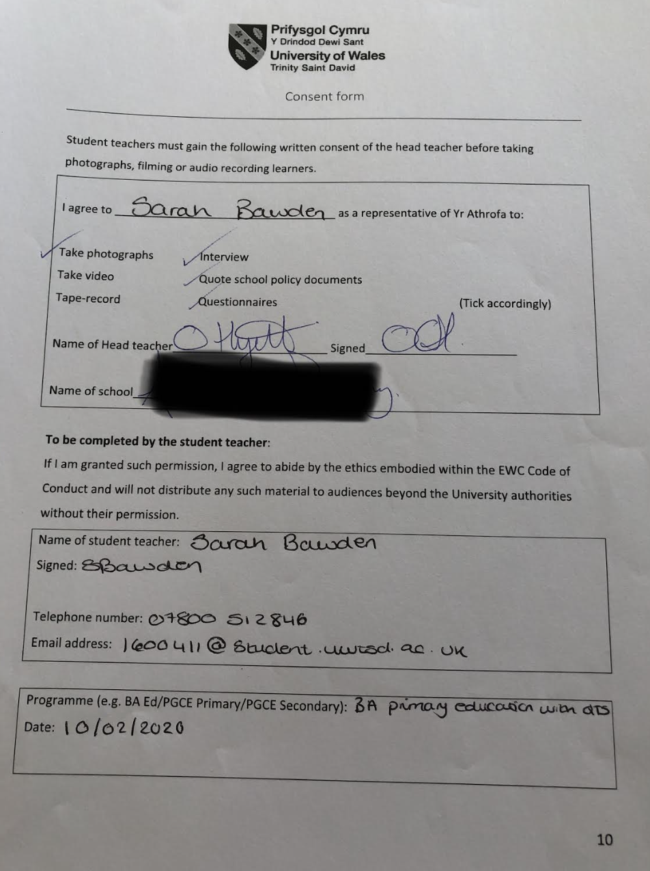
Appendix 2

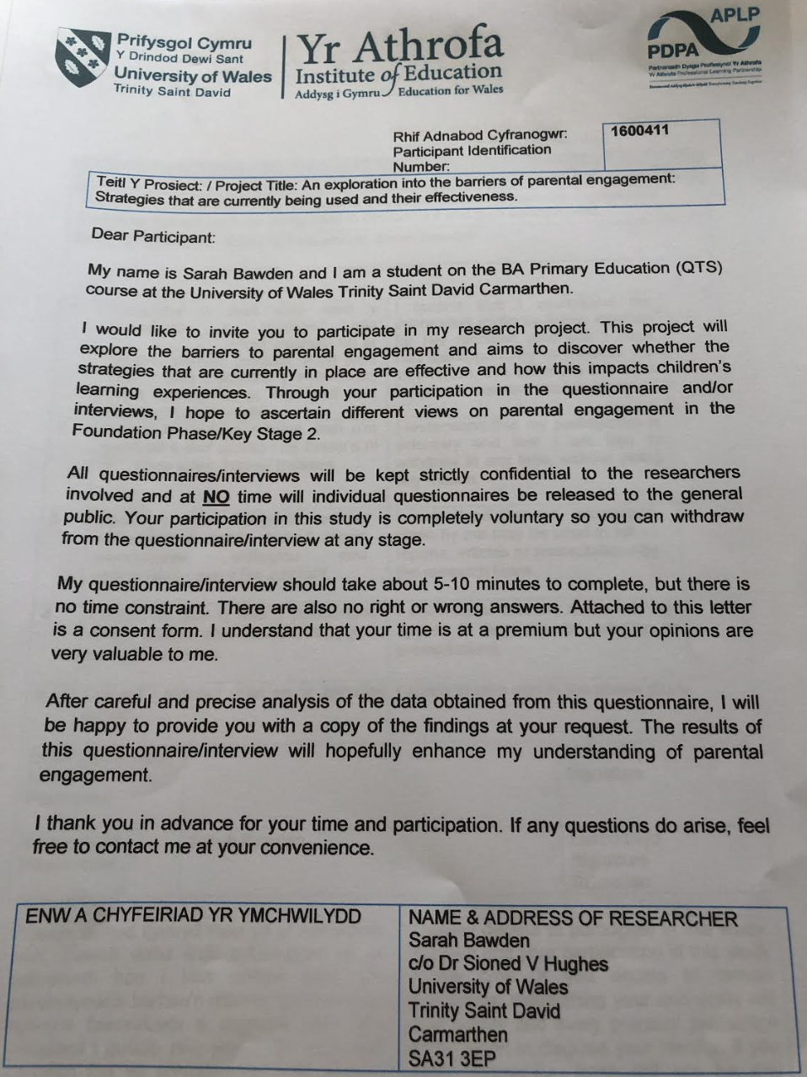
Appendix 3

Appendix 4
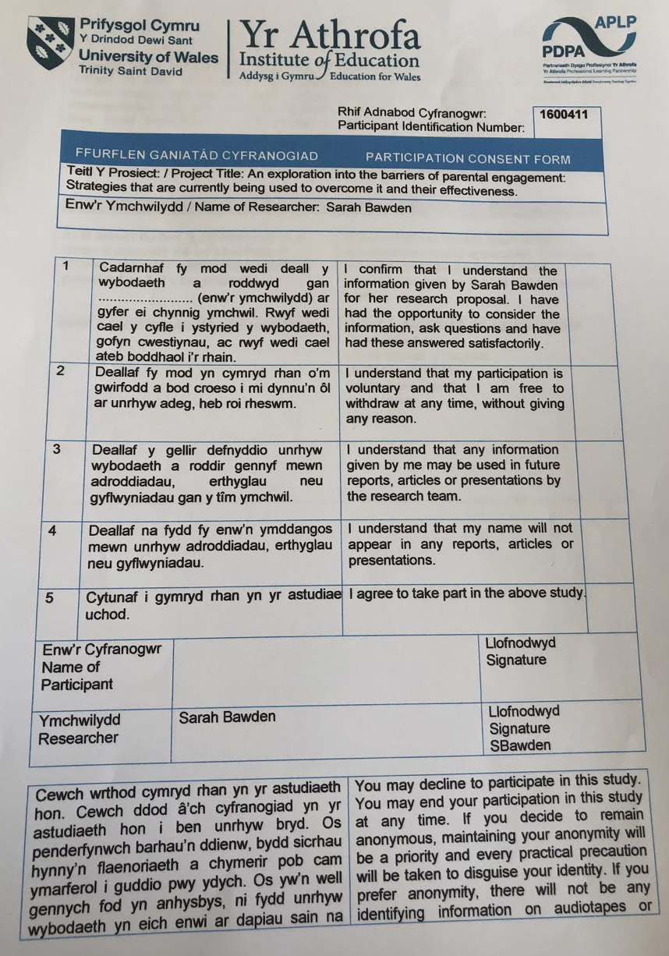

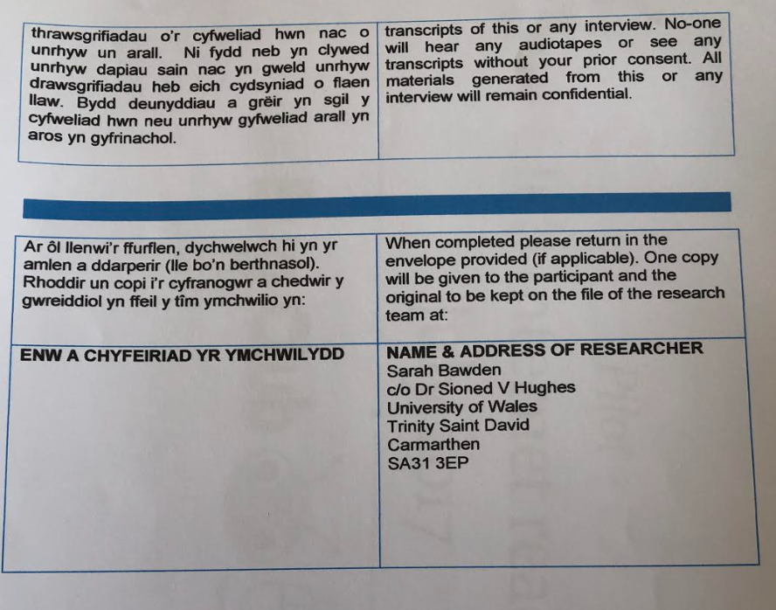

Appendix 5
ELECTIVE REPORT

Introduction
I would just like to thank you for the opportunity to share my findings with you today and would like to start by saying thank you for the support that everyone in the school has offered me throughout the duration of my elective experience.

Context
This presentation will take the form of an Estyn report on effective practice, with my personal observations and research contributing to the overall report.
A school located in Neath Port Talbot that at the time of the last inspection in 2018 had 228 pupils on role including 22 pupils who attended nursery class part-time. There are seven single-age classes, including the nursery and one mixed-age class in the foundation phase. The headteacher took up the post in 2014 and the deputy headteacher was appointed in 2017. Nearly all pupils are of White British heritage and very few speak English as an additional language. A few pupils speak Welsh at home.
The school identified approximately 37% of pupils as having additional learning needs which is above the Welsh average of 21%. A few pupils have a statement of special educational needs. The three-year average for pupils eligible for free school meals is around 17%, this figure has reduced over time and is now just below the Welsh average of 18%.
This school has pupils’ wellbeing at its heart. It is a school that works actively with the parents and the community to involve them in their child’s education.
The current headteacher was the third to take the post within a 12 month period, and stated that just as he took up his post he was approached by a parent of a child in the school and was told that she believed it was like “Charlie And The Chocolate Factory”, because once the gates were closed no one knew what went on. The headteacher then made it a priority to ensure parents and guardians were informed of not only their child’s progress but also the events that were going on in the school and how they could be involved in school life.
Situated within the school is a designated room called the ‘Cwtch’ which is where all the parental engagement strategies take place. The room is designed with different areas to engage both children and parents in different aspects. This includes a ball pit, reading area and a writing/creative area. The room has a calm atmosphere where both children and adults can feel safe, and unless a safeguarding issue arises, all conversations are confidential. The children know that the ‘Cwtch’ is a place where they can interact with their parents on a one to one level and where they are able to talk freely and openly.

Research findings on Parental Engagement
The statement that I proposed at the beginning of the elective experience was:
‘An exploration into strategies that are currently being used to improve parental engagement’
To research this statement and to collect both qualitative and quantitative data to inform my conclusion the following methodologies were adopted throughout my elective experience:
Observation and note taking, learning walks, interviews with pupils, parents and staff.
Strategies observed were parent and toddler group, relationship-based play, Bug Club Internet Reading Café, interaction between parents and staff at breakfast club
Initial reflections upon the data collected has suggested that the strategies being used are improving parental engagement both from parents and staff perspective. Parents believed that the strategies being used are improving parental engagement and staff members believed that in addition to improving parental engagement within the school, the involvement of the parents in the child’s education were improving relationships between child and parent. A number of parents interviewed had no direct involvement in their child’s education or in the life of the school before the introduction of the strategies.
Some parents that were approached originally for a Family Connects programme advocated by Save the Children were unreceptive to the idea, but after discussion and the encouragement of members of staff wanted to attend. As a result of their participation in this, they subsequently attended either relationship-based play, parent and toddler group and/or other parental engagement groups. This shows a clear connection between the initial engagement of the parent and increased participation in other groups.

There was a clear consensus between parents that although the strategies in place are effective and have greatly improved parental engagement, there are still a number of parents who would like to be more involved but cannot attend due to full time work. Suggestions from parents on how the school could improve included the introduction of these strategies as an after-school club when it may be easier for other parents to attend. Another suggestion was to hold additional sessions during half term.

It must be noted however, that parental engagement strategies are not a one size fits all, and that when observing the internet bug café there was a clear difference between the level of engagement between foundation phase parents and key stage 2 parents. Within the foundation phase session there was a 70% attendance from parents compared to 50% attendance from key stage 2. When interviewing the children from both phases, it was interesting to note the difference in the feelings of those children who did not have anyone attending. Most children from key stage 2 said that they understood why no one was there as there were work commitments, so they were not upset or let down. However, in the foundation phase session there was one pupil who was clearly upset that no one had turned up that day, and another who claimed that no one ever came to bug club, so he didn’t mind.

Whilst observing and interviewing during the relationship-based play session it was clear that both the child and parent appreciated the one on one time spent together. After observing the type of interaction between parent and child in the KS2 session of the reading café, where there appeared to be more conversation rather than reading, I asked parents in the relationship-based play session in the foundation phase whether they would attend a relationship-based play session that was adapted for children in KS2. All parents asked said that they would attend and that it could open opportunities to discuss matters with their child that they may not at home.

Most of the strategies seen were more focused on the foundation phase rather than KS2. I cannot comment on whether this is because there are not as many strategies out there for KS2, or whether it is because parents are less engaged as they feel that parental involvement is not as important when the child gets older. This is an area that I found interesting and would like to have researched further if time had permitted.
All the parents interviewed felt that the staff within the school had played a huge part in developing relationships between parents and the school and this relationship had contributed greatly to the effectiveness of the strategies.

Conclusion
Once again, I would like to thank all members of staff for their support and advice offered throughout my elective experience and for the opportunity to observe and gather valuable data that will inform my research project at UWTSD.

Appendix 6

Interview questions – Internet bug café Year 2/3

- Do you enjoy coming to the internet bug café?

100% responded yes.

- Does the internet bug café help you with your reading?

100% responded yes.

- Do you like your parents/guardians being involved in the internet bug café?

Yes – 80% No - 20%

- How does it make you feel when an adult doesn’t attend the internet bug café to read with you?

Child A – “It makes me sad because other parents turn up but not mine”
Child B – “Sometimes it makes me sad because I don’t have anyone to read to”
Child C – “It makes me sad because no one will be able to see how much better I am getting at reading”

Interviews of Internet bug café Year 4/5

- Do you enjoy coming to the internet bug café?

100% responded yes.

- Does the internet bug café help you with your reading?

100% responded yes.

- Do you like your parents/guardians being involved in the internet bug café?

Yes – 70% No - 30%

- How does it make you feel when an adult doesn’t attend the internet bug café to read with you?

Child A – “I don’t mind it as I have friends to read with and I understand that my mum has to work”
Child B – “It’s okay because I get to read with my friends instead and I know that my mum cannot make it down to the school”
Child C – “I don’t mind as they come when they can and I’m really grateful for that”

Appendix 7

Interview Questions – Parents in breakfast club

- When did you start attending breakfast club?

From the introduction of the breakfast club – 60%
Since the child has started school – 20%
Since changing employment – 20%

- How often do you attend breakfast club?

Attended 5 days a week – 100%

- Why do you attend breakfast club?

To fit in with working hours – 85%
Child has asked to attend – 15%

- Do you attend any other parental engagement strategies?

Yes – 90% No – 10%

- Do you feel the feel the strategies currently in place have improved parental engagement in this school?

Yes – 95% No – 5%

- Were you involved in school life or your child’s education in school before the current strategies were implemented and if answered no please tick all events you now attend.

90% answered no graph showing results in main report.

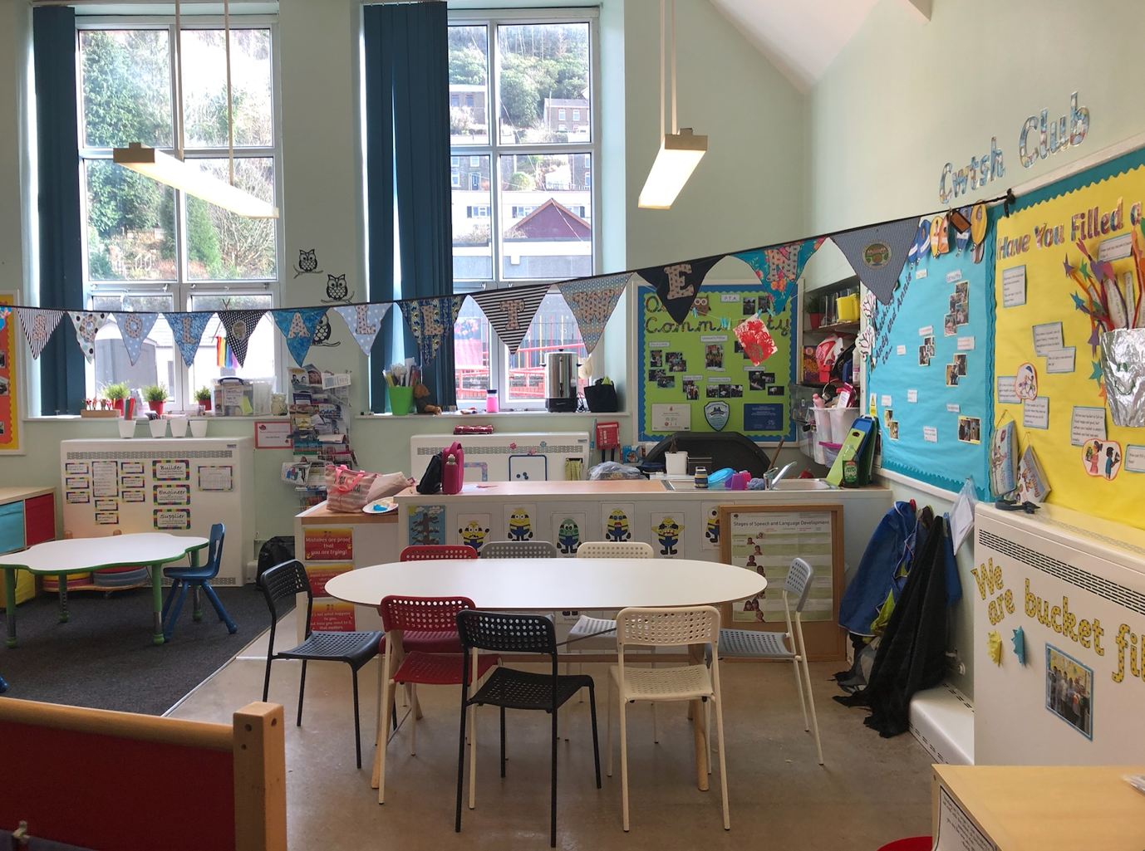
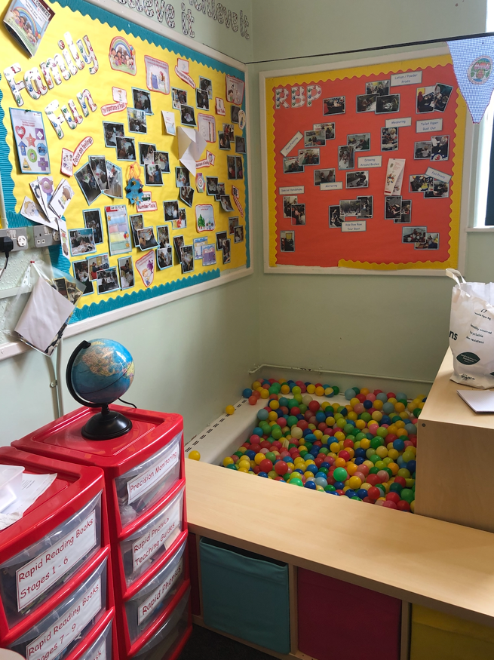
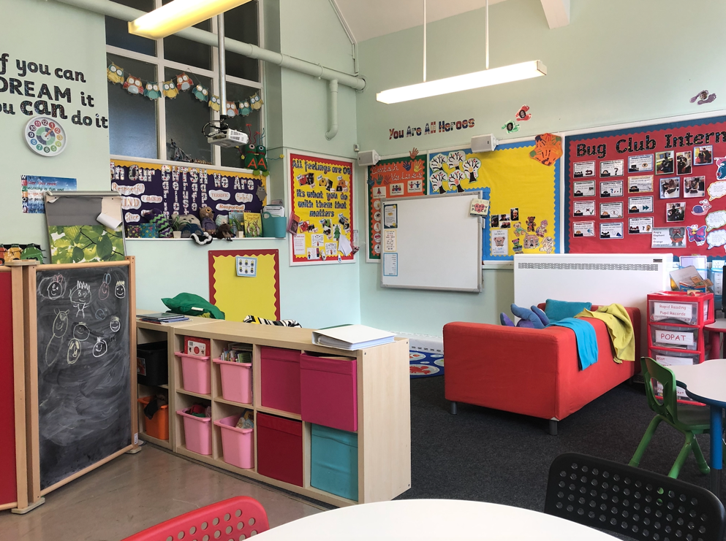
Appendix 8

Appendix 9

Interview question for staff in Key Stage 2

- Do you feel there is a high level of parental engagement within your phase?

Yes – 28% No – 72%

- Is there enough provision in place to engage parents within your phase?

Yes – 35% No – 65%

- What is the level of engagement with current strategies for this phase?

Results can be found in main report.

