Learning the Digital Era – Assessment 1
Unit 1: Written summary of essential skill for study and employment
There are several essential points in order to study successfully and to help oneself in future employment, these being the following:
Evaluating information, and finding credible academic sources:
Disinformation is rife, so it is critical when writing essays and reports that you understand how to filter through the noise as displayed in this poster from the IFLA [1].
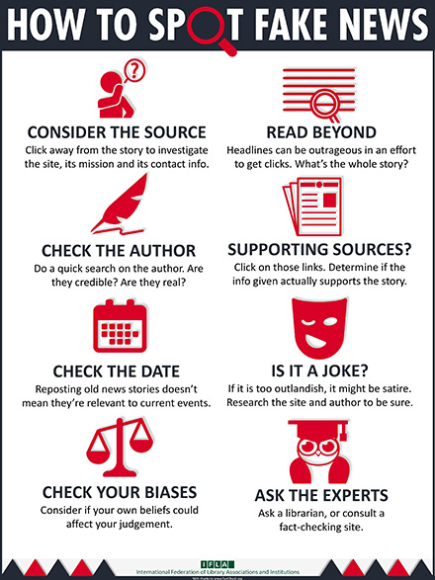
Finding credible academic sources is easily aided by the help of the University library at https://www.uwtsd.ac.uk/library/, which demonstrates a practical understanding of the knowledge [2].

Understanding and avoiding plagiarism
A critical skill to grasp, as plagiarism can even occur unknowingly, as the Global Journal of Enterprise Information Systems’ article on plagiarism avoidance states:
“Many students simply do not know what plagiarism is. Their awareness, if any, often derives from urban legends and myths that Internet contents are free to copy [3].”
With having an awareness of this problem, this can be remedied by citing your references, either by paraphrasing or direct quotes with quotation marks, following the format of your fields referencing style (such as IEEE).
It helps to remain consistent in how you record your sources for citation, a good example being to record them as you go [4].

List of references:
[1] IFLA, How to spot fakes news, 10th July 2020, [online], available: https://www.ifla.org/publications/node/11174, [Accessed 11th Oct 2020]
[2] C. Neville, The complete guide to referencing and avoiding plagiarism, ^{2nd} Ed, Open university press, 01/02/2020, p.8, [E-book] Available: https://www-vlebooks-com.ezproxy.uwtsd.ac.uk/Vleweb/Product/Index/155511?page=0
[3] D. Dhusia,S. Kesharwani, Strategy for writing Plagiarism free Research PaperVolume-11, Issue-2, Apr-June 2019, [Online], Available: https://web.a.ebscohost.com/ehost/pdfviewer/pdfviewer?vid=1&sid=a413d681-6c42-4d63-9518-37ea19625bb5%40sdc-v-sessmgr03, [Accessed 11th Oct 2020]
[4] UWTSD, IEEE Referencing Handbook, p.4, [online], available: https://uwtsd.ac.uk/media/uwtsd-website/content-assets/documents/library-and-learning-resources/infoskills/IEEE-eng_v.1.2.pdf, [Accessed 11th oct 2020]

