Assignment 1: Project Initiation Document
Name: Joseph Morgan
Student Number: 1802760
Name of organisation: Age Cymru West Glamorgan
Project: To procure a HR Management software that will allow for the storage of HR files in a single location, and can automate annual leave and sickness management processes.

1.0 Aim of project
To identify, purchase, and introduce a HR management system that can contain HR files and automate annual leave and sickness.
2.0 Objectives of project
A) To search for a HR software suitable to a small organisation or charity, investigating the features, costs and other details.
B) To provide an outline of the suitable HR software suitable/available to the Chief Executive officer of Age Cymru West Glamorgan by 13 January 2020.
C) To investigate and produce a suitable time frame for training, implementation and migration of data to the new software via a GANTT chart.
3.0 The business case for undertaking the project
The aim of this project sets out to identify a HR management system to allow for the ease of obtaining information from any given file, as well as automating annual leave and sickness. Due to the old system being – staff files managed via Microsoft OneDrive, and multiple spreadsheets for annual leave and sickness – quite complex, there is a need to have this broken down into one location for all data and operations for HR purposes. There is a need to obtain an HRIS (Human Resources Integrated System [Hendrickson, 2003]) to gather, store and analyse information in one place. The old system was likely to be prone to errors, and time consuming (Gilfillan, 2013). With increasing numbers of available systems available to small businesses, this project can specify which is needed by the number of employees (Narisi, 2009). It is also important that the data on the HRIS is shown in an integrated manner, being private and secure to the users (Turnbull, 2014). For users of the HRIS, it will need to have an ease of use, as well as convenience (Erts, 2017), as well as empowering themselves through the use of such software (Erts, 2017). Another issue with the old system was how much paper was being used for various tracking of issues, but with HRIS, paper can be kept to a minimum, being ‘green towards the environment (Erts, 2017; Strazza et al., 2015).
4.0 The risks associated with the project and how to overcome them
To identify risks associated with a project, the project manager should first view each objective and scan for various risks involved, and secondly, use a ‘measuring tape’ approach to access the likelihood of these risks influencing the project (Raydugin, 2013). One risk associated with this project is the cost of such software, and due to the nature of the organisation being a charity, cost is paramount to the viability of the project. A measure to put in place against this is to weigh up several options, and most importantly providing a cost-benefit analysis for the software itself.
Another risk associated with this project is the timeframe in which to complete the report by. As with any project, time is of an essence, thus it is important that time is monitored via various different tools, and one of which will be used in this project as a GANTT chart – a tool devised by Henry Gantt to monitor assignments and tasks involved within a project or task (Nurre & Weir, 2017).
5.0 The resources required to make the project a success
Projects need resources, and in respect to this project, time is required not only to research and set up, but to train, implement and migrate the overall scheme. The time required for this will be displayed in the GANTT chart as shown in point 7. Each task has its own timeframe, and can be clearly seen as to what.
Another resource in which this organisation requires is technology. Laptops with internet connections will be required to plan the project, and when the project is in place, the time to implement this alongside the PCs based in-office for staff to use, will also be required. This is to ensure staff can not only be trained, but can use this on a day-to-day basis, down to the whole purpose of carrying out this project.
Data from current employees will be required to assess which HR software will be suitable to purchase and implement. What a manager and an employee has in mind for a HR system is not necessarily the same, and is vital to ensuring the correct product is chosen. If there are differing views upon the manager, and the employees, several options can be weighed up for the project management team to look at in-depth.
Cash will be required for this project, but only at the point of initiating the immediate purchase of said software. Up until that point, no cash of note will be required.
6.0 Methodology
The research methodology is set up as a waterfall approach, an approach that has stages which are easily defined and follow a structure (Gablas et al., 2018). This way, the project is focused on what it wants to achieve. However, it can be resistant to changing conditions, and should be acted on appropriately (Gablas et al., 2018).
This project sets up to find two sources of information – what the employees want from a system; what systems are available out there. To find out what the employees want, a qualitative semi-structured informal interview will be carried out with each individual to define what an employee wants. As a primary data source, according to Saunders et al., (2016), the questions are structured, but informal and open to variety of questions suitable to the scenario, and can be beneficial due to the suggestion of openness between interviewer and interviewee. It also leads to more conceptualisation for analysis (Saunders et al, 2016).
The second source of information is a secondary data type, searching for qualitative information in the form of factual online information. This is advantageous because, with so much data available online, and such a variety available too, each case is suitable to itself (Saunders et al., 2016). Analysis at this point can be made as a comparison due to the factual nature.
7.0 Operationalisation
By maintaining the waterfall approach of following a set structure, a Work-Based Schedule (WBS) can be formulated to show what is required, and broken down into segments. This is shown below. Following this will be the GANTT chart displaying the time plan for the tasks stated will be undertaken.

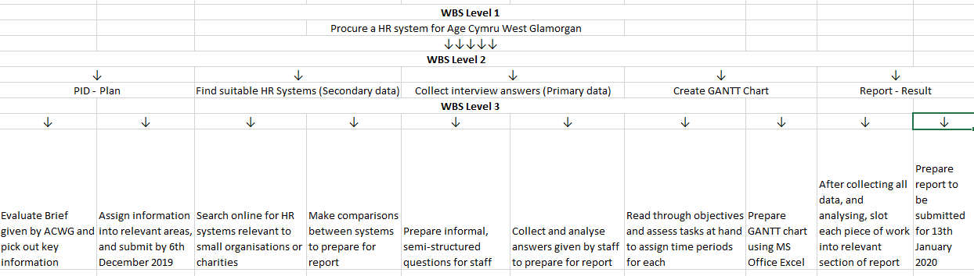
7.1 WBS & GANTT Chart
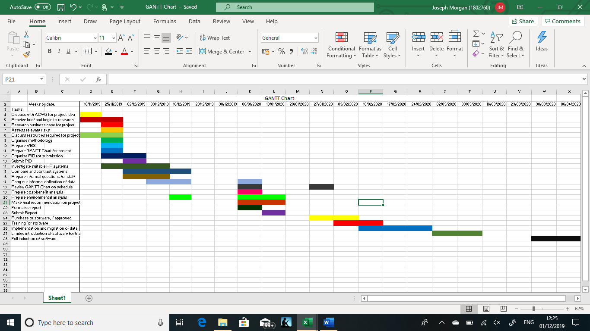

9.0 Appendices
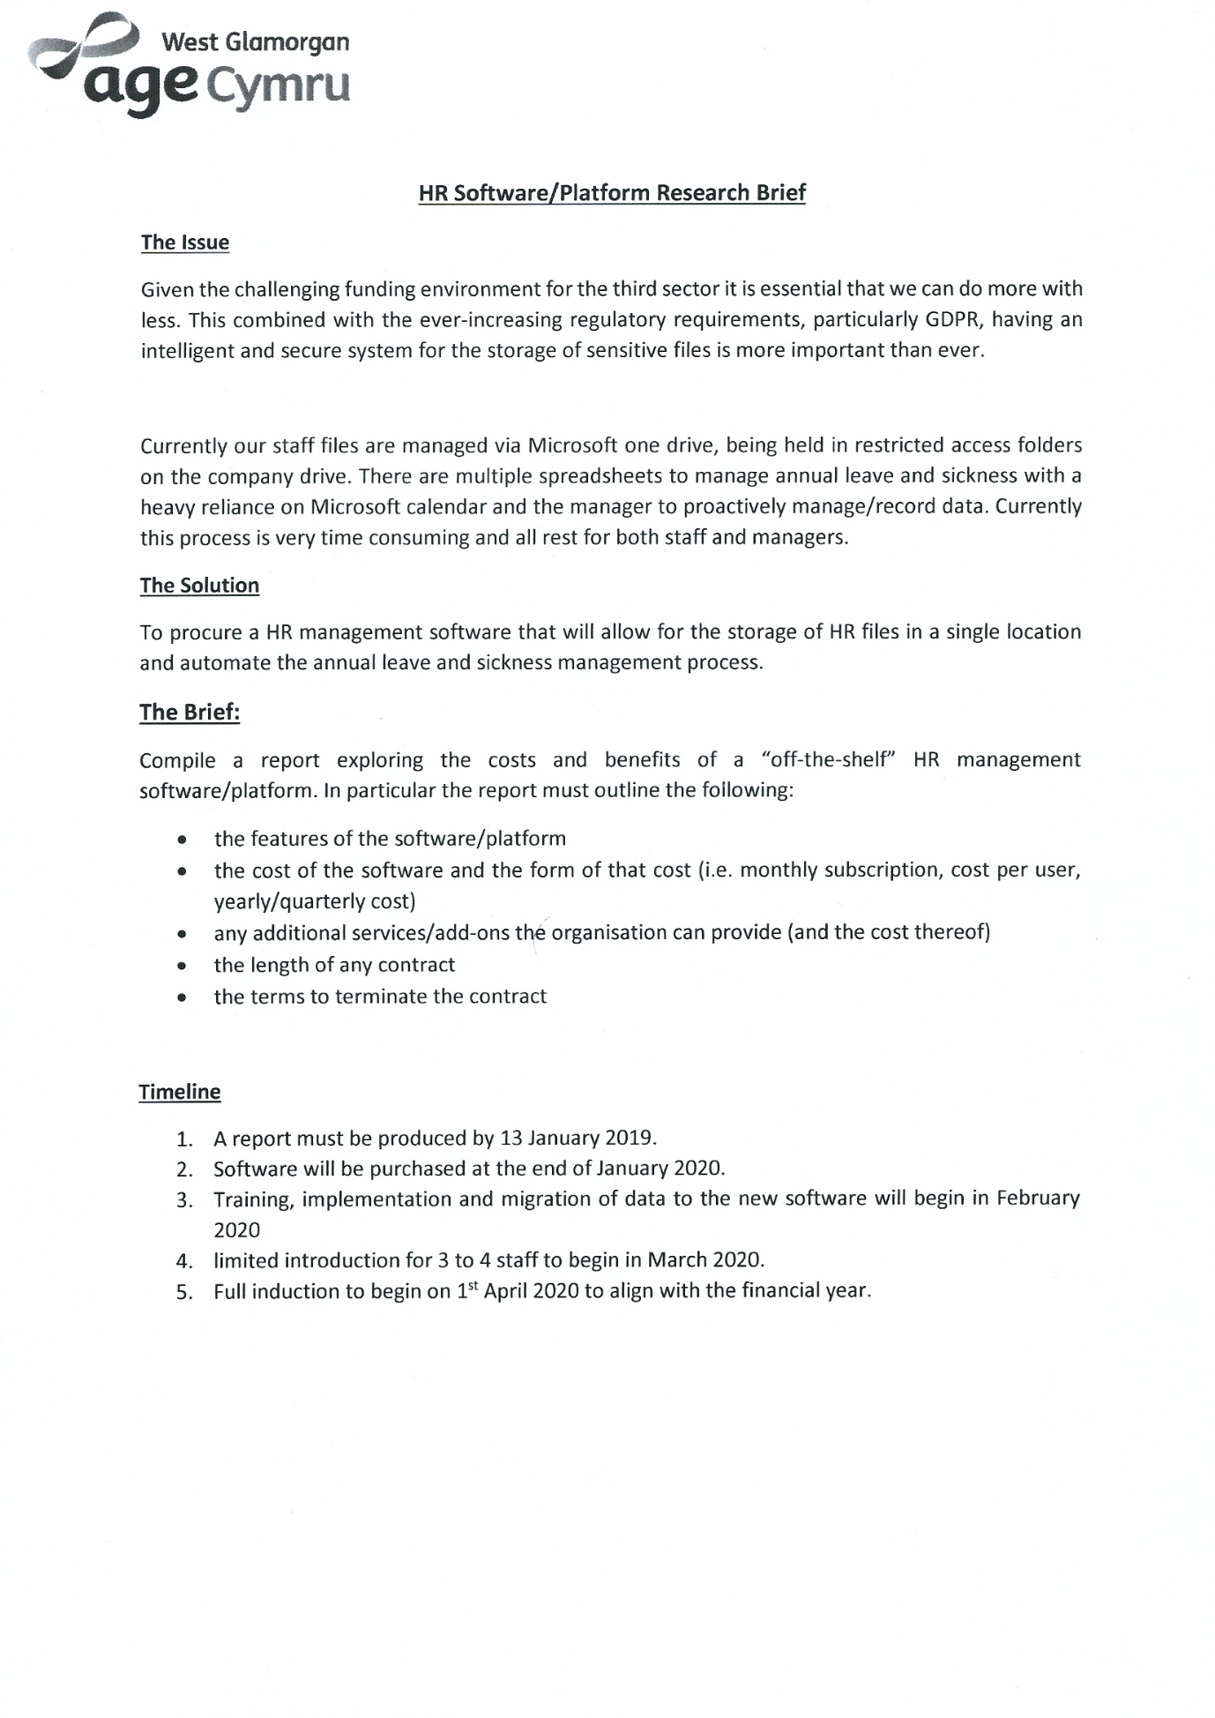
9.0 Reference List
- Turnbull, I., (2014), “Advantages to integrated HRMS”, Canadian HR Reporter, 27(19), p.23.
- Erts, N., (2017), “Still In Doubt? 53 Reasons To Use HR Systems: Saying yes to an HR management system”, Workforce Management (Time and Attendance) Excellence Essentials, pp.Workforce Management (Time and Attendance) Excellence Essentials, Dec 2017.
- Strazza, C. et al., (2015, “Investigation of green practices for paper use reduction onboard a cruise ship—a life cycle approach”, The International Journal of Life Cycle Assessment, 20(7), pp.982–993.
- Hendrickson, A. R. (2003), “Human Resource Information Systems: Backbone technology of contemporary human resources”, Journal of Labor Research, 24(3), 381-394.
- Gilfillan, D. P. (2013). How your small business can benefit from workforce management?
- Narisi, S. (2009), “Top 5 HR software choices for small businesses”, HR Tech News.
- Raydugin, Y., 2013. Project risk management essential methods for project teams and decision makers, pages 39-42, Hoboken: Wiley.
- Nurre, S. & Weir, J.D., (2017), “Interactive Excel-Based Gantt Chart Schedule Builder”, INFORMS Transactions on Education 17(2):49-57. Available at: https://doi.org/10.1287/ited.2016.0168
- Gablas, B., Ruzicky, E. & Ondrouchova, M., 2018. The Change in Management Style during then Course of a Project from the Classical to the Agile Approach. Journal of Competitiveness, 10(4), pp.38–53.
- Saunders, M., Lewis, P. & Thornhill, A., (2016), “Research methods for business students, Seventh edition.

