
Foreign Languages and Cultural Awareness
AIDE MEMOIRE FOR HOTEL STAFF
How to manage guest service experiences
for the international visitor

MODULE CODE: M5X01923

Mihaela Costea
1815099

Lecturer: Dale Clark
Written Assignment Part 2

January 17, 2020
University of Wales Trinity Saint David

Table of Contents

Executive Summary 2
1. Introduction 2
2. Cultural awareness in guest services 2
2.1. What is a service ? 3
2.2. The importance of culture in the guests services 3
3. Types of guests, depending on the country of origin 4
3.1. The Romanians.............................................................................................. 5
3.2. The Japanese.............................................................................................4-5
3.3. The Americans...............................................................................................5
3.4. The South Koreans.......................................................................................6
3.5. The French................................................................................................6-7.
3.6. The British.....................................................................................................7
3.7. The Russians.................................................................................................8
3.8. The Chinese..............................................................................................8-9
3.9. The Arabs................................................................................................9-10
3.10. The Africans............................................................................................10.
3.11. The Germans.......................................................................................10-11
4. Conclusion 12
5. Reference List 13

Executive Summary

The culture and traditions of a people are things that the management team must take into account when it comes to international guests.
The behaviour of the staff must be different, personalized to each type of guest, so that they feel welcomed, respected and even spoiled.

Introduction

The purpose of this assignment is to create an Aide Memorie to assist hotel employees in their behaviour with international guests. It will analyze the culture of the different countries from which the guests come from, their behaviour and their expectations regarding the accommodation and the holidays.

Cultural awareness in guest services

The guest service in a hotel represents all the services, facilities and the help that the hotel staff offers to the guests. Each guest is different and has its own culture, which is why the services also have to be personalized, to adapt to the needs and expectations of all categories of guests. (Collinsdictionary.com, 2020)
Of course, not all guests can always be satisfied. But everyone must receive the attention they expect to receive and the services they have chosen. Some guests want more attention and interaction from the staff, others do not want socializing. Guests can be friendly, distant, pretentious, sometimes unwell. The hotel staff must know exactly how to approach each one, depending on their state, the country from which they come and their culture.

- 1 What is the service?

Service is that action by which a person fulfil the needs of another person, in a certain social environment.
Guests perceive the service differently, depending on their culture, education and life experience.

- 2. The importance of culture in the guest services

It is the culture of each guest that determines what hotel employees and guests perceive as needs, how they will communicate, what values they have and how they will react. If the services provided do not meet the expectations of the guests, expectations that are closely related to their culture, the guests will be unimpressed and dissatisfied with the organization of the service. (Moran, Harris and Moran, 2007)
Culture is very important, it is an integral and essential part of the guest service at world-class hotels. Awareness of the importance of culture in the guest service is vital for the hotel management team. They will have to act in such a way as to meet all the expectations of the most diverse guests in order to stay on the market and prosper. (Scritub.com, 2020)

- Types of guests, depending on the country of origin

  - The Romanians

The behaviour of Romanian tourists has changed a lot in the last 20 years. Before the Romanians travelled by bus, they stayed in cheap hotels and took food in jars and now they are looking for all-inclusive vacations, 4-5 stars hotels and destinations from all over the world. (Wall-Street, 2020)
Romanians are respectful, polite, and very friendly people. They go on vacations, especially with the family. The most important thing for a Romanian at the hotel is the cleaning. Romanians often shake hands, but only men. Women reach out for men to kiss. It is a gesture of great respect. A man's usual greeting to a woman is: "kiss-hand".
Romanians prefer all-inclusive holidays and shopping with moderation.

  - The Japanese

The Japanese always travel in groups, do not like adventure and spend a lot of money on gifts. I spend very little time in hotels, just rest in rooms. They travel a lot and love shopping.
It is a tradition for them that relatives and friends give them money when they go on vacation and they bring them souvenirs on their return.
The Japanese rarely use the facilities offered by hotels, such as gyms, swimming pool, sauna. They prefer outdoor activities and travel, so their expectations for the services offered by hotels are not very high.
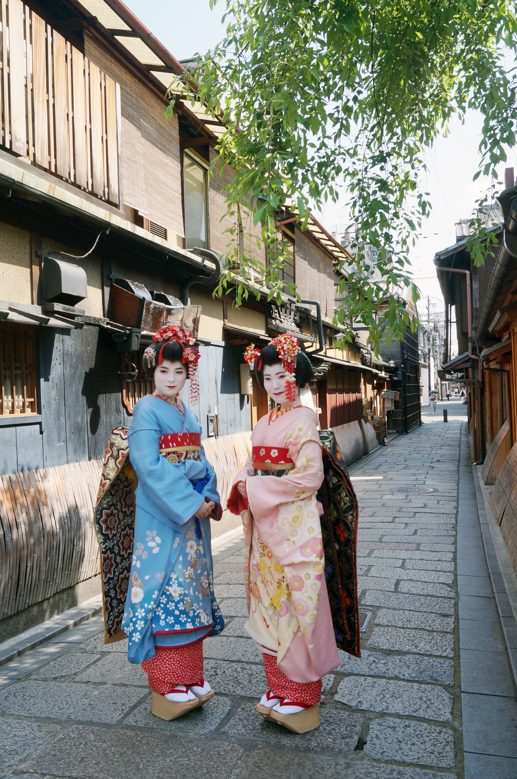

  - The Americans

Americans are proud people with highly developed self-esteem. They need to be liked by those around them so they seek to act and behave as others are expected to do. They do not like to criticize, so a conversation in which institutions or individuals are criticized can be considered annoying and embarrassing.


  - The South Koreans

South Koreans have a unique culture in which interpersonal relationships are more vertical than horizontal. The concept of equality is less common in them. Each person has a higher or lower social position.
The protocol is very important for South Koreans. They are considered among the most polite people. The hotel staff must know the protocol and its rules very well.
They make a bow when they say hello. Generally, I do not get used to shaking hands. However, lately, South Korean businessmen have modernized themselves and are accustomed to shaking hands with business partners as they make a bow.
They do not worry about time, if they arrive on time, leave on time or finish on time
They do not worry about time, if they arrive on time, leave on time or finish on time.
The use of a person's name is strictly prohibited in the South Korean protocol.
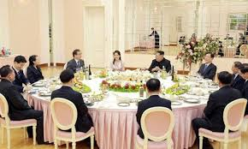

  - The French

The French are a people who are guided by the motto: Freedom, Fraternity, Equality. They are individualists, they consider that each one has to take care of his own person and not to mix in the affairs of others, he considers himself equal with all people, free and brothers.
The social status in France is given by the level of education but also by the size of the house. The French are trying to gain recognition by thinking and acting against others.
The French shake hands, the women giving the hand first. Punctuality is important among the French. (guests, 2020)
The French are friendly people, full of humour, sometimes sarcastic. They need to be admired.
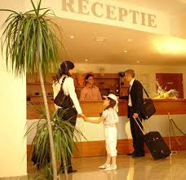

  - The British

The British are generally cool people but very polite and in good manners. They apologize very often, even for insignificant things.
They are nationalists and ignore the culture of other countries. Consume a lot of alcohol. (Britishcouncil.org, 2020)
They like to go on vacation with family or alone or with friends to watch a football match or a concert in another country. They usually do not respect the laws of the country they are going to, they are very noisy and very proud of them.
The British tourist serves food at the restaurant, prefers traditional food but tries other local culinary delights. The favourite food of the British is "fish and chips" and they expect everyone to know this, especially the hotel staff.
It is not tidy and does not give much importance to cleaning.


  - The Russians

Russian tourists are an important segment in the tourism market. As many of them have gained significant wealth over the past ten years, tourism outside the country's borders has grown. They love to go on a family vacation and love shopping where they leave large amounts of money.
Both men and women consume a lot of alcohol, especially vodka, so restaurants should be well-stocked.
They are warm and friendly people, they like fun, dancing parties.
Men kiss each other on the mouth, a sign of friendship and mutual respect.
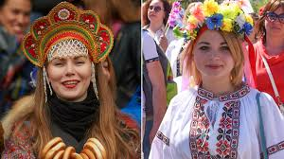

  - The Chinese

A significant feature of Chinese culture is its social nature, as opposed to the Western culture which is individualistic. The Chinese place great emphasis on society, on honesty, kindness and family values. (ro.ripleybelieves.com, 2020).

The Chinese are warm and friendly people, very polite. The best greeting for them is Ni hao or Nin hao if it is an older person. They usually travel in small groups or in the family. Prefer to stay in apartments where several people can fit in and do not spend much time in the accommodation units. Like the Japanese, they travel a lot, they like active vacations so they prefer trips included in holiday tickets.

They are very respectful people, quiet but completely disordered in their things. In the rooms in which it is accommodated, there is a complete disorder.
Hotel staff should not enter their rooms very often to clean them as they do not like to be walked by their belongings.
They appreciate very much if a foreigner speaks them in their language, so it is good for the hotel staff to greet them in Chinese.
The Chinese often shake hands and even hold hands on the street, even if they are not in love.

  - The Arabs

People in Arab countries are mostly Muslims. They prioritize their own person. Loyalty to family and cordiality are defining traits of these people.
The traditional greeting is by placing the right hand near the heart to show sincerity and warmth.
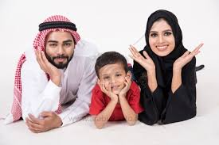
The man has the dominant role and he respects and protects the woman. They do not consume pork, alcohol, play gambling. Men kiss each other on both cheeks.
In some Arab countries, women are required to wear clothes that cover their entire body and in other women are allowed to wear the latest fashion. In some countries, women are illiterate, while in others they receive the highest education. From this point of view, the differences are very large between the Arab countries.

  - The Africans

North African countries are governed by Islamic culture. The central unit in African culture is the family, both the ordinary and the extended family, the tribe. Friendship is an important feature of Africans. Before doing any business, they become friends and trust the person they want to do business with.
In Africa, time is flexible. People don't rush. If one is in a hurry, the others look at him with suspicion and mistrust.
In Africans age is very important. The older a person is, the more respected he is.

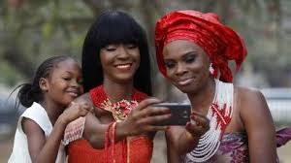

  - The Germans

The Germans are very hard-working people, not too open, reserved and even a little colder. They prefer to respect their privacy. They have a small circle of close people and make a big difference between an acquaintance and a friend.
The Germans are very organized, they like to plan everything in time. They are among the highest-paid Europeans so they have a high standard of living.
The way the hotel staff needs to address the Germans is with the title and then the name. It is important for them to shake hands. Greetings are appropriate.

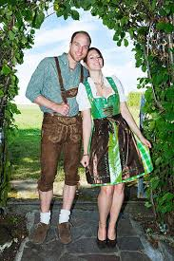

Do’s and Don’ts | Making a joke | Handshake | Call by name | Topic about the private life | Talk with hands in your pocket | Greetings | Make compliments
Romanians | do | do | do | do | do | do | do
South Koreans | don’t | do | don’t | don’t | don’t | do | don’t
Japanese | don’t | don’t | don’t | don’t | don’t | don’t | don’t
Germans | do | do | do | don’t | don’t | do | do
French | do | do | do | do | do | do | do
Arabs | don’t | do | don’t | don’t | don’t | don’t | don’t
British | do | do | do | don’t | do | do | do
Chinese | do | don’t | do | don’t | don’t | do | do
Africans | don’t | don’t | don’t | don’t | don’t | do | don’t

Conclusion

People from all countries are different so they have different expectations from hotel staff. Europeans are people who do not need a special protocol when it comes to vacations. They are waiting to be treated with warmth and friendship. (Facebook.com, 2020)
Arabs are mostly Muslims. They should be treated with respect and with a certain distance.
Asians prefer to be greeted in their language, they travel a lot and shop.

5. Reference List

Britishcouncil.org. (2020). Best and worst of British in the eyes of the world | British Council. [online] Available at: https://www.britishcouncil.org/contact/press/best-and-worst-british-eyes-world [Accessed 16 Jan. 2020].
Collinsdictionary.com. (2020). Guest services definition and meaning | Collins English Dictionary. [online] Available at: https://www.collinsdictionary.com/dictionary/english/guest-services [Accessed 15 Jan. 2020].
Facebook.com. (2020). Art of Hosting. [online] Available at: https://www.facebook.com/groups/artofhosting/ [Accessed 16 Jan. 2020].
guests, A. (2020). Advice on hosting French guests. [online] Community.withairbnb.com. Available at: https://community.withairbnb.com/t5/Hosting/Advice-on-hosting-French-guests/td-p/241833 [Accessed 16 Jan. 2020].
Managementmarketing.ro. (2020). [online] Available at: http://www.managementmarketing.ro/pdf/articole/25.pdf [Accessed 14 Jan. 2020].
Moran, R., Harris, P. and Moran, S. (2007). Managing cultural differences. Burlington, MA: Elsevier/Butterworth-Heinemann, pp.3-9.
ro.ripleybelieves.com. (2020). Cultura Și Tradițiile Chineze. [online] Available at: https://ro.ripleybelieves.com/chinese-culture-and-traditions-4459 [Accessed 16 Jan. 2020].
Scritub.com. (2020). Cultura - definitie, componente, termeni inruditi. tipuri de cultura. [online] Available at: http://www.scritub.com/arta-cultura/CULTURA-DEFINITIE-COMPONENTE-T94397.php [Accessed 15 Jan. 2020].
Wall-Street. (2020). Cum s-au schimbat turistii romani in ultimii 21 de ani: de la borcane cu mancare la pachet, la vacante all inclusive. [online] Available at: https://www.wall-street.ro [Accessed 14 Jan. 2020].

