Adrian Neacsu UWTSD 2312529

A critical evaluation of Genting UK’s business model, competitive environment, marketing strategy and financial development.

Entrepreneurship
Business Plan Development



Name: Adrian Mihai Neacsu
Student number: 2312529
Module Code: LCBB5013
Module Title: Entrepreneurship
Assignment Title: Task 1: Business Plan Development (Elements 1–4)
UWTSD Birmingham
Program of Study: BA Business Management

Contents
Introduction 3
Task 1: Business Plan Development 3
Business Idea 3
Products and Services 4
Objectives 5
Unique Selling Point (USP) 5
Element 2: Business Environment & Competitor Analysis 6
SWOT Analysis 6
Competitor Analysis 8
Element 3: 4Ps, Market Segmentation & Marketing Strategies 9
Market Segmentation and Target Customers 9
The 4Ps of Marketing 10
Online Marketing Strategies 12
Element 4: Financial Planning 13
Financial Development and Funding 13
References 14

Introduction
The UK gambling and leisure industry has changed considerably due to the growth of digital gaming, evolving customer expectations and tighter regulatory requirements. Casino operators must now compete not only with other land-based casinos, but also with online gambling businesses and wider leisure providers that target the same discretionary spending. This has increased the importance of differentiation, customer experience, responsible gambling and effective financial management.
This business plan critically evaluates Genting UK, one of the country’s largest casino and leisure operators and part of the international Genting Group. The company operates a substantial network of physical casinos alongside online gaming, hospitality, food, drink and entertainment services. Its integrated business model provides opportunities for customer engagement across both physical and digital channels, although it also exposes the organisation to regulatory, reputational and competitive pressures.
The report is divided into four elements. The first examines Genting UK’s business idea, products and services, objectives and unique selling point. The second applies SWOT analysis and evaluates direct and indirect competitors. The third examines market segmentation, target customers, the marketing mix and online marketing strategies. The final element examines the company’s financial development, initial funding and growth from its UK market entry to its current position.

Task 1: Business Plan Development

Business Idea
Genting UK is a British casino and leisure business within the wider Genting Group. Its land-based operations are managed by Genting Casinos UK Limited, while the brand also provides online casino and live-dealer services. The current venue directory identifies 32 UK casinos across major cities, including premium London clubs and Resorts World Casino in Birmingham (Genting Casino, 2026a). The business idea is therefore broader than operating gambling premises: Genting seeks to combine gaming, hospitality, food, drink and entertainment into an experience that customers can access both physically and digitally.
This positioning can be interpreted through Pine and Gilmore’s (1999) Experience Economy framework. Value is created not only by the games offered, but by the atmosphere, service, dining and social occasions surrounding them. Resorts World Casino illustrates this logic by combining gaming with bars, dining and live sport within the wider Resorts World Birmingham destination (Genting Casino, 2026b). The model can increase dwell time and expenditure while reducing dependence on a single activity. However, diversification does not remove gambling-related risk. Genting’s reputation, licence to operate and customer proposition remain closely connected to responsible gambling and regulatory compliance. The strategic implication is that experience-led differentiation must be supported by visible consumer protection rather than promotion alone.
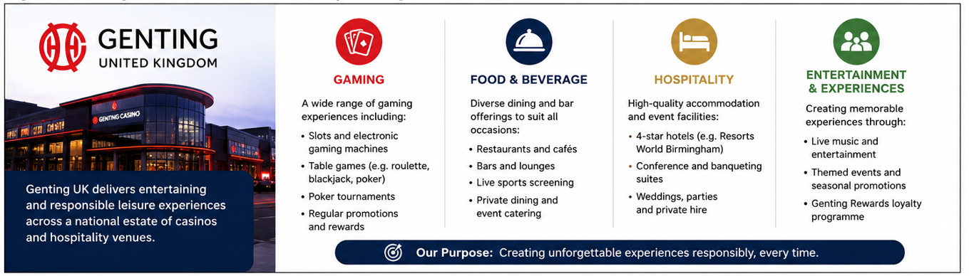
Figure 1Genting UK’s integrated business model and key service areas.
Source: Author’s own illustration based on Genting Casinos (2026).

Products and Services
Genting’s core services include roulette, blackjack, baccarat, poker, electronic gaming and premium gaming areas. These are complemented by bars, restaurants, live entertainment and venue-based events. Digitally, Genting offers online slots, table games and live casino content, including roulette streamed from selected Genting venues. Its website also promotes a members’ club and mobile access, creating links between venue visits and online engagement (Genting Casino, 2026c). This is an omnichannel proposition rather than two unrelated businesses.
The attractiveness of that proposition is supported by market evidence. Great Britain’s customer-facing gambling industry generated £16.8 billion in gross gambling yield during April 2024 to March 2025. Remote casino, betting and bingo produced £7.8 billion, while land-based sectors generated £4.8 billion. Within this, non-remote casino GGY rose by 7.9 per cent to £933.8 million (Gambling Commission, 2025). These figures indicate opportunities in both channels, but remote gambling is growing from a much larger base. Consequently, Genting must avoid allowing its physical estate to become disconnected from digital customer expectations.
From a Resource-Based Perspective, Genting’s established locations, support from the parent group, operational expertise, and well-known brand can be seen as valuable assets (Barney, 1991). However, their sustainability relies on whether these resources are challenging to replicate and effectively organized. While competitors can imitate games and promotions, duplicating a nationwide venue network, a trained service staff, and integrated live-streaming capabilities necessitates significantly higher investment. Therefore, Genting should leverage these assets to maintain consistent service and responsible gambling standards across all channels.

Objectives
In the short term, Genting UK should focus on profitable customer retention, digital conversion, venue productivity, and compliance. Key objectives should include enhancing members' utilisation of both online and land-based services, improving personalised communication, strengthening safer gambling interventions, and increasing non-gaming spending per visit. These priorities align with strategic management principles as they effectively translate the overarching mission into measurable operational outcomes (Johnson et al., 2020).
Long-term objectives should emphasise sustainable omnichannel growth, targeted modernisation of the casino portfolio, enhanced utilisation of customer analytics, and continued development of entertainment-focused destinations. Growth should not be evaluated solely based on gaming revenue; customer trust, regulatory compliance, service quality, and income generated from hospitality must also be considered. This balanced approach mitigates the risk that aggressive acquisition goals could compromise legitimacy or jeopardise long-term customer relationships.
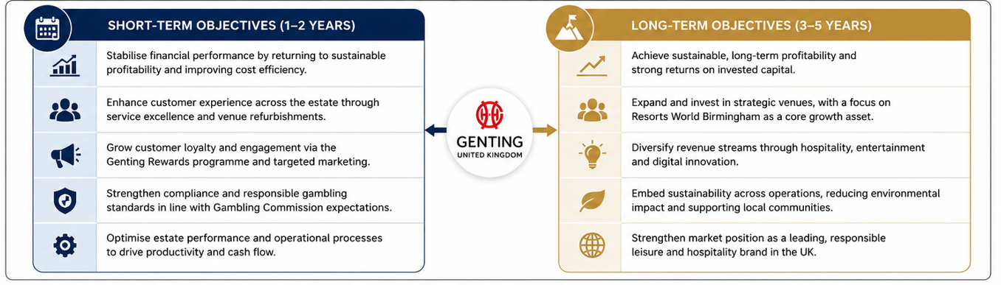
Figure 2 Figure 2: Genting UK’s short-term and long-term strategic objectives
Source: Author’s own illustration based on Genting Berhad (2025) and Genting Casinos (2026).

Unique Selling Point (USP)
Genting UK’s USP is the combination of a substantial national casino network, premium destination experiences and online gaming under one internationally supported brand. The strongest point of difference is not any individual game, since similar products are widely available, but the ability to move customers between trusted physical venues, hospitality experiences and digital live casino services.
This advantage is meaningful but not automatically sustainable. Online competitors may offer greater convenience and promotional intensity, while leisure businesses compete for the same discretionary spending without carrying gambling’s regulatory and reputational burden. Genting should therefore position itself around trusted entertainment, professional service and responsible omnichannel experiences rather than gambling volume. Overall, the business model is strategically credible because it combines tangible venues with scalable digital access; nevertheless, its future strength depends on continuous investment, service consistency and demonstrable customer protection.

Element 2: Business Environment & Competitor Analysis

SWOT Analysis
Genting UK operates in a market where physical casino recovery is occurring alongside faster digital growth. The Gambling Commission reported that Great Britain’s customer-facing gambling industry produced £16.8 billion in gross gambling yield during April 2024 to March 2025. Remote casino, betting and bingo generated £7.8 billion, whereas non-remote casinos generated £933.8 million, an annual increase of 7.9 per cent (Gambling Commission, 2025). This creates a favourable market opportunity, but also confirms that online competitors possess greater scale and convenience.
A principal strength is Genting’s combination of a recognised international brand, a nationwide venue estate, premium London casinos and Resorts World Birmingham. Through the Resource-Based View, these assets are valuable because they combine property, operational knowledge, hospitality capability and customer relationships (Barney, 1991). They are harder to reproduce than individual casino games, which are widely available. Genting can also connect land-based venues with online and live-casino services, creating cross-channel engagement. However, the advantage is sustainable only when the assets are organised into a consistent customer experience; an extensive estate becomes a weakness if ageing venues produce high fixed costs or inconsistent service.
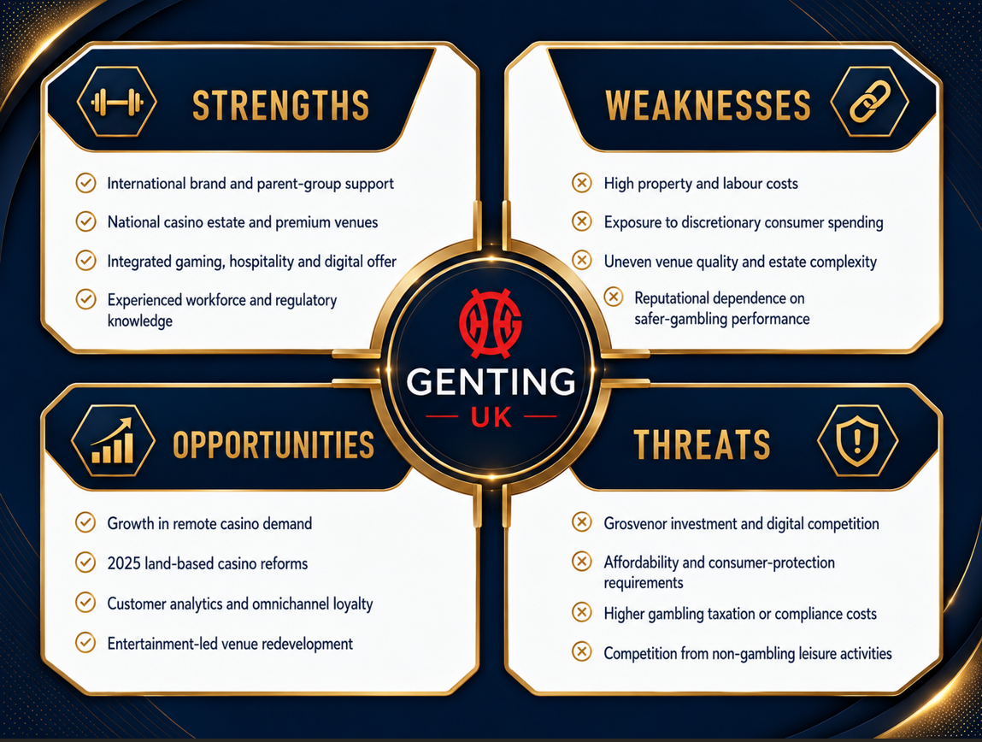
Figure 3: SWOT analysis of Genting UK
Source: Author’s own illustration based on Genting Berhad (2025), Gambling Commission (2025) and Rank Group (2025a).
Weaknesses arise from the economics and social legitimacy of land-based gambling. Casinos require substantial expenditure on premises, staffing, security and compliance, while demand is sensitive to household disposable income. Genting must also manage the tension between maximising customer value and preventing harmful gambling. Regulatory failure could create fines, license restrictions and reputational damage. In addition, the Commission’s 2025 legislative guidance allows eligible casinos to increase machine entitlements, creating an opportunity to improve productivity, but competitors can access the same reform (Gambling Commission, 2026). Therefore, regulation is not an automatic source of advantage; execution and responsible implementation determine who benefits.
Further opportunities include using customer analytics to personalise communication, modernising selected venues and positioning casinos as broader social destinations. The main threats are intensified competition, possible tax increases and substitution by online entertainment or family leisure. Porter (1985) argues that competitive advantage depends on delivering superior value or operating at lower cost. Genting is unlikely to win a pure cost contest against digital-only operators, so differentiation through trusted service, atmosphere and integrated entertainment is strategically more credible.

Competitor Analysis
Grosvenor Casinos is Genting’s closest direct competitor because it combines 51 casino venues with digital gaming and hospitality. Grosvenor’s like-for-like net gaming revenue rose 14 per cent to £378.4 million in 2024/25, supported by higher customer visits and spending (Rank Group, 2025a). This performance shows that investment in venues and customer experience can generate growth, but it also raises the competitive benchmark for Genting. Buzz Bingo is a second direct leisure-gaming competitor. Its omnichannel model is relevant because 44 per cent of online revenue in 2023 came from customers who first played in retail clubs (Buzz Group, 2024). Although bingo differs from casino gaming, Buzz competes for similar social-gaming customers and demonstrates the value of converting venue relationships into digital activity.
Flutter Entertainment is an indirect competitor whose online brands compete for gambling expenditure without requiring a large casino estate. Its UK and Ireland division generated $3.547 billion of revenue in 2025, illustrating the scale advantage available to digital-led groups (Flutter Entertainment, 2026). Hollywood Bowl is a different form of indirect competitor because it targets social occasions, group entertainment and discretionary spending. Its revenue increased 8.8 per cent to £250.7 million in 2025 (Hollywood Bowl Group, 2025). Its lower regulatory risk and broad family appeal increase substitution pressure on casino visits.
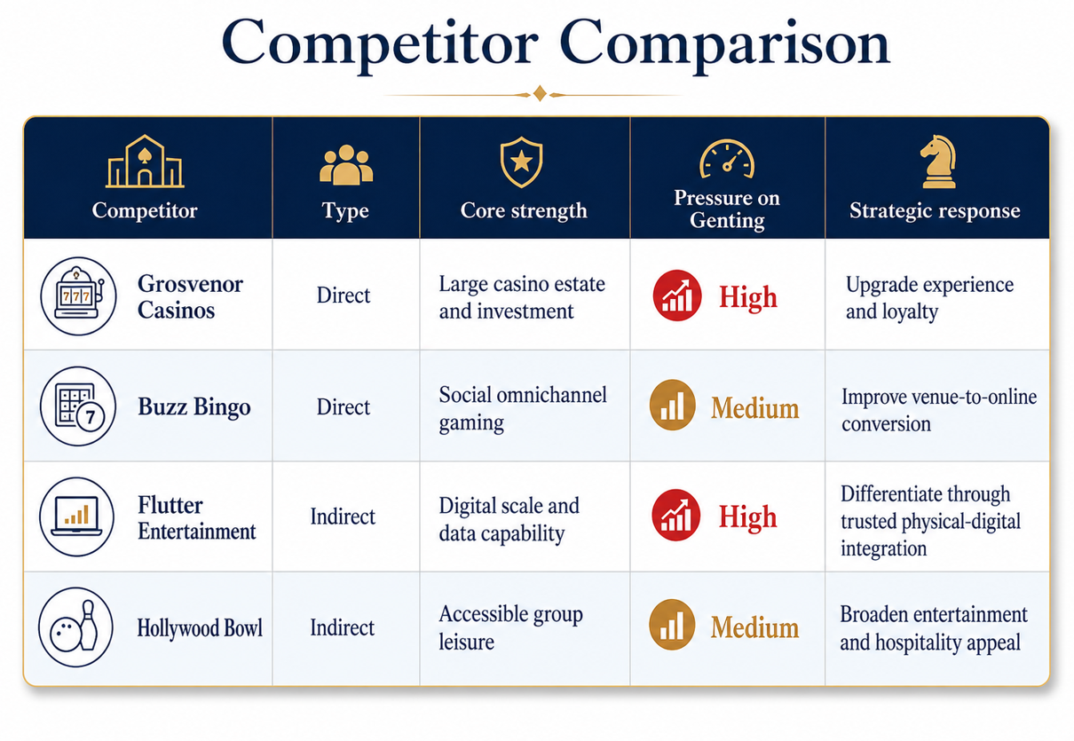
Figure 4Comparison of Genting UK’s direct and indirect competitors
Source: Author’s own illustration based on Buzz Group (2024), Flutter Entertainment (2026), Hollywood Bowl Group (2025) and Rank Group (2025a).
Overall, Genting’s strongest strategic assets are its venues, brand and ability to connect gaming with hospitality. Nevertheless, competitor evidence shows that these resources will not protect performance without sustained investment and digital integration. Management should prioritise the most productive venues, use loyalty data to connect channels and compete on trusted entertainment rather than promotional intensity. This approach cannot remove regulatory or economic risk, but it offers a more defensible position than imitating digital-only operators. Genting’s competitive sustainability, therefore, depends on converting physical scale into distinctive customer value while maintaining credible, safer-gambling standards. A selective investment strategy is preferable to uniform expansion: high-potential venues should receive refurbishment and entertainment investment, while weaker locations should be reviewed against customer demand, cost and strategic fit. This would protect cash flow and prevent the estate from becoming a burden rather than a source of differentiation.

Element 3: 4Ps, Market Segmentation & Marketing Strategies

Market Segmentation and Target Customers
Genting UK operates in a heterogeneous market, so undifferentiated marketing would weaken both relevance and regulatory control. The STP model suggests that organisations should divide a market into meaningful groups, select attractive segments and position an offer around their needs (Kotler, Keller and Chernev, 2022). Genting can segment geographically through its casino estate; demographically by age, income and life stage; psychographically by attitudes towards premium leisure, social entertainment and convenience; and behaviourally through visit frequency, game preference, channel use and loyalty status. These dimensions are more useful in combination than alone because two customers of the same age may have very different motivations and risk profiles.
The primary land-based segment comprises adults seeking a social night out that combines gaming with food, drink, live sport and entertainment. Venue propositions vary by location: Mayfair clubs appeal to premium and internationally mobile customers, while regional casinos compete more directly with bars, restaurants and group-leisure venues. A second segment consists of digitally confident adults who value convenience, game variety and mobile access. Genting’s online platform advertises more than 8,000 games and live roulette streamed from UK clubs, connecting digital convenience with the authenticity of physical dealers (Genting Casino, 2026a). A third segment includes loyal, higher-frequency customers reached through the six-tier Members’ Club and points-based rewards (Genting Casino, 2026b).
The target should not simply be “all adults who gamble”. Gambling Commission evidence shows overall participation is highest among 55–64-year-olds, but participation excluding lottery-only activity is stronger among adults aged 18–44 (Gambling Commission, 2025a; Gambling Commission, 2024). This suggests a portfolio approach: established venue customers may be retained through service and recognition, while younger legal-age adults are more likely to require mobile-first discovery and experience-led reasons to visit. However, casino activities are associated with comparatively higher gambling-risk indicators, so targeting must incorporate affordability, age verification and safer-gambling triggers. The strategic judgement is that customer lifetime value should be balanced against customer welfare rather than maximised without constraint.
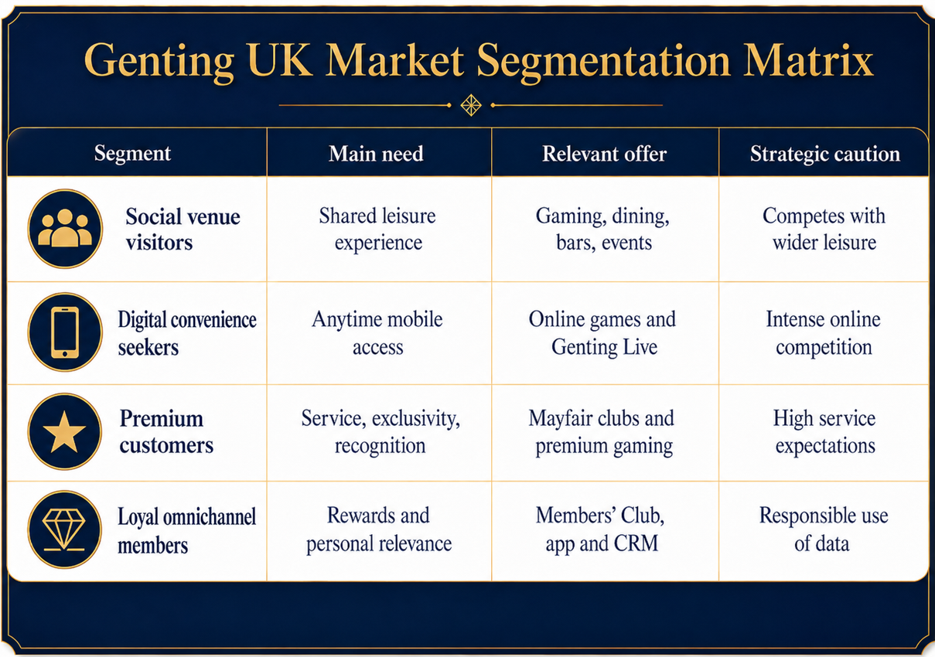
Figure 5: Genting UK market segmentation matrix Source: Author’s own illustration based on Kotler, Keller and Chernev (2022), Genting Casino (2026a), Genting Casino (2026b) and Genting Casino (2026c).

The 4Ps of Marketing
Product is Genting’s strongest differentiator because the offer combines table games, electronic gaming, online slots, live casino, bars, restaurants and entertainment. Genting Live strengthens this mix by streaming roulette from UK venues, including Resorts World Birmingham, to customers’ devices (Genting Casino, 2026c). This creates a tangible link competitors without physical estates cannot easily reproduce. Nevertheless, a very broad portfolio can create inconsistent quality between venues, so core standards for service, digital usability and responsible gambling are essential.
Price includes gaming stakes, food and beverage prices, membership rewards and promotional value. A tiered approach allows Genting to serve casual visitors and premium customers without relying on one price position. Welcome bonuses, free spins and loyalty points can reduce the perceived cost of trial, but their effectiveness is ethically and commercially ambiguous. Gambling Commission research found that incentives can influence renewed participation, meaning excessive promotional dependence may attract regulatory criticism and lower-quality revenue (Gambling Commission, 2021). Genting should therefore compete on transparent value and experience rather than aggressive bonus intensity.
Place is both physical and digital. The national casino network gives Genting access to urban leisure markets, while its website and mobile services remove geographic and opening-hour constraints. This hybrid distribution is strategically valuable because remote casino, betting and bingo represented 46 per cent of Great Britain’s industry gross gambling yield in 2024/25 (Gambling Commission, 2025b). Yet digital reach also exposes Genting to larger online specialists. The physical estate should therefore function as a differentiation asset through exclusive streamed tables, events and hospitality rather than as a costly parallel channel.
Promotion includes venue events, website content, search visibility, social media, email, app notifications, welcome offers and member rewards. Local pages communicate games, restaurants, bars, live sport and accessibility, supporting geographically targeted search and conversion. The wider content strategy also publishes leisure-related articles, which can attract search traffic beyond direct casino queries. Promotion must nevertheless remain consistent with the CAP Code and safer-gambling requirements. The best strategic position is trusted adult entertainment, not normalisation of high-frequency play.
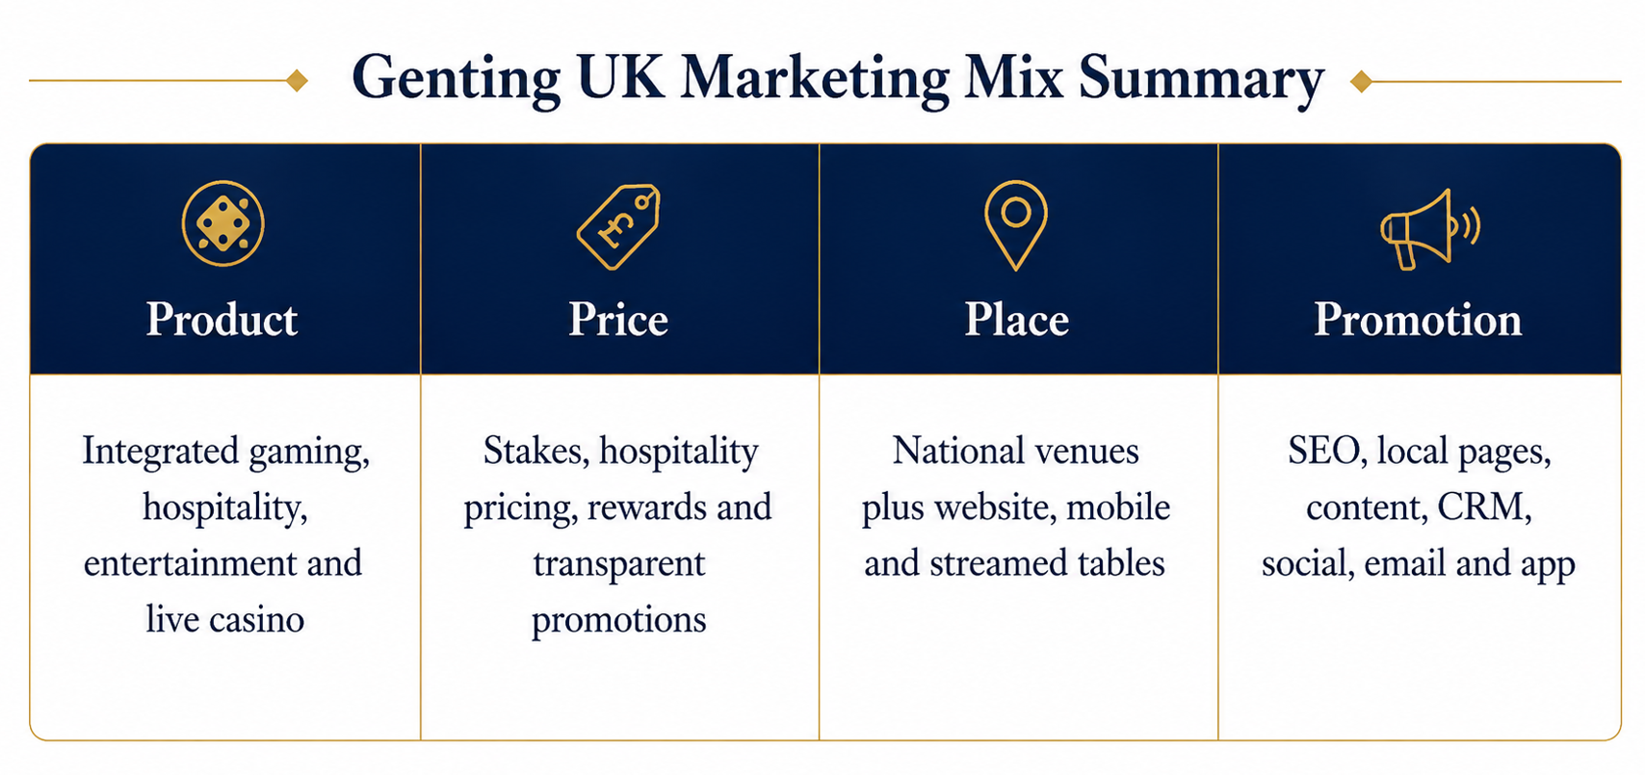
Figure 6: Genting UK marketing mix summary
Source: Author’s own illustration based on Kotler, Keller and Chernev (2022), Chaffey and Ellis-Chadwick (2022) and Genting Casino (2026a–c).

Online Marketing Strategies
Genting’s digital strategy attracts customers through search-engine visibility, a mobile-responsive website, online promotions, content marketing and the distinctive Genting Live proposition. Search and local venue pages capture high-intent enquiries such as nearby casinos, poker, restaurants or live sport. The online catalogue creates breadth, while welcome offers reduce trial barriers. Chaffey and Ellis-Chadwick (2022) argue that digital marketing should connect reach, interaction, conversion and continuing engagement; Genting broadly follows this journey by moving users from content or search to registration, play and loyalty.
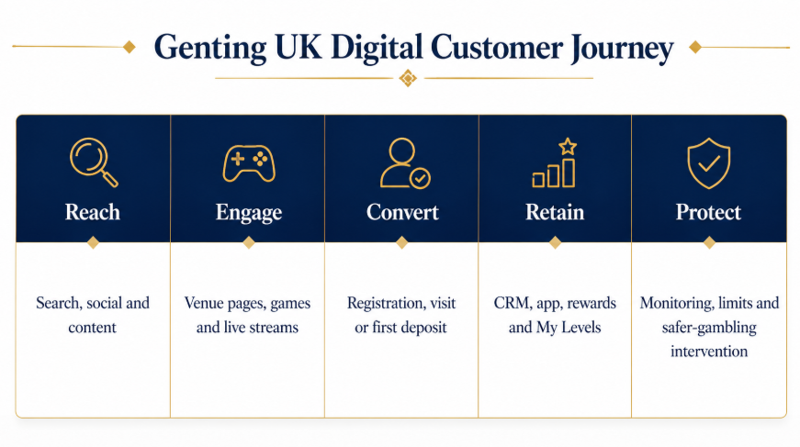
Figure 7: Genting UK digital customer journey
Source: Author’s own illustration based on Chaffey and Ellis-Chadwick (2022), Genting Casino (2026b), Google Play (2026) and Gambling Commission guidance.
Retention is supported by CRM, the Members’ Club, My Genting app and gamified features such as My Levels. The app communicates offers, tournaments and prize draws, while the loyalty programme uses six status levels to recognise repeat engagement (Genting Casino, 2026b; Google Play, 2026). This reflects relationship marketing, where value is created through ongoing interaction rather than isolated transactions (Grönroos, 1994). Data can improve personalisation and reduce irrelevant communication, but the same capability should also identify harmful patterns, suppress unsuitable promotions and trigger interventions. Payne and Frow (2005) emphasise that CRM is a cross-functional strategy rather than merely a communications tool; therefore, marketing, compliance, venue operations and customer service must share a responsible single-customer view.
Overall, Genting’s online marketing is strategically effective when it converts digital awareness into trusted omnichannel relationships. Its limitations are intense competition, privacy expectations, promotional regulation and the risk that personalisation becomes overly persuasive. Management should measure success through conversion, cross-channel retention, non-gaming spend, customer satisfaction and safer-gambling outcomes, not only deposits or gaming yield. This balanced scorecard would strengthen attraction and retention while protecting the legitimacy on which the brand’s long-term value depends.

Element 4: Financial Planning

Financial Development and Funding
Genting UK’s financial development is best understood as a parent-backed expansion rather than a conventional independent start-up. Genting entered the British market through acquisition, using corporate finance to secure an established operating base instead of building a casino estate from zero. Genting’s 2006 Annual Report states that the total consideration paid for the remaining 80 per cent equity stake in Stanley Leisure was RM3.5 billion equivalent (Genting Berhad, 2006). The same report notes that the acquired business contributed revenue of SGD183.5 million and net profit of SGD11.0 million between 6 October and 31 December 2006. On a full-year basis, Stanley Leisure would have contributed revenue of SGD688.4 million and net profit of SGD8.9 million to the Group in 2006 (Genting Berhad, 2006). These figures are important because they show that Genting’s UK platform began at a meaningful scale rather than in a fragile early-stage position.
Initial funding came primarily from Genting’s wider corporate structure and debt finance raised by the parent group. Genting’s 2007 Annual Report states that a GBP297.0 million loan had been taken by the GIPLC Group for the acquisition of Genting Stanley in 2006 and for working capital (Genting Berhad, 2007). This mix of acquisition funding and working capital support enabled Genting to absorb the purchase, integrate the business and continue operating while it refurbished and repositioned venues. Strategically, this financing route reduced the time and market uncertainty associated with organic entry. It also illustrates a key principle of corporate growth: acquisition can accelerate market access when sufficient capital and managerial capacity are available.
The company’s current position reflects how that initial investment was converted into a substantial UK estate. Genting’s UK corporate website states that the business now has 32 casinos across the country and 43 casino licences, while emphasising that since coming to the UK in 2006 Genting has steadily bought, refurbished and built new premises (Genting Casinos, 2026). Genting Berhad’s 2024 Integrated Annual Report similarly states that in the United Kingdom Genting Malaysia owns and operates over 30 casinos and that properties across the UK and Egypt estate reported higher business volumes in 2024 (Genting Berhad, 2025). Although the public reporting available here does not provide a full long-run revenue series specifically for the UK subsidiary, it does show the commercial trajectory clearly: parent-funded acquisition created scale, working-capital support enabled consolidation, and subsequent reinvestment allowed Genting UK to develop into one of the country’s largest leisure and entertainment operators.
Overall, Genting UK’s financial planning has relied less on entrepreneurial bootstrapping and more on strong parent backing, acquisition finance and phased reinvestment. That approach supported early growth by securing an immediate market presence and reducing entry risk. The main financial implication for the future is that growth should continue to be disciplined and return-focused, particularly as regulatory costs and competitive pressure remain high. In that context, careful capital allocation, estate quality improvements and continued omnichannel investment are more appropriate than expansion for its own sake.
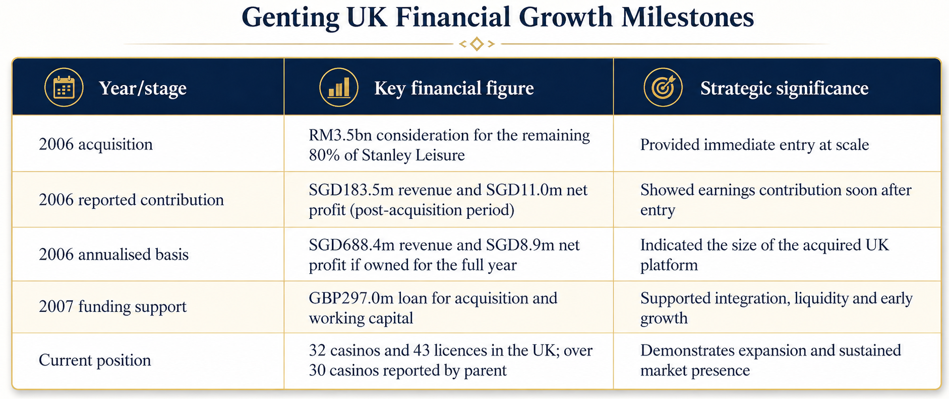
Figure 8: Genting UK financial growth milestones
Source: Author’s own illustration based on Genting Berhad (2006), Genting Berhad (2007), Genting Berhad (2025) and Genting Casinos (2026).

References
Barney, J. (1991) ‘Firm resources and sustained competitive advantage’, Journal of Management, 17(1), pp. 99–120.
Buzz Group (2024) Record FY23 growth continues in 2024. Available at: https://www.buzzgroupltd.co.uk/news/2023-results (Accessed: 19 June 2026).
Chaffey, D. and Ellis-Chadwick, F. (2022) Digital marketing: Strategy, implementation and practice. 8th edn. Harlow: Pearson.
Flutter Entertainment (2026) Annual report and accounts 2025. Available at: https://flutter.com/media/le5b5mp4/2025-annual-report-and-accounts.pdf (Accessed: 19 June 2026).
Gambling Commission (2021) Consumer experiences and attitudes to free bets and bonuses. Available at: https://www.gamblingcommission.gov.uk/about-us/guide/consumer-experiences-and-attitudes-to-free-bets-and-bonuses (Accessed: 19 June 2026).
Gambling Commission (2024) Gambling Survey for Great Britain: Annual report 2023 – Executive summary. Available at: https://www.gamblingcommission.gov.uk/report/gambling-survey-for-great-britain-annual-report-2023-official-statistics/gsgb-annual-report-executive-summary (Accessed: 19 June 2026).
Gambling Commission (2025) Industry statistics: Annual report, financial year April 2024 to March 2025. Available at: https://www.gamblingcommission.gov.uk/statistics-and-research/publication/industry-statistics-annual-report-financial-year-april-2024-to-march-2025 (Accessed: 19 June 2026).
Gambling Commission (2025a) Statistics on gambling participation: Wave 2, April to July 2025. Available at: https://www.gamblingcommission.gov.uk/statistics-and-research/publication/statistics-on-gambling-participation-wave-2-april-to-july-2025-official (Accessed: 19 June 2026).
Gambling Commission (2025b) Industry statistics: Annual report, financial year April 2024 to March 2025. Available at: https://www.gamblingcommission.gov.uk/statistics-and-research/publication/industry-statistics-annual-report-financial-year-april-2024-to-march-2025 (Accessed: 19 June 2026).
Gambling Commission (2026) Non-remote casino sector: Legislative changes guidance. Available at: https://www.gamblingcommission.gov.uk/licensees-and-businesses/guide/non-remote-casino-sector-legislative-changes-guidance/ (Accessed: 19 June 2026).
Genting Berhad (2006) Annual report 2006. Available at: https://www.genting.com/wp-content/uploads/2017/07/2006.pdf (Accessed: 19 June 2026).
Genting Berhad (2007) Annual report 2007. Available at: https://www.genting.com/wp-content/uploads/2017/07/2007.pdf (Accessed: 19 June 2026).
Genting Berhad (2025) Integrated annual report 2024. Available at: https://www.genting.com/wp-content/uploads/2025/05/GENTING_IAR24v3.pdf (Accessed: 19 June 2026).
Genting Casino (2026) Find your nearest local casino UK. Available at: https://www.gentingcasino.com/local-casinos/ (Accessed: 19 June 2026).
Genting Casino (2026a) Genting Casino: Online casino and live casino. Available at: https://www.gentingcasino.com/ (Accessed: 19 June 2026).
Genting Casino (2026b) Genting Casino Members’ Club. Available at: https://www.gentingcasino.com/members-club/ (Accessed: 19 June 2026).
Genting Casino (2026c) Genting Live. Available at: https://www.gentingcasino.com/live-casino/genting-live/ (Accessed: 19 June 2026).
Genting Casinos (2026) About Genting UK. Available at: https://www.gentingcasinos.co.uk/about-genting-uk/ (Accessed: 19 June 2026).
Google Play (2026) My Genting. Available at: https://play.google.com/store/apps/details?id=com.genting.rewards (Accessed: 19 June 2026).
Grönroos, C. (1994) ‘From marketing mix to relationship marketing: Towards a paradigm shift in marketing’, Management Decision, 32(2), pp. 4–20.
Hollywood Bowl Group (2025) Annual report 2025. Available at: https://ar.hollywoodbowlgroup.com/ (Accessed: 19 June 2026).
Johnson, G., Whittington, R., Scholes, K., Angwin, D. and Regnér, P. (2020) Exploring strategy. 12th edn. Harlow: Pearson.
Kotler, P., Keller, K.L. and Chernev, A. (2022) Marketing management. 16th edn. Harlow: Pearson.
Payne, A. and Frow, P. (2005) ‘A strategic framework for customer relationship management’, Journal of Marketing, 69(4), pp. 167–176.
Pine, B.J. and Gilmore, J.H. (1999) The experience economy: Work is theatre and every business a stage. Boston, MA: Harvard Business School Press.
Porter, M.E. (1985) Competitive advantage: Creating and sustaining superior performance. New York: Free Press.
Rank Group (2025a) Grosvenor Casinos: 2024/25 strategic KPIs. Available at: https://www.rank.com/our-brands/ (Accessed: 19 June 2026).
Rank Group (2025b) Annual report and accounts 2025. Available at: https://www.rank.com/investors/results-reports-and-presentations/ (Accessed: 19 June 2026).

