DS 1 Assessment

My Screenshots/Photos
- Please add 4–6 screenshots or photos of your digital life.
- You can use your phone or laptop.
- For each screenshot, write one or two sentences explaining what it shows.

Screenshot/Photo 1
[Insert Photo/Screenshot below]
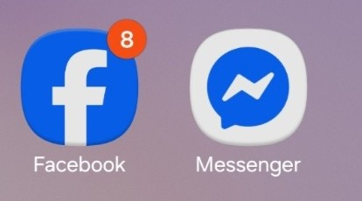
[Apps that I’m using for socialise and entertainment]

Screenshot/Photo 2
[Insert Photo/Screenshot below]
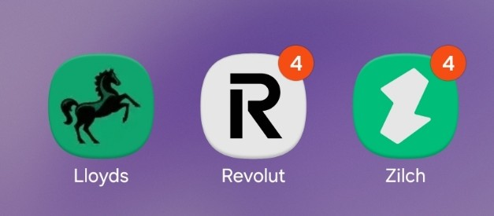
[Apps that I’m using for internet banking]

Screenshot/Photo 3
[Insert Photo/Screenshot below]
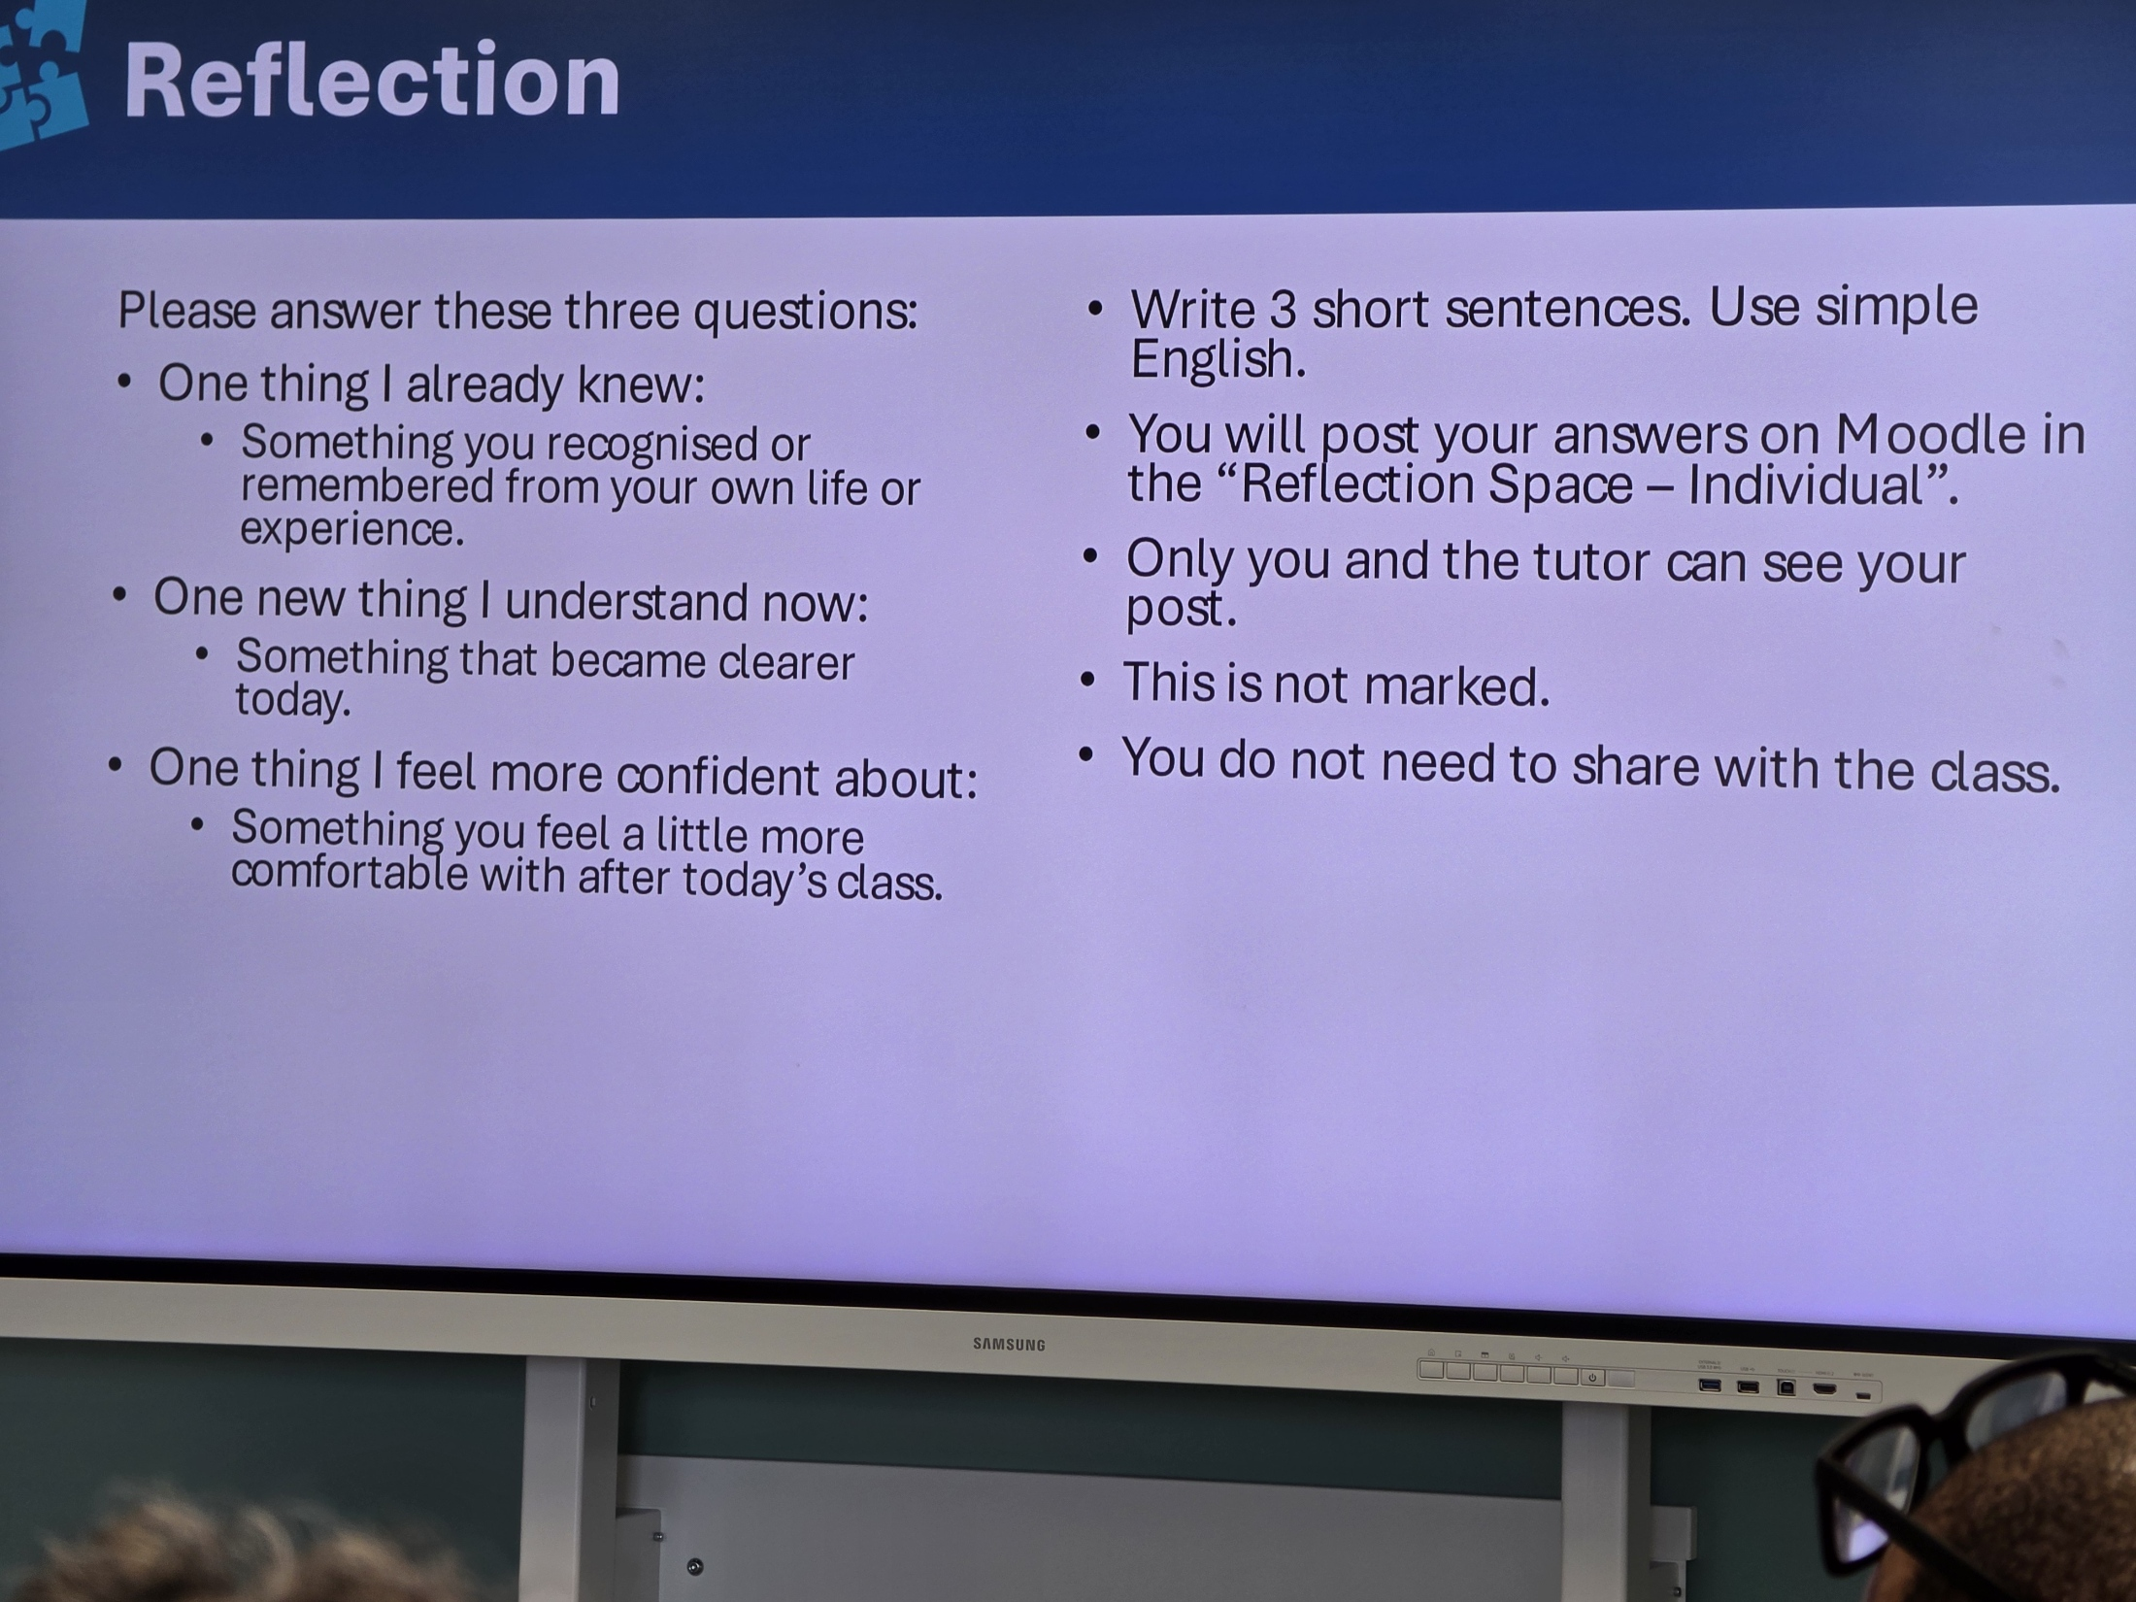
[This is the way that I’m using the phone camera to take pics in class for extra help]

Screenshot/Photo 4
[Insert Photo/Screenshot below]
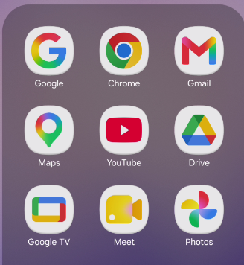
[Apps that I’m using for email, to organise photos, to navigate, to find information]

Screenshot/Photo 5
[Insert Photo/Screenshot below]
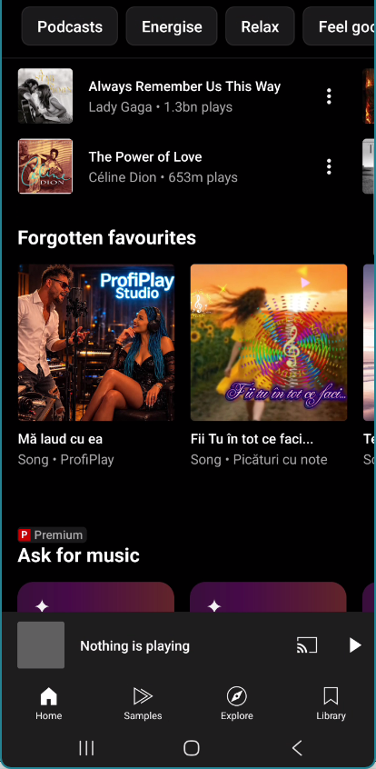
[YouTube music is the app that I’m using to leases music]

My Short Reflection
- Write 5–8 simple sentences about your digital life.
- You can use the sentence starters below if helpful.
- I use digital tools to organise my emails and my folders to make it easier to find.
- I often use these tools: Gmail, Word, PowerPoint, YouTube.
- I want to improve my knowledge about all Microsoft tools.
- Digital skills are important for me because it helps me to grow in the world of technology.
- I feel confident in using some of the tool in my day-by-day life like: YouTube, google search.

