
Skills for the Workplace
Module Assignment Submission
Student Name: | Caroline Smitham
Student Number: | 2011711
Module No: | BMSK4004
Module Title: | Problem Solving and Decision Making

Statement of Confirmation of Authenticity
By the act of making this submission, the student declares that this is the work of the student named above. The work has not, in whole or in part, been knowingly presented elsewhere for assessment, or where assessment has been built on a previous assessment, this has been identified. Where materials have been used from other sources it has been properly acknowledged. If this statement is untrue, the student acknowledges that an assessment offence has been committed.
Attention is drawn to the plagiarism and unfair practice policies of UWTSD.

Table of Contents
Analyse information on the identified problem, to help inform the decision-making process 17
Propose a range of alternative solutions to the problem 18
Using a decision-making technique, evaluate a range of solutions to identify the most appropriate option 19
Develop a detailed plan for implementing the solution 20
Communicate the plan to relevant stakeholders 21
Assess appropriate monitoring and review techniques to ensure successful implementation of solution 21
References 22
Appendix 1 22

Define a complex problem in the workplace, including its scope and impact

Every workplace is faced with a problem everyday, some could be simple problems and other are more complex. In my workplace at the University, we are often faced with a complex problem with a member of staff taking regular sick leave giving little notice to the department. The university is a public sector organisation and short notice sick leave can have a massive impact on students, visitors, and deliveries. It also effects the whole department including management and other staff members. The impact that sickness leave as on a whole department include:
- Reduced productivity
- Reduced motivation and morale from other team members
- Reduced customer satisfaction
- The cost of paying the persons salary as well as having to find, train and pay temporary staff.
The impact it has on other employees is the extra workload that they must take on, which can lead to stress and more sickness absence from other team members
According to the Office of National Statistics, the leading causes of sickness absence in the UK are:
- Musculoskeletal conditions e.g., Neck and back pain
- Minor illnesses like the common cold and more recently COVID19.
- Mental health issues including depression, anxiety, and stress.
With regular sickness leave from the team member they tend to miss deadlines, team meetings and any training sessions that may occur when they are off, this then can result in poor performance levels, lower productivity in their work.
There could be many reasons why this member of the team is taking frequent sick leave, so it is important to acknowledge their concerns and be supportive when they are in work.
There are a few options for the department to arrange cover they include having other staff members cover the building or using agency workers. The course of action required will depend on many factors like the length of absence and if further cover will be required in the future.
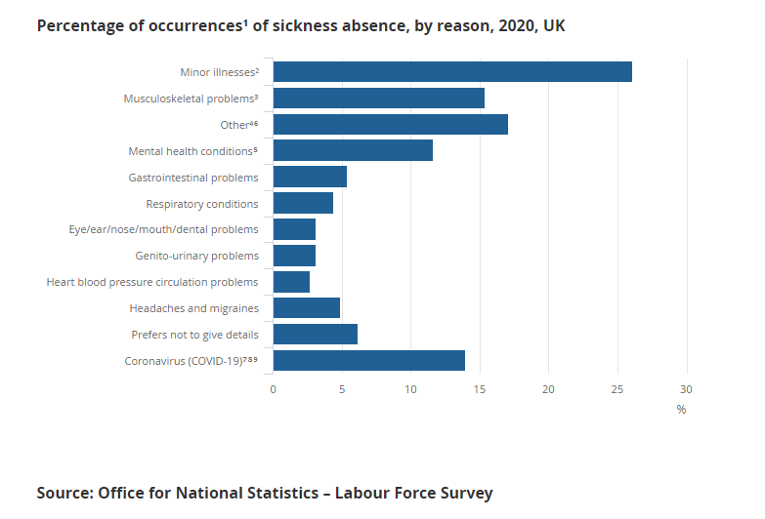

Analyse information on the identified problem, to help inform the decision-making process
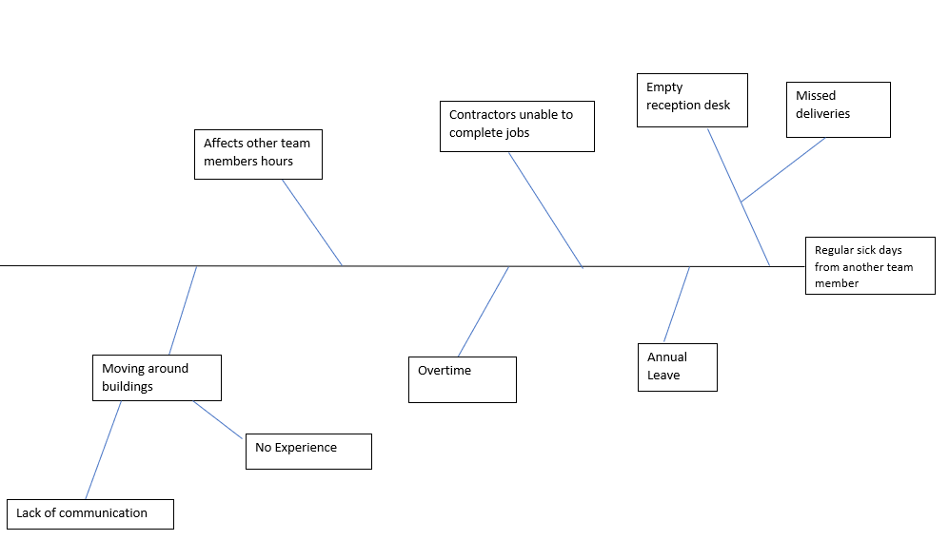

People take time of work for several reasons, when employees book time off for annual leave it is usually in advance and prior arrangements can be made. With regular unexpected sickness absence taken it can heavily impact productivity, employee and moral and influence profits. It affects other staff members as they must pick up the absent employees work as well as their own. Also, some staff members have no experience in the role that they need to cover so this then affects customer satisfaction.
There are many ways to reduce regular sickness absence at the workplace these include:
- An attendance/sickness policy
- Wellbeing programme for employees
- Reduce work-related stress (encouraging staff to take regular breaks)
- Motivate employees by offering incentives for performances
- Flexible working hours
- Provide support for personal problems
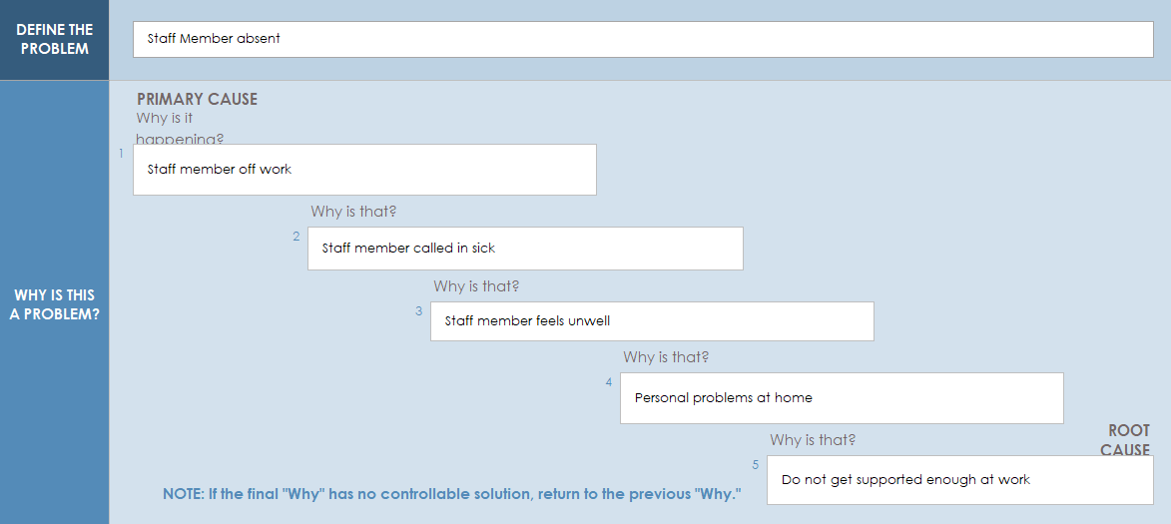
To get to the root of the problem, I have used ‘The 5 whys’ technique to get in an in depth understanding of the situation.

Staff members taking regular absence from work can be a difficult problem to deal with, as there are both genuine and poor excuses for not attending work without prior authorisation. It is important for employers to take an active approach to staff issues and focus on the root cause behind the problem.

Propose a range of alternative solutions to the problem

There are many ranges to solve the solution of covering an unplanned absent staff member, for short periods of leave the first port of call would be using existing staff members and would unlikely cause much disruption. By creating a clear sickness policy this can help monitor employee’s attendance record for better management and help if the employee needs extra support in work. (Appendix 1).
Employees who are not motivated find ways to miss work, if they are not enjoying their job, or do not feel appreciated or valued. Job satisfaction is essential for employees to succeed in their work, there are a few options that can keep employees motivated
- Hire strong motivated managers – According to survey monkey managers are responsible for at least 70% of the difference in employee engagement levels.
- Providing necessary tools – Keeping up to date with the latest technology and regular training as this helps avoid employees getting frustrated when they know how to do their job.

- Showing appreciation – Acknowledgement by managers, builds trust and according to survey monkey research employees who have supportive managers are 67% more engaged and are likely to stay in the company.

- Incentives – Employee incentive programmes help increase productivity and morale and build bonds with other team members. (Top Employee Incentive Programs Examples in Workplace)

- Agency Staff – This can help with cover to relieve the pressure of other team member is there is a long-term absence but there is a disadvantage with this option as recruitment agencies can be expensive.

Using a decision-making technique, evaluate a range of solutions to identify the most appropriate option

OPTIONS | TIME | COST | LOCATION | TOTAL
WEIGHTS | 2 | 3 | 5
Overtime for existing staff | 1 2 | 5 15 | 5 25 | 11 42
Relocating existing staff | 3 6 | 4 12 | 5 25 | 12 43
Recruitment agency staff | 5 10 | 1 3 | 2 10 | 8 23

I have produced two techniques on how to decide which is the best way to solve my problem. Above is a grid analysis that I have produced to decide between several options when factors need to be considered.
Before completing the grid analysis, I thought that employing agency staff would be the best option to the problem but after researching further it I found that agency staff do have disadvantages, they include the following:
- Lack of communication to other team members can have severe financial repercussions
- Agency staff have less training as work must be completed quickly – Although a temp worker may have some experience in the field of work required there is still a need to train to complete tasks.
- Agency staff do not have the same bond as long-term employees – It can be difficult to build rapport with other colleagues as it is only a temporary arrangement.
- Cost concerns, Agency staff will cost you money in commission or fees.

According to an article (How Much Do Recruitment Agencies Charge?2021) the fees that recruitment agencies charge employers can be significant. A recruitment agency will charge between 10-30% of the base annual salary.
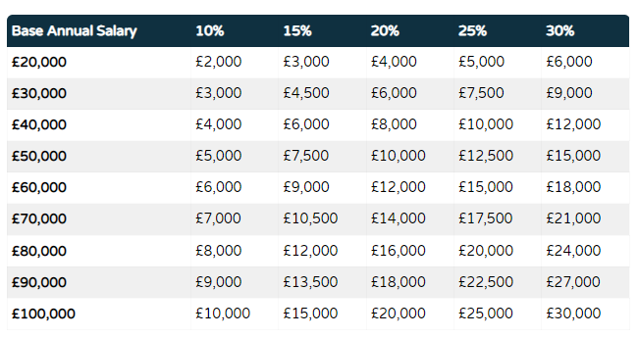
The table above highlights the predicted fees that recruitment agencies charge.
Cost Benefit Analysis Template
 | COST
 | Years
 | 1 | 2 | 3 | 4 | 5 | Cost Total
Recruitment Agency Staff | £6,600 | £7,260 | £7,986 | £8,783 | £9,661 | £40,290
Training | £1,530 | £500 | £1,530 | £500 | £0 | £4,060
Total Costs | £8,130 | £7,760 | £9,516 | £9,283 | £9,661 | £44,350
 | BENEFIT
 | Years
 | 1 | 2 | 3 | 4 | 5 | Benefits Total
Overtime for existing staff members | 6000 | 6600 | 7260 | 7986 | 8783 | 36629
Reduced Training costs | 500 | 500 | 500 | 500 | 500 | 2500
Total Benefits | 6500 | 7100 | 7760 | 8486 | 9283 | 39129
Work out ratios below
Benefit to Cost Ratio = Total Benefits = |  | 0.8:1
Total Costs
Net Annual Benefit = Annual Benefit - Annual Cost
(First year) | £8,130 | minus | £6,500 | = equals | £1,630
Net Annual Benefit = Total Benefits – Total Costs = |  |  | £39,129 | minus | £44,350
5 |  |  | 5
 |  |  | NAB = | -£5,221

In the cost benefit analysis above it is shown that that the cheaper option is not really the best option and does not really benefit cost wise in the future.
Recruiting agency workers is more costly but the advantage to this is they have access to the best candidates for the job, The candidates would have basic knowledge in their field of work, recruitment agencies check references, collect CV’s and filter jobseekers. (Niamh Keenan,2020). Hiring an agency worker is quicker than trying to find your own candidates and will save time and money in the future.
To have existing staff member cover shifts and taking on extra work can lead to employee burnout as people will end up taking on too much. More than three-quarters (79%) of UK workers have experienced burnout with 35% reporting high or extreme levels, according to new research. (“At a glance: reward and benefits headlines this week 26 November - 2 ...”) (“At a glance: reward and benefits headlines this week 26 November - 2 ...”) (Zoe Wickens, 2021). Human capital management technology business Ceridian’s annual 2022 Pulse of talent report surveyed 1,156 UK members of staff in organisations with at least 100 employees, revealing that the vast majority have struggled with burnout, while 58% are either actively seeking or open to new employment.
The research highlighted that the top three catalysts for this were increased workloads (49%), mental health challenges (34%), and pressure to meet deadlines (32%). (https://employeebenefits.co.uk/79-uk-staff-gone-through-burnout/).

Develop a detailed plan for implementing the solution

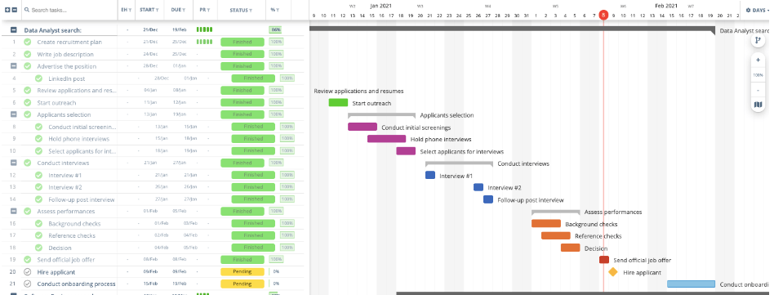
(https://instagantt.com/templates/job-recruitment-template)
Findind an individual to cover a role is not just selecting and hiring a person it is finding a person with the right skills and experience, recruiting involves an important amount of planning to attract and find the right candidate. The human resources department would help with this process as they are a group who are mailnly responsible for training and development, the steps needed to follow in the recruitment process are:
- Identify the hiring need.
- Writing a job description which is specific and also attractive
- Advertising the position.
- Recruiting the position.
- Reviewing multiple applications.
- Selecting applicants and conducting initial screenings.
- Interviewing.
- Assessment applicants and performances.
- Background checks.
- Decision making.
- Checking references.
- Sending official job offers.
- Hiring applicant.
- Onboarding process such as the administration tasks such as bank details, next of kin information.

Communicate the plan to relevant stakeholders

Assess appropriate monitoring and review techniques to ensure successful implementation of solution

References

, What is Employee Absenteeism? Effect, Reasons, Remedies-03-11T10:11:27.000Z, 2019-last update. Available: https://blog.vantagecircle.com/employee-absenteeism-hr-guide/ [Aug 31, 2022].
Grid Analysis to Make Tough Business Decisions. 2018.
What Are The Effects Of Sickness Absence On Your Workplace? | Occupational Health Business Management. 2015.
, 5 simple employee engagement ideas you need to implement. Available: https://www.surveymonkey.co.uk/mp/5-simple-employee-engagement-ideas-implement/ [Aug 31, 2022].
, Effective Problem-Solving Steps in the Workplace | Indeed.com. Available: https://www.indeed.com/career-advice/career-development/effective-problem-solving-steps [Aug 18, 2022].
, How To Manage Sickness In The Workplace. Available: https://www.search.co.uk/blog/2020/02/how-to-manage-sickness-in-the-workplace?source=google.com [Aug 24, 2022].
, Problem solving vs decision making – what is the difference?. Available: https://www.changeboard.com/article-details/16960/problem-solving-vs-decision-making-what-is-the-difference-/ [Aug 31, 2022].
, Top Employee Incentive Programs Examples in Workplace. Available: https://recognizeapp.com/cms/articles/top-employee-incentive-programs-examples-in-workplace [Aug 31, 2022].
JOHNSON, E., -07-31T08:35:38+00:00, 2020-last update, Reducing absenteeism in the workplace. Available: https://cpdonline.co.uk/knowledge-base/business/reducing-absenteeism-in-the-workplace/ [Aug 26, 2022].

Appendix 1

RETURN TO WORK DISCUSSION FORM

Managers must ensure completion of this form for all absences. The form should then be sent under confidential cover to the Human Resources Department to be placed on the employees personnel file and actioned, where necessary. Please refer to the guidelines before conducting a discussion with an employee.

Surname……………………………………… Forename………………………………… Position:………………………………….. Faculty/School/Department………………………………….
The purpose of the return-to-work discussion is to ensure that every employee appreciates that whenever they are absent from work, an important member of the team is missing. The standard questions below are to be used by the manager to guide the discussion. Please refer to the Return-to-Work Discussion Guidelines and the Sickness Absence Management Policy for guidance.

- What was the reason for the absence? ……………………………………………………

- Was this absence related to a previous absence? YES/NO (If YES please give
details) …………………………………………………………………………………………………………
……………………………………………………………………………………………………………

- Is there any likelihood of a reoccurrence? YES/NO

- Did you seek medical advice from your Doctor/Consultant YES/NO
- Do you require further medical treatment?
(If yes please give details) ……………………………………………………………………….
……………………………………………………………………………………………………….…………
…………………………………………………………………………………………….……………………
……………………………………………………………………

- Did the Doctor/Consultant give any advice in respect of your work/work pattern?
…..………………………………………………………………………………………………………………
……………………………………………………………………………………………………………

- Are there any underlying problems relating to the absence that you wish to discuss (personal, work or domestic) and, if so, can any assistance be given to you by your Line Manager or Department?
……………………………………………………………………………………………………………………………
……………………………………………………………………………………………………………………………
……………………………………………………………………………… Was the absence notified in accordance with the correct procedure?

YES/NO

(If not please detail reasons why not)
……………………………………………………………………………………………………………………………
………………………………………………………………………………..…………………………………………
…………………………………………………………………………………

Self certification completed YES/NO

Medical certificate provided YES/NO

OUTCOME OF DISCUSSION

The outcome of the discussion is: (please tick)

  - No further action in relation to this period of absence is required

  - Managerial support to assist employee to achieve better attendance

  - Referral to Occupational Health Advisor/Counselling

  - Progress to more formal procedure

This decision is appropriate for the following reasons:
……………………………………………………………………………………………………………………………
……………………………………………………………………………………………………………………………
……………………………………………………………………………………………………………………………
……………………………………

Manager’s Name ……………………………………………………… Position ……………………………………………………… Faculty/Department ………………………………………………………

Manager’s signature…………………………………. Date………………………….
I acknowledge Return to Work Discussion Forms shall be retained on my personal file

Employee’s signature………………………………. Date…………………………….

THIS FORM SHOULD BE SENT UNDER CONFIDENTIAL COVER TO THE HUMAN RESOURCES DEPARTMENT

