Laboratory Heat Exchanger Experiment
LAboratory Experiment write up
Joseph Woodhouse-thomas
2019
Contents
Introduction 3
Methodology 3
Equipment 3
Experiment 1 3
Experiment 2 3
Experiment 3 3
Risk Analysis 3
Results 3
Experiment 1 3
Experiment 2 3
Experiment 3 3
Analysis 3
Mass flow rates 3
Water 3
Air 3
Specific heal capacity 4
Power, temperature efficiencies, LMTD and heat transfer coefficient 4
Power 4
Temperature efficiency 4
LMTD 4
Heat transfer coefficient 4
Experiment analysis 4
Experiment 1 4
Power 4
Temperature efficiencies 4
Heat Transfer coefficient 4
Experiment 2 4
Power 4
Temperature efficiencies 4
Heat Transfer coefficient 4
Experiment 3 4
Power 4
Temperature efficiencies 4
Heat Transfer coefficient 4
Conclusion 4
References 4
Bibliography 4

Introduction

This report is designed to provide a summation of the tests undertaken using the ‘TD1007’ water to air heat exchanger. This report will contain the methodology undertaken while undertaking the lab experiment, furthermore, looking into the figures obtained from the data produced by the TD1007. Concluding by analysing the graphs produced and elaborating on the findings.

Methodology

Equipment

To conduct the experiment the TD1007 was used (Figure 1) it is a specially made device with built in temperature sensors.
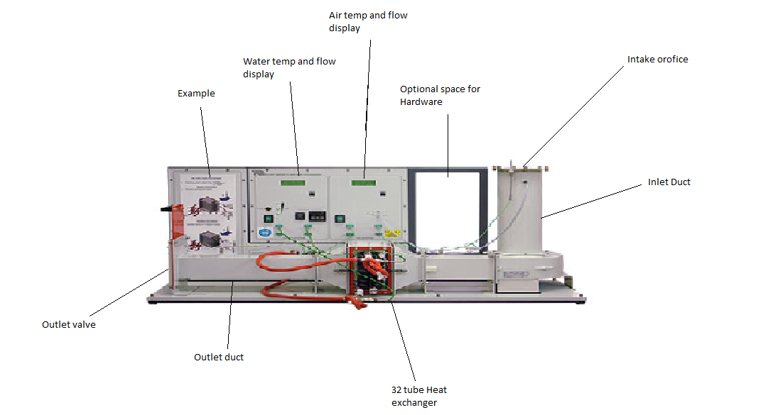
Figure 1 - TD1007 Heat Exchanger
The machine has a few key controls used within the experiment. A slide valve to control the pressure drop/ increase across the heat exchanger, a tap valve that determines the water mass flow rate, and a thermostat that controls the water chamber. Other equipment used was for the experiment was a stopwatch and a barometer to measure the rooms ambient pressure.

Experiment 1

The first experiment involved differing the water flow rate at a fixed water tank temperature.
- Set the TD1007 to parallel flow configuration
- Set the tank temperature to 60 º C
- Record the rooms ambient pressure using the barometer
- Note the intake orifice
- Turn on the intake fan using the slide valve, set the air pressure drop to 250pa.
- Turn on the water pump, using the valve set the water flow rate displayed to 2.25 L/min (This can vary +/- 0.01 L/min)
- Time four minutes for the temperature to stabilise, this can be recorder for 5-6 minutes depending on accuracy
- After four minutes record the water temperature in and out of the TD1007 heat exchanger and tank temperature
- After four minutes record the ambient temperature and air temperature in and out of the system
- Proceed by repeating this procedure at; 1.75, 1.25, 0.75, and 0.25pa decrease (allowing time for stabilization

Experiment 2

The second experiment involved changing the air flow rate with a fixed water temperature
- Set the TD1007 heat exchanger to parallel flow configuration
- set the tank thermo temperature to 60 º C
- Record the rooms ambient pressure using the barometer
- Not the intake orifice
- Turn on the intake fan using the slide valve, set the air pressure drop to 250pa
- Turn on the water pump, using the valve set the water flow rate displayed to 0.25 L/min (This can vary +/- 0.01 L/min)
- Time four minutes for the temperature to stabilise, this can be recorder for 5-6 minutes depending on accuracy
- After four minutes, record the water temperature in and out of the system and the tank temperature
- after four minutes record the ambient air temp and air temperature in and out of the system
- Repeat this process at flow rates; 200, 150, 100, 50pa pressure decrease

Experiment 3

- Set the TD1007 heat exchanger to parallel flow configuration
- Change the tank thermo temperature to 45 º C
- Record the rooms ambient pressure using the barometer
- Not the intake orifice
- Turn on the intake fan using the slide valve, set the air pressure drop to 250pa
- Turn on the water pump, using the valve set the water flow rate displayed to 0.25 L/min (This can vary +/- 0.01 L/min)
- Time four minutes for the temperature to stabilise, this can be recorder for 5-6 minutes depending on accuracy
- After four minutes, record the water temperature in and out of the system and the tank temperature
- after four minutes record the ambient air temp and air temperature in and out of the system
- Repeat this process at flow rates; 200, 150, 100, 50pa pressure decrease

Risk Analysis

The TD1007 is an enclosed system which means there is not a huge amount of heat transmitted from the machine, whereas PPE isn’t greatly necessary, it is still preferred that the conductor of the machine is left without a crowd surrounding them to prevent mistakes being made. Another area to look out for when under taking the experiment is the intake duct, it is necessary to keep hands away from this as it causes harm. To prevent anything from entering the intake duct, a metal mesh can be fitted at the top, this may affect the results but can be accounted for. It also steers clear of any un wanted objects entering the system.

Results

Experiment 1

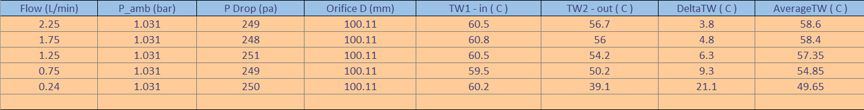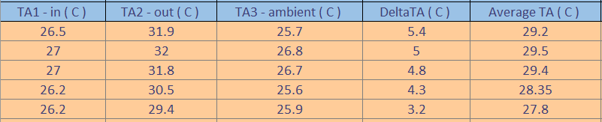
Figure 2 - Results for experiment 1

Experiment 2

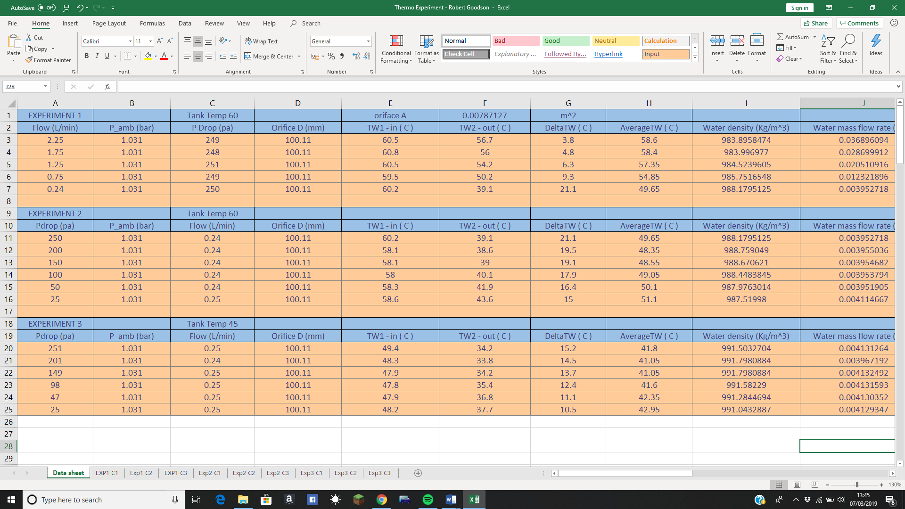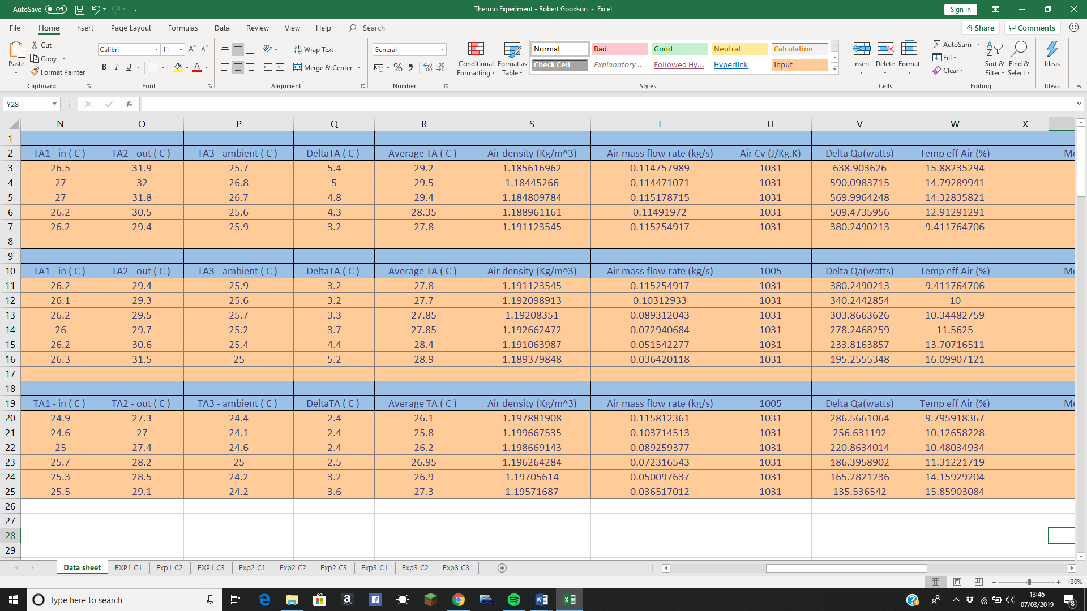
Figure 3 - results for experiment 2

Experiment 3

Figure 4 - Results for experiment 3

Analysis

Mass flow rates

Water

The heat exchanger records water flow in litres per minute, as the mass flow rate is required, further calculations are necessary. $Mass flow=ρ ×Volumetric flow,$where;
$ρ= \frac{kg}{m^{3}}$.
(Goodson, 2019) Although this could now be incorporated into the excel sheet, the change in temperature must be incorporated. TecQuipment have generated a formula concerning the relationship between water density and temperature, between the temperatures 4 and 70 º C. in this equation the temperature is takes as the average across the system.
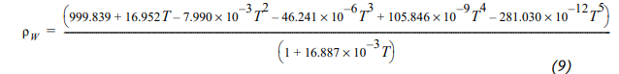
Figure 5 - Water density formula (TecQuipment)
Form this it is possible to convert the volumetric flow rate of the water, looking at experiment one;
$$Mass flow=983.8958474×\frac{2.25}{60000}$$
$=0.036896094 Kg/s$
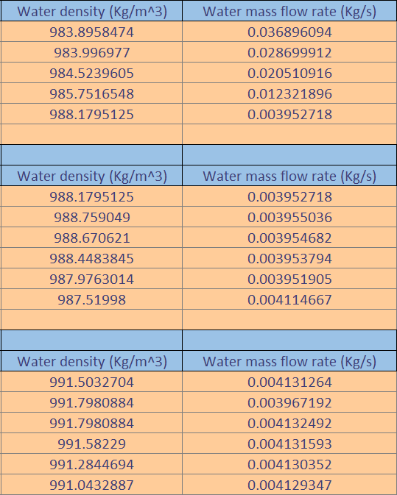
Figure 6 - water density and mass flow rates for experiment 1,2 and 3

Air

Just like the water, the heat exchanger does not measure the air mass flow rate. As don’t in the water, it is necessary to calculate some essential information to proceed. The system does however measure the pressure drop, it is evident that the correlation between a gasses pressure and its density can be calculated from the ideal gas equation;

$$ρ=\frac{p}{RT},$$

using this, the mass flow rate can be determined using the following;

${Mass flow}^{'}=C_{d}×A_{o}×\sqrt{∆p×2×ρ}$,

(TecQuipment, 2014).

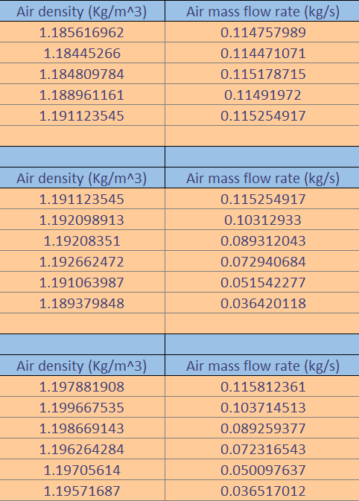
Figure 7 - air density and mass flow rate for experiment 1,2 and 3

Specific heal capacity

Continuing, the next step in the process is to calculate the specific heat capacity of each fluid, air is stated as 1031 J/kg.k, as it remains constant with the temperature range at atmospheric pressures (TecQuipment, 2014).

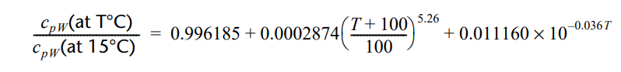
Figure 8 - formula linking water temp to specific heat capacity
(TecQuipment, 2014) Using the ratio of specific heat capacity at 15ºC and the mean temperature across the heat exchanger this formula can be used to link the water temperature to its specific capacity.

Power, temperature efficiencies, LMTD and heat transfer coefficient

Power

Power is the heat emitted by the water and absorbed by the air per unit time (J/s).

$\dot{Q}=\dot{m}C_{v}∆T$,

This equation shows the mass flow rate multiplied by the specific heat capacity and change in temperature between inlet and outlet. This is a raw indication of the heat energy exchange between the two fluids. An example of this is where the water flow was varied taking run 3 at 1.25L/min or as calculated 0.020510916 kg/s.

$$\dot{Q}=0.0205×4182.98×6.3$$
$$=540.52 W$$

However, the air in the same experiment came out as;

$$\dot{Q}=4.8×0.1151×1031$$
$$=569.99 W$$

As normally you would find that ${\dot{Q}}_{a}={\dot{Q}}_{w}$, as will be further investigated, this view of the heat exchanger does not hold the view of the non-ideal system. Looking forward, more processing is needed.

Temperature efficiency

Moving on from this the concept of temperature efficiencies arise. Temperature efficiency of the hot water circuit is the difference between the inlet and outlet temperatures over the maximum temperature differences between hot and cold fluid circuits multiplied by 100 to give a percentage, being the hot circuits ability to transfer the heat. The temperature efficiency of the cold circuit is the same procedure as the hot circuit, only using the difference between the inlet and outlet of the air. The mean temperature efficiency is the found adding the two temperature efficiencies together and dividing by two to be given the average efficiency between the two circuits.

Log Mean Temperature Difference

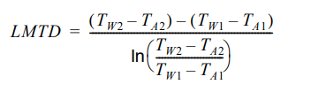
The log mean temperature difference (LMTD), is quite self-explanatory as it is a weighted average. It is the weighted average of the differences between the hot circuits and cold circuits inlet to the hot circuits and cold circuits outlet. Because the temperature is only measured at the outlet and inlet, the weighted average gives an approximation to the difference in the hot and cold circuits. The equation is as follows;
Figure 9 - LMTD equation (TecQuipment, 2014)

Heat transfer coefficient

The heat transfer coefficient is one in which describes the heat transfer at the boundary surface of the heat exchanger. It represents a concise way to quantify a heat exchangers performance. Given as;
$U (W/{m^{2}.K})$;
It shows output power of the exchanger per its unit area and temperature and represents their performance. This will form part of the further analysis as to the three experiments undertaken. As shown the higher the heat transfer coefficient the more efficient the heat exchanger. Heat transfer also utilises the previous property that;
$U=\frac{{\dot{Q}}_{w}}{A×LMTD}$ (TecQuipment, 2014).

Experiment analysis

Experiment 1
Analysing experiment 1, based on the previous figures generated, the effect of carrying the water mass flow rate.

Power

Figure 10 - Water mass flow rates effect on power output
Firstly, the graph clearly shows increasing power output and absorption, as the water mass flow rate increases. This means that even given a relatively constant air mass flow rate increasing the water mass flow rate, also increasing the time specific heat energy output, and increases the airs heat uptake despite not increasing its mass flow rate. it is important to note that the data here shows more power input to the air steam than the output. Considering the 1st thermodynamics this would disallow the spontaneous generation of energy within a system, concluding that the summation must be two-fold. One in which isn’t a perfectly isolated system and that energy externally to the system is being transferred.

Temperature efficiencies

Figure 11 - the effect of water mass flow rate on temperature efficiencies
It is clear from the chart that as water mass flow increases, the water circuit efficiency decreases, this is since the flow rate increases the water is presented less time to transfer its heat and so the temperature change between inlet and outlet reduces, on the other side as the water mass flow rate increases as does the air temperature efficiency. If it is related back to the power output data, the water passing through is outputting more heat per unit time, so the temperature efficiency increases at the fixed air mass flow rate. where the mean temperature efficiency decreases due to the dramatic decrease in the water temperature efficiency. This Implies that it depends on the goal of the heat exchanger; The higher mass flow rate has a worse temperature efficiency on the water side thus reducing the water temperature less but increases the air temperature efficiency because of the higher power output.

Heat Transfer coefficient

Figure 12 - The effect of varying water mass flow rate on heat transfer coefficient
The graph shows a clear trend that with an increase of water mass flow rate, the rate of heat transfer coefficient increases. This shows and backs up the notion that if passing a larger mass of high temperature water through a heat exchanger per unit time, increases the efficiency of the exchanger.

Experiment 2
Analysing experiment two, the effect of varying the air mass flow rate.

Power

Figure 13 - Air mass flow rates effect on power output

As expected from the trend line in the data, with increased air flow comes a rise in power absorption. It also shows an increase in power output from the water with increased mass air flow. An interesting observation is the large difference in power output of the water mass air flow. It is clear to see that the water is still clearly outputting significant power at lower air flow. It would be equitable to assume that the water is losing heat at the system boundary compounded by the lack of absorption by the air.

Temperature efficiencies

Figure 14 - The effect of the air mass flow rate on temperature efficiencies
Whereas in experiment one the data presented an intersecting trend, here we can see a difference in the temperature efficiencies, As the mass flow rate of air increases, so does the temperature efficiencies of the water. The airs temperature efficiency decreases, this keeps the mean temperature efficiency constant. These results are influenced by the temperature gradients between the hot and cold circuits. The lowest flow rate with the larger temperature gradient gives the highest temperature efficiency.

Heat Transfer coefficient

Figure 15 - The effect of varying air mass flow rate on heat transfer coefficient
Just the same as before, the graph shows an increase in the heat transfer coefficient, increasing with air mass flow rate. Despite the reduction in temperature efficiencies, there is still an increase in heat transfer per unit area and temperature. Therefore, it is evident in this data that the heat exchanger has better performance with higher mass air flow.

Experiment 3
Experiment 3 involves analysing the effect of changing the water tank temperature and air mass flow rate.

Power

Figure 16 - air mass flow rates effect on power output, water tank at 45 degrees
From the previous observation, the power output and absorption increase with air mass flow rate, however due to the reduced water tank temperature the absolute values have reduced. Around 80 Watts across the board, this is expected tough given that the energy released is entirely rational to the temperature difference and each fluid specific heat capacity. The absolute power output is reduced due to the tank temperature being closer to the ambient room temperature.

Temperature efficiencies

Figure 17 - The effect of air mass flow rate on temperature efficiency at tank temp of 45 degrees
The temperature efficiencies for this experiment and experiment 2 are very similar and show the same graph trend, as to increase in mass air flow for water and decrease for the air. The graph shows that the relative temperature gradients between the two circuits must be alike to decrease tank temperature. Knowing that the mean temperature efficiency remains similar to the previous experiment, it’s equitable to assume the tank temperatures has little effect on the temperature efficiencies.

Heat Transfer coefficient

Figure 18 - The effect of varying air mass flow rates and heat transfer coefficient with tank temp at 45 degrees
Due to the decrease in tank temperature, the graphs of the heat transfer coefficient sees a slight increase, this is due to the LMTD being reduced which is realistic as the heat transfer is proportional to the LMTD. Furthermore, the overall average temperature between the two fluids is the same value and the heat exchanger is more efficient.

Conclusion

To conclude this report, several trends can be seen, the higher flow rate of hot water increases the power output, this also showed that all systems are never perfectly insulated and that in this case the surrounding machine had a significant effect on the overall results. Furthermore, the temperature gradient between the two systems completely decides the efficiency of the system. additionally, to achieve the best heat transfer coefficient, the largest output of power output and the lowest LMTD must be attained.

Bibliography
Goodson, R. (2019). Thermofluid Dynamics. Swansea: moodle.
TecQuipment. (2014). TD1007 User Guide.

