EMERGENCY PLAN
First Aid/ Medical Emergencies
- CALL: 07885948573 - Designated First Aider – Chris Josty
- CALL: 01792 702222 – Morriston Hospital - Morriston, Cwmrhydyceirw, Swansea SA6 6NL
- CALL: 01792 704184 – Gorseinon Hospital - Gorseinon, Swansea SA4 4UU
- CALL: 01792 205666 – Singleton Hospital - Sketty Ln, Sketty, Swansea SA2 8QA
Site Evacuation
- Call all persons on the call sheet. Make sure everyone is accounted for.
- Confirm with Director of production and whoever is in charge of the site you are using to film on, to proceed with site evacuation.

Fire Emergency
- CALL: 0370 606 0699 – Morriston Fire Station - 50 Sway Rd, Morriston, Swansea SA6 6JA
Extreme Weather
- Contact all persons on the Call sheet.
- Confer whether to go ahead with filming or to post pone temporarily.
- Think of other ways to make day productive and efficient.
Film Production Cancellation/ Postponement
- Unless informed by the Director via a meeting or formal talk, do not presume filming is cancelled or postponed until told otherwise.

Missing Person
- CALL: 101 and inform them you would like to make a missing person’s report.

MAP OF SITE
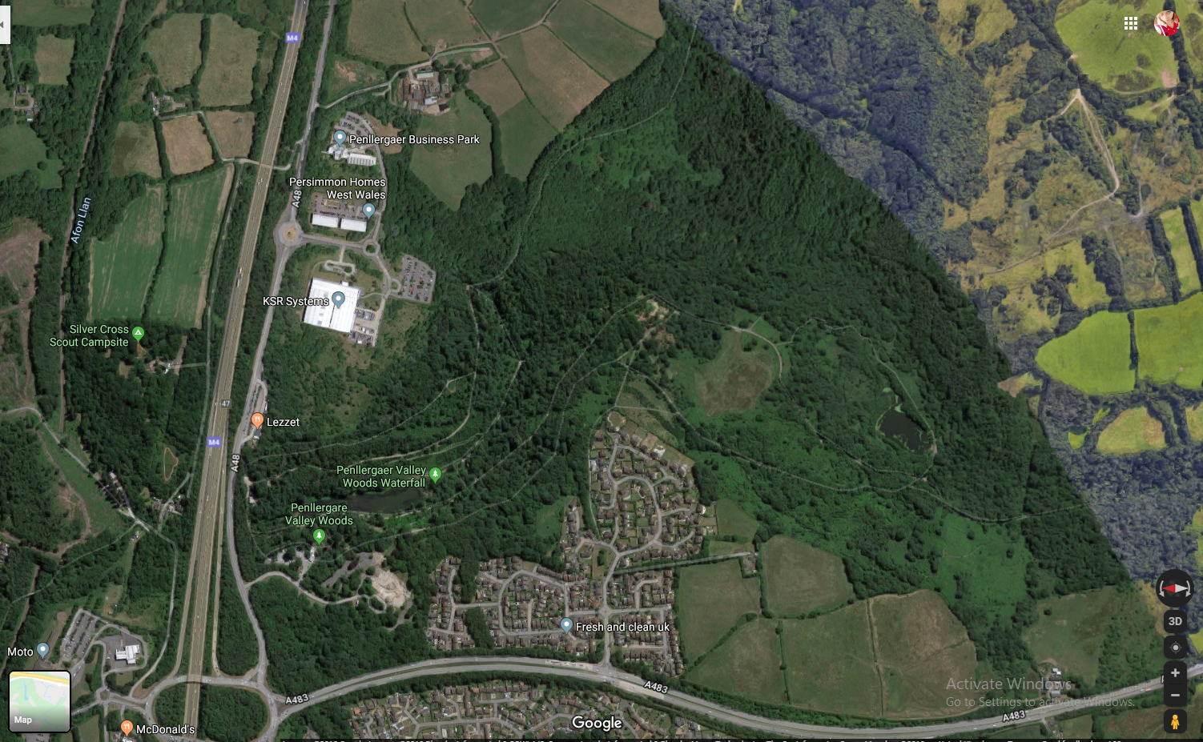
M4 Junction 47 services
Entrance Point to site

