University of Wales Trinity Saint David
Wales Institute of Science & Art



Material Selection Report & GD&T Drawings
Engineering Design and Materials (ACHA4004)

Badrakh Nyamsuren
2011093
July 2022
Contents
1. Introduction 3
2. Material Properties 4
3. Material Selection 4
4. Manufacturing Processes 5
5. Conclusion 8
6. Reference 9

Introduction
Most cars and motorcycles engine have a piston and it is important piece of it. The purpose of the piston is to take the pressure created during the process of combustion and convert it into a force applied to the crank shaft. The piston moves linearly and repeatedly up and down, which crank turns roundly. The pistons are made of different materials, sizes, shapes and manufacturing processes depending on its purpose or requirements such as, compression needs and quantity. This report will cover the material properties of a piston and its working environment. Therefore, the material that the piston could be manufactured from and the suitable manufacturing methods will be examined.

Material Properties

To produce a piston for an engine, there are few factors that should be mentioned before. Firstly, the new engine pistons must be able to function normally for hundreds and thousands of kilometres under high pressure and extreme temperature with no issue. To make this possible, the engineering this piece is not an easy task. It is clear that it has to be made of very strong materials and during its lifespan, the piston will work in extremely hot condition, vibration, inertia and tons of friction, which means, the material should be able to handle all the factors. The most suitable raw material that can take all the extreme conditions is Al¹³ periodic table or aluminium alloy containing Si (silicon) and most cars on the road has it (Koike and Tsuchida, 1997). According to European aluminium association, there are three basic types of aluminium piston alloys, AISi12 CUMgNi Eutectic alloy, AISiCuMgNi Hypereutectic alloy and AISi12Cu4Ni2Mg special eutectic alloy. The element aluminium is silver looking light weight metal that is abundant and widely used metal in automotive industry. The advantages of aluminium are high thermal conductivity, easy machinability, reliable, low density, simple net shape fabrication techniques and excellent recycling qualities (European Aluminium Association, 2011). In addition, aluminium piston can be used in both gasoline and diesel engines.

3. Material Selection450

The materials are the most important part of making the pistons. The piston will experience extreme conditions for many years and it has to survive it. There are materials can able to work in this condition and most pistons are also made from it. Most commonly used material is aluminium alloy containing Si or silicon because it is light, high thermal conductivity, easy machinability and very strong. Another material than can be used to make the piston is steel. They are significantly stronger than the aluminium pistons and it offers potential combustion and thermodynamic advantages that favour fuel consumption and reduced emission levels.

4. Manufacturing Processes 450

The car and motorcycle engine pistons are very hard working parts that are continuously subjected to back and forth movement. Almost all pistons are manufactured in two methods.

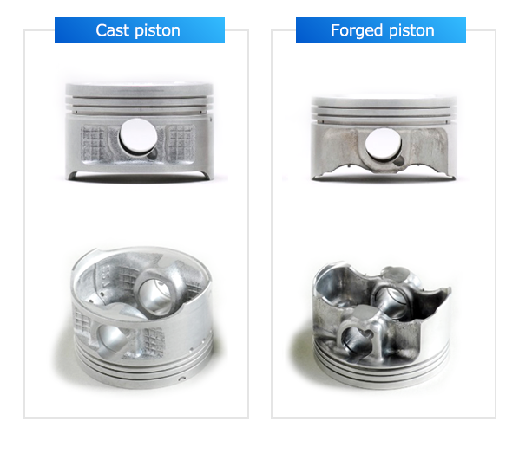
Figure 1. Cast piston and forged piston.

To start designing the piston from the ground, most engineers and designers start with sketching or dimensional drawing and then work it on the CAD drawing in order see the visuals and more changes if required, but most importantly, the purpose of the piston. For example, if the piston is for a performance engine then forged piston will be most likely required and cast pistons are for the stock or different applications. Once the design is complete, the piston can be made in two methods, casting and forged. The materials should be carefully chosen and the ability of machinability when producing, welding ability, casting ability and bonding ability must be considered before making the pistons.

4.1 Cast piston

In general, the majority of pistons are produced by gravity die casting. It is because it can produce large amount of products in short period of time but also optimized aluminium alloy compositions and well controlled solidification process will make the piston light and tough. Casting will involve pouring molten aluminium, alloy and silicone into a mold and letting it to become hard in shape when it cools down and make the piston’s shape (Yamaha, 2022). This method is widely used and it is because it can produce pistons with excellent properties from strength to heat resistance. During the casting process, alloy molecules settle freely, creating a random particle structure and expanding the potential for weaknesses. According to modern machine shop (2014), Federal Mogul Corp has developed a new casting method for a piston and it produces more wear resistant rings, stronger and higher quality pistons. This method is based on a vertical casting that uses mold design that allows optimization of the blank and gating system design which means the material flow will be controlled better. The cast pistons are cheaper compared to forged pistons because of the manufacturing methods and materials, but they are more than enough for most applications.
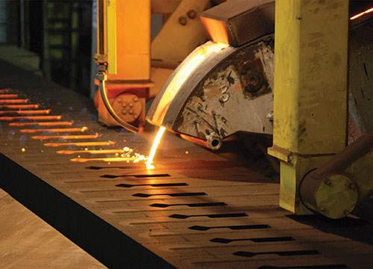
Figure 2. Casting process

4.2 Forged piston

Normally, the forged pistons are stronger compared to a cast piston. The cast pistons are good enough for most engines but when it comes to car enthusiasts and performance engine builders, the engines are usually fitted with forged pistons in order to provide high compression ratio, more horse power and enabling the engine to rev higher. It is because they are durable and customised to any configuration, which is important in performance engine. The main difference between the forged and cast piston is manufacturing technique. Forging is a process developed from blacksmithing that applies a comprehensive force to control and deform a metal into a specific shape. At its most basic, it is a blacksmith working a piece with a hammer and anvil (Huizenga, 2018). In addition, there is no need of heavy and expensive casting equipment as applied in the manufacturing cast pistons but, this does not mean that cast piston is better than forged piston. The method of forging compresses the molecules inside the alloy, which leads in a denser surface area compared to a cast piston. In fact, forged pistons are heavier than the cast pistons, but this is counteracted by the ability to provide a high compression ratio inside the engine and enabling the engine to rev higher which results more power (Cars Direct, 2022).

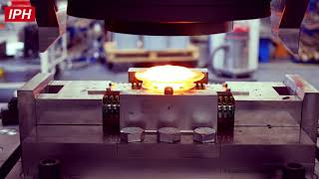
Figure 3. Forging the piston

5. Conclusion

In conclusion, many materials and piston manufacturing methods are have mentioned. In stock cars, cast pistons are more likely used in most application and forged pistons are expensive compared to the cast pistons but in terms of quality and strength they are mostly used on performance vehicles and custom engines. The aluminium alloy with silicon is the best option to make a strong and light piston that last long. In terms of manufacturing, the forged pistons are expensive and longer than cast pistons while making great quantity in short period. In future, engineers and designers may come up with better and cheaper manufacturing process to produce a great piston.

6. Reference

European Aluminium Association (2011) The Aluminium Automotive Manual. Available at: https://www.european-aluminium.eu/media/1570/aam-applications-power-train-1-pistons.pdf (Accessed: 20 March 2022).

Cars Direct (2022) The Benefits of Forged Pistons. Available at: https://www.carsdirect.com/aftermarket-parts/why-install-forged-pistons (Accessed: 20 July 2022).

Huizenga, P (2018) How a forged piston is produced. Available at: https://www.motortrend.com/how-to/1803-how-a-forged-piston-is-produced/ (Accessed: 20 July 2022).

John, C.N. (2022) What Metals Are Engine Piston Made From. Available at: https://itstillruns.com/metals-engine-pistons-made-from-12178964.html (Accessed: 20 March 2022).

Koike, T. and Tsuchida, N. (1997) Aluminium alloy for a piston and method of manufacturing a piston. Available at: https://patents.google.com/patent/EP0892075A1 (Accessed: 20 July 2022).

Modern Machine Shop (2014) New Casting Process for Better Piston Rings. Available at: https://www.mmsonline.com/articles/new-casting-process-for-better-piston-rings (Accessed: 20 July 2022).

Yamaha (2022) Forged Piston. Available at: https://global.yamaha-motor.com/business/mc/mc-tech/standard-technology/forgingPiston.html (Accessed: 20 July 2022).

Iphhannover (2017) Schmieden mit Hinterschenitten am Beispiel von Stahlkolben [video] Available at: https://www.youtube.com/watch?v=G6QXay3azYg (Accessed: 20 July 2022).

