STUDENT NAME: Nuria Monteiro Alves
STUDENT NUMBER: 2327581
MODULE CODE: LCLM 4001 Academic Skills (FEB 24)
LECTURER: Tim Hopkins
REFLECTIVE REPORT

CONTENT PAGE
- Introduction 3
- Reflection 4
  - Note-taking skills. 4-5
  - Finding information and research skills. 6-7
  - Referencing skills. 8-9
- Conclusion 10
- References 11
- Appendices 12
  - 12
  - 13-14
  - 15-16-17

- INTRODUCTION
During my time studying the Academic Skills Module, I have had an incredibly enriching and rewarding experience. The course has provided me with a wealth of new knowledge and skills, and I am excited to reflect on my experiences in this report.
To ensure that my report is comprehensive, I have taken diligent notes throughout the term and have utilized all the resources available on Moodle. This platform has been an invaluable tool for me throughout the course, providing me with access to a wide range of materials and resources that have helped me to better understand the concepts and ideas we have covered.
Of course, the most significant contributor to my success in this course has been the guidance and expertise of my instructor, Tim Hopkins. His teaching style is engaging and insightful, and he has a remarkable ability to break down complex ideas into manageable pieces that are easy to understand.
In composing this report, I have chosen to use the Gibbs (1988) method, which is widely recognized as one of the most complete and effective methods for reflecting on learning experiences. This method provides a solid foundation for conveying the knowledge and insights that I have gained from the Academic Skills Module, and I am confident that it will allow me to produce a report that is both informative and engaging.

- REFLECTION
  - NOTE TAKING SKILLS
In week 2, I learned the importance of notetaking. Listening is important, but taking notes is even more important so that the information becomes meaningful and makes sense.
It also helps with your working memory and learning. Not everyone has the same working memory capacity.
More things I have learned are different kinds of note-taking methods that exist as:
- Cornell notetaking
- Diagram/spidergram.
- Mind map.
- Linear notes
- Tabular notetaking
Throughout this module, I have had the pleasure of discovering various note-taking methods that have truly transformed my approach to learning. While I was already familiar with some techniques, the Cornell method presented a fresh and innovative approach that I quickly became intrigued by. Admittedly, the initial challenges of adapting to this new method were daunting, but my passion for effective learning strategies drove me to eagerly embrace this new approach.
The process of learning and mastering these note-taking methods has been an incredibly fulfilling experience, leading to a significant amount of personal growth. Although it has not always been easy, my persistence and dedication have paid off, and I have been able to witness my progress firsthand. I can confidently say that my newfound ease in practicing these methods is a testament to the rewards of perseverance and dedication.
From day one, the information presented in this module has been clear and concise. While many of the concepts were unfamiliar to me, the explanations provided were thorough and easy to understand. As a result, I was able to quickly grasp new ideas and concepts that were previously foreign to me.
Overall, my experience with this module has been overwhelmingly positive and useful. I have no criticisms or negative feedback to offer. Instead, I feel incredibly grateful for the opportunity to learn and master these note-taking methods, which I am confident will serve me well in my future studies, as well as in my personal and professional life.

Appendices1.1
  - FINDING INFORMATION AND RESEARCH SKILLS.
In week 3, I learned how to research and find information.
Ivana Curcic came to the class to teach how to find information through the University's online library. Also, I learned about different types of sources to find information. As a student, the most trustful sources to develop assignments are:
- Academic books- a formal source of information written by experts.
- Journal articles-they are published in academic journals about the original research.
- Conference papers-they are published after a conference.
- Newspaper-short articles aimed at the public about current events.
Another important point I learned is the difference between searching for information at the library and on the Internet. I also know how to evaluate information using the CRAAP test, which is a list of questions that help evaluate the found information.
There are:
- Currency-timelines of the information.
- Relevance-the importance of the information.
- Authority-the source of the information.
- Accuracy-the reliability, truthfulness and correctness of the information.
- Purpose-the reason the information exists.
As a non-native English speaker, I have found this particular topic quite challenging as it has required me to acquaint myself with a variety of new and unfamiliar words due to my limited English vocabulary. Initially, I was a bit frustrated, but with time, I have become very happy with the outcome of my efforts because I have learned many new words that I can now use in my daily life.
The process of familiarizing myself with these new words has been both interesting and positive, and I am excited about the knowledge I have gained. However, I must admit that this topic has been quite complicated for me because it is entirely new and requires a lot of vocabulary that I was not previously familiar with. Nonetheless, I am happy with my progress because I have learned a lot of new words that have expanded my vocabulary significantly.
Accurate and reliable information is essential in today's world, and for me, the best way to access information is the Internet. However, I am aware that the internet is not always the most reliable source of information as anyone can manipulate information to suit their needs. Therefore, I am always cautious and verify the information I find on the internet through other trustworthy sources.
Overall, I find this topic helpful because it teaches us how to avoid mistakes and trust the information we read and see. From this point on, I plan to become more familiar with newspapers, journal articles, books, and other reliable sources to ensure the information I provide is accurate and trustworthy.

Appendices 1.2
  - REFERENCING SKILLS
During the fourth week of my studies, I gained knowledge about the concept of referencing and how it plays a crucial role in academic writing. Referencing refers to the practice of crediting the sources that have been used in the research process.
In order to produce a comprehensive and well-researched assignment, it is essential to gather information from various sources like books, e-books, articles, and journals. The inclusion of references in the assignment indicates that the writer has accessed and utilized the information from credible sources and has a thorough understanding of the subject.
The reference list must be included at the end of the assignment. It should provide a detailed account of all the sources consulted.
The Harvard referencing method is the referencing style that I have learned, which is widely used in academic writing.
To reference we need to provide:
Author’s surname and initials.
Year of publication
Title of book, paper, or article
And if it is a book:
Place of publication
Publisher
Also, I learned about plagiarism, self-plagiarism, and collusion.
- Plagiarism-copy /takes someone else work.
- Self-plagiarism-copy your own work.
- Collusion-cooperation/collaboration with other people.
At first, I found it a bit challenging to understand the order and application of the information that needed to be provided. However, once I grasped it, it became quite easy. This newfound understanding was significant because I had never done it before, and it was a completely new concept for me to learn. It was good to learn how to reference various sources, and I appreciated the opportunity to do so. Although I found referencing to be the least interesting topic that I learned this term, it is still essential, and I will surely use it in my future studies. Even though I do not think that I will use this method in my personal and professional life, I understand the importance of learning it.
In conclusion, I found this topic to be both useful and important to learn, as it will be applied in my future assignments. To ensure that I don't forget what I have learned, I will continue to practice using references. By doing so, I hope to make referencing a habit, making it easier for me to apply what I have learned in my future assignments.

Appendices 1.3
- CONCLUSION
I am immensely grateful for the wealth of knowledge that I have gained from reading the report's contents. The report has covered a variety of topics which have proven to be incredibly valuable to me. As I reflect on what I have learned, I cannot help but feel proud of my newfound knowledge. I am confident that this knowledge will benefit me greatly, both professionally and personally, as I navigate through life. Being a non-native English speaker, studying these topics has not only helped expand my vocabulary but has also boosted my confidence in the language. Even the topics that I initially felt indifferent towards have turned out to be informative and positive. As the saying goes, "EL SABER NO OCUPA LUGAR" (knowledge takes up no space in the mind), and I am grateful for every bit of it.

- REFERENCES
UWSTD (2024) Moodle Slides WK2 UWSTD London.
UWSTD (2024) Moodle Slides WK3 UWSTD London.
UWSTD (2024) Moodle Slides WK4 UWSTD London.
DRISCOLLS (1988)

- APPENDICIES
1.1
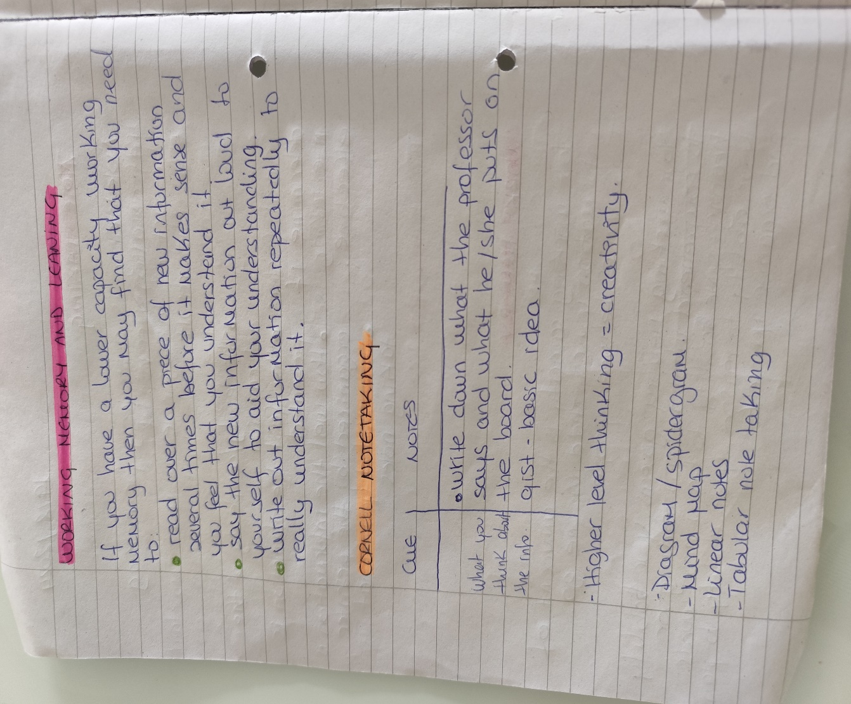

1.2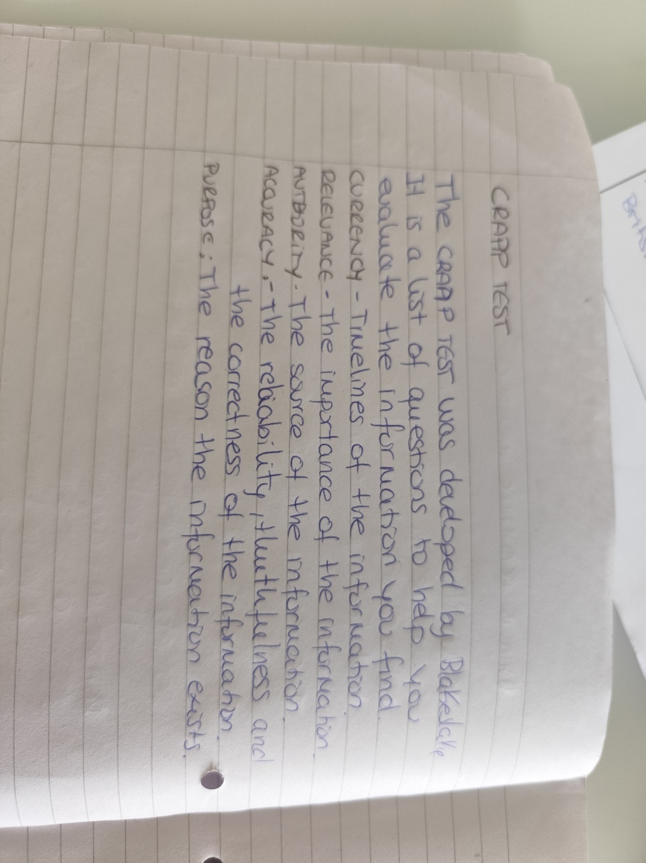
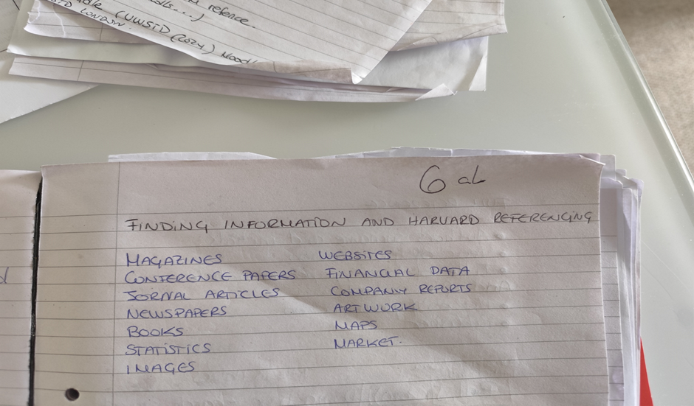

1.3


