An investigation of a potential no-traffic zone may increase protection of Bottlenose Dolphins (Tursiops truncatus) in Cardigan Bay Special Area of Conservation (SAC).

Naim Awal

1802441

Contents
- Introduction 3
  - Background on Cardigan Bay SAC 3
  - Background on no-take zones (NTZ) 4
  - Boat presence and dolphin behaviour 4
  - Rationale 5
  - Hypothesis 5
  - Independent and dependent variables 5
- Literature Review 5
2.1. Progress in the no-take zone 5
2.2. Progress in the no-traffic zone 6
2.3. Secondary data analysis 6
- Methodology 8
- Results 10
- Evaluation 10
5.1. Notable experiences 10
6. References 11

Tables
- Table 1: 8
Bottlenose dolphin juvenile mortality rates, within its first three years, studied from habitats globally (Veneruso and Evans, 2012).

Figures
- Figure 1: 3
Cardigan Bay SAC is represented as the rectangle and Pen Llŷn a’r Sarnau SAC is represented as the irregular polygon in Cardigan Bay, Wales, UK (Veneruso and Evans, 2012).
- Figure 2: 4
NTZ between Lamlash Bay and Holy Island, Isle of Arran, West coast of Scotland (COAST, nd; Scottish Government, 2008; Bower, 2011).
- Figure 3: 6
The average sightings density of bottlenose dolphins’ in Cardigan Bay SAC annually between May-July, units are groups/km² (Sea watch Foundation, nd).
- Figure 4: 7
A photograph of a bottlenose dolphin mother and her calf (Grout, 2018).
- Figure 5: 7
A flow chart showing various scales of coastal management for Ceredigion (Pallister, 2006).
- Figure 6: 9
A Google Earth image of New Quay coast within Cardigan Bay SAC, a recommendation to locate a designated a no-traffic zone, and a key stating vital information (Google Earth Pro, 2020).

- Introduction
  - Background on Cardigan Bay SAC
Bottlenose dolphins are listed as a priority species under the UK Biodiversity Action Plan (BAP) as well as a protected Annex II species (JNCC, 2015). There is an estimate of 300 identified Bottlenose Dolphins (Tursiops truncatus) in Cardigan Bay Special Area of Conservation (SAC) and is at favourable conservation status (FCS) (Simmonds, et al., 2013). Before Cardigan Bay having a designated special area of conservation (SAC), the status of bottlenose dolphins in the early 1990s is unknown (Veneruso and Evans, 2012), however, the next couple of decades meant that governance became a vital factor for marine protection in Cardigan Bay. Habitats Directive (92/43/EEC) has been adopted in 1992 by the European Union. Cardigan Bay was a candidate in 2001, however, the largest bay in the UK officially had a designated SAC in 2004 with the proximity of approximately 1000km² (Veneruso and Evans, 2012).

Figure 1: Cardigan Bay SAC is represented as the rectangle and Pen Llŷn a’r Sarnau SAC is represented as the irregular polygon in Cardigan Bay, Wales, UK (Veneruso and Evans, 2012).

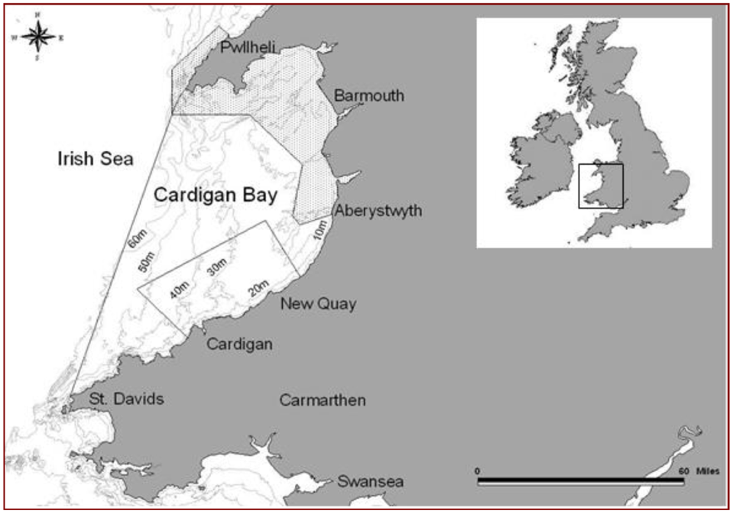

Figure 1 shows the Proximity of Cardigan Bay SAC and Pen Llŷn a’r Sarnau SAC in Cardigan Bay, however, the focus on this research proposal is only on Cardigan Bay SAC – in an area estimated to be 1000km² (Veneruso and Evans, 2012). The coordinates for Cardigan Bay are 52º12’55.93”N to 4º21’32.69”W. New Quay is one of several coastal towns at the Welsh coast that have a cetacean industry. New Quay, Aberystwyth and Cardigan have a total of 50% of cetacean-watching tour operations in Cardigan Bay (O’Connor et al., 2009; Hernández, 2015).

Cardigan Bay is one of two habitats for bottlenose dolphins in the UK, another habitat is Moray Firth in Scotland (Veneruso and Evans, 2012). Bottlenose dolphins are a predatorial species feeding on sand eel (Ammodytidae), wrasse (Labridae), flatfish (Pleuronectidae), blennies (Blenniidae), dragonet (Callionymus spp) and dragonet (Callionymus spp) (Evans et al., 2000; Dunn & Pawson, 2002; Pierpoint et al., 2009). In New Quay, bottlenose dolphins feed on white salmonids and pelagic shoaling species, such as mackerel (Scomber scombrus) and bass (Dicentrarchus labrax), as well as mullet (Mullidae) (Evans et al., 2002; Pierpoint et al., 2009).

  - Background on no-take zones (NTZ)
There are three no-take zones (NTZ) in the UK, one of which is in Lamlash Bay, Isle of Arran, Scotland (Bower, 2011). An estimated 0.04% of all marine protected areas in the world (MPA) are established as no-take zones (Jones, 2006). A no-take zone is a part of a marine protected area (MPA) where fishing and dumping, extracting natural materials and dredging are not allowed in given proximity, however, boats may still be allowed to enter the proximity of a no-take zone. The benefits of a no-take zone are that species, which are often protected, can spawn under protection that no human-made vessel is allowed to intervene (UKMPA, 2007). A no-traffic zone is similar to a no-take zone, boats are not allowed to enter the proximity of a no-traffic zone.

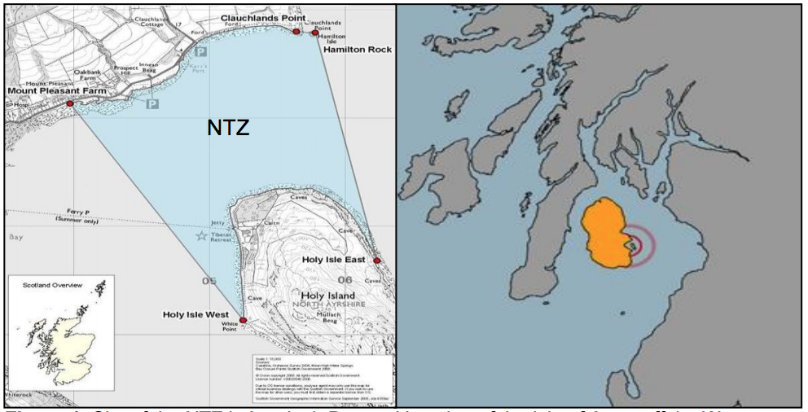
Figure 2: NTZ between Lamlash Bay and Holy Island, Isle of Arran, West coast of Scotland (COAST, nd; Scottish Government, 2008; Bower, 2011).

Figure 2 shows the no-take zone in Lamlash Bay, the map on the left demonstrates how the border of the no-take zone connects with four points; Mount Pleasant Farm, Hamilton Rock, Holy Isle West and Holy Isle East (COAST, nd.; Scottish Government, 2008; Bower, 2011). A comparison case study is Lamlash Bay, Isle of Arran, Scotland, the coordinates are 55º31’43.32”N to 5º06’45.35”W. A non-governmental organisation (NGO) called Community of Arran Seabed Trust (COAST) pushed to implement a no-take zone for 13 years, however, it was soon established in 2008 that expands to 2.67km² (Wood et al., 2020).

  - Boat presence and dolphin behaviour
Dolphins use various types of vocalisations; narrow frequency band when whistling that are used for navigation, orientation and hunting, short durational clicks used for echolocation and elongated pulse sounds used to socialise (Janik & Sayigh, 2013; Massey, 2014). Around the world, the number of commercial and personal vessel uses have increased since the 1990s, such vessels as tour boats, paddleboards or kayaks, and cargo ships (Lusseau et al., 2006; Tournadre, 2014). The noise from boat engines and propellers can increase risk of vulnerability and injuries, dolphins may reduce communicating with other dolphins (Parson, 2012) or may increase sound frequencies by vocalising to overlap the sounds created by boats (Jensen et al., 2009).

Since Cardigan Bay has a protected status known as Special Area of Conservation, helmsmen must abide by the Ceredigion Marine Conservation Code of Conduct (CMCCC) (figure 5). To regulate marine traffic, vessels must reduce their speed and staying 100m of distances with dolphins nearby, they must not drastically change directions and follow dolphins (CCC, 2008). An investigation conducted by Lohrengel and Evans (2017), they observed several bottlenose dolphins with injuries due to boat collisions; one particular dolphin, known as no. 035-03W that is a juvenile, sustained a peduncle injury due to propellers (Lohrengel and Evans, 2017). Despite the boat traffic regulations from Habitats Directive and CMCCC, Richardson (2012) believes Cardigan Bay SAC is not very successful due to the altercations between bottlenose dolphins and boats and suggests more studies with improved management and regulations required (Richardson, 2012).

  - Rationale
The purpose of this research proposal is to understand if implementing a no-traffic zone will further help to protect bottlenose dolphins, reducing vulnerability and mortality rates, in Cardigan Bay SAC, using Lamlash Bay’s no-take zone as a case study comparison.

  - Hypothesis
If a no-traffic zone was implemented in given proximity in Cardigan Bay SAC, the number of bottlenose dolphins’ sightings are expected to increase as there will be no human marine activities that may deter dolphins in the no-traffic zone, such human marine activities as fishing and cetacean watching. Increasing dolphin sightings within a no-traffic zone will mean reduced vulnerability and mortality risks of bottlenose dolphins, especially juveniles.

Despite vessels will not be allowed to enter the potential no-traffic zone, tour boats and fishing boats will still be allowed to have access outside the no-traffic zone proximity within Cardigan Bay SAC.

  - Independent and dependent variables
In this investigation, the independent variable is introducing a no-traffic zone in Cardigan Bay SAC, such implementation has not been incentivised in the area. The dependent variable is the number of bottlenose dolphins found in Cardigan Bay SAC as the protected marine species are the reason to incentivise a no-traffic zone (section 1.2., figure 3 and figure 6).

- Literature Review
There is a bare minimum research previously conducted in marine environments discussing no-traffic zones suggesting that such theory in Cardigan Bay SAC will the first known to be implemented in a UK marine protected area.

  - Progress in the no-take zone
The no-take zone incentive was first implemented in Lamlash Bay in 2008, led by COAST, the reason the no-take zone implemented in this region is to help sustain the shellfish and fish population in the area (Wood et al., 2020). Heavy mismanagement in the fisheries of the west coast, particularly Firth of Clyde, the population of prawns and scallops were at serious risk, as well as salmon farms causing water pollution and critically endangering the population of salmon, whitefish and seatrout (Wood, nd; COAST, 2019). COAST had several challenges that they had to face;
- Firstly, COAST had a variety of stakeholders involved in their campaign by raising awareness, such as NGO staff, engineers, marine scientists, civil servants, politicians as well as MSP (Macneish, nd; COAST, 2019).
- Next, COAST had to convince Government departments that there was a problem with the fish population at Lamlash Bay, such departments as Scottish Natural Heritage, the Scottish Executive Environment and Rural Affairs Department’s Inshore Fisheries branch (Macneish, nd; COAST, 2019).
- In 2003, further complications had risen when the Scottish Government dismissing requests made by COAST to protect Lamlash Bay by continuing to show support to commercial prawn trawling (Wood, nd; COAST, 2019).
- In 2009, Marine Scotland eventually acknowledged that the Scottish seas are a natural public resource and a public asset (Wood, nd; COAST, 2019).

COAST had gained support from Marine Spatial Planning (MSP), which was vital to have a no-take zone approved in Lamlash Bay (Macneish, nd; COAST, 2019). MSP is a framework that is set up by UNESCO to allow countries and NGOs, like COAST, to develop systematic marine ecosystem-based management. The purpose of using this operational framework is to allow groups to maintain the biodiversity of their valuable marine ecosystems whilst improving their economic potential of their marine environments, this is known as “Blue Economy” (Marine Spatial Planning, nd).

  - Progress in the no-traffic zone
Since there is a possibility that no research was formally conducted into no-traffic zones in UK marine environments, suggesting to implement a no-traffic zone in Cardigan Bay SAC is based on theoretical research. This research proposal discusses the potential use of the no-traffic zone in Cardigan Bay SAC by comparing the success of implementing a no-take zone in Lamlash Bay.

Similarly, with COAST in Lamlash Bay (section 2.1.), if an individual citizen or an NGO, such as Sea Watch Foundation, were to seek a no-traffic zone in Cardigan Bay SAC;
- They must start with raising public awareness to local stakeholders in New Quay, stakeholders may include residents, councillors, local business owner/workers and NGO staff/volunteers.
- Next, they will have to inform Government bodies about the incentive, such Government as Natural Resources Wales, Ceredigion County Council and Welsh Assembly Government (figure 4) (section 2.3.). The likelihood of gaining approval from Government bodies will increase with the support of MSP.
- There may be setbacks;
  - Time = To gain support from the public and organisations will take time, COAST has waited 13 years to gain approval to designate a no-take zone in Lamlash Bay (Wood et al., 2020).
  - Rejection = despite everyone’s efforts to request a no-traffic zone, there is a possibility of the request to be rejected, one cause of the difficulty to approve a no-take zone in Lamlash Bay is that Marine Scotland reluctantly acknowledged that the Scottish seas are natural public resource and a public asset (Wood, nd; COAST, 2019).

  - Secondary data analysis
Figure 3: The average sightings density of bottlenose dolphins’ in Cardigan Bay SAC annually between May-July, units are groups/km² (Sea watch Foundation, nd).

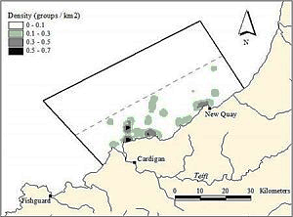

Figure 3 shows the sightings density of bottlenose dolphins in Cardigan Bay SAC, using a neighbourhood mean function. This map wit is a vital indication to where a no-traffic zone(s) may be designated in Cardigan Bay SAC. New Quay and North-East Cardigan have pockets of densities of 0.3-0.5 groups/km², Cardigan also has pockets of a high density of bottlenose dolphins with 0.5-0.7 groups/km² (Sea watch Foundation, nd). This data was gathered by from line transect method conducted by Sea Watch Foundation.

Figure 4: A photograph of a bottlenose dolphin mother and her calf (Grout, 2018).

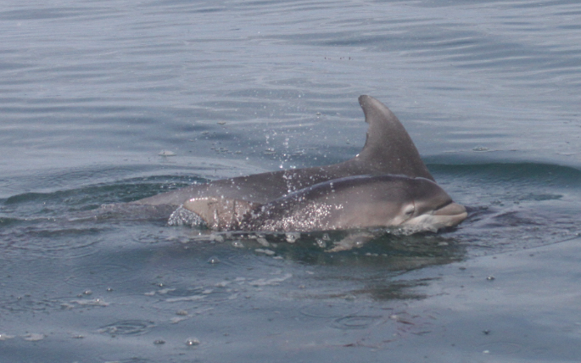

Figure 4 shows a photograph of a bottlenose dolphin mother and her calf in Cardigan Bay SAC (Grout, 2018). The photograph was taken during a boat-based observation by a fellow intern in August 2018, using methods, such as line transects (section 3.) and photo ID. Photo ID method is not necessary for this research proposal. To identify a bottlenose dolphin, their dorsal fins are tall and slightly rounded, which may be marked with scars. Calves are paler in colour and tend to be half the size of adults. Calves will swim next to their mothers (Sea Watch Foundation, nd) and tend to separate from their mothers by the fourth year (Veneruso and Evans, 2012).


Figure 5: A flow chart showing various scales of coastal management for Ceredigion (Pallister, 2006).

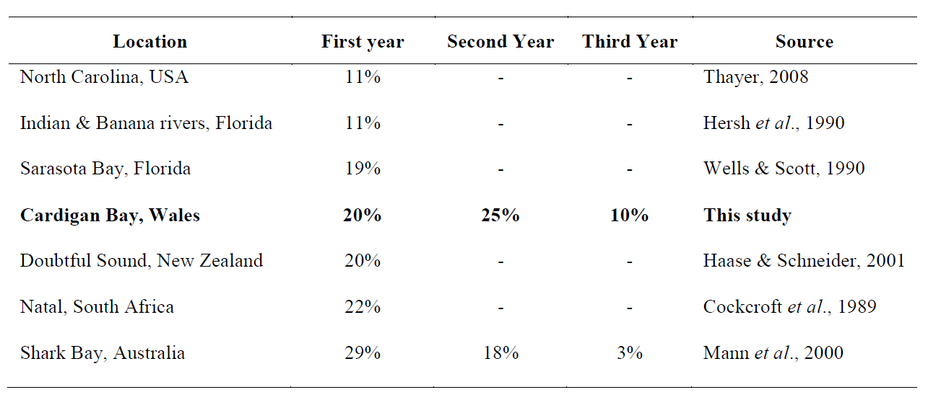
Figure 5 demonstrates a flow chart with various scales of coastal management for Ceredigion. In regards to any incentivised regulations and legislations from a national or an international scale, it is the responsibility of the Natural Resources Wales, a Welsh Assembly Government-sponsored body and previously known as Countryside Council for Wales, and Ceredigion County Council to monitor tour operators and NGOs (SWF = Sea Watch Foundation. CBMWC = Cardigan Bay Marine Wildlife Centre), to abide by the regulations and to notify information to the Welsh Assembly Government (Pallister, 2006). It is also important for tour operators, fishermen and NGOs to follow the regulations as well. Within the proximity of Cardigan Bay SAC, helmsmen of motorboats and non-motor boats must abide by the Ceredigion Marine Conservation Code of Conduct (CMCCC). CMCCC is incentivised under Wildlife and Countryside Act 1981 and the Countryside Rights of Way Act 2000 to protect bottlenose dolphins, harbour porpoises (Phocoena phocoena) and Atlantic grey seals (Halichoerus grypus) (Cardigan Bay Watersports, 2014).

Table 1: Bottlenose dolphin juvenile mortality rates, within its first three years, studied from habitats globally (Veneruso and Evans, 2012).

A study has been conducted by Veneruso and Evans (2012) investigating ‘Bottlenose Dolphin and Harbour Porpoise Monitoring in Cardigan Bay and Pen Llŷn a’r Sarnau Special Area of Conservation.’ Table 1 states that the mortality rate for bottlenose dolphin juveniles in Cardigan Bay, Wales, is 20% within its first year. The mortality rate for the second year is the highest of the three years with 25% as the lowest mortality rate is the third year with only 10%. The reasons for juvenile mortality rates are deemed unclear (Veneruso and Evans 2012), however, if the reason is due to anthropogenic marine activities, such as fishing, sailing, cetacean watching, the survival rates for juveniles will increase if a no-traffic zone in Cardigan Bay SAC is implemented leading to no anthropogenic marine activities in the given proximity and reducing vulnerability of young bottlenose dolphins.

Vessels can increase the risk of vulnerability and injuries from the noise produced from engines and propellers. Dolphins are susceptible to noise sensitivity as boats can have negative short-term impact on their natural activities, such as socialising, resting and feeding (Au and Green, 2000; Constantine et al., 2004), furthermore, dolphins may increase travel speed (Williams et al., 2002; Mattson et al., 2005; Marley et al., 2017) and duration of diving (Miller et al., 2008; Arcangeli et al., 2009; Bas et al., 2015, 2017) As a result, the change of behaviour may lead to health issues as their natural habits of breathing changes (Stockin et al., 2008; Schaffar et al. 2009). Long-term impacts of boat traffic disturbances are dolphins may leave their habitats and pods of dolphins may decrease (Lusseau and Bejder, 2007; New et al., 2013; Richardson et al., 2013; Williams et al., 2014; Marley et al., 2017). Lusseau (2007), Courbis and Timmel (2009) believe that dolphins increase their surface behaviour near boats because of the inability to vocally communicate, alternative communication is believed to come from increased tail slapping (Lusseau, 2007; Courbis and Timmel, 2009).

- Methodology
In 1991, Sea Watch Foundation was founded, the non-governmental organisation research dolphin behaviour and wellbeing. An internship opportunity with Sea Watch Foundation is probable between 1st June to 6th September 2020 as part of the dissertation research. During the 14 weeks, the primary data includes;
- Scan sampling = visually observing, with binoculars, and allocating dolphin sightings on a map, also taking notes on their surroundings, such boats, litter and other marine species, that may impose a potential threat to bottlenose dolphins. This method will be used by conducting land observations at the harbour (Sea watch Foundation, nd).
- Line transects = visually observing and allocating dolphin sightings using a GPS, also taking notes on their surroundings, such boats, litter and other marine species, that may impose a potential threat to bottlenose dolphins. This method will be used by conducting land observations at the harbour. This method will be used by conducting boat observations on a tour motorboat (Veneruso and Evans, 2012).
- Google Earth = any sightings must be reported to Sea Watch Foundation. Using Google Earth helps accurately estimate the location of dolphin sightings from land-based observations (Sea watch Foundation, nd).
- Global Positioning System (GPS) = Using a GPS helps accurately estimate the location of dolphin sightings from boat-based observations (Sea watch Foundation, nd).

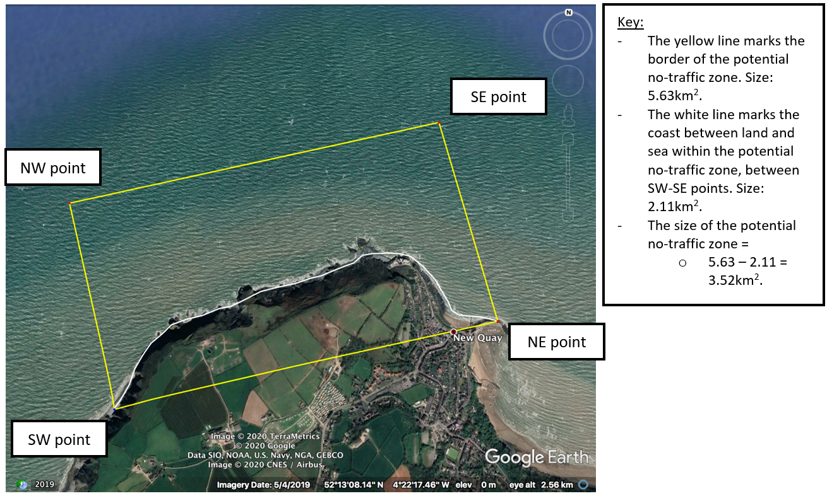
Figure 6: A Google Earth image of New Quay coast within Cardigan Bay SAC, a recommendation to locate a designated a no-traffic zone, and a key stating vital information (Google Earth Pro, 2020).

As previously mentioned, figure 3 (section 2.3.) shows that the highest density off the coast of New Quay is 0.3-0.5 groups/km². Using such information from figure 3 means that locating a no-traffic zone in Cardigan Bay SAC can be recommended; Figure 6 shows an image of New Quay coast within Cardigan Bay SAC from Google Earth Pro (2020) software, a recommendation to locate a designated a no-traffic zone, and a key stating vital information. The yellow and the white lines refer to the size of the potential no-traffic zone, which is 3.52km², with the shape of an irregular polygon. The North-West point coordinates are 54º13’14.53”N to 4º22’17.46”W, the North-East point coordinates are 52º13’30”.59”N to 4º21’32.38”W, the South-West point coordinates are 52º12’43.84”N to 4º22’21.75”W and the South-West point coordinates are 52º12’58.16”N to 4º22’50.07”W, which is the New Quay Harbour.

Although there may be potential conflicts between the authorities implementing a no-traffic zone (figure5) and fishermen and tour operators in New Quay, theoretically, fisheries and tour operators will still have access in Cardigan Bay SAC except the potential no-traffic zone (figure 6) (Brown and Trebilco, 2013).

- Results
To reiterate the methodology (section 3.) Scan sampling and line transect methods will be vital to identify sightings of bottlenose dolphins to then estimate their location by annotating a map of New Quay, which is provided by Sea Watch Foundation.

The use of Google Earth Pro is important to accurately estimate the location of dolphin sightings from land-based and boat-based observations using coordinates. If the trend shows to have a high abundance of bottlenose dolphins in a small proximity, as mentioned discussing figure 3 and figure 6, a no-traffic zone will be recommended.

- Evaluation
As bottlenose dolphins are enlisted as a protected species by Biodiversity Action Plan (BAP) (JNCC, 2015) and are in a favourable status condition in globally including Cardigan Bay SAC (Veneruso and Evans, 2012). However, to reiterate the opinion of Richardson (2012) (section 2.2.), he believes that the regulations of Cardigan Bay SAC are very successful and suggests improvements are needed in management and regulations (Richardson, 2012), perhaps the improvement in regulation Cardigan Bay SAC needs is an implementation of a no-traffic zone.

Limitations for the primary data research may include;
- Weather = harsh weather means reduced visibility for scan sampling and increases in sea state – experience, learning if the sea state is 4 or higher means observations will be temporarily postponed (Sea watch Foundation).
- Distance = regardless of the weather, visibility will always be limited at a given distance for the naked eye and using binoculars; the further out the dolphin is from the shore or the boat, the harder it is to observe its behaviour.

Potential bias for the primary data may include;
- When conducting boat-based observations, boats may impact dolphins’ natural state of behaviour as dolphins may travel to a different location, swimming either toward boats or away from boats.

  - Notable Experiences
I previously volunteered as an intern at Sea Watch Foundation for 7 weeks in 2018. The experience allowed me to learn and use new practical skills, which can be used for my return to Sea Watch Foundation as an intern for a second time – however, to research data for my dissertation. Skills, such as scan sampling and line transects (section 3.), as all skills that I learned in 2018.

- References
- Arcangeli, A. et al. (2009). The short-term impact of dolphin-watching on the behaviour of bottlenose dolphins (Tursiops truncatus) in western Australia. Journal of Marine Animals and their Ecology, 2(1), 3-9. (Accessed: 20th February 2020).
- Au, W.W.L. and Green, M. (2000). Acoustic interaction of humpback whales and whalewatching boats. Marine Environmental Research. 49(5). 469-481. (Accessed: 20th February 2020).
- Baş, A. A. et al. (2017). Marine vessels alter the behaviour of bottlenose dolphins Tursiops truncatus in the Istanbul Strait, Turkey. Endangered Species Research. 34. 1-14. (Accessed: 20th February 2020).
- Baş, A.A. et al. (2015). Selection of critical habitats for bottlenose dolphins (Tursiops truncatus) based on behavioral data, in relation to marine traffic in the Istanbul Strait, Turkey. Marine Mammal Science. 31(3). 979-997. (Accessed: 20th February 2020).
- Bower, R. (2011). Social factors in a fully protected marine reserve: Awareness of and attitudes towards the Lamlash Bay no-take zone, Isle of Arran. p3. (Accessed: 18th February 2020).
- Brown C.J. and Trebilco R. (2013). Unintended Cultivation, Shifting Baselines and Conflict between Objectives for Fisheries and Conservation. Conservation Biology, Volume 28, No. 3, 677–688. DOI: 10.1111/cobi.12267. (Accessed: 20th February 2020).
- Cardigan Bay Watersports (2014). Ceredigion Marine Conservation Code of Conduct. Available at: https://www.cardiganbaywatersports.org.uk/policies/ceredigion-marine-conservation-code-of-conduct/. (Accessed: 19th February 2020).
- Ceredigion County Council (CCC), (2008). Countryside Council for Wales, Environment Agency Wales, North Western and North Wales Sea Fisheries Committee, Pembrokeshire Coast National Park Authority, Pembrokeshire County Council, South Wales Sea Fisheries Committee, Trinity House, & D’r Cymru Welsh Water UK. (2008). Cardigan Bay Special Area of Conservation Management Plan. (Accessed: 20th February 2020).
- COAST (2019). The Lamlash Bay No-Take Zone. Available at: https://ffi.maps.arcgis.com/apps/Cascade/index.html?appid=70448e12ec3c45139beca33dfc990b7a. (Accessed: 18th February 2020).
- Constantine, R. et al. (2004). Dolphin-watching tour boats change bottlenose dolphin (Tursiops truncatus) behaviour. Biological Conservation. 72 117(3). 299–307. (Accessed: 20th February 2020).
- Courbis, S. and Timmel, G. (2009). Effects of vessels and swimmers on behavior of Hawaiian spinner dolphins (Stenella longirostris) in Kealake’akua, Honaunau, and Kauhako bays, Hawai’i. Marine Mammal Science. 25(2). 430–440. (Accessed: 20th February 2020).
- Dunn M.R. and Pawson M.G. (2002). The stock structure and migrations of plaice populations on the west coast of England and Wales. Journal of Fish Biology 61: 360-393. (Accessed: 20th February 2020).
- Evans P.G.H., Baines M.E. and Shepard B. (2000). Bottlenose dolphin prey and habitat sampling trials. Report to the Countryside Council for Wales. Sea Watch Foundation, Oxford, 67pp. (Accessed: 20th February 2020).
- Google Earth Pro. (2020). New Quay, Wales, UK. (Accessed:20th February 2020).
- Grout, E. (2018). A photograph of a bottlenose dolphin mother and her calf. Sea Watch Foundation. (Accessed: 20 February, 2020).
- Hernández, O. G. (2015). Economic impacts of sustainable marine tourism in the local economy. Case study: Dolphin watching activity in New Quay, Cardigan, Wales. School of Management and Business Aberystwyth University, Wales-UK. (Accessed: 20th Febraury 2020).
- Janik, V.M., and Sayigh, L.S. (2013). Communication in bottlenose dolphins: 50 years of signature whistle research. Journal of Comparative Physiology A: Neuroethology, Sensory, Neural, and Behavioral Physiology, 199(6), 479-489. (Accessed: 20th February 2020).
- Jensen, F.H. et al. (2009). Vessel noise effects on delphinid communication. Marine Ecology Progress Series, 395, 161–175. (Accessed: 20th February 2020).
- JNCC (2015). Natura 2000 – Standard data form. (Accessed:20th February 2020).
- Jones, P. (2006). Marine Policy. Collective action problems posed by no-take zones. (Accessed: 18th February).
- Lusseau, D. (2007). Evidence for social role in a dolphin social network. Evolutionary Ecology, 21(3), 357–366. (Accessed: 20th February 2020).
- Lohrengel K. and Evans P. (2017). Bottlenose dolphin monitoring in Cardigan Bay, 2014-2016. Report to Natural Resources Wales. (Accessed: 20th February 2020).
- Lusseau, D. and Bejder, L. (2007). The Long-term Consequences of Short-term Responses to Disturbance Experiences from Whalewatching Impact Assessment. International Journal of Comparative Psychology. 20(2). 228–236. (Accessed: 20th February 2020).
- Lusseau, D. (2006). The short-term behavioral reactions of bottlenose dolphins to interactions with boats in Doubtful Sound, New Zealand. Marine Mammal Science. 22(4). 802–818. (Accessed: 20th February 2020).
- Macneish, D. (nd). The Lamlash Bay No-Take Zone. COAST. Available at: https://ffi.maps.arcgis.com/apps/Cascade/index.html?appid=70448e12ec3c45139beca33dfc990b7a. (Accessed: 18th February 2020).
- Marine Spatial Planning (nd). An Introduction to Marine Spatial Planning. UNESCO. Available at: http://msp.ioc-unesco.org/msp-good-practices/msp-good-practices-overview/. (Accessed: 19th February 2020).
- Marley, S.A. et al. (2017). Occupancy of bottlenose dolphins (Tursiops aduncus) in relation to vessel traffic, dredging, and environmental variables within a highly urbanised estuary. Hydrobiologia. 792(1). 243–263. (Accessed: 20th February 2020).
- Massey De. M. (2014). Whistle variations within the bottlenose dolphin population of Cardigan Bay, Wales. MSc Thesis, University of Wales, Bangor. Pp. 80. (Accessed: 20th February 2020).
- Mattson, M.C. et al. (2005). Effects of boat activity on the behavior of bottlenose dolphins (Tursiops truncatus) in waters surrounding Hilton Head Island, South Carolina. Aquatic Mammals. 31(1). 133-140. (Accessed: 20th February 2020).
- Miller, L.J. et al. (2008). Immediate response of Atlantic bottlenose dolphins to high-speed personal watercraft in the Mississippi Sound. Journal of the Marine Biological Association of the United Kingdom. 88(6). 1139–1143. (Accessed: 20th February 2020).
- New, L.F. et al. (2013). Modelling the biological significance of behavioural change in coastal bottlenose dolphins in response to disturbance. Functional Ecology. 27(2). 314–322. (Accessed: 20th February 2020).
- O’Connor, S., Campbell, R., Cortez, H., & Knowles, T. (2009). Whale Watching Worldwide: tourism numbers, expenditures and expanding economic benefits. Special report. Yarmouth MA, USA: The International Fund for Animal Welfare prepared by Economists at Large. (Accessed 20th February 2020).
- Pallister, A., (2006). A Study to Establish the Degree of Compliance of the Marine Wildlife-Watching Industry in Ceredigion and Pembrokeshire with the Definition of Marine Ecotourism and Subsequent Guidelines for Good Practice Given in the ‘Marine Ecotourism for the Atlantic Area’ Report 2002. MSc Environmental Education. Trinity College Carmarthen. (Accessed: 19th February 2020).
- Parsons, E.C.M. (2012). The Negative Impacts of Whale-Watching. Journal of Marine Biology, 2012. 1–9. (Accessed: 20th February 2020).
- Pierpoint C., Allan L., Arnold H., Evans P., Perry S., Wilberforce L. and Baxter J. (2009). Monitoring important coastal sites for bottlenose dolphin in Cardigan Bay, UK. Journal of the Marine Biological Association of the United Kingdom 89 (5): 1033-1043. (Accessed: 20th February 2020).
- Richardson, et al. (2013). Marine Mammals and Noise. Academic Press, New York. (Accessed: 20th February 2020).
- Richardson, H. (2012). The effect of boat disturbance on the bottlenose dolphin (Tursiops truncatus) of Cardigan Bay in Wales MSc thesis, Department of Geography, University College London. (Accessed: 20th February 2020).
- Schaffar, A. et al. (2009). Avoidance of whale watching boats by humpback whales in their main breeding ground in New Caledonia. International Whaling Commission. SC/61/WW6. 9. (Accessed: 20th February 2020).
- Sea watch Foundation (nd). How Sightings are Used. Available at: https://www.seawatchfoundation.org.uk/how-sightings-are-used/. (Accessed: 18th February 2020).
- Sea watch Foundation (nd). Welsh Sea Watchers Project Volunteer Handbook. pp16-22. (Accessed: 19th February 2020).
- Stockin, K. A.et al. (2008). Tourism affects the behavioural budget of the common dolphin Delphinus sp. in the Hauraki Gulf, New Zealand. Marine Ecology Progress Series. 355. 287-295. (Accessed: 20th February 2020).
- UKMPA. (2007). Frequently Asked Questions. What is a No Take Zone? Available at: http://www.ukmpas.org/faq.html. (Accessed: 19th February: 2020).
- Veneruno, G., Evans, P. G. H. (2012). Bottlenose Dolphin and Harbour Porpoise Monitoring in Cardigan Bay and Pen Llŷn a’r Sarnau Special Areas of Conservation. CCW Monitoring Report No. 95. (Accessed: 13th February 2020).
- Williams, R. et al. (2002). Behavioural responses of killer whales (Orcinus orca) to whale-watching boats: Opportunistic observations and experimental approaches. Journal of Zoology. 256(2). 255–270. (Accessed: 20th February 2020).
- Williams, R. et al. (2014). Severity of killer whale behavioral responses to ship noise: A dose-response study. Marine Pollution Bulletin. 79(1–2). 254–260. (Accessed: 20th February 2020).
- Wood, H. et al. (2020). Marine Conservation Begins at Home: How a Local Community and Protection of a Small Bay Sent Waves of Changes Around the UK and Beyond. Frontiers in Marine Science. p1. (Accessed 19th February 2020).
- Wood, H. (nd). The Lamlash Bay No-Take Zone. COAST. Available at: https://ffi.maps.arcgis.com/apps/Cascade/index.html?appid=70448e12ec3c45139beca33dfc990b7a. (Accessed: 18th February 2020).

