Student Name: Noman Akhtar
Student ID: 2026819
Teacher Name: Paul Ranson

Digital Skills and Research Methods

Title:

“How I can use the DIKW and CRAAP frameworks to confirm or refute my collected Academic GRIT test result (Primary Data) compared to the UWTSD GRIT Result (secondary Data) based on the work of Angela Duckworth TED Talk lecture”

Table of Contents
INTRODUCTION 1
LITERATURE REVIEW 1
RESEARCH METHODOLOGY 2
DATA ANALYSIS 3
SUMMARY OF FINDINGS AND DISCUSSIONS 8
CONCLUSION 8

INTRODUCTION
Power abuse in the workplace is a kind of negative practice which influence the behavior and productivity of individual within the organization. Abuse of power is commissioned as an unlawful that affects the performance of employees (D’Cruz and Noronha, 2018). An organization is a comprehensive nuthatch consisting different of departments which can be accomplished with the personalized efforts of employees yets the workplace.
Moreover, this research mainly consists of five close-ended questions in the form of quantitative research. The report will help conduct a research survey of 50 employees and then the result will be helpful to the workplace formingrmin bar graphs and charts. This research will perform the primary research which is mainly carried out through the questionnaire In this research, a sub-organization of 50 employees to answer the questions regarding power abuse in the workplace.

LITERATURE REVIEW
Power of abuse is a negative feeling that influences the performance and productivity of the employee. Power abuse two or workplace referred to as a humiliations exploitation of low-level employees by their superiors who uses their power for their fits. According to D’Cruz, Noronha, and, Lutgen-Sandv,ik, 2018, there are various kinds of abusive acts which takes place within the organization. It causes emotional or physical harm to the workers powered by abuse violence, bullying, discrimination, and harassment Violence can be defined as an act t e of threat or physical harm against another person at the worksite. Workplace bullying can cause anxiety, depression, fear, and post-traumatic disorder symptoms. Discrimination among workers leads to unfair treatment of employees in the workplace. Harassment can be considered as actions or comments that work findings offensive. All these effects the performance and hence this might cause a serious disordinate o individual.

RESEARCH METHODOLOGY
The most common methods used in carrying out the research are qualitative and quantitative methods. The qualitative method is referred to as a method of observation based on non-numerical data collection that seeks to collect the answers to the questions. This data is collected via primary or secondary data collection method and it provides the depth information about human behavior in the workplace(Paull and Omari, 2015). The quantitative research method is a numerical data collection technique used for analysianalyzingta via statistical, metamathematical, or computational techniques. The research is mainly based on the primary data collection method. Most of the employees involved in this survey were below the age of 30 years and havandewer experience in their jobs. The survey discovered the negative practices of the higher management authority employees. People who generally poses the power and position are more involved in such abusive practices so the survey was mainly aimed at collecting data from the lower level of employees who do not ppossespossess wwereor authority. This survey has targeted mostly the female employees of the multinational company who are often exploited by their senior staff members.
To survey analyzing the power abuse in the workplace, both methods will be used to analyze the data (Hodgins and Mannix McNamara, 2017). For a better understanding of the opinions and perceptions of the people regarding the negative use of power at Powerade, graphs and pie charts will be used for the clear observation of the data which is collected from the population. The survey is focused on the large data collection via sampling technique. SamplThe sampling is oasis general for mar marketing researcollect a group of people who can answer all the questions of a survey. The sample needs to be representative of the population as it is not possible to collect the data from a large number of people who maiwhoonsumes that money as well as time. So, a survey will be carried out from 2 multinational companies among which 30 and 20 employees are randomly selected as a sample toto forceurfor vey. The data regarding the absinthe a workplace abuselected from each selected individual. The data collection tin method is a process by which the researchers collect the information from all the relevant sourcetoto find the answers to research questions. This

is mainly done to test the hypothesis which results in evaluating the outcome (Power abuse at workplace, 2017).
In this research there are 5 questions are designed on abuse in the workplace and the answer will be collected on a 3-point scale of agree, neutral l, al, and disagree. This allows the peoptofor fasresponsend to the questions and also helps in easy and efficient data collection. Fsurveying on the employees of two multinational companies, 50 surveys are distributed to unto whauntie employees feegardinregardingr abuse at the workplace. Ethics in data collection is referred to as a systematizindefendinggto, and recommending the concepts of right and wrong absinthe collection of the data (De Cieri and et.al., 2019). In order Tohfulfillcal considerations of the research, it is important to obtain the approval from ethical approval committee before commencing data collection.

DATA ANALYSIS
Questionnaire
Ques-1 Do you feel that your superior uses his power in selfish way?
- Agree
- Disagree
- Neutral
Ques-2 Have you ever been abused physically or mentally by your senior staff members?
- Agree
- Disagree
- Neutral
Ques-3 Do you consider it to be a typical incident of Violence at your workplace?
- Agree
- Disagree
- Neutral
Ques-4 Do you think that the incident could have been prevented?
- Agree
- Disagree
- Neutral
Ques-5 Do you feel that people holding superior powers are misusing their position and authority in wrong way?

Superior uses power in a selfish way

a. Agree | 20
b. Disagree | 23
c. Neutral | 7
Total | 50

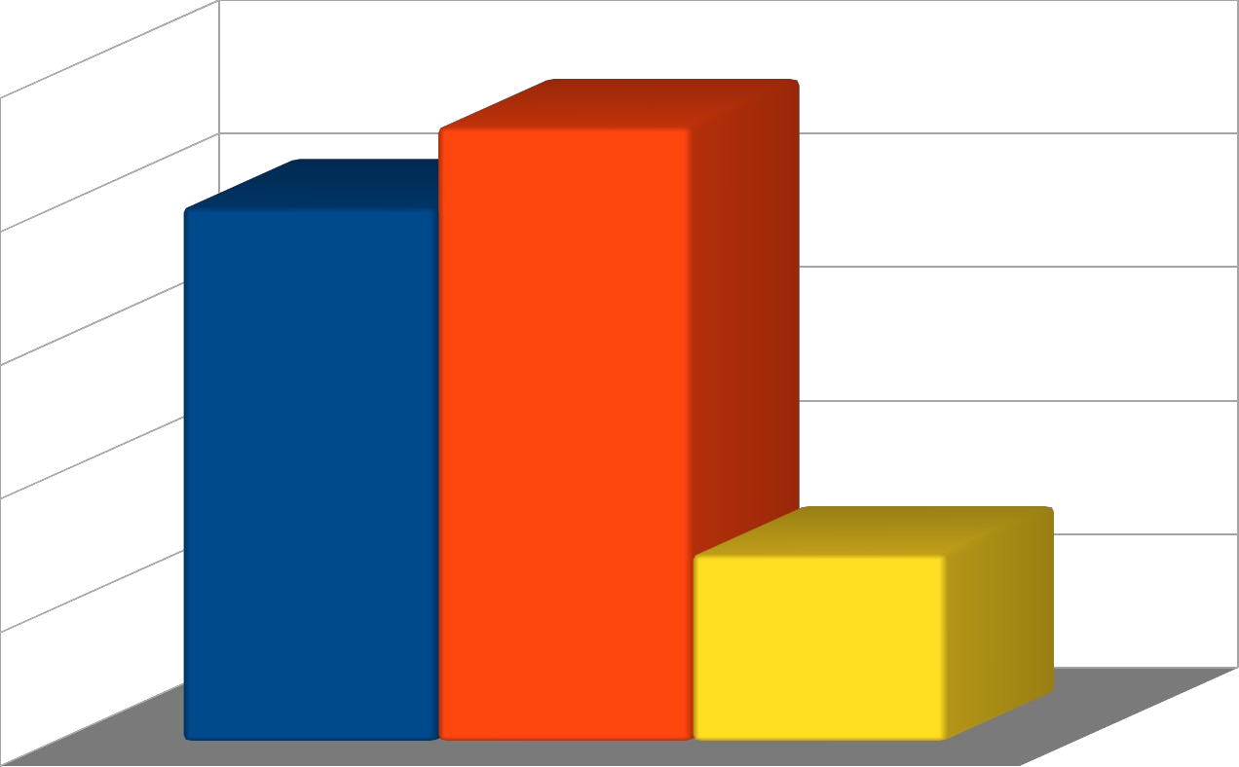
25

20

15 a. Agree
  - Disagree
  - Neutral
10

5

0

Interpretation: From the above data, it can be interpreted that not only the people who
have powers are involved in such abusive practices at the workplace but employees at the same level may be responsible for such harassment. The above graphs depict that 20 employees agree on the question that employees who hold superior power misuse their power for their objectives. However, 23 is the maximum number of employees out of a total of 50 who feel that all the superiors do not use their power in the wrong way. 7 out of the total 50 respondents were confused about nor voted agree and neither do they disagree with the question.

Physical or mental abusive practices occurred at the workplace through senior staff

a. Agree | 30
b. Disagree | 18

c. Neutral | 2
Total | 50

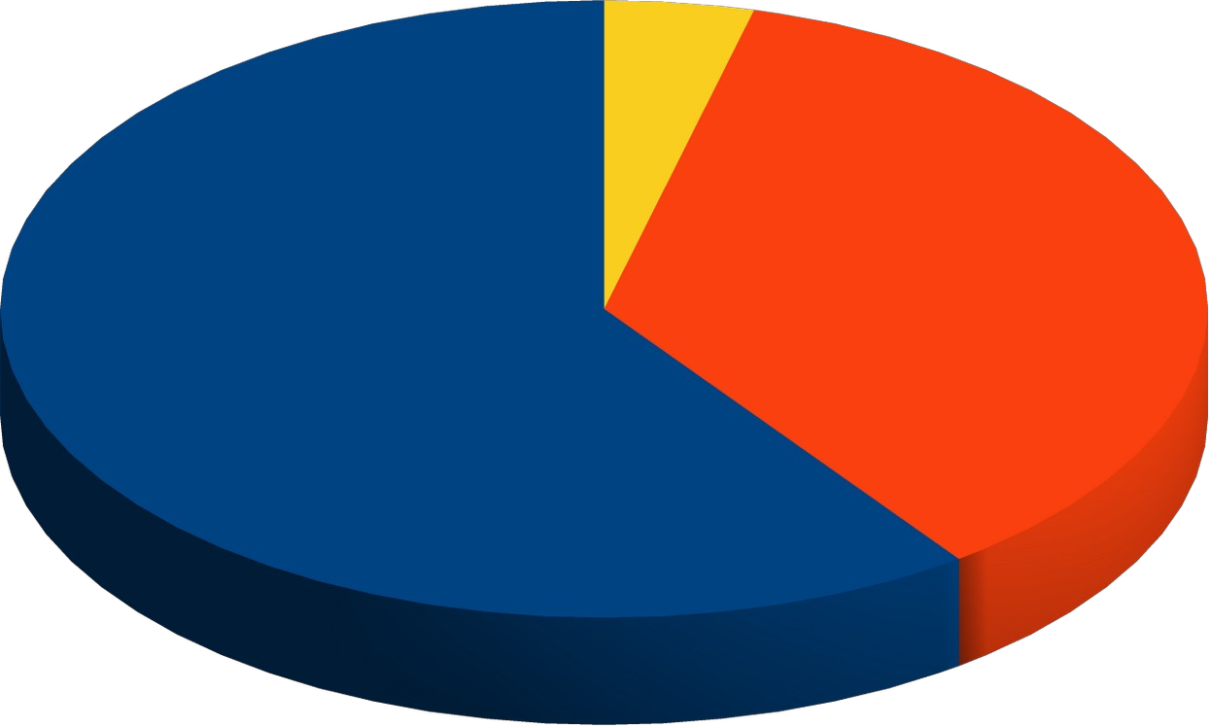
  - Agree
  - Disagree
  - Neutral

Interpretation: From the above-collected data, it can be interpreted that abusive practices occurred in the workplace mainly practiced by senior staff members. From the above survey, 30 employees out of 50 agree that senior staff is involved in power abuse in the workplace. However, 18 employees among them disagree with the question that physical or mental harassment is practiced by senior staff. On the other hand, 2 employees were found confused about such questions and they neither favored the question nor opposed the question.

Practice of violence often occurred in the workplace

a. Agree | 12
b. Disagree | 37
c. Neutral | 1
Total | 50

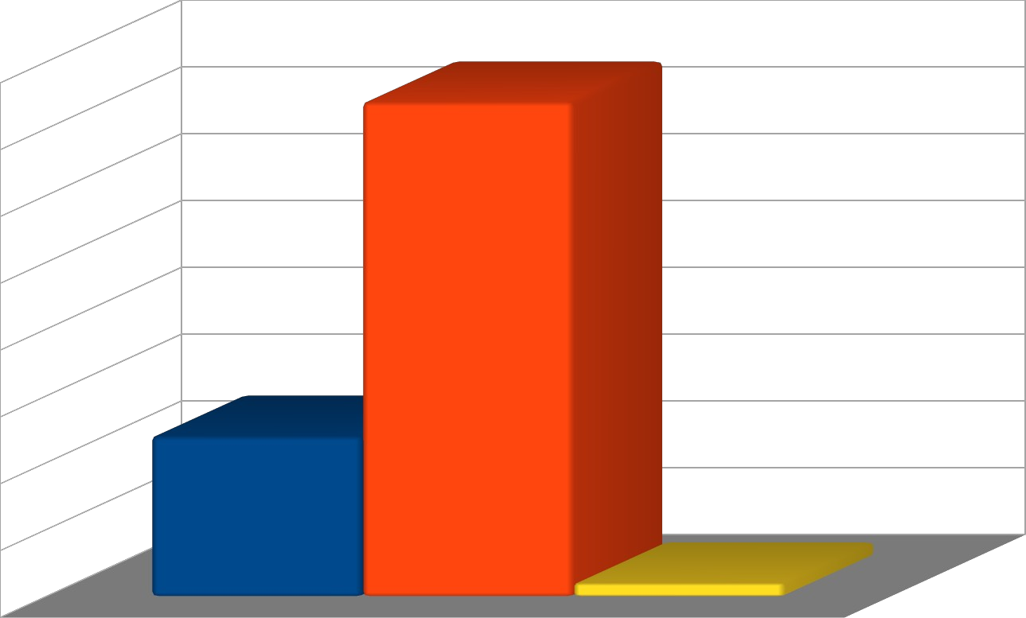
40

35

30
25 a. Agree
b. Disagree
20 c. Neutral
15

10

5

0

Interpretation: From the above survey, it can be interpreted that violence is less
occurred at the workplace as compared to harassment. As a maximum number of employees disagree that is 37 out of a total 50 that violence occurred in the workplace. However, 12 among them feel that violence also occurred at their workplace which is one of the greatest issues which affects individual behavior and leads to anxiety among people. Only 1 of the employee among 50 was neutral who even did not respond to the question.

Incident could have been prevented at the same time

a. Agree | 15
b. Disagree | 20
c. Neutral | 15
Total | 50

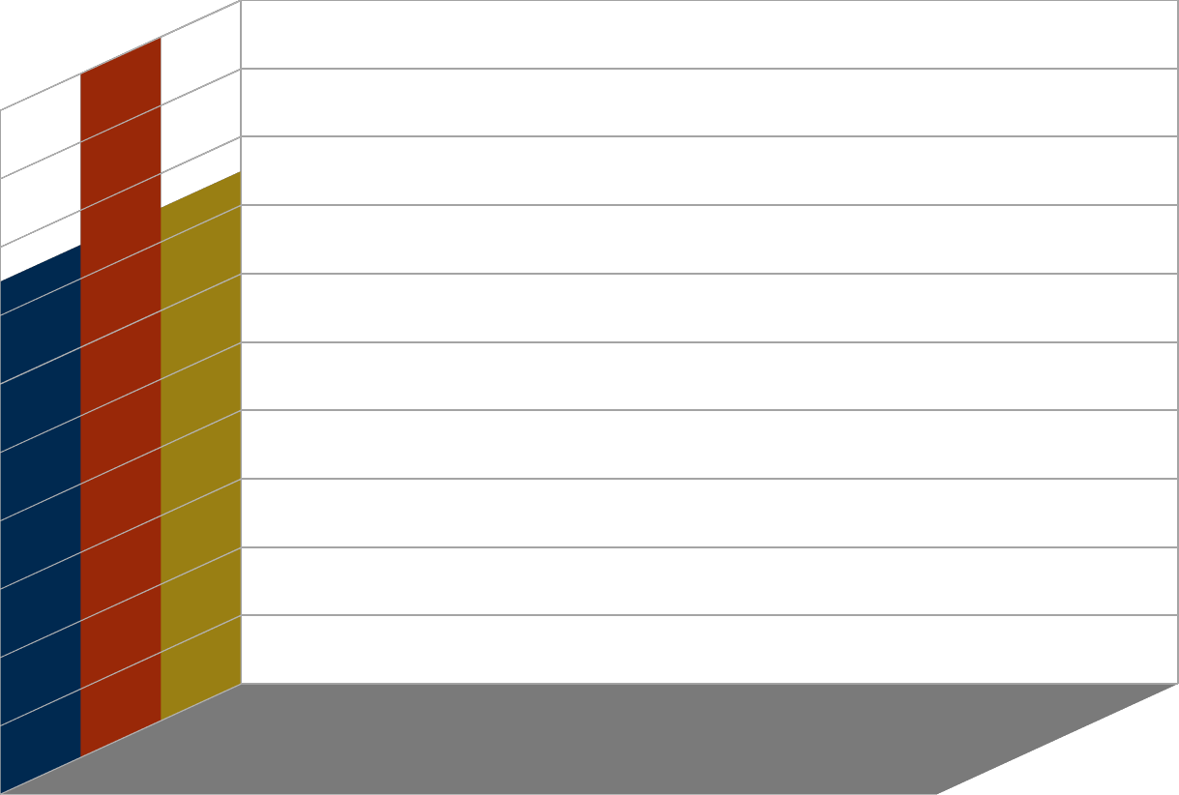
20
18
16
14
  - Agree
12 b. Disagree
10 c. Neutral
8
6
4
2
0

Interpretation: When the surveyor asked questions regarding the prevention of such abusive practices at the workplace then maximum employees responds that it could not be prevented at the time of its occurrence. However, many of them were in a neutral state and were confused about the answer to this question. 15 employees out of a total of 50 said no and 15 among them were neutral about the question. On the other hand, 20 employees are the maximum number of respondents who disagreed with a question.

Power misused by the superiors leads to abusive practices in the workplace

a. Agree | 25
b. Disagree | 8
c. Neutral | 17
Total | 50

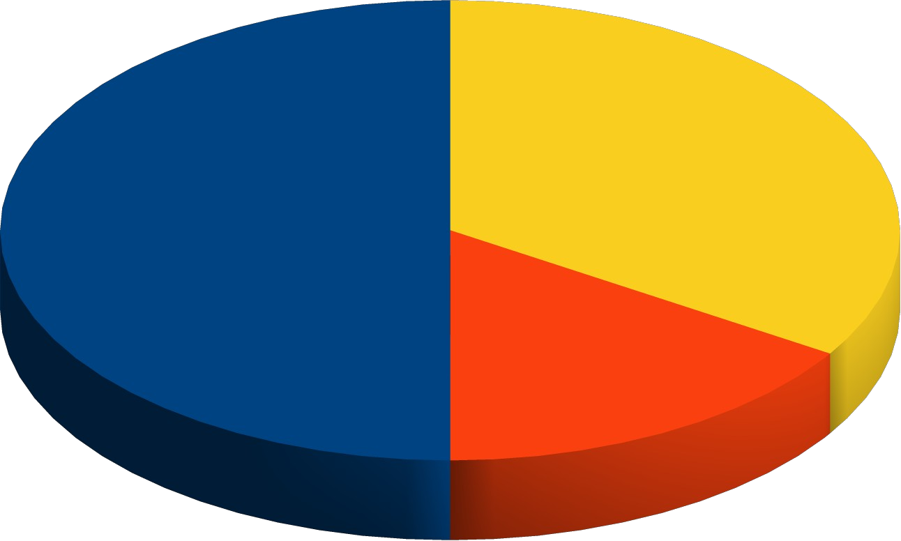
  - Agree
  - Disagree
  - Neutral

Interpretation: In a survey when employees were asked about the authority and superior position of the employees who possess power in their hands. So from the above data collected in a survey, it can be interpreted that top management people misuse their power in the wrong way as it leads to the exploitation and humiliation of the employees at a lower level. It can also be interpreted that most of the employees found to be the victims of power abuse are females who often face such issues in the workplace. From the above graph, it can be concluded that 25 workers out of a total of 50 aa greedy on the question that people who have higher authority negatively use their power On the other hand, 8 number of employees were opposing the same question as they believe that all do not misuse their position and power. Out of the, 17 employees were in a neutral state and cannot be able to answer the same question in either yes or no.

SUMMARY OF FINDINGS AND DISCUSSIONS
From the above analysis, it can be concluded that most of the employees are becoming the victims of workplace abuse. It can also be found that most female employees have to face such abusive problems at the workplace as they are exploited by their senior staff members. It is a very critical concern that needs to be communicated to higher authorities so that the power to the superiors should be used in the right direction and not for their benefit. However, due to the lack of time in surveying observing the abusive practices at the workplace. Therefore, from the above information, I was able to press ent limited range of data and statistical information but this limited information is enough to identify the wrong practiceinat the workplace. However, for future research, I would recommend expanding the

sample frame of employees within small as well as multinational companies would help me to provide a clear understanding and visuals about abusive workplace practices. Moreover, in the future wide range of employees are targeted via online surveys which help me to get the appropriate data analysis results and provide clear viewpoints regarding the research.

CONCLUSION
From the above study, it can be concluded that power abuse of the employees in the form creates a wrong impression in the minds of employees. Also, it can be concluded that it affects individual behavior which results in a negative environment in the workplace and hence it lowers the business performance and prevents the organization from meeting the main objectives (Rai and Agarwal, 2016). The study has provided perceptions and viewpoints of various employees who are likely to become the victims of such power abuse at the organization. The report has reflected on the wrong practice in the workplace and also develops awareness about legal actions regarding such abusive practices. Although, employees need to take regarding such practices which exploited human behavior in the workplace.

REFERENCES
Books and Journals
D’Cruz, P., Noronha, E. and Lutgen-Sandvik, P., 2018. Power, subjectivity, and context in workplace bullying, emotional abuse, and harassment: Insights from postpositivism. Qualitative Research in Organizations and Management: An International Journal. 13(1). pp.2-9.
Wee, E.X. And et.al., 2017. Moving from Abuse to Reconciliation: A Power-Dependence Perspective on When and How a Follower Can Break the Spiral of Abuse. Academy of Management Journal. 60(6). pp.2352-2380.
Paul, M. and Omari, M., 2015. 14 Workplace abuse, incivility, and bullying. Workplace Abuse, Incivility, and Bullying: Methodological and cultural perspectives. p.208.
De Cieri, H. and et.al., 2019. Workplace bullying: an examination of power and perpetrators. Personnel Review. 48(2). pp.324-341.
Hodgins, M. and Mannix McNamara, P., 2017. Bullying and incivility in higher education workplaces: Micropolitics and the abuse of power. Qualitative Research in Organizations and Management: An International Journal. 12(3). pp.190-206.
D’Cruz, P. and Noronha, E., 2018. Abuse on online labor markets: Targets’ coping, power, and control. Qualitative Research in Organizations and Management: An International Journal. 13(1). pp.53-78.
Rai, A. and Agarwal, U.A., 2016. Workplace bullying: A review and future research directions. South Asian Journal of Management. 23(3). p.27.
abuse at workplace.2017.[Online].Available through:<https://www.atl.org.uk/Images/ATL_Workplace_Bullying_Toolkit%20(update).pdf>

