Student Name: Adenike Atinuke Bola-Sanni
Student ID: 1808705
Lecturers Name: Mr Syed Jaffery
Module: Workplace Culture and its impact on Organisational Efficiency
Module Code: BMSW 5105

Executive Summary
Organisations need to apply the required policies and theories to get the maximum output from the workplace. In this report, some important management theories will be applied the theories are mainly scientific management theory, administrative management theory. Behavioural management theory, management science theory etc. the analysis within the organisation with PESTEL analysis and SWOT will be applied too for “HSBC Holdings PLC”. Organisations need to develop their theories applicable to their workplace. Organisations like “HSBC Holdings PLC” applied their management theories and this helped them to increase their productivity and effectiveness in their workplace. By analysing their external factors in the organisations with SWOT analysis and PESTEL analysis also helped them to understand their external environment in this report. (BUSH, 2020)

Table of Contents
Executive Summary 2
Introduction 4
(a). An Introduction to “HSBC Holdings PLC” 5
(b)The key theories that will be applied in the “HSBC Holdings PLC” Company for this report..7
(c) Applying key theories and Environmental scanning tools in “HSBC Holdings PLC” by analysing the external environmental factors along with COVID-19 affect in organisational culture and its performance. 13
(d). Critically assess the extent to which I think "HSBC" presents cultural and ethical standards and the personal ethical standards, values and beliefs of most employees are sustainable 18
Conclusion 25
References 26

Introduction
Business organizations are often getting influence by the external factors of the business and the management of the business organization can easily control most of the factors. But the environmental factor is the one that is unpredictable and can hamper the business mostly from the other influencing factors. As an analyst of the “HSBC Holdings PLC” in this assignment, I am going to explain the effect of COVID 19 an external factor of the business organization on the organizational culture and its performance. I am going to explain the cultural standards of the company, its ethical standards, the value of the employees of the organization and their personal ethics. Also showing how all these things support the organization to achieve the business aim (Oumlil et al, 2017).

(a). An Introduction to “HSBC Holdings PLC”
The “HSBC Holdings PLC” is the United Kingdom-based multinational investment bank company that provides different financial supports to the business organizations. It is a public limited company that provides financial services. The company provides its service in all over the world so the company can contribute to the business of the world (Strydom et al, 2018).
The company was first founded in 1865 as the Hong Kong Shanghai Bank and it gets its present name in 199. Sir Tomas Sutherland is the founder of this financial organization or bank and the important persons related to the bank in recent time are Mark Tucker and Noel Quinn and Mark is the chairman of the company and Noel is the chief executive of this organization (Kara et al, 2016).

Figure: Logo of the “HSBC Holdings PLC” (Skinner et al, 2019).
Mission
To increases the investment of the bank and support business organization by supporting them in the international business by investing money in the business.
Vision
To expand the business of this company in other countries and be the most profitable financial bank in the world by supporting the clients

The “HSBC Holdings PLC” provides different services to its clients such as offer insurance and finance to the customers, plays the role of retailing banking, investment banking, wealth management of the clients’ etc. The business organization has 253,351 employees who always serve for the company from every part of the world. The headquarter of this company is situated in 8 Canada Square, Canary Wharf, London, the United Kingdom where all the important decisions about the company are taken and also the board meeting of this company happens here (Strydom et al, 2018).
This financial organization is the 6th biggest financial bank in the world according to the recent report. The “HSBC Holdings PLC” operates its business in 65 countries where more than 3900 offices operate their daily activities for the bank. Besides this, the organization has more than 38 million clients and customers who often make their transaction from the organization. Based on four different business groups the businesses of “HSBC Holdings PLC” are oriented (Strydom et al, 2018).
Also, this financial organization is listed in two different stock exchanges one is Hong Kong Stock Exchange and the other one is the London Stock exchange. In the year 2007, this financial bank was published the most earning bank of the world and beat Bank of America and Citigroup (Presbitero et al, 2019).

(b)The key theories that will be applied in the “HSBC Holdings PLC” Company for this report
Management Theories:
Organisations need to manage their work properly and strategically and to do that they need the help of management theories. These theories are the guideline for the organisations to operate the business properly. Modern organisations always try to make the best use of these theories in the workplace. As there are various types of management theories and managers don’t just follow only one of them they try to use those theories in different situations for the organisations and tackle the situations with these theories (Palmer, 2015).
They select suitable theories based on their culture and environments. There are various types of management theories the most popular among them are scientific management theory, administrative management theory. Behavioural management theory, management science theory, organisation environment theory, contingency management theory, system management theory etc. (Schaffer et al, 2016)
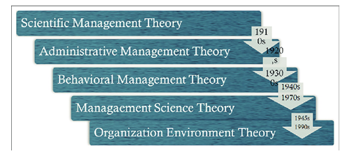
Source: Management Theories (Hillary, 2015)

Scientific Management Theory:
One of the earliest management theorists Fredrik Taylor pioneered this theory. The factor changed in scientific management is before the organisations thought that the employees need to be forced to work and without force, the employees won’t work accordingly. Scientific management theories suggest that organisations should not force the workers and just make the works simple from them scientifically and the employees will be more productive (Strydom et al, 2018).
New rules have to be developed in the workplace scientifically and train the employees scientifically in the workplace. Finding the most efficient ways is to use in the workplace which will increase the productivity in the workplace. “HSBC Holdings PLC” divides works between the managers and workers to get the most effective output from the workplace. Based on their working capability employees would be paid (Schaffer et al, 2016).
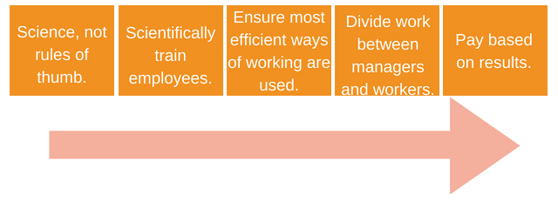

Source: Scientific Management Theory (Hillary, 2015)
Administrative Management Theory:
This theory tries to find a proper rational way to design the organisations as a whole. This theory helps the organisations to work with a clear vision within the organisations and this helps the employees to understand and work towards their works to achieve the organisation's goal. “HSBC Holdings PLC” tries to maintain equity in the division of the workplace (Emmerich, 2011).
The decline has to be maintained from the individuals form the basis of the organisations. Employees try to understand their responsibility towards the work. A main positive feature of this theory is the unity of the directions from the authority towards the workplace. The chain helps the organisation to cooperate with the employees in the workplace and helped them to understand their responsibility and this helps them to understand. The commands from the main authority are maintained perfectly in this theory. (Hillary, 2015)
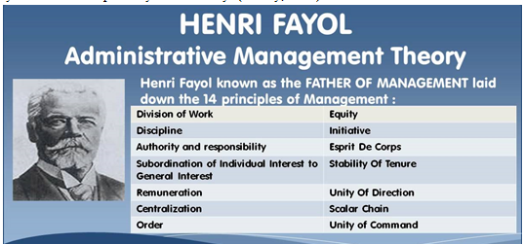
Source: Administrative Management Theory (BUSH, 2020)

Behavioural Management Theory:
In this theory, the behavioural factors of their employees are mostly concerned by the authority and managers. Increasing employee productivity with the help of motivation in the workplace helps the organisations to be more effective and efficient. This is mainly the human relations management in the workplace and this helps the organisations to understand and cooperate with the employees. In this COVID-19 situation, employees need the help of organisations financially and mentally (Strydom et al, 2018).
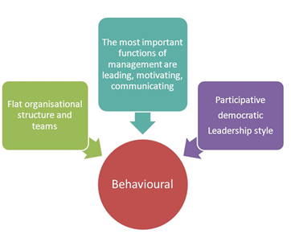
Source: Behavioural Management Theory (Hillary, 2015)
“HSBC Holdings PLC” uses these theories to manage the organisations leading and motivating. In the communication sectors, the authority is also very useful to cooperate with the workers. Motivation is important in the workplace and the theories of behavioural management help organisation to manage the employee’s motivations and help to be effective in the workplace. This approach towards the employees helps organisations to achieve employee’s satisfaction towards the organisations. (Schaffer et al, 2016)

Management Science Theory:
This theory mainly focused on the productivity of the employees in the workplace and how perfectly they are cooperating with the workplace. Different techniques can easily help the organisations to achieve employee’s effectiveness in the workplace (Cassidy et al, 2011). Workplaces need to have an environment where employees could give their maximum effort for perfect productions within the organisations (Strydom et al, 2018).
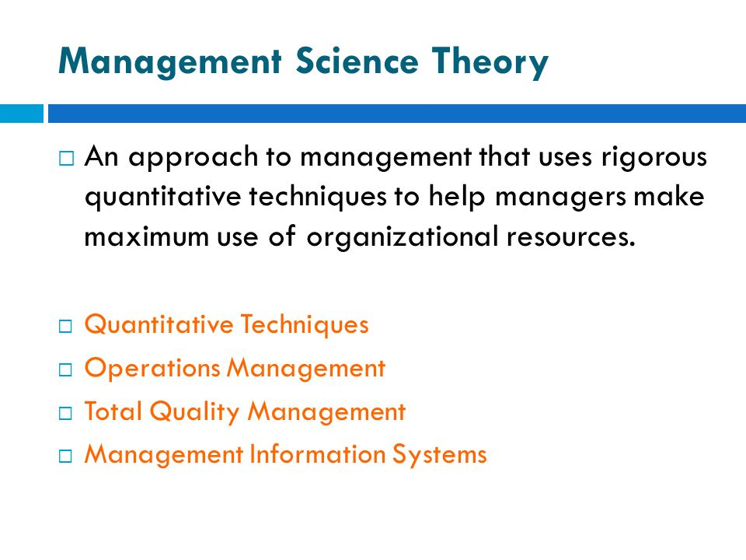
Source: Management Science Theory (Hillary, 2015)
There are different techniques applied by the management science theories like “HSBC Holdings PLC” is applying quantitative techniques to help the employees being effective even in this COVID-19. This cooperation’s with the employees helped the organisations to make a positive impact on the employees (Strydom et al, 2018).
Employees are trying to give their maximum efforts in the workplace from their own will and this is the impact of using management science theory in the workplace. As it’s obvious that to increase production in the workplace and be cooperative with the employees, organisations have to follow the techniques in the workplace. (BUSH, 2020)

Organisation Environment Theory:
This theory defines that the organisation needs to be flexible to its environment and ready to take actions according to the situations. This theory is also known as the contingency theory in organisations (Cassidy et al, 2011). To lead the organisations to make any decisions under any circumstances the organisations need to undertake the analysis of their environments and under the environmental issues, they have to cooperate with their workplaces and take decisions (Strydom et al, 2018).
“HSBC Holdings PLC” is taking steps under their environmental issuers to fight with their current situations. As currently, organisations are facing a critical situation for the COVID-19 they need to lead their organisations accordingly the situations maintaining safety in the organisation's workplace. They need to take actions in both internal factors and external factors within the organisations. This is mandatory to take actions accordingly the environmental need in the workplace to be more productive and successful. (Schaffer et al, 2016)
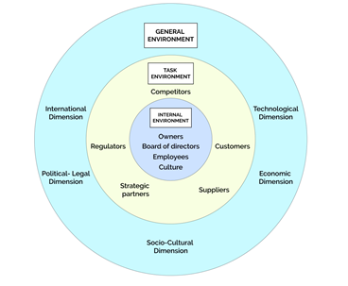
Source: Organisation Environment Theory Factors (BUSH, 2020)

(c)Applying key theories and Environmental scanning tools in “HSBC Holdings PLC” by analysing the external environmental factors along with COVID-19 affect in organisational culture and its performance.
SWOT Analysis of “HSBC Holdings PLC”:
SWOT analysis refers to analysing the organisations external factors find its strength, weakness, opportunities and threats within the organisations which could help the organisations to find their positive side in the marketplace alongside the weak side of theirs. This helps them to make decisions in future decision making processes and planning process. Organisations need to understand the importance of the analysis of their external environment as they can help them to fight uncertainty (Cassidy et al, 2011).
“HSBC Holdings PLC” has made the effective use of this analysis in the workplace as they are providing the most efficient work environment for their employees within their environments. And this helps the employees to be more motivated towards the work. (BUSH, 2020)
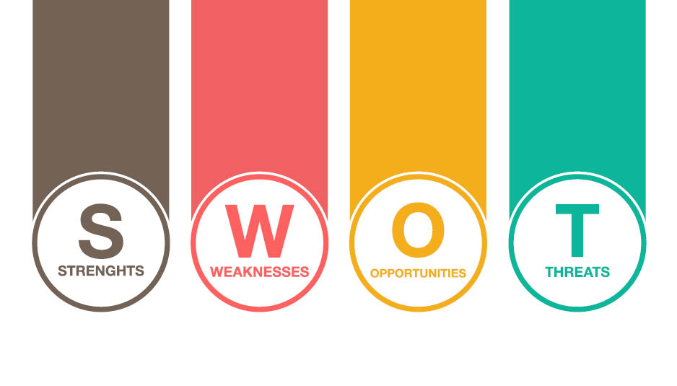

Source: SWOT Analysis (Schaffer et al, 2016)

Strengths of “HSBC Holdings PLC”:
With the proper analysis of their external environment the main strengths of “HSBC Holdings PLC” is obvious in the marketplace. Their customers are more satisfied with their services from their competitors. Knowing the strengths of their organisation helps the organisation to manage their next business move and they know exactly where to focus more to fight with the competitors in the marketplace. Their automation the business activity helps to improve their service and products quality and achieve consumer’s satisfaction too. They are showing super performance in their new markets too. (Schaffer et al, 2016)
The weakness of “HSBC Holdings PLC”:
Knowing the weakness of the organisations helps the managers to find the exact point where they need to focus more and improve their productivity and effectively in the workplace. To fight with the future uncertainty organisations need to improve in the weakness factors. “HSBC Holdings PLC” has weakness in the financial planning sectors. They need more investments in their technology sectors as they are introducing new technology to their consumers, for their low investments in these sectors it’s not enough effective in the marketplace and also in the workplace. (Hillary, 2015)
Opportunities for “HSBC Holdings PLC”:
Their new technologies in the marketplace and workplace help them to come up with a new price strategy. With the scope of market development, they can easily find the best possible way to achieve their competencies in the workplace and also in the marketplace. They are also using the new environmental policies to use as a new opportunity for their organisations and this helps them to build more customer trusts. Organisations need to use their opportunities effectively in the workplace to fight with the uncertainty May came in near future. (Emmerich, 2011)

Threats for “HSBC Holdings PLC”:
Currently the biggest threat for any organisations is COVID-19 and for this pandemic, the environmental factors are not stable in the marketplace. Organisations are facing difficulties to adjust in these situations. An organisation facing intense competition in the marketplace which is turning them into employee-focused organisations and this is mandatory for any organisations to achieve marketplace. Overcoming the threats “HSBC Holdings PLC” can effectively improve in the marketplace using their opportunities and strengths. (Palmer, 2015)
PESTEL Analysis of “HSBC Holdings PLC”:
PESTEL Analysis in the organisation is important to improve the production rate in the organisation. Analysing the environmental factors in any organisation is important as they help the organisations to understand the uncertainty and to find the strength and weakness in any business situation. “HSBC Holdings PLC” tries to implement the business behaviours with the help of business organisations external factors. The main factors of this analysis are Political, Economic, Social, Technological, Environmental and Legal factors. Each of this used to increase the production rate of the organisations. (Schaffer et al, 2016)
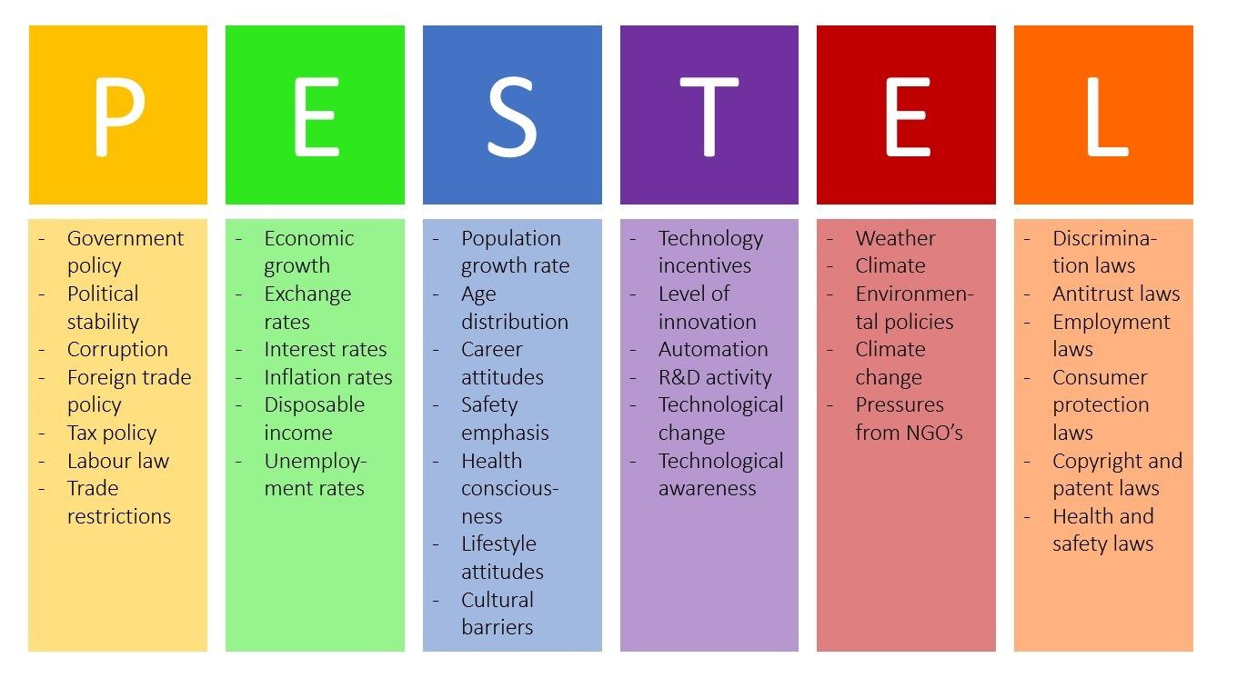

Source: PESTEL Analysis of “HSBC Holdings PLC” (BUSH, 2020)

Political Factor:
Political factors mainly affect the organisation's decision-making process where managers need to take the political factors s the main issues as this can influence the business organisations structure. “HSBC Holdings PLC” follows these political environments factors to increase their stability in the market and this helps them to continuously provide customers with effective services. (Palmer, 2015)
Economic Factors: Economic factors are mainly used to make financial decisions in the marketplace and help the organisation to compete with their products. This is the main factor in the decision-making process of the financial manager in the workplace and this helps the manager to plan different strategies within the organisation economic situation. (Schaffer et al, 2016)
Social Factors: Social factors are mainly referring to the source environment where the business organisations mainly develop their business organisations and help to find out the organisations the best possible outcome for the business organisations. Societal factors depending on the factors where the business mainly develops their policies and finds out the cooperation policies within the society. (BUSH, 2020)
Environmental factors: environmental factors are the core environment where the business organisations develop their business in business organisations. The environments are the source of building any organisations function any particular organisation and this helps the organisation to understand its ability to improve their source and resources. The resources they get from the environments helps them to grow more in their particular environment. (Cassidy et al, 2011)
Legal Factors: legal factors refer to the law and policies the organisations mainly follow and they had to maintain in the workplaces. Though the legal factors are depending on the environments they’re working and what types of business activities they are doing. Without maintaining the legal factors organisations cannot operate their business. (Hillary, 2015)

Technological Factors:
Technological factors are recently the most well-known factors in the environment as they are changing very continuously. Organisations are optimizing their technological factors in their workplace as they are increasing the production level and the effectiveness of the employees. This is mandatory for any organisations recently in the organisations (Strydom et al, 2018).
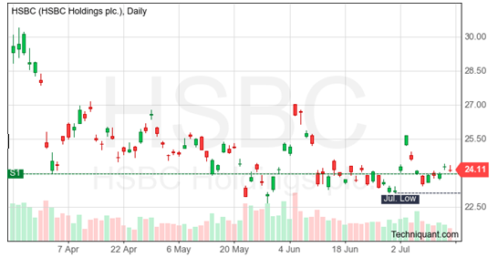
Source: Technological Factors of “HSBC Holdings PLC” (Schaffer et al, 2016)

(d). Critically assess the extent to which I think "HSBC" presents cultural and ethical standards and the personal ethical standards, values and beliefs of most employees are sustainable
Cultural standards of the organization
Cultural standards are a way that identifies the behaviour of different organizational things within the business organization. In the case of the “HSBC Holdings PLC” the leaders and the managers of this company established the culture of the organization and ensure a proper communication system between the employees and the other part of the business (Onyusheva et al, 2018).
The management of the bank tries to protect the cultural value of the customers because this organization has different employees who have a different religion, age, choices and point of view. The cultural standards of the “HSBC Holdings PLC” ensure better working for the organization. Though the recent COVID 19 pandemic harms the business a lot by bringing restriction in the workplace and the global business the bank started to come back from the hard situation by applying different strategy (Bhattacharya et al, 2018).
Edgar Schein’s culture model
Edgar Schein provided the theory of organizational culture and in his model; he discussed the basic assumptions values and behaviour. Behaviour and the values practices in the organization is the visible part of the organizational culture. The “HSBC Holdings PLC” faces a lot of cultural difficulties because of the COVID 19 pandemic. The organization brings a lot of restriction and limitation in the working place and environment due to this infectious disease all over the world (Wright et al, 2018).
The “HSBC Holdings PLC” applies the Edgar Schein model to adopt the necessary cultural change in their organization so that the company can operate the business activities in the time of COVID 19. Though it is not easy to adopt any culture in a moment for the organization, the bank can practice the changing culture every day so that the bank can easily adopt a new culture in its working environment to operate organizational activities without facing any issue for the COVID 19 (Weber et al, 2020).
In a culture model of Edgar Schein, he discusses three different levels of an organization’s culture. The levels are discussed below-
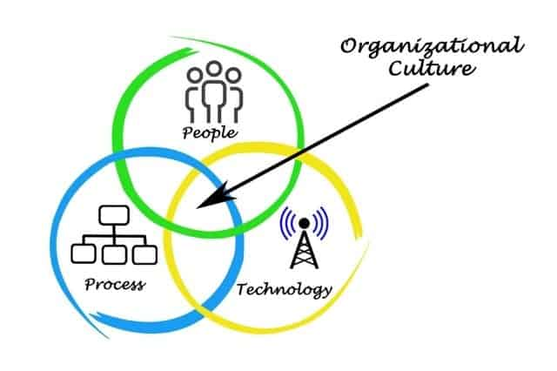
Figure: Factors related to the organizational culture (Sarwar et al, 2020).
Three things make the organizational culture effective that can change the working environment and the “HSBC Holdings PLC” can change the culture by changing these factors in the working environment. The bank can introduce new technology to develop the communication system so that the organization can communicate with the clients and other organizations in this COVID 19 pandemic. The process of operating business activities can be changed to adopt the situation in the domestic and international business of the company (Oumlil et al, 2017).
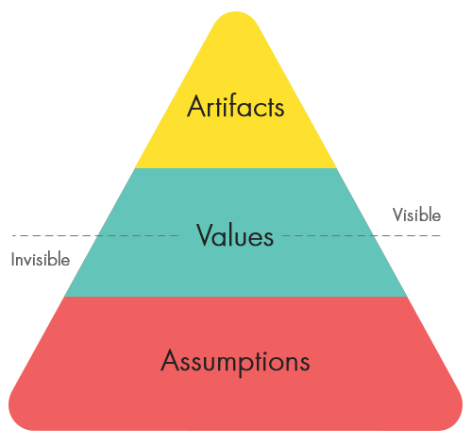
Figure: Edgar Schein’s organizational culture model (Kara et al, 2016).
Artefacts
The artefacts things are the first element of Edgar Schein’s model and these cultural elements are tangible things. The artefacts things of the “HSBC Holdings PLC” support the company to build a strong cultural factor in the working environment of the company. This factor of the model supports the company to provide personal space for the employees in this COVID 19 situation that ensures its safety in the working place. The languages of the employees, decoration of the office is included in this stage of the model (Skinner et al, 2019).
Values
Values are very important for the business organization because it leads the employees of a business organization properly and without facing any issues in the working place. In the case of “HSBC Holdings PLC” the philosophies, rules, principles and the belief of the company is known as the value of this company. The values of this bank support the business activities in the international business by restricting the openness activities and accepting the internet-based activities (Strydom et al, 2018).
Basic Assumptions
The assumption is one of the most important cultural elements of the organizational culture that supports the “HSBC Holdings PLC” to divide the time for different tasks. It also supports to allocate the space of the employees so that the employee can get enough space to operate their tasks comfortably and safely in this pandemic situation. It also supports the bank from giving an idea about the employees and the clients by judging their nature (Presbitero et al, 2019).

Ethical standards of the organization
Organizational ethics
Organizational ethics is the thing that supports a business organization to lead the business organization by maintaining all the external and internal factors of the organization. For example, the “HSBC Holdings PLC” always sets its organizational rules depending on the capability of the employees, external factors, and the culture of the business organization. The bank always supports its employees and supports them by showing ethical codes like allowing them to feel free motivate them for their work also the organization shows honesty, respect, trust and fairness to its customers and employees that show the ethical side of the organization (Onyusheva et al, 2018).
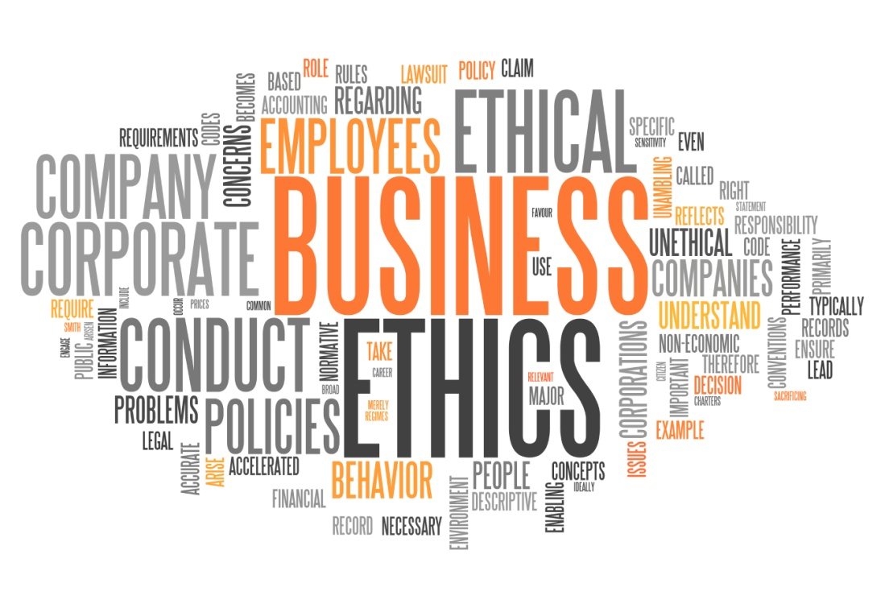
Figure: Ethics of a business organization (Bhattacharya et al, 2018).
To face the COVID 19 pandemic to the “HSBC Holdings PLC” the company shows ethical values to its employees so that the employees and the customers can not face any difficulties for the outer world situations. The bank restricted client engagement in the office time and arranges safety tools for the employees like sanitizer, face masks, PP kits etc. so that the company can ensure the safety of its employees (Wright et al, 2018).
Ethical development model
It is very important for the “HSBC Holdings PLC” to develop the ethical power of the company. The ethical development model of this company is given below-
Amoral organization
This is the last stage ethical value of a business organization because the organization that always focuses on earning profits follows amoral ethical organizational. “HSBC Holdings PLC” always supports its employees and customers and follows high ethical values in their business organization (Weber et al, 2020).
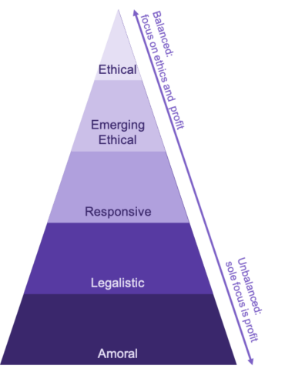
Figure: Ethical development model (Oumlil et al, 2017).
Legalistic organization
Legalistic organizations do not follow the extreme level of ethical value in its business activities because the rules and regulations are the first preference of this business organization. In the case of “HSBC Holdings PLC” is always follows the rules and regulation so that the company cannot face any legal issues in its business activities (Sarwar et al, 2020).
Responsive organization
The responsive organization is the middle-level organization because this type of business organizations follows the ethicality in their organization depending on the situation and it also gives enough focus on the profit of the business. For example, the “HSBC Holdings PLC” ensures its profit all the time and besides this, the organization follows the proper ethical value in the working environment (Skinner et al, 2019).
Emerging ethical
The final stage of the ethical extension appears in emerging moral situations. At this stage "HSBC Holding plc" nearly consider the bank's business interests for ethics and value. By following this ethical practice the company can easily face the recent issues related to the business organization can be eliminated (Kara et al, 2016).
Ethical organization
This stage is only applicable to the organizations that are operating their business only for the ethical purpose. As the “HSBC Holdings PLC” is a financial company and concern about the profit of the organization the company follows a balance ethical values and balance business operating system in its business activities. This supports the company to successfully maintain its business operation by ensuring the ethical value of the company (Strydom et al, 2018).
Personal Ethical Standards and Values of the Employees
Personal ethical standards are very important for the employees of a business organization because they support the business organization by keeping the working environment suitable for work. It is a process that supports a person to increase his judge ability that he is right or wrong. The “HSBC Holdings PLC” organization’s leaders always inspire their employees so that they can select the good thing for the organization and escape the wrong things from the working environment (Presbitero et al, 2019).
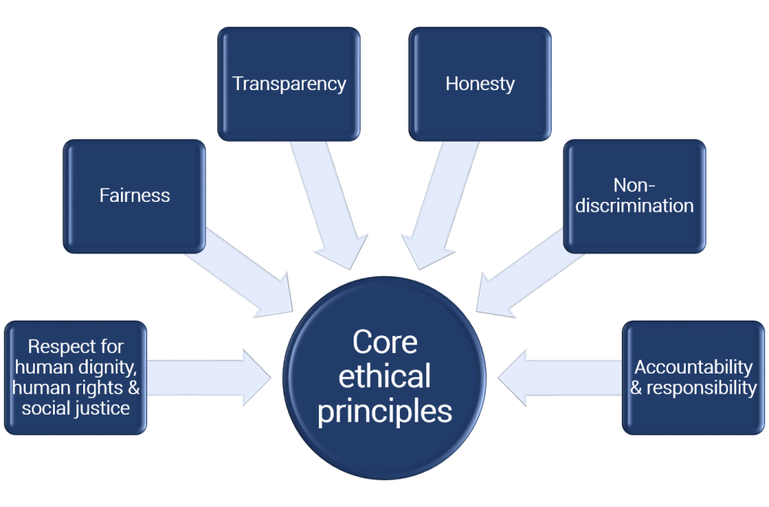
Figure: Principles of ethical value (Onyusheva et al, 2018).
Personal ethics of good employees and how it supports the organization
The “HSBC Holdings PLC” always follows the ethical standards in its activities and the employees of these organizations also follow the same thing strictly. This ethical standards and value of the company and employees support the company to achieve its business objectives and social responsibilities. The employees of the organization show their ethical value by concern for others, giving respect and showing honesty to the organization, supporting other employees to do their tasks (Bhattacharya et al, 2018).
The “HSBC Holdings PLC” also arranges some ethical practice training and seminar for the employees of this company to face different issues like COVID 19. The personal ethics of the employees of the organization supports the organization by keeping important information safe from the outside world. Besides this, the employees of this organization always behave well with the customers and try to solve all their problems it supports the organization to maintain good relation to the customers. Also, the ethical value of the employees supports the company to maintain its social responsibilities like developing labour policy, charitable giving and participating in the fair-trade (Wright et al, 2018)

Conclusion
Business organizations face very difficult phases during the COVID 19 pandemic because of the lockdown situation. To face the difficult situation of the hazard the business organizations take different strategies like changing their communication system, operating system and global business system. The “HSBC Holdings PLC” focuses on the cultural changes in its business activities to ensure a healthy and stress-free working environment in the organization. Besides this, the management of the organization inspires its employees and encourage them to show ethical value so that no one can feel hopeless in this difficult situation. Thus the company ensures its business objectives as well as ethical value (Weber et al, 2020).

References
Bhattacharya, S., Neelam, N. and Murthy, V., 2018. Ethical Value Positioning of Management Students of India and Germany. Journal of Academic Ethics, 16(3), pp.257-274.
BUSH, T., 2020. Theories Of Educational Leadership And Management. [Place of publication not identified]: SAGE PUBLICATIONS.
Cassidy, C., Kreitner, R. and VanHuss, S., 2011. Administrative Management. London: Pitman.
Emmerich, H., 2011. Federal Organization And Administrative Management. University: University of Alabama Press.
Hillary, R., 2015. Small And Medium-Sized Enterprises And The Environment. United Kingdom: Pearson Education Canada.
Kara, A., Rojas-Méndez, J.I. and Turan, M., 2016. Ethical evaluations of business students in an emerging market: Effects of ethical sensitivity, cultural values, personality, and religiosity. Journal of Academic Ethics, 14(4), pp.297-325. RIFAT_NAYEEM
Onyusheva, I.V. and Jordkoh, M., 2018. Socio-Cultural Environment of International Business: National and Ethical Aspects. Вестник университета Туран, (4), pp.62-68.
Oumlil, A.B. and Balloun, J.L., 2017. Cultural variations and ethical business decision making: a study of individualistic and collective cultures. Journal of Business & Industrial Marketing.
Palmer, M., 2015. The Human Factor In Political Development. Waltham, Mass.: Ginn.
Presbitero, A. and Teng-Calleja, M., 2019. Ethical leadership, team leader’s cultural intelligence and ethical behavior of team members. Personnel Review.
Sarwar, H., Ishaq, M.I., Amin, A. and Ahmed, R., 2020. Ethical leadership, work engagement, employees’ well-being, and performance: a cross-cultural comparison. Journal of Sustainable Tourism, 28(12), pp.2008-2026.
Schaffer, R., Agusti, F. and Dhooge, L., 2016. International Business Law And Its Environment. Singapore: Pearson.
Skinner, H., 2019. The impact of cultural values and economic constraints on tourism businesses’ ethical practices. International Journal of Tourism Cities.
Strydom, B.D., 2018. Ethical leadership across cultural value orientations (Doctoral dissertation, University of Pretoria).
Weber, J. and McManus Warnell, J., 2020. Exploring the Relationship of Variant Degrees of National Economic Freedom to the Ethical Profiles of Millennial Business Students in Eight Countries. Business & Society, p.0007650320963679.
Wright, S.A. and Schultz, A.E., 2018. The rising tide of artificial intelligence and business automation: Developing an ethical framework. Business Horizons, 61(6), pp.823-832.

