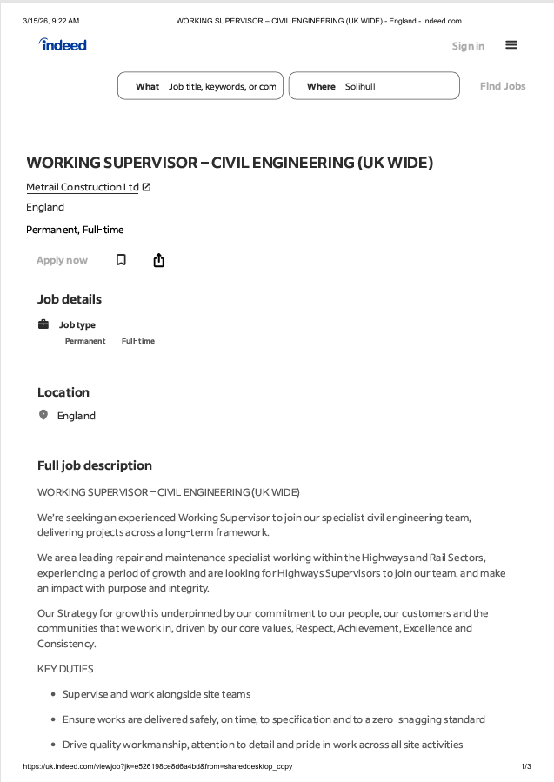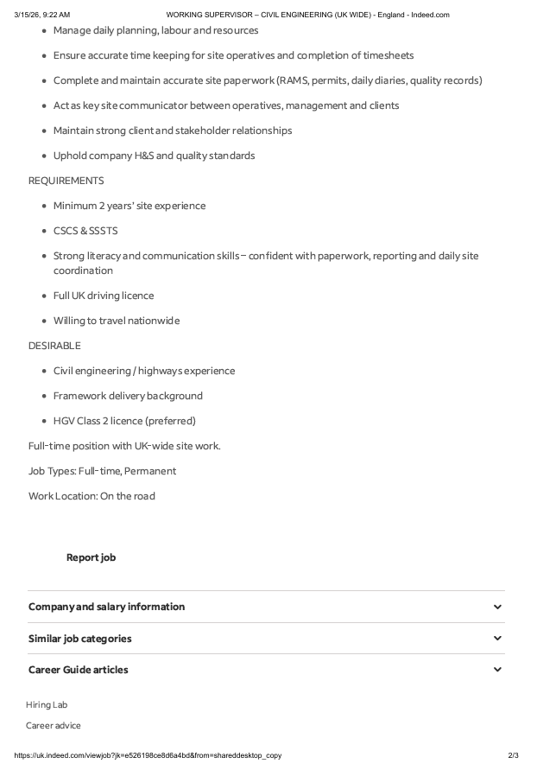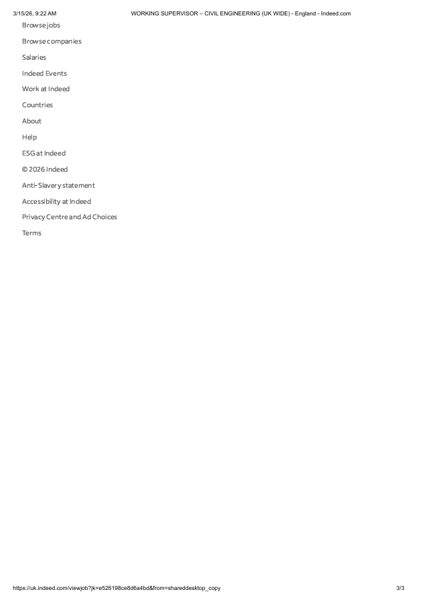

COVER LETTER

Ioan Leoapa
21, xxxx Street, London
David Edwards
Metrail Construction LTD
82, Lucerne Road, Colchester
15/03/2026

Dear Mr. Edwards
I wish to apply for the role of working supervisor, currently being advertised on Indeed. Please find enclosed my CV for your consideration.
Attached is my CV, I have over 12 years experience in the construction industry, and I believe my strong leadership skills, practical construction knowledge, and ability to manage teams and projects efficiently during this time make me the right/perfect candidate for the role.
In my current role as a supervisor at Styne Greenhouses LTD, I have been responsible for overseeing daily site operations, coordinating construction teams, ensuring work is completed safely and to a high standard, and managing materials and schedules to meet project deadlines.
During this experience, I have developed strong organisational and problem-solving skills, coupled with my enthusiasm and dedication, strong leadership, communication, and project management skills, has helped me deliver projects successfully while maintaining high quality and safety standards.
I am confident that I can bring this level of success with me to your organisation and help Metrail Construction LTD build upon their reputation as a trusted and reliable construction company delivering high-quality projects. With my previous experience and expertise, I believe my contribution will have a positive impact on your team and ongoing projects.
Thank you taking the time to consider my application.
I look forward to hearing from you and discussing this opportunity further.
Yours sincerely,
Ioan Leoapa

CV
Ioan Leoapa
Colchester, UK
Phone: 07511862455
Email: ioanleoapa@gmail.com
Full UK Driving Licence
Professional Profile
Experienced Construction Supervisor with over 12 years of experience in the construction industry. Skilled in supervising teams, managing site operations, coordinating materials, and ensuring projects are completed on time and to high quality standards. Strong knowledge of health and safety regulations, project planning, and team leadership. Reliable, hardworking, and committed to delivering successful construction projects.
Key Skills
Construction Site Supervision
Team Leadership & Workforce Management
Health & Safety Compliance
Project Coordination
Problem Solving
Quality Control
Materials & Equipment Management
Communication with Clients and Contractors
Time Management & Organisation
Work Experience
Construction Supervisor – Styne Greenhouses LTD
Dates: 2012 – Present
Supervising construction teams on site
Planning and organising daily work schedules
Ensuring projects are completed safely and on time
Monitoring quality of work and materials
Coordinating with contractors, suppliers, and clients
Ensuring compliance with health and safety regulations
Managing tools, equipment, and site materials
Solving on-site problems and supporting team productivity
Construction Worker / Skilled Tradesperson
Various Construction Projects – Dates: 2013 – 2020
Structural and renovation work
Installation of building materials and systems
Site preparation and finishing work
Working closely with supervisors and project managers
Maintaining high quality workmanship and safety standards
Education / Training
Construction Skills Training
Health & Safety Training
Manual Handling Training
CSCS Card
Additional Skills
Ability to manage multiple projects
Strong work ethic and reliability
Experience with construction tools and machinery
Good communication and leadership skills
References
Charles Hill director Styne Greenhouses LTD
07511587457

