Research, build, and deploy a Virtualised Enterprise network
Network Operating Systems and Services – ACCA5023
28/02/2026
2317483@student.uwtsd.ac.uk
Daniel Leone (2317483)

Table of Contents
Table of Figures 2
1. Introduction 3
2. Research and analysis 4
2.1 Hypervisor Architecture 4
2.1.1 Overview of Hypervisors 4
2.1.2 Type 1 Hypervisors 5
2.1.3 Type 2 Hypervisors 6
2.1.4 Key differences and considerations 7
2.3 Principles of IP Addressing and Network Identification 8
2.3.1 IP Addressing Overview 8
2.3.2 IPv4 Addresses 8
2.3.3 IPv6 Addresses 9
2.3.4 Summary 9
2.4 Routing Concepts and Strategy 10
2.4.1 Routing and Switching Overview 10
2.4.2 Static and Dynamic Routing 10
2.4.3 Routing Strategy for NOSS2026 implementation 10
2.5 Network Services and Their Role 11
2.5.1 Network Services Overview 11
3. Network Deployment and Configuration 13
3.1 Justification of Hypervisor Selection 13
3.2 Acquisition of Software and Environment Setup 13
3.2.1 Software Download 13
3.2.2 Virtual Network Deployment 16
3.3 IP Addressing Configuration & Testing 27
3.3.1 Debian Server IP Configuration 27
3.3.2 Connectivity Testing 29
4. Reflective Evaluation 31
4.1 Technical Reflection 31
4.2 Personal Development Reflection 31
5. Appendices 33
5.1 Hierarchical Privilege 33
5.2 VLSM scheme 34
References 35

Table of Figures

Figure 1, NOSS2026 Topology 4
Figure 2, type 1 (Bare Metal) hypervisor [1] 6
Figure 3, Type 2 (hosted) Hypervisor [1] 7
Figure 4, Hypervisor Key differences and Considerations [5, p. 42] [28] [11] [4] [7] [27] [8] 8
Figure 5, IPV4 address structure [29] 10
Figure 6, Enhanced NOSS2026 Topology 12
Figure 7, Examples of Network Services [28] [14, pp. 15,40, 379-380] [23] [24, pp. 80-82] [30] 13
Figure 8, Oracle VirtualBox (Type 2 Hypervisor) 14
Figure 9, Windows Server 2022 14
Figure 10, Windows 10 (Client) 15
Figure 11, Debian (Server & Client) 15
Figure 12, Windows Server (S-DC) 16
Figure 13, Configuring Server Name Within Windows 17
Figure 14, Adding Network Adapter to S-DC 18
Figure 15, Adding adapter 3 to S-DC 19
Figure 16, Windows Client (ClientS1) 20
Figure 17, Adding network adapter to ClientS1 21
Figure 18, Debian Server (L-CD) 22
Figure 19, L-CD installation settings 22
Figure 20, Adding Network adapter to L-CD 23
Figure 21, Adding adapter 3 to L-CD 24
Figure 22, Debian Client (ClientL1) 25
Figure 23, Naming Debian client 25
Figure 24, ClientL1 Installation Settings 26
Figure 25, Adding Network adapter to ClientL1 27
Figure 26, Debian Server (L-CD) IP config. 28
Figure 27, Debain Server (L-CD) Network adapters (Down) 28
Figure 28, Debian Server (L-CD) Network adapters (UP) 29
Figure 29, Connectivity testing: S-DC and ClientS1 30
Figure 30, Connectivity testing: L-CD and ClientL1 30
Figure 31, Connectivity testing: L-CD and S-DC 31
Figure 32, Connectivity testing: ClientL1 and ClientS1 31
Figure 33, Protection rings [2] 33

1. Introduction

This aim of this report is to outline the design and implementation of a virtualised network for NOSS2026, a theoretical organisation with locations in Swansea and London. The proposed network topology (Figure 1) requires deploying both a Windows Server and Debian Server to provide client connectivity, and support future addition of network services. All servers and clients are deployed as virtual machines (VMs) in a controlled lab environment, allowing practical demonstration of core network operating system principles while considering performance, security, scalability, and resource management. The report integrates research and practical work, evaluating virtualisation platforms, documenting the deployment and configuration of the virtual infrastructure, and reflecting on technical and personal learning outcomes from the implementation.
Figure 1, NOSS2026 Topology
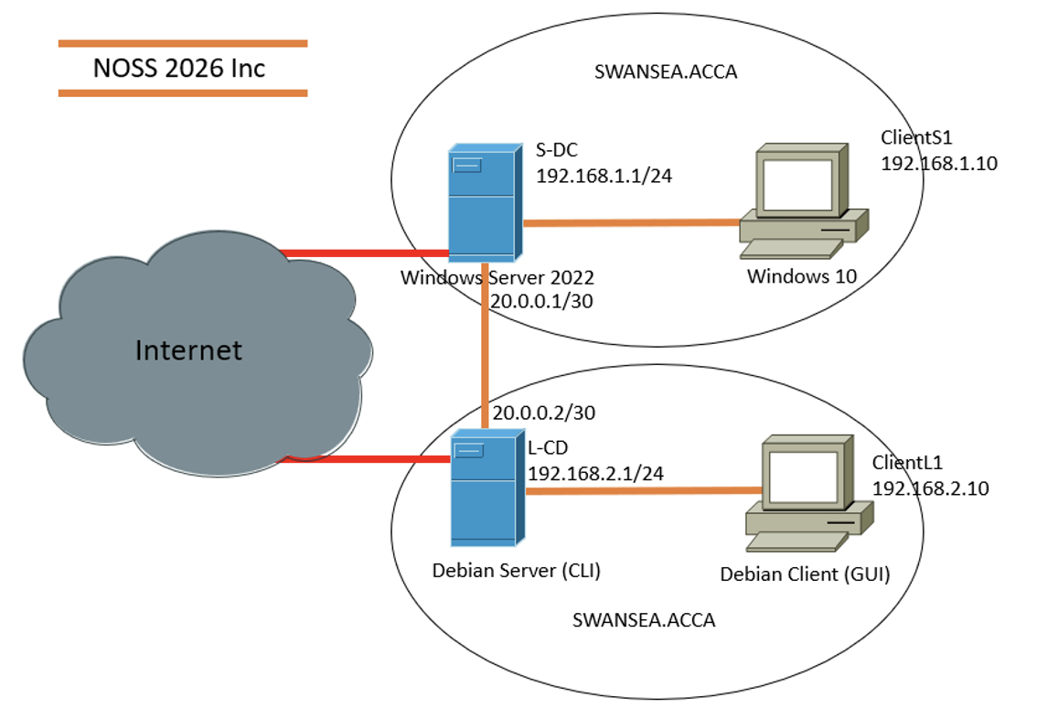

2. Research and analysis

2.1 Hypervisor Architecture

2.1.1 Overview of Hypervisors
Hypervisors are platforms that allow multiple operating systems (OS), referred to as ‘guest’ OS, to run simultaneously on a single physical computer known as the ‘host’ system [1, p. 5] [2, p. 321] [3] [4]. Through virtualisation, the hypervisor manages the guest’s access to underlying hardware resources. In effect, the hypervisor abstracts each VM into a complete and independent computer system. [1, p. 9] [5, p. 40] [3] [4] [6] [7] [8]. In addition to resource management, hypervisors can provide administrative functions such as snapshot creation, and control the operational state of VMs. E.g., Powering on or off [5, p. 41] [1, pp. 10, 28]. Hypervisors are classified into two architectural models: Type 1 (bare metal) and Type 2 (hosted) [5, p. 41] [1, p. 6] [4] [9] [6].

2.1.2 Type 1 Hypervisors

Type 1 hypervisors run directly on physical hardware and can operate at a higher privilege level than an OS. With this type of hypervisor, the guest OS operate at their native privilege level, however they no longer have the same direct control of hardware resources. Instead, the type 1 hypervisor intercepts resource requests for each guest OS, enforcing strict isolation and security, preventing conflicts and managing access to shared resources [10] [2, p. 321] [11]. Examples of Type 1 hypervisors include VMware ESXi, Microsoft Hyper-V, Oracle VM Server, and Proxmox [9] [5, p. 42] [4].
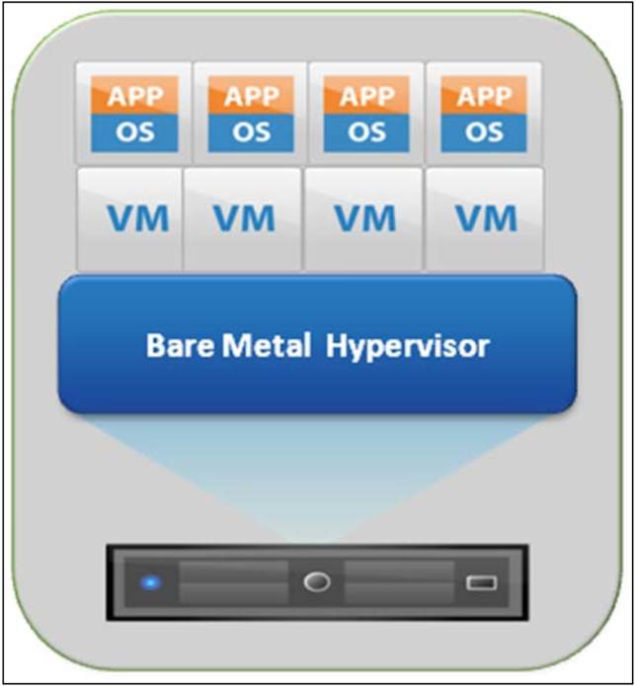
Figure 2, type 1 (Bare Metal) hypervisor [1]

2.1.3 Type 2 Hypervisors

Type 2 hypervisors run as an application on top of a host operating system, operating at a lower privilege level than the host OS. Consequently, the virtual machines they manage also operate at this lower privilege [12]. This adds an additional layer of abstraction between the VMs and the physical hardware, reducing efficiency compared with Type 1 hypervisors, since all resource requests are negotiated between the hypervisor and host OS [2, pp. 329-330] [7]. The host OS also consumes system resources, which can further impact VM performance. Additionally, the isolation and security of the VMs are considered weaker compared to Type 1 hypervisors [11]. Examples include Oracle VirtualBox, VMware Workstation, and Parallels [9] [4].
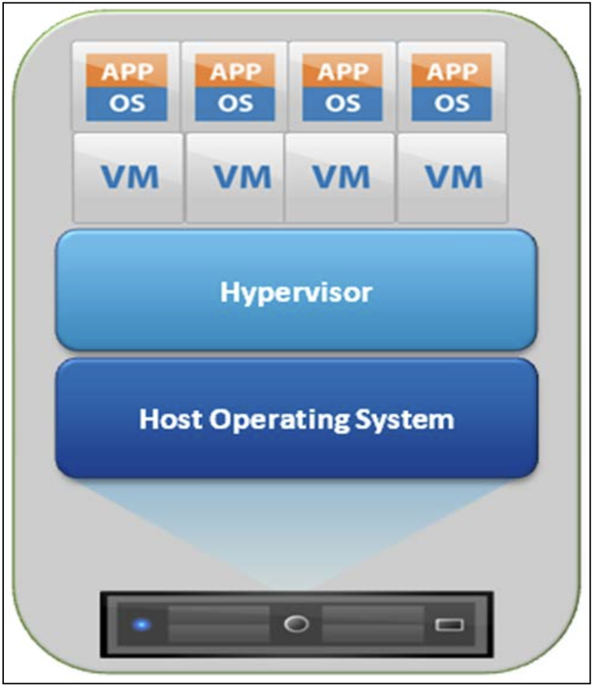
Figure 3, Type 2 (hosted) Hypervisor [1]

2.1.4 Key differences and considerations
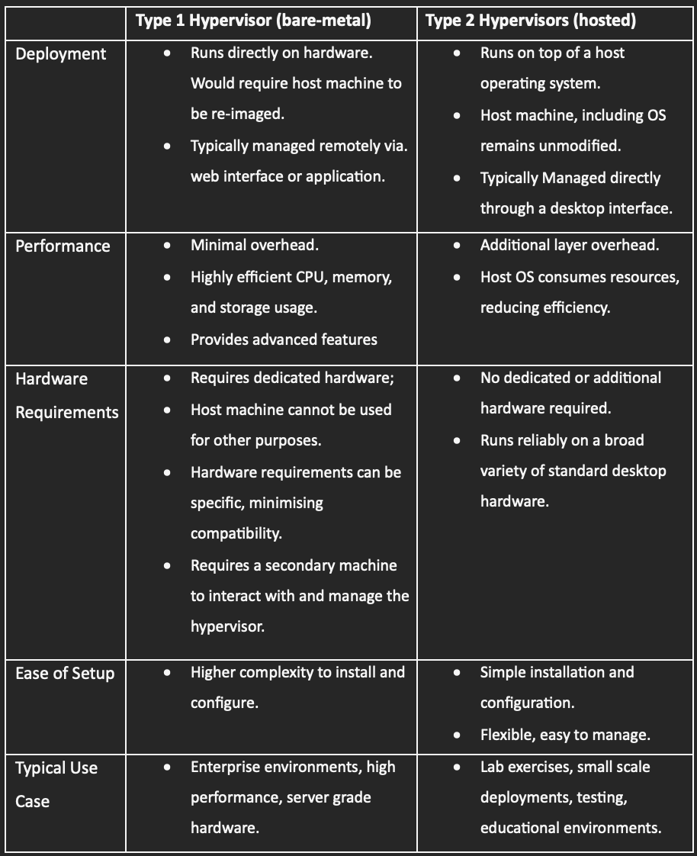
Figure 4, Hypervisor Key differences and Considerations [5, p. 42] [28] [11] [4] [7] [27] [8]

2.3 Principles of IP Addressing and Network Identification

2.3.1 IP Addressing Overview

IP (Internet Protocol) addresses are numerical identifiers assigned to network interfaces to enable communication. Their fundamental purposes include:
- Uniquely identify each device or interface.
- Ensure data reaches the correct destination.
- Support structured and scalable networks.
- Prevent address conflicts.
[13] [14, p. 29] [15, p. 24] [16]

Each address has a network portion, identifying the network segment, and a host portion, identifying the device within that network [15, p. 30].

2.3.2 IPv4 Addresses

- IPv4 addresses are 32-bit identifiers written in dotted decimal notation.
E.g., 192.168.1.1
- They consist of four 8-bit octets, each from 0–255.
- Subnetting divides a network into smaller segmented networks, giving separate groups of devices distinct address ranges.
- CIDR (Classless Inter-Domain Routing) notation is used to represent these subnets, specifying the number of bits in the network portion.
E.g., 192.168.1.0/24, first 24 bits for the network, remaining 8 bits for hosts.
[13] [15, pp. 25-26,28] [17] [18] [16]

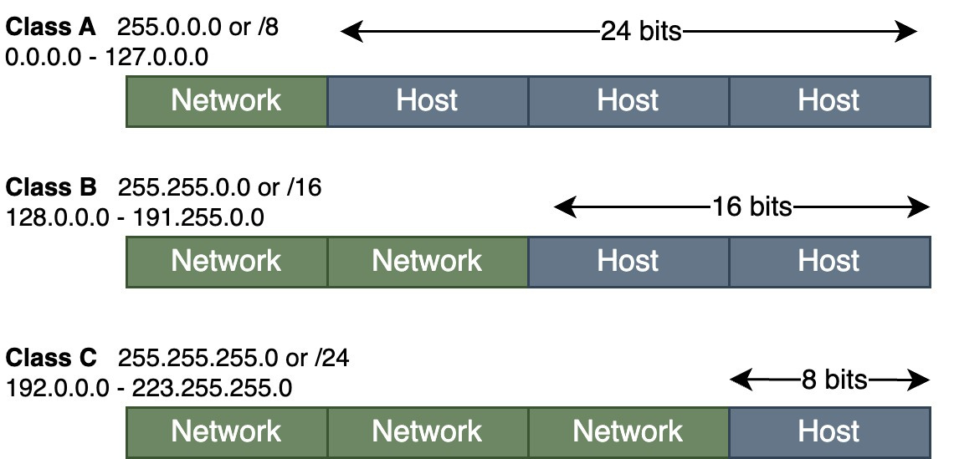
Figure 5, IPV4 address structure [29]

2.3.3 IPv6 Addresses

- IPv6 addresses are 128-bit identifiers written in hexadecimal, separated by colons.
E.g., 2001:0db8:0000:0000:0000:0000:0000:0001
(can be shortened to 2001:0db8::1)
- Can also be subnetted. However, its large address space provides vastly more unique addresses, significantly reducing the primary need for subnetting compared to IPv4
[13] [14, p. 29] [15, p. 34] [19, p. 24] [16]

2.3.4 Summary

IP addressing is essential for communication across networks. IPv6 was developed to overcome the limitations of IPv4, providing a larger address space which supports network growth. Both protocols can operate simultaneously, allowing networks to adopt IPv6 gradually while maintaining IPv4 compatibility [20] [13] [14, p. 29].

2.4 Routing Concepts and Strategy

2.4.1 Routing and Switching Overview

Routing is the process of forwarding data packets between different networks using IP addresses [19, p. 8]. A router determines the correct path for traffic to reach its destination. Without routing, communication would be limited to devices within the same LAN [14, pp. 145-147]. Within a local network, switches forward data to the correct device using their permanent physical address called the MAC address [16] [14, p. 69].

2.4.2 Static and Dynamic Routing

Static routing involves manually configuring routes on a router. This method is suitable for small networks where the topology does not frequently change. Static routes must be manually updated if the topology is modified [19, pp. 8-11, 15]. Dynamic routing automatically shares routing information between routers, allowing networks to adapt to changes and select efficient paths, thus avoiding errors. It best suited for larger networks [19, p. 15] [14, pp. 143-145].

2.4.3 Routing Strategy for NOSS2026 implementation

The NOSS2026 topology consists of two separate LANs; one hosting the Windows Server and client, and the other hosting the Debian Server and client. The two LANs are connected via a dedicated network connection between the servers.

Future enhancements to the implementation will require the Debian Server to be configured as a DHCP relay agent, forwarding DHCP broadcast requests from its local network to the Windows Server, which will provide the DHCP service, Outlined in figure 6, below. As DHCP broadcasts do not cross routers by default, routing must be configured to enable DHCP communication between the networks [21] [22].

Figure 6, Enhanced NOSS2026 Topology
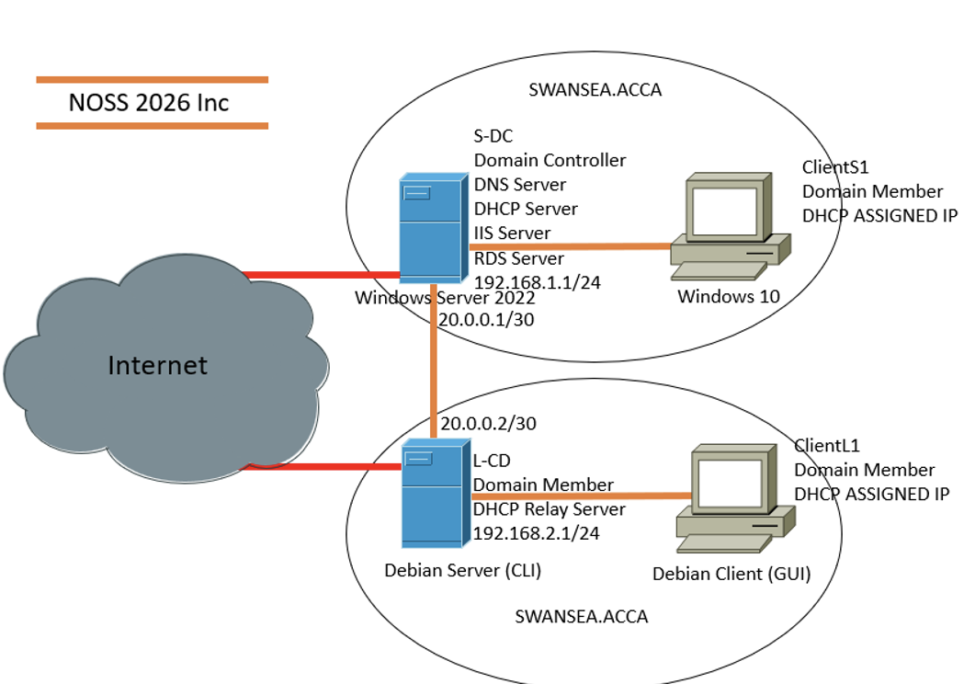
Given the small and fixed structure of the topology, static routing would be an appropriate approach. It will allow manual route configuration between the two LANs, ensuring reliable communication while keeping the setup simple to troubleshoot.

2.5 Network Services and Their Role

2.5.1 Network Services Overview

Network services consist of roles and features that are specifically designed to provide essential functions to clients and support the network infrastructure, in simple terms they make a server useful. By implementing these roles, servers deliver a broad range of practical services, including establishing secure communications, automating configuration, managing user authentication, and issuing digital certificates [23] [24, p. 80].

2.5.2 Examples of Network Services
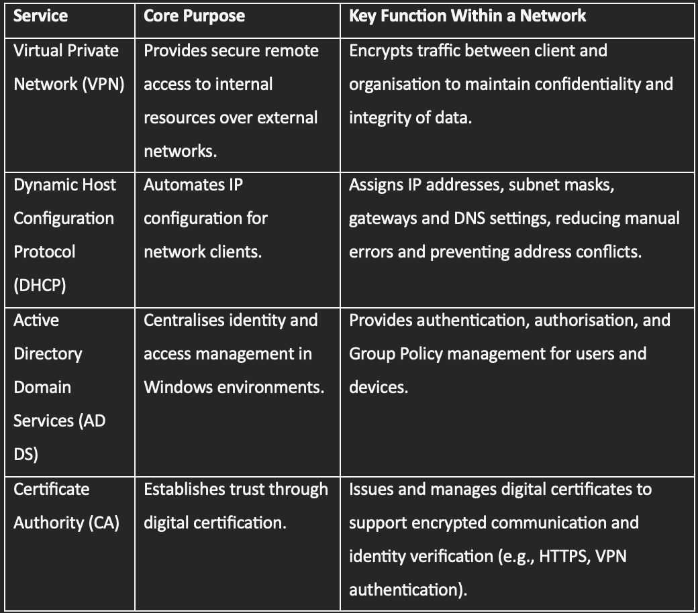
Figure 7, Examples of Network Services [28] [14, pp. 15,40, 379-380] [23] [24, pp. 80-82] [30]

3. Network Deployment and Configuration

3.1 Justification of Hypervisor Selection

When selecting a hypervisor, the author considered the factors outlined in section 2. Type 1 hypervisors are technically superior, offering high security, efficiency and minimal overhead, however their requirement for dedicated hardware and more complex configuration reduces practicality in a university lab environment. In this implementation, A Type 2 hypervisor can be considered advantageous for its simpler management and adequate performance on standard desktop systems. Furthermore, the university lab systems are sufficiently powerful to handle the overhead of a hosted solution. Oracle VirtualBox has been pre-installed on these systems, is compatible with both Windows and Linux guests [9], is widely used in education, and can support the networking objectives of this implementation. The author’s decision to use Oracle VirtualBox prioritises accessibility and flexibility over performance.

3.2 Acquisition of Software and Environment Setup

3.2.1 Software Download

The following screenshots document the acquisition of the required virtualisation software and Operating Systems.
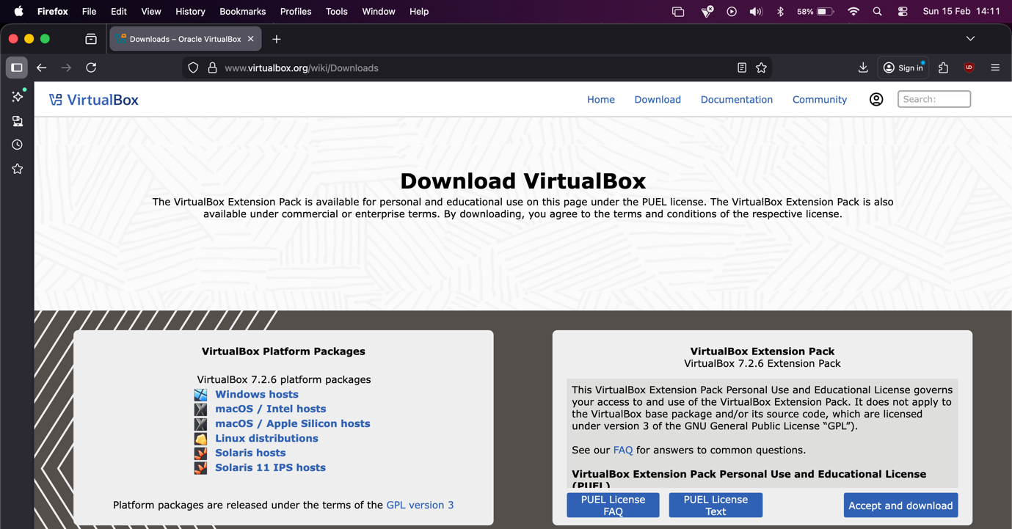

Figure 8, Oracle VirtualBox (Type 2 Hypervisor)

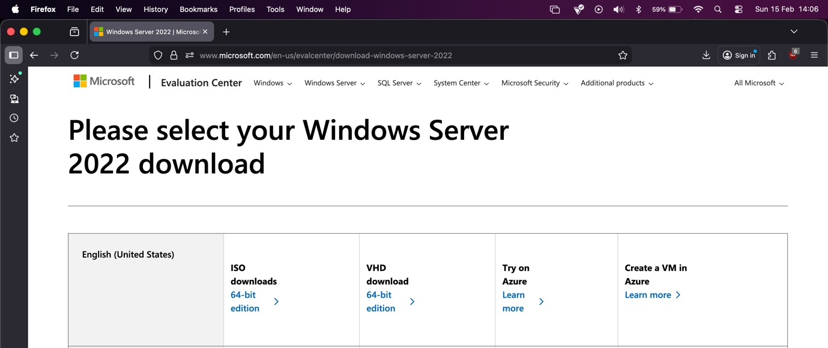

Figure 9, Windows Server 2022

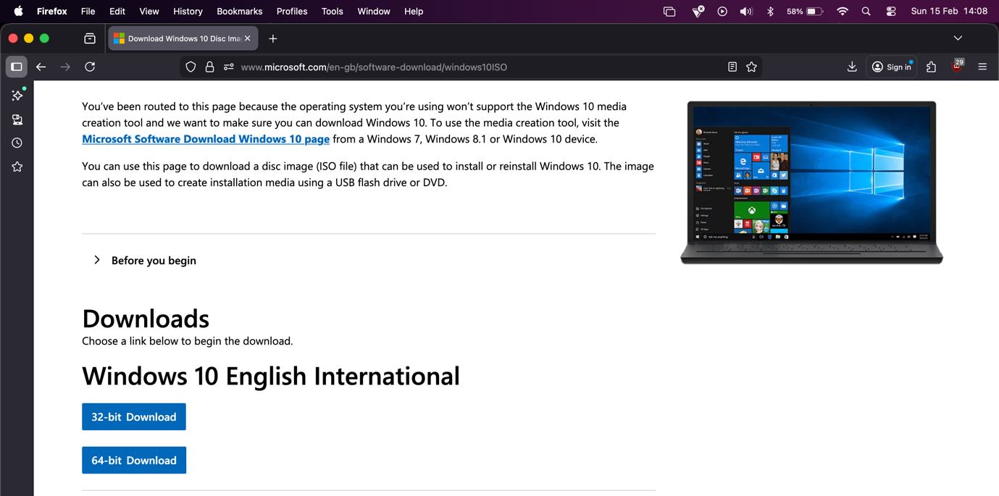
Figure 10, Windows 10 (Client)

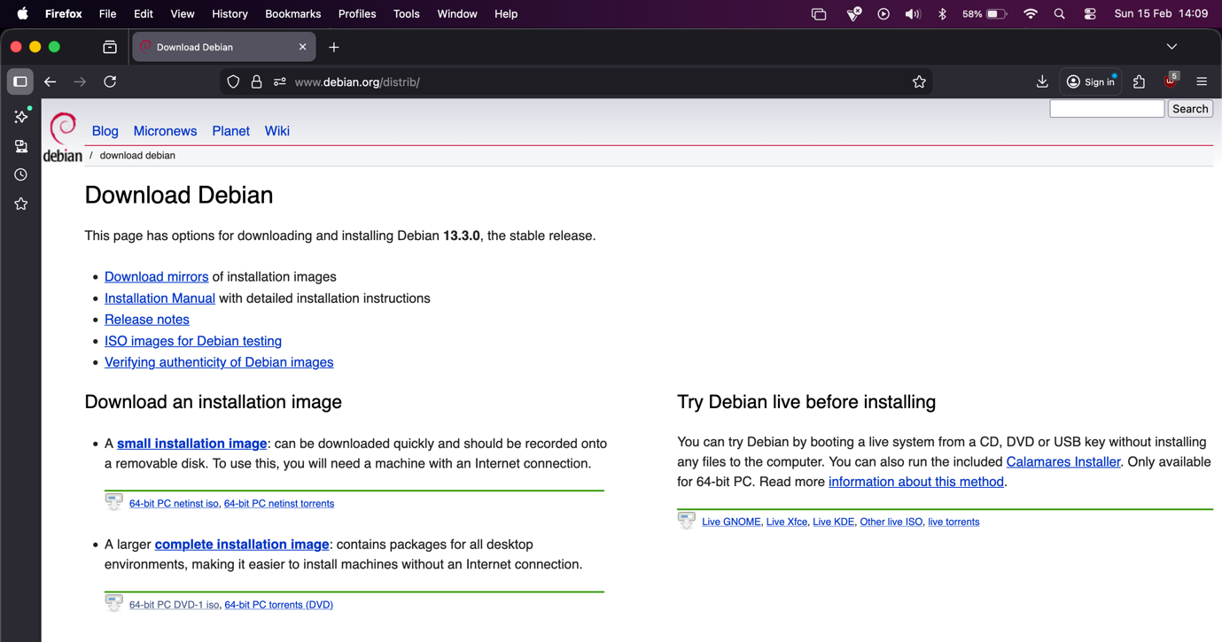
Figure 11, Debian distro (Server & Client)

3.2.2 Virtual Network Deployment

3.2.2.1 Windows server
The following screenshots detail key stages of the deployment.

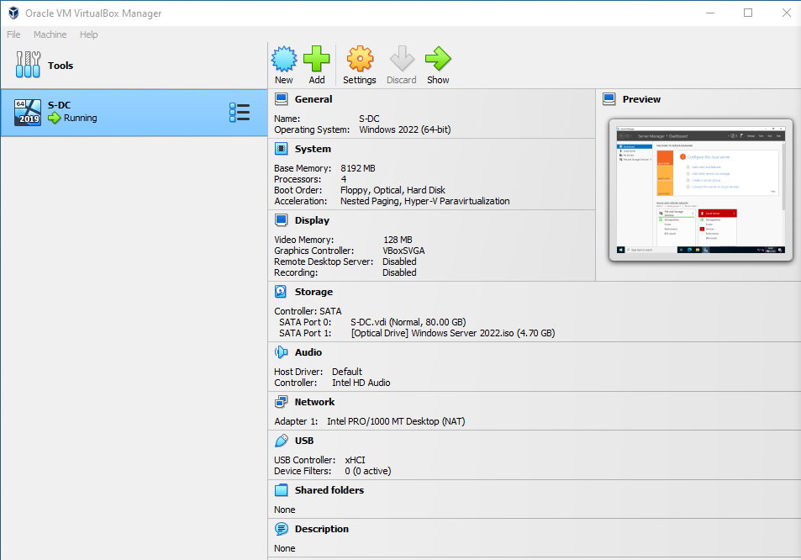
Windows Server VM, including hardware allocation information:
Figure 12, Windows Server (S-DC)

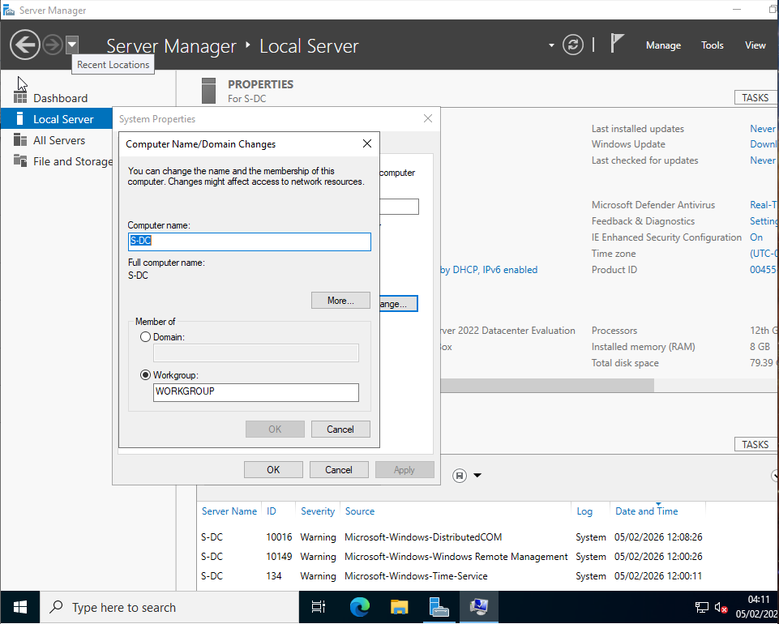
Changing Windows Server name:
Figure 13, Configuring Server Name Within Windows

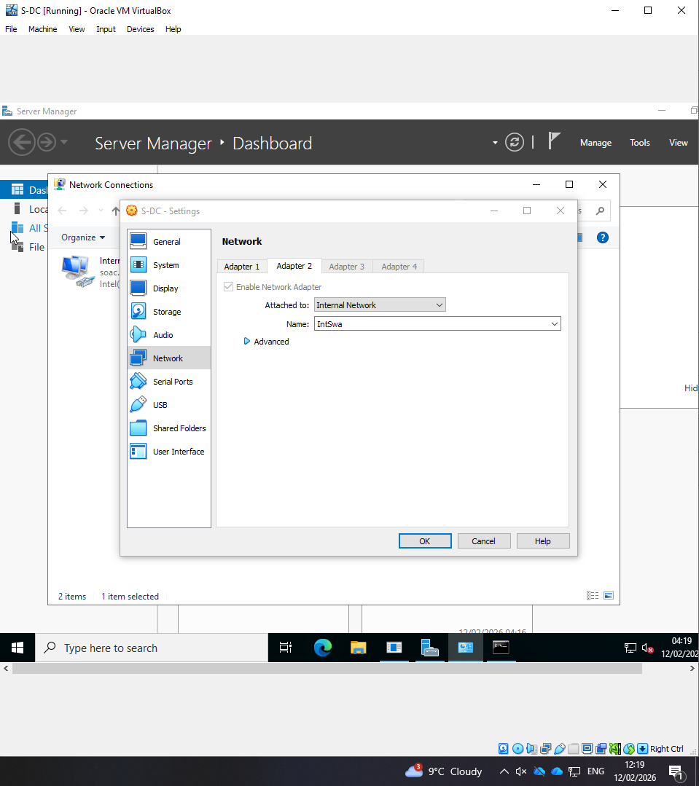
Adding Networking adapter to S-DC for Swansea LAN:
Figure 14, Adding Network Adapter to S-DC

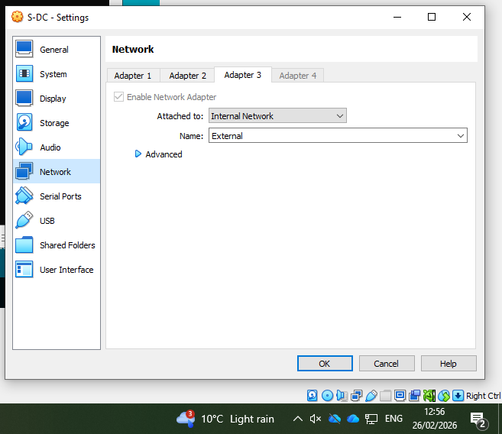
Adding adapter 3 to Windows Server (link to Debian Server):
Figure 15, Adding adapter 3 to S-DC

3.2.2.2 Windows Client

Windows Client VM, including hardware allocation information:
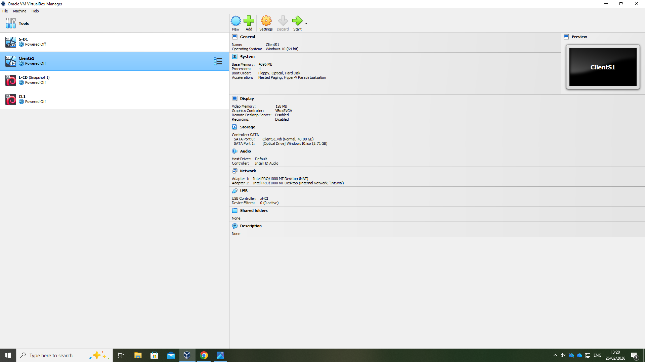
Figure 16, Windows Client (ClientS1)

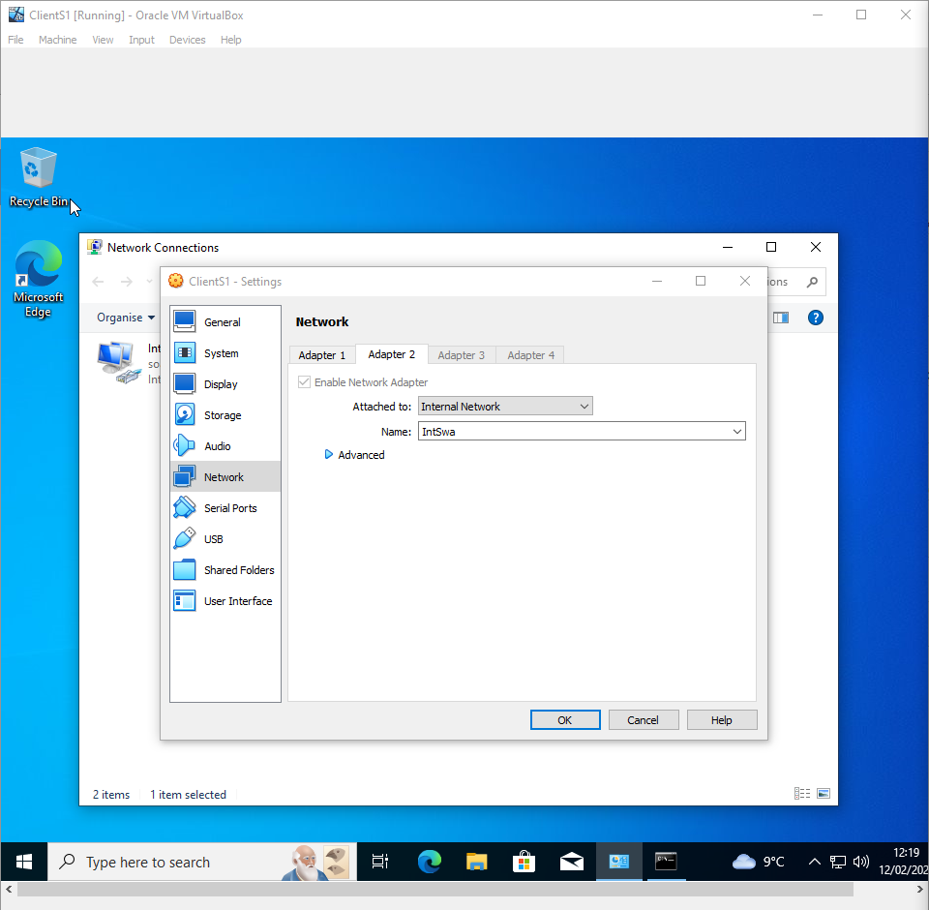
Adding Networking adapter to ClientS1 for Swansea LAN:
Figure 17, Adding network adapter to ClientS1

3.2.2.3 Debian Server

Debian Server VM, including hardware allocation information:
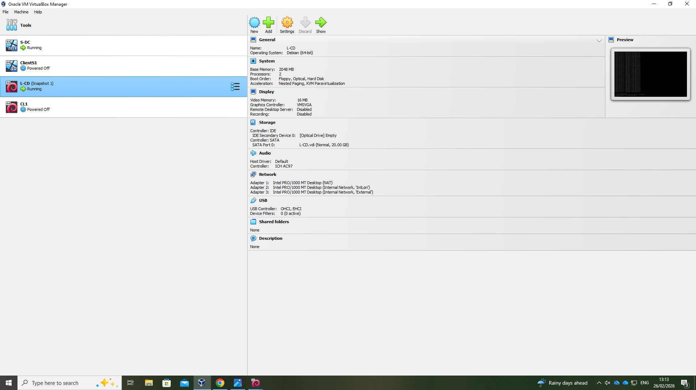
Figure 18, Debian Server (L-CD)

Installation Settings (CLI based install, no desktop environment):
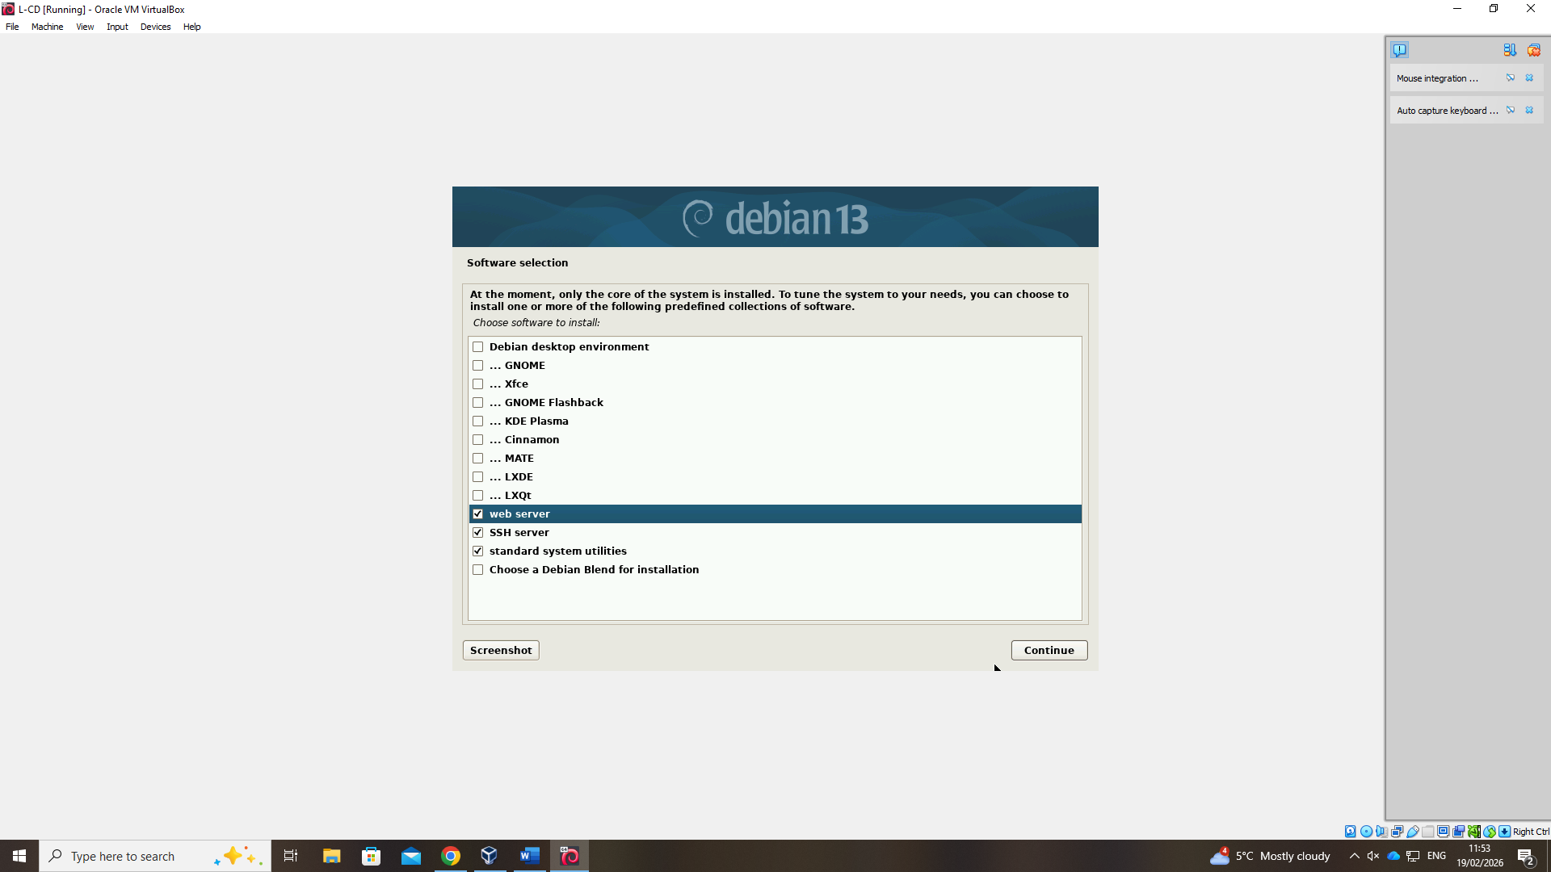
Figure 19, L-CD installation settings

Adding Networking adapter to L-CD for London LAN:
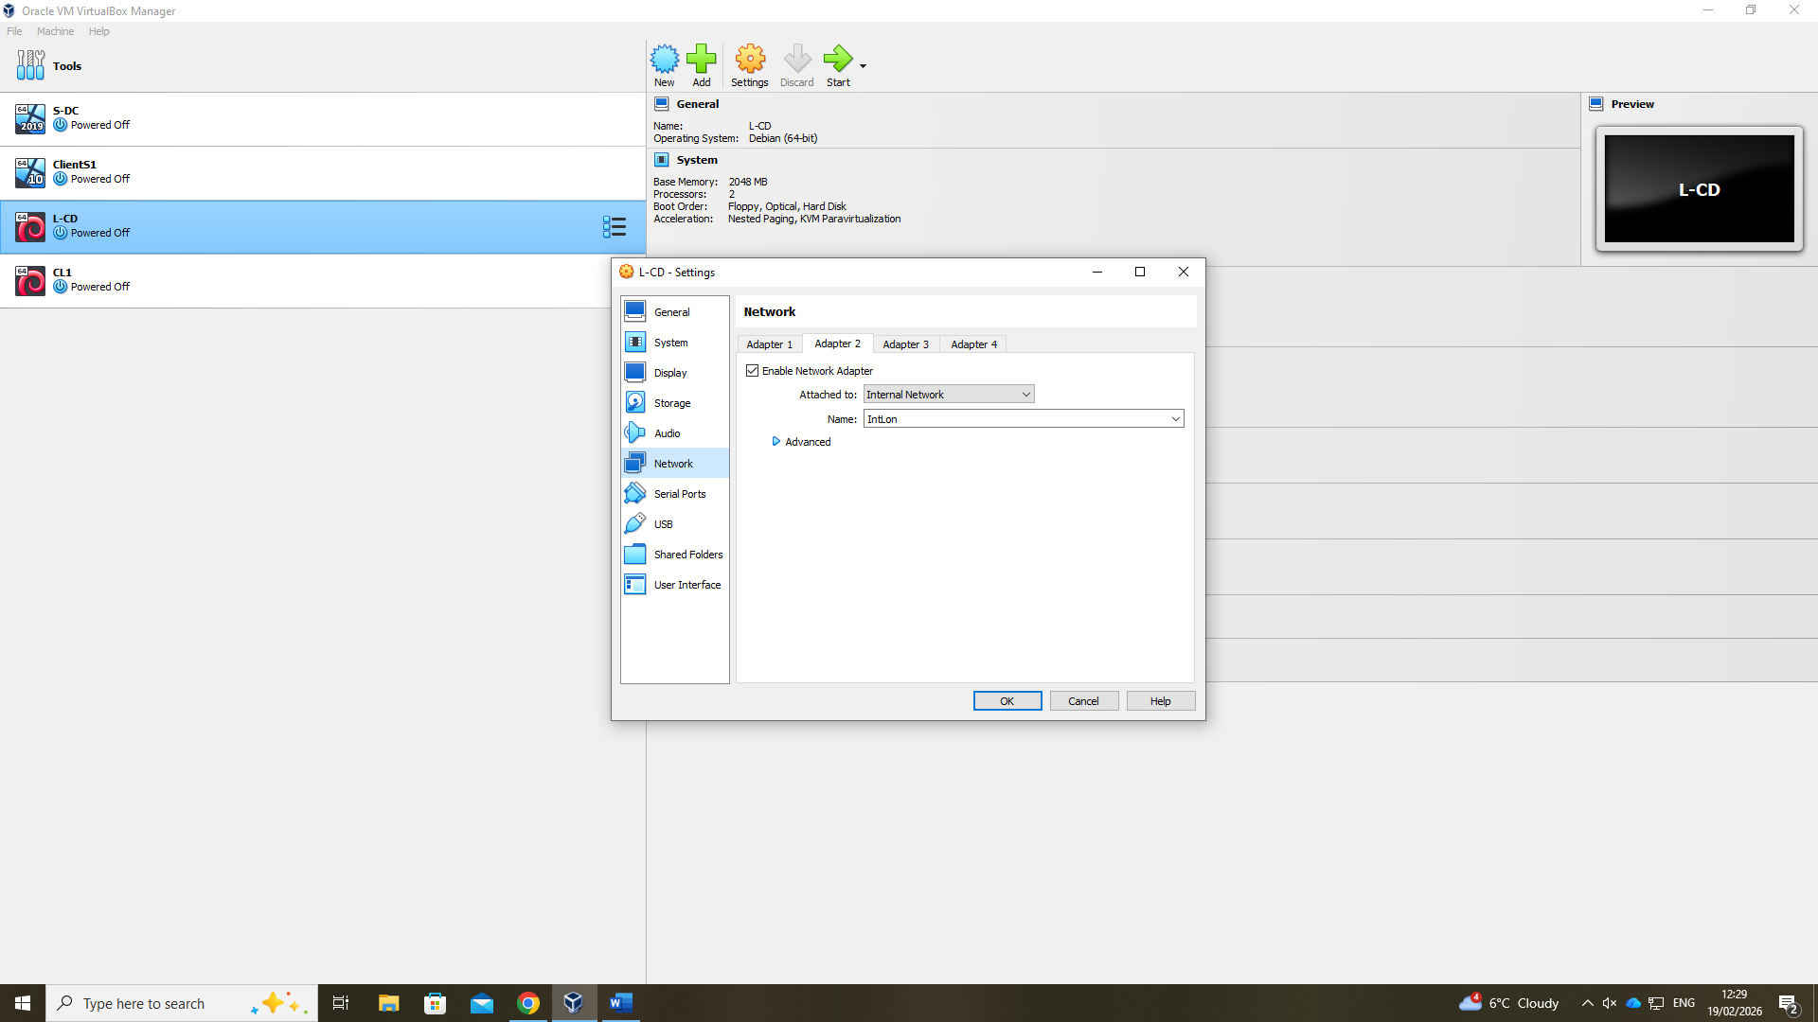

Figure 20, Adding Network adapter to L-CD
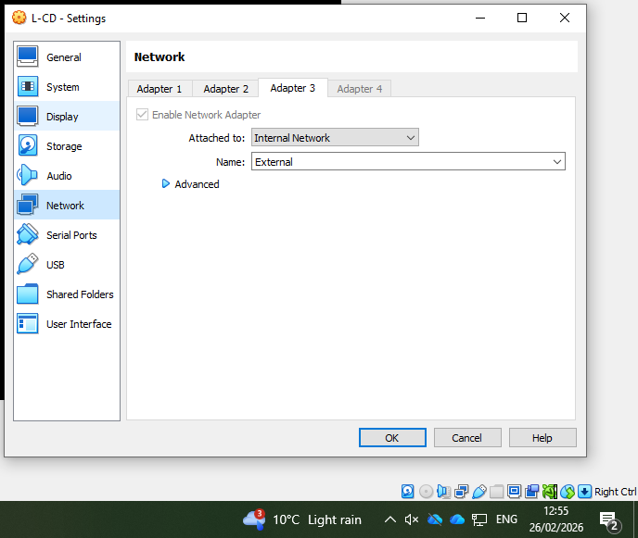
Adding adapter 3 to L-CD (link to Windows Server):
Figure 21, Adding adapter 3 to L-CD

3.2.2.4 Debian Client

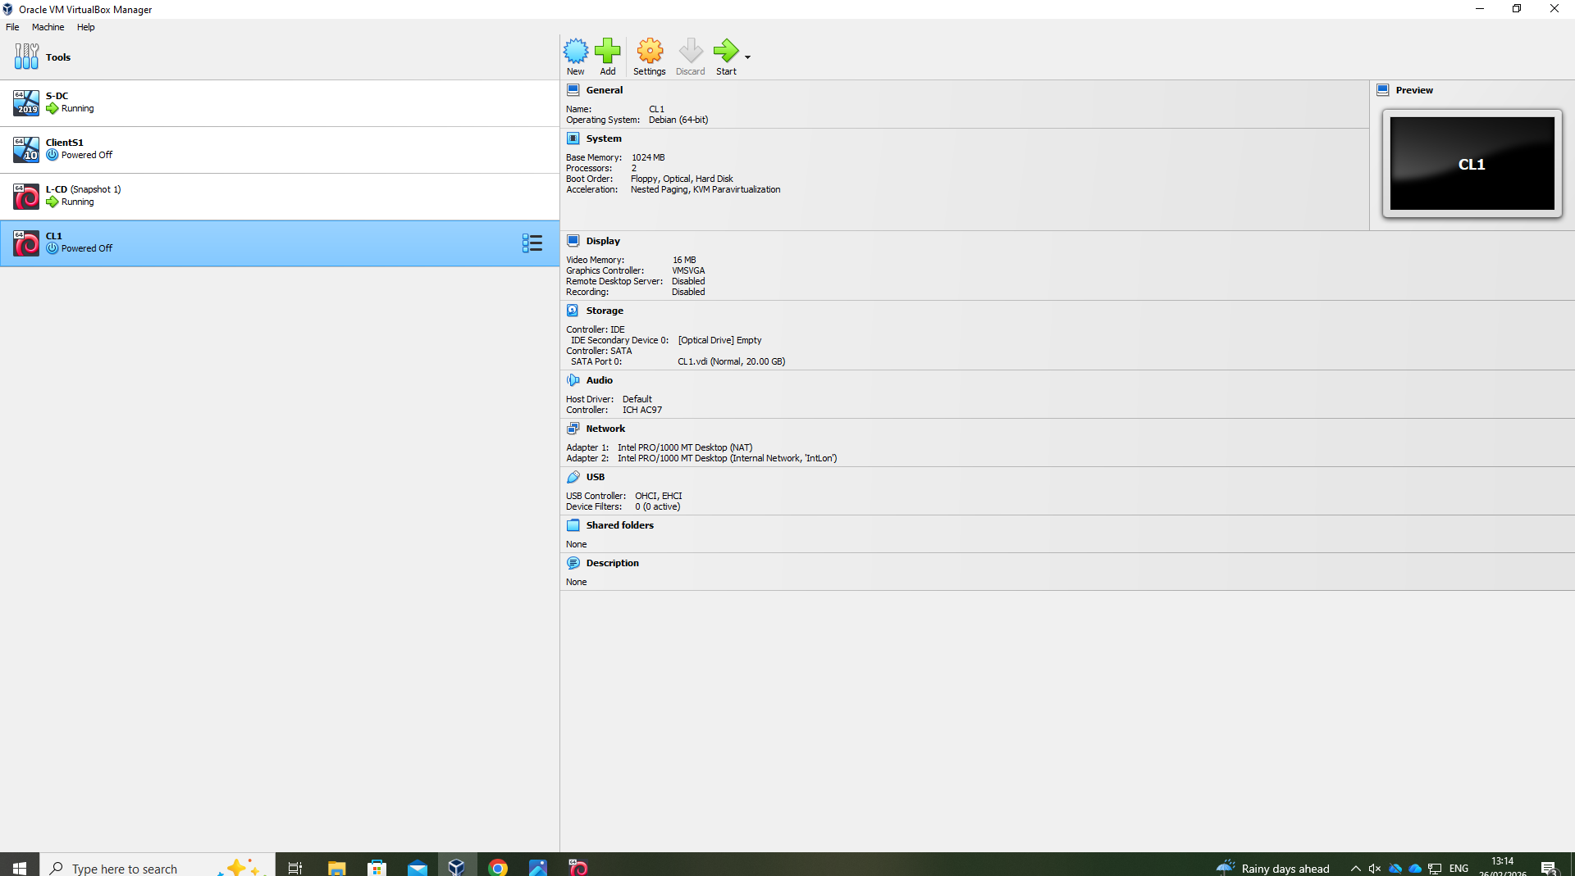
Devian Client VM, including hardware allocation information:
Figure 22, Debian Client (ClientL1)

Naming Debian Client:
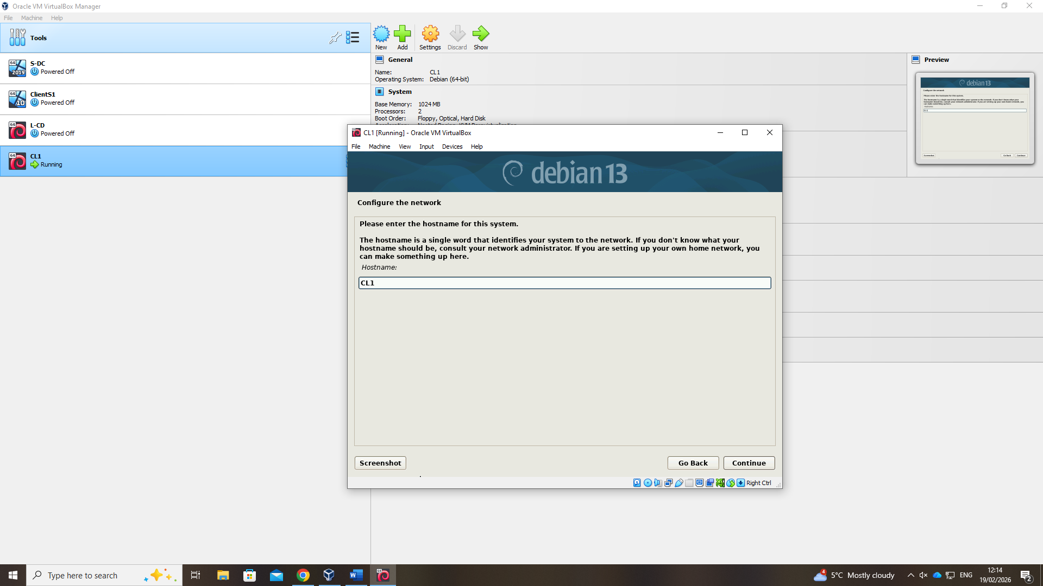
Figure 23, Naming Debian client
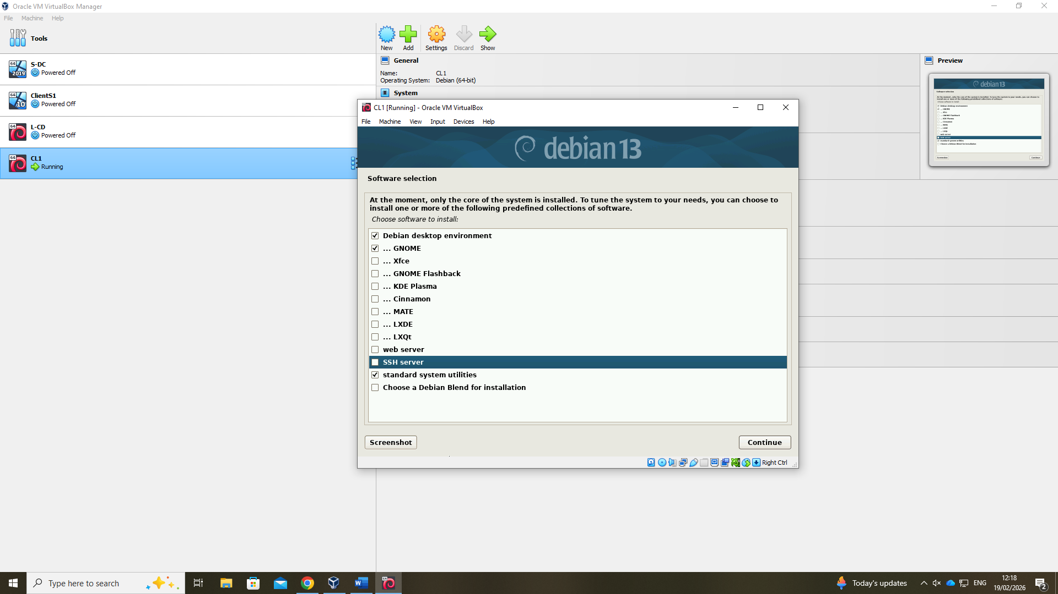
Installation Settings (GUI based install):
Figure 24, ClientL1 Installation Settings

Adding Networking adapter to ClientL1 for London LAN:
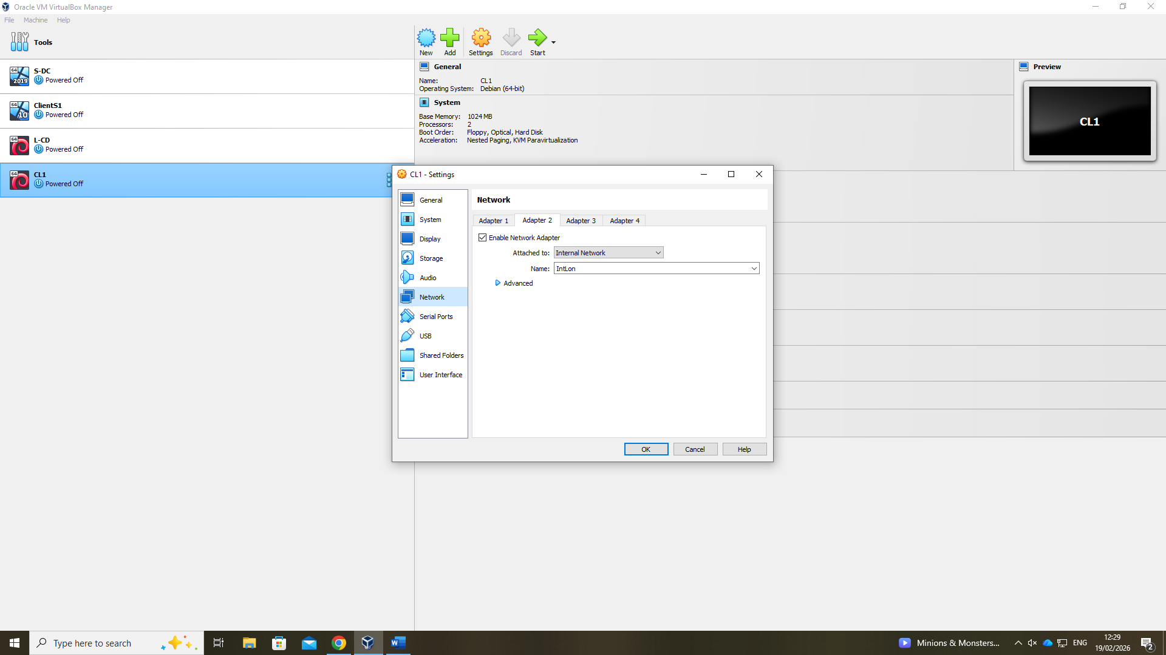
Figure 25, Adding Network adapter to ClientL1

3.3 IP Addressing Configuration & Testing

3.3.1 Debian Server IP Configuration

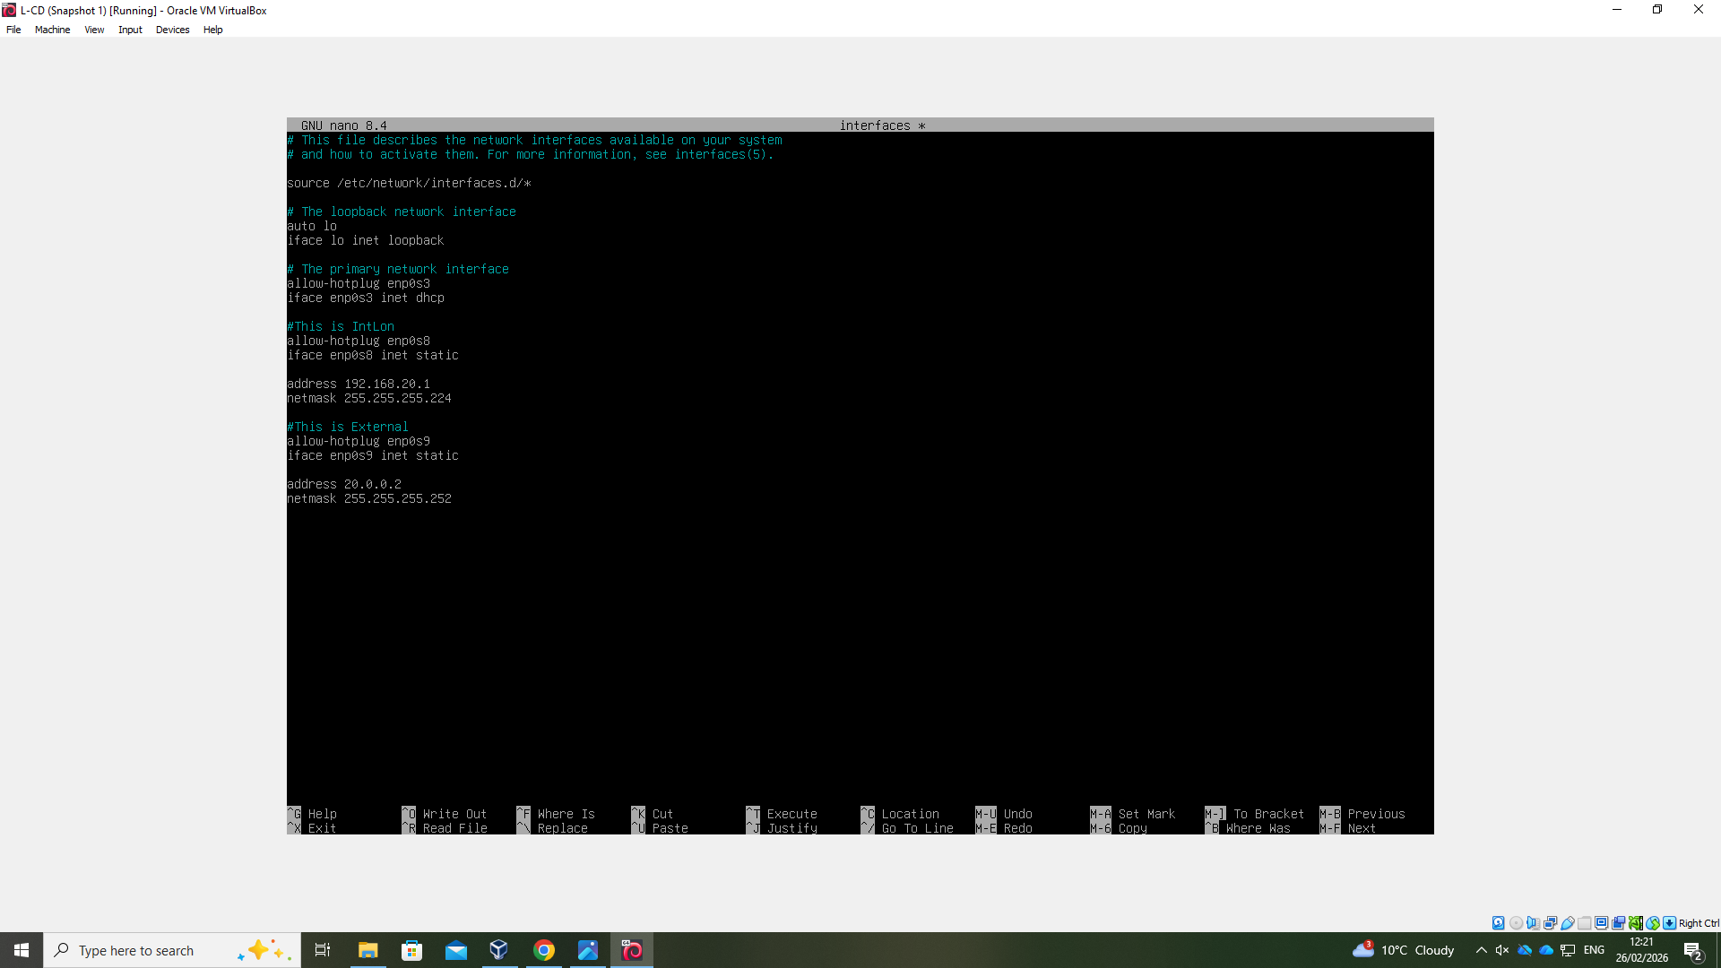
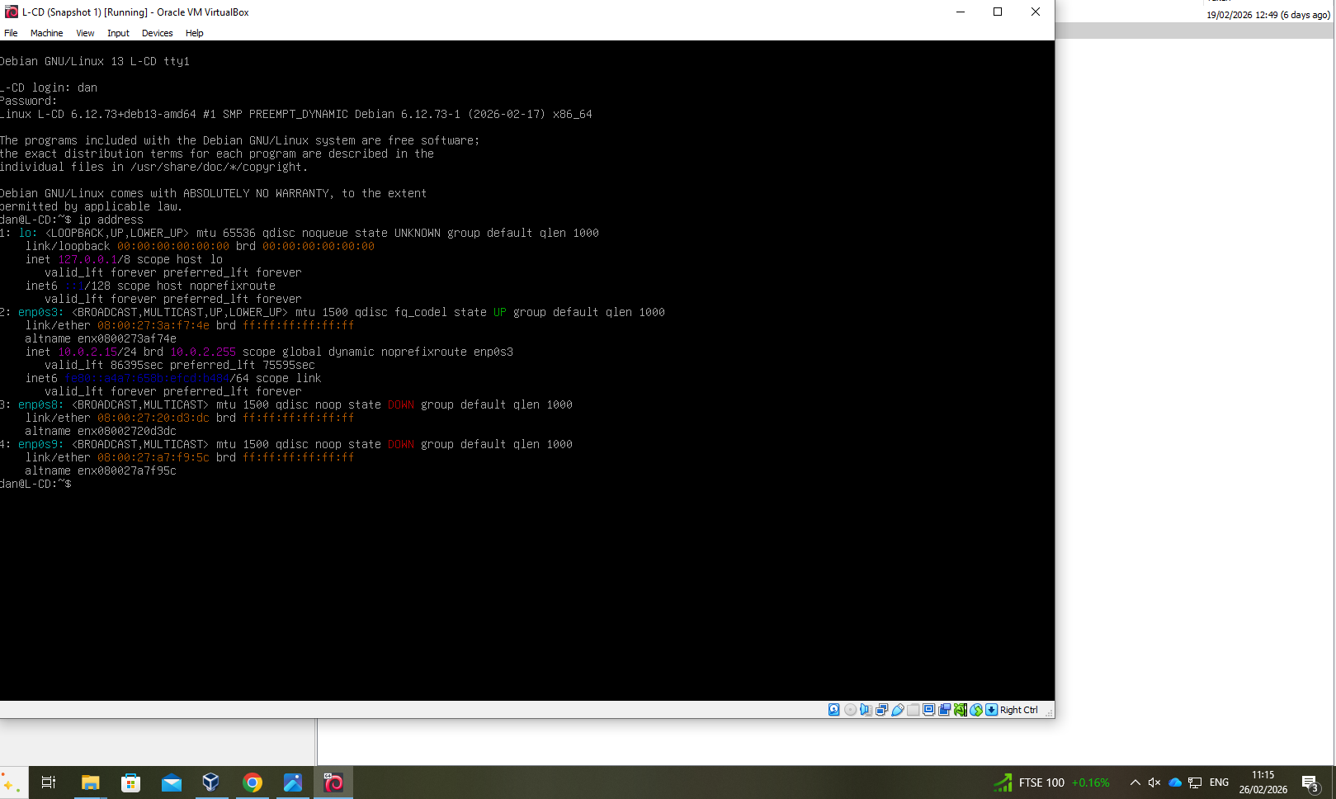
Figure 26, Debian Server (L-CD) IP config.
Figure 27, Debain Server (L-CD) Network adapters (Down)

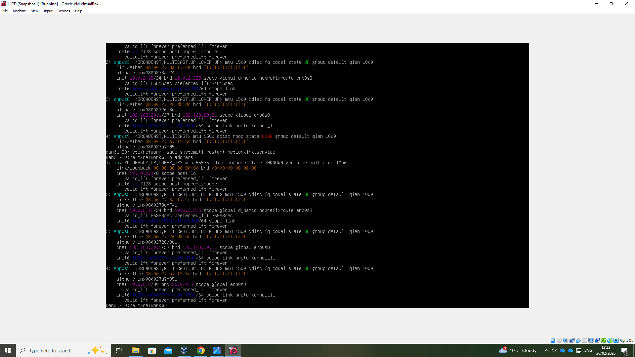
Figure 28, Debian Server (L-CD) Network adapters (UP)

3.3.2 Connectivity Testing

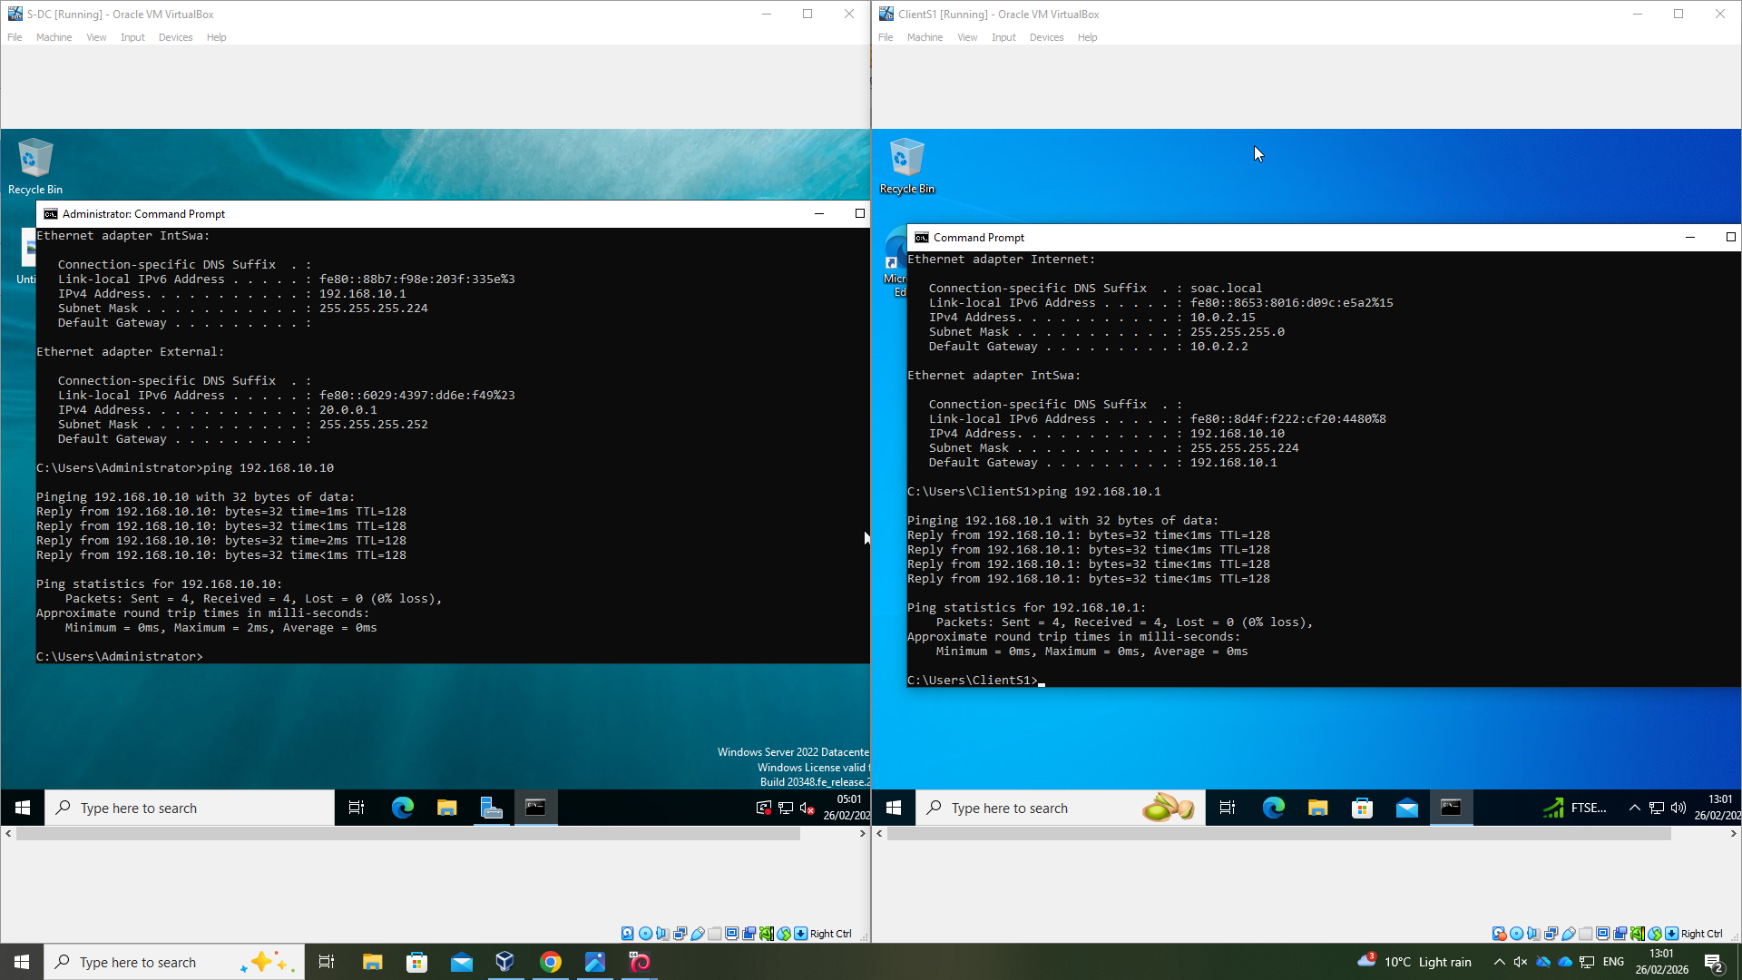
Windows Server and Windows Client successful connection:
Figure 29, Connectivity testing: S-DC and ClientS1

Debian Server and Debian Client successful connection:
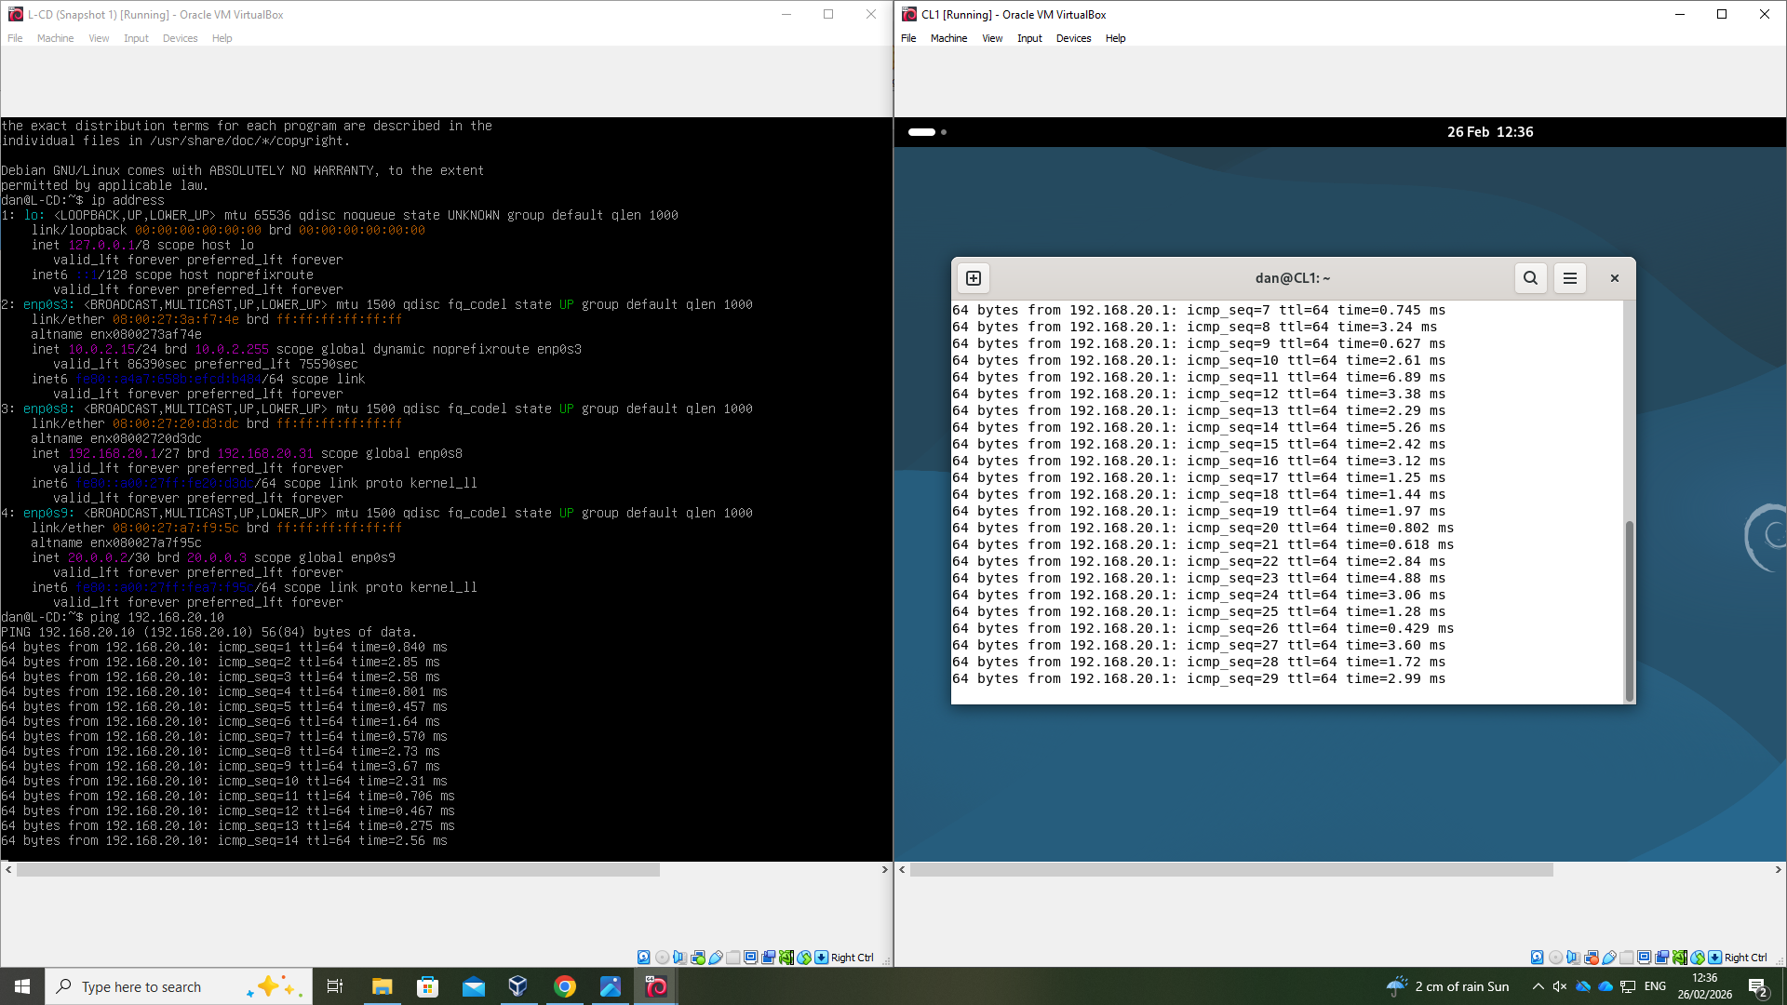
Figure 30, Connectivity testing: L-CD and ClientL1
Debian Server and Windows Server successful connection:
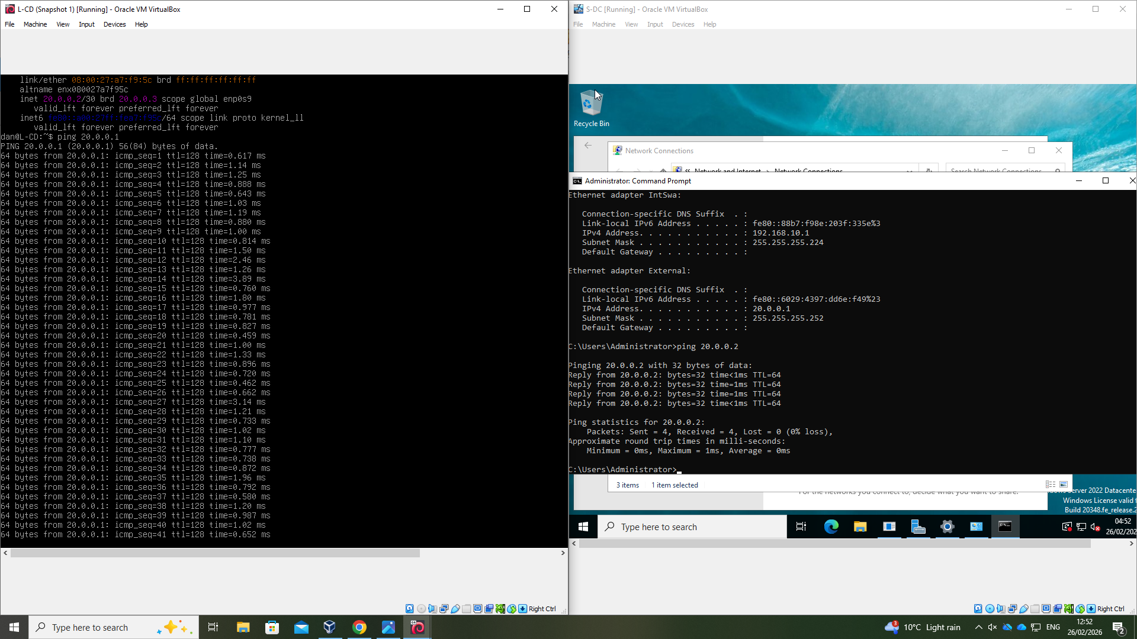
Figure 31, Connectivity testing: L-CD and S-DC

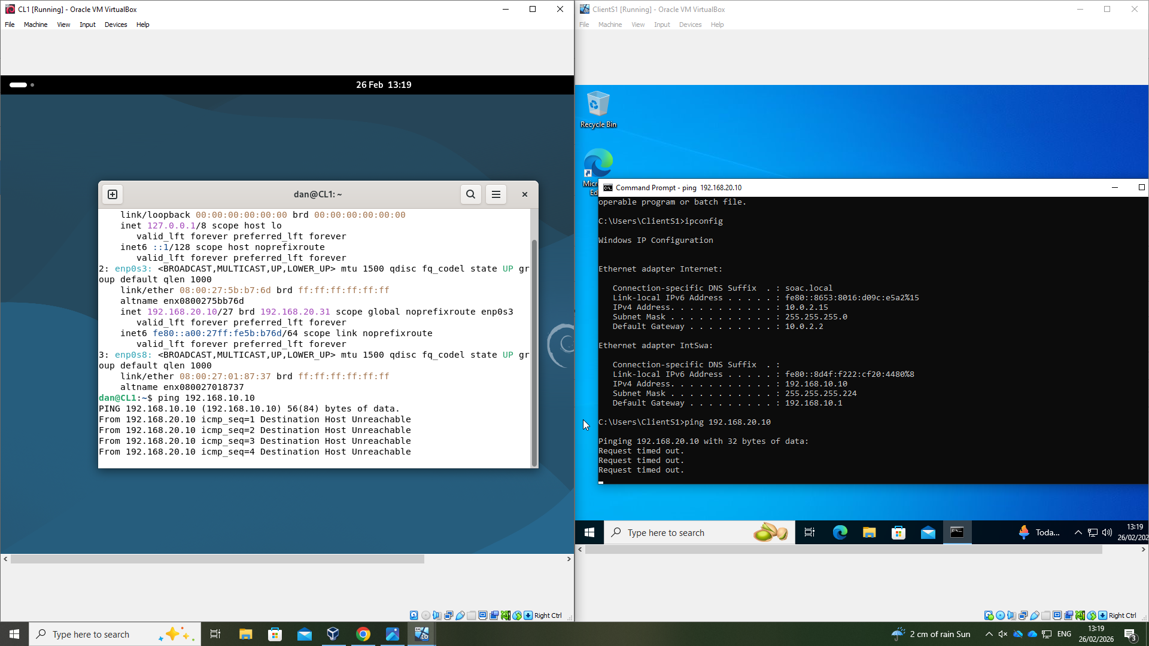
Debian client and Windows Client unreachable (Routing not yet configured):
Figure 32, Connectivity testing: ClientL1 and ClientS1

4. Reflective Evaluation

4.1 Technical Reflection

This project enhanced knowledge of virtualisation, particularly the distinction between Type 1 and Type 2 hypervisors. Appreciating how hypervisors operate relative to guest operating systems improved knowledge of system architecture and resource management in virtualised environments.

Initial connectivity testing of the Windows Server and Client, failed due to Windows Defender Firewall blocking the ping. Disabling the firewall confirmed that the IP addressing and network configuration were correct, highlighting how security controls can impact testing. For future implementations, defining firewall rules rather than disabling protection entirely would achieve a more secure and controlled approach.

Although services such as DHCP, VPN, and Active Directory have not yet been deployed, researching their functions and considering their integration improved understanding of network services and how they can automate administrative tasks and optimise essential enterprise network functions.

4.2 Personal Development Reflection

This project highlighted the importance of soft skills such as engagement and time management, by requiring careful sequencing of the virtual machines’ setup, network configuration, all necessary preparation ready for the planned deployment of network services.

Additionally, working with Debian Linux, particularly via. the command line interface, provided valuable exposure to Linux environments, configuring and troubleshooting in this manner strengthened practical skills, as well as built confidence with working in CLI based environments.

Engagement with these tasks, alongside independent research, has enhanced overall capability in both virtualisation and the deployment and management of networks. The project has established a strong foundation of practical experience and technical understanding.

5. Appendices

5.1 Hierarchical Privilege
Modern processor architectures implement a hierarchical privilege model, commonly referred to as ‘protection rings’, to regulate access to critical system resources. Jim Ledin describes this concept using the analogy of a medieval castle, where the inner rings have greater privilege and access to protected areas than the outer rings. On Windows and Linux systems [9], the operating system kernel operates in ‘ring 0’, which is typically the highest level of privilege, while user applications run in ring 3 with restricted access. On modern processors, the Type 1 hypervisor can operate in ‘ring -1’ [10] [2, pp. 230-234].
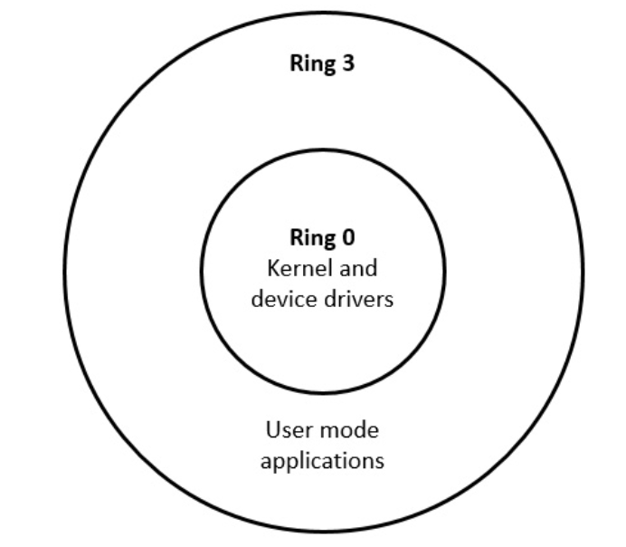
Figure 33, Protection rings [2]

5.2 VLSM scheme

The original NOSS2026 topology used /24 subnets for Swansea and London LANs, despite each site having only two devices, resulting in substantial address waste. VLSM was applied to assign /27 subnets to each LAN, providing sufficient capacity for current devices and supporting future expansion. /30 has been applied to the site link supporting the two servers only.

VLSM Addressing Table:
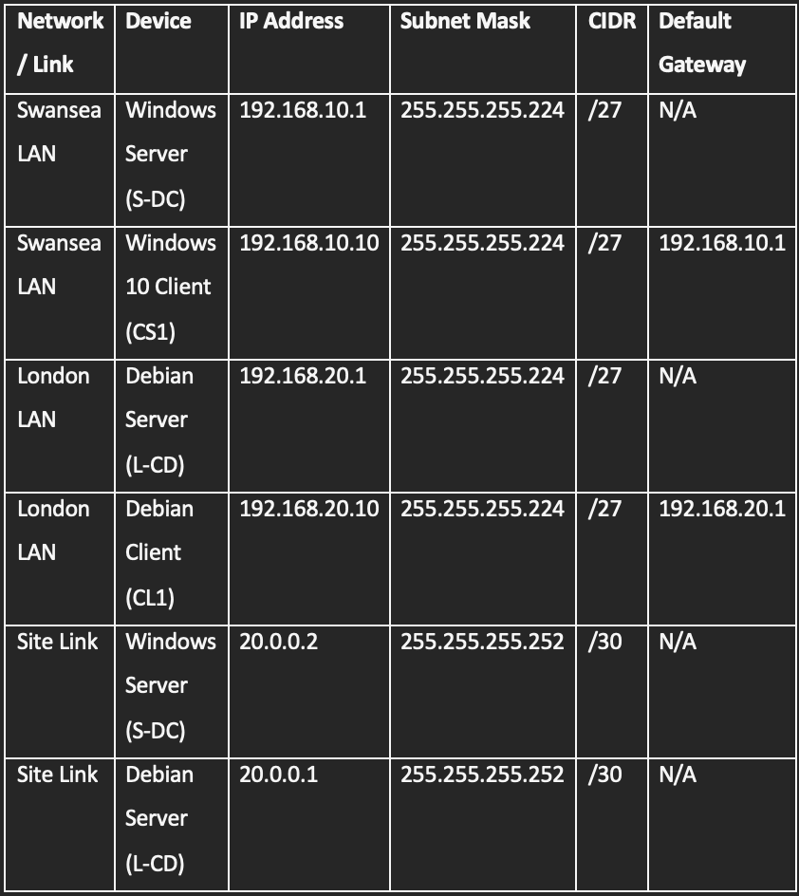

References

[1] | P. Dash , Getting Started with Oracle VM VirtualBox, Packt Publishing, 2013.
[2] | J. Ledin, Modern Computer Architecture and Organization Second Edition, Packt Publishing, 2022.
[3] | G. Aryotejo, E. A. Sarwoko, A. Sugiharto and M. M. Hakim, “Performance of Virtual Machine Managers for Computer Network Learning,” in 2021 5th International Conference on Informatics and Computational Sciences (ICICoS), 2021.
[4] | D. Pousa and J. Rufino, “EVALUATION OF TYPE-1 HYPERVISORS ON DESKTOP-CLASS VIRTUALIZATION HOSTS,” IADIS International Journal on Computer Science and Information Systems, vol. 12, no. 2, pp. 86-101, 2017.
[5] | T. Robinson, Building Virtual Machine Labs: A Hands-On Guide (Second Edition) By: Tony Robinson, Independently published, 2021.
[6] | S. Susnjara and S. Ian, “What is a virtual machine (VM)?,” [Online]. Available: https://www.ibm.com/think/topics/virtual-machines. [Accessed 23 February 2026].
[7] | VMWare, “What is a hypervisor?,” [Online]. Available: https://www.vmware.com/topics/hypervisor. [Accessed 23 February 2026].
[8] | S. T. King, G. W. Dunlap and P. M. Chen, “Operating System Support for Virtual Machines,” Computer Science and Engineering Division Department of Electrical Engineering and Computer Science University of Michigan.
[9] | D. T. Vojnak, B. S. Ðorđević, V. V. Timčenko and S. M. Štrbac, “Performance Comparison of the type-2 hypervisor VirtualBox and VMWare Workstation,” in 2019 27th Telecommunications Forum (TELFOR), Belgrade, Serbia, 2019.
[10] | M.-R. Tarmidi, “Why Is the Hypervisor More Privileged Than the Kernel?,” 19 October 2025. [Online]. Available: https://medium.com/@mohammedredatarmidi/why-is-the-hypervisor-more-privileged-than-the-kernel-1eabbbc9caaf. [Accessed 24 February 2026].
[11] | Amazon AWS, “What’s the Difference Between Type 1 and Type 2 Hypervisors?,” [Online]. Available: https://aws.amazon.com/compare/the-difference-between-type-1-and-type-2-hypervisors/. [Accessed 25 February 2026].
[12] | Oracle, “Oracle® VM VirtualBox Administrator's Guide for Release 6.0,” [Online]. Available: https://docs.oracle.com/en/virtualization/virtualbox/6.0/admin/swvirt-details.html. [Accessed 24 February 2026].
[13] | A. G. AlEnezi and M. F. F. AlDhamen, “A Comparative Study between IPv4 and IPv6,” International Journal of Advanced Research in Computer and Communication Engineering, vol. 12, no. 3, pp. 52-55, 2023.
[14] | C. Leiden and M. Wilensky, TCP/IP For Dummies 6th Edition, Indianapolis, Indiana: Wiley Publishing Inc., 2009.
[15] | C. Hunt, TCP/IP Network Administration, Third Edition, O'Reilly, 2002.
[16] | O. Buxton, “What is an IP address and how does it work?,” 18 December 2025. [Online]. Available: https://uk.norton.com/blog/wifi/what-is-an-ip-address. [Accessed 27 February 2026].
[17] | Microsoft, “Understand TCP/IP addressing and subnetting basics,” [Online]. Available: https://learn.microsoft.com/en-us/troubleshoot/windows-client/networking/tcpip-addressing-and-subnetting. [Accessed 27 February 2026].
[18] | L. J. Diaz, “The Only IP Book You Will Ever Need!,” 2014, pp. 29-31.
[19] | B. Hartpence, Pocket Guide to Routing and Switching, Oreilly, 2011.
[20] | A. N. A. Ali, “Comparison study between IPV4 & IPV6,” IJCSI International Journal of Computer Science Issues, vol. 9, no. 3, pp. 314-317, 2012.
[21] | “DHCP User Guide,” 5 November 2025. [Online]. Available: https://www.juniper.net/documentation/us/en/software/junos/dhcp/topics/topic-map/dhcp-relay-agent-security-devices.html. [Accessed 27 February 2026].
[22] | “Configuring DHCP Relay,” Cisco, 12 June 2025. [Online]. Available: https://documentation.meraki.com/SASE_and_SD-WAN/MX/Design_and_Configure/Configuration_Guides/DHCP/Configuring_DHCP_Relay. [Accessed 27 February 2026].
[23] | Microsoft, “Active Directory Domain Services overview,” [Online]. Available: https://learn.microsoft.com/en-us/windows-server/identity/ad-ds/get-started/virtual-dc/active-directory-domain-services-overview. [Accessed 2026 February 27].
[24] | S. Perrott, Windows Server 2022 & Powershell All-In-One For Dummies, John Wiley & Sons, Inc., 2022.
[25] | R. Blum, Linux All-In-One 7th edition, John Wiley & Sons, Inc., 2023.
[26] | IBM, “Routing with point-to-point connections,” 8 April 2025. [Online]. Available: https://www.ibm.com/docs/en/i/7.6.0?topic=ssw_ibm_i_76/rzajw/rzajwptop.html. [Accessed 25 February 2026].
[27] | “Proxmox VE Administration Guide,” 12 December 2025. [Online]. Available: https://pve.proxmox.com/pve-docs/pve-admin-guide.html. [Accessed 27 February 2026].
[28] | “ChatGPT, Generative AI - Private communication,” [Online]. Available: https://chatgpt.com. [Accessed 23 February 2026].
[29] | A. Xu, “A Crash Course in IPv4 Addressing,” 28 March 2024. [Online]. Available: https://blog.bytebytego.com/p/a-crash-course-in-ipv4-addressing. [Accessed 27 February 2026].
[30] | NCSC, “Device security guidance, Virtual Private Networks (VPNs),” [Online]. Available: https://www.ncsc.gov.uk/collection/device-security-guidance/infrastructure/virtual-private-networks. [Accessed 27 February 2026].

