HTML & CSS Web Development
INTRODUCTION TO WEB DEVELOPMENT
David Godwin (1702032)
Kemi Ademoye

Abstract
This report is based around the website, Emeryst, and will talk about the following:
- It will look at the overall structure of the website and its layout
- If the website is accessible to blind, colour blind and partially sighted people
- Does the website meet the WCAG 2.0 criteria
- Does the website have any errors, both visually and in the code and if so why this might be.

Contents Page
Chapter Number | Chapter Name | Page Number
I | Requirements | 3
I.II | Introduction | 3
I.III | Site Map | 3
I.IV | Wireframe | 4
II | Implementation | 5
II.I | Completed Website | 5
II.II | Validation | 10
III | Evaluation | 11
III.I | Accessibility | 11
III.II | Website Evaluation | 12
III.III | Future Improvements | 12
 | References | 13

I
REQUIREMENTS

INTRODUCTION
This report is about the website, Emeryst.
The website is designed so that people that may be having computer trouble or require some other form of computer support. The website doesn’t do a very good job at conveying this on the home page and requires the user to read the about me section first.

SITE MAP

INDEX
(Home Page)
CONTACT FORM CONFIRMATION
CONTACT
FACEBOOK
PRICES
SERVICES
ABOUT
Form submission
Auto redirect

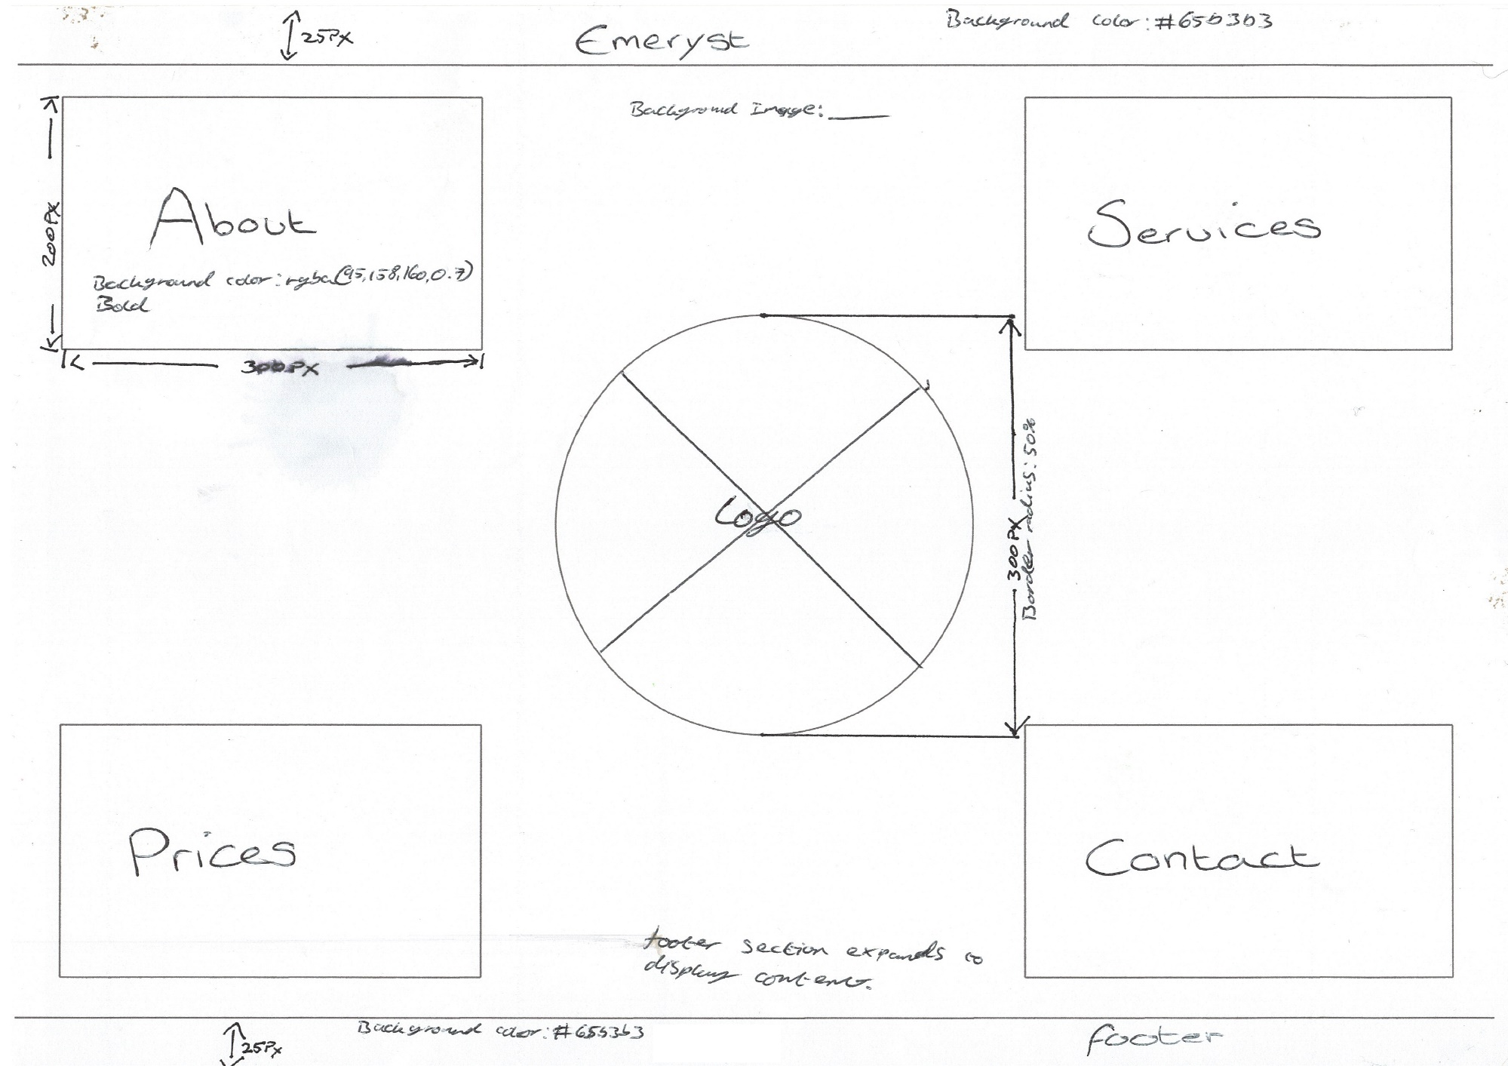
WIREFRAME

II
IMPLEMENTATION

COMPLETED WEBSITE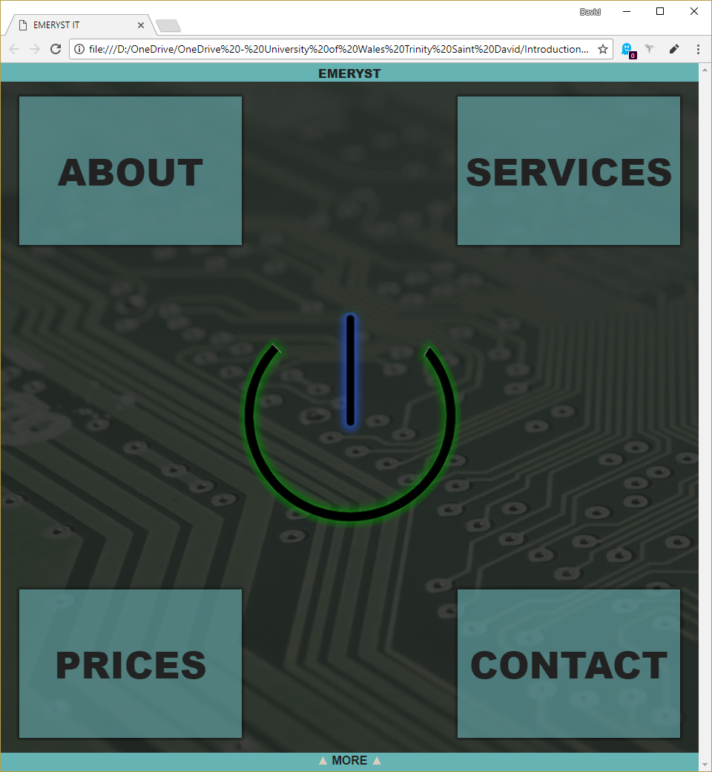

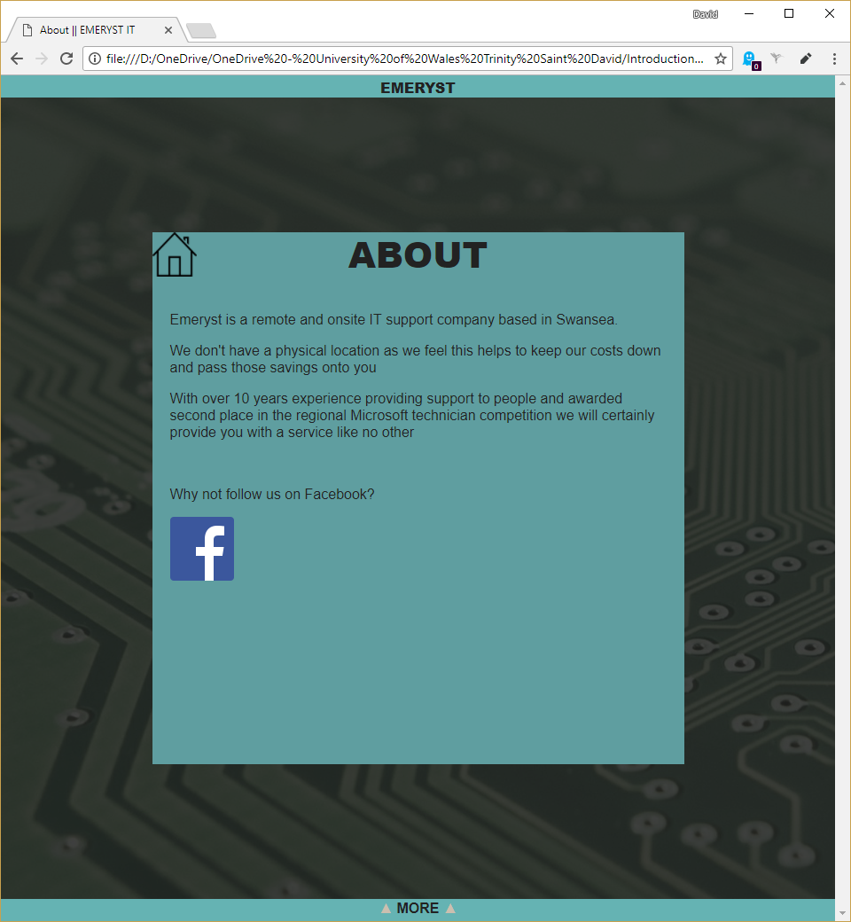
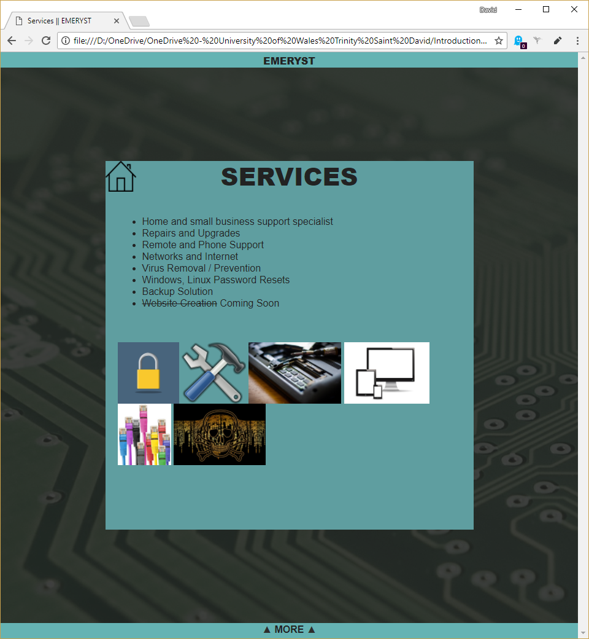

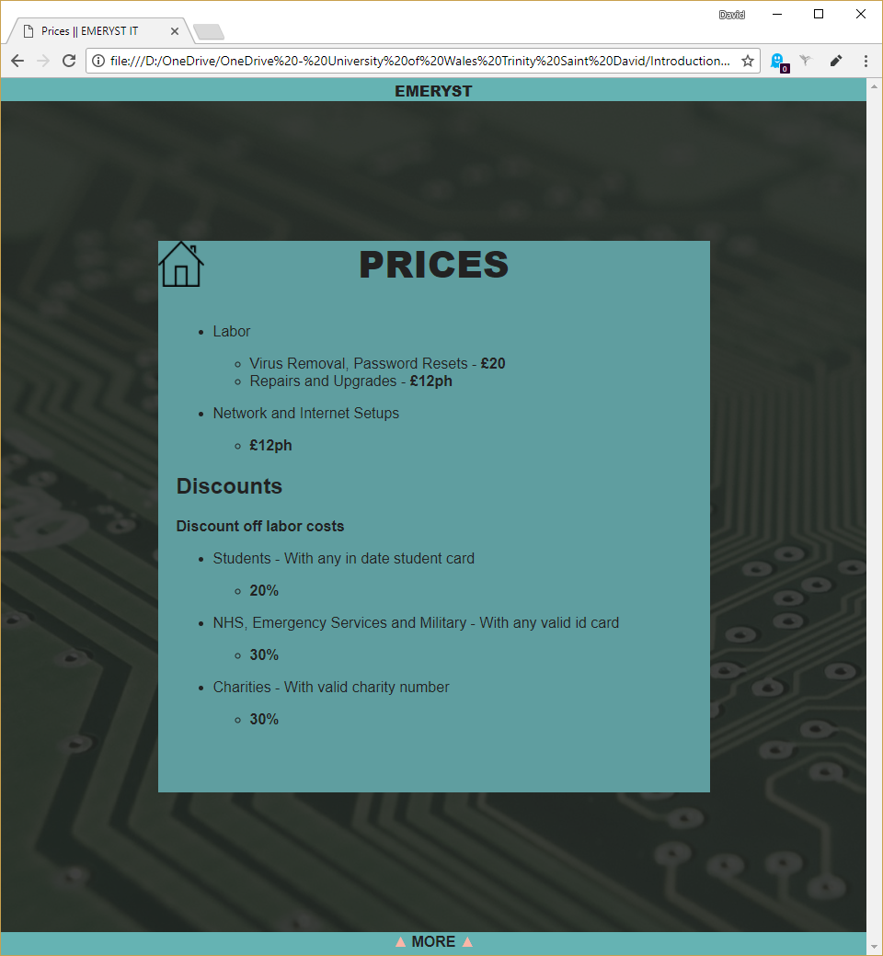

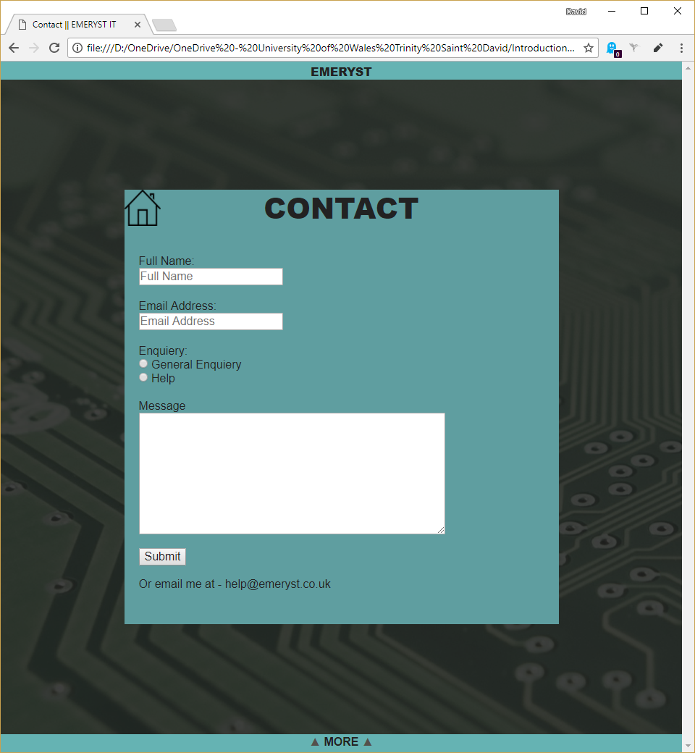
[1]

VALIDATION
Whilst checking the validity of the HTML code for Emeryst two errors were picked up.
- On line 95 the image element is missing an alt attribute. This isn’t something that will break the website, but it does mean that it will be skipped over by a screen reader.
- On line 100, in the copyright information there is a semicolon missing after the “&copy”. It still displays © when viewed in the browser so it’s not important but could create issues when trying to include other special characters further down the code.

The CSS validator came up with some interesting errors and warnings. The majority of these aren’t even errors but an outdated validator.
- Line 39, Unrecognized at-rule “@-webkit-keyframes”. Browser extension, so not an issue.
- Line 161, #circle Parse Error “);”. This appears to be some code that got left behind during editing.
- Line 254, Parse Error “}”. This isn’t an error but the end of a media query.
- Warning Line 36, Property -webkit-animation is an unknown vendor extension. This is the browser extension for Firefox so therefore is not an issue at all.
- Warning Line 157, Property -webkit-border-radius is an unknown vendor extension. Again, browser extension so not an issue.
- Warning Line 158, Property -moz-border-radius is an unknown vendor extension. And finally, another browser extension, not an issue.

III
EVALUATION

ACCESSIBILITY
When evaluating the accessibility of the website one can use the WCAG 2.0 standard [2]. When evaluating the Emeryst website against that standard, the website could do with some improvements.
Starting with what is good with the website, all the headings are clearly visible being large enough and distinct from other text items. As for all the text content, if someone wants to zoom in they can, and the text will grow bigger. However, the text on the home screen will eventually overlap and become unreadable.
All of the images and media within the website have alternative text although they're not exactly descriptive but this could be easy adapted.
The colour scheme used for the website ensures that all of the text content is readable against the background and the different sections are clearly distinguishable.
The website is easily navigated and can be done so in a couple of different ways. The first and main way is by using the main buttons on the home page to navigate to the other pages and then by clicking on the home icon on those pages to go back. The other way is by going into the footer and using those links to go from any page to any page. The final way is just to go to the home page from any other page except the home page by clicking on the title in the header.
The one and only form used on the website meets the requirements in that it will identify any input errors and tell you exactly what is wrong and where when you try to submit the form. If it has been set up it will also allow you to use the autofill option in the web browser.
The text on the website follows standard grammar and spelling, except for the name of the website. This means that any screen reader and in affect the user can understand the sentence and paragraph structure.

WEBSITE EVALUATION
The purpose of the website is just to advertise the services of Emeryst. The design of the website in general makes it extremely easy to navigate as it has been designed more like a mobile application than a website which for an information site is great. The home page has its large icons and no clutter, so it makes it easy to find the information you require.
The font colours, sizes and style is readable and the chosen colour scheme is slightly on the darker side but all the colours go with each other and isn’t glaring and in your face.

FUTURE IMPROVEMENTS
There are a few improvements that could be made for the website such as making it responsive to screen size as opposed to just shrinking everything down.
The home page could also be improved by maybe having some form of information explaining what the website is instead of having to go to the about section as soon as the visitor arrives.

To conclude this report, the website functions and works well, it does however have a lot of room for improvements such as it’s design, and the understandability from when you reach the home page. These are all things that a website designer would know how to do where as a developer may know what a good website looks like but cannot create a good looking one himself.

References

[1] | “Simple Form to Email PHP Contact Form,” FreeContactForm, [Online]. Available: http://www.freecontactform.com/email_form.php. [Accessed 8 November 2017].
[2] | E. Eggert and S. Abou-Zahra, “How to Meet WCAG 2.0,” W3C, 20 July 2017. [Online]. Available: https://www.w3.org/WAI/WCAG20/quickref/?showtechniques=246. [Accessed 20 December 2017].
[3] | “W3Schools,” W3Schools, [Online]. Available: https://www.w3schools.com/. [Accessed November 2017].

