STRATEGIC REFLECTION ON HUMAN CAPITAL, INNOVATION AND FUTURE WORK

Table of Contents
Part 1: Building a Culture of Innovation & Future Work Practices 3
1. Introduction 3
2. Current Practices in Culture and Work in Technology Firms 3
3. Cultural and Structural Initiatives to Embed Innovation 5
3.1 Innovation Sprints 5
3.2 Intrapreneurship Programmes 5
3.3 Cross-Functional Teams 5
3.4 Building Psychological Safety 5
4. Future of Work Model: Hybrid and Flexible Practices 6
5. Impact on Employee Motivation and Performance 7
6. Conclusion 9
Part 2: Reflective Analysis 10
1. Reflection Using Gibbs’ Reflective Cycle 10
Description 10
Feelings 10
Evaluation 11
Analysis 11
Conclusion 12
Action Plan 12
2. AI and Future Relevance 13
References 14

Part 1: Building a Culture of Innovation & Future Work Practices

1. Introduction
Aether Innovations is a rapidly expanding technology firm with a workforce of approximately 300 employees, which is now experiencing a serious organisational problem known as zero growth, high employee turnover, and reduced customer satisfaction. They are usually symptomatic of more systemic and cultural dysfunctions in organisations, particularly dynamic processes such as technology, where innovation and agility are fundamental to sustainable competitive advantage.
The strategy as proposed in this report is an integrated human capital policy that seeks to build a culture of innovation and embrace future sensitive employment practices. The report critically assesses the prevailing culture and work issues of technology organisations compared to the prevailing Human Resource Management (HRM) theories and practices in the industry and offers strategic recommendations. These include embracing innovation-based cultural interventions, reform of work practices around the tenets of hybrid models, and performance incentives to drive the motivation and output of employees. Lastly, the report depicts how an integrated people management approach can result in employee satisfaction and organisational success.

2. Current Practices in Culture and Work in Technology Firms
Technology organisations are considered to be generally the most innovative organisations although the work demonstrates that not all of them can sustain an actual culture of innovation due to structural and cultural discongruence. The model of organisational culture developed by Schein (2010) is founded on the premise that culture has three levels: artefacts, espounded values, and underlying assumptions. Most technological enterprises promote innovation on the surface (open offices, agile branding), which is reinforced by risk-averse, performance-based assumptions that hamper creativity.
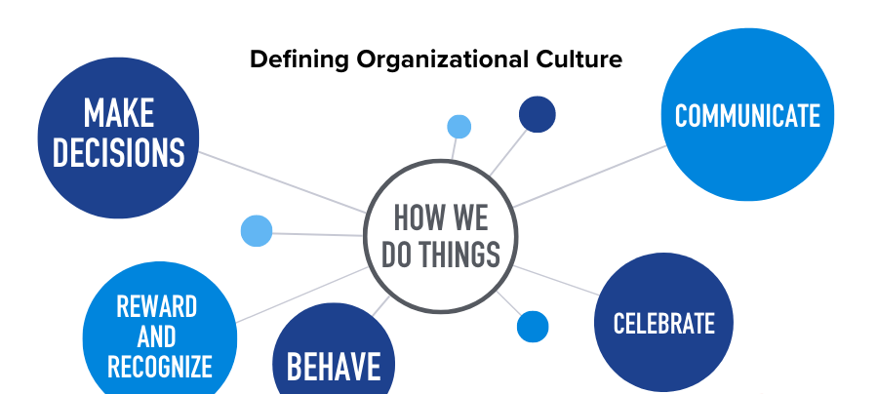
Figure 1: The Ultimate Guide to Company Culture
(Source: quantumworkplace.com, 2026)
Another common issue is that hierarchical patterns of decision-making remain in place, which cannot match with the demands of agility and rapid innovation. Although Agile and Scrum are popular methodologies, they tend to be adopted without adequate depth, leading to so-called pseudo-agility when the flexibility is claimed, yet not actually implemented (Ayanponle et al., 2024). This leads to lack of alignment between organisational goals and employee experience.
Furthermore, employee burnout is a grave problem in the technological industry. Workload, deadlines, and continuous performance pressure make engagement and turnover less probable. Two-Factor Herzberg Theory explains that dissatisfaction cannot drive but may be prevented by salary and job security. Most technology companies do not sufficiently cover the intrinsic motivation, such as recognition, autonomy, and meaningful work.
Another major limitation is the lack of psychological safety as defined by Edmondson (1999). Fear of criticism or failure can also motivate the employees not to share ideas or disturb the status quo (Ezeafulukwe et al., 2024). This suppresses innovation and limits organisational learning. In addition, a siloed team structure impacts negatively on the flow of information among various functions, which water down on problem solving processes as well as the richness of ideas.
Overall, technology companies can focus on the rhetoric of innovation, but structural inertia, cultural incompatibility, and traditions of poor motivation will perversely affect the results.

3. Cultural and Structural Initiatives to Embed Innovation
To address these issues, Aether Innovations would have to implement a package of cultural and structural initiatives that allow further innovation and involvement of employees.

3.1 Innovation Sprints
Sprints of innovation are brief bursts of intense design thinking that incorporate ideation, prototyping, and testing. This type of sprint promotes rapid experimentation and reduces the fear of failure by learning through iteration. The Componential Theory of Creativity suggests that domain knowledge, ability to think creatively, and intrinsic motivation are the driving factors of creativity (Yakusheva, Lee and Weiss, 2024). These are directly supplemented by innovation sprints, which integrate formal experimentation, and collaboration.
However, innovation sprints ought to be conducted cautiously to avoid innovation burnout where employees are bombarded with change initiatives. Its effectiveness, in turn, demands certain objectives, schedules, and mobilization of resources.

3.2 Intrapreneurship Programmes
The intrapreneurship programmes will help the employees introduce and bring new ideas in the organisation. This is in line with the Self-Determination Theory (Deci and Ryan, 2000) that emphasizes autonomy, competence and relatedness as drivers of motivation. Engagement and creativity can be enhanced by providing employees ownership in a project.
Nevertheless, intrapreneurial work requires strong leadership incentives, and appraisal visibility. In the absence of these, they turn symbolic and disengaged workers.

3.3 Cross-Functional Teams
Cross functional teams play a vital role in dismantling the organisational silos to achieve innovation. In these teams, various views may be combined, which leads to a more amicable solution to the problem and exchange of knowledge (Jatobá et al., 2023). High-Performance Work Systems (HPWS) demonstrate that team-based systems may result in enhanced employee performance and organisational success.

3.4 Building Psychological Safety
Innovation requires a psychological safety culture. Leaders are expected to promote open communications, culture of failure and consultation with employees. Learning behaviour needs psychologically safe environments to promote innovation (Edmondson, 1999).
This culture cannot be built in a single day and a lot to do with concurrent leadership behaviour, but in the long run, the rewards are more of trust, participation and organisational durability.

4. Future of Work Model: Hybrid and Flexible Practices
Alongside the cultural change, the potential of a future-oriented model of work at Aether Innovations, which will improve flexibility, collaboration, and efficiency, should be taken into account. A hybrid work system, as a combination of remote work and in-office work, is a form of working that is balanced to meet the needs of the modern workforce (Moh’d et al., 2024).
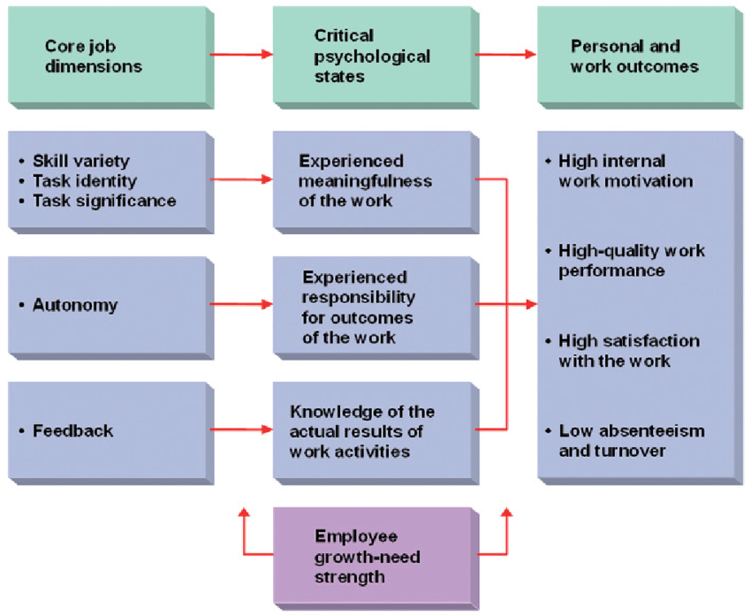
Figure 2: Job Characteristic Model
(Source: researchgate.net, 2026)
According to Job Characteristics Model (Hackman and Oldham, 1976), autonomy, task variety and feedback are the criteria that increase employee motivation. Hybrid working conditions introduce freedom since employees are at liberty to work stations and work schedules (Zhang, 2024). This elasticity can lead to a higher job satisfaction and productivity.
A sociotechnical systems view should combine technology and social systems. Online collaboration tools such as Slack, Microsoft Teams, and project management software can easily coordinate and communicate distributed teams. Yet it is not merely assimilatory of technology; organisations must create articulate patterns of virtual collaboration and standards.
Despite the advantages of hybrid work, it is not devoid of such difficulties as the risk of isolation, a breakdown in team communication and a lack of contact with colleagues. The Boundary Theory holds that work and personal life may become interconnected, and it may lead to stress and burnout if not managed well (Tuffaha, 2023). To reduce such risks, organisations are advised to institute institutionalised communication practices, regular team meetings, and unabashed predictability in terms of availability.

5. Impact on Employee Motivation and Performance
The proposed cultural and structural changes are expected to impact positively the motivation and performance of employees at Aether Innovations. The organisation can satisfy both intrinsic and extrinsic motivation needs through flexible working and innovation programs.
According to the Hierarchy of Needs developed by Maslow, people are encouraged to meet with higher needs when the basic needs are met, including esteem and self-actualisation. Innovation-based workspaces enable workers to satisfy these higher needs, such as creativity, recognition, and provision of personal growth opportunities (Snell et al., 2023).
Initiative | Description | Expected Benefits | Potential Challenges
Innovation Sprints | Short, structured cycles for idea generation, prototyping, and testing | Enhances creativity, rapid problem-solving, and experimentation | Risk of employee fatigue and resource strain
Intrapreneurship Programmes | Employees develop and pitch internal business ideas | Increases engagement, ownership, and innovation | Requires strong leadership support and fair evaluation systems
Cross-Functional Teams | Collaboration across departments to solve problems | Promotes knowledge sharing, diverse perspectives, and innovation | Coordination issues and potential role conflicts
Psychological Safety Culture | Environment where employees feel safe to share ideas and take risks | Encourages learning, trust, and continuous improvement | Requires consistent leadership behaviour and cultural change
Hybrid Work Model | Combination of remote and office-based work | Improves flexibility, autonomy, and work-life balance | Risk of isolation and reduced team cohesion
Digital Collaboration Tools | Use of platforms (e.g., Teams, Slack) for communication and coordination | Enhances communication efficiency and remote collaboration | Over-reliance on technology and communication overload
Table 1: Key Innovation and Future Work Initiatives at Aether Innovations
The role of intrinsic motivations such as achievement, responsibility, and recognition is also emphasized by the Two-Factor Theory of Herzberg. These factors are directly influenced by programmes such as intrapreneurship programmes and innovation sprints, resulting into higher job satisfaction and engagement.
In addition, Expectancy Theory (Vroom, 1964) assumes that motivation is based on the perception that performance and rewards are the outcomes of effort. Aether Innovations can reinforce this relationship through matching performance management to innovation output and rewarding effort on the part of employees whenever performance is enhanced.
It is important to note that culture, structure and work practices are a self reinforcing system. The positive culture encourages innovation, flexible work culture supports productivity, and engagement models keep workers motivated (Kadirov et al., 2024). This resonance is not only efficient in improving employee performance but also customer satisfaction and organisation performance.

6. Conclusion
The low growth rate, high turnover and decreased customer satisfaction of Aether Innovations indicate that company needs a radical review of its human capital strategy. The development of creativity and engagement requires structural initiatives such as innovation sprints, intrapreneurship programmes, and cross-functional groups as it has been demonstrated in the current report.
Additionally, a hybrid workplace model suits the current labor requirements and enhances flexibility and efficiency. With the practices integrated along with the current motivation theories, the organisation will be well placed to create a synthesized framework that drives performance and innovation.

Part 2: Reflective Analysis

1. Reflection Using Gibbs’ Reflective Cycle

Description
Through this module of Human Capital Management, I have developed a deep understanding of how strategic HR practices can facilitate organisational performance, particularly in the future of work and innovation. The module has presented some of the most critical concepts in the organisational culture, employee motivation, performance management and the role of HR in strategic change (Bowers, Terry and Irwin, 2025). The theme was the ways in which organisations can embrace innovation using people-friendly methods which include flexible work arrangements, empowerment of employees and collaborative design.
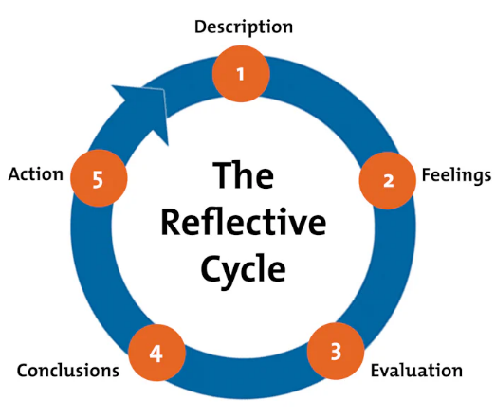
Figure 3: Gibbs' Reflective Cycle
(Source: mindtools.com, 2026)
Besides, I also explored the different theoretical models, including the organisational culture model by Schein, the Two-Factor Theory by Herzberg and the Job Characteristics Model. The theories created a research foundation on understanding the ways HR strategies can be customized to increase employee engagement, creativity, and productivity.

Feelings
My pre-module perception of HR was rather simple and utilitarian. My initial understanding of HR was that it is a profession that involves human management, training, and hiring. I had not appreciated its strategic role in organisational culture and innovation. As a result, I had initially underestimated the complexity and importance of human capital to organisational success.
However, my attitude shifted drastically during the module. I began to appreciate HR as a strategic partner that assumes a pioneering role in organisational change. The data about the cultures of innovation and work practices of the future was also highly informative and caused me to question my previous ideas about the traditional model of the workplace (Tussis and Miles, 2025). Now I am sure that I can perform HR analysis and suggest strategic interventions to support organisational goals.

Evaluation
One of the most rewarding aspects of the module was practice and theory. The emergence of the famous models, such as the Two-Factor Theory and the Self-Determination Theory developed by Herzberg, helped to explain the driving forces, which are motivation factors among employees. One of these experiences was that I understood that extrinsic rewards such as salary issue are not so crucial in long-term engagement as compared to intrinsic rewards such as autonomy, recognition and meaningful work.
The discussion of organisational culture was also very helpful. The Schein model allowed me to critically examine the interactions between visible practices and unspoken assumptions that affect employee behaviour.
However, I also learnt that not all theoretical models can be directly translated into real life cases due to organisational complexities and constraints. One such thing is that whereas Job Characteristics Model dictates specific job design features, these modifications may be implemented poorly in large organisations due to structural limitations and change resistance.

Analysis
The module has also helped me to critically assess the application of HR theories to real organisational challenges. A lack of intrinsic motivation and a poor culture of organisation may serve as a marker of the cause of high turnover and low innovation within Aether Innovations (Akhigbe and Monday, 2022). Applying the theory of Herzberg, one might realise that it is not just necessary to increase the salaries or benefits but the organisations should also strive to increase the degree of job satisfaction by meaningful work and recognition.
Similarly, the concept of psychological safety applies best to the issues of innovation. Most organisations may fear failure or criticism and they may not present new ideas to the organisation.
The practical usefulness of HR theories is also demonstrated in the emergence of hybrid forms of work. Job Characteristics Model explains how worker autonomy and flexibility may lead to increased job satisfaction, and Boundary Theory explains the challenges related to work-life balance.

Conclusion
This learning experience has provided me with a lot in as far as the strategic value of HR within modern organisations is concerned. I have realised the importance of critical evaluation of HR practices and the necessity to align people strategies with organisational objectives.
Interestingly, I have also learned to be more conscious of my strengths and weaknesses. I had heard much about theory, but I have to practice more practical skills in applying these concepts.

Action Plan
Some of the most critical skills that I will continue to develop to be a better HR professional in future are as follows:
- Leadership Skills: I also wish to practise my team-leading, change management, and organisational culture abilities. This will involve a mixture of group work experience and leadership opportunities.
- Digital HR Competencies: With the increasing use of technology in HR, I will be training in mastering HR analytics, digital tools, and data-driven decisions. It will make me up to date with modern human resource practice (McCarthy et al., 2025).
- Strategic Thinking: I shall aim to enhance my capabilities of aligning HR strategies with business targets. This involves organisational awareness of objectives, environmental scanning and sound decision making.

2. AI and Future Relevance
Artificial intelligence (AI) is developing rapidly, and the nature of work, in particular, of HR, is shifting correspondingly. They are increasingly automating their day-to-day duties such as screening of CVs, data processing, and maintenance of employee records (Butler, 2023). This can enhance efficiency, but it also raises the issue of job displacement and the future of HR professionals.
I know I will have to implement a human-AI collaboration approach to remain relevant. Rather than viewing AI as a replacement, I view it as a chance to hone my competencies. As an example of this, AI may be used to scan big data, forecast workforce trends, and spearhead evidence-based decision-making.

References
Part 1
Ayanponle, L.O., Awonuga, K.F., Asuzu, O.F., Daraojimba, R.E., Elufioye, O.A. and Daraojimba, O.D., 2024. A review of innovative HR strategies in enhancing workforce efficiency in the US. International Journal of Science and Research Archive, 11(1), pp.817-827.
Ezeafulukwe, C., Onyekwelu, S.C., Onyekwelu, N.P., Ike, C.U., Bello, B.G. and Asuzu, F.O., 2024. Best practices in human resources for inclusive employment: An in-depth review. International Journal of Science and Research Archive, 11(1), pp.1286-1293.
Jatobá, M.N., Ferreira, J.J., Fernandes, P.O. and Teixeira, J.P., 2023. Intelligent human resources for the adoption of artificial intelligence: a systematic literature review. Journal of Organizational Change Management, 36(7), pp.1099-1124.
Kadirov, A., Shakirova, Y., Ismoilova, G. and Makhmudova, N., 2024, April. AI in human resource management: Reimagining talent acquisition, development, and retention. In 2024 International conference on knowledge engineering and communication systems (ICKECS) (Vol. 1, pp. 1-8). IEEE.
Moh’d, S., Gregory, P., Barroca, L. and Sharp, H., 2024. Agile human resource management: A systematic mapping study. German Journal of Human Resource Management, 38(4), pp.345-374.
quantumworkplace.com, 2026. The Ultimate Guide to Company Culture [Online]. Available at: https://www.quantumworkplace.com/future-of-work/workplace-culture / [Accessed on: 17.03.2026]
researchgate.net, 2026. Job Characteristic Model [Online]. Available at: https://www.researchgate.net/figure/Job-Characteristic-Model-Source-Hackman-Oldham-1976_fig1_236583047 / [Accessed on: 17.03.2026]
Snell, S.A., Swart, J., Morris, S. and Boon, C., 2023. The HR ecosystem: Emerging trends and a future research agenda. Human Resource Management, 62(1), pp.5-14.
Tuffaha, M., 2023. The impact of artificial intelligence bias on human resource management functions: systematic literature review and future research directions. European Journal of Business and Innovation Research, 11(4), pp.35-58.
Yakusheva, O., Lee, K.A. and Weiss, M., 2024. The nursing human capital value model. International journal of nursing studies, 160, p.104890.
Zhang, H., 2024. Exploring the impact of AI on human resource management: A case study of organizational adaptation and employee dynamics. IEEE Transactions on Engineering Management, 71, pp.14991-15004.
Part 2
Akhigbe, T. and Monday, E., 2022. Reflection and reflective practice in general practice: a systematic review exploring and evaluating key variables influencing reflective practice. education, 8, p.9.
Bowers, M., Terry, D. and Irwin, P., 2025. The impact of reflective practice on nursing students: a scoping review. Nurse Education in Practice, p.104468.
Butler, H., 2023. Understanding the territory of reflective practice. Creating the reflective habit, pp.4-24.
McCarthy, B., Connolly, M., Timmins, F. and O’Connell, N., 2025. Recruiting participants for palliative care research: A reflective discussion paper. Nursing ethics, 32(7), pp.2091-2099.
mindtools.com, 2026. Gibbs' Reflective Cycle [Online]. Available at: https://www.mindtools.com/ano9qiu/gibbs-reflective-cycle/ [Accessed on: 16.03.2026]
Tussis, L. and Miles, H.L., 2025. A review of the reflective practice (RP) offer in a youth homeless charity in England during COVID-19 as part of a psychologically informed environment (PIE) approach. Housing, Care and Support, pp.1-12.

