Knowledge & Information Management Skills
BMSW 5106

Student - Rume Meah
ID - 1813924
Lecturer – Buddhi Pathak
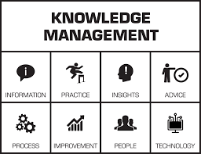
Table of Contents
Page
- Aim…………………………………………………………………………………………...3
- Method………………………………………………………………………………………3
- Introduction……………………………………………………………………….…………3
- Why are Information Systems essential for the case company Zopa?.......…………4
- What information systems are implemented by Zopa? Describe the input, processing, and output of any one of such systems …………………………………..5
- How computer-based information systems can support managers at each level and functions of Zopa operations……………………………………………………..….7
- Discuss Zopa’s potential knowledge management challenges and offer recommendations to strengthen their knowledge management practices from the knowledge acquisition retention-transfer perspectives……………………………8.
- Discuss how the overall approach adopted by Zopa Incorporates Porters Generic competitive strategy and in what ways the use of IS/IT has achieved to a competitive advantage…………………………………………………...10
- How does the knowledge management practice of the case company will benefit from progress in information technology? ……………………………………..12
- How would the case organisation implement enterprise resource planning (ERP) systems, explain both advantages and challenges of having ERP systems with example...............................................................................................13
- Conclusion……………………………………………………………………………..…..15
- References…………………………………………………………………..………..……16
- Appendix……………………………………………………………………….……17

- Aim
The aim of this report is to apply the various concepts and theories I have learnt within this module, by applying these to the case study company Zopa Loans.
- Method
I will be using primary and secondary information to help answer the questions.
- Introduction
The world revolves around money. The economy, businesses, and individuals rely on the exchange of money for products and services. The banking world is significant in providing such services to the economy. Over the years the banking and finance world has evolved, by investing into state-of-the-art Information Technology, lending, borrowing has been streamlined for consumers to access easily. One such avenue which finance has extended into is peer to peer lending.

- Zopa “Zone of Possible Agreement” is the first online peer to peer lending organisation in the UK.

What is peer to peer lending in a nutshell?
This is a web-based platform (Klafft, M, 2008), which enables borrowers to request loans which is then up to private lenders to subsidise through auction like bids. This cuts out the middleman i.e. banks and reduces costs. Each borrower can request loans on personal individual (appendix 1) circumstances in more depth, this transparent information is provided to the lender so they can make a calculated decision. By taking these factors into account they can decide which borrowers are suited to their needs. Borrowers and Lender have direct communication channels but information is generic so they do not actually know who they are lending or loaning from.

Zopa, according to Companies house (2020), Zopa Limited is a Private Limited company incorporated 4th August 2004. There are currently 5 directors, 1 secretary, registered at 1st Floor Cottons Centre, 47-49 Tooley Street, London, England, SE1 2QG.
Zopa has cumulative over 400,00 customers facilitating £4 billion via their platform.

- Why are information systems essential for the case company Zopa?
Zopa is a finance company, their primary objective is to deliver their financial products and services to their consumers, to do this they require an information system. A robust system must be in place, incorporating all the data required to process each application for both borrowers and lenders.
Zopa has thousands if not millions of raw data, from a borrows/ lenders personal details, stakeholder (Appendix 2) details to economic rates that they use to offer deals (Appendix 3). All this data must be captured and turned into usable information. An information system incorporates and analyses all this data and identifies valuable information e.g. business and marketing trends, which help make informed decisions. Provides Realtime information, streamlining core business processes to help employees to do more with less resources.
These systems are fundamental in mining “Big Data” (Yan et al. 2015), – volume, wide range of data collected, Velocity – speed in which data is collected and processed, Variety – data generated from social media, image, audio, video, smart phones etc. Research into Big Data focuses on methodologies, techniques, application, practices, all these will provide a better insight into the companies short/long term strategies.
Zopa uses the Fintech P2P (technology), this is widely recognised as a rapid growing innovative technology within finance. Fintech is also championed by the UK’s government who plan to use this technology for a greater UK growth (HM Treasury, 2015), the government have helped fund Zopa to the tune of £10 million. By working with the government regulatory / tax systems, Zopa can create the right investment environment.
Zopa technical infrastructure platform is built using Kubernetes automation technology, this automatically generates Zopa’s application deployment lifecycle, additional development of own code is not required. It provides more control to developers, less repetitive work, automation across platforms.
However even though Information Systems has considerable advantages it is not without risk (Telecommute, 2018). These systems will be prone to negatively influence our culture, human and country.
- No Work security, increasing unemployment – Work which was previously considered manual and now being replaced by sophisticated software, saving time for organisation, therefore less employees are required.
- Security – Prone to hackers, selling of personal data is a huge (Dark Web) market, a robust security system must in place.

- What information systems are implemented by Zopa? Describe the input, processing, and output of any one of such systems?
In 2019, Zopa launched a tool “Borrowing Power” which combines -
- Machine Learning – Artificial Intelligence (Emerson et al. 2019) which replicates human thought process by using statistical methods, providing computer models with the ability to learn from a dataset. For example, it can help improve detection of fraud, regulation, and payment processing. For investors it provides information on return forecasting, risks, portfolio etc.
- Data science – Analysis of data using processes, techniques, principles (Provost, Fawcett, 2013),
- Innovative technology – Financial technology taxonomy (Gai, Meikang and Qui, 2018) helped breakthrough many areas in Big Data, data analytics, image processing, cloud computing, mobile networks etc.
These helped provide an algorithm to allow customers to be able to borrow at the best rate. The tool provides transparency into how their borrowing power is made up from, and which Zopa’s loans and rate they are eligible for. It also allowed customers to see their loan availability and whether they can improve their credit score.
Customers “borrowing power” score taken from 1-10, incorporating 5 components in addition to credit rate data, hard searches, credit limits, credit utilisation and affordability based on individual circumstances. For Lenders Zopa provide an auction like function which allows them to choose who they would like to lend to (Appendix 4 and 5).

For Example (Diagram 1) -
Scenario 1 - This applicant is on paper has a good financial history overall, is not a huge risk not to repay loan. Due to their decline in income, from an analytical point of view, Zopa would need to consider the new income and recalculate the repayment structure.
Scenario 2 - Reason of unemployment is not his fault; the loan amount is not huge. On paper as they live at home, should have more disposable income. The fact the applicant is in active communication with Zopa, indicates the sincerity in making payment. Zopa requires tacit knowledge developed Machine Learning, into making a proactive beneficial decision, therefore restructuring payment schedule.
In both scenarios Zopa’s decisions can be made instantly because of information systems of historical data capture and real time knowledge research into affordability, that ZOPA would have built up over the years.
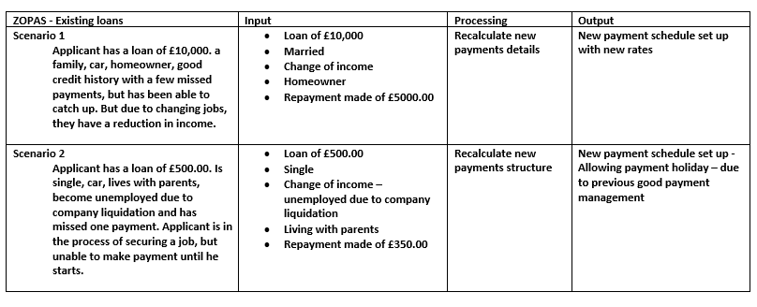
Diagram 1

- How computer-based information systems can support managers at each level and functions of Zopa operations.
Zopa is well established, skilled In order for Zopa to stay at top of thoer game, they must have a organisational structure in place (Appendix 7), their centralised systems breaks down all business information systems into sub sets with skilled workers.
ZOPAS Centralised Business Information system consists of -
- Historical Data – data which is collected in one assessable location
- Data Existence – duplicate data accessible at multiple servers
- Integration – data from various sources/ formats
- Reporting – Running reports from operational systems
- Data Growth – Accumulation of data via gigabytes to petabytes
- Data Quality – Knowledge base regarding systems and current data
- Varying data – Changes in data sources and application features
- Time – Reporting queries against historical data
Zopa employs 400 people, in different divisional departments there are systems. Business Information systems can help managers (Appendix 7) with strategies by identifying trends and possible pitfalls for Zopa for example, Chief Risks officer - Amy Fisher the department of Operational risk, have access to historical data dating back to 2007/08 recession. Being the only P2P lender who were operating back then provides a huge competitive advantage in the current Covid 19 climate. Zopa have a unique position in managing loans within a stressful environment, using a similar strategy used within the recession (Appendix 6) would be highly beneficial as both circumstances deal with economic financial decline.

Diagram 2

- Discuss Zopa’s potential knowledge management challenges and offer recommendations to strengthen their knowledge management practices from the knowledge acquisition retention-transfer perspectives.
In the Covid 19 pandemic, digital fraud is on the rise. According to Security Magazine (2020). due to increasing digital banking services, online approvals, and deemphasising in-person transactions makes it harder to verify identities. Fraudsters are using more sophisticated tactics by combining both real and fake information. For example, in the instances of a person’s sudden demise i.e. Coronavirus, people privy to their personal information can use this to their advantage by applying for a loan within a timescale, as you have 5 days to register a death (Gov.UK, 2020) and you have up to 84 days to “Tell Us Once” government service to advise of the individuals death, even then it is up to the relatives of the demise to notify credit agency (Experian, 2013), the file is flagged to indicate death but they periodically receive a “dead file” from Social Security Administration, banks, utilities etc.
To counteract this Zopa’s customers should provide additional (knowledge acquisition) health details, smoker/ non-smoker, etc, this information (retention) would be managed by their database, and analysed (transfer), should a trend be seen. Another way would be to have real-time access to the death registry, by means of supporting Zopa’s application through the laws and regulations via the proper government channels.

Diagram 3
Another aspect that Zopa may find challenging is the risk of unprecedented default of payment, for example a business owner may request may a fraudulent loan for a non-existent project, exaggerating their financial position in paying back the loan, causing default in the process. This will have a knock-on effect on the Zopa’s credibility.
The components of Knowledge Management program in Zopa are its people, processes and its technology (Tsui, 2002). Management process is capturing, categorising, storing, searching and distribution.

- Discuss how the overall approach adopted by Zopa Incorporates Porters Generic competitive strategy and in what ways the use of IS/IT has achieved to a competitive advantage?
Zopa was formed due to market research (Anderson, Kupp, 2008) based on “freeformers” these individuals are basically self-employed, free-lance worker i.e. consultants and entrepreneurs with irregular income and were identified as underserved by financial service institutions. Research indicated that there was approximately £6 million in a UK population of £60 million, creating a niche and that internet growth will expand. Together with this knowledge Zopa was born. Lender steadily increased their investments, increasing borrowers. There were low default rates because of the social aspect that was incorporated into the applicant process. Generic information was only provided by both parties and direct communication formed by lender and borrows help personalise the transactions. Data analysis of consumer requirements helped Zopa decide where their competition lies.
Zopas Information systems would require systematic data analysis regularly, to identify key areas in which is Competitive Rivalry. One such method used is the 5 Porters system (Appendix 8).
Threat of Substitution HIGH
- Shadow Banks are generally unregulated, they consist of brokers, brokers and credit intermediaries.
Zopa are regulated by Financial Conduct Authority and Prudential Regulation Authority, so consumers are protected.
- Banks offering competitive rate.
Zopa can achieve lower rates because they are using the personification method.
- Non-bank financial companies do not hold a banking licence, are not subject to banking regulations.
Zopa have a full banking licence so consumers are protected.
Bargaining Power of Suppliers MODERATE
- There are other companies (banks etc) that can provide loans and interest rates.
Zopa – Due to personalisation is consumer financial position, they can provide competitive rates.

Bargaining Power of Buyers MODERATE
- There is a limit on how much borrowers can apply for can offer lower transaction fees compared to traditional banks.
Zopa – Because there is a low investment inclusion, people are more than willing to invest, borrowers can pay back loan with less stress.
- Interest rates are comparatively affordable.
Zopa – This is due to using innovative technology, market research providing affordability limit.
Threat of New Entrants MODERATE
- It will be difficult for new companies to attract lenders
Zopa – Now a brand name and are one of the first p2p lending, offering vast number of products, continuing to be developing.
- Model used is easy to replicate.
- Zopa – Build on current model to have advantage, analyse further niche markets i.e. pensions.
Competitive Rivalry HIGH
- Opposing companies will offer similar rates and service.
- Zopa – Extend innovative products with additional perks i.e. Points card system etc.
In addition to using 5 Porters to analyse the Micro Environment, using SWOT analysis (Appendix 9) and PESTLE for Macro Environment (Appendix 10) can further identify key strengths/ weaknesses and strategically develop areas i.e. new products.

- How does the knowledge management practice of the case company will benefit from progress in information technology?
Knowledge Management practice is advantageous, by sharing, ideas and experiences, technology, skills training, through formal and informal communications systems in a systematic way helps provide a flexible distribution point. through cross collaboration through organizational functions by using technological variables i.e., software, hardware etc.
By using Big Data (McAfee, Bryjolfsson, 2012) data scientist can measure and manage more precisely. Companies in the top 3rd of their industry, who used data in decision making were found to be on average 6% more profitable, 5% more productive in comparison to their competitors. Data is factual but by using t, data analysists can identify trends and executives can take this information to make further developments. However Big Data (Varier, 2016) provides problems with challenges such as cultural change, technology change, organisational boundaries but also provides opportunities regarding customer insights, data driven innovative products, provide new revenue streams.
Zopa has used trends from analytical data to provide new products. Research and development would be required to further capture the ideal market i.e. pension. P2P platform can adapt their model to this area, by acquiring skilled workers in the pension’s arena. Consumers obviously would like to be in the best financial position when they retire. Zopa can use their available knowledge management structure to duplicate a similar model for pensions i.e. rates, monthly payments, as they already have the technology to optimise this.
Blockchains and BIS systems help streamline data, providing information. E.g. new points card like Tesco’s, Zopa can integrate with Tesco’s and provide further cliental and vice versa. It would require further research to see how viable it can be.

- How would the case organisation implement enterprise resource planning (ERP) systems, explain both advantages and challenges of having ERP systems with example?
The advantages of having an EPR system would be that it runs easier, procedure is automated, reports are user friendly, it is an efficient system. Using an EPR system is expensive but rather than having multiple systems meaning additional cost, all systems are under one umbrella and have real time interactive. The system can be aligned to Zopa’s organisation needs. It has total visibility, Zopa can monitor activities daily – borrower repayments and lenders payments. It helps improve your planning and reporting i.e. financial reports, cash flow statements, custom reports generated quickly. This system can be standalone or integrated, it runs under a cloud-based function which would be off site. Improves efficiency by decreasing repetitive activities making time for other additional enhancements. It streamlines customer service, as information is centralised the sales team can focus on maintaining and building customer relationships. Each transaction is end-to end. ERP systems provide a good level of security, by proving centralised backup of the most sensitive and critical data. Improves communication and able to collaborate between sub sectors, provides real time project updates, able to provide employees to make proactive decisions.
The disadvantage of using a ERP system is the cost, does the cost out way the output? There is the addition to software, the implementation process – time consuming, customising Zopa’s process will take time any mistakes can cause huge problems. Update will also be time consuming and costly. As Zopa contains millions of data, if there is an incorrect system implementation then it will affect all the whole system (diagram 4).
Zopa is a E-Business, as all their business activities are conducted through the internet using their systems. Zopa’s infrastructure is a combination of hardware such as servers and PCs (Diagram 4), the network incorporates shareholders (Appendix 11). It is imperative for that Zopa is stringent on security (Damanpur, Damanpur, 2001), as one model will not support every organisation, security is wholly dependent on each organisations by analysing which software, hardware, BIS, Zopa will put in the required security measures.

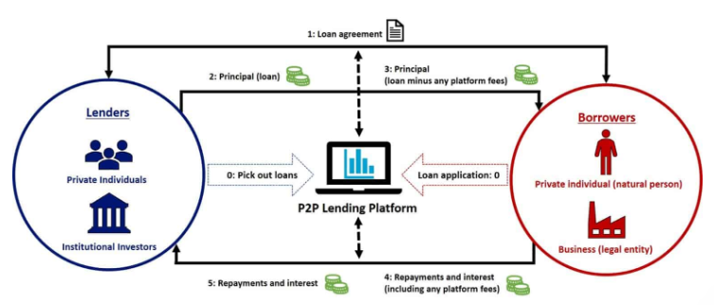
Diagram 4

- Conclusion

In history banks have controlled our money, and whoever has money controls the world. The high street Banks are evolving, technology and knowledge have progressed, the banks as we know today must adapt to meet the changing environment.

Knowledge management is key to a successful organisation. A culture that advocates knowledge sharing enhances its reach, gaining tacit knowledge from senior people who are close to retirement, have knowledge that cannot be reproduced by new employees. Knowledge management helps with effective decision making, which has already been tested and proven. Retaining this data in innovative technology with the help of blockchain, Fintech makes it user friendly, quick, and efficient.

Research by Zopa identified a niche in the market and with Research and Development, by providing consumers with affordable repayment loans. Millions of data from shareholders are stored in data bases, using blockchains. Innovative ideas are being produced every day, directly impacting how we work today. The more technology takes over jobs that were once considered manual, there will be more people available to employ in other areas of business, to be retrained. The more data is analysed the more organisations can interpret trends but not without knowledge management. Knowledge is power, it can’t be taken from you, there is no limit in sharing it, its renewable, its liberating.

However where is technology going to stop? From cookies to social networks, our personal data is captured knowing and unknowing, our like and dislikes. Bill Gates has devised a patent application WO/2020/060606 which states that this will allow technology to monitor people’s activity for exchange of cryptocurrency, information will be collected by a sensor, user device determines whether the task has been done. Businesses will thrive on technology, but some may start to see Technology as infringing on basic human rights.

- References
Anderson, A. Kupp, M (2008) Zopa.com – innovation in the U.K. financial services industry. Available at: file:///C:/Users/rumem/Downloads/08_JournalofFinancialTransformation_zopa.pdf (Accessed: 26 November 2020).
Damanpur, F and Damanpur, JA. (2002). E-Business e-commerce evolution: perspective and strategy. Available at: https://www.emerald.com/insight/content/doi/10.1108/03074350110767268/full/html. Accessed: 27 November 2020).
Emerson, S. Kennedy, R., O'Shea, L. and O'Brien, J., 2019, May. Trends and applications of machine learning in quantitative finance. In 8th International Conference on Economics and Finance Research (ICEFR 2019).
Experian (2013) ‘How to notify Experian that someone has died’, The Experian Team [blog]. 14 August. Available at: https://www.experian.com/blogs/ask-experian/how-to-notify-experian-that-someone-has-died/ (Accessed: 25th November 2020).
Gai, K., Qiu, M. and Sun, X., 2018. A survey on FinTech. Journal of Network and Computer Applications, 103, pp.262-273.
GOV.UK (2020) What to do when someone dies: step by step. Available at: https://www.gov.uk/when-someone-dies (Accessed: 25 November 2020).
HM Treasury, (2015) ‘Fintech is the future’, says Andrea Leadsom’. Available at: https://www.gov.uk/government/speeches/fintech-is-the-future-says-andrea-leadsom (Accessed: 26 November 2020).
ITAC, Telecommute. (2018) The Disadvantages of Information Systems. Available at: https://www.telecommute.org/the-disadvantages-of-information-systems/ (Accessed: 21 November 2020).
Klafft, M., 2008, July. Online peer-to-peer lending: a lenders' perspective. In Proceedings of the international conference on E-learning, E-business, enterprise information systems, and E-government, EEE (pp. 371-375).
McAfee, A. Brynjolfsson, E (2012) Big Data: The Management Revolution. Available at: https://hbr.org/2012/10/big-data-the-management-revolution. (Accessed: 27 November 2020).
Provost, F. and Fawcett, T. 2013. Data science and its relationship to big data and data-driven decision making. Big data, 1(1), pp.51-59.
Security Magazine (2020) 9 Reasons digital fraud is on the rise. Available at: https://www.securitymagazine.com/articles/93912-reasons-digital-fraud-is-on-the-rise (Accessed: 24 November 2020).
Tsui, E., 2002, July. Technologies for personal and peer-to-peer (p2p) knowledge management. In CSC Leading Edge Forum Technology Grant Report.
Varier, R. (2016) Roopesh Varier American Express Lecture 04/16/16 Data Science Speakers [video]. Available at: https://www.youtube.com/watch?v=VxCWhqZwowI&list=PLMhs4-EUscnecHM1sZmj8SpGFo2f_RZi7&index=55 (Accessed: 28 October 2020)
Yan, J. Yu, W. and Zhao, J.L., 2015. How signaling and search costs affect information asymmetry in P2P lending: the economics of big data. Financial Innovation, 1(1), p.19.
Zopa Limited (2020) Companies House Available at: https://beta.companieshouse.gov.uk/company/05197592 (Accessed: 28 September 2020).

- Appendix
Appendix 1
- the borrower’s credit rating, as determined by an external rating agency

- the borrower’s debt to income ratio

- verified bank account information (if applicable)
- verified home ownership (if applicable)
- detailed information on income and monthly expenses (not verified by the platform)
- past and present delinquencies of the borrower
- negative credit-related public records
- current credit lines
- the current credit balances
- bankcard utilization and enquiries by lenders during last 6 months.

Appendix 1
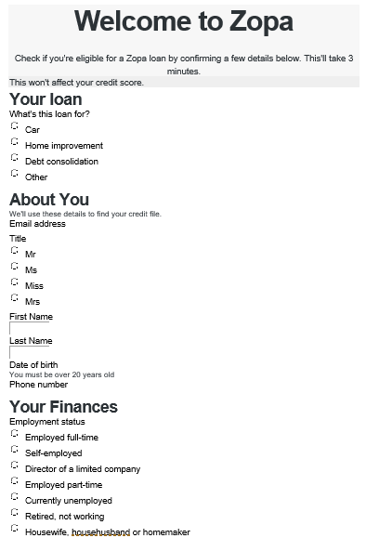
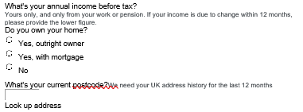

Appendix 3
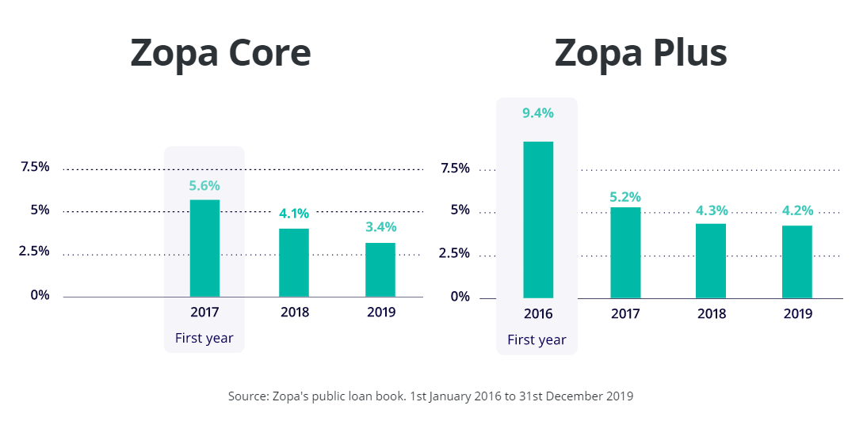

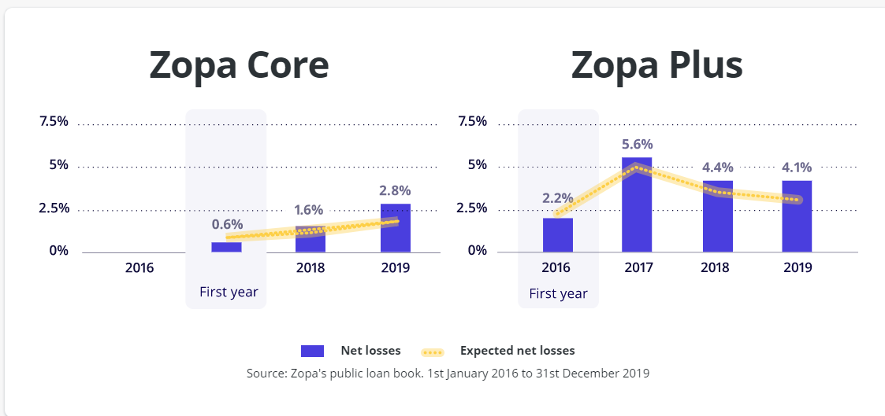

Appendix 4

Appendix 5

Appendix 6

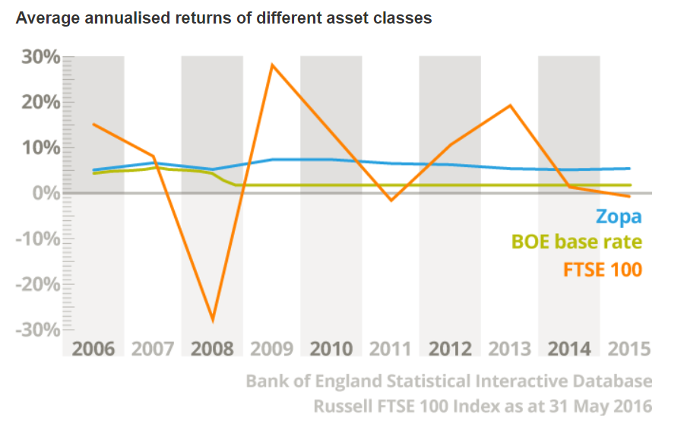
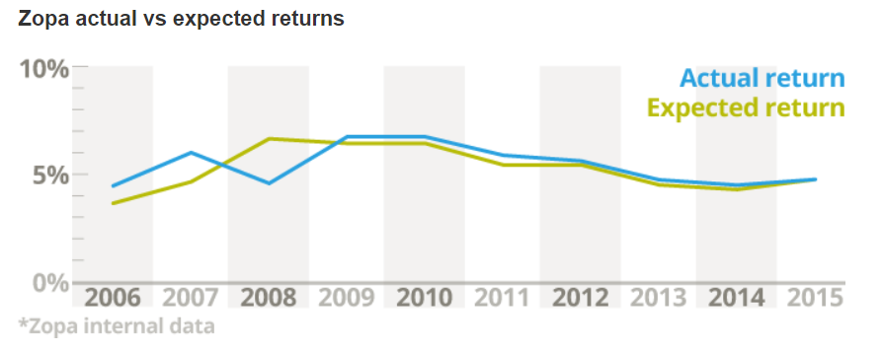

Appendix 7
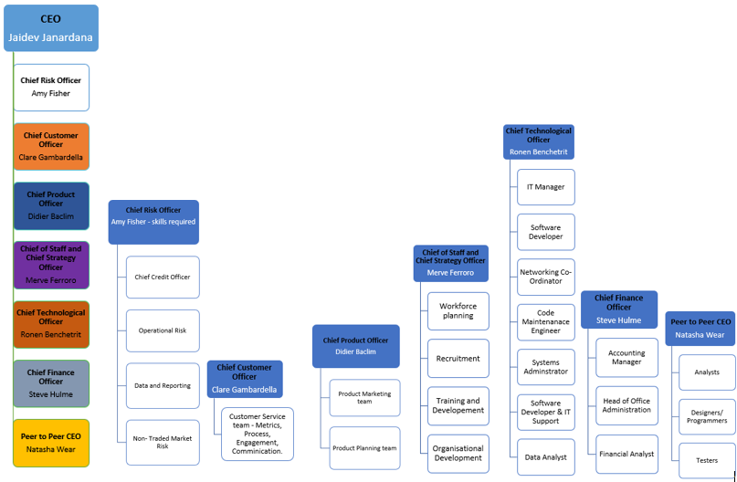
Appendix 8

Appendix 9

Appendix 10

Appendix 11

