Festus Tumi: 2121888

BMIH 6007 International Meetings Management for the Hotel Industry

Lecturer: Kathryn Flynn

“A Presentation for a Technology and Innovation Event”

Submission Date: 10th May 2024

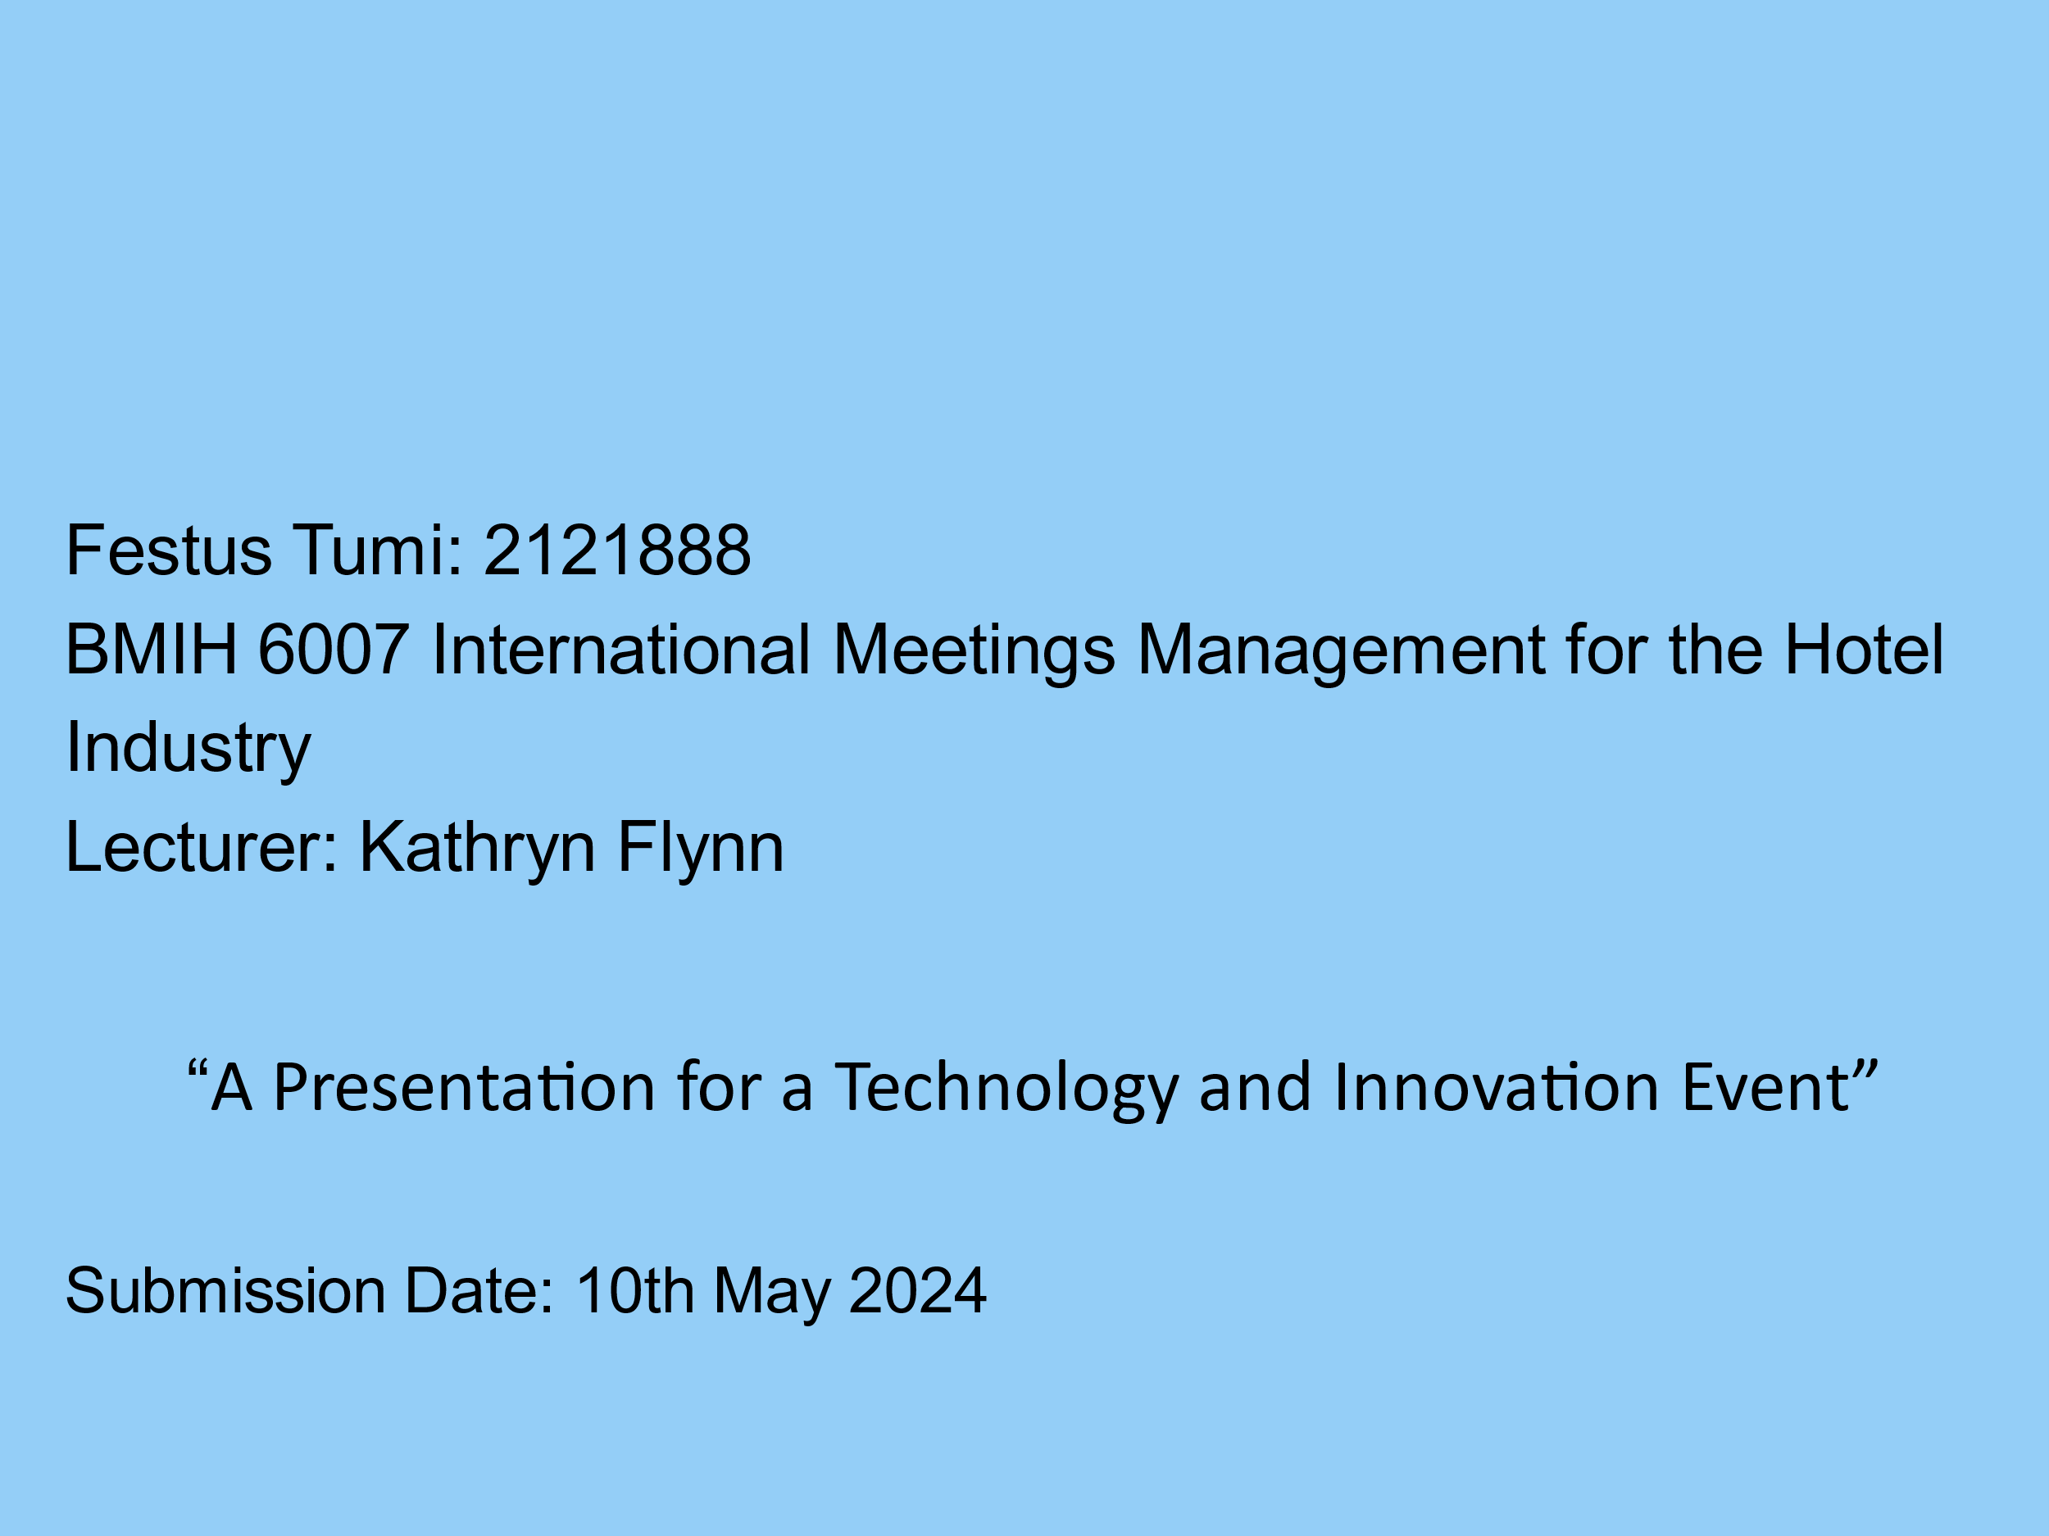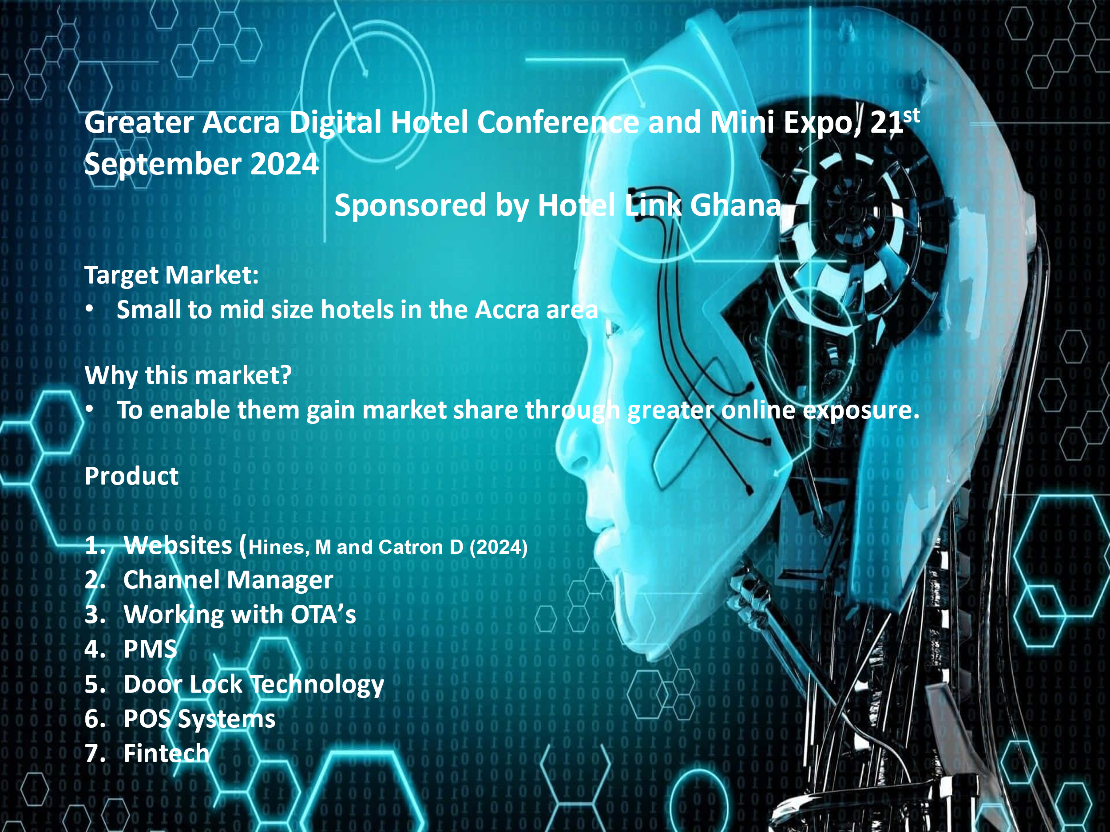

Presenters Notes
1. 80% of hotels don’t have websites -CEO of Ghana Tourism Authority (2021)
2. Number of licensed tourist accommodation establishments in Ghana from 2016 to 2022
3. Ghana bets on ‘Detty December’ tourists to boost revenue
Nana Oye Ankrah 21 Dec. 2023 Semanfor https://www.semafor.com/article/12/19/2023/ghana-bets-on-detty-december-visitors-for-revenue. Accessed: 30th April 2024
4. Hotel Link: The Core Solutions For Your Property
https://www.hotellinksolutions.com/hotel-marketing-solutions
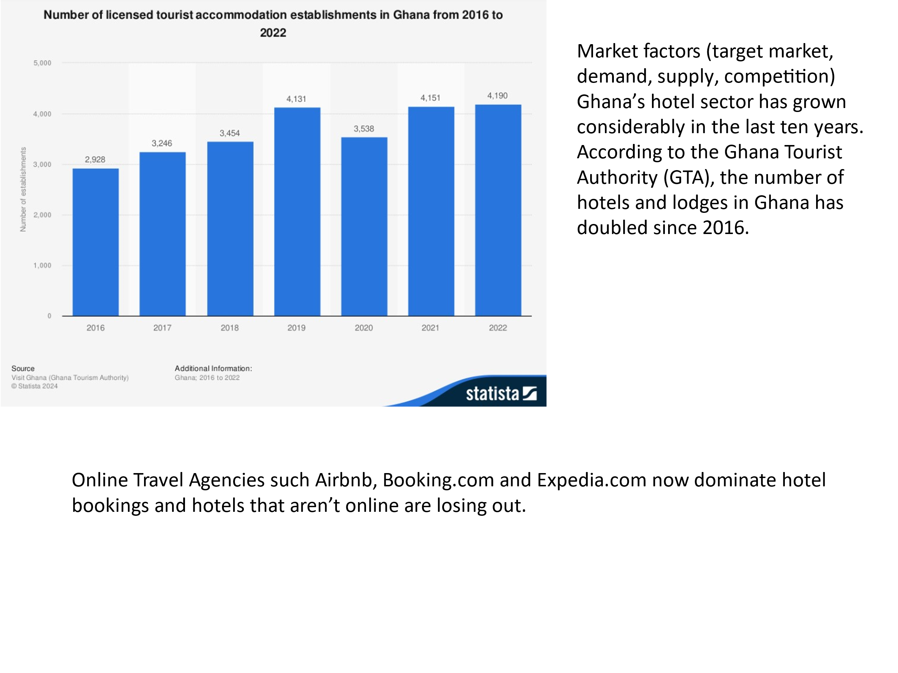
Presenters Notes:
According to the Ghana Tourist Authority (GTA), the number of hotels and lodges in Ghana grew at an average of 54 percent during 2008-2017, an increase from 1,250 in 2008, to 2,914 in 2017. As at 2023 Accor, IHG, Groupe du Louvre, Kempinski and Marriott dominate the upscale and luxury market and have a solid online presence using their own expensively developed PMS and distribution systems.
Nearly two-thirds of total hotel chain revenue is now booked online. Online travel agencies still account for most of that, but direct bookings are catching up. (Phocuswire)
With the vast majority without websites, HLG sees an opportunity to bring all the relevant stakeholders together under HLG’s umbrella, but each able to earn their income.
Invited: Greater Accra Regional hotel associations (Target market), individual hotel owners, .
Attendees: OTA’s, Fintech Companies, Telcos, Smart Door Technology
The Expo will also have the Ghana Hotel Association and Ghana Progressive Hotels Association in attendance.

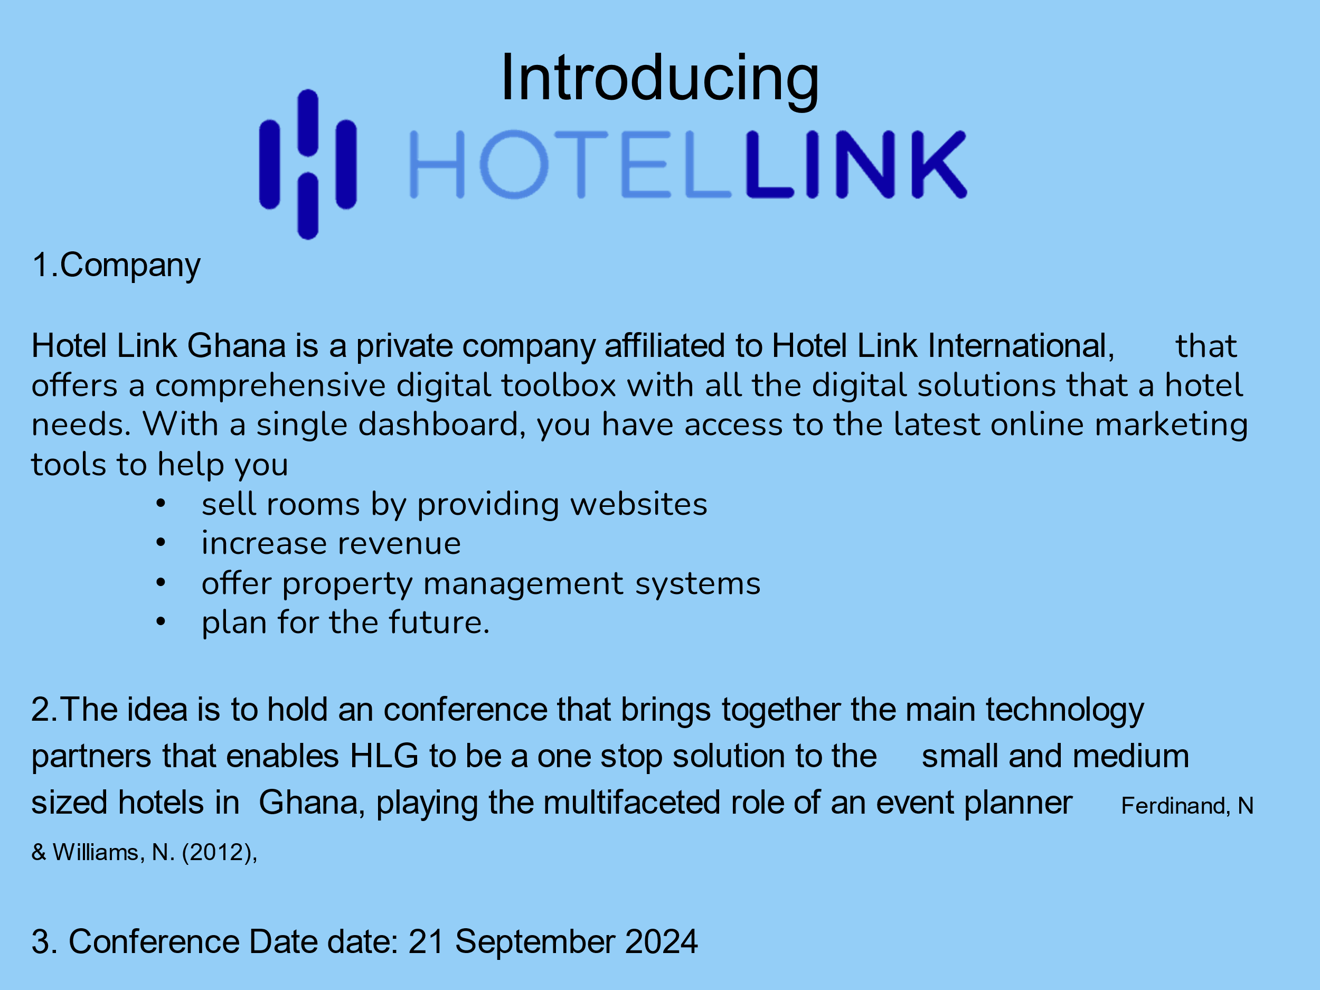

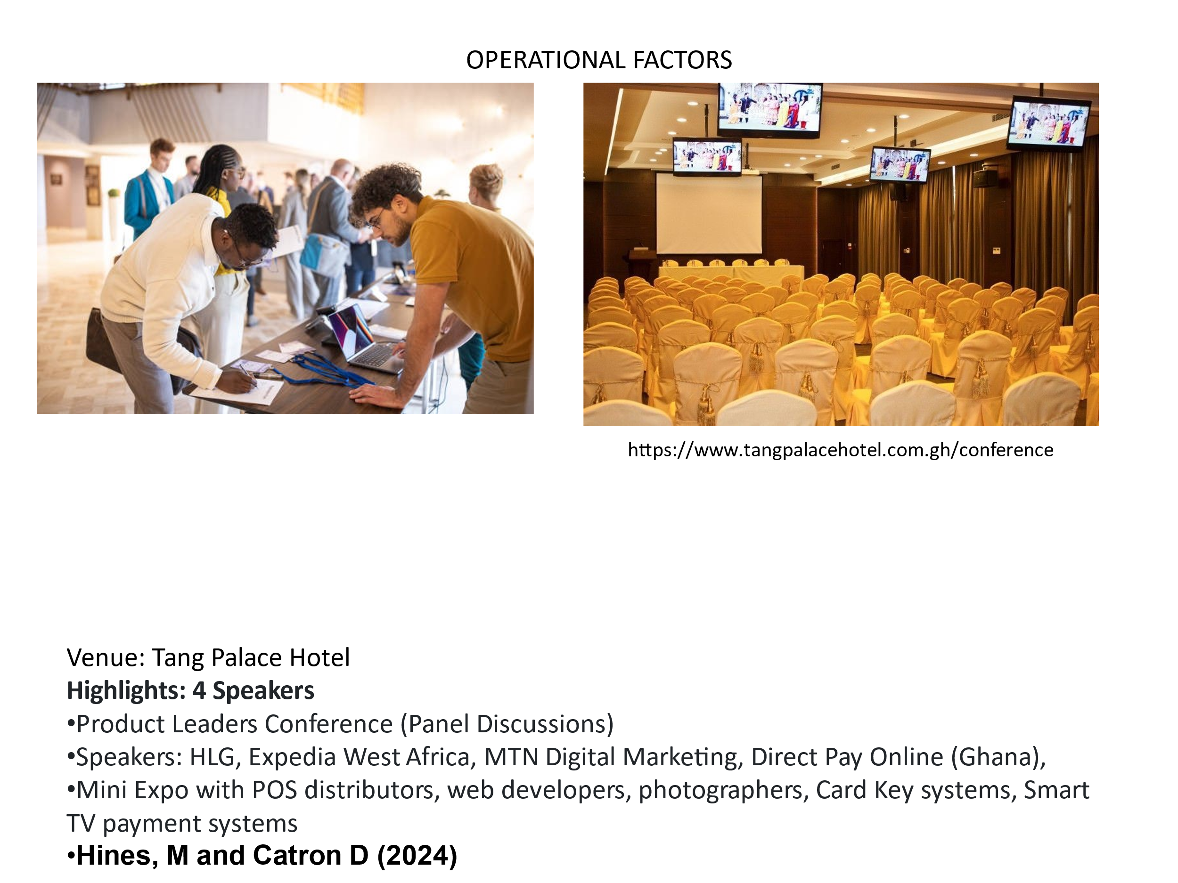
Presenters Notes:
Tang Palace Hotel Main ballroom with break out rooms for individual “speed dating” sessions. Capacity is 400 seated.
Email Invitations: Utilise SENDER for Email direct marketing targeting previously churned clients, unconverted clients.
Contact GTA, GHA and GPHA with invites.
Event staff will be provided by HLG, and will be responsible for email registration, and ushering.
Marketing materials: Lanyards and Hotel Attendees name tags provided by Hotel Link International.
Venue to provide small booths or tables leading to main conference area to display product or speak to guests directly.

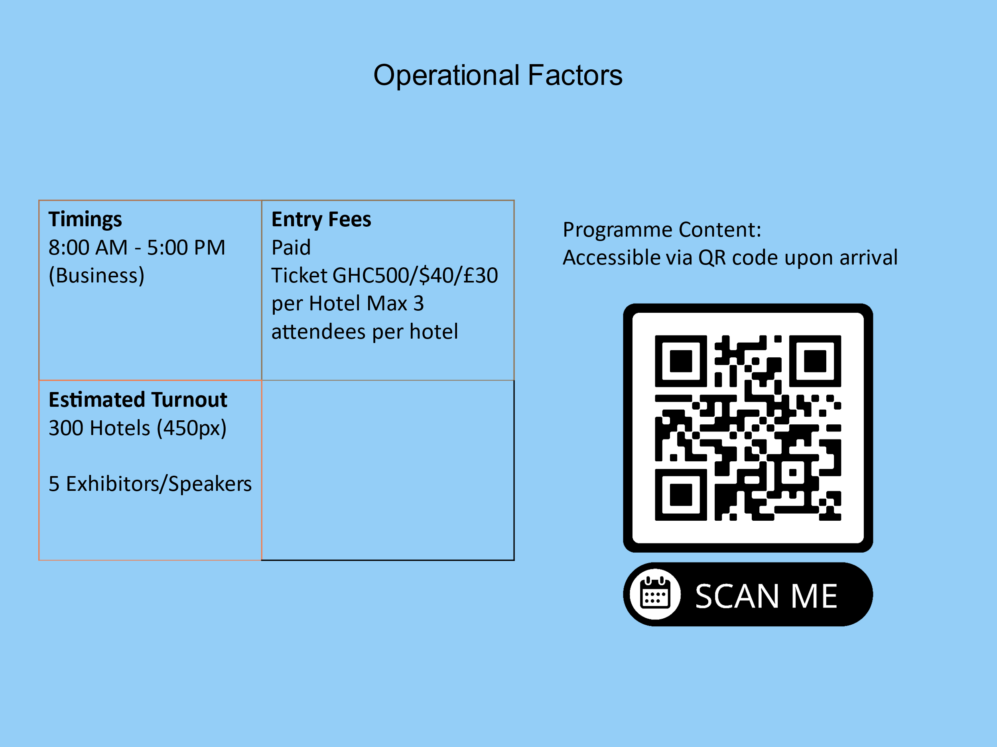
Presenters Notes:
HLG to lead the conference. Resource persons and speakers from various sectors to speak at the conference. Each stakeholder has a vested interest for the event to be successful. Each stakeholder will have 30 minutes to speak about how the use of their technology will have on the success of the hotels bottom line.
Ability to Negotiate with Partners: OTA’s (Booking.com, Expedia.com) Telcos (MTN, Vodafone), Smart Door Lock systems and software (Assa Bloy, Ezee), Smart TV retailers, resort photographers. Each to provide small marketing gifts like pens, tote bags, umbrellas, mugs, key holders etc.

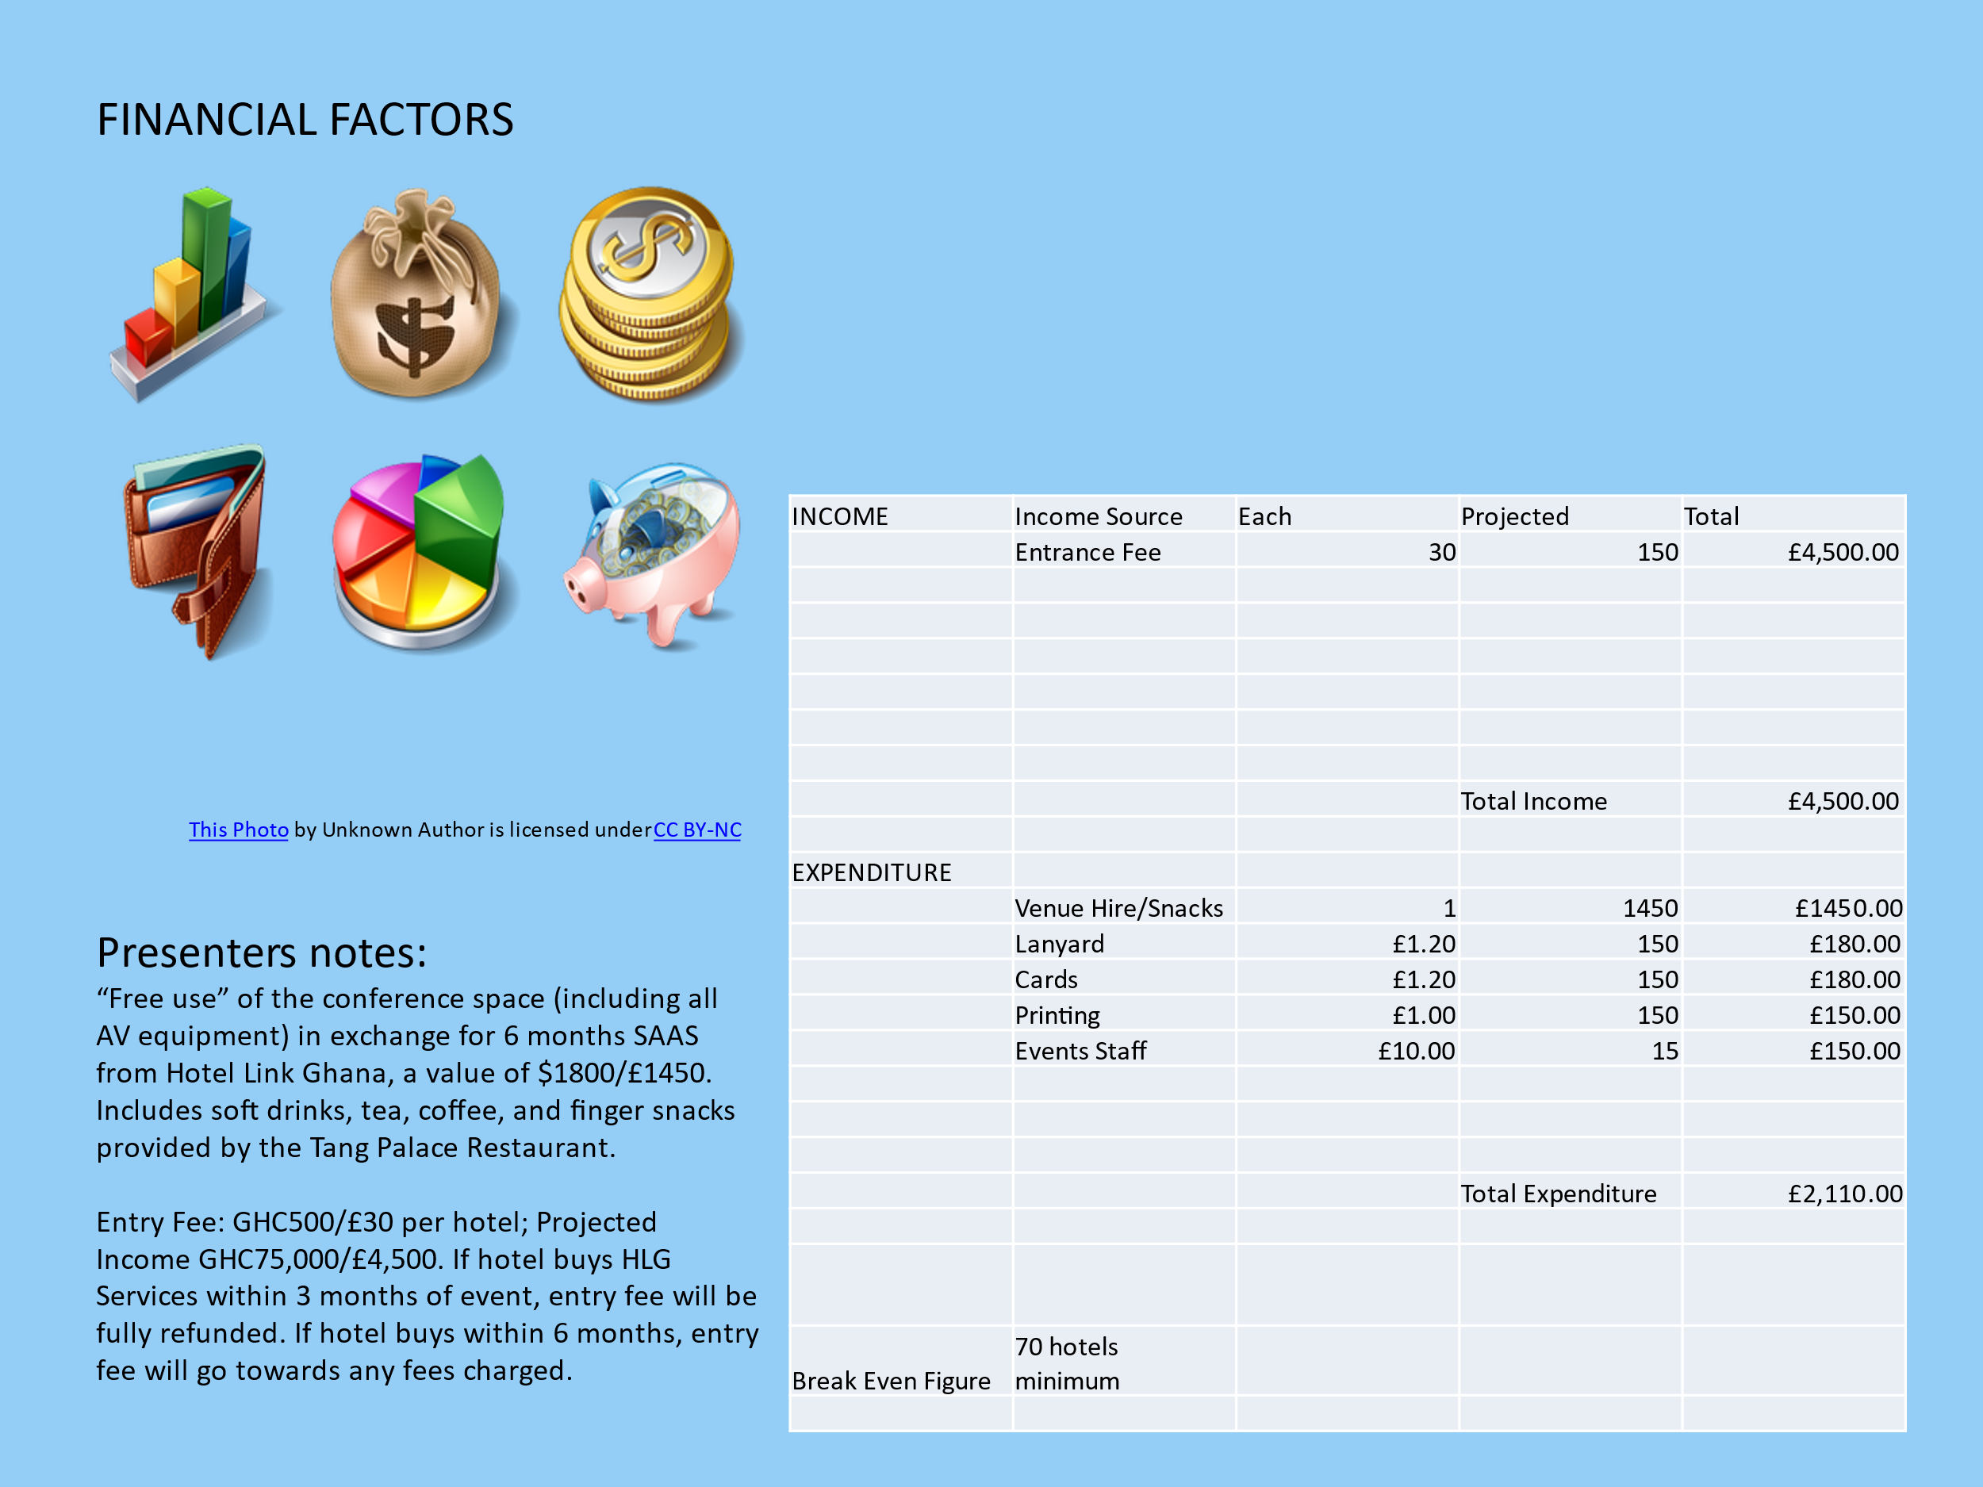

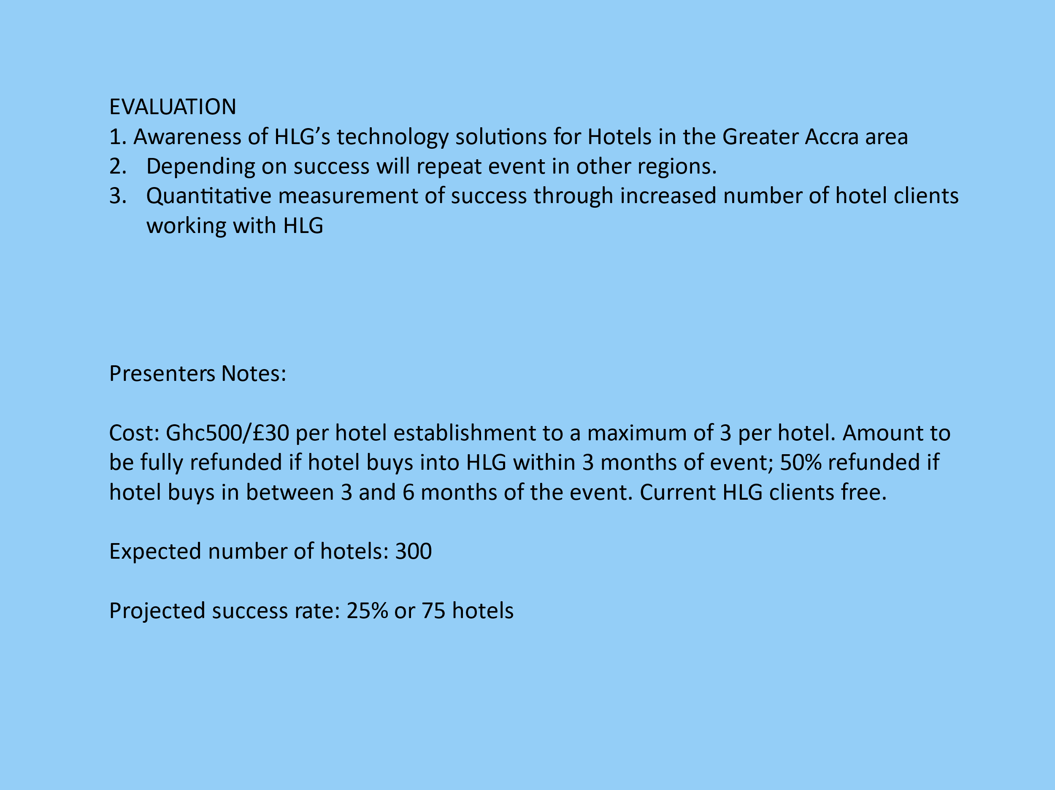

APPENDIX 1. QR code text

Conference Running Order:

9.00am Introduction by Festus Tumi of Hotel Link Ghana
  - Purpose of Conference
  - Aims for Hoteliers
  - Expected Outcomes
  - The power and essence of hotel websites and the need for integrated PMS systems
Speakers:
9.30 – 10.30am Kofi Annan – Expedia.com West Africa Regional Manager
How OTAs have opened up local hotels to international markets at no upfront cost. How OTA’s complement hotel own sites
10.30 -10.45am Tea/Coffee Break
11.00am – 12.00pm Roy Jines and Leif Ryman– Direct Pay Online and Hotel Link Pay respectively. The benefits of online transactions and exploding the myths.
12pm – 12.30pm Finger snacks/ Tea and Coffee
12.30 – 1.00pm Benedicta Annan MTN Telecommunications - The transport/power that makes it all happen
1.00pm to 5pm Mini Expo Attendees have the opportunity to interact with POS vendors, photographers, electronic card key suppliers, and Smart TV distributors. Also to have one on one conversations with event speakers and network with other attendees.

REFERENCES

1. 80% of hotels don’t have websites -CEO of Ghana Tourism Authority (2021)
https://www.graphic.com.gh/entertainment/showbiz-news/80-of-hotels-don-t-have-websites-ceo-of-ghana-tourism-authority.html Gifty Owusu-Amoah Showbiz News Jun - 27 - 2021 , Accessed: 29 April 2024
2. Number of licensed tourist accommodation establishments in Ghana from 2016 to 2022 Doris Dokua Sasu (2023) Statista. Com Available at: https://www.statista.com/statistics/1250228/number-of-tourist-accommodation-establishments-in-ghana/ Accessed: 29 April 2024
3. Ghana bets on ‘Detty December’ tourists to boost revenue
Nana Oye Ankrah 21 Dec. 2023 Semanfor.com Available at: https://www.semafor.com/article/12/19/2023/ghana-bets-on-detty-december-visitors-for-revenue. Accessed: 30th April 2024
4. Hotel Link: The Core Solutions For Your Property
Available at: https://www.hotellinksolutions.com/hotel-marketing-solutions. Accessed: 30th April 2024
5. Inter Tourism Expo Accra 2024
10 Times 2024 Available at: https://10times.com/e1pr-d082-r0ks Accessed: 30th April 2024
6. . Phocus Wire News/ Technology Record Online Direct Bookings Are Driving Innovation In Hospitality,
Hines, M and Catron D (2024) Available at: https://www.phocuswire.com/h2c-study-hotel-online-bookings-digitalization#:~:text=Bookings%20through%20OTAs%20were%20down,one%2Dthird%20the%20prior%20year Accessed: 2nd May 2024
7. Lanyards and ID Cards from Mega Eye
https://megaeyegh.com/product/custom-zen-lanyard/
8. Ferdinand, N & Williams, N. (2012) Event Staging: The Routledge Handbook of Events
Available at: https://www.taylorfrancis.com/chapters/edit/10.4324/9780203803936-26/event-staging-nicole-ferdinand-nigel-williams?context=ubx. Accessed:30th April 2024
9. Bowdin et al (2024) Events Management 4th Edition
Available at: https://www.routledge.com/Events-Management/Bowdin-Allen-Harris-Jago-OToole-McDonnell/p/book/9780367491840 Accessed: 9th May 2024
10. Beech, John & Kaiser-Jovy, Sebastian & Kaspar, Robert. (2014). The Business of Events Management edited by John Beech, Sebastian Kaiser & Robert Kaspar.
Available at: https://www.researchgate.net/publication/322405487_The_Business_of_Events_Management_edited_by_John_Beech_Sebastian_Kaiser_Robert_Kaspar/link/5a57c8ffa6fdccf0ad1a37b1/download?_tp=eyJjb250ZXh0Ijp7ImZpcnN0UGFnZSI6InB1YmxpY2F0aW9uIiwicGFnZSI6InB1YmxpY2F0aW9uIn19 Accessed: 9th May 2024
11. Getz, D (2019) Event Impact Assessment: Theory and methods for event management and tourism
Goodfellow Publishers
Available at:https://books.google.co.uk/books?hl=en&lr=&id=hsRLEAAAQBAJ&oi=fnd&pg=PR1&dq=event+management+theory&ots=NBy_I83rrm&sig=yGzBdvrKTZm3bwFRpUyeYu8v9hM&redir_esc=y#v=onepage&q=event%20management%20theory&f=false Accessed: 9th May 2024

