FIELDWORK PLACEMENT CONTRACT
Where possible please complete this information electronically, the text boxes will expand to contain the necessary information.
STUDENT INFORMATION
Student Name | Samantha John
Student Address | 2 Britannia House, Tenby Road, St Clears. Carmarthenshire. SA334JW
Student University e mail | 1301843@student.uwtsd.ac.uk
Student DBS Status and date | Completed
Additional requirements
Name of fieldwork supervisor | Darrel Williams
Fieldwork supervisor Tel.
Fieldwork supervisor e mail | D.G.Williams@uwtsd.ac.uk

HOST ORGANISATION INFORMATION

Name of Organisation |  |  | Leaving Care Team
Tel. |  |  | 01267246399
Email |  |  | Corporateparenting@carmarthenshire.gov.uk
Aims/ Purpose of the Organisation |  |  | Support Care Leavers (15-25 year olds) with EET, Accommodation, Life skills and to live independently.
Duration of placement |  |  | Level 7 Placement: 200 hours (100 or more face to face Youth Work).
Please detail the activities expected of the student  (Use more space if necessary) |  |  | Support and engage with young people. Advocate on their behalf. Advise and guide the young people to become independent.
Facilities/equipment available to student |  |  | Mobile, laptop and office.
Please confirm that your organisation has in place the following and where the student can have access to them:
a. Equal Opportunities Policy and procedures |  |  | Yes
b. Safeguarding policy and procedures including a designated child protection officer |  |  | Yes
c. Disability Policy (please state how you will meet any special requirements noted by the student) |  |  | Yes
d. Health and Safety Policy and procedures |  |  | Yes
e. Risk assessments including significant risks identified? A copy to be forwarded to the University. |  |  | Yes
During induction the student will be made fully aware of the organisation's rules of conduct (including boundary management), practices and policies, including Safeguarding and Health and Safety (e.g. accident reporting).

The student will be covered by your employer's liability insurance whilst on your premises and undertaking any assigned tasks.

Yes No

During the placement, the student will be responsible to:
Name of Line Manager | Monica Lewis
Position | Team manager
Telephone No. | 01267246399
Email | Mjlewis@carmarthenshire.gov.uk
UNIVERSITY INFORMATION

Name of visiting tutor |  | Darrel Williams
Telephone Number
Email address |  | See below

Student, line manager, and visiting tutor to sign below:

I hereby agree to the terms and conditions outlined above

Signed (student)……S.John……………………………………… Date: 20.9.19…………………

Signed (line manager)…M.Lewis…………………………………… Date 20.9.19…………………

Signed (visiting tutor)………………………………………… Date: ………………….

Risk Assessment:
Details:
Description | Leaving Care Team
Department: | Children Services
Location: | Carmarthenshire
Author: | Samantha John
Line Manager: | Monica Lewis
Date: | 20.9.19
Applicable Equipment:
Associated Risk Assessment(s): | See table.
Version:
Review Date:
Approved by:
Reason for latest update

Print name: ___Samantha John________________________________
Signed: _____S.John______________________________
Authorised by: _____M. Lewis______________________________
Print name: ____Monica Lewis_______________________________

Risk Assessment
Ref | Hazard / Task / Activity  Area of Concern | Persons at Risk | Existing Controls | Describe Any Further Controls / Actions Needed | Actions By Whom | Action By When
1 | Sensitive information shared | Staff/ Young person | Confidentiality Policy/Young person aware of sharing information for wellbeing of themselves and others. | Inform young person of protocol before the engagement begins | Staff/Young person
2 | Heightened emotion from the young person. | Staff/Young Person | Assess the situation before engagement. Pair up with another staff member. KIT with manager. | Inform team before engagement. Keep in touch. | Staff
3 | Travelling in the car to appointments/visits | Staff/Young Person | Travelling policy. Travel preparation. | Check weather conditions before driving. | Staff
4 | Covid-19 | Staff/young person | Follow Government guidelines. KIT with manager. | Assess the case and discuss with management to deliver support. | Staff
5 | Critical incidents | Staff/Young person | Assess the situation and contact relevant services. Pair up with another staff member. KIT with manager. | Continued assessment and ensure relevant services are involved to prevent further incidents. | Staff/young person

FIELDWORK PRACTICE SUPERVISION CONTRACT

Practicalities | Monthly supervision. Reasonable interruption is in an emergency, illness, annual leave, or important meetings. Supervision to be re-arranged. Supervision held in a private area to discuss.1-2 per month. Informal supervisions in between. Supervision will last between 2-3 hours depending on the information to discuss. Supervisor to arrange the meetings via work calendar.
For example - timing, frequency, place, what are reasonable interruptions.
Boundaries | Supervision is confidential. Personal issues or professional conflicts kept confidential. Case knowledge, planning and assessments would be shared. Practice would be entered onto the database. In accordance to behaviours within CCC policies.
What can be discussed, what cannot, confidentiality, how will gossip be dealt with.
Working together | Two way. Would not be personalised. Case discussion would be one focus, other is PCP.  Expectations-learning and developing different strategies to support young people, different approaches, planning. Understanding the role of a personal advisor. Supervisee understands that anything can be shared during the supervision. Supervisor to support the supervisee with fears and develop hopes into a planned way to turn into goals.
Sharing expectations, what the focus of the relationship will be hopes and fears, the ethos of the supervision.
Session Format | Partially case discussion and planning.  PCP -developing self and support.  Reflection reports on situations, stressful engagements.  Discussions on incidents and plan around the young person’s wishes. Discuss the goals set for each young person and if they have been completed.
What will each session be like? Will all the time be spent on one incident; are supervisees expected to bring written recordings or verbatim accounts?
Organisational & Professional context | Fitness to practice-based on Social Care Wales policy.  Time management, boundaries, behaviour, expectations as a staff member.  Responsibilities:  Supervisor-prepared with agenda, learning outcomes. Planning tasks with complex cases. Discuss cases and give opinion for support.  Supervisee-Professional dilemmas, reflections, stressful interactions-with clients and staff. In depth knowledge of support with cases to discuss.
Expectations, fitness to practise, responsibilities on supervisor and supervisee, professional and ethical boundary discussions.

Signed (supervisee) S John Date: 1.10.19
Signed (supervisor) M Lewis Date: 1.10.19

PROFESSIONAL DEVELOPMENT PLAN
For completion by the student after consultation with the Line Manager and Fieldwork Supervisor at the outset of the Placement
Student | Samantha John
Line Manager | Monica Lewis
Placement | Leaving Care Team
Date | 14.10.19

Students will be expected to consider their placement experience to demonstrate competence in the key aspects of youth work outlined in the table below based on the National Occupational Standards for Youth Work (LSIS, 2012) and the Principles and Purposes Document (WAG, 2013).

Line manager’s opening comments about the placement – exactly what type of work will the placement involve?
- To communicate via telephone and face to face with service users and other professionals
- To arrange visits to and visit other agencies
- To shadow team members engaging in different experiences involving service users.
- To reflect on weekly experiences
- To prepare and engage in supervision
- To relate theory to practice
- To attend Team Meetings
- To look at assessment tools used by the team and how they integrate these in the work with young people.
- To engage and communicate with both colleagues and service users whilst on placement
- To identify ethical dilemmas whilst on practice placement.
- To prepare and fully engage in formal supervision sessions with workplace practice assessor
- To enhance knowledge of legislation and policy that the agency in which placed adheres to.
- Comply to the confidentiality statements and Information Handling Policy
- Student to prepare for and attend regular supervision
- Inform the assessor if absent from the PLO
- Participate in induction and inform the Practice Assessor if they are absent for any reason
- Comply to the code of practice (Care Council)
- Comply with the policies within Carmarthenshire County Council

Student initial comments about the Placement.
All staff and management have been welcoming. Team includes 7 Personal Advisors (PA) and team manager.
I did not understand the role of a personal advisor before meeting the manager and I had minimal work with young people. The manager has arranged that I will shadow the PA’s for 6 weeks to understand and learn how we support and guide the young people. Weekly supervision with the manager is arranged.
Placement is based in an office. The office is shared between two teams.
Service-9am-5pm weekdays.

PROFESSIONAL DEVELOPMENT PLAN

Please complete the form electronically to enable the boxes to expand, ensuring you provide adequate detail.

 | 1. Work in accordance with the 5 pillars of Principles and Purposes of Youth Work in Wales (2013) (Educative, Expressive, Participative, Inclusive, Empowering). | 2. Facilitate the personal, social and educational development of young people | 3. Promote inclusion, equality and young people’s interests and wellbeing | 4. Work with young people and others | 5.Develop youth work strategy and practice | 6. Develop, lead and manage self and others
What do you need to learn? | The support offered to the young people. How to best support and guide the young people? Use pillars in support plan. | Arrange activities and group work. Support young people’s wishes and ideas through practical. Advocate for the young person to engage in EET. | Understand young people’s wishes by engagement. Involving all young people in activities. Deliver support equally. | Creating positive engagements with each young person. Support the young people with decisions regarding EET. Create relationships with staff and agencies. | Put policies and procedures into practice. Deliver support to develop independence. | Develop skills during the shadowing. Discuss in supervision. Contribute in activities and ideas for the young people. Support team with mind mapping and planning.
Activities you will learn from (how will you learn, what will you learn from) | Self-reflection  Shadowing colleagues  Supervision | Self-reflection  Shadowing colleagues  Supervision | Self-reflection  Shadowing colleagues  Supervision | Self-reflection  Shadowing colleagues  Supervision | Self-reflection  Shadowing colleagues  Supervision | Self-reflection  Shadowing colleagues  Supervision

Student | Samantha John
Supervisor | Monica Lewis
Date | 14.10.19

A community profile.
A group of young people living in Llanelli.
Samantha John
1301843
September 2019

Aim
The aim of this paper is to create a community profile with a group of young people living in the Llanelli town. It will consider statistical information and the views, hopes and aspirations of the young people. It will gather information on homelessness in the area and the process of seeking accommodation as a young person.

Equality of Opportunity and Valuing Diversity
It is important to ensure ethical approval in all aspect of research. This ensures the research is open and honest, to bridge trust between the primary researcher and the participants and to promote the aims and objectives of the research. Ethical guidelines are there to support the primary researcher and the participants by outlining the aims and objectives of research clearly (SkillsYouNeed, 2011). Each person involved in the research is aware of the information of their input into the research. To ensure this research is ethical, I have completed an ethics form. The participant receives an information document about the research, and they are informed that they can withdraw at any point from the research process. The young people involved will be treated equally and will receive no judgement with the information gathered. All individuals will be treated with respect and positive regard.
Methods, subjects and content
The intervention included group work with four young people and individual conversations regarding their situations. There will be an observation on meetings with the youth accommodation panel and semi-structured conversations with services and agencies linked with accommodation. Four young people were involved from the beginning of the project, two males and two females. Four sessions were spent asking questions to each young person to understand their perspective of the town. All young people were eighteen years old and have lived in foster care but have moved into different types of accommodation status. The young people receive support from a Personal Advisor and other agencies.

Geography
The Town is situated in the south eastern corner of Carmarthenshire in south west Wales some twelve miles west of the City of Swansea. Llanelli is a coastal town where the Welsh language is widely spoken. Communications for both industry and tourists are excellent with Intercity rail connections, and a direct road link connecting to the M4 motorway. The coastal relief road with its splendid scenic views connects the town with Swansea and towards Western Carmarthenshire. (Llanelli Town Council, 2020)

The wider community
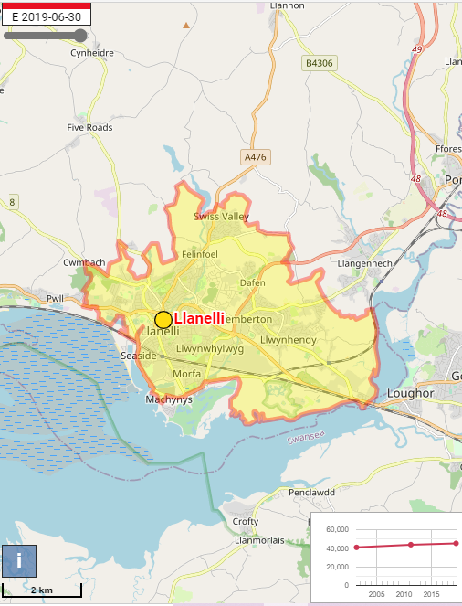
Llanelli is the largest town in Carmarthenshire. The population of the village was 45,309 persons at the time of the 2019 census. 21,963 males and 23,346 females. 11,059 people were aged 0-19yr and 5,437 people were aged 20-29yr. Since 2000, the population as a whole has risen. Within the wider community, 1.6% of the population (706 people) were described as being Asian, and 0.6% (274 people) as mixed/multiple ethnicities. Other ethnic groups are Black and Arab.

Figure 1.

Previous youth work in the community
At the time of the study, there was a weekly meeting with Voices in which one young person attended. There was floating support for the young people that lived independently and clubs available via different agencies such as ‘St John’s ambulance service’ and CYCA. Unfortunately, the United Kingdom went into a pandemic lockdown that meant all youth clubs and youth work was unable to continue and was put on hold. This affected the young people and their weekly routine but also their education. ‘There are clubs available, but I don’t want to go to them, I would rather hang out with my friends on the streets’ said one of the young people. Some of the young people shared that they did not feel safe attending clubs on weeknights as they feared the walk home in the dark. Others would rather meet their friends without it being controlled and they ‘could do what they wanted’.

Joined up working?
The young people have a personal advisor each who supports them with education, employment, training, accommodation, and independent skills. Some of the young people are involved with other agencies to support with needs that the personal advisors are not specialised to support. Some young people attend Voices for Care one night per week to discuss their support from other services.

Table 2. Groups involvement with other agencies.
Agency | No. of the group involved | Male | Female
Education Psychologist | 2 |  | 2
Bereavement Counselling | 1 | 1
Not in Education, Employment and Training | 2 | 1 | 1
Educated otherwise than school | 1 |  | 1
Housing Officer | 2 | 1 | 1
Living in Supported Lodgings | 2 | 1 | 1
Mental Health Services | 2 | 1 | 1
Personal Advisor, Leaving Care Team | 4 | 2 | 2

Housing
In 2019-20, 16 to 17 year olds were placed in temporary B&B accommodation under the current Homelessness legislation on 93 occasions, and on a further 66 occasions under children’s social services legislation. Care leavers aged 18 to 21 years old were placed in temporary B&B accommodation under the current Homelessness legislation on a further 84 occasions (Welsh Government, 2020).
In 2019, Tyisha in Llanelli is one of the most deprived areas in the country with daily anti-social behaviour, drug dealing and alcohol misuse. This was ranked in terms of education and employment, income, health, and community safety. In June 2020, Tyisha had the highest crime rate in Llanelli of 102 crimes. The locals do not feel safe, and many have moved property (Mirror, 2020).
Housing projects in Llanelli:
- The Wallich
- Llety
- King George
- Llamau
- Clos Sant Paul
- Hafal
- Shelter Cymru
- CTAP
- Llanelli training house
The youth accommodation panel meet fortnightly to discuss vacancies in the Carmarthenshire area. Every young person who has claimed to be homeless is put on a list and this is reviewed in each meeting. The purpose of the panel is to ensure that all young people are safe and have been acknowledged of their current accommodation situation. Moreover, to signpost access to relevant support additional to their accommodation needs.

Transport
Llanelli is linked to the M4 motorway via the A4138 and to Swansea via the Loughor Bridge on the A484. There are regular bus services between Swansea and Carmarthen and a National Express service to London. Young people aged between 16-21 years old can apply for a travel card for free that takes a third off the original price of a bus ticket (Welsh Government, 2021).
Services from Llanelli railway station connect with Fishguard Harbour and Swansea along the West Wales Line. The district is also served by stations, at Bynea, Llangennech, Pembrey & Burry Port and Kidwelly. Young people aged between 16-25 can buy a railcard for £30 per year which will take a third off the original price of a train ticket (trainline, 2021).

The intervention.
One-to one work.
Everyone involved was spoken to by me in a non-informal interview via telephone. Due to Covid-19 restrictions I was unable to meet with the young people. Discussions involved how they felt about the town and what they felt was needed to make the town better. The young people explained their situations with accommodation and if they feel that the support helped and what could have been differently. It was recognised that accommodation support is much needed for the young people from their lack of knowledge on how to live independently. The young people explained that the support helped them to understand how to pay bills, what bills they need to pay, upkeep of hygiene etc. It was also stated that knowing they had the support when they need it gave them reassurance that they would be able to succeed living independently. All the young people stated that they dislike walking down ‘Station Road’ as this is acknowledged with drugs and anti-social behaviour. This seems to be the street that young people stay away from and there is an element of worry and fear.
I was able to speak to the Youth accommodation panel and understand the system of support for homelessness via an interview. The panel ensure that all young people are accommodated in emergency accommodation until an accommodation is available for the young person to be moved. The young people receive floating support to gain independent skills and identify other needs that the young people may need (Nacro, 2021).

Conclusion
Unfortunately, it has been recognised that there is not enough accommodation for young people in Llanelli but more importantly how the residents feel about the current situation on Tyisha and Station Road. Therefore, the council has created and supported a regeneration project called ‘Transforming Tyisha’. The aim of this project is to create a place where people want to live and work. This project involves approximately 110 new accommodation which will help with the current situation with homelessness (Carmarthenshire County Council, no date). It was acknowledged that there is a lack of knowledge and understanding on how to live independently. Therefore, I suggest that all young people, 18-21 should be offered floating support to learn skills on how to live independently. More importantly, for the young people to feel confident and secure with living on their own.

Reference List.
Carmarthenshire County Council (no date) Tyisha. Transforming Tyisha. Transforming Tyisha (gov.wales) [Accessed: 21 February 2021].
City Population (2021) Llanelli (Carmarthenshire, Wales / Cymru, United Kingdom) - Population Statistics, Charts, Map, Location, Weather and Web Information (citypopulation.de) [Accessed: 17 February 2021].
Llanelli Town Council (2020) About Llanelli. About Llanelli - Llanelli Town Council [Accessed: 19 February 2021].
Mirror (2020) Inside one of UK’s most deprived towns which has been ‘taken over by drug dealers’. Inside one of UK's most deprived towns which has been 'taken over by drug dealers' - Mirror Online [Accessed: 21 February 2021].
Nacro (2021) Nacro Carmarthenshire Generic Floating Support Service. Carmarthenshire Generic Floating Support Service | Wales | Nacro [Accessed: 8 March 2021].
SkillsYouNeed (2011) https://www.skillsyouneed.com/learn/research-ethics.html [Accessed: 12 January 2021].
Trainline (2021) 16-25 Railcard. 16-25 Railcard | Young Persons & Student Railcard | BUY NOW 👇 from Trainline (thetrainline.com) [Accessed: 25 February 2021].
Welsh Government (2020) Homelessness in Wales, 2019-20. Homelessness in Wales, 2019-20 (gov.wales) [Accessed: 18 February 2021].
Welsh Government (2021) My Travel Pass. Home ♥ mytravelpass | Welsh Government [Accessed: 25 February 2021].
Wikipedia (2021) Llanelli. Llanelli - Wikipedia [Accessed: 18 February 2021].

An observation of the work placement.

The Leaving Care Team consists of one manager and eight Personal Advisors. The Personal Advisors share an office, and the team manager is separate next door. Each Personal Advisor receives a mobile phone and laptop. Most of the team’s work is agile however it is expected for all members to attend team meetings at the office fortnightly. It is a diverse team, and the Personal Advisors have different strengths and abilities to bring to the team.
Personal Advisor’s advocate for young people between the age of fifteen and twenty-five, the support can continue up to twenty-five if the young person is still in education. Personal Advisor’s support young people with education, employment, training, accommodation, health, and to develop into independency. There is approximately 135 young people assigned to the team to transition from care to independence.
Between the age of fifteen and eighteen, the Personal Advisor will work alongside the Social Worker to support the young person. Once the young person is eighteen, the childcare team sign off and the Personal Advisor continues support. Working with other professionals, attending meetings, and leading meetings. Completing statutory tasks such as engage with the young people every 8 weeks and complete 6 monthly pathway plan. The Personal Advisor is involved with making referrals, recording tasks, and duty tasks.
The young people that Personal Advisors support are care leavers. The Personal Advisors are corporate parents to the young people. The team deliver support from 9am until 5pm on weekdays, however the team is flexible if there is a valid reason to do so. Each team member is assigned cases via the team manager by assessing who would be compatible and has the skills to work with the young person. A Personal Advisor can be assigned to support up to twenty young people. The priority is to support and enable care experienced young adults to realise their aspiration and ambition and have a sense of feeling cared for, cared about and able to care for themselves. Champion their voice as Corporate Parents in all that we do.

Case Study
Week 1
The young person has been in many foster placements and found herself unable to settle in a placement. The young person was unable to be looked after by her mother who has mental health issues and her father had passed away. The young person misuses substances and has found it hard to create positive friendships and relationships. The young person is 18 years old and lives in supported lodgings. During the last twelve months, I have worked with the young person once a week either face to face contact, telephone, or face time. The purpose of the sessions was to find education, employment, and training opportunities, and ensure that the young person is happy in accommodation (CLD Standards Council Scotland, 2019).
At first, the young person would not engage with me and I found it hard to build a relationship. The young person found it difficult to trust and engage with new people and with anyone involved with social services. The young person caused worry and concern when she would go missing for a few nights at a time and would not return to supported lodgings. The young person uses negative behaviour and bold attitude as a defence mechanism (PsychCentral, 2016). She found it difficult to make positive decisions and make friendships with her peers. She lost weight and began getting in trouble with the police from shoplifting and possession of a weapon. The family were known to get into trouble with police therefore she felt that she could not be different, and this was the life she was supposed to live. Her relationship with her mother was volatile. The young person could not understand nor forgive her mother for making her go into care. The mother found it difficult to make a relationship with the young person because of the young person’s feelings and behaviour towards her. It was identified that therapy was needed to create a bond between them however the young person refused to attend. I continued reaching out each week on the same day and time which created a routine and a constant in the young person’s life (Ingram and Harris, 2001).
Week 10
Eventually the young person began to engage with me, this enabled her to share her wishes and feelings. This continued and built a relationship between the young person and me which is the central practice of youth work (Youth Work National Occupational Standards, 2019). I found that the young person had no independent skills and found it hard to engage with any sort of education and training. She found it difficult to maintain the attendance of training and refused to attend college based on that she felt it did not suit her. During the engagements, the young person and I would discuss opportunities to engage in employment, education, and training but more importantly the young person shared that she is pregnant and will need alternative accommodation. One characteristic of the youth service in Wales is to be driven by a young-people-first approach (Welsh Assembly Government, 2007), therefore I listened to the young person’s needs and developed a plan with her.
Week 13
Once the young person found out she was pregnant she decided to stop smoking cannabis without support. The young person understood that this will affect the development of the baby. The young person is in a positive relationship and has changed her behaviour and attitude. We discussed where she would like to live and created the account for her to begin bidding on one-bedroom properties. The young person attended all medical appointments and engagements with me. The young person was offered accommodation and moved in with my support. I had seen a big change in the young person in a small amount of time. It was difficult for her not to have the cannabis as her coping mechanism but persevered because of the baby. The young person moved into the property and developed independent skills with my support (Youth Work National Occupational Standards, 2019).
Week 14-50
During the nine months of pregnancy, the young person showed ability to live independently and continues to demonstrate learning. Through support from me, the young person can budget, keep her home clean and live on her own confidently. The young person continues not to smoke cannabis and has chosen to not use again. The young person recognises that support is a positive attribute for her journey and welcomes the help as a universal approach (Welsh Assembly Government, 2007). During this time, she has repaired her relationship with her mother, and this has developed into a healthy relationship. The young person understands that her mother could not look after as a child and accepts that her mother had to put her in care. The young person has shown resilience and learnt how to forgive. I have seen a dramatic positive change in this young person, and it has been an incredible journey to watch.
Week 51
The young person gave birth to a baby girl and has also been offered a two-bedroom house in the area that she wanted. The young person will be moving to the area where her mum lives to receive support as and when she wants it. The young person is so happy and cannot wait to move. She also understands that I am available for support when she needs it, but she recognises that she is independent and can achieve any goal independently. This was my goal to achieve; to create an independent young person (Harrison and Wise, 2005).

Reference List.
CLD Standards Council Scotland (2019) Youth work National Occupational Standards. Glasgow: CLD Standards Council Scotland.
Harrison, R. and Wise, C. (2005) Working with Young People. London: Sage.
Ingram, G. and Harris, J. (2001) Delivering GOOD Youth Work. A Working Guide to Surviving and Thriving. Russell House Publishing.
PsychCentral (2016) 15 Common Defense Mechanisms. 15 Common Defense Mechanisms (psychcentral.com) [Accessed: 9 March 2021].
Welsh Assembly Government (2007) Young People, Youth Work, Youth Service. Department for Education, Lifelong Learning and Skills.
Youth Work National Occupational Standards (2019) Summary Functional Map For Youth Work. CLD Standards Council.

Reflective recording-case study.

Session information
Case study on a young person. The young person has progressed during the last twelve months with independence skills and life choices. The young person and I engaged each week to offer advice, guidance and support with education, employment, training, and accommodation. I have supported this young person throughout her development of the last 52 weeks and was involved with the transformation to independent living. The young person faced many obstacles during this period and developed skills through receiving support and guidance from a multi-agency approach (Every Child Matters, 2005).

Observations

Observations took place over a twelve-month period. In this time, the young person made a positive journey and developed skills and knowledge to live independently. The young person found it hard to trust agencies at the beginning however has developed links with a range of settings that have supported her through her journey (Welsh Assembly Government, 2007). The young person is bold, confident and did not want to hear or take advice from other people but has understood throughout the last year that advice and guidance is what she needs. I have seen the young person go through different critical incidents which have shaped her journey to where she is now. The young person used drugs to help with her mental health however when she found out she was pregnant, this stopped. The young person went through withdrawal but persevered through it for her baby to be healthy. The pregnancy changed the young person’s life. It was clear that the young person did not care about herself, but the baby was important and needed to be loved the way that the young person had not received.

Evaluation
The continuous support from myself meant that regardless of how the young person felt or behaved I was the constant in her life (Welsh Government, 2014).
The young person eventually let me in and began to trust me, take my advice and guidance.
The young person stopped misusing drugs.
The young person receives the appropriate support to help her continue her journey to independency. She shows her strength and commitment to the baby by continuing to stop misusing drugs.
The young person has learned and developed independent skills to live on her own successfully.
The young person seeks support when necessary and ensures that she continues to acknowledge when she needs help.

The young person had a volatile relationship with her mother, therapy did not help.
It was difficult to build a relationship with the young person at the beginning, this could be reflected on for me to use different skills to create the relationship quicker.
The lack of trust for social services is concerning.

Feelings

I am proud of this young person. It has been a rollercoaster of emotions and situations during this period. At the beginning of the journey, I felt that I would not gain the young person’s trust or engagement however I persevered, used a lot of patience which was successful (Ingram and Harris, 2001). I felt accomplished that the young person was willing to engage with me and listened to my advice. Once the engagements began, I found myself excited to work with the young person and eager to continue the good relationship with learning tools and ideas to help develop skills and knowledge. I was happy to hear of her pregnancy and the positive bond with her mother which I know was important to the young person. The courage this young person showed by changing her lifestyle was inspiring. I found it exciting to see the change in the young person even when she could not, and I continued to tell her how well she was doing. The reassurance from services helped her progression and I felt that in some way I had helped her with the journey.

Learning outcomes

Learn skills to create a relationship with the young person sooner (Welsh Government, 2019).
Understanding the effect of relationship breakdowns with family.
Gather information on pregnancy and what services are involved with the mother and child.
Attend course on substance misuse and different type of drugs.
Continue to support the young person post pregnancy.

Conclusions
Perseverance and patience are important elements to support a young person (Ingram and Harris, 2001). The journey can be long but will always be worth it. Young people are reluctant to trust easily which is not a negative trait to have. However, once that trust has built, it is an opportunity to help with their life journey. This young person has had a hard start in life and has made bad choices but has shown her strength to change the course of her life. Fortunately, the young person is now living independently with a new-born baby and a positive circle of support to continue with her journey to adulthood. She has changed from

Reference List.
Every Child Matters Chang for Children (2005) Multi-agency working. ECM_FactSheet (wokingham.gov.uk) [Accessed: 10 March 2021].
Ingram, G. and Harris, J. (2001) Delivering GOOD Youth Work. A Working Guide to Surviving and Thriving. Russell House Publishing.
Welsh Assembly Government (2007) Young People, Youth Work, Youth Service: National Youth Service Strategy for Wales. Assembly Government.
Welsh Government (2014) National Youth Work Strategy for Wales 2014-2018. Education Wales.
Welsh Government (2019) Youth Work Strategy for Wales. Education Wales.

Reflective Recordings

Reflective recording. 24.10.19

Session information

Shadowed a social worker to a visit. The young person is a mother of two young girls. The social worker informed of the young person’s situation on route to the young person’s house. The purpose of the visit was to deliver abuse and healthy relationship sessions. The young person has made bad choices in relationship and has been a victim of abuse. The social worker is concerned that the young person will go back to previous relationship as they are still involved with her social circle. The young person is vulnerable and is easily led astray; she does not like to be alone.
The social worker delivered the session through informal conversation with an A2 pad showing the information in the young person’s living room. The young person gave permission for me to attend the session.

Observations

The young person and the social worker began the session with the young person answering questions about the last session. The young person was able to answer successfully and that reassured the social worker that the young person had listened and remembered.
I could tell that the young person and social worker have a positive relationship. The social worker explained what the session will involve today. The session included what is abuse and the signs and behaviours to look for. The young person engaged in the lesson and understood the importance of the topic discussed. I could see that the young person was comfortable discussing this topic through her body language, this could be because she was in a safe learning climate (Ingram and Harris, 2001). The young person sat comfortably on the sofa leaning forward which shows to me positive engagement.

Evaluation

The young person learnt skills and knowledge about abuse. The young person recognised the importance of understanding signs and symptoms of different types of abuse to be able to make sensible choices (Ingram and Harris, 2001) The relationship between the social worker and young person is positive. The young person learnt new information that will be important for future relationships.

The young person engaged positively and enjoyed working with the social worker. I do not feel that there is anything I would do differently and there was nothing that was negative in this session.

Feelings

I was not nervous this time which informed me that I am getting used to meeting new people. I felt at ease when we arrived as the young person was welcoming to me and I could tell instantly that she had no issue with me joining the session. During the session, I had to stop myself from engaging as I knew this was not my session however it showed that I would enjoy delivering topics to young people. I felt happy every time the young person understood a point, but I also enjoyed seeing her face light up when she realised herself that she understood. I enjoyed shadowing this visit because it was a positive engagement and outcome.

Learning outcomes

Young people need sessions to discuss topics like this to develop positively.
Informal sessions ensure that the young person is comfortable and willing to engage (Jeffs and Smiths, 2008).
Adults think that young people know simple topics that is learnt through everyday life however care leavers did not grow up in ‘normal’ family settings and miss information that adults expect them to know.
Young people want to be loved and will accept any form of a relationship to feel this.
Young people are willing to learn from people they trust and feel comfortable with but also because it is voluntary (Welsh Assembly Government, 2007).

Conclusions

I recognised that I would enjoy delivering sessions with young people to ensure they develop and grow into independent adults with healthy relationships. We learn every day from peers, family, and colleagues therefore we need to ensure that young people learn also (Youth Work National Occupational Standards, 2019). It is important for young women to understand domestic abuse. Young women are the most likely to be victims of domestic abuse through first relationships or the lack of knowledge or understanding healthy relationships (Safelives, 2017).
I have learnt skills from this session, and I will use them for when I work with young people such as, delivering the session in a comfortable environment, informal, build trust before delivering sessions and the way of delivering the sessions (Ingram and Harris, 2001).

Reference List
Ingram, G. and Harris, J. (2001) Delivering GOOD Youth Work. A Working Guide to Surviving and Thriving. Russell House Publishing.
Jeffs, T, and Smith, M. (2008) Valuing Youth Work. In The National Youth Agency, Youth and Policy 100th Anniversary Edition, Leicester. The NYA.
Safelives (2017) Why education is important for understanding domestic abuse. Why education is important for understanding domestic abuse | Safelives [Accessed:26 February 2021].
Welsh Assembly Government (2007) Young People, Youth Work, Youth Service: National Youth Service Strategy for Wales. Assembly Government.
Youth Work National Occupational Standards (2019) Youth Work Values. CLD Standards Council.

Reflective recording 21.11.19.

Session information

I shadowed a PA to meet a young person.
The young person is new to the team and this is the introductory meeting. Therefore, the PA could not give me much information on the young person. Young person has autism and complex needs. We have been informed that the YP self-harms. The PA will introduce themselves and explain their role and arrange weekly engagements to build relationship. We were also informed that the young person finds it hard to meet new people.
The meeting was based in the young person’s kitchen so that she felt comfortable in her own surroundings (Ingram and Harris, 2001). The young person, PA and I sat around the kitchen table. The PA and young person conversed a little however the PA said a sentence, and this resulted in the young person walking out of the kitchen and locking herself in the bedroom. The PA mentioned that the young person’s make up was good.

Observations
I recognised that the young person was unwilling to engage with us. She had her head down and would not make eye contact. The young person wore short sleeve top which showed her self-harm scars, and she was picking at the scars which showed anxiousness. The PA spoke to the young person carefully and gave time for the young person to converse. I found myself not making eye contact in the conversation as I did not want to overwhelm the young person. However, the moment the young person left the room I felt deflated that the session ended. I recognised that the young person’s trigger to leave was the ‘make up’ comment therefore I had a lot of different reasons as to why she had left the room and why that particular comment had upset her.

Evaluation

The young person engaged with us which is a positive outcome considering she finds it difficult to meet new people. The first step had been achieved of the meeting, the young person has a face to a name. However, the young person did end the session because she was unhappy about a comment. This allows us to continue to learn about what we should not do/say to make the young person uncomfortable.
We understand that the young person does not like comments regarding her appearance so this will not be mentioned in the next meeting. Therefore, we have gathered information and self-reflected to help with the next meeting as making a relationship is paramount (Ingram and Harris, 2001)

Feelings

I felt that I had a lot of knowledge of Autism before going into this meeting, but this changed when I left. I found that this young person had other complex needs alongside the Autism. I acknowledged that I need further support on this to be able to deliver support to the young person (Skills You Need, 2021). I instantly felt nervous once I met the young person as I knew it was important to get this engagement correct to begin a relationship. Therefore, when the young person left, I felt disappointed that we did not get this right. On the other hand, it made me determined to assess and reflect on this visit to try better next time.
It was the first time I had seen self-harm scars which surprisingly did not disturb me even though I have fainted in the past from accidents on other people.
Overall, I felt that the visit went as well as it could have for an introductory with added factors but there is a lot to learn.

Learning outcomes

Seek courses on Autism and mental health.
The young person has issues with image therefore this would not be addressed or complimented unless the young person brings it into conversation.
Continue reflection after each visit to create a safe conversation.
Arrange to visit weekly to build relationship.
Create a plan with identifying needs and meeting the needs (Ingram and Harris, 2001).

Conclusions

Meeting a young person for the first time is always difficult however there were factors added to make this harder. The young person has additional needs therefore this will be a slow burning relationship that will need consistency and empathy but more importantly, a lot of patience (McMullin, 2018). The courses will help with understanding and developing the relationship but also reassurance to the PA that they are delivering the correct support. This relationship will need consistency and weekly contact to begin the progression of the relationship. Weekly visits will help the PA to learn more about the young person and create the support that will work most effective for the PA and young person .

Reference List
Ingram, G. and Harris, J. (2001) Delivering GOOD Youth Work. A Working Guide to Surviving and Thriving. Russell House Publishing.
McMullin, C. (2018) Building Relationships with Young People: A Model for Practice. Building Relationships with Young People: A Model for Practice – Relational Social Work (erickson.international) [Accessed: 9 March 2021].
Skills You Need (2021) Identifying Areas of Personal Development. Identifying Areas for Personal Development | SkillsYouNeed [Accessed: 9 March 2021].

Reflective recording 12.11.19.

Session information

Attended LAC Review. LAC Review is a multi-agency meeting including the young person every 6 months to discuss the young person and update the last 6 months but also plan for the next 6 months (Newham London, 2021). The young person did not want to attend the meeting.
Discussions regarding PA support. The young person lives in Croydon and we cannot support the young person to the full potential due to the distance. Discussions around a local PA Service to support in our absence.

Observations

The meeting included 8 people around a table talking about what they do to support the young person. The meeting was seamless, and each topic was discussed, and each service had input. The Independent Reviewing Officer (IRO) oversaw the meeting and they controlled who spoke and when. The young person did not attend however the IRO had spoken to the young person before the meeting to gain their views and to share this with all services.

Evaluation

The meeting went well, and everyone was aware of the current situation with the young person. All services attended the meeting which can be difficult at times. The young person had his voice heard via the IRO however it would have been beneficial for the young person to be at the meeting to respond to the information from services. After much discussion, everyone agreed that a PA service from Croydon should be involved to support the young person to ensure inclusion and accessibility (Welsh Government, 2019).

It was a constructive and seamless meeting. Each service was able to share their role and what had been completed. It also gave the services direction on what they need to do next with the young person. It helped to have the IRO controlling the meeting to ensure that everyone in attendance had an opportunity to speak.

Feelings
This was the first LAC review I had attended. I felt shy which is not usually a feeling I use. I felt overwhelmed and worried about my knowledge of the PA role if anyone asked me a question. I did not know the role of each person either so I was learning this all the way through the meeting and I found myself shocked with how many services can be involved with one person. On the other hand, it was a good opportunity for me to learn what each service delivered, and I understand more about each role.
I could understand why the young person did not want to attend as it would have been overwhelming. On the other hand, my role is to advocate for the young person (Ingram and Harris, 2001), and I would have liked the young person to hear the information to be able to share their views but also to hear the progression the young person has made and the positive remarks.

Learning outcomes

I have learnt to always look at roles and responsibilities of services before attending a meeting and to find information on what they do specifically for the young person to advocate appropriately.
Ensure that the young person receives the correct support and engage with a PA service in Croydon.
Prepare before going into the meeting with notes. Reassure myself that if I do not know the answer then that is ok. I can explain that I have not got the answer but will find out and get in touch with the service.
Explain to the young person that it is important for him to be heard and be involved with his plan. Encourage the young person to attend the LAC Reviews and to create a way that he is comfortable e.g., virtual meeting.

Conclusions

The most important element of the meeting is that the young person receives support tailored to his needs. The PA service in Croydon will work alongside the team to create a plan of support for the next six months. To create a way to include the young person in the meetings and ensure they are comfortable to express their voice (Harrison and Wise, 2005). I suggest that the young person could attend the meeting virtually so that they only see a screen instead of many faces or be on loudspeaker via mobile phone.

Reference List.
Harrison, R. and Wise, C. (2005) Working with Young People. London: Sage.
Ingram, G. and Harris, J. (2001) Delivering GOOD Youth Work. A Working Guide to Surviving and Thriving. Russell House Publishing.
Newham London (2021) Reviews for looked-after children: a guide for parents. Reviews for looked-after children: a guide for parents – Newham Council [Accessed: 9 March 2021].
Welsh Government (2019) Youth Work Strategy for Wales. Education Wales.

Reflective recording 1.10.19.

Session information

Arrived at the Next Step Team. Met one of the Personal Advisors (PA) at reception. I was directed to a room of 7 people who were working on their laptops or talking on the phone. The PA that met me at the reception introduced me to the team. My task today was to get to know each PA and listen to their tasks. I was advised to ask questions about the work they do and learn the role of a PA.

Observations

I watched each member of the team discuss with colleagues about different incidents that have occurred. I was able to see how the process would be in different scenarios which helped me to understand the role. It was interesting to watch the team help each other to discuss problems and share different opinions to solve the problems (Youth Employment UK, 2021). Each colleague is diverse and have different strengths and experiences to bring to the team which showed during the discussions. The team involved me in each discussion, and I was able to help with some of the decisions. The staff stayed in the office all day, engaging in phone calls and emails but made time to answer my questions.

Evaluation

The team instantly made me feel comfortable and it was clear to see the positive team morale. The team helped me all day and did not make me feel that I was interrupting their day. I learnt about the role of a personal advisor and understood some of the services that the team engage with.

Feelings
I was nervous and felt out of my depth because I had not worked with young people and I knew there was a lot to learn about this role. Once the PA met me at the office and showed understanding of how I felt, I instantly felt better. However, I continued to worry of what the team would think of me and my lack of knowledge of the role. I was quiet and shy when I was met with the whole team and a little overwhelmed with so many people to meet. At first, I was reluctant to ask questions because I felt like I was bothering the team, but I think they realised this and would tell me about the situations with a young person for me to input in conversation. Therefore, as time passed the nerves started to fade and I enjoyed working with each team member. I found that the day went fast, and I enjoyed getting to know the team and learn about all the different support they give to young people.

Learning outcomes

Continue learning about the PA role (Child Law Advice, no date).
Ask questions when I do not understand.
Begin a diary of my working days to help with reflection (Ink and Volt, 2018).
Gather information from each PA and begin shadowing for experience.

Conclusions

The role of a Personal Advisor is complex to learn and it will take a long time for me to understand and experience the whole experience however I am excited to begin. The team are really welcoming and supportive of each other and I know that during my time in the team they will help and support me.

Reference List.
Child Law Advice (no date) What does a personal advisor do? Services for children leaving care (childlawadvice.org.uk) [Accessed: 8 March 2021].
Ink and Volt (2018) Why You Should Reflect On Your Day Every Day. Why You Should Reflect on Your Day Every Day – Ink+Volt (inkandvolt.com) [Accessed: 9 March 2021].
Youth Employment UK (2021) What are Teamwork Skills? What Are Teamwork Skills | Build Skills For Life And Work | Young Professional - Youth Employment UK [Accessed: 9 March 2021].

Reflective recording 3.12.19.

Session information

I shadowed a PA to a visit. The young person is pregnant and homeless; currently living with her sister. The young person was agitated and angry towards the PA. The PA spoke in a calm manner which eventually calmed the young person. The PA created Social housing account with the young person and informed the young person of accommodation options available to her whilst she bids for properties (Canfod Cartref Homefinder, 2017). The young person has learning difficulties therefore the PA simplified the information to ensure the young person understood. The young person decided to stay with her sister until she was provided a one-bedroom property through social housing. The home had a funny smell which I did not recognise. When we left the property, I felt unwell with a floaty head. I discussed this with the PA and she confirmed that the young person’s brother smokes cannabis regularly in the home.

Observations

The PA understood the young person and how to engage successfully. It was clear that the young person trusted the PA and after the angry outburst was willing to listen to the PA about her options (Ingram and Harris, 2001). The young person is pregnant and has learning difficulties, so the different emotions is understandable. I can see that the PA and young person is a good match with the PA having the calming demeanour that helps the young person. The PA is deeply knowledgeable about accommodation options which also calmed the young person. The PA had made sure she had the correct information to deliver to the young person but also showed the process on the laptop with the account.

Evaluation

The PA understood the young person and knew how to calm her anger outburst. The relationship between the young person and PA is positive and trusting. The young person was willing to listen to options and was given the opportunity to decide what was best for her (Welsh Government, 2019). The PA let the young person make her own decisions and respected her choice.
The young person is living with her brother that smokes cannabis which isn’t healthy for her pregnancy and the brother should not have smoked cannabis when there is visitors in the home. The PA and I should not have been in the home and if I had known what the smell was, I would not have gone into the home.
The engagement between the PA worked well and the outcome was accomplished.

Feelings
I was not happy that I was affected by Cannabis and felt awful all night. I do not feel this should be a situation any person should have to be in. I felt that the PA should have taken us outside to continue the session as she recognised the smell.
I felt uncomfortable and a little scared when the young person was angry towards the PA. I was anxious that the situation could not be alleviated, and I was so glad that she has a calming demeanour that helped the situation. I did not know much about accommodation options which made me feel that I could not help with input. I was happy that the meeting ended on a good note, a complete opposite to how it started which is what the role is supposed to do (Ingram and Harris, 2001).

Learning outcomes

Now that I know the smell of Cannabis, I will take myself out of the situation and speak to the young person in a different setting or outdoors.
Learn more about accommodation options and understand the process.
Look for courses regarding how to handle conflict and uncomfortable situations to develop my skills (Welsh Government, 2019).

Conclusions
The visit was successful, and the goal was achieved. In future, the visits should be arranged outside of the young person’s sister’s home so that the PA is not around substance misuse. More importantly, the young person needs to be moved from the home as soon as possible so that she and the baby are not around it either. Supporting a young person to retrieve accommodation can be challenging due to the lack of availability of properties but the PA will advocate for the young person and this will help the process (Welsh Government, 2019). Hopefully the process will not take long and the young person can continue with her journey of independence.

Reference List.
Canfod Cartref Home Finder (2017) Welcome to Canfod Cartref Homefinder. Home - Homechoice (canfodcartref.org.uk) [Accessed: 9 March 2021].
Ingram, G. and Harris, J. (2001) Delivering GOOD Youth Work. A Working Guide to Surviving and Thriving. Russell House Publishing.
Welsh Government (2019) Youth Work Strategy for Wales. Education Wales.

Reflective recording 1.4.20.

Session information

Covid-19 National Lockdown (World Health Organisation, 2021).
Team meeting to discuss how the team will deliver support in this situation. The team discussed what situations is classed as an emergency to travel. The team agreed that the young people over 18 will be priority, under 18 will be supported by the social worker.
The manager asks for a spreadsheet of information on all young people over 18. The young people are to be colour coded; red, amber, and green to determine their situation, circle of support and vulnerability.
The manager informed us of the expectation as a member of staff in the current situation. The supervision sessions will be changed to weekly and team meetings will be arranged twice per week to enable the manager to support us through this challenging time (Ingram and Harris, 2001).
Staff are expected to collect office equipment to work from home.

Observations

This meeting was virtual, and it was clear to see that all the team’s facial expressions were full of worry and concern. The team are usually happy and bubbly but this was not the case today. The manager looked stressed and spoke differently than normal. The team morale was serious, and the PA’s had lots of questions directed to the manager about the current situation and how we will deliver our service as usual. As the manager continued to explain the changes and expectations from the PA’s, the team’s body language changed, and their facial expressions continued to show worry. The manager tried to help the morale by reassuring the team that they were capable to deliver the support with the new regulations and with support from each other we will get through this difficult time. Crandall and Perrewé (1995) state that stress must be supported by the supervisor through addressing the issue and deliver coping resources and patterns. The manager reminded the team that she was available any time to discuss the new regulations further and to share any issues or concerns they may have.

Evaluation

The manager explained the current situation and expectation from the team. She also reassured us that she is available for support when we need it.
The manager could not answer all our questions in the meeting however has stated she will find the answers.
The meeting was hard and solemn which is not the way it usually is.
The group morale was low, and all the questions asked were things we are feeling and thinking which showed we all feel the same.
There is a lot more paperwork to complete which will be difficult to do on top of calming the young people.

Feelings

I feel a kaleidoscope of emotions because this is not a situation that I have been through before. I feel confused and overwhelmed with the information received during the meeting but felt better knowing that all the team felt the same, even the manager. It is odd to think that we will not be seeing our young people face to face. I feel unsure how I am going to reassure the young people when I do not feel assured myself. However, on the plus side, this is the first time that I understand how the young people feel about an incident as I am living through it also so that may strengthen the relationship between us. I feel reassured that the manager has arranged frequent supervision sessions so that I can share my worries and fears (Carpenter et al.,2012).

Learning outcomes

Change the way I support the young people through virtual links.
Continue to learn different ways to deliver training and skills to the young people.
Ensure that I speak to the manager when I am feeling overwhelmed or unsure about a situation via supervision (Smith, 1996-2011).
Keep talking to colleagues to learn their approaches with the young people.
Self-care is important.
Understand Covid-19 and continue to look at updates from government.

Conclusions

During this hard time, we all need to come together to ensure we maintain the support to young people. As a team, we understand how hard this change will be on the young people and we will ensure that we keep in touch more than usual to check on their welfare (Jeffs and Smith, 2008). A change can be scary and overwhelming, and this can affect a person in different ways so by keeping in touch weekly, this will alleviate the feelings.
Weekly supervision will support the staff and help with the support delivered to the young people. This will also support the staff’s wellbeing, and this will keep up the team morale (Rousmaniere, 2014).

Reference List.
Carpenter, J., Webb, C., Bostock, L. & Coomber, C. (2012) Effective supervision in social work and social care. Social Care Institute for Excellence. Research Paper.
Crandall, P. & Perrewé, P. L. (1995) Occupational Stress. A Handbook. Taylor & Francis.
Jeffs, T, and Smith, M. (2008) Valuing Youth Work. In the National Youth Agency, Youth and Policy 100th Anniversary Edition. Leicester: The NYA.
Rousmaniere, T. (2014) Using Technology to Enhance Clinical Supervision and Training. John Wiley & Sons, Ltd.
Smith, M. K. (1996-2011) ‘The functions of supervision’, The encyclopaedia of pedagogy and informal education. (Accessed: 13 March 2021)
World Health Organisation (2021) Coronavirus. Coronavirus (who.int) [Accessed: 10 March 2021].

Reflective recording 10.12.20.

Session information

Attended Carmarthenshire Youth Accommodation Panel meeting virtually. This was a multiagency meeting (Welsh Assembly Government, 2007) with eleven participants from different accommodation projects, housing associations and accommodation officers. The meeting involved a chairperson to control the meeting. Everyone had an opportunity to share their information. The meeting included updates from each agency, issues with the young people in accommodation, young people who are homeless, availabilities, information on the young people and their circle of support, and any changes to the young people’s status. A list was shared of all the young people who need to be accommodated as soon as possible. All agencies discussed and concluded accommodation that would suit each young person. The Panel also discuss agencies to access for the young people to help with their additional needs such as mental health and substance misuse (Ingram and Harris, 2001).

Observations
All agencies worked well together and advocated for their young people. It was clear to see that all agencies had the young person’s best interests at heart by informing the panel the interests of the young people and where is best for them to live. The agencies advocated for the young people to receive the appropriate accommodation (Welsh Government, 2013). All involved had different experiences to bring to the meeting and useful information.

Evaluation

The agencies advocated for the young people. The meeting was organised and arrangements for the young people were concluded. The agencies worked efficiently to decide where young people will live and what agencies are needed to support the young person. There will be 8 young people hearing good news that they have been offered accommodation.

Unfortunately, there is not enough availability to accommodate all the young people and therefore there is a waiting list. It must be difficult for the young people waiting for accommodation. Everybody should have a place to live. There is need for more accommodation to handle the amount of homelessness. Moreover, Covid 19 (World Health Organisation, 2021) has contributed with the issue of accommodation due to outbreaks with contractors and lockdowns halting movement between accommodation.

Feelings
I had heard about the panel, but this was the first time I had attended a meeting. I found the meeting interesting and informative. I understand how limited the accommodation is for young people and found myself being angry that the young people need to depend on a list. It was difficult to hear the situations the young people are in right now and how much support they need, other than accommodation. On the other hand, it was reassuring to hear the support from the agencies and that they advocate for the young people to be accommodated. I learnt things during this meeting which will help my support with the young people, and I met links that will become useful to me in the future.

Learning outcomes

Links for accommodation when my young people become homeless.
Outreach services to contact for support.
Information on accommodation projects.
How the accommodation panel works.
Information on pregnancy acceptance through housing and what documents are needed for proof.
Future projects to help with lack of housing.
Information on the young people’s situations.
Advocating is important.

Conclusions
Unfortunately, there are many young people that need to be accommodated but not enough accommodation to cater for this. The youth accommodation panel meet every two weeks to discuss the list and updates on young people. Agencies must continue to advocate for their young people and keep them safe in the interim (Welsh Government, 2013). Hopefully, having this panel will ensure that eventually al young people will be safely accommodated to cater their needs and support. Covid 19 has affected the movement of accommodation being available and has made it difficult for young people to find their home. Hopefully, in the coming months this will change, and we will see a difference in the process of available housing.

Reference List.

Ingram, G. and Harris, J. (2001) Delivering GOOD Youth Work. A Working Guide to Surviving and Thriving. Russell House Publishing.
Welsh Assembly Government (2007) Young People, Youth Work, Youth Service. Department for Education, Lifelong Learning and Skills.
Welsh Government (2013) Youth Work in Wales: Principles and Purposes. Youth Work in Wales Review Group.
World Health Organisation (2021) Coronavirus. Coronavirus (who.int) [Accessed: 10 March 2021].

Supervision meetings

3rd September 2019 SUPERVISION MA Youth & Community

- How are you feeling about the PLO?
Comfortable with everything – happy to have the opportunity
- Are you happy with the learning opportunities being provided?
Positive relationships with both young people and team members
Feel that continuing to progress in the role
- Can you give examples of when you have been able to relate theory to practice?
Observed /used different models of work within the PLO
Reflective Practice.

- What units of the NOS for Youth work have you seen/ used in practice?
Participation and active involvement Equality, diversity and inclusion Partnership with young people and others Personal social and political development

- Plans for the coming week- l
Induction file
Young persons Moving in plans
Rota for KA transport and accommodation
Email re Care First Policy

- AOB/CONCERNS

4/5/2018 SUPERVISION MA Youth & Community

- How are you feeling about the PLO?

Good
- Are you happy with the learning opportunities being provided?

Yes it fits in around the knowledge and experience needed

- Can you give examples of when you have been able to relate theory to practice?
Observed /used different models of work within the PLO
Reflective Practice
Shadowing learning lots
Young people feelings important
Providing opportunities

- What units of the NOS for Youth work have you seen/ used in practice?
Participation and active involvement Equality, diversity and inclusion Partnership with young people and others Personal social and political development

Differences in approach of different PA
Nurturing
Teaching
Supportive team to provide learning engage in reflective conversation
Self-reflect – Visual learning identify this in some young people provide them with visual responses tools

- Plans for the coming week-

Looking at roles and responsibilities
Explore activities for an all-female group to support learning and development
Shadowing different tasks/experiences

- AOB/CONCERNS
7th December 2019 SUPERVISION MA Youth & Community

- How are you feeling about the PLO?

- Are you happy with the learning opportunities being provided?
8 months of work enjoying the role still learning and asking questions appropriately getting on well with the team

- Can you give examples of when you have been able to relate theory to practice?
Observed /used different models of work within the PLO
Reflective Practice ?

CS still not engaging trying different approaches
Decision to transfer the case try a different PA – someone who knew her when attending youth club

- What units of the NOS for Youth work have you seen/ used in practice?
Participation and active involvement Equality, diversity and inclusion Partnership with young people and others Personal social and political development

KA – shared that another worker plays with her hair whilst they sit on the couch together – says she doesn’t like it says its “disgusting”
Discussion on professional behaviours appropriate interaction with young people – listening to young people

LA
Moved placements stopped self harming
In college

J no benefits set up regular payments

CC NEET keeps cancelling
KIT unannounced visits – some engagement through text
Planning for case work
Crisis intervention
Task centred
Social Learning theory
Advocacy meeting together to plan #JG trainee runs out possible employment in the farm – home with family for Christmas

- Plans for the coming week-
Ensure cases have somewhere to go for Christmas not alone
Transport plans
Food Finance

- AOB/CONCERNS

SUPERVISION MA Youth & Community

- How are you feeling about the PLO?
Great 6 cases and additional support to team members being undertaken

- Are you happy with the learning opportunities being provided?
Lots of opportunities to learn and develop skills shadowing and undertaking tasks for other PA’s

- Can you give examples of when you have been able to relate theory to practice?
Observed /used different models of work within the PLO
Reflective Practice ?
Task Centred
DW needs specialist support- Remploy specific needs support needs focus

JG Employed on a farm
Equitable support needed financially
purchase bike for independence and equality issues
appropriate work clothing

- What units of the NOS for Youth work have you seen/ used in practice?
Participation and active involvement Equality, diversity and inclusion Partnership with young people and others Personal social and political development

KA
Traineeship in carpentry 3 days a week
Accommodation options
Therapy EMA needed no entitlement – CCC to bridge the gap and make the payment of £30 each week – K attending on the basis of other young people.

- Plans for the coming week- l

Shadowing
Looking at entitlements ensuring those on case load are provided with these

- AOB/CONCERNS

14/5/2020 SUPERVISION MA Youth & Community

- How are you feeling about the PLO?
Enjoy being in the placement and with the team

- Are you happy with the learning opportunities being provided?
Happy with everything the placement covers the learning opportunities
PA role advocacy enabling
Advice guidance
inclusion

- Can you give examples of when you have been able to relate theory to practice?
Observed /used different models of work within the PLO
Reflective Practice
Task Centred practice importance in the role to enable young people to go through processes
Awareness of rights and responsibilities

- What units of the NOS for Youth work have you seen/ used in practice?
Participation and active involvement Equality, diversity and inclusion Partnership with young people and others Personal social and political development

Duty

- Plans for the coming week-

Client LA charity shop
Reflections next supervision go through
Book in to see different providers look at accommodation options the ethos of the organisation being aware of their engagement supportive of diversity issues?
Book into excel and food bank
Look at the CP business plan

- AOB/CONCERNS

16/08/2020 SUPERVISION MA Youth & Community

- How are you feeling about the PLO?
Everything going well pleased to be in the placement

- Are you happy with the learning opportunities being provided?

The placement continues to support the needs of the course role of Personal advisor fits in well with the course requirements

- Can you give examples of when you have been able to relate theory to practice?
Observed /used different models of work within the PLO
Reflective Practice

- What units of the NOS for Youth work have you seen/ used in practice?
Participation and active involvement Equality, diversity and inclusion Partnership with young people and others Personal social and political development

Identified sometimes barriers with other professionals – utilising power, position.
Social workers believing its ok to issue instructions /tasks to Personal Advisors instead of setting at the objective’s NEET to EET and allowing the PA to determine how best to communicate and engage in the journey within the framework of professional practice – Discuss on values professional boundaries – respect.

OCN – not engaging in the process – try different types of engagement – visual learner?

- Plans for the coming week-

Identify Creative Media opportunities for Client LA
Look at IAAG
POD
Introduction to new case
Completing EMA forms

- AOB/CONCERNS

No additional concerns not discussed

20th September 2019 SUPERVISION MA Youth & Community

- How are you feeling about the PLO?

- Are you happy with the learning opportunities being provided?

Have positive relationships with young people
Self management skills developing
Managing the stress utilising reflection
Getting on well with team members

- Can you give examples of when you have been able to relate theory to practice?
Observed /used different models of work within the PLO
Reflective Practice ?
Advice and Guidance IAAG
Pathway Plan review – preparation approach to support JG – some learning difficulties – using Social Learning theory ? modelling within work etc…….
Discussed
Corporate Parenting Mantra
“If it were my child”

- What units of the NOS for Youth work have you seen/ used in practice?
Participation and active involvement Equality, diversity and inclusion Partnership with young people and others Personal social and political development

LA complex case trying different ways of communication
Reflection on self trying to identify what works for LA
LA chooses limited engagement – taking time
Reflection different approaches

Corporate Parenting Mantra
“If it were my child”
Supporting of culture recognising each child as an individual member of society

- Plans for the coming week- l

Voices From Care – posters completed – voice of the child central to these
Target plans with incentives
Pathway Plan Review – 1st one with JG

- AOB/CONCERNS
K – may not be entitled to the service checked legislation – Supervisor to check with service manager

25th October 2020 SUPERVISION MA Youth & Community

- How are you feeling about the PLO?
Going well no problems feel that as an indidual within the team “ I can work more independently” Feeling more at ease with the role.

- Are you happy with the learning opportunities being provided?
Yes some challenges with understanding the paperwork required for Supporting People – Team member to support with this and example of the process to be identified to use for future claims

- Can you give examples of when you have been able to relate theory to practice?
Observed /used different models of work within the PLO
Reflective Practice ?

- What units of the NOS for Youth work have you seen/ used in practice?
Participation and active involvement Equality, diversity and inclusion Partnership with young people and others Personal social and political development

Discussion over Business Support writing a recording on Care first which contains incorrect information – judgemental discriminatory language opinions based on assumptions. Non-professional recording falling outside of the Care Recording Policy – supervisor - senior management – has requested its removal or change for compliance with policy. Business support not signed up to Care standards- different role

- Plans for the coming week- l

Asylum seekers course
Follow up with senior management the response re recording
Continue to support plans for individual case work

- AOB/CONCERNS

Confidential

Education and Children’s Services

AGENDA FORM

Supervision Form For: Sam John | Supervisor: Monica Lewis
Team: Next Step | Date: 16/12/19
Agenda Item(s) – as appropriate (actions – remember to record)
- Action progress Update from previous supervision

- Identification of Success this month

- Opportunities for Learning presented this month ( including from work activity and cases; theory and practice; anti discriminatory practice; and application of theoretical models)

- Caseload, numbers; reviews; relationships; other matters not recorded in POD/ allocation recording.

- Team Issues – accommodation; team processes – conflicts, working together ;

- Future possibilities, including training and ongoing personal development – identified needs

- Objectives [linked to appraisal] -

- Personal Issues

- AOB

RECORD OF SUPERVISION
 | 1. |  | Action progress Update from previous supervision  Additional Responsibilities Housing/Education/Participation  Case Work with young people discussion will now be task focused on spreadsheet
 | 2. |  | Identification of Success this month (include actions achieved from last supervision)  Young People NEET to EET training  Young People HE continued  OCN/qualifications  Participation  Re engagement  Planning well for cases looking for strengths of young people building on these  Check POD meetings to update on JT SS  Move to self-authorisation of case recording because they continue to be well written
 | 3. |  | Opportunities for Learning presented this month (include actions to be undertaken. Any uncompleted actions from last supervision)  Training Course  Processes including JCP Claiming Benefits/PIP Accessing Services  First Aid update – check with Health & Safety EC  Apply for the professional Boundaries training
 | 4. |  | Team Issues - accommodation, team processes - conflicts, working together (include actions  Professional Behaviours – Respectful  Confidentiality/Banter/Support  No discussion needed on this
 | 5. |  | Future possibilities, including training and ongoing personal development – identified needs ( include actions)  Career Development – increasing knowledge base  Continue with Youth $ Community course  IAAG continuing – completion end of January  Continued positive feedback from young people  Continue with valuable reflection on case work
 | 6. |  | Objectives (include actions)  Challenging Cases  CH Mental health issues unpredictable behaviour/responses  LA L& D needs interface – focused continued responses engagement
 | 7. |  | Personal issues (include actions)  Health & Wellbeing  “Tools for Work”  Operation due in January
 | 8. |  | A.O.B. (include actions)
 |  | Signed: |  | M. Lewis |  |  |  | S. John
 |  |  |  | (Supervisor) |  |  | (Supervisee)
 |  | Date & Time of next meeting: |  |  |  |  |  | or attach list for group
 |  |  |  |  |  |  |  | sessions

If the Supervisee disagrees with what is being recorded this should be recorded in the Supervision Record. Any other disagreements relating to Supervision need to follow the “Disagreements” Guidelines (point 5) in the policy.

Confidential

Education and Children’s Services

AGENDA FORM

Supervision Form For: Sam John | Supervisor: Monica Lewis
Team: Next Step | Date: 26/9/2019
Agenda Item(s) – as appropriate (actions – remember to record)
- Action progress Update from previous supervision

- Identification of Success this month

- Opportunities for Learning presented this month ( including from work activity and cases; theory and practice; anti discriminatory practice; and application of theoretical models)

- Caseload, numbers; reviews; relationships; other matters not recorded in POD/ allocation recording.

- Team Issues – accommodation; team processes – conflicts, working together ;

- Future possibilities, including training and ongoing personal development – identified needs

- Objectives [linked to appraisal] -

- Personal Issues

- AOB

RECORD OF SUPERVISION
 | 1. |  | Action progress Update from previous supervision  CM JT SR LP CC CH AM  All settled  1 in LRC  TW in University  GR HA in school Year 11  JG working  CW pregnant  NEET CA Careers appointment – discussion on balance in terms of supportive appointments equitable support – opportunities  LA receipt of support form SQ
 | 2. |  | Identification of Success this month (include actions achieved from last supervision)  JG – settled in work – journey L&D recognised – supportive placement to employment support provided by Sam appropriate balance  S Voluntary Work  Good feedback provided by Foster carers and Young People who receive regular contact via txt and phone calls  Recordings – exemplary – concise clear factual
 | 3. |  | Opportunities for Learning presented this month (include actions to be undertaken. Any uncompleted actions from last supervision)  Engage mentor re college – timetable txt agreed every 10 days to support young person
 | 4. |  | Team Issues - accommodation, team processes - conflicts, working together (include actions  Concern re Work colleague CJ – worker sat in all day whilst young he had no electric broken windows glass – issues remained unreported to housing  CW F TW – all uncompleted tasks  CT abusive phone call which was shared on handsfree with colleague  CJ been in for duty – not taking calls  BW not attending interview  SB uncompleted tasks – did not drop off food to client  KM participation work stressed juggling too many activities  Discussed stressors strengths and weakness working together as teams – how teams work
 | 5. |  | Future possibilities, including training and ongoing personal development – identified needs ( include actions)  Saturday university course  IAAG continuing – end of October
 | 6. |  | Objectives (include actions)  Continue to provide PA support for cases in accordance with individual plans  Reflect on how teams /groups work  Continue to provide focused recordings  Focus on NEET young people – explore opportunities we may be able to support
 | 7. |  | Personal issues (include actions)  None discussed not relevant
 | 8. |  | A.O.B. (include actions)  Case Transfer CL  Contact SE re case 709356  CW case transfer date 12th August because took over then providing appropriate support
 |  | Signed: |  | M. Lewis | S. John
 |  |  |  | (Supervisor) |  |  | (Supervisee)
 |  | Date & Time of next meeting: |  |  |  |  |  | or attach list for group
 |  |  |  |  |  |  |  | sessions

If the Supervisee disagrees with what is being recorded this should be recorded in the Supervision Record. Any other disagreements relating to Supervision need to follow the “Disagreements” Guidelines (point 5) in the policy.

Confidential

Education and Children’s Services

AGENDA FORM

Supervision Form For: Sam John | Supervisor: Monica Lewis
Team: Next Step | Date: 29/10/2019
Agenda Item(s) – as appropriate (actions – remember to record)
- Action progress Update from previous supervision

- Identification of Success this month

- Opportunities for Learning presented this month ( including from work activity and cases; theory and practice; anti discriminatory practice; and application of theoretical models)

- Caseload, numbers; reviews; relationships; other matters not recorded in POD/ allocation recording.

- Team Issues – accommodation; team processes – conflicts, working together ;

- Future possibilities, including training and ongoing personal development – identified needs

- Objectives [linked to appraisal] -

- Personal Issues

- AOB

RECORD OF SUPERVISION
 | 1. |  | Action progress Update from previous supervision  Young People NEET to EET/Training  HE  OCN Qualifications  Participation  Re-engagement  KA Business sense Mental Health issues- CAMHS today meeting her tomorrow  Phone contact regularly  Thea CHOICES reengage AD since AD death no drugs had an impact on her – refused private counselling which was offered  JB completed school college now in foster placement – creative media in college  LA Elite training engaged well – another meeting next week paid work  LP Ammanford with dad – happy  CM Public services level 2 Craig – provisional licence.  H- 16 in November continued with school ESOL test 12 November 19 pre-college in January  KH Painting decorating care and support worker Ammanford UCAS application PPR  TW University Aberystwyth – contact agreed 3 weekly  AW visiting today returning Thursday – Review finances  JG – no issues doing well – remain open  GR 16 moved on -not ready for Supported Lodgings – open days military college Swansea  Change in accommodation – visiting fortnightly  A – plan to visit in November 15  SS 6th form college  CC painting & decoration in Ammanford need to contact for update  FS working in sandwich shop – no payment involved PIP in place . LRC negotiating return to their programme  SR laptop new placement has a brother who was a care leaver. CYCA transport /taxi?  Many Tears – Saturday Sailing tomorrow  JT foster placement and college  CW Birthing partners discussed all planned 1st Feb  CH meet her away form the home with PB joint engagement assess the situation – emotional within her home  PP Spreadsheet HE support provided  Bursary – legal obligation over 3 years £2000  Additional – will pay for specialised equipment trips for course  Need to maximise benefits and grants all need to be applied for  Senior management scrutinise the agreements contract need signing  CT – prefers to be supported by ST
 | 2. |  | Identification of Success this month (include actions achieved from last supervision)  Young People NEET to EET training  Young People HE continued  OCN/qualifications  Participation  Re engagement  Good feedback provided by Foster carers and Young People who receive regular contact via txt and phone calls  Recordings – exemplary – concise clear factual
 | 3. |  | Opportunities for Learning presented this month (include actions to be undertaken. Any uncompleted actions from last supervision)  Training Course  Processes including JCP Claiming Benefits/PIP Accessing Services  Engage mentor re college – timetable txt agreed every 10 days to support young person
 | 4. |  | Team Issues - accommodation, team processes - conflicts, working together (include actions  Professional Behaviours – Respectful  Confidentiality/Banter/Support  Concern colleagues use language, lack of tact and trying to take control exercising authority which hadn’t been given not in line with post  Discussion on difference in cultures of organisation – grading was provided for specialist responsibility not for senior management control and power.  Personal issues – “baggage” impact on work colleagues domestic abuse situation within work’s has policies structure to provide appropriate support in situations. Colleague provided with the support – optional and choice part of the processes  Discussion on loss grief separation change all impacting on work
 | 5. |  | Future possibilities, including training and ongoing personal development – identified needs ( include actions)  Career Development – increasing knowledge base  Saturday university course going well  IAAG continuing – end of October  Continued positive feedback from young people  Continue with valuable reflection on case work
 | 6. |  | Objectives (include actions)  Continue to provide PA support for cases in accordance with individual plans  Continue to provide focused recordings  Focus on NEET young people – explore opportunities we may be able to support  Challenging Cases  CT  CH  CW  K  LA
 | 7. |  | Personal issues (include actions)  Health & Wellbeing  “Tools for Work”  Check-up due in December – post operation may need additional procedure
 | 8. |  | A.O.B. (include actions)  Continue with MA youth Work  IAAG  Declaration of interest form needs completing  Continue in completing Supporting People Paperwork
 |  | Signed: |  | M. Lewis |  |  |  | S.John
 |  |  |  | (Supervisor) |  |  | (Supervisee)
 |  | Date & Time of next meeting: |  |  |  |  |  | or attach list for group
 |  |  |  |  |  |  |  | sessions

If the Supervisee disagrees with what is being recorded this should be recorded in the Supervision Record. Any other disagreements relating to Supervision need to follow the “Disagreements” Guidelines (point 5) in the policy.

University of Wales Trinity Saint David
MA Youth and Community Work
Level 7 Fieldwork Placement Observation Report
Student Name: Samantha John
Observer: Darrel Williams
Setting: Individual Support Session Online
Date: 10 Feb 2021
Age of Participant: 16
Staff present: 1

The project involves working with young people to cook healthy meals as part of developing independent living skills. The student had organised the whole project with young people, selecting recipes and ingredients.
The student outlined her aims and objectives for the session. Resources provided by the student were fit for purpose and Sam made good use of her excellent communication skills in delivering the session, exploring issues around family and relationships with the young person. It was evident that Sam had developed a good relationship with this young person. There was excellent interaction and the student’s use of language and instruction was clear which helped her to demonstrate first class leadership skills. The participant responded very positively and willingly to Sam’s guidance. The student was confident; she supported, prompted and encouraged the participant to engage in the session throughout. Sam’s relaxed informal approach was well appreciated.
The session content and delivery was excellent, relevant and was based very much on the needs of the young person present. Sam’s aims and objectives were achieved. When challenged, the student could relate her practice to theory. The concept of Youth work values and principles were apparent, although in quite a challenging context. Sam used prompts effectively (I can tell what you’re thinking..) and took opportunities for discussion of issues the young person was experiencing more generally. It was also clear that the young person was provided with opportunities to influence what was being cooked each week. Sam also demonstrated excellent awareness in reinforcing positive choices being made by the young person when a discussion arose regarding contact with her family.
Working remotely has caused some challenges for Sam and sometimes technology has let us down when we have tried to but Sam has completed the placement and achieved the necessary standard of a professionally qualified worker. Overall Sam demonstrated extremely effective interventions with the young person through excellent ability to use dialogue in the maintenance of an effective relationship with the young person. The pitch, tone and flow of Sam’s communication with the young person was also very good although at times was stifled a little by a poor internet connection.
Sam is an effective trainee youth worker who displays a considerable independence and commitment to further professional development. Sam has been a pleasure to deal with throughout her placements and has demonstrated excellent commitment.
Provisional Observation Grade: 74 (A)
This grade is provisional and subject to further scrutiny and approval by the relevant examination board.

Summary of own learning and development.
The Leaving Care Team is a valuable team that help vulnerable young people that have had horrific pasts. The more I worked with the team, the more I understood their role to support young people with education, employment, training, and accommodation. However, the most important support the young people receive is a person who they can contact when they do not understand something, when they need advice, opportunities to grow and develop or a support network for their life choices and dreams (Welsh Government, 2019). It is a point of contact for the young person to use when they need it. I had no experience working with young people before working with the team, therefore I developed so much knowledge and skills. I learnt that young people need a voice and a safe place to share their voice (Youth Work National Occupational Standards, 2019). Young people feel valued when they make their own decisions and choose their path into adulthood (Harrison and Wise, 2005). Moreover, I learnt about young people and looking at the world through their eyes and the issues they face each day. I felt that through my support I was able to help their day, even if it was a small part.
I feel that I fitted in with the team quickly and I was willing to listen and learn. I think It helped that I had no previous experience therefore I accepted all support and information but also ensured that I worked towards the team’s expectations and work ethic. I feel that I worked well with the young people in groups and one-to-one and listened to their voice (Ingram and Harris, 2001). I enjoy meeting new people and getting to know them therefore it was not hard for me to build relationships with the team and the young people. I am willing to work hard and use my knowledge and skills to help with situations and problem solve with the team. I felt that I was an effective team player (Indeed, 2020). I am a confident person when I feel comfortable in my surroundings and this also mirrors how young people feel therefore, I ensured that I made the young people comfortable which enabled them to work with me positively (Ingram and Harris, 2001). I recognised that I felt comfortable instantly in the team. I am a patient person, and this will help when I am building a relationship with the young people as I do not expect the young person to trust me instantly, this will take time (Jeffs and Smith, 2010).
Moving forward, I need to research on agencies that will help the young people to continue onto adulthood. This will help me become quicker to create a support network for the young people’s needs. I have learnt about different situations of life and never to judge a person. I was a teaching assistant in a primary school therefore I have a creative mind to create and adapt lessons to the learner. I think this would help the team to create new ways to deliver independent skills and make it fun and inviting. As I have no experience with young people, this gives a fresh perspective on ways that the team deliver support. I recognised that to work with a young person effectively, I must move through the stages seamlessly which is something that develops through practice (Collander-Brown, 2010). I have a basic food hygiene certificate to deliver cookery sessions with the young people and other independent skills such as, building a Curriculum Vitae (see evidence) I recognised that making connections with outside agencies results in a better support network and quicker intervention for the young people (Atkinson et al., 2007).
However, even though I learnt a lot in my time with the team, there is still more to learn. A personal advisor learns new experiences with each young person therefore it is a continuous learning development. I need to learn more about financial benefits and how it works or who is eligible (Department for Work & Pensions, no date). There is more to learn on accommodation options and what links to use to accommodate the young people. I also need to research about the social services and the timeline of the young person in care (Social Care Wales, 2021). I acknowledge that the more meetings I attend the more my confidence will develop. Moreover, my confidence of the role will enable me to converse more in the meetings. I felt that the lack of knowledge regarding the role affected my ability to instantly help the young person. If the young person asked me a question, I acknowledged that I had to go back to the team for the information therefore the engagement was static between the young person and I. Moreover, I felt agitated when I could not give the information to the young person because it was not information that I could gather e.g., when the young person would be accommodated. I found that some young people do not want the support and I found this hard to accept because I could identify needs that they would benefit from my support. However, I understand that youth work is based on a voluntary engagement (Youth Work in Wales Review Group, 2018) therefore I would wait until the young person is ready to accept support.
In the future, I would like to work with young people in accommodation issues. To advocate on their behalf. Seeing how hard it is for the young person to obtain accommodation I feel that I need to support youth in this area. Ensuring that young people know where to go and what to do when they are homeless. Must be a scary time for youth when they have no place of their own or a safe place. Hierarchy of Needs.
Reference List
Atkinson, M., Jones, M. and Lamont, E. (2007) Multi-agency working and its implications for practice: A review of the literature. CfBT Education Trust.
Collander-Brown, D. (2010) Being with an other as a practitioner: uncovering the nature of working with individuals. In Jeffs, T., and Smith, M. (2010) Youth work practice. Red Globe Press.
Department for Work & Pensions (no date) Employment and benefits support. Making a new claim - Understanding Universal Credit [Accessed: March 19 2021].
Harrison, R. and Wise, C. (2005) Working with Young People. London:Sage.
Indeed (2020) 6 Qualities That Make a Great Team Player. 6 Qualities That Make a Great Team Player | Indeed.com [Accessed: March 18 2021].
Ingram, G. and Harris, J. (2001) Delivering GOOD Youth Work. A Working Guide to Surviving and Thriving. Russell House Publishing.
Jeffs, T., and Smith, M. (2010) Introducing youth work.
Social Care Wales (2021) Resources and guidance. Home - Social Care Wales | Social Care Wales [Accessed: March 19 2021].
Welsh Government (2019) Youth Work Strategy for Wales. Youth Engagement Branch.
Youth Work in Wales Review Group (2018) YOUTH WORK IN WALES: PRINCIPLES AND PURPOSES. Education Workforce Council.
Youth Work National Occupational Standards (2019) Functional Map. National Occupational Standards.

Fieldwork Supervisors Final Report - Key areas of competence
When considering the level of competence of a student in supervision please refer to the marking criteria outlined below:

Grade | Description | Equivalent % marks towards HE qualification
A | An exceptional trainee Youth worker who is a reflective practitioner; shows initiative and an ability to work independently for a sustained period; demonstrates thoroughness and commitment to all aspects of professional practice. | 70%+
B | An effective trainee youth worker who displays a degree of independence and commitment to further professional development. | 60-69%
C | A satisfactory trainee youth worker who has met the requirements appropriate for a professionally qualified Youth Worker and with further experience should develop into an effective youth worker. | 50-59%
D | A rather weak trainee youth worker with a basic level of knowledge or skill. May be very poorly organised with very limited understanding of important concepts. | 40-49%
E Fail | A weak trainee youth worker who has been unable or unwilling to meet the required standard, may demonstrate inappropriate values or lack understanding or attention to detail. | Below 40%

FIELDWORK SUPERVISOR’S FINAL REPORT
This section of the report should be completed by the fieldwork supervisor. To complete the report we would like you to use the headings below giving specific examples to support your observations and make reference to the Table above.
How did the student use supervision and respond to feedback?
At the beginning of the placement Sam was lacking in confidence; however, through reflection Sam was able to identify her transferable skills and gain the confidence she needed to build on these.
Agreement was reached in supervision for Sam to work through induction to develop skills though shadowing, listening, observing and reflection.

In supervision we have taken the opportunity to look at issues in relation to Anti Oppressive Practice and language sensitive practice. Through discussion Sam was able to evidence how the power of language has potential to be oppressive and create exclusion and inclusion

To what extent did the student seek challenging situations, and how were these worked with?
Sam has been observed as an effective worker, who has demonstrated the ability to determine needs and emulate effective engagement to support the personal social and educational development of young people. Sam has demonstrated her ability to provide support for young people who have complex needs and provide increased challenge. Sam has utilised consistent approaches which enabled the young people to feel secure in the support which was being provided

To what extent did the student show enthusiasm, commitment, creativity and innovation?
Throughout the placement opportunity Sam has observed and engaged in activities which have been designed to fully engage young people around their needs and interests supportive of race, religion, gender and language. Sam has grasped the need to develop individual plans to support increased understanding and engagement to stimulate interest whilst simultaneously supporting their wellbeing and growth.
Sam has developed incentivised programmes for individuals/groups to learn and develop providing them with realistic goals /plans.

How well was the student able to relate theory to practice and reflect on her/his own practice and that of others?
Sam observed how other team members work with other professionals to share information and formulate plans. Sam has embraced this opportunity with her enthusiasm and eagerness to learn and develop modelling herself on experienced workers to enhance her skills.
Throughout this placement learning opportunity Sam has evidenced the knowledge basis and experience of youth work.

Sam has recognised that despite the challenges presented it is essential to adhered to the principles of Youth Work. Through discussion both informal and formal in the supervision process and Sam is aware of the need to promote inclusion and support diversity.

It is evident that Sam is aware of the need to establish trust and confidence in positive working relationships to give young people every opportunity to take control and improve their lives.

How did the student articulate her/his own beliefs and values and relate them to the work?
Throughout the placement Sam has explored her own values and prejudices in relation to her professional judgements. Within supervision Sam regularly discussed and reflected on her intervention with young people and continued to respond in a positive way to the advice and guidance provided. With Sam her starting point has been to consider whether the young persons need, wishes and feelings are being supported without any bias held by herself or others in service provision.

Sam discussed openly within the team room her values and readily listened to other team members viewpoint before assessing situations and making judgements. Sam written work is evidence of this – as her records are a summary of intervention based on clear straightforward language, concise and compliant with the organisational policy.

How pro-active was the student in demonstrating anti oppressive beliefs, language, and behaviour?
Through discussion in supervision Sam was able to demonstrate an understanding of how language has the potential to be oppressive and create inclusion alongside exclusion.

Sam discussed individual cases paying attention to age and understanding whilst at the same time considering her own self. Sam recognised and challenged discrimination, disadvantage and inequality adhering to the teams ethos “If it were my child…..I would want , I would bring, I would ensure…”
Sam was able to recognise professional dilemmas and support the individual choice of young people.

In your professional opinion has the student achieved the necessary standards to function as a professionally qualified Youth and Community Worker?
Sam’s strengths at this stage would be her engagement with young people on a one-to-one basis along with her ability to assess and develop plans to support the differing needs of young people who often live complex and chaotic lives. Sam has demonstrated good youth work skills – providing flexible and at times intensive support to individual young people. Her maturity in approach to young people who have no trust with adults is evident.

At this stage I feel that Sam is already a good youth worker who has embraced the pillars of youth work.

Provisional grade for supervision (%).80%

Signed Supervisor | M. Lewis
Signed Student | S. John
Date | 23.3.21

LINE MANAGER’S FINAL REPORT
The University would like to remind the line manager of the importance of their role in the assessment of the student. This role is fundamental in ensuring standards of practice of those working with young people in communities, and cannot be taken lightly.

To ensure the desired results are achieved, all those involved in the placement are required to understand and remain committed to the process of supervised practice. Issues of competence which might jeopardise a student’s ability to complete the module successfully should be identified and communicated to the visiting tutor or fieldwork coordinator as soon as possible.

After the student’s induction to the placement, the student will have drawn up a professional development plan balancing the needs of the student and the requirements of the programme. As line manager you will have carried out managerial supervision and an interim review of the placement. This document is the final report, and will include your final assessment of the standards achieved by the student on placement.

Key areas of competence
When considering the level of competence of a student please refer to the marking criteria outlined below:

Grade | Description | Equivalent % marks HE qualification
A | An exceptional trainee Youth worker who is a reflective practitioner; shows initiative and an ability to work independently for a sustained period; demonstrates thoroughness and commitment to all aspects of professional practice. | 70%+
B | An effective trainee youth worker who displays a degree of independence and commitment to further professional development. | 60-69%
C | A satisfactory trainee youth worker who has met the requirements appropriate for a professionally qualified Youth Worker and with further experience should develop into an effective youth worker. | 50-59%
D | A rather weak trainee youth worker with a basic level of knowledge or skill. May be very poorly organised with very limited understanding of important concepts. | 40-49%
E Fail | A weak trainee youth worker who has been unable or unwilling to meet the required standard, may demonstrate inappropriate values or lack understanding or attention to detail. | Below 40%

LINE MANAGER’S FINAL REPORT (continued)
Work in accordance with the pillars of Youth Work in Wales: Principles and Purposes
A Exceptional  70%+ | B Effective  60-69% | C Satisfactory  50-59% | D Rather weak  40-49% | E Weak  0-39%
As a student within the placement Sam has demonstrated youth work skills and established a good understanding of the principle and purposes of youth work.

Sam adopted an inclusive environment engaging young people in planning and reviewing support to embrace their needs. From the start of the placement Sam developed professional relationships, based on inclusivity, equality, and diversity.

Sam formulated individual plans which supported the learning needs for young people’s growth and development. Sam has engaged with young people giving with clear understanding of their learning needs and capacity to bring focus to their lives. With some of the young people Sam created structured educational programmes to support them to become independent. Sam was able to create a balanced environment for young people to enjoy both informal/formal activities.

Facilitate the personal, social and educational development of young people
A Exceptional  70%+ | B Effective  60-69% | C Satisfactory  50-59% | D Rather weak  40-49% | E Weak  0-39%
At the beginning of the placement Sam was lacking in confidence; however, through reflection Sam was able to identify her transferable skills and gain the confidence she needed to build on these. Sam gained confidence and applied the skills and educational knowledge she had to engage young people in support.
Sam has developed her skills though shadowing, listening, observing and reflection.

Sam has been observed as an effective worker, who has demonstrated the ability to determine needs and emulate effective engagement to support the personal social and educational development of young people. Sam has demonstrated her ability to provide support for young people who have complex needs and provide increased challenge. Sam has utilised consistent approaches which enabled the young people to feel secure in the support which was being provided

Sam has developed her skills within the placement though shadowing, listening, observing and reflection.

Promote inclusion, equality and young people’s interests and wellbeing
A Exceptional  70%+ | B Effective  60-69% | C Satisfactory  50-59% | D Rather weak  40-49% | E Weak  0-39%
Sam familiarised herself with the organisational policies and practice in relation to Welsh language equality and diversity. Sam recognises the importance of language and how it can be powerful in relation to practice.

Throughout the placement opportunity Sam has observed and engaged in activities which have been designed to fully engage young people around their needs and interests supportive of race, religion, gender and language. Sam has grasped the need to develop individual plans to support increased understanding and engagement to stimulate interest whilst simultaneously supporting their wellbeing and growth.

Sam received training on the organisational polices in relation to Safeguarding Policies Procedures and Practice This provided both a framework and solid base which Sam adhered to within the placement. Sam observed the factors involved in lone working in the community and ensured that her practice was embedded within the organisational safeguarding policies.

Through learning about the young person, Sam grasped the ethos that understanding the learning needs and interests of young people helped supporting their wellbeing and growth. Sam ensured all the young people could complete activities to their ability and embraced the skills they did not know they were able to do.

Work with young people and others
A Exceptional  70%+ | B Effective  60-69% | C Satisfactory  50-59% | D Rather weak  40-49% | E Weak  0-39%
Sam completed her learning experience in a busy team whose aim is to safeguard young people negotiating planning negotiating and advocating on their behalf to ensure that they reach their potential and live fulfilling lives.

Sam has explored ways of forming relationships by providing opportunities for young people to engage and develop their skills. With young people who provided increased challenge and identifiable learning needs Sam utilised consistent approaches which enabled the young people to feel secure in the support which was being provided

Sam has developed incentivised programmes for individuals/groups to learn and develop providing them with realistic goals /plans.

Sam observed how other team members work with other professionals to share information and formulate plans. Sam has embraced this opportunity with her enthusiasm and eagerness to learn and develop modelling herself on experienced workers to enhance her skills.

In supervision we have taken the opportunity to look at issues in relation to Anti Oppressive Practice and language sensitive practice. Through discussion Sam was able to evidence how the power of language has potential to be oppressive and create exclusion and inclusion

Working in partnership with other agencies and professionals Sam has been able to access and maintain a network of regular support for the young people on her case load
Develop youth work strategy and practice
A Exceptional  70%+ | B Effective  60-69% | C Satisfactory  50-59% | D Rather weak  40-49% | E Weak  0-39%
Sam has invested in consultation re policies and frameworks within the team. With new staff and other students Sam has supported them by providing opportunities for them to shadow her and teach them the organisational processes. Sam has been proactive in this listening, supporting and has brought clarity to processes to enable the completion of work

Sam has developed incentivised programmes for individuals/groups to learn and develop providing them with realistic goals /plans.

Develop, lead and manage others
A Exceptional  70%+ | B Effective  60-69% | C Satisfactory  50-59% | D Rather weak  40-49% | E Weak  0-39%
Sam has engaged in supporting new staff to learn and develop through providing opportunities to shadow developing timetables for work.
Sam has also led in organising and providing emergency practical packages of support for young people

Sam has embraced the opportunity with her enthusiasm and eagerness to learn and develop modelling herself on experienced workers to enhance her skills.
Sam has volunteered to undertake tasks in support of the team to ensure that service delivery is achieved

LINE MANAGER’S FINAL REPORT (continued)
How has the student developed during the placement?
Throughout this placement learning opportunity Sam has evidenced the knowledge basis and experience of youth work.

Sam has recognised that despite the challenges presented it is essential to adhered to the principles of Youth Work. Through discussion both informal and formal in the supervision process and Sam is aware of the need to promote inclusion and support diversity.

It is evident that Sam is aware of the need to establish trust and confidence in positive working relationships to give young people every opportunity to take control and improve their lives.

From the work undertaken with learning opportunity Sam has supported individual young people from diverse backgrounds who lived chaotic and challenging lifestyles. It is evident from practice that Sam is aware of the need to provide both individually and group opportunities for young people to learn and develop.

Sam has supported young people in a variety of situations providing positive outcomes including from
- NEET to EET,
- established support networks,
- securing tenancies and becoming good tenants,
- school to higher education,
- mental health problems to securing mental health support including counselling.

As a team member it is evident that Sam is supportive and trustworthy; willing to provide practical and focused support when needed.

Sam’s written work is to a high standard and remains within the framework of the organisational policy meeting the required timescales.
Both her colleagues and young people respect and value the work she has undertaken with young people.

What are your suggestions for further professional development?
Sam’s strengths at this stage would be her engagement with young people on a one-to-one basis along with her ability to assess and develop plans to support the differing needs of young people who often live complex and chaotic lives. Sam has demonstrated good youth work skills – providing flexible and at times intensive support to individual young people. Her maturity in approach to young people who have no trust with adults is evident.

At this stage I feel that Sam is already a good youth worker who has embraced the pillars of youth work. However, in this placement there has been limited opportunity to support group work. I am confident that with increased opportunities Sam will continue to demonstrate her strengths in this area.

Has the student passed the placement? Please take into account your view of the student’s performance in each of the Key Aspects of Youth Work (Please circle clearly).
Yes, Pass | A
Line Manager’s Provision Grade for the Student
80%
Further Comments
Sam was provided with a variety of opportunities for learning. This is a busy team dealing with children from 15 to 25 years old. Sam had opportunity to engage with other worker, learn and develop her skills. Sam has invested fully in the opportunity and has developed youth work skills which will translate into many situations.

Sam has continued to grow and develop. Sam it has been a pleasure to provide a placement for you and I wish you well on your journey.

Signed Line Manager | M. Lewis
Signed Student | S. John
Date | 23.3.21

Evidence

Emails

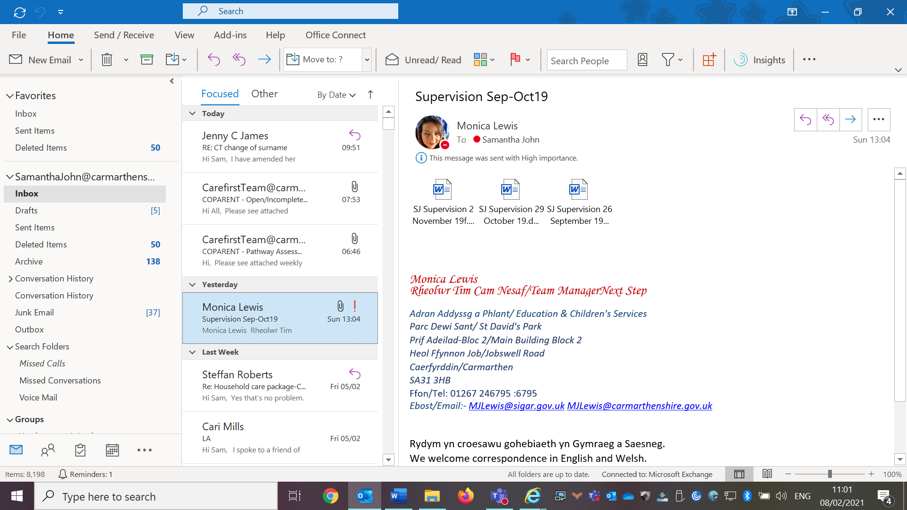

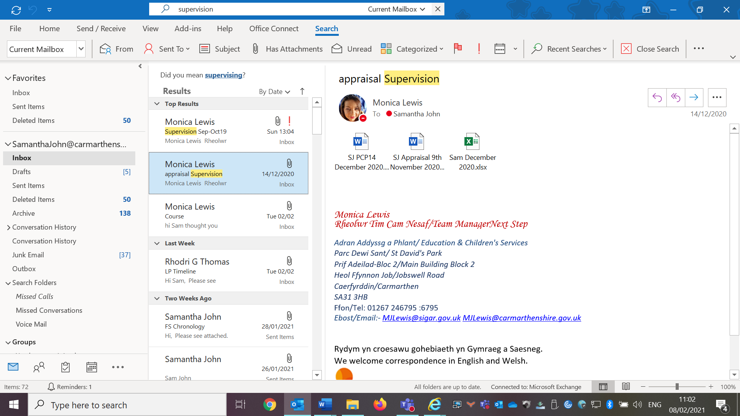

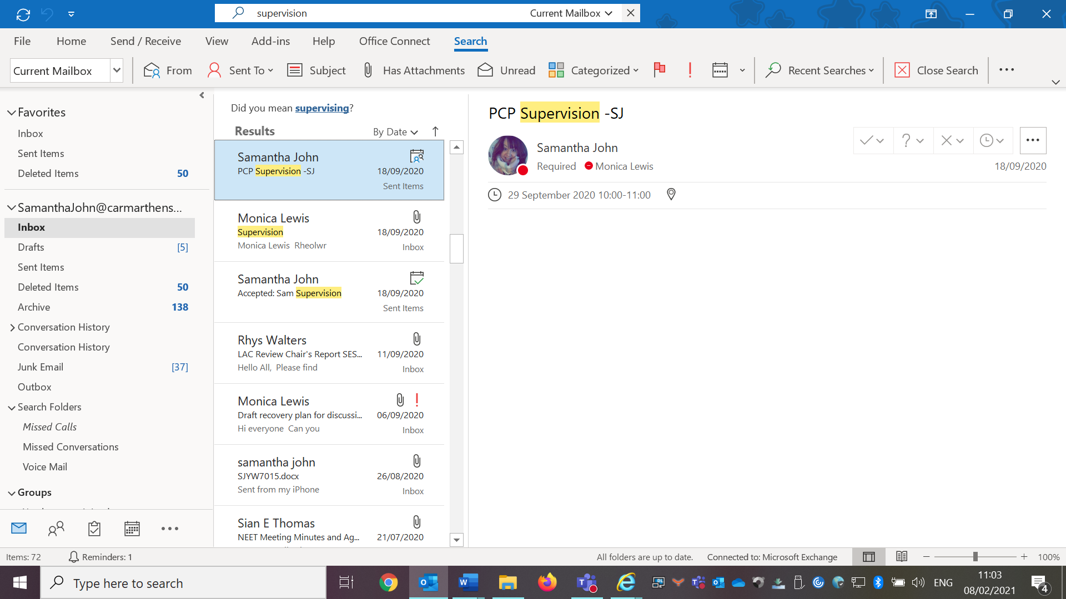

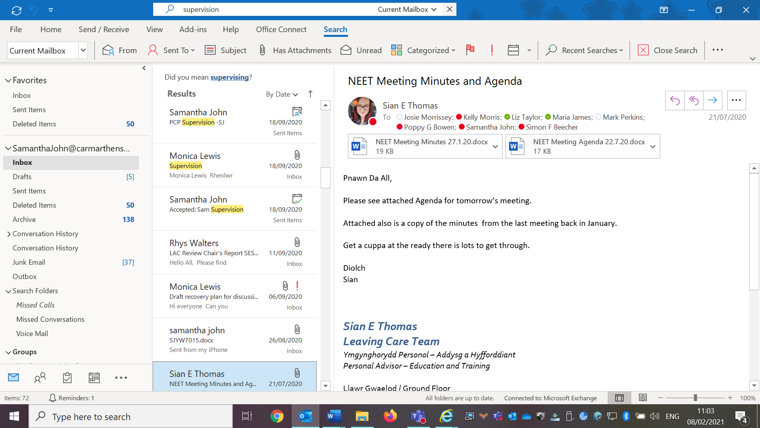

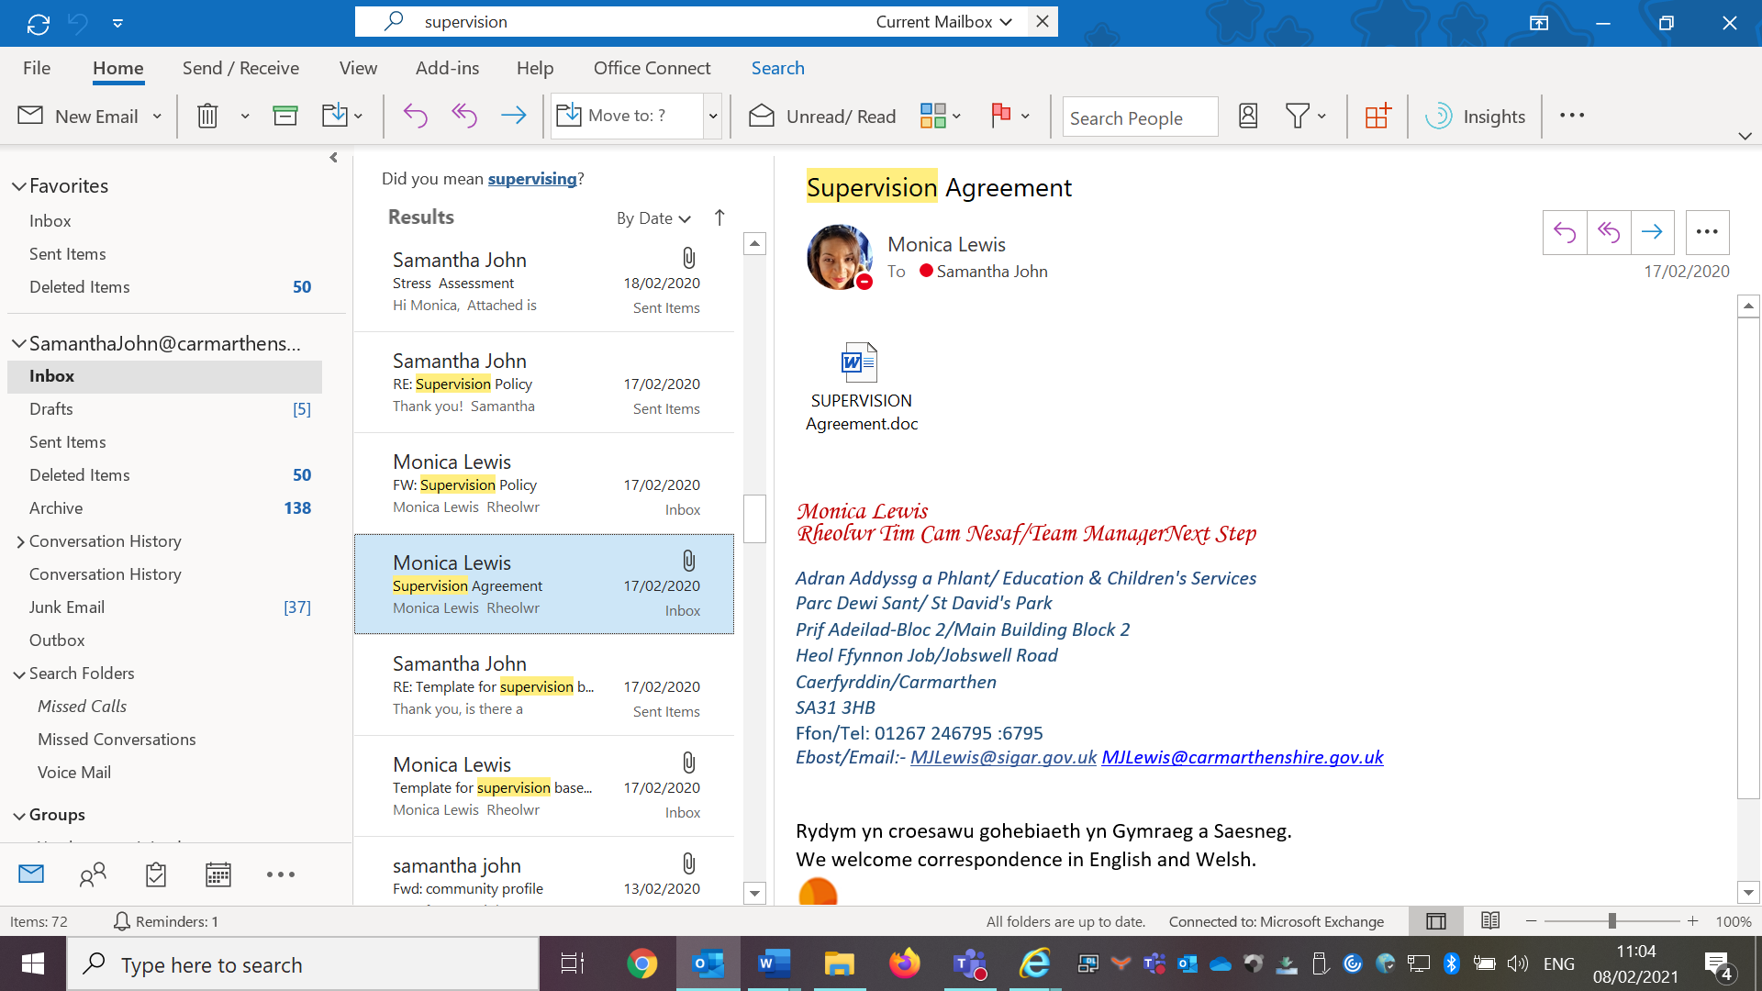

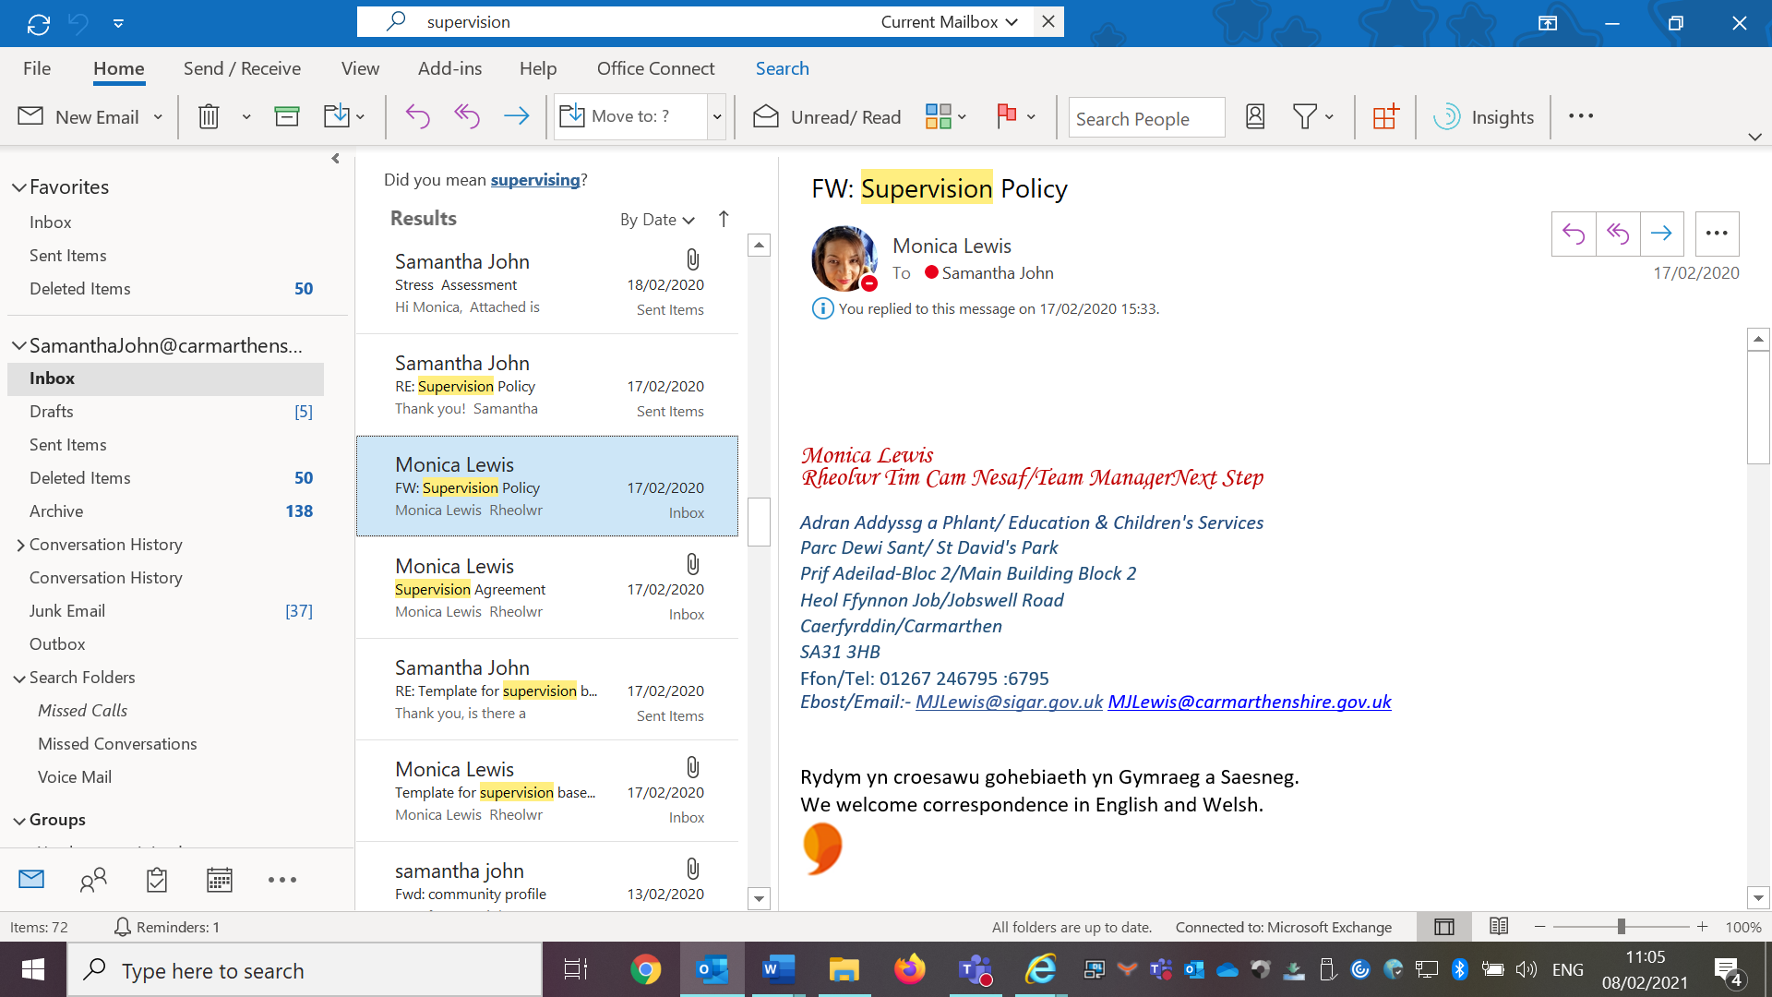

Calendar

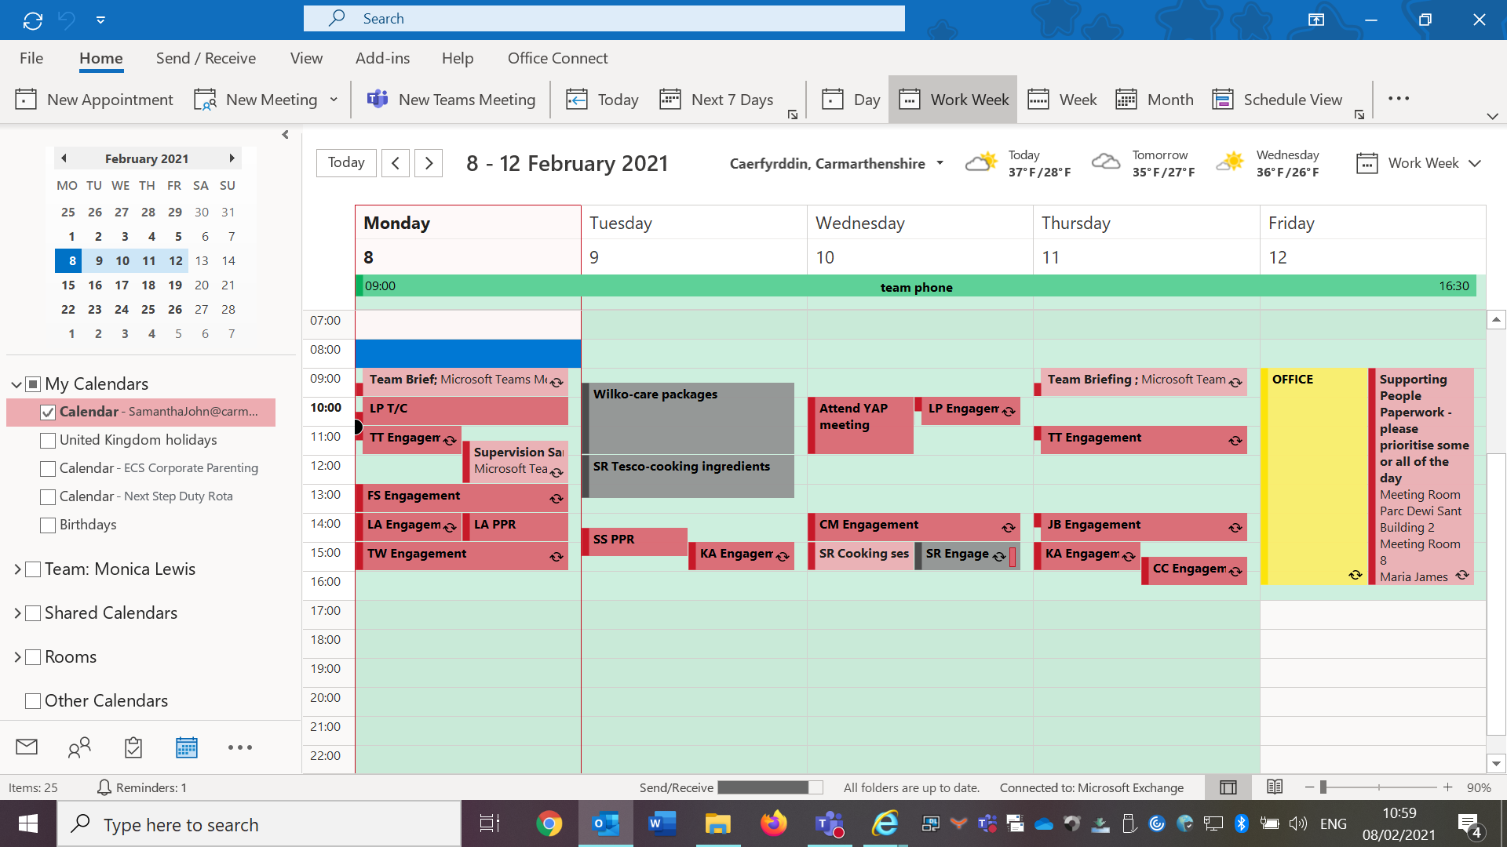



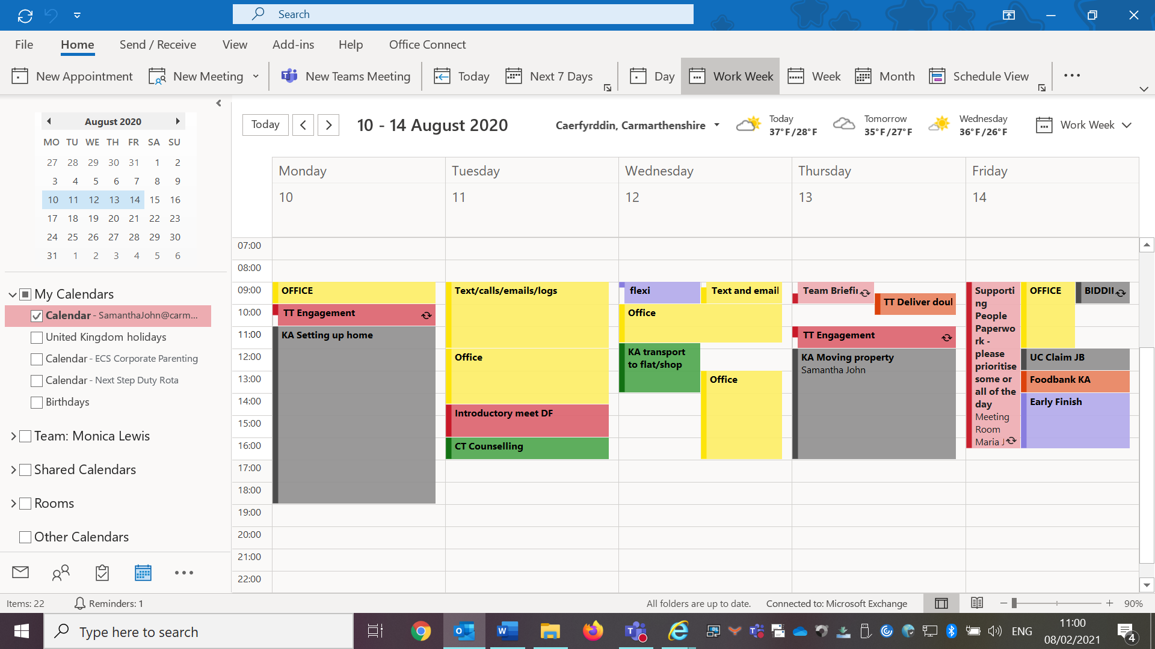

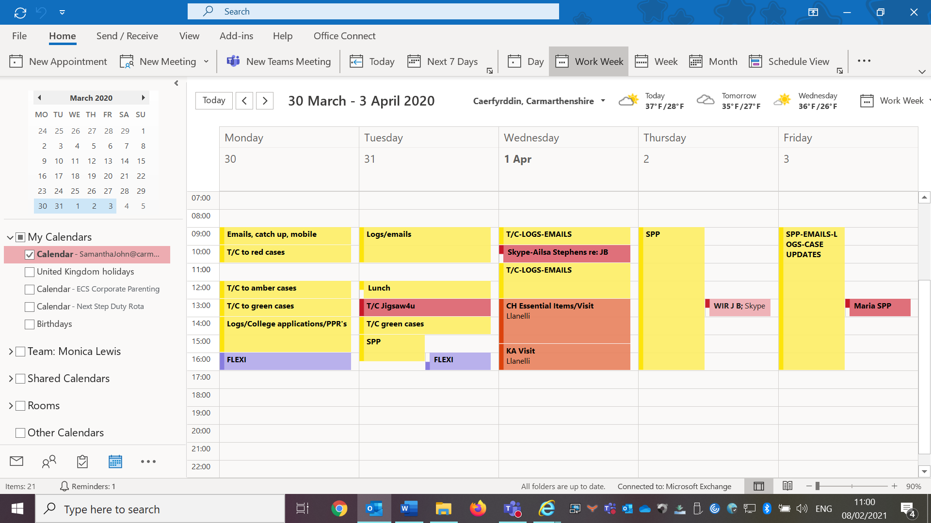

Cooking session with a young person via virtual meeting.

Lesson Plan
Lesson Title: Making Pizza baguette’s-Cooking
Lesson duration: 1 hour via Whats App video link
Content:
Discuss health and safety.
Identify each ingredient.
Make Pizza baguette and cook.
Reflection.
Goal:
Make a snack that is cost effective and easy to make.
Develop cooking skills.

Skills developed:
Health and Safety in the kitchen.
Working together.
Creativity.
Budgeting.
Communication.
Cooking.
Summary of task/action:
The young person will be making the snack with support from Personal Advisor via video call. This will develop the young person’s cooking skills to develop onto independent living. The young person will discuss the process with Personal Advisor during the session. Recognising that you can make a nice snack at a small cost instead of buying takeaway or a pizza from a shop. After the task, there will be time to reflect on the task and if we would change it next time.
Materials/equipment:
Ingredients-baguette’s, ham, pineapple, tomato puree, grated cheese, pepperoni.
Oven.
Oven tray.
Oven glove.
Mobile phone.

Outcome:
The young person will develop cooking skills and think about making cost effective choices. Understand health and safety procedures before cooking. The young person will develop confidence to cook independently.

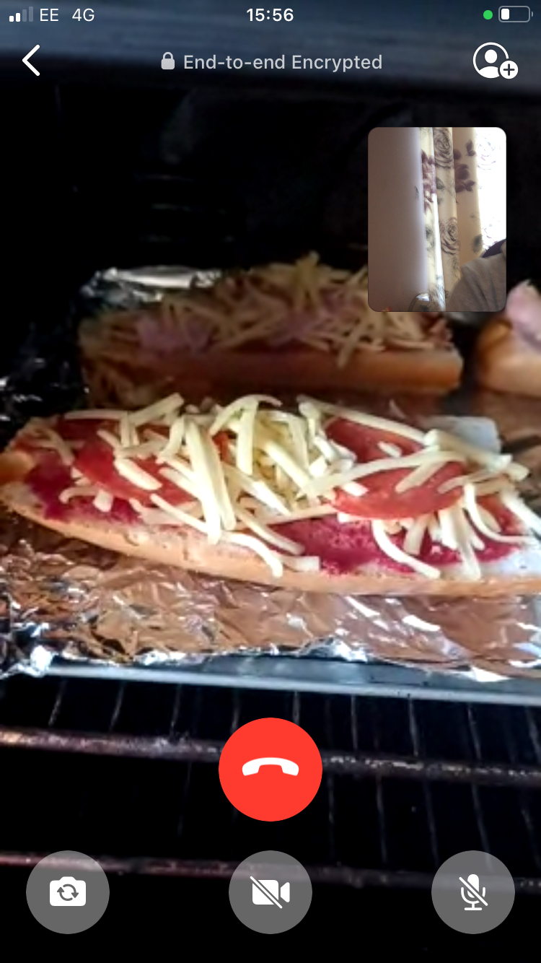

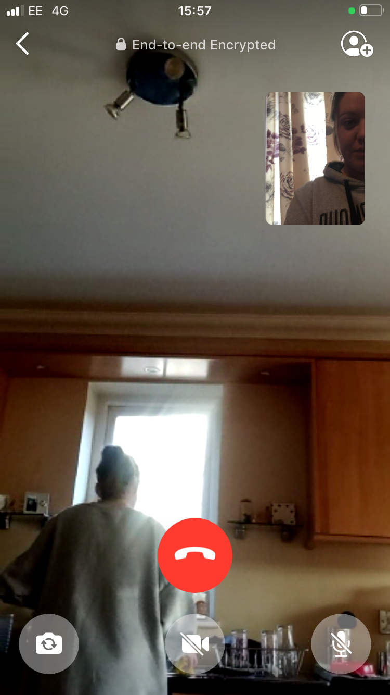
Creating a CV with a young person.

Lesson Plan
Lesson Title: Creating CV
Lesson duration: 1 Hour via Whats app video call
Content:
Create CV with young person.

Goal:
Complete CV to search for part time employment.

Skills developed:
Learning how to create a CV.
Listening skills.
Computer skills.
Using email.

Summary of task/action:
I sent a CV template to the young person via email before the session. The young person completes CV on the laptop with me on the video call supporting and advising. Discussed what is important to include in a CV. The young person shared information with me to include in the CV and we discussed if the information was appropriate to put into a CV. CV to be printed by the young person and sent to part time employment.

Materials/equipment:
Mobile phone
Printer.
Laptop.
Email.

Outcome:
The young person will create a CV to use whilst searching for part time employment. The young person will keep the CV and amend if necessary.

Sam Hood
0 Margaret Street, Ammanford, Carmarthenshire, SA10 2NN |01234 567890 | 123@outlook.com

OBJECTIVE
A hardworking and motivated individual who is eager to start a new role. I am a resilient individual who can adapt in new situations and ready to grow with the company to hit and exceed targets. I enjoy using my own initiative and possess excellent communications skills which will enable me to work well both with colleagues and customers.

Education

GCSE’s / 2028 / Ysgol Dyffryn Amman
English-B
Maths-C
Science (Double Award)-C/C
Welsh-C
Welsh BAC L2-Pass
Engineering L2-Merit
Art-C
Photography-C

Completed Creative Media Level 0 in Coleg Sir Gar. Currently completing Creative Media Level 1.

Skills Summary
- I am a flexible individual who is happy to work to a flexible shift patterns, including split shifts and night working.
- Work independently and use my own initiative
- Excellent communication skills
- Effective time management
- Enjoy troubleshooting and photoshop alongside creative thinking
- Can work effectively under pressure

Hobbies and Interests
-I enjoy photography and engage in taking pictures outdoors and editing through photoshop.
-Spending time playing video games and keeping in touch with friends during the pandemic.
-I enjoy attending the gym however due to the current situation I am now completing home workouts to keep active and fit.
-I enjoy spending time with family and friends.
-Continuously learning and developing independently through online tutorials and courses.
-I enjoy spending time cooking and developing skills via new recipes.
-I enjoy following a timetable to keep myself motivated and healthy.

Consent form

Full title of Research Study: Fieldwork 1
Name of Primary Researcher: Samantha John
Please initial box
- I confirm that I understand the above research study and have had the
opportunity to ask questions which have been answered fully.

- I understand that my participation is voluntary, and I am free to
withdraw at any time without giving any reason, without my legal
rights being affected.

- I understand that my information may be looked at by responsible
individuals from UWTSD. I give permission for these individuals to
access my information that is relevant to this research.

- The procedures regarding confidentiality have been clearly explained.

- The use of the data in research, sharing and archiving has been explained
to me.

- I agree to take part in the above study.

_______________ ________________________ _________
Name of Participant Signature Date

______________________ ________________________ _________
Name of Person taking consent Signature Date

______________________ ________________________ _________
Name of Primary Researcher Signature Date

