Student Name: Matthew Evans
P Number: 1702092
Programme of Study: BA Creative Computer Games Design
Module: M4X0559

Tutor running seminars: Scott Smith

Word count: (1202)

For this imagined space I wanted to create an exhibition that would bridge the gap between video games and the real world. To do this I wanted to choose a specific game that had a close connection to the real world, this game is Battlefield 1. It is set in World War 1, in numerous locations that the war occurred in. In the exhibition, I wanted to have two main screens displaying the game side by side with actual footage from the war. In the room, I wanted sounds of gunfire and sound effects from the game to make it seem as if you are there, inside of the game. As well as the sounds from the game being played, some of the voice acting from the game could also be played alongside some of the audio recordings taken from the war, this would make the experience even more immersive. There would also be glass cabinets displaying artefacts from the time, such as weapons, clothes, and equipment. The exhibition will be displaying the connection between the war and the game, but it will also be informing people on the history around the war and what went on.

There are many similarities and connections between the game and the actual war. This is because the game developers took a lot of time researching on the war to make it as historically correct as possible whilst also making it fun to play. One of the many things in the game that are historically correct is the Red Baron pack, this is a booster pack in Battlefield 1. “The pack is inspired by Manfred von Richthofen, a famous German pilot known as the Red Baron” (Battlefield Wiki, 2018). The red baron was a German fighter pilot in the war, his real name was Manfred von Richthofen. He was a pilot with the Imperial German Army Air Service during World War 1. The pack in Battlefield one gives the player a vehicle skin for the Fokker aeroplane, an emblem and a weapon skin for the P08. This is just one of the connections between the game and the actual war. The creators of the game designed the plane directly off the actual plane in the war as they wanted it to be historically accurate. In the exhibition, there would be an image of the Red Baron from the war side by side with the virtual one inside of Battlefield 1.

The creators of the game also went into detail when they were designing all the weapons in the game. They looked at actual guns and listened to the fire to make sure that the sounds in the game were as accurate as possible. All the weapons in Battlefield 1 are based off real guns from that time frame in the war. There is a gun in the game called the Kolibri (German for hummingbird), it is a tiny pistol that looks almost toy-like. This was an actual gun from the wartime, it was introduced in “1914 by Franz Pfannl” (Battlefield Wiki, 2018). Other weapons in the game like this one has been researched by the creators of the game. The sounds they make and the way in which they operate is all researched to make the game as accurate as possible. Members of the Battlefield community have also shown some of the in-game weapons to a World War 1 historian. “According to Casey, most of Battlefield’s guns look accurate to the real things” (Fenlon, 2018). Not only did the creators of the game research and make the weapons they also researched the equipment used such as shovels, swords and knifes. Each useable weapon and equipment was researched and carefully designed for the game. In the exhibition there would be some real weapons on display inside of display cases to show viewers the real weapons from the time of the war, behind these cases would be screened with a 360-degree view of the virtual weapon from the game.

One of the main ways in which World War 1 took place was in the trenches. In the book Amiens: Dawn of victory it says that “Trenches gave good shelter” (MCWILLIAMS, 2001). Trench warfare was one of the main tactics which both sides utilized, this made the war go on for 4 years because most of the fighting was done with artillery strikes and going over the top. Going over the top was when soldiers grouped up together and went into no man’s land to attempt to storm the enemy’s trenches and therefore gain land, most of the deaths in the war were caused by soldiers being ordered to go over the top and never come back. In Battlefield 1 there are trenches on almost every map that players can play on. The trenches are incredibly detailed with wooden supports holding up the walls, motor shells scattered around, ammo crates stacked up together and living quarters in some parts of the trenches. In the exhibition, there would be images of the conditions that the soldiers had to live with inside of the trenches compared with the trenches from the game. This will display the similarities and the differences between them. The tranches in battlefield 1 are realistic and accurate to the trenches in the war but there are some key differences, such as the amount of mud and dirt in them as well as the terrible diseases that occur in those living conditions.

In the game, there is a map that players can play on called Amiens. “The map is set during the later stages of Operation Michael during the German Spring Offensive in France, 1918” (Battlefield Wiki, 2018). This was an actual city in the war where The Battle of Amiens took place. “It was an Allied victory that helped bring an end to World War I” (HISTORY.com, 2018). The battle of Amiens started on 8 August 1918 and ended on 11 November 1918. It was known as the Hundred days offensive. In Battlefield 1 you can play the operation Kaiserschlacht, which takes you through the nearby city of St. Quentin and then into Amiens. This level of detail in the game is very impressive as this battle took place in the war and lead to the end of World War 1.

To conclude, the exhibition would need a large space with enough room to hold, monitors with gameplay and videos of the war, display cabinets which would display weapons and equipment from the war and have enough room for around 30 people to comfortably view the exhibition. The room would also need to have speakers to produce sounds from the game and war. The exhibition would be to display the similarities between the game and World War 1, by doing this it is also teaching the viewers about the historic events in the war and is also showing people the amount of research that goes into creating games and making them an experience as well as an enjoyable game. The exhibition would also serve as an experience for people who have possible served in the wars or for families who had relatives in the war, it could let them experience some of the aspects of the war.
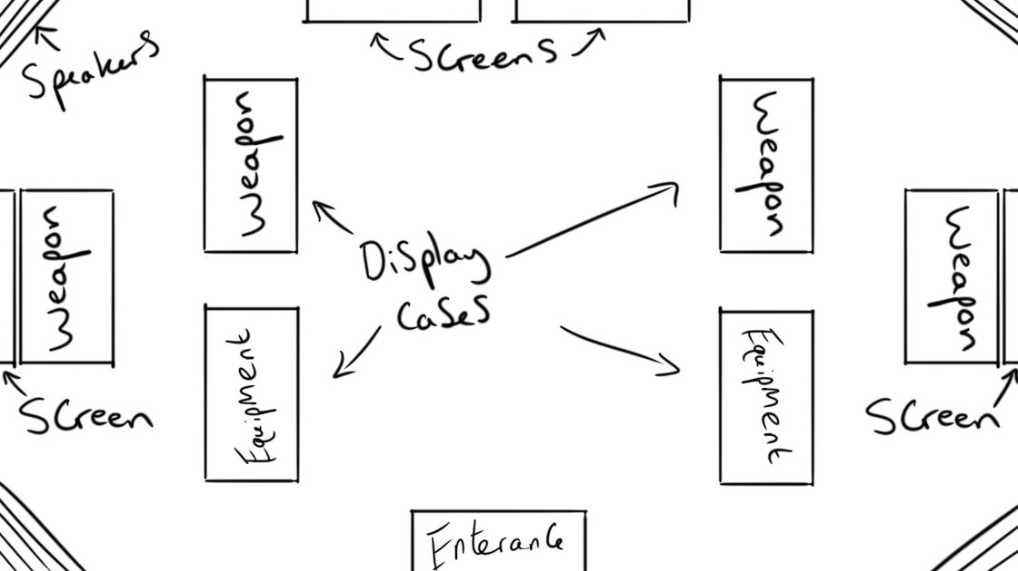

Bibliography
Battlefield Wiki. (2018). Battlefield 1: Red Baron Pack. [online] Available at: http://battlefield.wikia.com/wiki/Battlefield_1:_Red_Baron_Pack [Accessed 26 Mar. 2018].
Battlefield Wiki. (2018). Kolibri. [online] Available at: http://battlefield.wikia.com/wiki/Kolibri [Accessed 26 Mar. 2018].
Rolling Stone. (2018). 'Battlefield 1': How Realistic Are Games' WWI-Era Weapons? [online] Available at: https://www.rollingstone.com/glixel/news/battlefield-1-how-realistic-are-games-wwi-era-weapons-w448290 [Accessed 26 Mar. 2018].
Fenlon, W. (2018). We showed Battlefield 1 to a World War I historian. [online] PCgamer. Available at: https://www.pcgamer.com/we-showed-battlefield-1-to-a-world-war-i-historian/ [Accessed 27 Mar. 2018].
MCWILLIAMS, J. (2001). AMIENS: Dawn of victory. Dundurn, p.177.
Battlefield Wiki. (2018). Amiens. [online] Available at: http://battlefield.wikia.com/wiki/Amiens [Accessed 27 Mar. 2018].
The art of battlefield 1. (2016). Dark Horse.

