THE
wonder of you

Following our recent performance in Saturday’s 1-1 draw at home in the league a game that we should have won on paper beforehand however as we know the game isn’t played on paper, the feeling was one of misery and annoyance that we couldn’t do more to win the game with lots of missed chances, very laboured in our approach and a below scratch performance. However, upon reflection with the other coaches and myself the result wasn’t that bad yes, we didn’t play well but we didn’t lose the game and created many chances to achieve the result we wanted. So, we brush ourselves down take the positive into next weeks game and work on what went wrong in training.

Reflection helps me to learn about myself and of the team that way we can plan and prepare better for the future not only for games but also within my personal life it plays a major role back in 2019 I was involved in a serious RTA sustaining life changing injuries and a lot in my life has changed sometimes I feel always for the worse but on reflection my life has just taken a different path whereas I have to now focus on the changes in my life.

“The popular saying ‘when life give you lemons, make lemonade’ is about making the very best out of a bad situation.
The ‘lemons’ is a sour, unfortunate or bad event that you might find yourself facing and the ‘lemonade’ is the opportunity or positive outcome.
It’s about looking for the positives and focusing on what you can do to make the situation better for yourself and others.”

In life we must create our own luck and not allow fate to create our future, you must be optimistic with self-belief and with continuous reflection you can achieve what you want to achieve. Never stop believing in yourself and the doubters will soon disappear, and your journey will continue on your own path yes there’ll be bumps but a straight flat road isn’t as exciting.

“I use reflection as a tool to change aspects of my life so that I get to feel calm. Reflection, when used as a tool helps me understand my life in its entirety. It’s important to reflect, to see how we can make improvements I use reflection as a tool to change aspects of my life so that I get to feel calm. Reflection, when used as a tool helps me understand my life in its entirety.” (Ilana Estelle December 2011)

Reflection is where we allow ourselves to take time to think about, evaluate and think about the behaviours. attitude, what motivate you and the desires you must achieve and better yourself. A process of deep thoughts and emotions to determine the why behind them.

“The world is your mirror, and your mind is a magnet. What you perceive in this world is largely a reflection of your own attitudes and beliefs. Life will give you what you attract with your thoughts think, act, and talk negatively and your world will be negative. Think and act and talk with enthusiasm and you will attract positive results.” ~ Michael LeBoeuf

I use reflection on a regular basis in all aspects of life and find it a very useful tool to have in my toolbox. If you are reading this and don’t reflect, just try it who knows it could be the new you and create a new journey through life.

REFRENCES

Why we should reflect - The CP Diary
When Life Gives You Lemons Quotes & Sayings - The Goal Chaser
65 Best Reflection Quotes On Success In Life – OverallMotivation

What is good time management?

Time management is the process of planning and exercising conscious control of time spent on specific activities, especially to increase effectiveness, efficiency, and productivity. It involves of various demands upon a person relating to work, social life, family, hobbies, personal interests, and commitments with the finite nature of time. Using time effectively gives the person "choice" on spending or managing activities at their own time and expediency.^{[1]} Time management may be aided by a range of skills, tools, and techniques used to manage time when accomplishing specific tasks, projects, and goals complying with a due date. Initially, time management referred to just business or work activities, but eventually, the term broadened to include personal activities as well. A time management system is a designed combination of processes, tools, techniques, and methods. Time management is usually a necessity in any project management as it determines the project completion time and scope.
The major themes arising from the literature on time management include creating an environment conducive to effectiveness (in terms of cost-benefit, quality of results, and time to complete tasks or project), setting of priorities, the related process of reduction of time spent on non-priorities, and implementation of goals.

Good time management is a major key to success to achieving goals, through good time management you allow yourself to prepare and plan for given tasks as opposed to rushing and leaving till last minute therefore the level of work will predominantly be at a higher lever which has the chance of bettering yourself and achieving your goal. Planning successfully is a skill that’s used by many to ensure their life is in good order whether that be at family time, work, sports or any social activity, For example if you were to have poor time management at college/university it could hinder you to hit your work tasks targets, dates and grades, if at work you were continuously late it could lead to a deduction of pay, deduction of wages or worse case for continued poor time management disciplinary/loss of job and within a sports team it could lead to you not being picked in a team on matchday and left out as it doesn’t show dedication, with all the negatives tat poor time management can bring it could lead to stress and anxiety or other illnesses and bad feeling within yourself.

“Whatever time management strategies you use, take time to evaluate how they have worked for you. Do you have a healthy balance between work and home life? Are you accomplishing the tasks that are most important in your life? Are you investing enough time in your own personal wellbeing? If the answer is “no” to any of these questions, then revaluate your time management strategies and transition to ones that will work better for you. Successful time management leads to greater personal happiness, more accomplishments at home and at work, and a more satisfying future.”

The author believes people who have good time management skills will answer YES to the above as they have set themselves strategies to succeed, some of the strategies/plans will include some things like:
- Know how to spend your time – time logs evaluate results every 30mins (time keeping)
- Set priorities – do the most important task first prioritise what needs to be done
- Get organized – poor organisation will lead to going off track more easily and worktime less effective.
- Schedule appropriately – do not double book when you plan to do work, have friends around, go out somewhere as its difficult to jump back in where you left off
- Don’t procrastinate – don’t put it off because you think you can’t do it the longer you put it off the more difficult it becomes.

“The benefits of managing time are simple. Good time management allows you to accomplish bigger results in a shorter period of time which leads to more time freedom, helps you focus better, allows you to be more productive, lowers your stress and gives you more time to spend with the people that matter most. The benefits of managing time are simple. Good time management allows you to accomplish bigger results in a shorter period of time which leads to more time freedom, helps you focus better, allows you to be more productive, lowers your stress and gives you more time to spend with the people that matter most.”
Good time management enables you to achieve greater levels of performance and productivity. When you work smarter, not harder, you achieve better results in less time with less effort. Working smarter enables you to get more done and achieve your goals faster.

To conclude the author believes from the evidence we read and practice on time management everyone should look to possess this skill in their own lives as much as possible, by accomplishing this the chances are that they will be more successful, productive, and live a less stressful life, which will also allow to spend more time creating memories and enjoying the finer things in life.

“Time is a created thing. To say, ‘I don’t have time’ is to say, ‘I don’t want to” Lao Tzu ancient Chinese philosopher and writer.

References

10 Benefits of Time Management - Lucemi Consulting
Time Management: 10 Strategies for Better Time Management | UGA Cooperative Extension
Time management - Wikipedia
26 Time Management Quotes About Time by Greatest Minds (everhour.com)

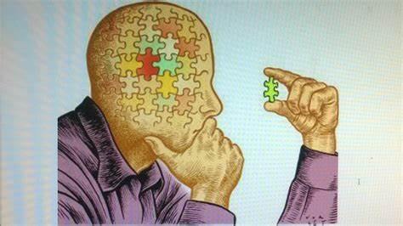


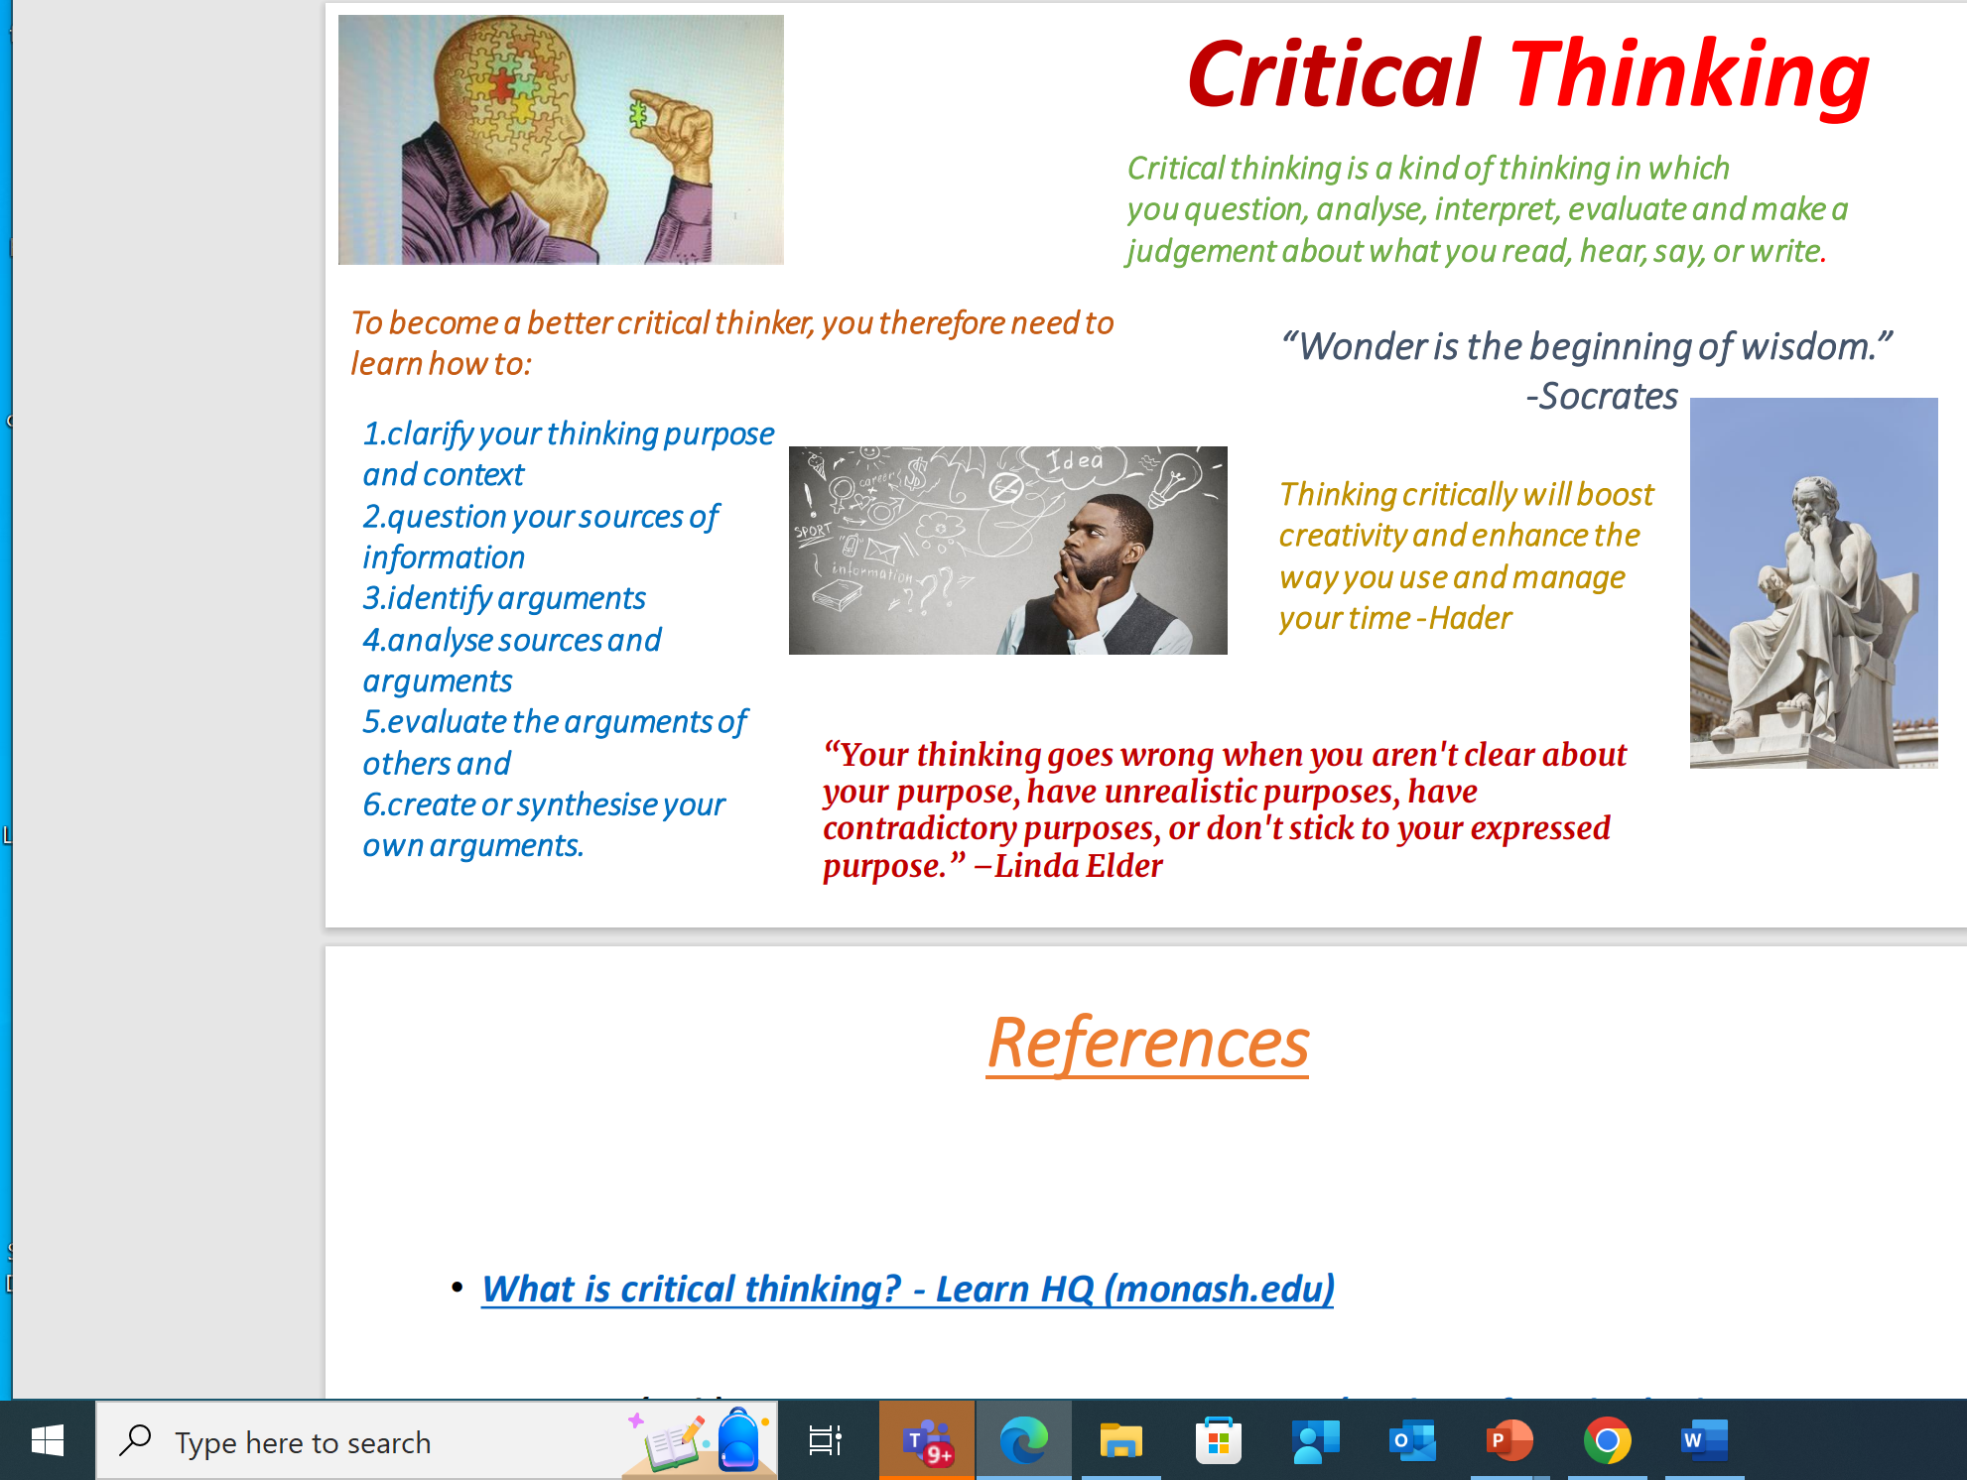
Critical Thinking
Critical thinking is a kind of thinking in which you question, analyse, interpret, evaluate and make a judgement about what you read, hear, say, or write.
- clarify your thinking purpose and context
- question your sources of information
- identify arguments
- analyse sources and arguments
- evaluate the arguments of others and
- create or synthesise your own arguments.
To become a better critical thinker, you therefore need to learn how to:
“Wonder is the beginning of wisdom.”
-Socrates
“Your thinking goes wrong when you aren't clear about your purpose, have unrealistic purposes, have contradictory purposes, or don't stick to your expressed purpose.” –Linda Elder
Thinking critically will boost creativity and enhance the way you use and manage your time -Hader

