REFLECTIVE report
Academic and employability skills
Name: Jennifer Amaning 1817753
Lecturer: Christopher Mafuva
Module code: BMSW4001
University name: University of Wales Trinity Saint David
Date: 3rd January 2019
Content

Introduction 2
What is reflective writing? 3
What is a reflection report? 3
My reflection 3
Conclusion 5
References 5

Introduction

The purpose of this report is to describe what exactly reflective writing is and how I can relay it to my own personal experiences. I will be using Gibbs model of reflection to identify the method of reflection that applies to me. The Gibbs reflection model is a methodical system that allows you to take specific steps in order to achieve an end goal. The Gibbs reflective model is a formal reflection which allows an individual to examine and put forth a theory which is effective to one’s self and put into preparation the development of reflection. Gibbs reflection model was established by Graham Gibbs in 1988 to help build a learning experience. This theory was created to explore an individual’s experience and help revisit experiences which allow one to learn and structure things in one’s life that were good or bad and how it can be changed if it happened again. Gibbs reflection model covers 6 different stages such as:
- Description of the experience
- Feelings about the experience
- Evaluation of the experience, good and bad
- Analysis of what the situation is
- Conclusion on key learnings and what could be done differently next time
- Action plan on how to deal with the situation differently if it occurs again in the future.

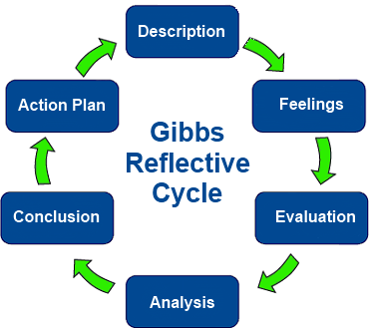
Gibbs (1988)

What is reflective writing?

Reflective writing is an authorisation of reflective thinking, which allows an individual to look back at an experience an event an idea or an object that holds significance to one’s life. Reflective writing allows an individual to reflect on the complexity of a past events and look at it from different outlook to try to adopt an explanation through their own understanding. Furthermore, reflective writing helps an individual reflect on what changes need to be made if a similar situation occurs again and learn from the faults made and understand how and why those transpired.

What is a reflection report?

Reflective writing is a quantity of writing that summarises a persons critical thinking on a subject. A reflective report allows students to identify and highlight their own experiences and thoughts in a theoretical setting. It allows a student to express themselves in depth and allows them to reflect on what can be improved in the future. Further, a reflective report is when the writer reflects on his or her experiences in life. The writer writes about those experiences exploring how he or she has changed, developed, or grown from those experiences. The format of a reflective report can change depending on the audience. For example, writing a report on for university course can effect changes in how the essay is organised. A reflective report has three main structures which consists of the introduction, the body and the conclusion. The introduction should speak directly about what the overall topic will be about. The body of the report should address experiences and how those have helped in the in the past and present. Finally, the conclusion should focus on what can be done differently to better yourself and the steps willing to take to make these changes happen.

My reflection

My name is Jennifer Amaning. I applied for Health and Social Care at the University of Wale Trinity Saint David in June 2019. I was excited to start this new journey because I have an interest in health and social care and this was the best time in my life to start this course. My first term was very interesting for me as this was the first time returning to education and the first-time attending university therefore, I was little anxious. The first term consisted of learning how to use the Moodle application, meeting our lectures and familiarizing ourselves on the different modules we were going to take, covering Effective communication, Digital skills and research methods, Professional career development and Academics, and employability skills.
The first two weeks of the first term seemed quite simple and easy because we were getting familiar with the course and what we would be expected to learn, using the Moodle application to access our work and also being able to download the work, and uploading our assignments on the Moodle application. I learnt how important it was to understand the different levels of communications and how different people deliver and receive information. Moreover, I learnt about myself and my learning style and in learning this I realised that I was a combination learner. My line of work allows me to be mobile a lot of the time and with little time to sit down. Therefore, having to be seated for eight hours in the day was very challenging for me but this was something I had to learn to do to complete this course.
By week three and four most if not all the lectures started speaking about the assignments and presentations that we would be doing which worried me because I did not have enough information to confidently start these assignments, which consisted of 2,000 words. I quickly realised that university was not like college and was far more complex than I expected. I was not ready to start the assignment and I was beginning to get a little nervous. The lectures explained as much as they could and as clear as they possibly could but I realised that I had to really learn and understand Moodle because that is where all the work that we do in class was and it gave us access to all the modules that we were studying.
In week five and six I was a little comfortable and confident because I started to understand the individual modules a bit clearer. I started to enjoy attending certain lectures and I also had a better understanding on how to do a presentation using PowerPoint, which was exciting for me because this was the first time, I would be giving a presentation. I also learnt how to summarise, paraphrase and referencing, which was something new to me and I did not realise how it would play a very important part in completing my assignments. We were coming toward the end of the first term and I had learnt enough to start on my assignments with a better understanding on what was expected. The only thing that I still had a bit of a struggle with was referencing because I don’t think I had a clear understanding on how to do it but because I had the basic knowledge on how to do it so I was ready to do my best. I realised that all the modules connected one way or another in helping me complete my assignments. When holding our presentations, commutation was very important because we had to work with individuals from different background and English was not their first language so when communicating I had to be mindful of my delivery and how it would be received by my group members as our presentation was fast approaching.
The final week of the first term was the day we had our class presentation, which I felt went well. Although I was nervous, we did our best. I can say term one was very challenging for me because I returned to studying after many years and had to work around going to university and working at the same time. It was challenging as I had to fit in doing my assignments after work and sometimes, I was too tired so I would abandon my work. I don’t know how I managed to complete my assignment and submit it in such little time, but I knew that I had to be more organised next term.
The first week of term two was on a different campus and we also had new lectures and we had new classmates. I was a bit disappointed because I had to start the process of getting to know the new lectures all over again and in a new environment. The first two weeks we reviewed employability skills and how important it is to have the skills that can enable you to get your desired job in the future. We also covered how to write a CV and the information that is required in writing a CV. Although I already had a CV, I was able to update it as I had learnt how to format it and make it easy and concise, as there had been a lot of information that was not required to be in my CV. During the preceding weeks, I learnt about reflective writing and how important it is to reflect on yourself and how to make improvements on yourself in the future. I particularly enjoyed the one about self-reflection because I realised a lot about myself and how I can improve and organise myself to effectively complete assignments on time.
During weeks four and five, we covered analytical and critical thinking and how these can help with organisation by putting things in place and how this helps to reflect on what changes might have to be made to better a situation.
By week seven and eight, we deep dived into how to do presentations and the skills required to give a good presentation, as well as how to keep the ordnance interested in what the speaker is saying by using different gestures such as body language and eye contact. We also had an individual mini presentation on different reflection module. My topic was on reflective writing which I was excited about because this was what our assignment was based on. I had to present to the class, which made me nervous because although this was not the first time doing a presentation, it was the first time doing it on my own. I thought I did well but based on the feedback report,( please refer to appendices) I have areas of improvement, which I will work on to improve in the future.

Conclusion

I have learnt that there has been a big improvement for me in how I felt when I started this new journey of going to study at a university. I did not expect to be doing as well as I have. Although I found it stressful at times, I have seen a big improvement from term one to term two. I have acquired academic and personal skills, that have allowed me to write assignments with paraphrasing and referencing, which I was not able to do when I first started this course. This way of writing has allowed me to get a better understanding of writing assignments. Moreover, the course has helped me personally, as I am now able to reflect on how I learn best and how I deal with balancing my workload with studying. If I compare my level of organisation and my time management from the first to the second term it was less stressful because I have been able to allow more time to do my assignments and I have a clearer understanding of the topics. I am able to put into practice the knowledge that I acquired which has helped me to understand and finish my assignments in a timely manner. Through using Gibbs module of reflection, I have been able to reflect on my approach and have been able to make improvements to make sure that I am effective in my approach for the second term.

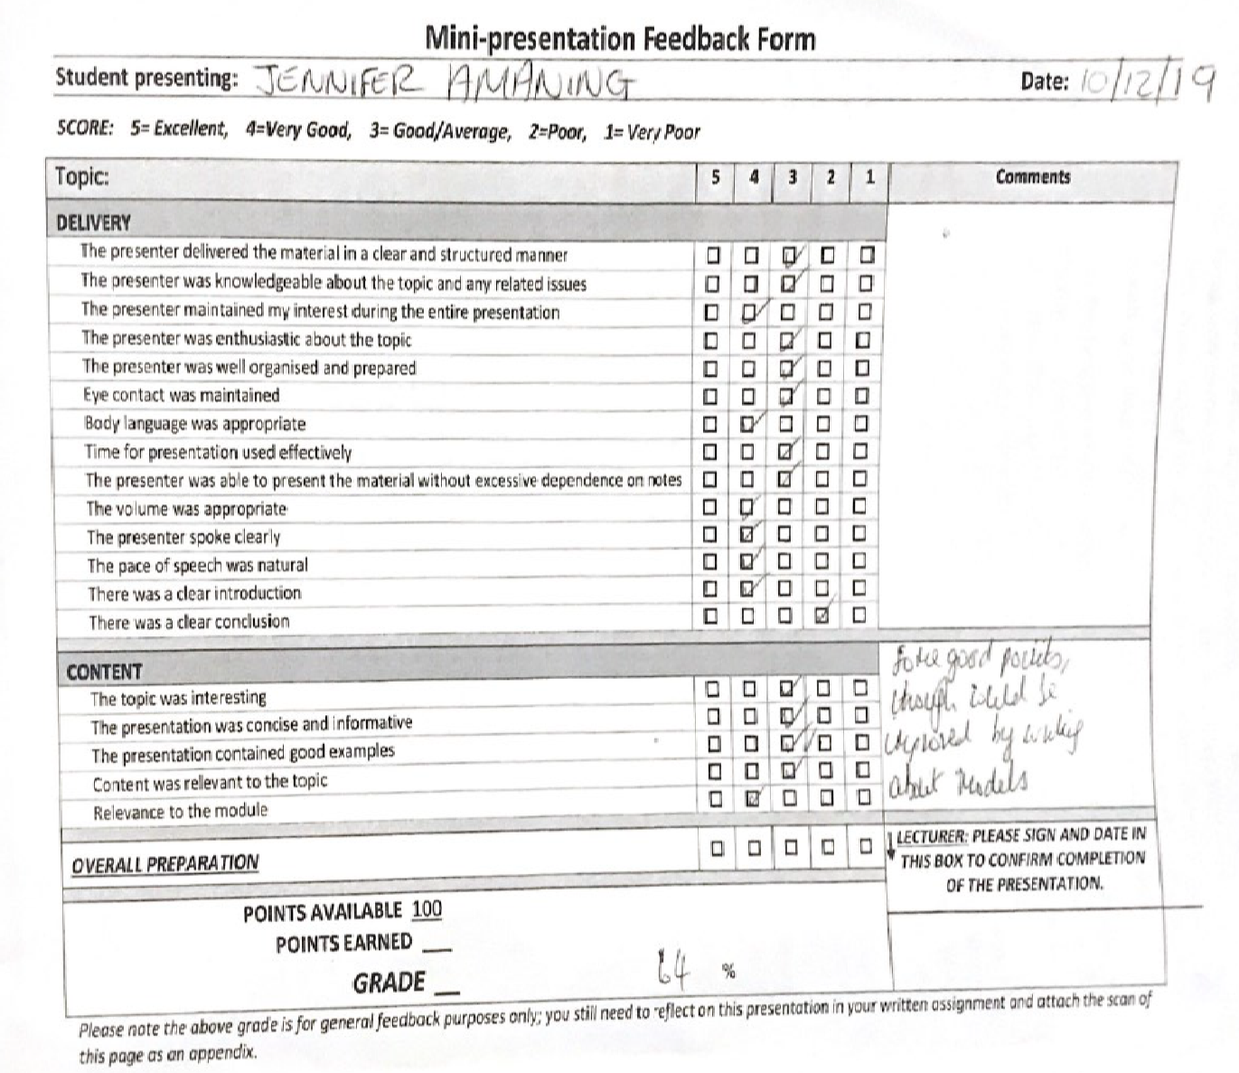
Appendices

References

Reflecting on ‘Reflective practice’ PBPL paper 52 Linda Finlay A discussion paper prepared for PBPL CETL (www.open.ac.uk/pbpl. January 2008
The author Journal compilation 2008 Health Libraries Group.Health Information and Libraries Journal, 25 , pp.229–232
This article was published on The University of Edinburgh 2019. 20 Mar, 2019
The writePass Journal 2019
Gibbs, G. (1988) Learning by Doing: A guide to teaching and learning methods. Oxford: Further Education Unit.
Bolton, G (2010) Reflective Practice, Writing and Professional Development (3rd edition), California, SAGE publications.
Hunt, C. (2001) Shifting shadows: metaphors and maps for facilitating reflective practice, Reflective Practice, 2(3), p.275-287
Johns, C. (2006) Engaging reflection in practice: A narrative approach. Oxford, UK: Blackwell Publishing.

