7/24/2025
University of Wales Trinity Saint David
London campus
E-Portfolio Link: https://2542109.wixsite.com/nexgen-portfolio
Module Name: Learning In the Digital Era
Module Code: ACCA 4026

Student Name: Adao Filipe Das Neves Oliveira
Student ID: 2542109
Group: 1

Lecturer’s Name: Koushik Modak

LDE Assignment 1
E-Portfolio
Table of Contents
Introduction 2
Main Body 3
Task 1: Cybersecurity Essential Academic and Employment Skills 3
Task 1 (a): Report on Essential Academic and Employment Skills 3
Task 1 (b): Evaluation of Task 1 (a) based on Similarity report 5
Task 2: Collaborative Mind Map and Individual Poster 6
Mind Map (Collaborative) 6
Poster (Individual) 7
Task 3: Virtual Collaboration and RefWorks 8
Report on Virtual Collaboration 8
Step-by-step process of using RefWorks with visuals 9
Task 4: E-Portfolio Creation and Evaluation 11
Task 4 (a): E-Portfolio Creation 11
Task 4 (b): Illustrative Review of E-Portfolio tool Selection 12
Conclusion 17
References 18

Introduction

Cyber security is an important profession that protects people, property and organisational resources. The job demands technical skills, professionalism and good working skills. Academic as well as employment skills aid cyber security professionals in the effective execution of their duties. These skills also facilitate career advancement, efficiency in the workplace and lifelong learning in the cyber security sector.

Main Body

Task 1: Cybersecurity Essential Academic and Employment Skills

Task 1 (a): Report on Essential Academic and Employment Skills

Employment skills, including academic skills, are crucial in building a successful career in cyber security. Cyber security personnel defend computer infrastructure, networks, information, and online resources against cyber threats and unauthorized access [1]. Effective communication abilities matter as cyber security specialists have frequent personal communication with employees, management, customers, and technical staff. Open communication assists with clarifying security risks, reporting on incidents, and offering security guidance.
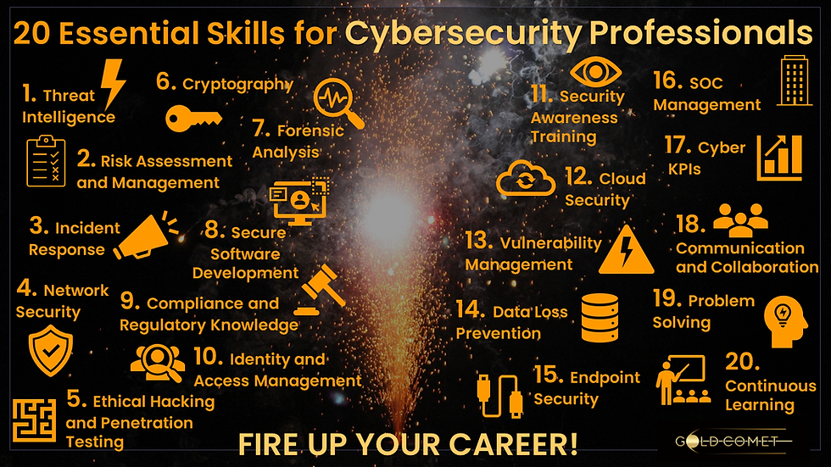
Teamwork is also fundamental as cyber security specialists collaborate with IT departments and other parties in ensuring the organisation does not experience any form of security breach. Problem-solving skills will be beneficial to uncover security vulnerabilities and come up with the necessary solutions to reduce cyber risks [2]. Time management helps professionals monitor systems, respond to security incidents, and accomplish security tasks in the necessary time frames. Digital skills are essential since cybersecurity is based on monitoring tools on the network, security software, cloud technologies, and threat detection tools. Critical thinking assists in analysing security threats and enabling the professionals to make sound decisions in cases of cyber-incidents. These strengths reinforce academic and professional performance.
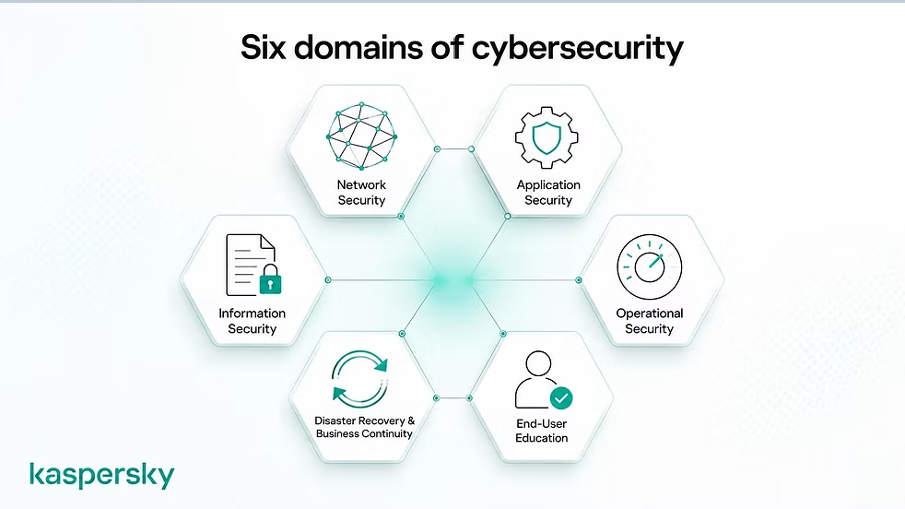
These skills will equip me for a professional career in cybersecurity. Proper communication will assist in explaining the technical problems being raised as well as reacting effectively to cybersecurity attacks. Teamwork will enhance teamwork with IT professionals and lead to a safe organisational environment [3]. It will also be possible to focus on time management, fulfil the set responsibilities, and maintain professional standards. Digital competence will also assist me in utilizing contemporary cybersecurity tools and writing correct reports on security. Critical thinking and problem-solving will enhance my skills in detecting cyber threats and effectively responding to security threats. Thus, educational and job skills will facilitate my career growth, enhance my performance at work, and allow me to become successful in the field of cybersecurity in the long term. AI tool such as Chat GPT is used in terms of revising the grammar mistakes [4].

Task 1 (b): Evaluation of Task 1 (a) based on Similarity report

Task 1(a) Turnitin similarity report indicates a score of 40% similarity. The majority of similarities are associated with entries in the referral list, technical terms, and commonly used academic phrases. Throughout the report, proper IEEE citations were provided. The work proves that I comprehend the topic and follow academic integrity and proper referencing practices. I would award myself 75%. The work demonstrates a strong understanding of the topic, clear academic engagement, and appropriate use of IEEE referencing. Although the Turnitin similarity score is 40%, most matches relate to the reference list, technical terminology, and common academic phrases rather than copied ideas. Therefore, the work shows academic integrity and good overall quality.

Task 2: Collaborative Mind Map and Individual Poster

Mind Map (Collaborative)
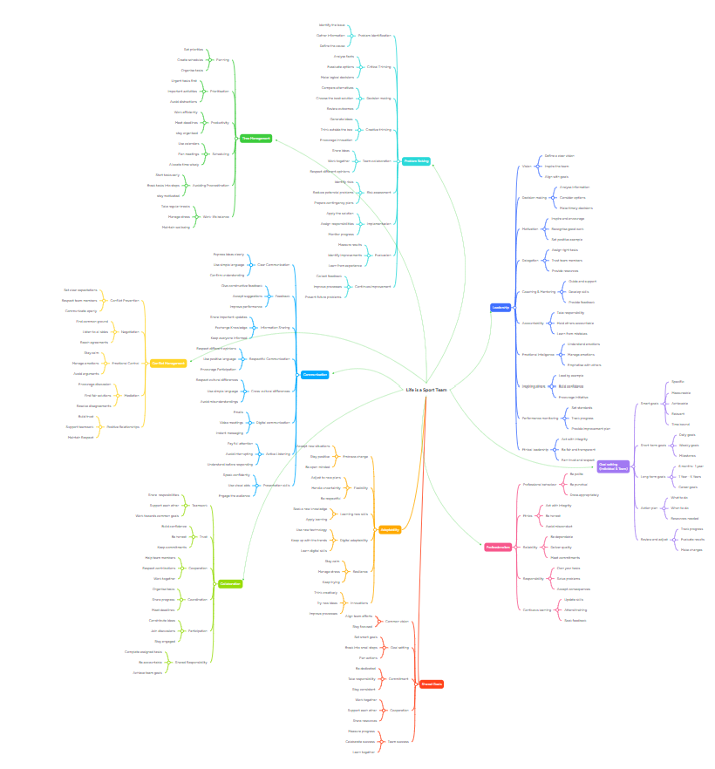

Figure 1: Group mind map
Group members:
Adão Oliveira
Abdul Basit Sedique
Jonathan Ngugi
Daniela Estrada
Mind map link: https://mm.tt/map/4037194957?t=NnIikFIrEa

Poster (Individual)
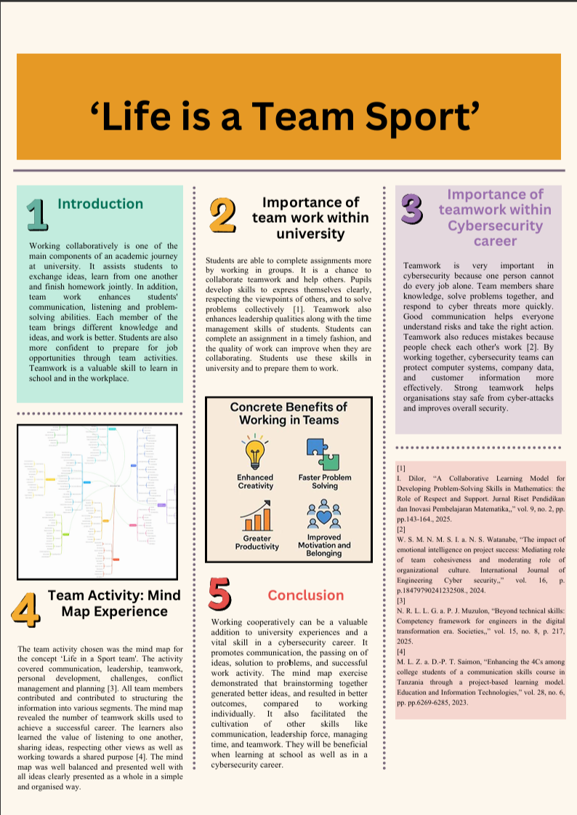
Figure 2: Academic Poster

Task 3: Virtual Collaboration and RefWorks

Report on Virtual Collaboration

Forming a team
The first stage of virtual collaboration is creating a team. Team: A group of individuals who contribute such as to achieve a goal. A virtual team is a team that communicates through the internet and works from different locations. The team members can reside in different cities or countries. The most significant thing is to select the appropriate population for a team. Work should be shared so that all have the skills and knowledge necessary for the task [5]. Teams should also have varying abilities as everyone has a way of contributing. The second important point is to make the team goal clear. All team members should have an understanding of the team goal. In this matter if a team has an understanding of the goal, it is easier to get along and complete your tasks on time. This ensures there won't be confusion or a lot of redundant work. Clear roles aid in organising teamwork. Good communication is also very important. Regular video or phoning, emailing or posting on a chat app or online work platform with team members. They ought to exchange ideas, pose queries, and provides updates on their work. All team members to be respectful to one another, listening and back each other up in the group. They should be sincere, finish the task in time, and cooperate in solving the problems. Trust enhances the team and teamwork. Lastly, the group should establish easy guidelines [6]. For instance, members should arrive to meetings at the right time, promptly respond to messages, and accept alternative views. The team works smoothly because of the following simple rules. One of the elements of virtual working is the establishment of a team. A successful virtual team should have the right team members, clear objectives, defined roles, communication and trust and easy team rules. With these in place, the team can function efficiently and collaborate effectively toward goals that they are able to meet.

Step-by-step process of using RefWorks with visuals

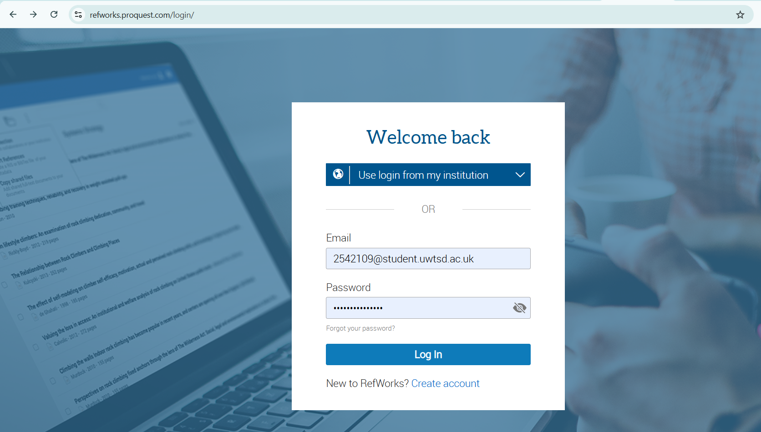
I entered my university email and password into my RefWorks account. I then logged in and went to the homepage and my personal reference library in RefWorks.
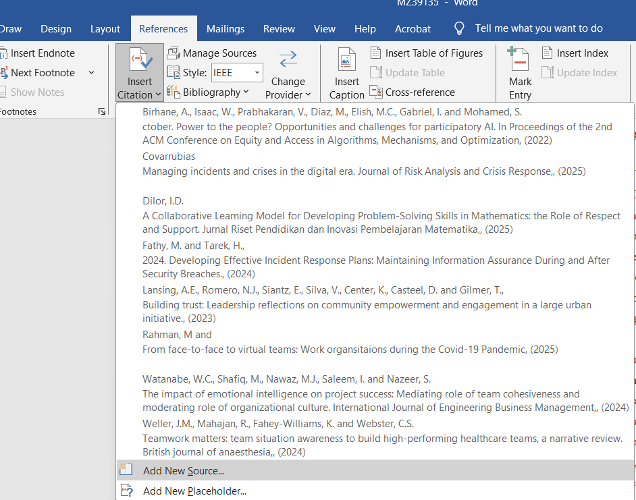
I went to the window of All References to see the imported sources. I took one of the journal articles and analysed its bibliographic characteristics, such as the author, title, information about the publication, and DOI.

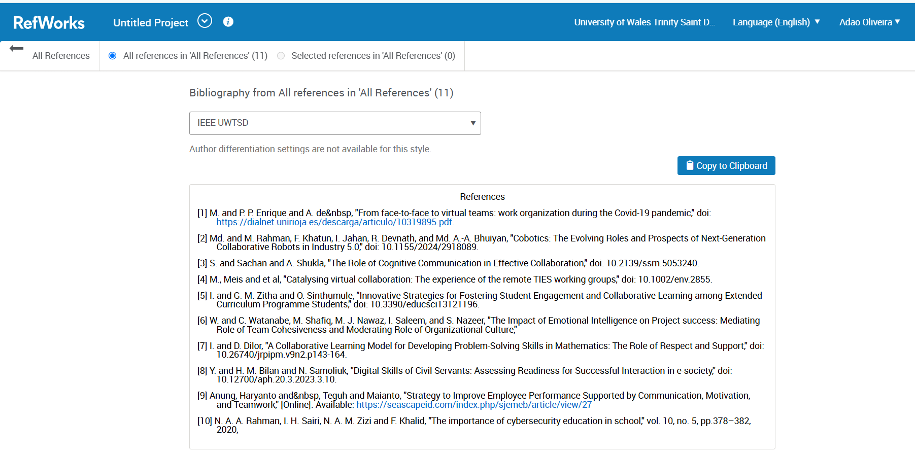
I used the Create Bibliography option of the toolbar. After that, I chose the IEEE UWTSD style of referencing. The entire reference list was automatically created through the creation of a properly formatted reference list by RefWorks.

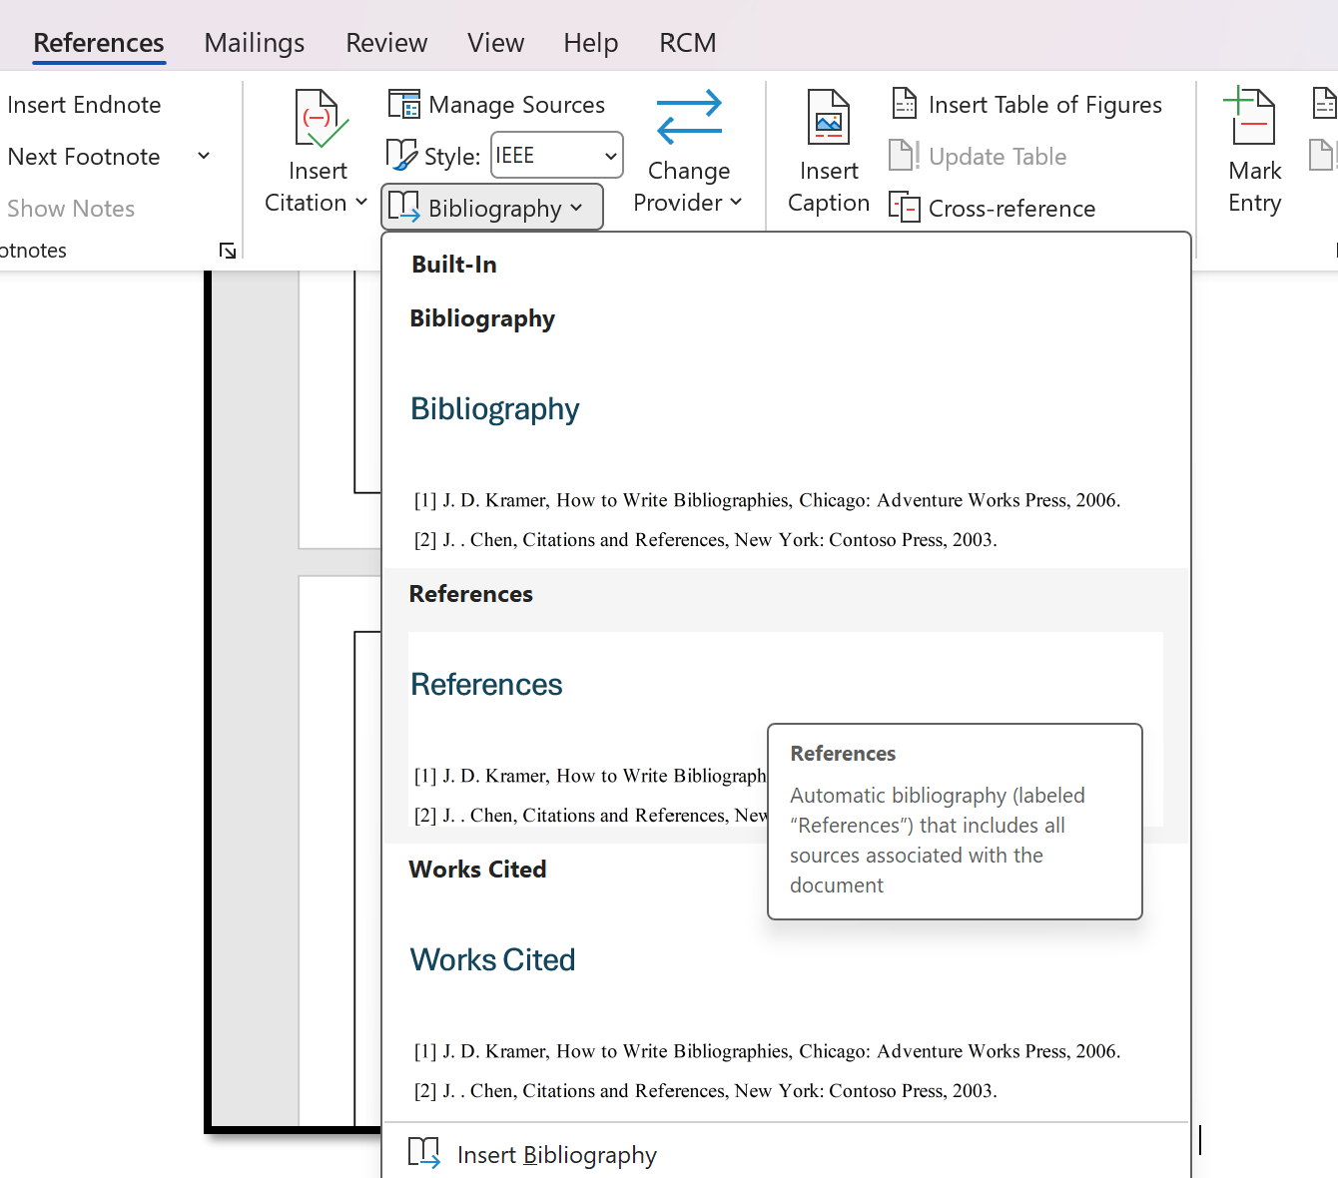
Lastly, I pasted the generated bibliography and placed it in my assignment. This facilitated the proper formatting, consistency, and accuracy of IEEE references and minimized errors in manual referencing as well as enhanced the scholarly value of the report.

Task 4: E-Portfolio Creation and Evaluation

Task 4 (a): E-Portfolio Creation

Review my E-portfolio

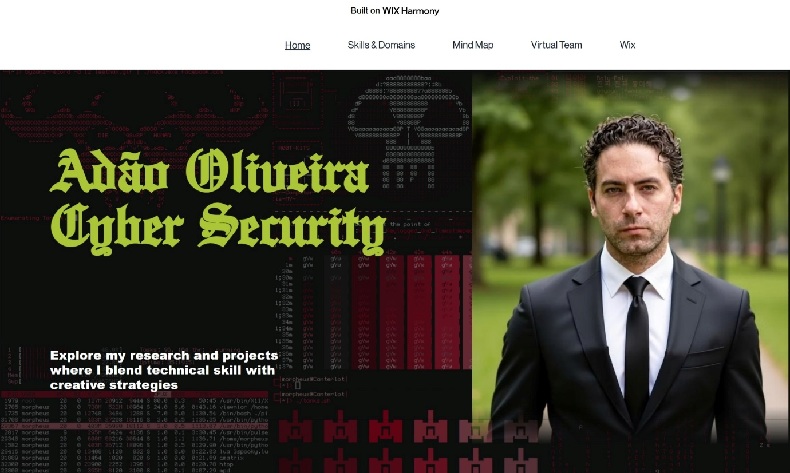

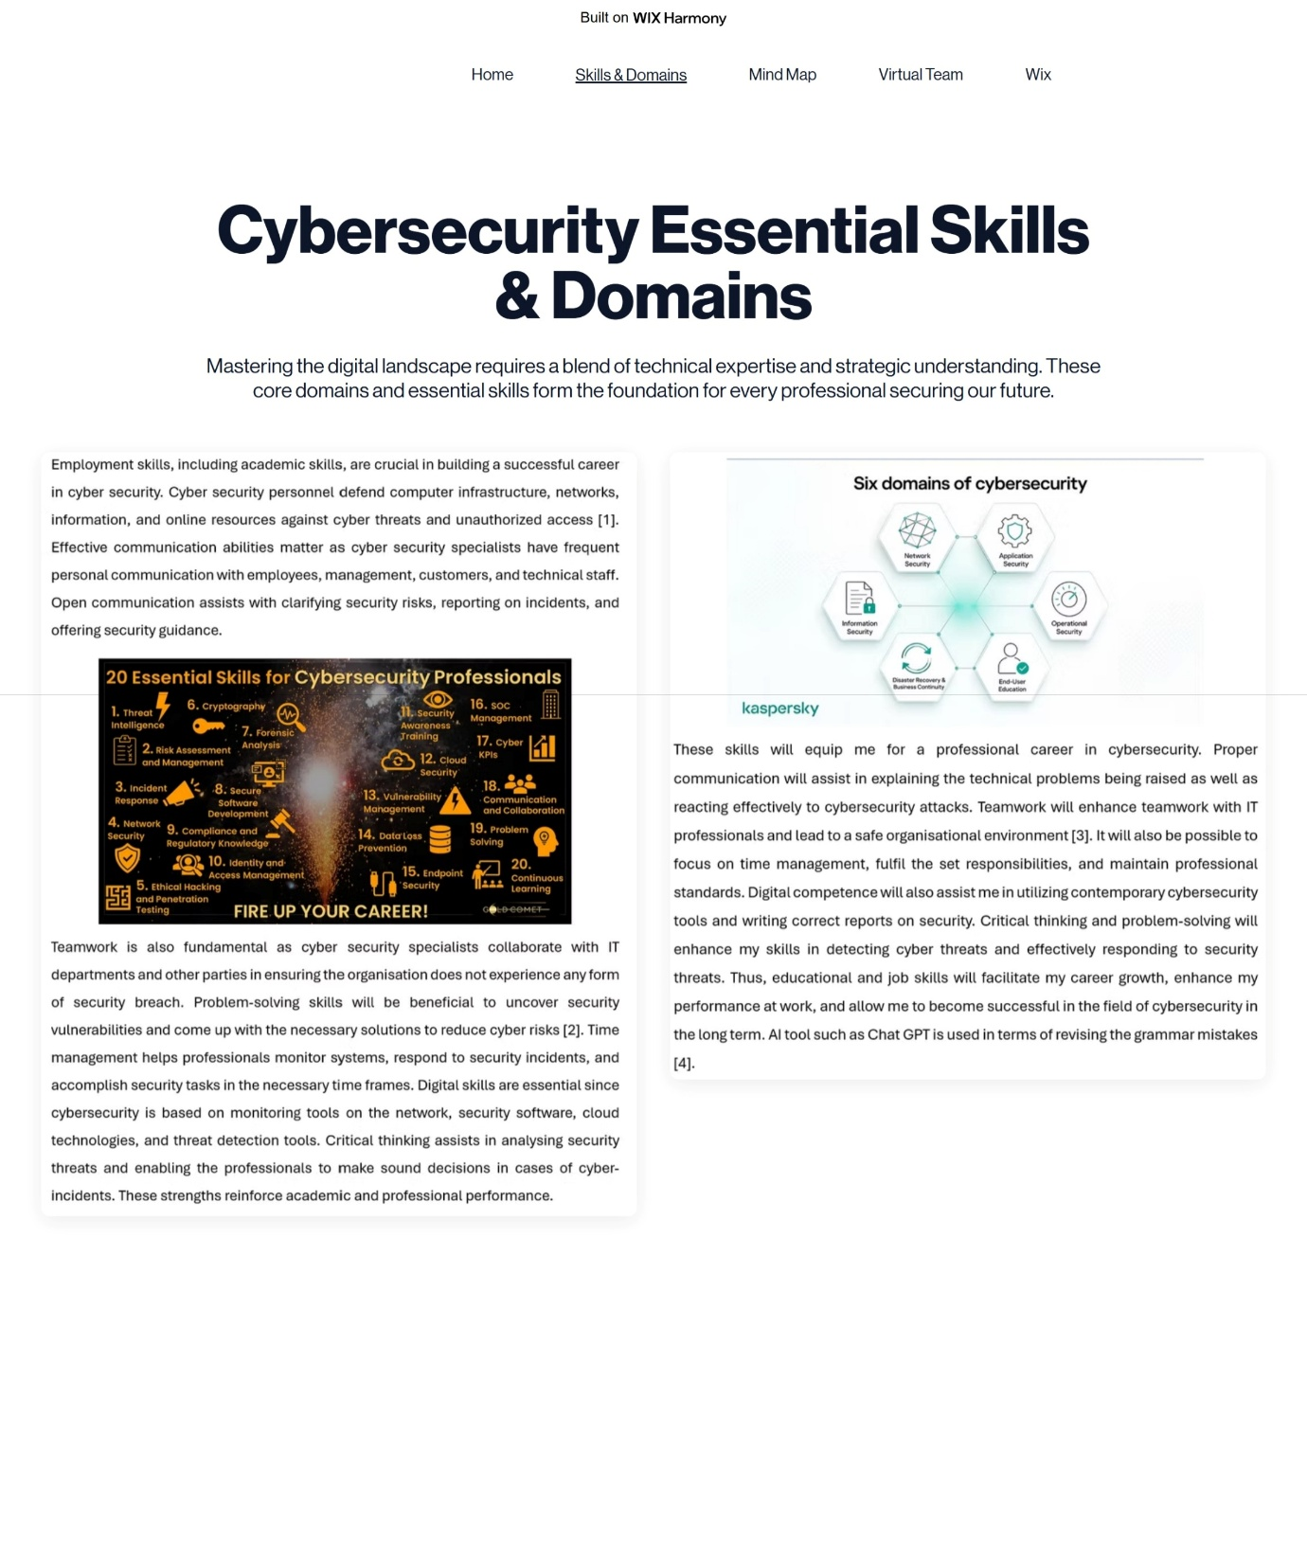

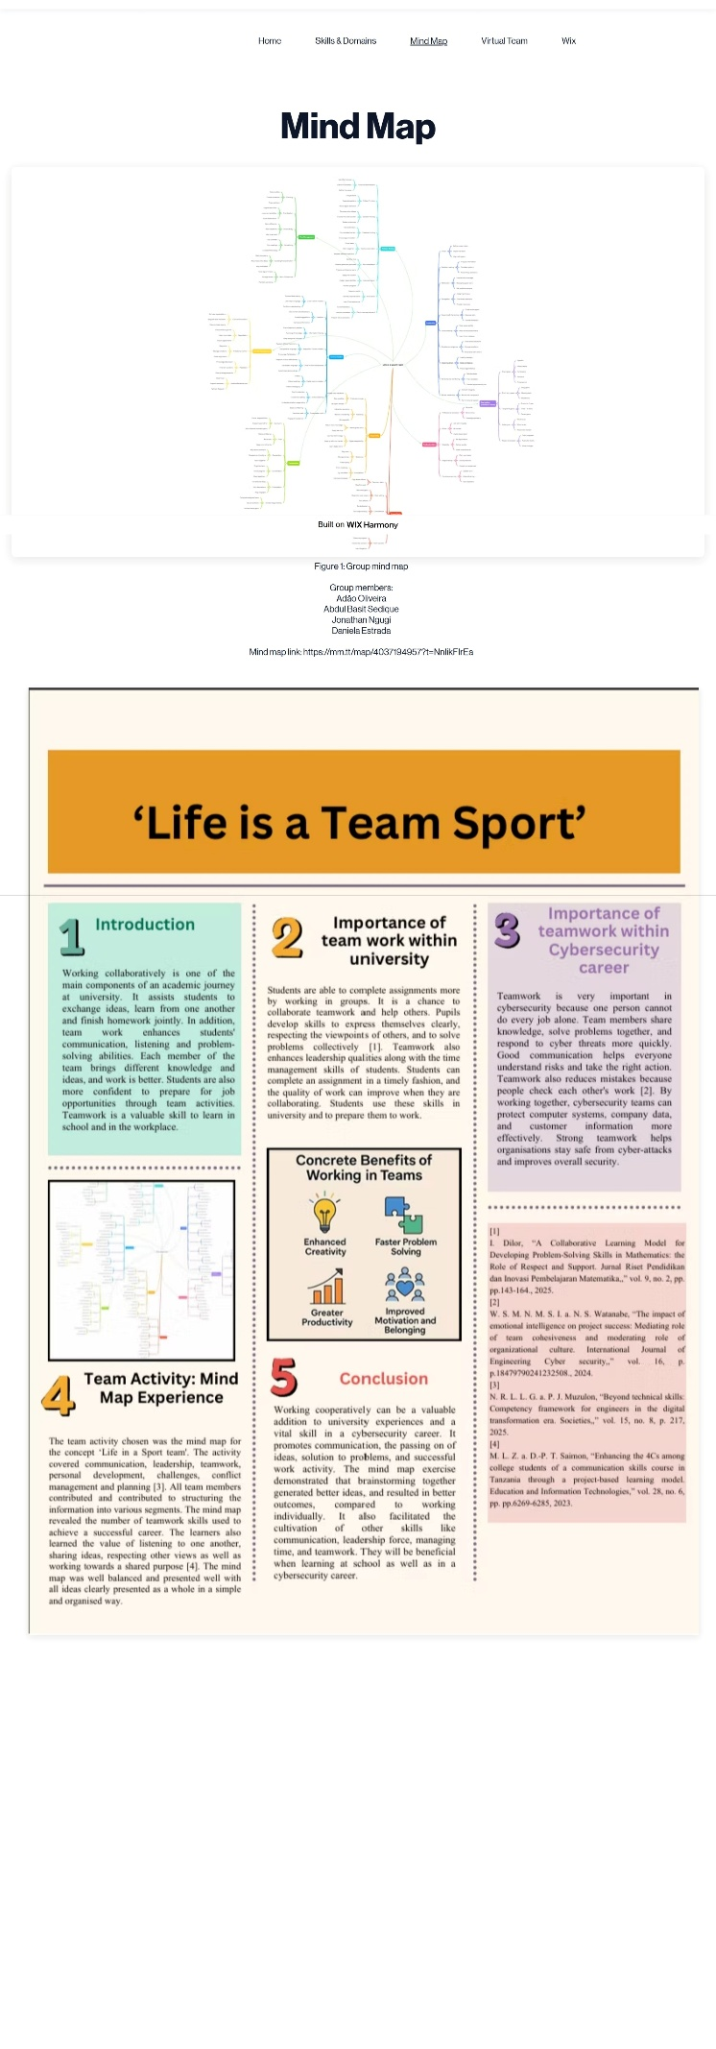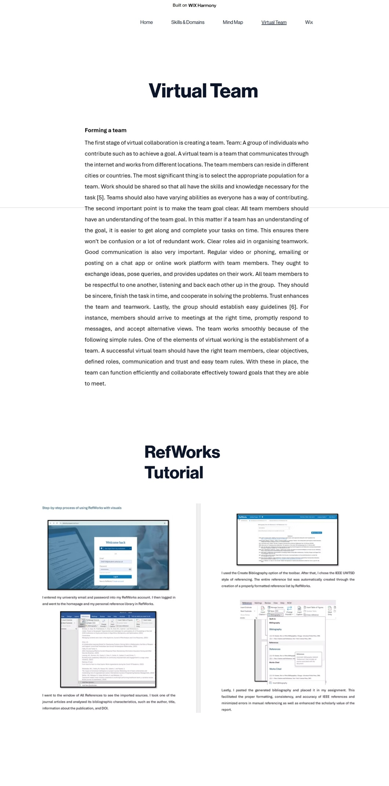



Task 4 (b): Illustrative Review of E-Portfolio tool Selection

Wix was chosen to design this e-portfolio because it is easy to use, requires no coding and offers a clear, user-friendly interface. Its ready-made templates make it simple to create a professional-looking site, while drag-and-drop tools allow text, images, videos and other media to be added without technical skills. The portfolio can be organised into separate pages (for example, personal information, skills, projects, certificates and reflections), helping visitors quickly find what they need. Wix sites are responsive on mobiles, tablets and computers, and the platform offers extensive design options, such as custom colours, fonts, layouts and images, so the portfolio can be tailored to a personal style. Changes are saved automatically, reducing the risk of losing work. Overall, Wix is a flexible, convenient and effective platform for an academic e-portfolio [8], supporting a polished, professional and well-organised presentation of achievements and development.

Conclusion

Conclusively, the skills required for a career in security service are academic and employment skills. Job performance and professional development are enhanced by communication, teamwork, digital competence, critical thinking, and time management. Acquiring these skills in college equips one to meet expectations in the workplace and work towards achieving organisational safety and security goals.

References
Task 1
[1] | M. a. N. P. Lehto, Cyber Security., Springer Nature., 2022.
[2] | A. B. T. a. S. P. George, “Bridging the Security Skills Gap: A Comprehensive Framework for Developing Application Security Competencies in Modern Software Engineering.,” vol. 3, no. 3, pp. 96-123, 2025.
[3] | F. Almeida, “Comparative analysis of EU-based cybersecurity skills frameworks,” ScienceDirect, April 2025. [Online]. Available: https://www.sciencedirect.com/science/article/pii/S0167404825000185. [Accessed 21 07 2026].
[4] | C. Gpt, “ChatGpt.Com,” 07 2026. [Online]. Available: https://chatgpt.com/. [Accessed 21 07 2026].  Task 3
[5] | S. N. A. a. H. A. Järvelä, “Human and artificial intelligence collaboration for socially shared regulation in learning.,” British Journal of Educational Technology, vol. 54, no. 5, pp. 1057-1076, 2023.
[6] | L. G. M. M. K. M. C. S. E. B. K. S. T. S. T. A. T. F. T. a. F. J. Martin, “Learning each other’s language and building trust: Community-engaged transdisciplinary team building for research on human trafficking operations and disruption. I,” International Journal of Qualitative Methods,, vol. 21, p. P.16094069221101966., 2022.  Task 4
[7] | A. a. G. S. Chanchlani, “Comprehensive Review on Various Web Technology Tools.,” Grenze International Journal of Engineering & Technology (GIJET), vol. 11, 2025.
[8] | Y. Cheng, “E-portfolios in EFL writing: Benefits and challenges.,” Language Education & Assessment, pp. pp.52-69, 2022.

