Strategic Management & Sustainability

Written Report
AstraZeneca Case study

Module code: LCBB6004
Student name: Marina Cretu
Student ID: 2122650
Location: 1 Westferry Circus, London

Table of Content
- Introduction………………………………………………...3
- Company Background……………………………………..4
- Business and Corporate Key Strategies…………………..5
  - Application of Porter’s Generic Strategies…………..6-7
  - Ansoff Matrix………………………………………………7-8
- AstraZeneca Resources and Capabilities…………………8-9
4.1 Value Chain Analysis………………………………………...9-12
4.2 AstraZeneca VRIO Framework………………………….12
- Evaluation of Strategy in Action………………………….12-13
- Sustainability Efforts………………………………………13-14
  - Examining the Company’s Sustainability Efforts……13-14
  - Sustainability Goals of AstraZeneca…………………15
- The Company’s Strategic Directions in the Future……...15-16
- Conclusion…………………………………………………..17
- References…………………………………………………..18

Introduction
AstraZeneca is a globally recognized biopharmaceutical company headquartered in Cambridge, UK, and is listed on the London Stock Exchange as part of the FTSE 100 Index. The company is known for its focus on the research, development, and commercialization of prescription medicines, particularly in oncology, cardiovascular, renal, and respiratory diseases. AstraZeneca's corporate and business strategies have been pivotal in its growth, driving innovation and expanding its market presence worldwide. This report critically analyzes AstraZeneca’s corporate and business strategies, evaluating their alignment with its resources and capabilities. It will also assess the success of the company’s strategy implementation, focusing on how these strategies have enabled AstraZeneca to compete effectively in the pharmaceutical industry. Furthermore, the report examines AstraZeneca’s commitment to sustainability and environmental considerations, evaluating how these efforts have contributed to the company’s competitive advantage. Finally, strategic recommendations will be provided, focusing on how future sustainability practices can enhance AstraZeneca's competitive positioning. In this analysis, key strategic frameworks such as Porter’s Generic Strategies (Porter, 1980), the VRIO framework (Barney, 1991), and the Balanced Scorecard (Kaplan & Norton, 1992) will be employed to provide a comprehensive evaluation of AstraZeneca’s strategic choices and their implementation. The analysis will be supported by evidence from the company’s financial reports, sustainability reports, and market performance data. This approach ensures a thorough and objective assessment of AstraZeneca's strategic direction and future potential.

Company Background
One of the biggest pharmaceutical firms globally, AstraZeneca was founded in 1999 as a result of the merging of Sweden's Astra AB and the UK's Zeneca Group PLC. Headquartered in Cambridge, UK, AstraZeneca employs over 83,000 people across more than 100 countries (AstraZeneca, 2023). The company operates primarily in three therapeutic areas: Oncology, Cardiovascular, Renal & Metabolism (CVRM), and Respiratory & Immunology. Oncology is a major focus, contributing significantly to revenue with treatments such as Tagrisso, Imfinzi, and Lynparza, which have revolutionized care standards globally. CVRM is another key area, where AstraZeneca leads in developing therapies for chronic conditions like heart failure and diabetes. In Respiratory & Immunology, the company has advanced treatments including Symbicort and Fasenra, targeting asthma and chronic obstructive pulmonary disease (COPD) (AstraZeneca, 2023). AstraZeneca’s commitment to innovation is evident in its substantial R&D investment, amounting to around 23% of its revenue, which fuels the development of new medicines and enhancement of its existing portfolio (AstraZeneca, 2022). The company’s global expansion strategy emphasizes growth in both established and emerging markets, particularly in Asia. By 2022, emerging markets contributed nearly 35% of their total revenue, reflecting their strategic importance (AstraZeneca, 2023). Additionally, AstraZeneca is dedicated to sustainability, aiming for zero carbon emissions from its operations by 2025 and carbon neutrality across its value chain by 2030. It also strives to improve healthcare access in underserved regions, reinforcing its reputation as a socially responsible organization (AstraZeneca, 2022). Overall, AstraZeneca’s focus on innovation, global reach, and sustainability supports its continued success and industry leadership.

Business and Corporate Key Strategies
AstraZeneca’s business and corporate strategies are designed to reinforce its position as a global leader in the pharmaceutical industry through innovation, targeted market expansion, and strategic partnerships.
Business Strategy: AstraZeneca's business strategy is centered on differentiating itself through innovation. The company's top priorities are developing novel, high-quality medications in the critical therapeutic areas of immunology and respiratory and cardiovascular, oncology, and renal and metabolism (CVRM). AstraZeneca spends a large portion of its revenue—roughly 23 percent—on research and development to develop novel medicines that meet unmet medical needs and enhance patient outcomes (AstraZeneca, 2023). This differentiation strategy allows AstraZeneca to create a unique value proposition, setting itself apart from competitors through the introduction of breakthrough therapies.
Corporate Strategy: AstraZeneca’s corporate strategy emphasizes global expansion, strategic partnerships, and diversification. The company has strategically expanded its presence in high-growth markets, particularly in Asia, with a strong focus on China. Strategic acquisitions, such as the purchase of Alexion Pharmaceuticals in 2021, have allowed AstraZeneca to diversify its portfolio and enter new therapeutic areas, such as rare diseases (AstraZeneca, 2021). Furthermore, AstraZeneca has formed key partnerships and collaborations, such as its alliance with Daiichi Sankyo for the development of cancer treatments, which enhance its R&D capabilities and market reach.
These strategies collectively aim to drive long-term growth, maintain AstraZeneca’s competitive edge, and ensure its leadership in the global pharmaceutical market.

Application of Porter’s Generic Strategies
Porter's framework for generic strategies, which identifies three main tactics that businesses can use to gain a competitive edge, can be used to evaluate AstraZeneca's strategic approach: Focus, Differentiation, and Cost Leadership (Porter, 1980). AstraZeneca primarily employs a Differentiation strategy, although elements of the Focus strategy are also evident in its operations.
Differentiation Strategy: AstraZeneca differentiates itself by developing unique, superior products through intensive R&D. This strategy is clear in its oncology portfolio, where drugs like Tagrisso, Lynparza, and Imfinzi have set new care standards. The company’s commitment to precision medicine, tailoring treatments to individual patients, further enhances its differentiation. By offering innovative and effective solutions, AstraZeneca can command premium prices and build strong customer loyalty.
Focus Strategy: In addition to differentiation, AstraZeneca uses a Focus strategy by concentrating on specific therapeutic areas—Oncology, Cardiovascular, Renal & Metabolism (CVRM), and Respiratory & Immunology. Within these areas, AstraZeneca targets niche markets where it can leverage its expertise and innovation. For instance, in oncology, the company focuses on targeted therapies and precision medicine, areas where it has developed notable expertise. This focused approach allows AstraZeneca to allocate resources effectively and maintain a leadership position in these specialized segments.

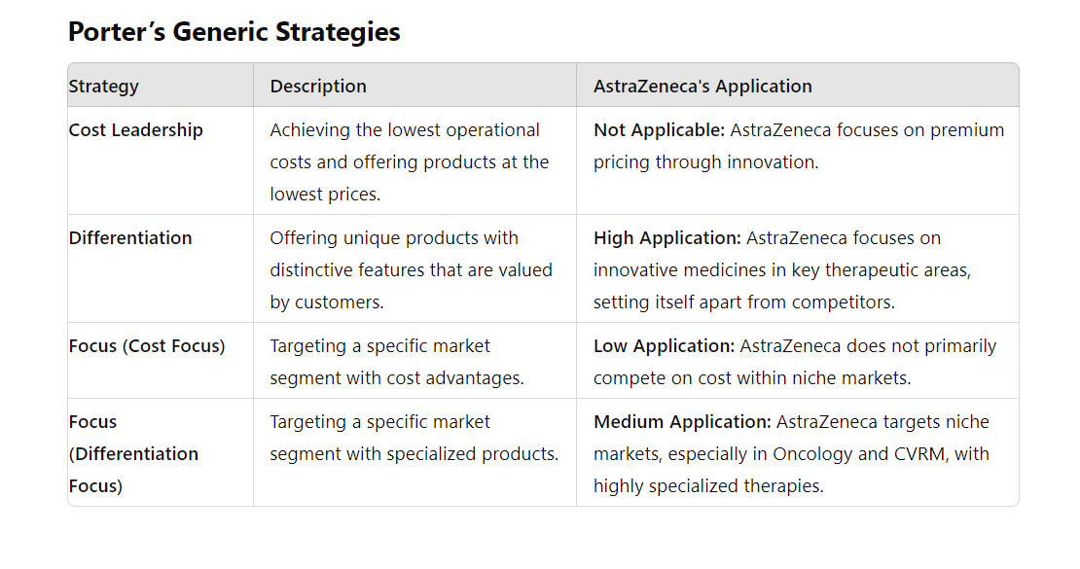

Aapplication of the Ansoff MatrixToo help organizations define their growth strategy, the Ansoff Matrix is a strategic planning tool that focuses on four important areas: market penetration, product development, market development, and diversification. AstraZeneca’s growth strategies can be effectively analyzed using this framework.
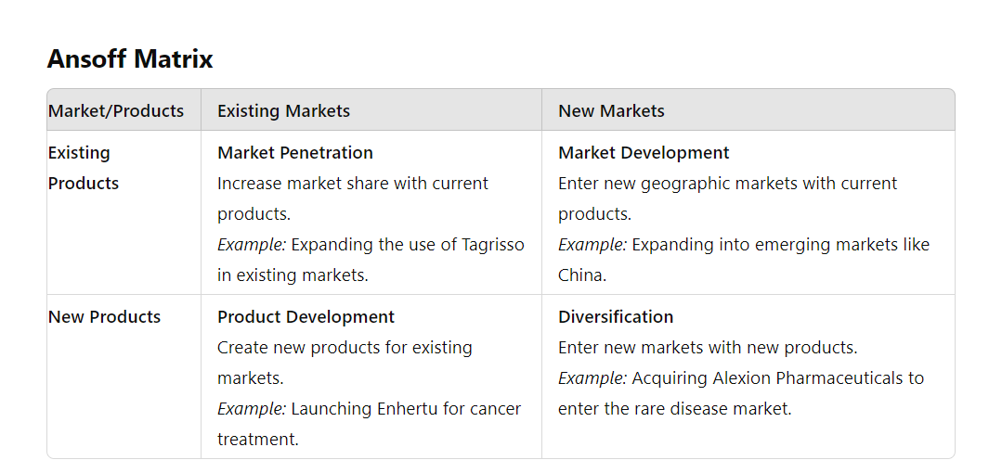
Market Penetration (Existing Products/Existing Markets): Focuses on increasing the share of current products in existing markets. AstraZeneca achieves this by enhancing the market presence of established drugs and improving sales strategies.
Product Development (New Products/Existing Markets): Involves introducing new products to existing markets. AstraZeneca invests significantly in R&D to launch innovative therapies within its established therapeutic areas.
Market Development (Existing Products/New Markets): Expands into new geographic or demographic markets with current products. AstraZeneca’s growth in emerging markets is an example of this strategy.
Diversification (New Products/New Markets): Entails developing new products for new markets. AstraZeneca's acquisition of Alexion Pharmaceuticals and its exploration of new therapeutic areas are examples of diversification.
This matrix helps AstraZeneca to strategize and allocate resources effectively to achieve growth and competitive advantage across various dimensions of its business.

AstraZeneca Resources and Capabilities
AstraZeneca's success in the pharmaceutical industry is underpinned by its substantial resources and capabilities, which can be analyzed through the VRIO framework (Barney, 1991). Four criteria—Value, Rarity, Imitability, and Organization—are used by the VRIO framework to assess a firm's capabilities and resources. Here’s an in-depth look at AstraZeneca’s key resources and capabilities:

Research and Development (R&D) Capability
AstraZeneca invests about 23% of its revenue into R&D, maintaining a leading position in pharmaceutical innovation (AstraZeneca, 2023). Its extensive pipeline, including over 150 new drug candidates, is a rare and valuable asset. The company’s unique R&D processes, strong academic partnerships, and clinical trial networks are difficult to replicate (Barney, 1991). This well-organized approach supports efficient execution and management of R&D projects (AstraZeneca, 2022).

Intellectual Property (IP) Portfolio
AstraZeneca’s extensive IP portfolio, including numerous patents, is crucial for market exclusivity and revenue generation (AstraZeneca, 2023). This portfolio, covering various therapeutic areas, is a rare asset that secures AstraZeneca’s competitive edge. The company’s well-organized IP management system, including dedicated teams for patent filings and enforcement, ensures effective protection and optimization of its innovations (AstraZeneca, 2022). This strategic management reinforces AstraZeneca’s position as an industry leader and maintains its profitability and market position.

Global Market Presence and Distribution Network
AstraZeneca operates in over 100 countries, leveraging a vast distribution network to reach a broad customer base (AstraZeneca, 2023). This global presence allows the company to capitalize on economies of scale and enhance market penetration. The efficiency and scale of AstraZeneca’s distribution network are relatively rare in the industry, giving it a significant competitive advantage. AstraZeneca’s well-organized supply chain management and strategic local partnerships ensure effective product distribution and comprehensive market coverage (AstraZeneca, 2022).

Value Chain Analysis of AstraZeneca
Value Chain Analysis, a strategic tool developed by Michael Porter, identifies key activities within a company that contribute to its competitive advantage. This framework divides activities into primary and support categories, analyzing how each adds value. For AstraZeneca, a global biopharmaceutical leader, the value chain includes critical activities from R&D to marketing and distribution:

Primary Activities
Inbound Logistics
Inbound logistics involve the procurement of raw materials, research materials, and the management of relationships with suppliers. AstraZeneca sources high-quality raw and research materials from global suppliers, ensuring timely delivery and maintaining product integrity from the outset (AstraZeneca, 2023).
Operations
Operations encompass the processes involved in manufacturing and producing drugs. Innovative production technologies and cutting-edge manufacturing facilities are features of AstraZeneca's operations. Modern manufacturing facilities run by the corporation follow Good Manufacturing Practices (GMP). AstraZeneca invests in process optimization and automation to enhance production and reduce costs (AstraZeneca, 2022)
Outbound Logistics
Outbound logistics involve the distribution and delivery of finished products to customers and markets. AstraZeneca employs a comprehensive distribution network to ensure its products reach global markets efficiently. This includes partnerships with distribution companies and a robust supply chain management system. The company’s global market presence and distribution capabilities enable it to serve a wide range of geographic regions, ensuring timely delivery and availability of its medicines (AstraZeneca, 2023).
Marketing and Sales
Marketing and sales activities focus on promoting and selling products to customers. AstraZeneca’s marketing strategy involves targeted campaigns to healthcare professionals and patients. The company invests in educational programs, digital marketing, and market research to build brand awareness and drive product adoption.

Service
Service activities include post-sale support and customer service. AstraZeneca provides comprehensive support to healthcare providers and patients, including product information, training, and assistance. The company’s commitment to patient support includes programs that help patients access medications, understand their treatments, and manage side effects. AstraZeneca’s focus on customer service enhances its reputation and fosters loyalty (AstraZeneca, 2023).

Support Activities
Firm Infrastructure
Firm infrastructure includes the company’s organizational structure, management, and administrative systems. AstraZeneca’s infrastructure supports its global operations through effective management and governance structures. The company invests in technology and systems that enhance operational efficiency and strategic decision-making.
Human Resource Management
Human resource management involves recruiting, training, and retaining employees. AstraZeneca focuses on attracting top talent and providing continuous training and development opportunities. The company fosters a culture of innovation and excellence, which is critical for maintaining its competitive edge. AstraZeneca’s HR practices include employee engagement programs, career development, and competitive compensation packages (AstraZeneca, 2022).
Technology Development
Technology development includes research and development, innovation, and technological advancements. AstraZeneca’s R&D capabilities are central to its value chain. The company invests heavily in technology development to advance drug discovery, clinical trials, and product development. AstraZeneca’s innovation strategy includes collaborations with biotech firms and academic institutions to leverage cutting-edge technologies and enhance its drug pipeline (AstraZeneca, 2023).

AstraZeneca’s VRIO Framework
A company's resources and capabilities are examined using Jay Barney's VRIO framework to see if they can provide a source of long-term competitive advantage. Four criteria—Value, Rarity, Imitability, and Organization—are used by the framework to assess resources and capabilities. Here’s a detailed analysis of AstraZeneca’s resources and capabilities using the VRIO framework:
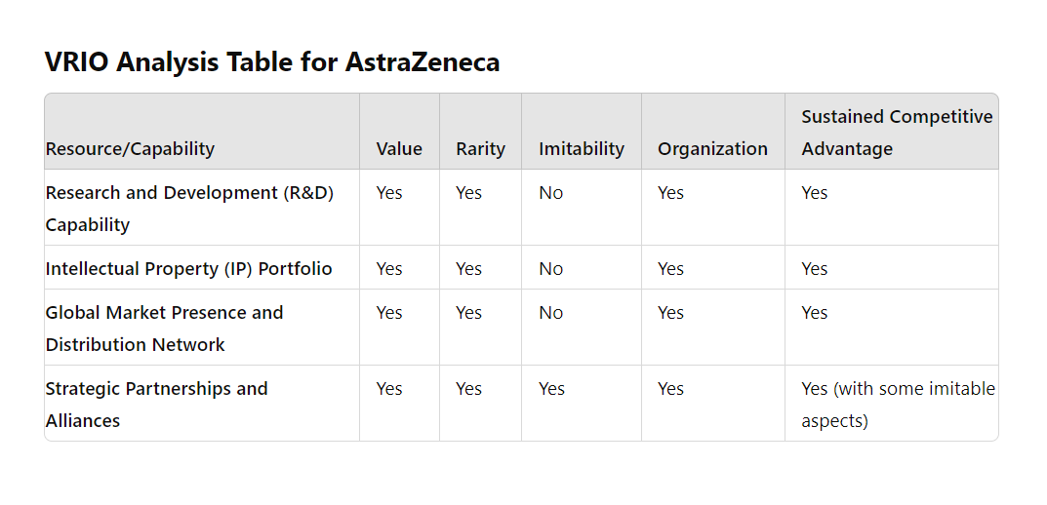This table provides a comprehensive view of how AstraZeneca’s resources and capabilities align with the VRIO framework, highlighting the areas where the company achieves a sustained competitive advantage.

Evaluation of Strategy in Action for AstraZeneca
Evaluating AstraZeneca's strategy in action involves assessing how effectively the company has implemented its strategic choices and whether these strategies have delivered the intended outcomes. This evaluation covers several dimensions: the success of its corporate and business strategies, competitive positioning, market performance, and alignment with sustainability objectives.

Corporate Strategies
AstraZeneca’s corporate strategy emphasizes innovation and growth through significant R&D investment, allocating around 23% of its revenue to this area (AstraZeneca, 2023). This focus has generated a strong pipeline in oncology, cardiovascular, and respiratory diseases. Additionally, the company engages in strategic acquisitions and partnerships to enhance its R&D capabilities and expand its portfolio, such as the acquisition of Alexion Pharmaceuticals, which strengthened its presence in immunology and rare diseases (AstraZeneca, 2021).
Business Strategy
AstraZeneca’s business strategy revolves around Therapeutic Focus, concentrating on key therapeutic areas such as oncology, respiratory, and cardiovascular diseases. The company has achieved notable success with drugs like Tagrisso (for lung cancer) and Farxiga (for heart failure and diabetes) (AstraZeneca, 2022). Global Market Expansion, AstraZeneca has expanded its market presence through global distribution networks and strategic alliances. This approach has enhanced its ability to serve diverse markets and address global healthcare needs.

Sustainability Efforts at AstraZeneca
AstraZeneca is deeply committed to integrating sustainability into its business operations, reflecting a strong focus on environmental stewardship, social responsibility, and ethical governance. The company's sustainability strategy is driven by a clear vision to address global challenges while creating long-term value for stakeholders.
Environmental sustainability is a cornerstone of AstraZeneca's strategy. The company has set an ambitious goal to achieve carbon neutrality across its global operations by 2025. This commitment involves a comprehensive approach to reducing greenhouse gas emissions, which includes transitioning to renewable energy sources, optimizing energy use within its manufacturing processes, and enhancing overall energy efficiency. In addition to its internal environmental efforts, AstraZeneca is committed to reducing the environmental impact of its supply chain. The company collaborates with suppliers to ensure adherence to environmental performance standards and encourages sustainable practices throughout its supply chain.
Social responsibility, AstraZeneca demonstrates a strong commitment to improving global health and expanding access to medicines. The company supports various initiatives aimed at providing affordable medications to underserved populations and enhancing healthcare infrastructure in developing regions.
Diversity, equity, and inclusion (DEI) are central to AstraZeneca's workplace culture. The company actively promotes a diverse and inclusive environment by implementing programs that support gender equality and the representation of underrepresented groups. Community engagement is also a key aspect of AstraZeneca’s social responsibility efforts, with the company investing in education and health outreach programs to address social challenges and support community development.
Ethical governance plays a critical role in AstraZeneca's sustainability efforts. The company adheres to high standards of corporate governance and ethical conduct, guided by a comprehensive code of conduct that sets expectations for integrity and compliance. This code ensures that ethical decision-making is embedded in all business practices. AstraZeneca also maintains rigorous anti-corruption measures, conducting regular training and audits to prevent bribery and corruption.

Sustainability Goals of AstraZeneca
AstraZeneca has established a comprehensive set of sustainability goals that reflect its deep commitment to environmental stewardship, social responsibility, and ethical governance (AstraZeneca, 2023). These goals are integral to the company’s strategy, addressing global challenges and fostering long-term value creation. The company aims to achieve carbon neutrality by 2025 through a multifaceted approach, including investing in renewable energy sources like wind and solar power, improving the energy efficiency of its facilities, and implementing carbon offsetting projects.
In addition to reducing greenhouse gas emissions, AstraZeneca is dedicated to minimizing waste and enhancing resource efficiency. This involves better waste management practices, increasing recycling rates, exploring waste-to-energy solutions, and adopting technologies to reduce water consumption. The company is also focused on sustainable packaging, striving to use recyclable and biodegradable materials to lessen its environmental impact. Socially, AstraZeneca is committed to enhancing global health and expanding access to medicines. The company works with governments and NGOs to make treatments more affordable in low- and middle-income countries. AstraZeneca also supports patient assistance programs to help individuals access necessary medications and manage their health conditions effectively. Through these initiatives, AstraZeneca aims to address global challenges and create long-term value while upholding high standards of ethical governance.

The Company’s Strategic Directions in the Future
AstraZeneca’s future strategy will be influenced by evolving market conditions, technological advancements, and global health needs, positioning the company for long-term growth and sustainability. The company aims to expand in emerging markets such as parts of Asia, Africa, and Latin America, where growing populations and improving healthcare infrastructure present significant opportunities. By forming local partnerships and customizing products for these regions, AstraZeneca plans to enhance its market presence and impact. In addition, AstraZeneca will emphasize advancing precision medicine by developing therapies tailored to individual genetic, environmental, and lifestyle factors. Leveraging genomics and biotechnology, the company seeks to provide targeted treatments, improve patient outcomes, and maintain a leadership role in drug innovation. Investment in digital health technologies is also a strategic priority. AstraZeneca will utilize tools like telemedicine, digital therapeutics, and artificial intelligence to boost patient engagement, streamline clinical trials, and enhance drug discovery. These technologies are expected to optimize R&D processes and offer valuable insights into patient needs and treatment effectiveness. Sustainability is a key focus, with AstraZeneca committed to achieving carbon neutrality by 2025. The company will advance resource efficiency, increase the use of renewable energy, adopt circular economy practices, and integrate environmental, social, and governance (ESG) criteria into operations. These efforts will help reduce environmental impact and align with global sustainability goals. AstraZeneca will also intensify global health initiatives, working to improve access to medicines in underserved regions through partnerships and affordable treatment solutions. Innovation and collaboration with academic, research, and industry partners will be central to accelerating drug development and advancing new therapies.

Conclusion
AstraZeneca’s strategic review underscores its commitment to innovation, sustainability, and global health impact, positioning the company for future success. Utilizing Porter’s Generic Strategies, AstraZeneca focuses on differentiation and innovation by investing in R&D, especially in oncology and rare diseases, which helps set it apart with advanced therapies and personalized medicine. The Ansoff Matrix analysis reveals AstraZeneca’s dual strategy of market penetration and development through expansion into emerging markets and continuous product innovation, enhancing market presence and diversifying its portfolio. The company’s robust infrastructure, including extensive R&D capabilities, strong brand equity, and a global operational network, supports its strategic goals. The VRIO framework highlights AstraZeneca’s unique resources, such as its innovative R&D processes and strategic partnerships, providing a sustainable competitive advantage. AstraZeneca’s strategy in action shows effective implementation, marked by milestones in drug development, market expansion, and sustainability. The company’s proactive approach to achieving carbon neutrality, reducing waste, and improving global health access demonstrates its commitment to environmental and social responsibility. Future strategies will likely include expanding in emerging markets, advancing precision medicine, and investing in digital health technologies. AstraZeneca’s focus on these areas, along with sustainability and innovation, will drive future growth and reinforce its industry leadership.

References:
AstraZeneca, (2023). Annual Report (2022). [Online] Available at: https://www.astrazeneca.com/investors/annual-reports.html [Accessed 27 August 2024].
AstraZeneca, (2023). Sustainability Report (2023). [Online] Available at: https://www.astrazeneca.com/sustainability.html [Accessed 27 August 2024].
Barney, J. (1991) ‘Firm Resources and Sustained Competitive Advantage’, Journal of Management, 17(1), pp. 99–120.
Johnson, G., Scholes, K., and Whittington, R., (2017). Exploring Corporate Strategy: Text and Cases. Pearson Education, Harlow.
Kaplan, R.S. and Norton, D.P. (1997) ‘The Balanced Scorecard: Translating Strategy into Action’, T + D. Alexandria: Association for Talent Development, pp. 50-.
Patterson, S., (2020). AstraZeneca’s Competitive Positioning in the Global Market. Business Strategy Review, 31(2), pp.45-60
Porter, M.E. (1998) Competitive strategy : techniques for analyzing industries and competitors : with a new introduction. 1st Free Press ed. New York: Free Press.
Porter, M.E., (1985). Competitive Advantage: Creating and Sustaining Superior Performance. Free Press, New York.
Teece, D.J., Pisano, G. and Shuen, A. (1997) ‘Dynamic capabilities and strategic management’, Strategic management journal, 18(7), pp. 509–533.
Wernerfelt, B. (1984) ‘A Resource-based View of the Firm: Summary’, Strategic management journal, 5(2), pp. 171-.

