
Danny Finnegan (2539446)

CertHE Computing Skill for Workplace
Learning in the Digital Era
ACCA4025
Martin Svejda
Assignment 1: E-Portfolio

Contents
(1)IEEE Referencing & written summary on essential academic and employment skills (350 words): 2
Written Summary 3
2) Collaborative Teamwork and Professional Academic poster (A3 Poster): 5
(b) Professional Academic poster: 6
3) Automatic Referencing tool (450 words): 7
Unit 3 Topic Summary – Virtual Collaboration 7
4) E-Portfolio creation and review: 12

(1)IEEE Referencing & written summary on essential academic and employment skills (350 words):
  - Produce a written summary with some supporting visuals (images/figures), on the topic of essential skills for study and employment (approx. 250 words) in your Career area. The summary should consider:
    - How the development of such skills will support you in your chosen Career after you graduate.
    - Citations and a list of references should be included (Approx. 4/5 sources). Using the IEEE referencing standard (UWTSD IEEE Ref. handbook) include citations and a reference list (including 1 online source, 1 credible book, 1 credible article and 1 AI source).


Figure 1: Example of a person using a computer


Figure 2: Example of a student learning in computer science
Source: Heidelberg University.

Written Summary
A successful career in Computer Science requires a combination of academic, technical, and employability skills. While programming knowledge is important, employers increasingly seek graduates who can communicate effectively, solve complex problems, work collaboratively, and adapt to rapidly changing technologies.
One of the most important academic skills is critical thinking. Computer science professionals frequently analyse problems, evaluate solutions, and design efficient systems. Strong research skills are also essential, allowing graduates to locate reliable information, assess emerging technologies, and apply evidence-based approaches to software development and digital innovation.
Digital literacy is another key requirement. Modern organisations rely on cloud computing, artificial intelligence (AI), cybersecurity, and data analytics. Recent UK higher education research highlights the growing importance of digital and AI-related competencies for both study and employment. Students who develop these skills are better prepared for graduate roles and future technological developments.
In addition to technical expertise, communication and teamwork skills are highly valued by employers. Computer scientists often work within multidisciplinary teams where they must explain technical concepts to non-technical stakeholders. Effective communication improves project outcomes and supports collaboration throughout the software development lifecycle.
Time management and self-motivation are equally important. University study requires students to manage deadlines, balance workloads, and complete independent learning tasks. These abilities transfer directly to professional environments where employees are expected to prioritise tasks and deliver projects efficiently

After graduation, the development of these skills will support my career by improving my ability to design software solutions, collaborate with colleagues, adapt to technological change, and meet employer expectations. As the UK digital sector continues to grow, graduates who combine technical knowledge with strong employability skills will be better positioned to secure and progress within professional computing roles [1], [3].

[1] Jisc, "2024/25 UK Higher Education Students Digital Experience Insights Survey Findings," Jisc, 2025. [Online]. Available: https://digitalinsights.jisc.ac.uk/reports-and-briefings/our-reports/2024-25-uk-higher-education-students-digital-experience-insights-survey-findings/. [Accessed: 24-Jun-2026].
[2] T. Gaddis, Starting Out with Programming Logic and Design, 6th ed. Harlow, UK: Pearson Education, 2022.
[3] C. Ball, "Digital Skills: The Must-Have for Graduates," Prospects, 2025. [Online]. Available: https://www.prospects.ac.uk/the-topic/digital-skills-the-must-have-for-graduates. [Accessed: 24-Jun-2026].
[4] M. Csernoch, J. T. Kiss, V. Takács and D. Máté, "Exploring Higher Education Competencies through Spreadsheet Self-Assessment and Time," arXiv, Sep. 2024.

- Collaborative Teamwork and Professional Academic poster (A3 Poster):
  - Team Activity: In a small team, work together to produce a mind-map that summarises the key considerations of effective teamwork. Your mind map should be clear and concise and no more than approx. 400-500 words or approx.150 words per person. It can be produced using freely available Online Mapping technology of your choice (e.g. Mindmeister.com, Coggle.it, GitMind.com, Ayoa.com) or an Office 365 Application.

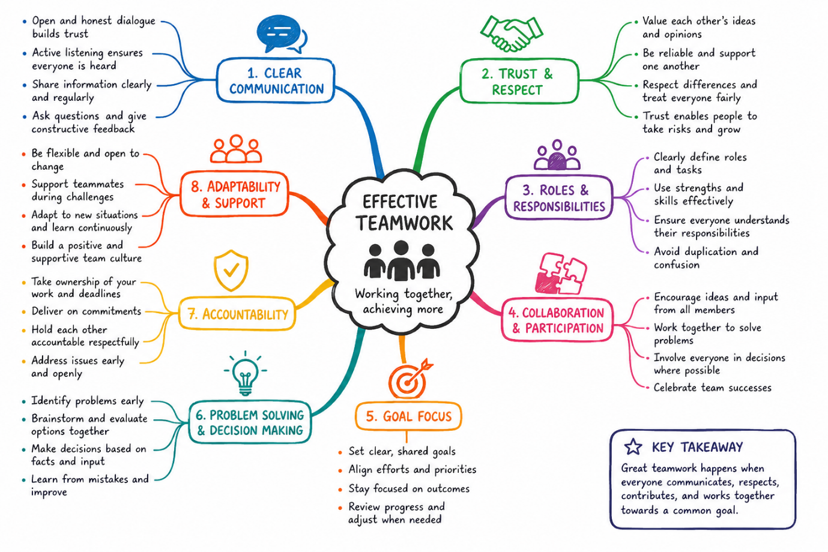
Screenshot 1 : Mind map

(b) Professional Academic poster: Create an A3 academic poster highlighting why some of the areas/concepts covered in the Moodle Unit 2 topic 4 ‘Life is a Team Sport’ are important for academic and career success in your chosen discipline.

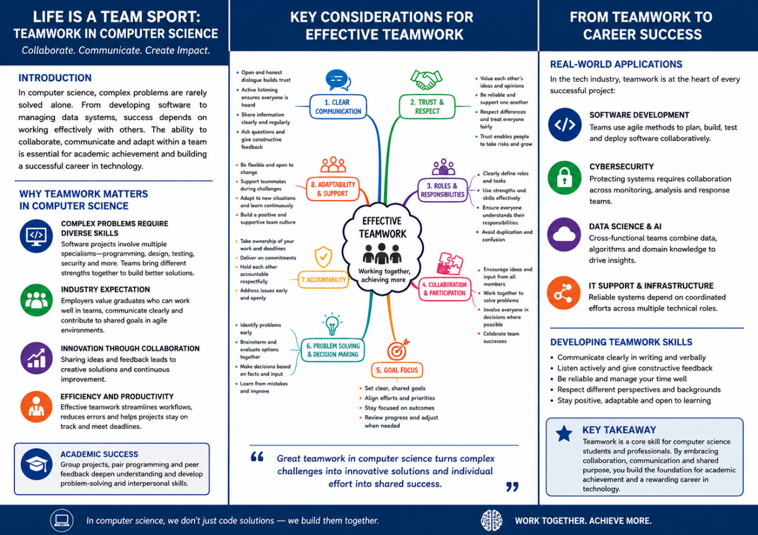
Screenshot 2: Academic Poster

Automatic Referencing tool (450 words):
Use an automatic referencing tool (such as RefWorks) to add relevant IEEE citations and a reference list to the task outlined below.

Unit 3 Topic Summary – Virtual Collaboration
Virtual collaboration refers to people working together through digital technologies rather than sharing the same physical workplace. It has become a fundamental part of modern organisations, allowing employees to communicate, share information and complete projects regardless of location. The widespread adoption of cloud-based software, video conferencing and collaborative document platforms has transformed how businesses operate and has improved flexibility for both employers and employees.
One of the main advantages of virtual collaboration is improved communication. Platforms such as Microsoft Teams enable staff to hold meetings, exchange instant messages, share files and collaborate on documents in real time. This reduces delays in decision-making and helps teams remain connected, particularly when operating in hybrid or remote environments. Effective virtual collaboration can also improve productivity by allowing employees to access shared resources securely from different locations while maintaining business continuity [1].
Another important benefit is flexibility. Employees can work from home or other locations while maintaining regular contact with colleagues. Research from the Chartered Institute of Personnel and Development (CIPD) highlights that flexible and hybrid working can improve employee wellbeing, increase job satisfaction and support a healthier work-life balance when managed effectively [2]. Organisations also benefit from access to a wider talent pool because recruitment is no longer limited by geographical location.
Despite these benefits, virtual collaboration presents several challenges. Communication can become less effective if team members rely solely on written messages, increasing the risk of misunderstandings. Maintaining employee engagement and organisational culture can also be difficult when colleagues rarely meet face-to-face. Managers therefore need to establish clear communication practices, schedule regular virtual meetings and encourage collaboration to ensure that all team members feel included and supported [2].
Security is another important consideration. As employees increasingly access company systems remotely, organisations must implement secure authentication, data protection measures and regular cybersecurity training to reduce the risk of cyber threats [3].
Overall, virtual collaboration has become an essential element of modern business. When supported by appropriate technology, effective leadership and strong cybersecurity practices, it enables organisations to remain productive, flexible and competitive while supporting employee wellbeing.
References (IEEE)
[1] Microsoft UK, Microsoft Teams for Hybrid Working, 2024. Available: https://www.applytosupply.digitalmarketplace.service.gov.uk/g-cloud/services/462172929868240
[2] Chartered Institute of Personnel and Development (CIPD), Flexible and Hybrid Working: Guidance for People Professionals, 2025. Available: https://www.cipd.org/en/knowledge/guides/flexible-working/
[3] Chartered Institute of Personnel and Development (CIPD), Effective Hybrid Working, 2024. Available: https://www.cipd.org/globalassets/media/knowledge/knowledge-hub/guides/2024-pdfs/hybrid-working-taskforce-guide-feb2024.pdf

- Use of Refworks: Document several screenshots with brief accompanying description to provide practical evidence of the use of RefWorks/other automatic referencing management tool. (Approx 100 words)

Practical evidence of using RefWorks was provided through a series of screenshots that documented each stage of the referencing process. These images show how academic sources were imported into RefWorks, organised into a project folder, and used to generate accurate IEEE in-text citations and a reference list automatically. The screenshots also demonstrate the use of the RefWorks Citation Manager to insert references directly into the document. Using RefWorks helped ensure consistent formatting, improved the accuracy of citations, and reduced the time required to create and manage references, demonstrating effective use of digital academic referencing software.

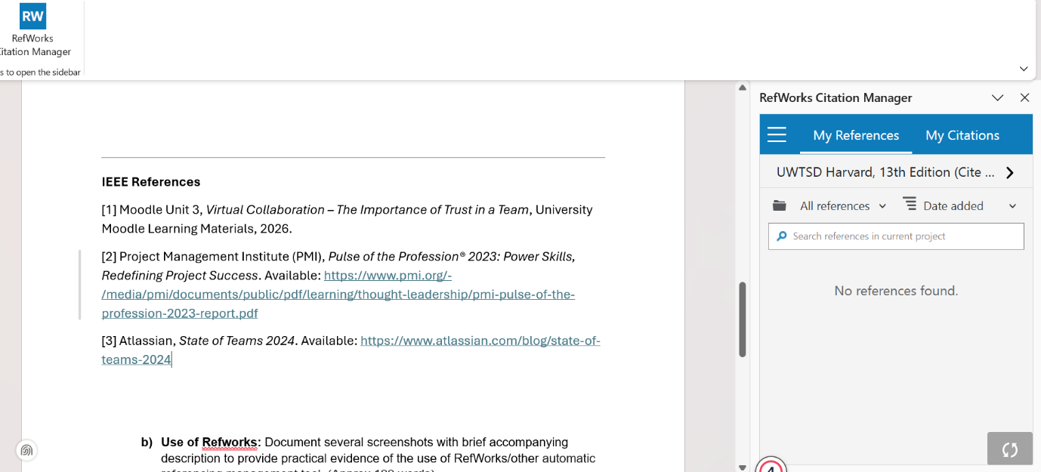
Screenshot 3

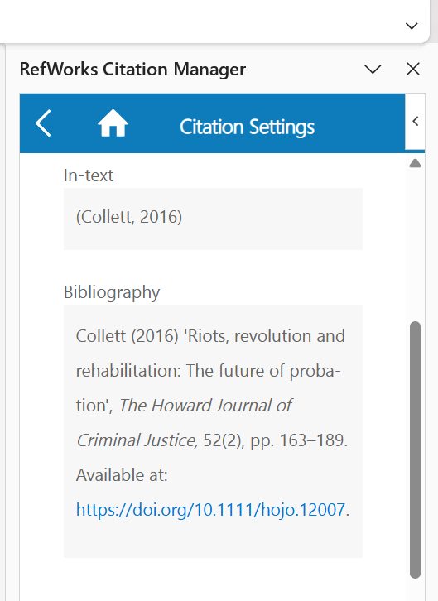
Screenshot 4

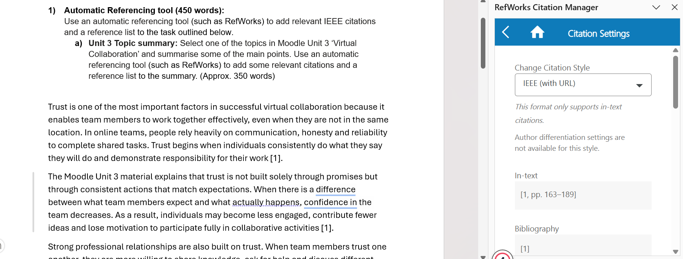
Screenshot 5

- E-Portfolio creation and review: (No word count required)
  - Create an Online e-portfolio with a page for each task answer.
- Choose the platform to create your Online e-portfolio (e.g. a free Online Website builder such as Google Sites, Wix, Weebly, or MS OneNote). Whichever method you choose, you must ensure your tutor is able to easily view your portfolio online and each task answer for marking purposes.
    - Your e-portfolio should have a welcome/home page, and a page/section for each task answer.
  - Produce an illustrative review:
    - On a task 4 page in your e-portfolio, briefly state which tool you have used to build your e-portfolio and the reason for using it.

The tool I used to create my portfolio was “Google Sites”, I used as I found it the easiest tool to use and it was one of the suggested tools. Below is the link and screenshots of my online portfolio.

Online link: https://sites.google.com/view/danny-finnegan-computing/home



