Report
“Physical activity for adults UK”
Infographic

Student Name: Svetlana Spinu
ID: 2009037
Module: Data Analysis and Visualisation
Lecturer: Koushik Modak
Date: 04.04.2022

Contents
Infographic 3
Introduction 4
Brief analysis of the Task 4
Explanation of the given infographic 4
Identifying the message 5
Evaluate the way colour is used 5
Evaluate the way text is used 5
Evaluate the suitability of the graph and the way graphics are incorporated 6
Cognition 6
Improvements of the Infographic 7
Conclusion and Recommendation: 7
Appendices 8
Bibliography 9

Infographic
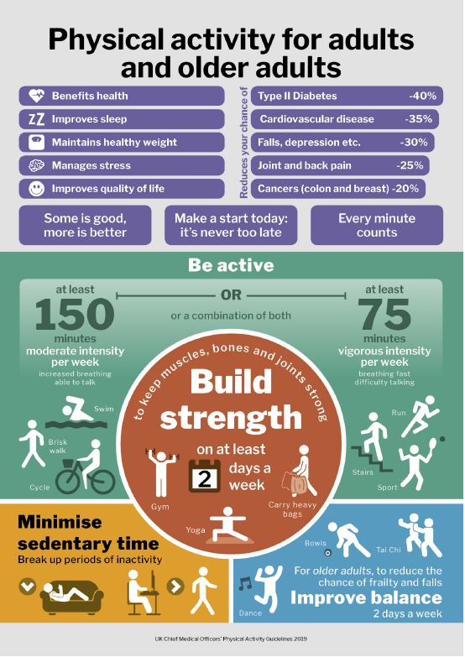

Introduction
This Report represent a description and analysis for the “Physical activity for adults and older adults” Infographic. The Evaluation is based and follow the aspects of visualisation design like identifying the message, assess the way colour is used, the text, the graphs, cognition and some ideas for improving the infographic.

Brief analysis of the Task
The main requirement of the task is to evaluate the Infographic following the analysis protocol along with the mandatory conditions noted in the task, including any particularly good features of the poster, any problems that I have identified and my ideas for improving the design. The Report has a limit of words, and the information is aimed with purpose references sources.

Explanation of the given infographic
The Infographic attach above represent an informative and educational advertising promoting the benefits of physical activity for adults and older adults. It contains a lot of information: text, graphs illustration, statistical comparison, using different colures, which aim to promote physical activities for adults.

Identifying the message
The message of the poster is emphasized by highlight and structured information using drawing images and colours that increase readability and make information easy to scan.
The main message of the poster can be divide in 2 section. The first part is about the benefits and advantages of adult’s physical activity for health and well-being, promoting how physical activity can improve your health. On the second part we can see what physical activity practice can be, using clear drawings and a brief explanation about how many times and why this activity should be practice.

Evaluate the way color is used
The colours do fit the subject, although the reference sources recommend using a maximum of 2-3 colours for the best look of a poster, the explanation is that too many colours make the poster to look chaotic and unprofessional, but having no colour makes it dull and plain [1]. The colours used in this poster are faded, even thus are more than 3 colours, the poster looks well structured, and the information is highlighted and easy to read.

Evaluate the way text is used
The text on the poster is write in a various way, having a large title positioned in the central of the poster, the main message of every part of the poster is well highlighted and every drawn is having a proper explanation. The negative part is that some parts of the text are positioned in a way that are not easy to be read, the size of the font is too small, and that make the poster difficult to read from a distance. The illustration and the text dominate the poster and is confusing when is come to identify the beginning of the poster or the introduction.

Evaluate the suitability of the graph and the way graphics are incorporated
The graphics are drawn to give a visual explanation of the information from the poster. The graphic drawings are different for every section of the poster and well design to provide a perceptible description of the information that is being presented.
There is no graph that don’t provide an information and that makes the poster to be overall good designed and not raising any ethical issues.
Besides that, the graphics helps to identify the goal of the poster, it makes easy to understand the target audience, match the emotions and simulate the eyes to explore the sections that provide important information. [2]

Cognition
In terms of cognition the poster provide a up to date information, a popular and topic subject that can be associated with a large target audience. The poster creates a “take action” feeling, and a demanding behaviour about physical activity and that helps to develop and propagandize a more efficient marketing messages.
Regarding the terms of memory load or mental modelling in relation with the poster it improves by the effects of graphs illustrations, and text that makes you believe the information, to store and recall past sensations, impressions [3]and make you think about the physical activities in corelation with our health, and what we can do to improve or change the physical activities in everyday life.

Improvements of the Infographic
Overall, the poster has a positive message, an accurate and structured information along with the explicit illustration. However, I must admit that in a way the poster it looks a chaos of information, and colours, and it gives a lost and confused feeling when it comes about from where we should start to read the information, and I cannot concentrate visual at one section or part of the poster because the information is extended everywhere and the illustrations and background colours it covers the font of the text. [4]
A few suggestions to improve the aspect of the poster for easy of readability and following the main message are to use background and colours that enhance the nature of the subject, the maximum of 3 colours will be the limit. A monochromatic colour, that use one colour but in a variety of shades and tints may be a good solution. For an easy readability the text and poster elements should be arranged in columns, the dark text should be on light background, and the light text on dark background.
A good balance of images and text, using white spaces as pauses and arranging the elements in order to understand how to read the poster from the top to the bottom and left to right will make the poster to look mor attractive for the target audience. [4]

Conclusion and Recommendation:
The Report is a personal evaluation of the Infographic, based on different references sources and contains some recommendations and intention to improve the cognitive and visual design of the infographic. Altogether, the Infographic may need a summary of targets to simplify the information, to be easier understand by the target audience, easy to digest and to be constantly review by them. [5]

Appendices

A version of the infographic more clear, visible and easy to understand the message.
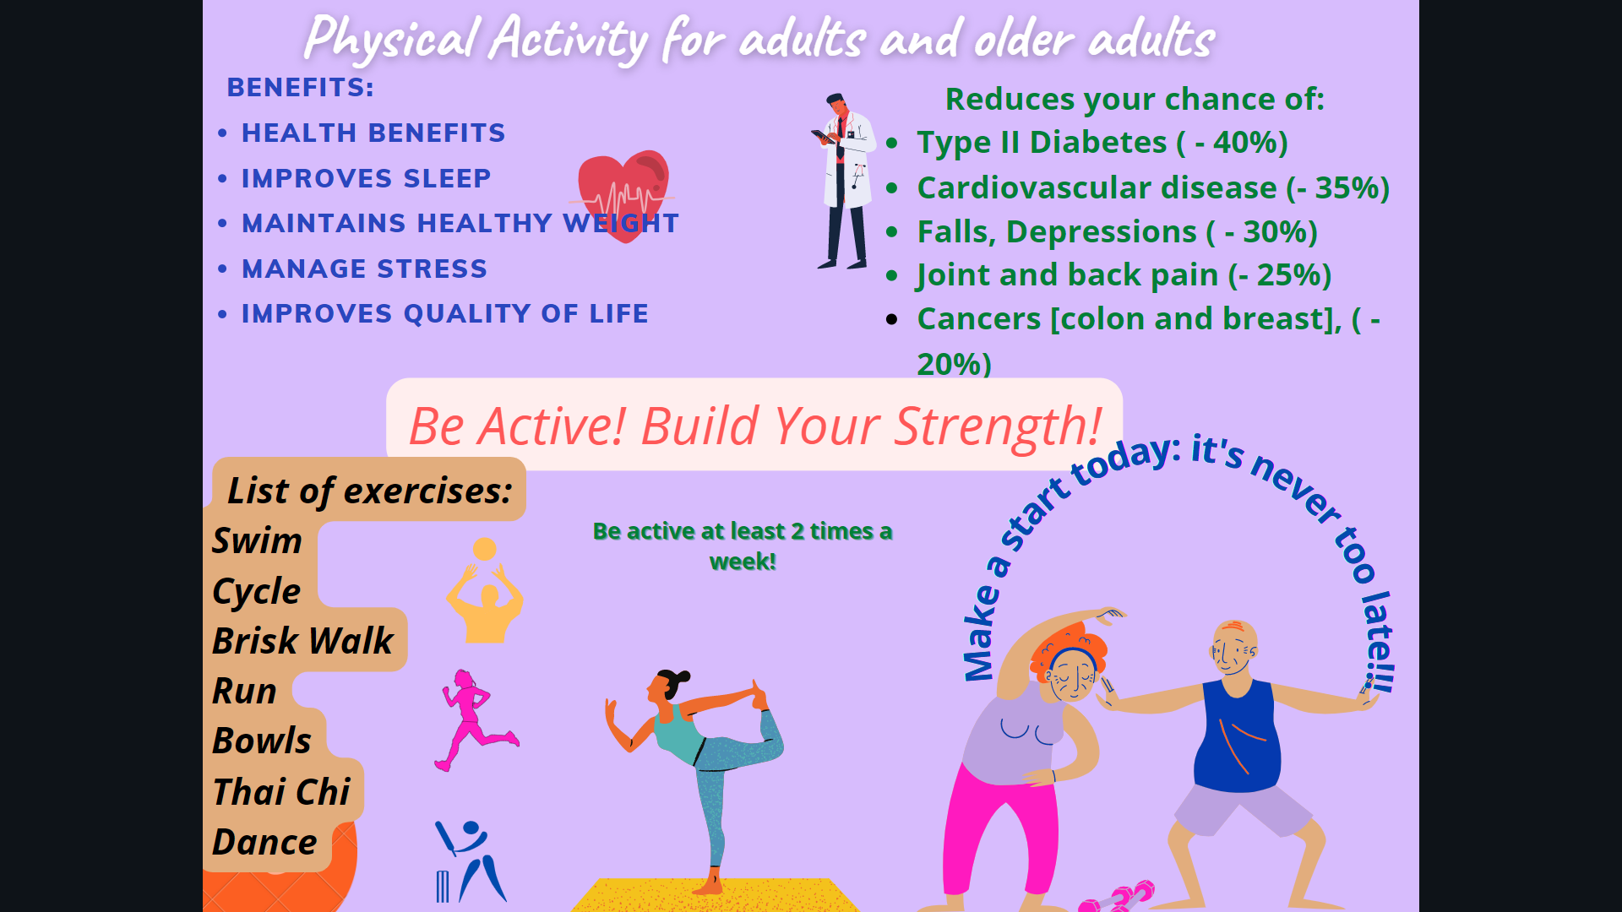

Bibliography

[1] | M. Smiciklas, The Power of Infographics, Indianopolis: Pearson education, Inc., 2012.
[2] | J. Ferreira, "Infographics an Introduction," 28 October 2014. [Online]. Available: https://www.researchgate.net/publication/266082644_Infographics_An_introduction. [Accessed 19 March 2022].
[3] | C. Toth, "Revisiting a Genre: Teaching Infographics in Business and Professional Communication Courses," Business Comunication Quartely, 12 November 2013. [Online]. Available: https://journals.sagepub.com/doi/full/10.1177/1080569913506253?casa_token=oGXfuLH9bZ8AAAAA%3AEKGiSszQpQNjDB2pFcuM-iztt1qBi4S90cJltlcAFu8OrbhyPGod8SQvQye9Of9yayi4LADH6ag. [Accessed 19 March 2022].
[4] | A. Kirk, Data Visualisation: A Handbook for Data Driven Design, Chicago: SAGE Publications Ltd, 2019.
[5] | N. Z. J. L. Hui Huang, "Exploring Visual Information Flows in Infographics," Publication History, Chicago, 2020.

