BMIH6008
Hotel Placement Research Project

Student Name: Nazmeen Akhtar
Student ID: 2123059
Tutor: Christopher Wilkin.
Abstract
This research work aims to study the problems of Holiday Inn Birmingham City Centre establishment with particular reference to the reasons leading to staff deficits and problems of recruitment and retention to ascertain the effect of the aforementioned problems on the operations of the hotel establishment. The study seeks to establish factors that lead to these staffing issues, especially concerning a hotel occupying a strategic business region. The report addresses three main research questions such as: by analysing the following factors it was identified that Holiday Inn Birmingham City Centre faces some serious challenges with a shortage of workers. Factors that affect recruitment and retention of the employees in a hotel situated in Birmingham city center. They could be applied to ensure higher levels of workforce recruitment, retention, and stability in hotels. To collect data on these issues, both, secondary data sources and primary data were collected from a survey. The article review looks at what has been written in the past on staffing problems affecting the hospitality industry and how issues like job satisfaction, compensation, and work hours have been addressed. The following are the real-life realities of these challenges as gathered from primary data that included employees and management of Holiday Inn Birmingham City Centre. This paper concludes that research findings suggest that the lack of staff was due to factors including high living costs in city centers, competition by other employers, and lack of career advancement. Some of the issues highlighted are a lack of competitive benefits, issues of talent acquisition, and other challenges occasioned by the rigorous nature of the hospitality business. In light of these concerns, the report provides several solutions that include establishing improved employee relations programs, providing remunerations and benefits that match market rates, and creating paths for the formal progression of their careers.

Table of Contents
1. Introduction 6
1.1 Background 6
1.1.1 Purpose of Research Activity 6
1.1.2 Research Questions 6
1.1.3 Aims of Research Activity 6
1.1.4 Objectives of Research Activity 7
2. Literature Review 8
2.1 Contests and Approaches for Employee Maintenance in the Hospitality Business 8
2.2. Satisfying Human Resources through Talent Administration Approaches 9
2.3 Impact of Appropriate factors in Career Preservation 10
3. Methodology 12
3.1 Case Study Approach 12
3.1.1 Benefits of the Case Study Approach 12
3.1.2 Limitations of the Case Study Approach 12
3.2 Data Collection Techniques 12
3.2.1 Primary Data Collection 12
3.2.2 Survey Design 12
3.2.3 Survey Questionnaire 13
3.2.4 Secondary Data Collection 20
3.2.5 Literature Review 20
3.3 Data Analysis 20
3.3.1 Quantitative Data Analysis 20
3.3.2 Qualitative Data Analysis 20
3.4 Justification of Methods 21
4. Case Study Discussion (Holiday Inn Hotel, Birmingham City Centre) 21
4.1 Brief History of Holiday Inn Birmingham City Centre 21
4.2 SWOT Analysis 22
4.2.1 Strengths 22
4.2.2 Weaknesses 22
4.2.3 Opportunities 22
4.2.4 Threats 23
4.3 PEST Analysis 23
4.3.1 Political Factors 23
4.3.2 Economic Factors 23
4.3.3 Social Factors 24
4.3.4 Technological Factors 24
4.4 Competitor Analysis 24
4.4.1 Hilton Birmingham Metropole 24
4.4.2 Novotel Birmingham Centre 25
4.5 Digital Ethnography (Netnography) 25
4.5.1 Operational Evaluation Analysis 25
4.5.2 Social Media Perceptions 26
5. Theme Exploration 26
5.1 Employment Issues at Holiday Inn Birmingham 26
5.1.1 Rivalry for Aptitude 26
5.1.2 High Rate of Existing 26
5.1.3 Business Observation 27
5.1.4 The Issue with Employment Procedure 27
5.2 Retaining Problems of Holiday Inn Birmingham 27
5.2.1 High Employee Turnover 27
5.2.2 Deficiency of career development 27
5.2.3 The Office and Work-life Intrusion Problems 28
5. 3 Inspiration of Residence on Employment and Employer Maintenance 28
5.3.1 Transference availability 28
5.3.2 Luxurious Lifespan in Birmingham City Centre 28
5.3.3 Rivalry for Talent in the City Center 29
5.3.4 Influence of Local Activities, and Tourism 29
5.4 Places of Expansion and Enhancement 29
5.4.1 Competitive Compensation and Benefits 29
5.4.2 Worker Progress & Training plans 30
5.4.3 Successful Strategies in Recruitment and Talent Branding 30
6. Conclusions 31
6.1 Future Recommendations 31
7. Reflective Account 33
Introduction 33
Explanations and Practices 33
Academic Perceptions 33
Individual Expansion 34
Broader Implications 34
Future Considerations 35
References 36

1. Introduction

1.1 Background
Hospitality is important to all countries’ economies as it provides necessary services to tourists and business people. Several issues remain pertinent to the sector, especially concerning talent acquisition and management, urban areas where channel competition is stiff, and business needs are ever-rising. IHG’s Holiday Inn Birmingham City Centre is an example of such a task. This is a four-star hotel situated in the city center of Birmingham and is strategically placed to attract a wide business base drawing from both business and relaxation visitors, arriving by transport and facilities the new emerging urbanite. Being an advantage in the attraction of guests that also poses major problems for personnel shortage within the premises, concerning staff shortages and layoffs which affect overall working performance and visitor satisfaction. This paper focuses on examining the staffing problems of Holiday Inn Birmingham City Centre in terms of supply and demand for workers, major holdups affecting worker employment, and consequences of staff shortages in the hotel(Shahab and Webb, 2023). This report has focused on performing a literature review together with survey questionnaires to come up with practical solutions that will help in increasing workforce stability and increasing the performance of the hotel business.

1.1.1 Purpose of Research Activity
This research activity identifies the reasons for Holiday Inn Birmingham City Centre staffing problems. It also highlights the challenges of recruitment, retention, and turnover, which will provide useful insights for the hotel in managing workforce and operational efficiencies(Tipping et al., 2021).

1.1.2 Research Questions
Q1: What are the major factors contributing to the shortage of workers in the case of Holiday Inn Birmingham City Centre?
Q2: What are the major factors that impact recruitment and retention in a hotel located in Birmingham city center?
Q3: What kind of measures can be implemented to better guarantee the recruitment, retention, and stability of a hotel workforce?

1.1.3 Aims of Research Activity
The research aims to identify and investigate some of the contributory factors creating these staffing difficulties and examine the effects of the hotel's central location on recruitment and retention problems.

1.1.4 Objectives of Research Activity
To address the challenges of staff shortage with the help of a well-outlined literature review in the hotel that is located in the city center
To identify the level and consequences of the shortage of staff at Holiday Inn Birmingham City Centre through a primary collection of data using questionnaires.
To outline the major factors that enhance the recruitment and retention of staff while improving operational efficiency at Holiday Inn, Birmingham City.

2. Literature Review
The forces of this industry have profoundly affected regional workforce management concerning staffing, worker turnover, and the general scarcity of skilled employees. All these challenges are compounded by competing for talent in center city areas such as Birmingham besides grappling with economic constraints and the demanding nature of the service industry.

2.1 Contests and Approaches for Employee Maintenance in the Hospitality Business
According to Ghani et al., 2022, this paper aims to find the importance of satisfaction which is one of the most important antecedents of retention in the hospitality industry, especially in large metropolitan areas where competition to attract and maintain quality employees is stiff(Matt et al., 2020). Employing the case of the hospitality industry authors explain notions of organizational commitment, particularly regarding remuneration, flexibility of working hours, and job security. Differentiating the intrinsic and extrinsic factors this research focuses on an assortment of intrinsic factors influencing job satisfaction such as recognition, and opportunities for promotion(Kim and Stanford, 2021). This study was conducted with the participation of employees working in hospitality sectors in city-center hotels, the results concluded that high turnover rates result from employee dissatisfaction with wages and long working hours (Kuong and in, 2020). On the other hand, with high job satisfaction, the respondents were willing to remain within the organization regardless of the levels of work demands. It does reveal that nonpecuniary attributes play a pivotal role in terms of employment-earning loyalty(Farahani et al., 2023). For example, variable working shifts, promotion policies, and rewards were viewed to boost levels of job satisfaction while decreasing turnover rates (Ghani et al., 2022).This paper’s findings are especially pertinent in light of Holiday Inn Birmingham City Centre. The hotel is located in a promising market which prevents the payment of wages comparable to those in other sectors, and that causes dissatisfaction among workers. Holiday Inn could have increased satisfaction levels wherein it has a very high turnover rate by employing hard-established relationships with non-financial factors such as professional development and employee commitment(MATLAB et al., 2021). This study indicates that employee engagement should not only be tied to the increase in employee compensation but should be looked at under the overall retention management strategy.
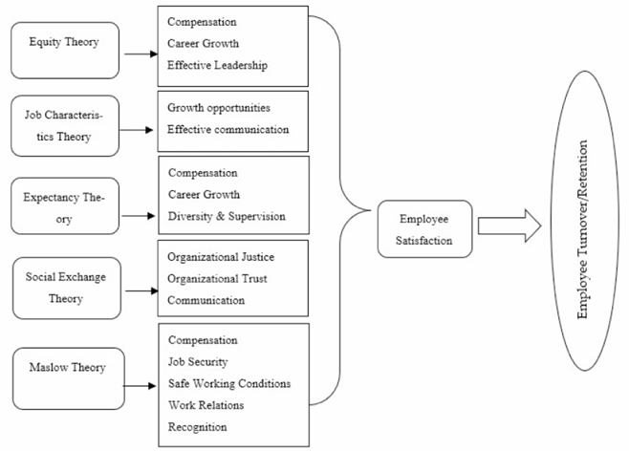
Figure 1 Model of theories of employee satisfaction
Source: (Ghani et al., 2022)

2.2. Satisfying Human Resources through Talent Administration Approaches
According to Hasaean and Özge, 2022,the challenges of recruitment in Middle Eastern hotels are functioning for some main reasons such as the competition for employees is high, economic factors are important, and the environment of the hotels. The authors do a good job of detailing the problems of recruitment of staff and their use of economic factors and competition as some of the ways that hotels in urban areas struggle to attract talent(King et al., 2021). The intended study employs to talk directly to the employees in the HRM position of hotels that are situated in Birmingham, Manchester, and London. The study finds that high prices for rents in the city's central business districts and low wages earnings in the industry act as major pullbacks to recruitment(Yang et al., 2021). As such, potential employees look for other sectors with better paying and stable working conditions leaving hotels facing a big challenge in staffing. Other works also show that the shortage of cheap houses and transport facilities could also keep people from going to work in city-center hotels(Guimaraes, 2022). This paper implies that hotels are required to re-strategize their employment plans by providing employees with attractive employee rewards that must overcome these urbanization-related hurdles, including relocation costs, transport allowances, or affordable accommodation linked to such authorities(Dubki et al., 2021).In the case of this hotel described in the work particular emphasis is placed on the necessity of the change in the recruitment methodologies with attention to the peculiarities of employment in the urban environment. Increasing the wage rates might not be possible because either the budget does not allow it or the industry standards do not allow but, but introducing ideas like offering house rents or giving transport allowances can help the hotel get more candidates(Cole et al., 2024). Also, Holiday Inn should organize talent acquisition activities with the educational establishments in the country, providing internships as well as starting positions for students. The study also highlights the need to adopt specific strategies due to the dynamic environment encountered in operational urban hotels.

2.3 Impact of Appropriate factors in Career Preservation
According to Chang and Busser, 2020, employee turnover has always been a major concern to hospitality organizations as turnover affects the quality of services as well as organizational efficiency. Reviews how different retention strategies in the hospitality industry to establish their efficiency. Employing questionnaire data collected from hospitality workers in the urban and rural context the study examines the impact of various retention factors on the level of employee commitment(Ohanian et al., 2020). This research identifies three key strategies for improving retention: First, on the employee’s side we have recognition programs, the second is promotion programs and the third one is flexible work options(Chang and Busser, 2020). This paper identified the methods used for appreciating employees found to improve the level of job satisfaction persons used in the study suggested that general incentives like “employee of the month” recognition and special incentives given to employees based on outstanding productivity boost job satisfaction(Chaim, 2021). Organizational development, for instance, promotion, and training opportunities are key areas that contribute greatly to staff retention because they provide career growth for the employees. Last but not least, the employees were able to have a part-time option along with shift options that were flexibly planned which actually decreased the turnover and also reduced burnout(Arab et al., 2022).A number of these retention measures could significantly affect the organization’s workforce steadiness. Appreciation regimes are good for morale and do create a sense of community among the employees training promotions are also good for the long-term employment of the employees so there is little chance of staff bouncing. Another area that discusses is flexibility as a crucial element in retaining staff, especially in hard and expensive locations like the city center(Michael and Fotiadis, 2022).
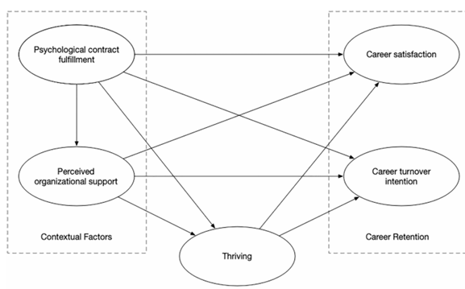
Figure 2 The proposed Conceptual Model
Source: (Chang and Busser, 2020)

3. Methodology
The study design aimed at ensuring that a holistic cross-sectional knowledge of Holiday Inn Birmingham City Centre’s staffing issues especially on recruitment, retention, and workforce stability is attained. They used both primary and secondary research to supplement quantitative, qualitative, and experience research as the case study examines issues affecting the business(Moody et al., 2021).

3.1 Case Study Approach
The first research method selected in this study is the case study technique. A case study is a focused paper on a specific subject, in this case, Holiday Inn Birmingham City Centre which prevents a generalized discussion of the challenges and makes it easier to focus on the intricacies surrounding recruitment and retention measures(García Carrizo, 2023).

3.1.1 Benefits of the Case Study Approach
The advantage of employing a case study in this study is that it provides a rich account of the problem under study in its natural environment(Rohu and Signal, 2020). This method affords insight into the particular strategies and workers at Holiday Inn Birmingham that could not be gathered by other larger more general quantitative assessments.

3.1.2 Limitations of the Case Study Approach
The case study approach also has some of the following weaknesses. The first one is the question of generality, among others. All these aspects imply that the findings of this study may not be generalizable to other related hotels or entrepreneurship ventures in other locations or environments(CourseNotes and Mihael, 2020).

3.2 Data Collection Techniques

3.2.1 Primary Data Collection
The first method of data collection involved the administration of structured questionnaires to both the staff and managers of Holiday Inn Birmingham City Centre. The questions were developed to collect additional specific information concerning the staffing problems with emphasis on the recruitment and retention problems and the geographical stability of employment (Mazhar et al., 2021).

3.2.2 Survey Design
The continuous main survey used both quantitative and qualitative approaches to gather the information. The quantitative questions included self-administered Questions designed to make the respondent provide his or her ratio scale estimation of their degree of satisfaction with particular aspects of their employment like wages, working conditions, or opportunities to be promoted (Liu et al., 2022).

3.2.3 Survey Questionnaire
Where are you at present at Holiday Inn Birmingham City Centre?
- Front Desk/Reception
- Housekeeping
- Food and Beverage Services
- Management
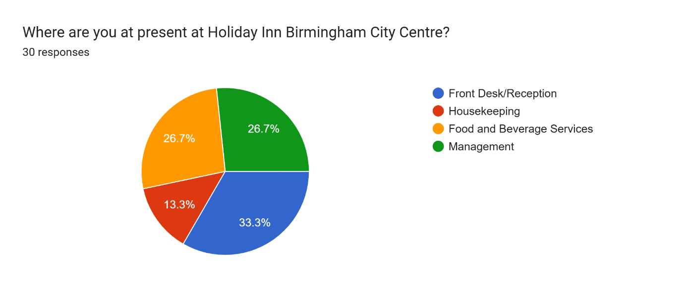
To whom do I work at Holiday Inn Birmingham City Centre?
- Less than 6 months
- 6 months – 1 year
- 1 – 3 years
- More than 3 years
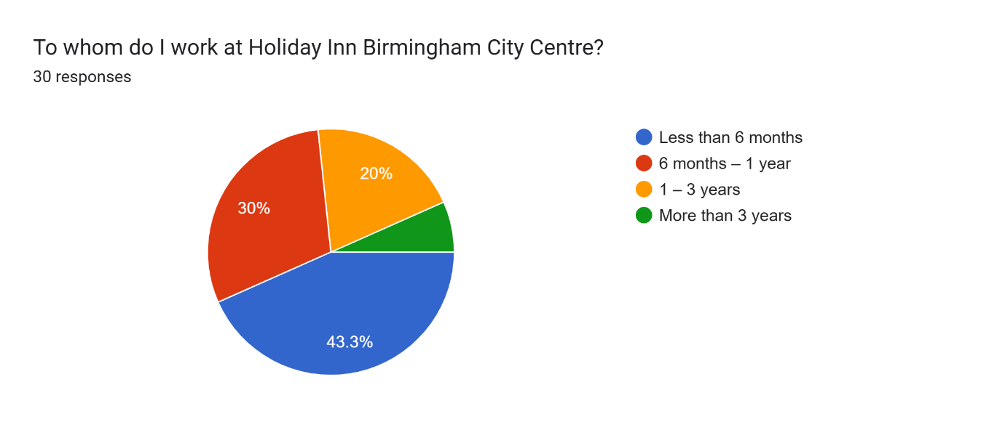
So how do I rate my overall job satisfaction with the hotel?
- Very satisfied
- Satisfied
- Neutral
- Dissatisfied
- Very dissatisfied
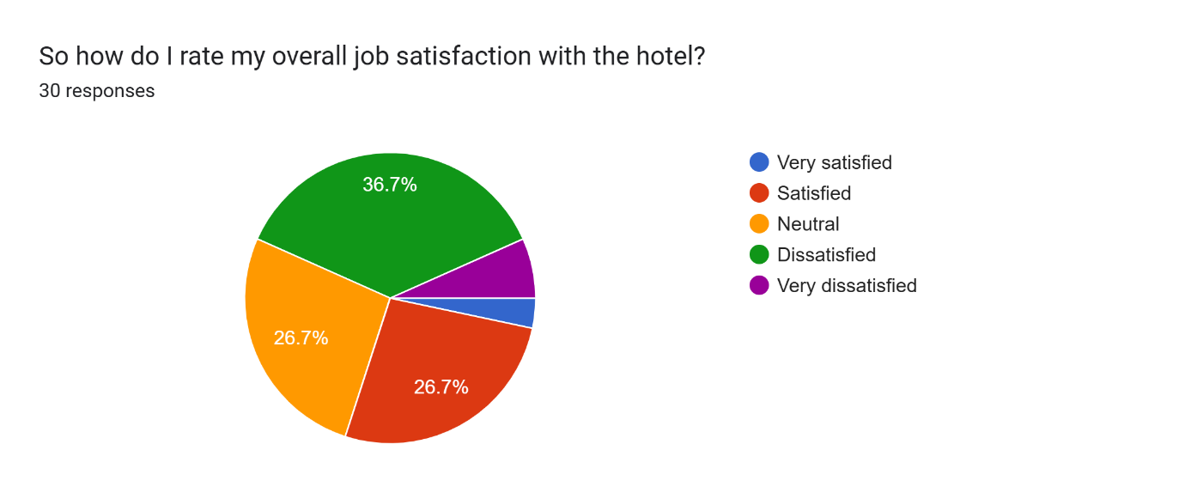
What is your opinion of the biggest challenge in recruiting new staff at Holiday Inn Birmingham City Centre?
- High cost of living in the city centre
- Competition from other employers
- Lack of career advancement opportunities
- Rigid working hours
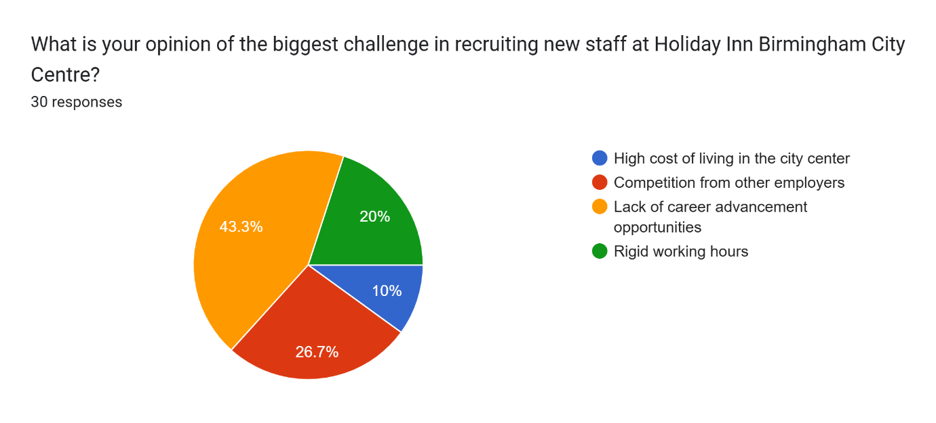
What would you say about the employee turnover rate for the hotel right now?
- Very high
- High
- Moderate
- Low
- Very low
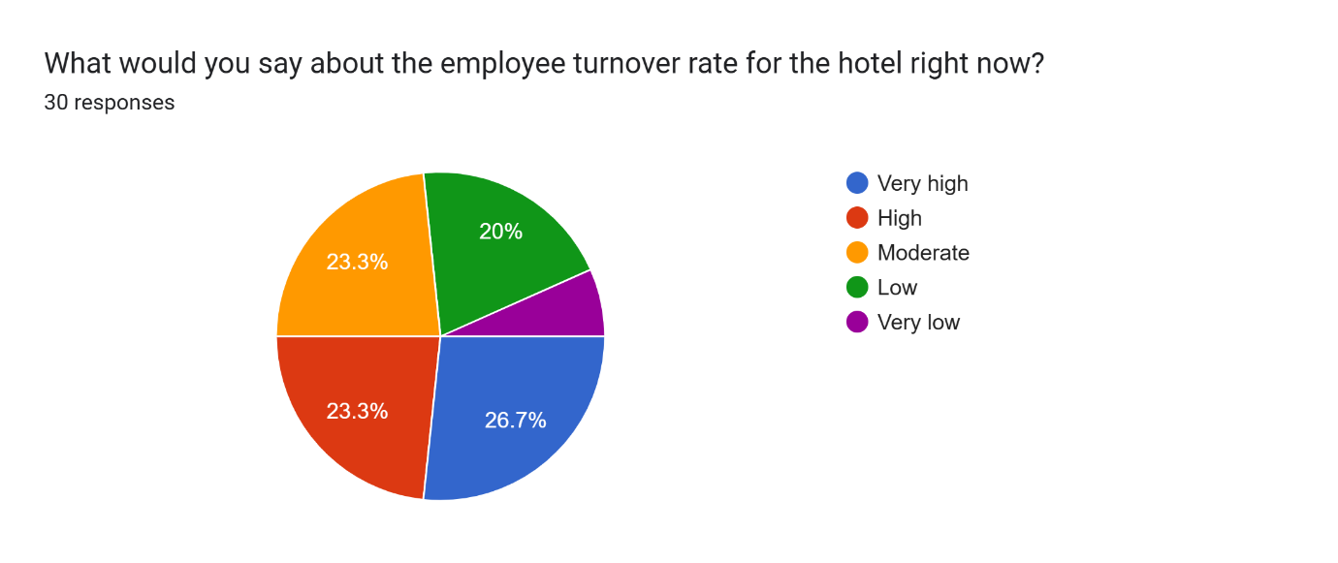
Why do you think that the main reason for employee turnover in the hotel company is?
- Low pay and benefits
- Lack of job satisfaction
- Long working hours
- Limited opportunities for promotion
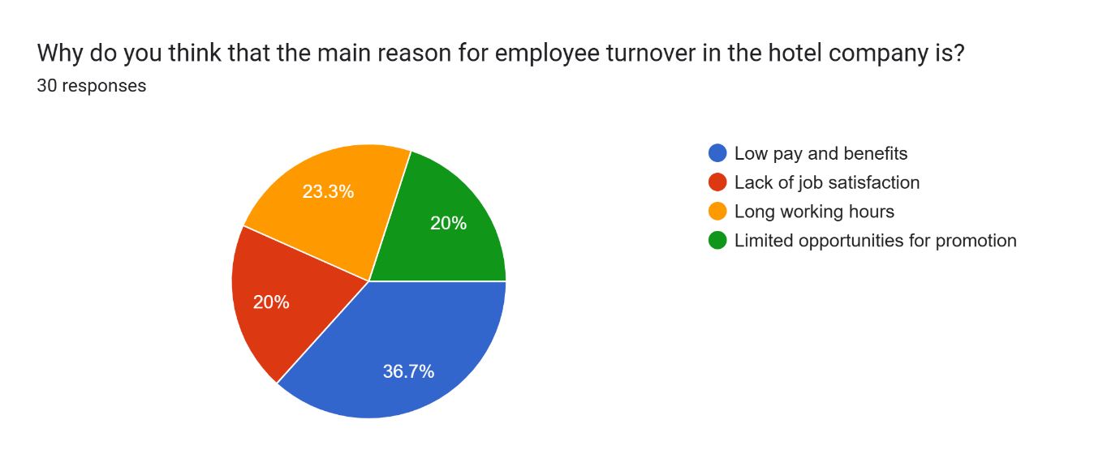
Just how effective do you think the hotel's current recruitment strategies are?
- Very effective
- Effective
- Neutral
- Ineffective
- Very ineffective
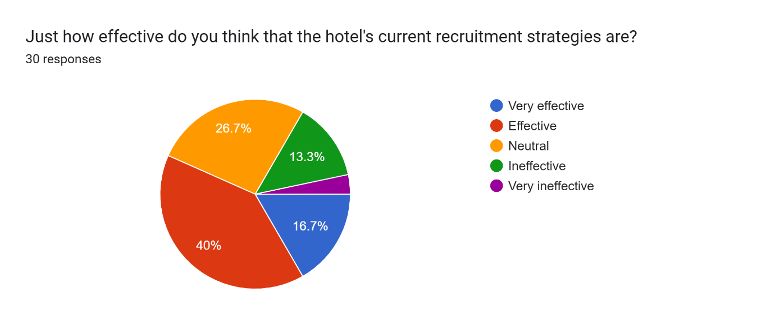
what would be the best factor to improve staff retention at Holiday Inn Birmingham City Centre?
- Higher pay
- Better benefits (healthcare, pensions, etc.)
- More flexible working hours
- More training and career development opportunities
- Improved work-life balance
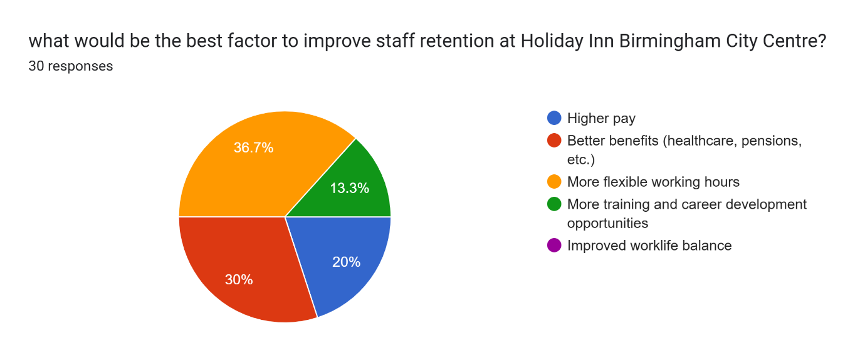
What would you give the hotel in terms of training and development opportunities?
- Excellent
- Good
- Average
- Poor
- Very poor
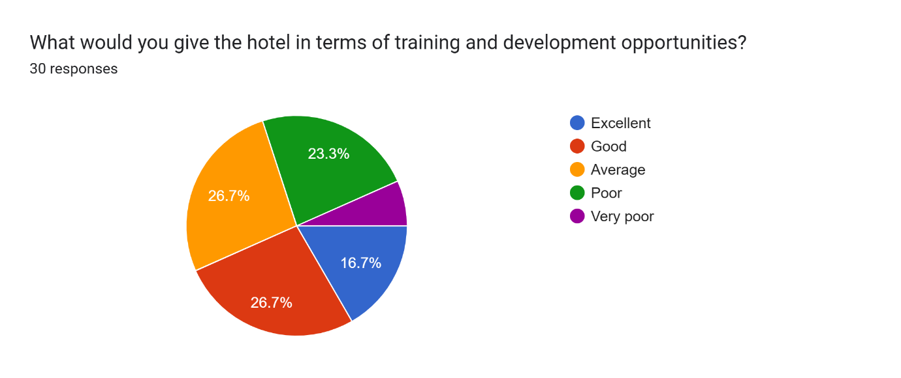
Do you think the hotel has a positive or negative impact recruiting new staff, because of its central location?
- Very positive
- Positive
- Neutral
- Negative
- Very negative
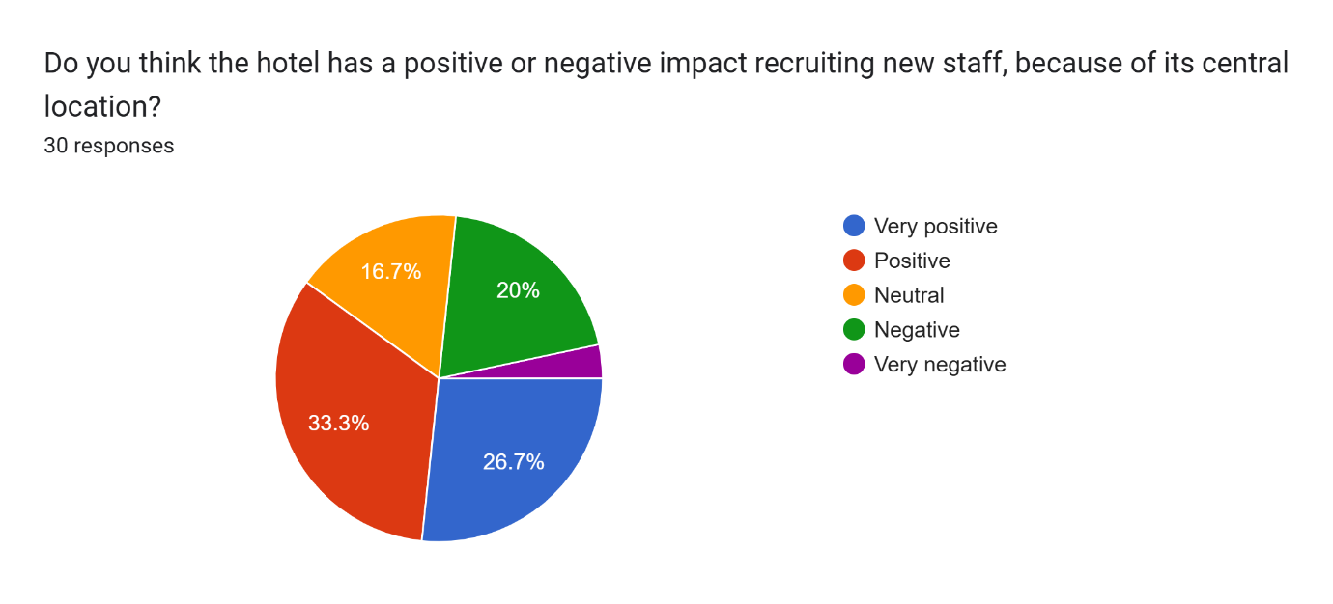
How do you think the hotel’s salary and benefits packages compare to other hotels in Birmingham?
- Much better
- Slightly better
- About the same
- Slightly worse
- Much worse
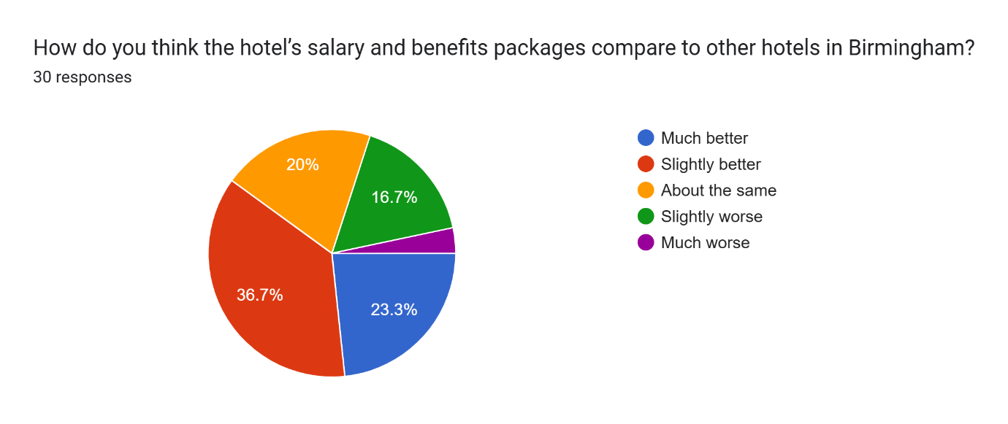
What score would you give Holiday Inn Birmingham City Centre for an employer rating?
- Very likely
- Likely
- Neutral
- Unlikely
- Very unlikely
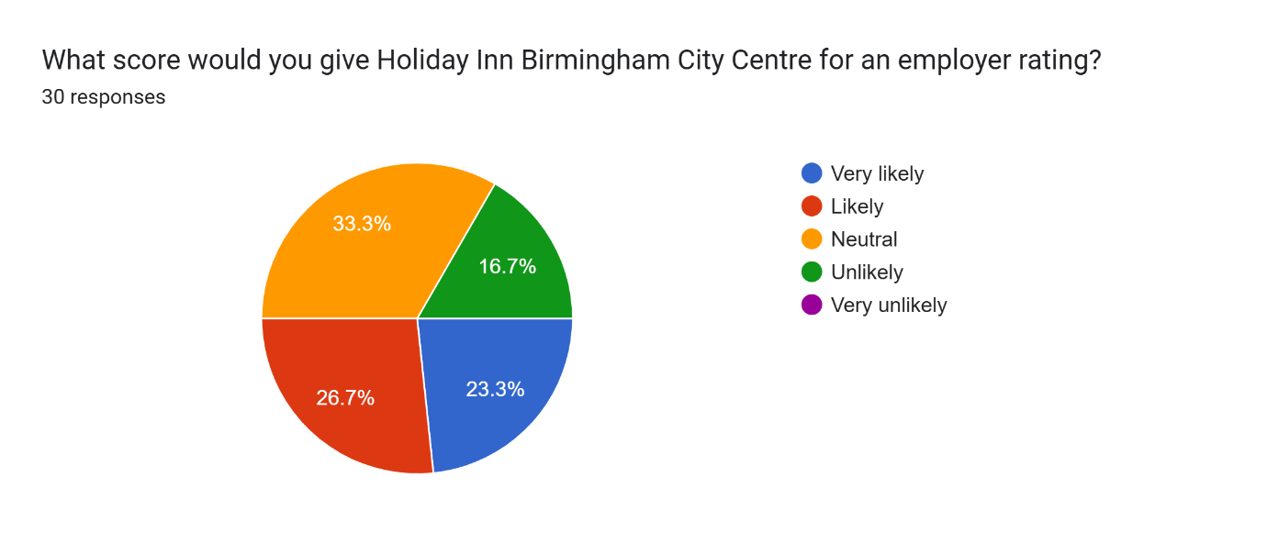
Do you like the work-life balance offered at the hotel?
- Very satisfied
- Satisfied
- Neutral
- Dissatisfied
- Very dissatisfied
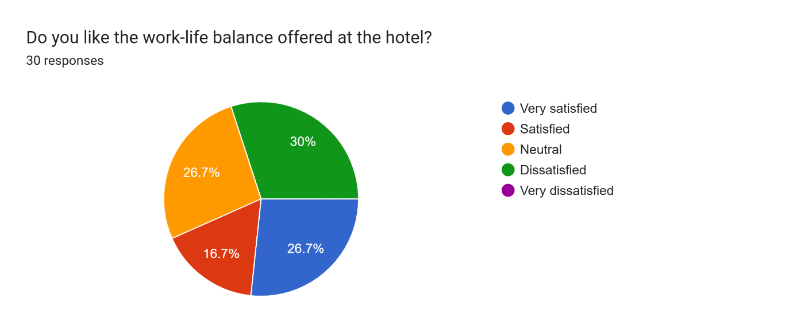
How would the hotel attract and retain staff recruitment and retention?
- Offer better pay and benefits
- Improve workplace culture
- Provide clearer career progression paths
- Increase flexibility in work schedules
- Invest in better recruitment channels
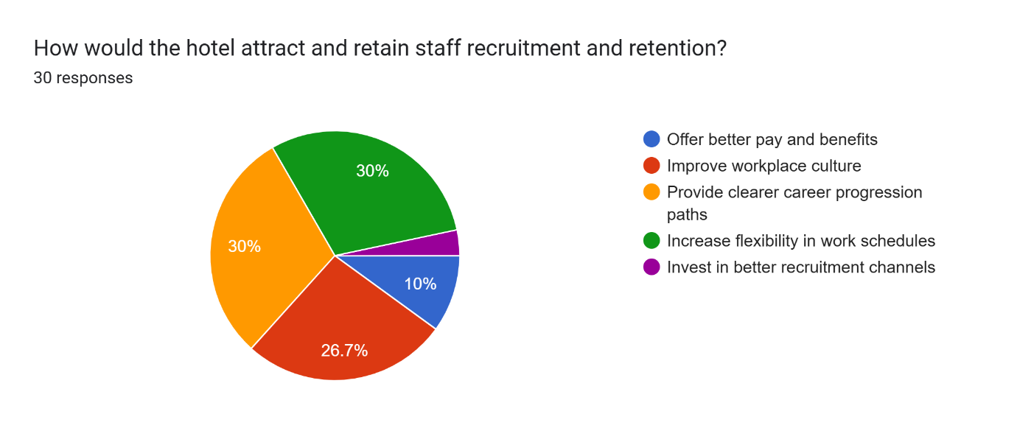
You also think the hotel offers enough support for people to make their careers further?
- Strongly agree
- Agree
- Neutral
- Disagree
- Strongly disagree
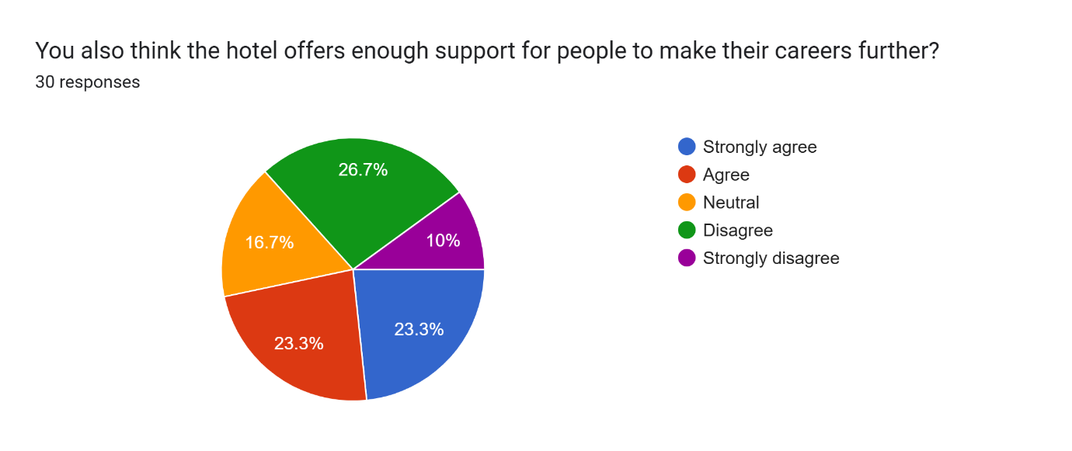

3.2.4 Secondary Data Collection
Secondary data was collected from tertiary sources such as scholarly journals, industry publications, and internal documents of Holiday Inn Birmingham City Centre.

3.2.5 Literature Review
An analysis of literature, a research question with hypotheses that focused on the themes elicited from the review of extant literature on recruitment and retention in the hospitality industry (Line et al., 2020). In the literature review section, some of the difficulties raised included employees’ unhappiness, high turnover, and the influence of city-centre sites.

3.3 Data Analysis

3.3.1 Quantitative Data Analysis
Data gathered through the survey was measured data then descriptive statistics was used on the collected data. It assisted in coming up with the summary of the replies which may help in profiling various trends of the organization’s status such as employment satisfaction, staff turnover, and recruitment challenges(Truong et al., 2020).

3.3.2 Qualitative Data Analysis
In addition, thematic analysis was used to analyze the collected qualitative data. This method concerned the analysis of the most frequent motives mentioned in the open-ended questions, which were, for example, dissatisfaction with the management support, absence of career advancement, and conflicts with the organizational schedule(Mariani and Baggio, 2020).

3.4 Justification of Methods
Primary data through survey and secondary data from literature and reports along with adopting the case study method give a proper and integrated study of the nature of staffing problems as experienced by Holiday Inn Birmingham City Centre. The case study approach is highly descriptive and contextual, making the study rich in detail, the use of qualitative and quantitative data makes results more valid.

4. Case Study Discussion (Holiday Inn Hotel, Birmingham City Centre)

4.1 Brief History of Holiday Inn Birmingham City Centre
Holiday Inn Birmingham City Centre is an independent hotel manager that operates as part of the InterContinental Hotels Group (IHG) which is the world’s largest multinational hospitality company dealing in mid-scale hotel franchises. Located within the city center of Birmingham, the hotel is conveniently positioned near a transport terminal including the Birmingham New Street Station for tourists and businessmen. This hotel boasts well over 200 rooms, digital conferencing services, a dining hall, and numerous services meant to complement the hotel guest systems and services ranging from free Wi-Fi to free parking within the facility compound(Marandi et al., 2024). Being a city center hotel, Holiday Inn Birmingham always has a high occupancy of guests, especially during events, conferences, and festivals that are always common in the city. On the one hand, it is well situated, it is central on the other hand, it poses certain difficulties, especially regarding personnel(Sakovska et al., 2021). The property stated that life in the urban areas of Birmingham is costly, and this means that the hotel struggles to hire and retain staff, especially those employees at the bottom end of the pay scale such as cleaners and waiters. There is also strong competitive pressure in the context of hotels where many other hospitality brands are present in the city, creating enormous pressure on recruitment as well as operational efficiency(Gürlek and Kılıç, 2021).

The hotel has a population diversity where people from different cultures work in various positions such as receptionists, food and beverage staff, and cleaners(Alberti and Iannuzzi, 2020). High turnover rates have remained problematic mainly owing to the high demands and task requirements typical of most hospitality employment opportunities and due to the stiff market competition inherent to the Birmingham employment market(Papadopoulos and Ioannou, 2023). In addition, Holiday Inn Birmingham City Centre operates with strict adherence to the guidelines of the parent company, InterContinental Hotels Group, and brand corporate guidelines in organization management, staff management, customer relations, and service delivery(Budhwar et al., 2023). This ensures uniformity across different IHG facilities.It can also reduce self-sufficiency or decision-making at the individual facility level, especially in addressing particular staffing challenges arising from the hotel’s situation in an urban environment(Ntounis et al., 2022). The hotel on most occasions has received good feedback from its guests regarding the area of location and customer service.

4.2 SWOT Analysis
SWOT analysis allows Holiday Inn Birmingham City Centre to appraise the strengths, weaknesses, opportunities, and threats when operating in the market. This analysis will seek to identify the internal and external forces that are likely to affect the function of the hotel and its workforce(Bunyamin, 2023).

4.2.1 Strengths
Leading Location: It will be recalled that one of the most important strategic advantages of this hotel is its prime location in the heart of Birmingham(Green et al., 2021). Being located near transportation terminals, shopping malls, and function facilities makes the hotel suitable to accommodate various forms of visitors which include tourists and business people.
Robust Brand Acknowledgment: Being part of the IHG group, the Holiday Inn Birmingham City Centre is advantageously positioned in terms of brand image and customer affinity.
MiscellaneousEmployees: Culturally and lingually diverse employees are employed in the hotel’s workforce calendar from different parts of the globe(Rahimi et al., 2022). The above diversity helps the hotel to be adaptable and serve a wide market, especially the international market.

4.2.2 Weaknesses
High Revenue Rates: One ofthe long-standing issues on the employee front is high turnover rates, especially among employees providing services such as housekeeping, food, and beverages. This results in high costs of recruitment and training, and poor quality of service to the clients(Fu et al., 2022).
Staffing Shortages: Since it is located in the city Centre of Birmingham, talent competition is high, and the establishment cannot afford to pay high wages for the operation personnel(Ntounis et al., 2022).

4.2.3 Opportunities
Businesses with ResidentInstructive Institutions:The hotel could employ local talents as a source of economic help, and use interns from colleges and universities. This could also assist in refilling human resource deficits whilst attracting young talents with a passion for hospitality careers(Morley, 2020).
Use of Innovative Technologies: Implementation of smart technologies to enhance organizational procedures, for instance, the application of technological self-service check-in systems and AI-based cleaning equipment offers an option of avoiding direct employment of employees in some capacities and enhancing customer service(Slade et al., 2023).

4.2.4 Threats
Rivalry from Further Hotels: This hotel struggles with competitors of other large hotel chains and individual hotels in the area of Birmingham city center. Such competition is compounded by issues with the staffing of the hotel and it is well known to negatively impact the services hence customer satisfaction(Platt and Warwick, 2020).
FinancialAmbiguity: External environmental variables, including Brexit and the COVID-19 outbreak, result in transforming demand within the sphere. This fluctuation might harm the hotel's operation financially and personnel in terms of the stability of the workforce(Ntounis et al., 2022).

4.3 PEST Analysis
PEST stands for political, economic, social, and technological factors that affect the Holiday Inn Birmingham City Centre and has a connection with the issues of managing the workforce(FIRAT and Necibe, 2024).

4.3.1 Political Factors
Migration and BrexitProcedure: Brexit has affected the supply of labor in the hospitality industry. Fewer EU citizens have been going to the UK for work, which is the major cause of the staff deficit in hotels such as Holiday Inn Birmingham City Centre. Recent reforms in immigration laws after the Brexit deal have contracted the accessibility of foreigners to work for them and this has compounded the effects of staff shortage(de Ruyter et al., 2021).
AdministrationGuidelines: Probably the most significant internal vulnerability is the legal authority regulating the hospitality industry through health, safety, labor, and environmental requirements. Failure to adhere to these regulations is an Author’s responsibility but it may also raise business operational expenses, especially in a highly regulated urban area such as Birmingham(Vathi and Trandafoiu, 2023).

4.3.2 Economic Factors
Price of Existing: Among all the economic factors influencing the operations of Holiday Inn Birmingham City Centre, the highest level of living in Birmingham is preferable for today. The occupancy cost that is experienced in the city center limits the hotel’s ability to attract and retain its employees, especially those offered low wages(Tranos et al., 2021).
Wage Pressure: Wages in the hospitality industry are relatively low and this factor has brought the problem of trying to attract employees from other industries. The need to pay highly for staff to be able to attract him/her due to a shortage of human resources in the market leads to high operating costs for the hotel(Hill and Cheshire, 2023).

4.3.3 Social Factors
Fluctuating EmployeePotentials: New-generation employees in the hospitality industry have high expectations of flexibility at the workplace, working hours, stress-free working environment, and opportunities to advance in their careers. Due to the mentioned changes, Birmingham City Centre has to satisfy these expectations by hiring young employees(Barber, 2021).
Multiplicity and Attachment: The hospitality industry is one of the most diverse members of the workforce in the industry. Working with such a large population of staff diversity means that the hotel must ensure that it has put in place some policies that will help the employees. There are also ways that organizations may take to enhance the levels of retention for their employees such as valuing the employees through showing respect to them(Moraes et al., 2021).

4.3.4 Technological Factors
Computerization and Artificial Intelligence: the use of check-in kiosks and various other artificial intelligence-based interactive service-delivering systems helps the hotel in managing the human staff workforce, and makes some processes more efficient and independent from staff assistance. The possible downside of such technologies is the issue of job Automation within those industries that seek to adopt such technologies at first(Said et al., 2024).
Digital Marketing:Technology has its part to play in the ways that the hotel communicates and sells services to consumers. To this extent, social accounts, ratings and reviews, and online booking are relevant means for capturing guests. A constant job of monitoring and maintaining the hotel’s image on the Internet needs manpower, a problem considering the difficulties of getting enough staff during shortages(Al-Gasawneh et al., 2022).

4.4 Competitor Analysis
The following field and competitor analysis prove that Holiday Inn Birmingham City Centre faces stiff market competition from other competitors existing in the same industry locally as well as internationally(Rahimi et al., 2022). This competitor analysis will be directed to other hotel rivals such as Hilton, Marriott, and Premier Inn in the Birmingham city center about Holiday Inn pricing, quality, and staff management.

4.4.1 Hilton Birmingham Metropole
Valuing: With regards to Hilton Birmingham Metropole is that it is an upscale Hotel and businesses come with higher stay rates compared to high prices are attributed to its brand image, many facilities offered, and close location to the National Exhibition Centre(Smith, 2023).
Superiority: Since it is in the competitive luxury hotels segment, Hilton stands out as one with higher customer satisfaction due to the quality services and other facilities that it provides. It is a result of impressive staff retention with a lower staff turnover compared with that of Holiday Inn and better employee benefits(Musial, 2023).
Employees Management: Hilton has a privileged position around the globe, and it can offer employment to more promising performers Hilton pays great attention to its employees’ professional education. It gives employees focus on their career progression and increases the organizational commitment they have hence increasing the time they will spend working for Hilton(Aroul et al., 2023).

4.4.2
Valuing: The competitor that directly opposes Holiday Inn in its pricing policy is Novotel which provides midscale in the downtown area. The two hotels orient themselves to businessmen and tourists and charge almost the same prices for their rooms. On the other hand, Novotel is usually on offer and could quite easily drown price-conscious tourists and guests to their hotel properties out of Holiday Inn.
Superiority: Novotel is a similar brand to Holiday Inn: services and facilities are almost identical, but customers point out that the level of cleanliness and efficiency of services is higher. That is why Novotel can serve food and beverages at a level higher since it has a better staff-to-staff turnover ratio(Grüger et al., 2023).
Employees Management: Flexible working time is another practice that has been employed at Novotel and other HRM firms to address stains and boost staff morale through the promotion of wellness activity.

4.5 Digital Ethnography (Netnography)
Digital ethnography is therefore a more structured and formalized approach to data collection and analysis that takes a qualitative approach to study what consumers are saying about products, services, and brands on the web and through social media and other online consumer-generated forums(Atsiz and Seyitoglu, 2023). For Holiday Inn Birmingham City Centre, findings from the first ethnographic research aim to provide the user-guest perspective of the hotel’s internal environment, especially in staffing and services.

4.5.1 OperationalEvaluation Analysis
The survey of user-generated content from sites like TripAdvisor, Google reviews, as well as Booking.com shows both positive and negative feedback for Holiday Inn Birmingham City Centre. It is not uncommon to see guests boasting of the hotel's strategic positioning, gaining some, kept, moderate price, and warm hosts. Customers like access to various city attractions and opportunities to get to them as well as business facilities so the hotel is equally suitable for the business and tourists(Razil et al., 2022). The complaints of the miserable experience of the customers are normally reported about service delivery and hygiene which may be attributed to staff shortage in the hotel industry.

4.5.2 Social Media Perceptions
Feedback on Holiday Inn Birmingham City Centre on social networkssuch as Twitter and Instagram is focused on customer-oriented services. While some would have pleasant things to say about the hotel staff, others are customers who complain about being served slowly and never hearing from the management after their complaints. Such comments call for better workforce planning to establish a stable workforce that will be trained to deliver quality service(Brown and Wilson. 2021).

5. Theme Exploration
The challenges for recruitment and retention in health and human services organizations require discussion analysis here because they are important aspects that impact an organization.One of the significant issues for the hotel industry is the capacity to recruit and retain an efficient and dedicated workforce with hotels situated in city centers operating in a highly competitive market, this issue becomes important(Mehraliyev et al., 2022). Holiday Inn Birmingham City Centre also experiences major concern over the recruitment and retention of employees where some challenges include competition for employees, economic constraints, and a demanding working environment due to the nature of jobs offered in the sector of hospitality.

5.1 EmploymentIssues at Holiday Inn Birmingham

5.1.1 Rivalry for Aptitude
There is stiff competition for workers amongst the hospitality companies and therefore, talent competition is one of the key challenges evident at Holiday Inn Birmingham City Centre. Over the years, it has been realized that the city center of Birmingham is also abundant with hotels, restaurants, and most especially service industries in their market competition for few but qualified workers. It is not exclusive to the hospitality industry only, companies in the retail, entertainment, and customer service areas also compete for such candidates(Langston and Zhang, 2021). Limitations in competing allow Holiday Inn to struggle to promote it as an employer of choice. They can find better salary packages or better working conditions in the larger hotel chains or better still in specialty hotel chains better off than boutique hotels with wider profit margins.

5.1.2 High Rate of Existing
The high cost of living in Birmingham’s city center also worsens recruitment issues. For example, the cost of housing is beyond the reach of many prospective employees let alone the young, aspiring candidates signing up for internships and other low-skill jobs. For the employees who reside in other parts of the city, the challenge is that workers are pricey and time-consuming to recruit due to the long distances involved in commuting(Pittard and Ewing, 2024). Some of the best talents do not apply in the company since many potential employees prefer to work in suburban areas or industries that pay better than Holiday Inn Birmingham City Centre.

5.1.3 BusinessObservation
As mentioned earlier, the hospitality industry has requirement specification image problems, particularly in entry-level and operational employment categories where images have long working hours, low pay, and laid-off career mobility. Such a perception ensures that hotels like Holiday Inn find it difficult to attract young employees or those who prefer fixed-term employment(Hansen et al., 2021).

5.1.4 The Issue with the EmploymentProcedure
This shows that even our recruitment process is inefficient and it is a key reason why Holiday Inn is struggling to recruit enough staff. This might not be enough to create awareness, and therefore, there is a need to use other means of reaching a larger audience of potential employees(Duvic-Paoli, 2022). The hotel does not also engage in effective affiliations with local learning institutions theseought to supply the hotel with human resources through internships or bulk recruitments.

5.2 RetainingProblems of Holiday Inn Birmingham

5.2.1 High Employee Turnover
As in many hotels in the central city, there is a high turnover of employees in HIBC, especially in the jobs with low pay. There is a high turnover in employees or workers, particularly in areas like housekeeping, front office desk, and reception, and mostly in situations where working involves lifting heavy equipment such as in fast food chains or restaurants, the wages offered are low. This continuous outsourcing of employees has become a critical challenge because the human resource department of the hotel is constantly searching for new employees to replace the outgoing employee recruitment and training are expensive processes(Tahir and Raza, 2020).

5.2.2 Deficiency of career development
The respondent’s perception that there are few promotional avenues in Holiday Inn Birmingham is a major reason for turnover intention. Such systems create low expectations of promotion in the company among employees at the entry level, hence frustration prevails. Due to poorly defined career management programs, the employees are likely to leave the hotel for other organizations, despite their overall job satisfaction. At the moment, there are no specific channels for promotions, there is no concept of professional coaching or personal advancement training within the hotel. The employees get a perception that they are stuck within the company and there will be high turnover as they seek other opportunities in other hotels as well as other markets(Lawani et al. 2022).

5.2.3 The Office and Work-life IntrusionProblems
They have other key issues affecting retention practices however, they will focus on two main areas, including Work-life balance as mentioned, carrying out research to identify the views of the hotelchain hired after a six-month vacancy will reveal that Holiday Inn Birmingham City Centre faces other major retention challenges. This is a true prediction of this type of work environment since many job positions in the hospitality environments involve employees working during the evenings, weekends, and even holidays. This can breed burnout especially where employees especially at the unit operations level can be assigned to work in a sequence of shifts during the peak demand seasons. It even worsens by the fact that the schedules are fixed and the employees hardly have control over their work schedules. Looking at the detailing of the organizational structure of the industry, flexibility in the demand of employees, especially in the schedules, may sound like a vacation to other job performers unfortunately, the hotel failed to accommodate the young employees’ preferences for a strict work timetable.

5. 3 Inspiration of Residence on Employment and EmployerMaintenance

5.3.1 Transferenceavailability
This is a powerful advertisement point to the guests and employees because it will be easily accessible using public transport. This is slightly offset by the fact that most of the Birmingham employees can easily come to work by either bus or train because they live outside the expensive city center. Another weakness as a result of this is that an employee is at the mercy of the public transport especially for those who use regional or national train services some of which unfortunately will have to endure unpredictable delays or disruptions during rush hours.

5.3.2 LuxuriousLifespan in Birmingham City Centre
Since Holiday Inn is situated in Birmingham City Centre, the company experiences a daunting task in terms of recruitment and retention of workers majorly because the cost of living within the city centre is very high. The cost of houses in the city center of Birmingham has increased over the past few years while wages for workers especially those in cleaning or restaurant service industries barely meet the cost of rent for houses near their workplace. A large number of workers can afford to rent or buy accommodation only in distant districts of the city or in neighboring towns which results in spending additional time and money on transportation.

5.3.3 Rivalry for Talent in the City Center
Its location at Holiday Inn Birmingham City Centre makes make it operate right from under the noses of other hotels, restaurants, and service industry players. Due to the stiff competition, the number of hotels in Birmingham is large, meaning that the job seekers are commanding only a few options in the market. This competition is especially true in the lower job grade, where the paying skills are meager, and skills are easily movable to other industries. Besides competing with the other hotels in the industry, Holiday Inn Birmingham competes with the retail and the service industry where some of the clients may offer a better working environment or better remuneration.

5.3.4 Influence of Local Activities, and Tourism
There is always something happening in Birmingham including events, conferences, and exhibitions to mention but a few. In as much as these events benefit the hotel by boosting its guest bookings they also generate more demand for the workforce. Due to the high business volumes recorded during such occasions, this demands high occupancy rates in the hotel hence the need to employ all human resources(Salinero et al., 2022). Nevertheless, because such events are not permanent, the hotel may face formidable challenges in securing enough manpower for the duration of the event because there simply may not be enough qualified people available for hire in the region. Such a higher business volume during this period can overwhelm existing employees, and where there is inadequate staffing, this problem can greatly affect the employees.

5.4 Places of Expansion and Enhancement
From the policy strategy formulated in tackling staffing issues of Holiday Inn Birmingham City Centre some of the areas of development and improvement include such areas cover the methods of improving the satisfaction level of the employees, increasing the efficiency of the recruitment process, and developing a healthy organizational culture. The hotel can stabilize the workforce and work substantially more efficiently by focusing on these initiatives.

5.4.1 Competitive Compensation and Benefits
The most significant rationale for the staffing issues is the unfair remuneration system provided to its employees to embrace the job. Due to current market competition, Holiday Inn Birmingham City Centre needs to conduct a detailed analysis of compensation packages designed within the hotel. This review should consider the following:
SupervisoryStandard: Experience has shown that benchmarking salaries and benefits at least annually against analogous hotels in the region is important in making sure that Honeycomb offers its staff competitive pay. This analysis should also embrace the perks that relate to medical cover, pension schemes, and group discounts among others(Anggraeni et al., 2023).
Presentation-basedEncouragements: There should be improvements in the employee performance awards whereby he or she should be awarded in proportion to the performance he or she has produced. This could involve and promised bonus such as extra cash at the end of every three months by use of customer ratings, and company performance ratings.

5.4.2 WorkerProgress&Training plans
Employee training and development are valued for retention and job satisfaction of the employees. Holiday Inn Birmingham City Centre should focus on the following areas:
PlannedProfessionPaths:Create coherent guidelines for the advancement of an employee’s career, the skills and experience needed to progress. This might entail setting up the kind of training where the experienced staff helps others who are new in the organization in their career paths.
ExerciseProspects: Scheduling specific time in providing training and workshops for hard skills, especially in customer operations, and soft skills like leadership and interpersonal communication. In this case, the needed training programs should be developed for the several departments of the hotel.
IncessantKnowledgeAtmosphere: The last is to support employer’s employees by advising them to attend classes or get a higher degree or certification in the hospitality sector. The financial compensation or any other motivation, the hotel could offer for the workers seeking professional advancement.

5.4.3 Successful Strategies in Recruitment and Talent Branding
To hire the right talent, Holiday Inn Birmingham City Centre needs to improve the following factors concerning the recruitment process and employer branding. Key areas for improvement include:
Practice of NumericalStages: Increased use of modern platforms in recruitment such as the use of social media in conveying the recruitment advertisements widely. Adverts placed to source for a suitable candidate should include aspects of the hotel’s positive working environment, development opportunities, and qualities of the job.
Progresscorporations: Regularly establish partnerships with educational institutions and hospitality programs. It can in a way develop a pool of employees where the hotel can assess them before they offer them formal employment. Marketing the hotel to enhance its reputation as the preferred place of work in Birmingham.

6. Conclusions
In conclusion, regarding the staffing issues, the following factors closest to Holiday Inn Birmingham City Centre evidence that the problem of effective employee retention and job satisfaction in the context of the hospitality sector has various sides. These findings show that pay parity is a major tenet of Recruitment but it is not the key driver of staff retention. Some of these factors include career progression paths, organizational environment, and staff participation respectively all of which are important in the employee lives. It has to stimulate employment in a way that goes beyond simple dollar signals to keep staff throughout the entire hotel, while considering the stresses that come with the job, so critical in a service industry, in its evaluations. The main reasons that employers should ensure competitive or above competitive wages, opportunities for employee promotions, and job satisfaction are essential for skilled employee attraction. The research should also emphasize the need for organizations to support and promote enhanced staff learning through better-structured training, and other possible staff learning development schemes. Staff members who are sure that their employer is keen on having them gain further professional experience for themselves are likely to be happier and more loyal to the job. Mention, therefore, should also be made of the importance of fostering a healthy organizational culture in terms of teamwork, employee fellow feel, and respect for others. Any organization within the industry that fosters such a culture also gets increased employee productivity and boosts morale of the guests which all work towards the success of the hotel. Solving various aspects of the staffing issues is vital for Holiday Inn Birmingham City Centre as a company focused on personnel retention and promoting the engaged and highly motivated staff capable of delivering high-quality services and products.

6.1 Future Recommendations
When addressing the staffing and retention problem of Holiday Inn Birmingham City Centre the following strategic suggestions are provided.
StudyReimbursement Packages
It is necessary to carry out detailed market research with honest evaluations of competitor organizations concerning the offered wages and conditions. A fair compensation package that includes merit awards, incentives, adequate, and variable benefits will go a long way towards gaining and sustaining talent.
InstrumentCompleteExercisePlans
Training and development should start with a program that should include a clear onboarding program, skill development, and leadership programs. About promotion, the following can be stated Promoting employees in predefined paths can increase their commitment towards the organization.
ImproveEmploymentApproaches
Promote the use of technological sources in terms of job boards, social networks, and fairs in the region to widen the sourcing pool. These relationships enhance internship possibilities and achieve a sound means of recruitment contacts.
SubstituteEmployerAssignation
It is necessary to carry out frequent surveys to ascertain how satisfied the employees are in their jobs, and to hear any feedback that they may wish to give. Implementation of special programs that would involve acknowledging efforts of the employees, and creation of policies which would enable the workers to have a healthy closure between their working and personal lives.
EncourageanOptimistic Organizational Principles
It is recommended on the management level to pay much attention to the values that should be established in an organization, including respect, inclusion, and teamwork. Increasing the frequency of team-oriented activities, creating open channels of communication, and providing the opportunity for the employees to utilize their input into the collaboration of the team will improve the relationships of the team.
Concentration on EmployerHappiness
Think of actions that focus on boosting the health of workers by offering wellness programs, paid days off for mental health, and access to counsellors. It was established that the promotion of organizational health for the employee would tremendously improve gratification and loyalty in the workforce.

7. Reflective Account

Introduction
I am grateful to have the opportunity to analyse my clinical experience at Holiday Inn Birmingham City Centre because it offered me an understanding of the human resource management universe of the hospitality industry. It has been my privilege to watch the trials and successes that accompany a multigenerational and multicultural staff in a stressful setting. As a result, this reflective account will discuss the process of learning, key theories that have been incorporated into practice, individual development, and the societal significance of the learning process in the context of staffing and employee engagement.

Explanations and Practices
As a staff of Holiday Inn, there are various areas that I took part in managing them, areas touching on operations management such as training, guest relations as well as solving guest’s complaints. My other general areas wherethe morale of employees is one of the most determinable factors to the general morale of the guests. I saw how stimulated and committed employees could bring a higher level of service to the guests and, in turn, guarantee praise and consumers’ return. On the flip side, I also observed the negative impact that poor morale and high turnover subsequently cause on service delivery. It was important for the hotel to realize that future investments in employee health were a strategic imperative for the organization.
Besides conducting myself through interactions with employees, I engaged in other competency development training for the staff. Both of these sessions suggested a need for continuous training to create talented and dynamic personnel. I came to the realization that training goes beyond imparting knowledge to the employees but also building loyalty among employees. This experience was coherent with the theoretical concept of EE which presupposes that organizations should strive for employees’ continued growth to keep them on board.

AcademicPerceptions
During my work at Holiday Inn, I managed to apply quite several theories that I learned in class, especially in motivation and organizational behaviour. Of the many theories one which stood out was Maslow’s Need Hierarchy theory, which asserted that people have needs that are arranged in a hierarchy from basic physiological needs to self-actualization. Since my last observation session, I noticed that the ordinary needs of organizational employees were met for the most part, however, many of the employees showed concern for self-actualization needs which is a part of Maslow’s hierarchy of needs.

Herzberg’s Two Factor Theory was more applicable when am working at the hotel. This theory divides factors into the ‘hygiene factors’ which avoid dissatisfaction, and ‘motivators’ which generate satisfaction at the workplace. This study discovered that during a discussion with the staff, workers were content with hygiene factors at the workplace but desired organizational factors that included recognition, responsibilities, and advancement. This understanding supported the notion that improvement of hygiene factors alone is insufficient for enhancing organizational workplace climate.

IndividualExpansion
In my opinion, this has been a very valuable experience personal and professional. Through this position, I integrated and improved skills such as communication skills, problem-solving, and conflict-solving skills which are so vital in the hospitality industry. Communication skills were developed through interacting with numerous guests and colleagues and enabling effective actions in numerous situations. I also saw how listening and understanding when the employee is reporting a matter is crucial as these show that you trust the employee.
It also pointed to flexibility as one of the essential aspects of the working environment that changed frequently. The nature of the hospitality industry is that it is very vulnerable to various surprises, for example, a shortage of staff or the emergence of new expectations from guests. They taught me how to stay cool during stress and how to solve problems. Such flexibility not only enhanced my productivity but also helped in creating a positive environment with my coworkers who are also struggling some of the time.

Broader Implications
In perspective, I have seen it is heartbreaking but those troubles that Holiday Inn Birmingham City Centre has undergone are common in hospitality management. The employee turnover and staffing difficulties that concern the hotel are not peculiar only to the company but also typical for the whole hotel industry worldwide, which has a high rate of employee turnover. Such realization underlines the necessity of actions and practices that would consider the occupation of employees in industries.
At the same time, my practical findings emphasize the need for enhancing career admiration within organizations. In other words, employees who have a perception of organizational value will be more committed and effective in their work. This is in line with present literature on the motivation of employees in organizations to embrace recognition programs as well as offering feedback frequently, to increase rating among employees.

Future Considerations
In that regard, I think that the time spent at Holiday Inn will remain valuable in developing my perspective on human resource management in my career. Having seen how engagement has affected the performance of the company I have learnt the importance of engagement in organizations. While seeking to secure work in this line, I will ensure that I promote the right organizational climates, highly recommend employee development, and make policies to support workers.Also, I have acknowledged the significance of training and knowledge updates within the hospitality industry. The requirement for flexible workers will continue to increase as the industry advances. Hence, I intend to remain updated with existing trends and practices about engaging and training employees and be in a position to add value to my future organizations.

8. References
Alberti, G. and Iannuzzi, F.E., (2020)‘Embodied intersectionality and the intersectional management of hotel labour: The everyday experiences of social differentiation in customer‐oriented work’m Gender, Work & Organization, 27(6), pp.1165-1180.https://onlinelibrary.wiley.com/doi/abs/10.1111/gwao.12454
Al-Gasawneh, J.A., AlZubi, K.N., Anuar, M.M., Padlee, S.F., Ul-Haque, A. and Saputra, J. (2022)‘Marketing performance sustainability in the Jordanian hospitality industry: The roles of customer relationship management and service quality’, Sustainability, 14(2), p.803.https://www.mdpi.com/2071-1050/14/2/803
Anggraeni, R.D., Ismail, T., Lestari, T. and Ramdhani, D. (2023)‘The Relationship between Strategic Leadership, Competitive Advantage and Intellectual Capital: Evidence from Hotel in Tangerang Indonesia’, Britain International of Humanities and Social Sciences (BIoHS) Journal, 5(2), pp.100-112.http://www.biarjournal.com/index.php/biohs/article/view/899
Aroul, R.R., Hodari, D., Bianchi, G. and Martignoni, G. (2023)‘The impact of brand affiliation on asset values: the case of UK hotels’, Journal of property research, 40(2), pp.157-187.https://www.tandfonline.com/doi/abs/10.1080/09599916.2022.2114925
Arab, M., Ansari, J., Azhar, M. and Ali, M. (2022)‘Exploring the influence of training and development on employee’s performance: Empirical evidence from the Indian tourism industry’, Management Science Letters, 12(2), pp.89-100.http://growingscience.com/beta/msl/5200-exploring-the-influence-of-training-and-development-on-employees-performance-empirical-evidence-from-the-indian-tourism-industry.html
Atish, O. and Systole, F. (2023)‘A ethnography approach on the daily local-guided shopping tour experiences of travellers: An unexplored facet of the sharing economy’, Journal of Vacation Marketing, 29(1), pp.103-118.https://journals.sagepub.com/doi/abs/10.1177/13567667221078248
Barber, T. (2021)‘Differentiated embedding among the Vietnamese refugees in London and the UK: fragmentation, complexity, and ‘in/visibility’, Journal of Ethnic and Migration Studies, 47(21), pp.4835-4852.https://www.tandfonline.com/doi/full/10.1080/1369183X.2020.1724414
Brown, D. and Wilson, S. (2021)‘Climbing the virtual mountain: A ethnography of the sharing and collecting behaviours of online Munro-bagging’, In Emerging Transformations in Tourism and Hospitality, pp. 170-186. https://www.taylorfrancis.com/chapters/edit/10.4324/9781003105930-13/climbing-virtual-mountain-david-brown-sharon-wilson
Budhwar, P., Chowdhury, S., Wood, G., Anguini’s, H., Bamber, G.J., Beltran, J.R., Bosele, P., Lee Cooke, F., Decker, S., Denis, A. and Dey, P.K. (2023)‘Human resource management in the age of generative artificial intelligence: Perspectives and research directions on ChatGPT’, Human Resource Management Journal, 33(3), pp.606-659.https://onlinelibrary.wiley.com/doi/abs/10.1111/1748-8583.12524
Bunyamin, B. (2023)‘Swot Analysis of Teaching Factory Effectiveness’, British Journal of Teacher Education and Pedagogy, 2(2), pp.43-52.https://www.al-kindipublisher.com/index.php/bjtep/article/view/5596
Chaim, M. (2021)‘Employee of the Month as a Motivational Best Practice in Lebanese Hotels’, Arabian Journal of Business and Management Review (Kuwait Chapter), 10(1), pp.28-35.https://platform.almanhal.com/Files/Articles/238890
Chang, W. and Busser, J.A. (2020)‘Hospitality career retention: the role of contextual factors and thriving at work’, International Journal of Contemporary Hospitality Management, 32(1), pp.193-211.http://dx.doi.org/10.1108/IJCHM-10-2018-0831
Cole, M., Stuart, M., Hardy, K. and Spencer, D. (2024)‘Wage theft and the struggle over the working day in hospitality work: a typology of unpaid labour time’, Work, Employment and Society, 38(1), pp.103-121.https://journals.sagepub.com/doi/abs/10.1177/09500170221111719
de Ruyter, A., Hearne, D., Beer, J. and Zaman, Y. (2021)‘Brexit, Birmingham and the 2022 Commonwealth Games: an opportunity for regeneration and rejuvenation?’, Managing Sport and Leisure, 26(5), pp.413-428.https://www.tandfonline.com/doi/abs/10.1080/23750472.2020.1820369
Dubki, M., Borkowska-Niszczota, M. and Andrzej, R. (2021)‘Tourist Accommodation Establishments during the Pandemic–Consequences and Aid Report on a Survey among Polish Micro-enterprises Offering Accommodation Services’, Journal of Intercultural Management, 13(1), pp.1-25.https://sciendo.com/pdf/10.2478/joim-2021-0001
Duvic-Paoli, L.A. (2022)RI-imagining the making of climate law and policy in citizens’ assemblies’, Transnational Environmental Law, 11(2), pp.235-261.https://www.cambridge.org/core/journals/transnational-environmental-law/article/reimagining-the-making-of-climate-law-and-policy-in-citizens-assemblies/A591CF2EBFF3E60CF2BC4FE3655503E3
Farahani, A., Nasrullah, L., Safina, A. and Nik bakhsh, R. (2023)‘Designing an e-Business Model in Iranian Sports Tourism with Emphasis on Organizational Factors’, Research in Sport Management and Marketing, 4(3), pp.77-97.https://rsmm.uma.ac.ir/article_2291_58c64e220cc84a0c240048984022e22c.pdf
FIRAT, M.Ç. and Necibe, Ş.E.N. (2024)‘Food Poisonings at Hotels, Tripadvisor Reviews in Türkiye’, Journal of Tourism & Gastronomy Studies, 12(3), pp.1966-1982.https://jotags.net/index.php/jotags/article/view/2164
Fu, L., Linden Meyer, A., Phillimore, J. and Lessard-Phillips, L., 2022. Vulnerable migrants’ access to healthcare in the early stages of the COVID-19 pandemic in the UK. Public Health, 203, pp.36-42.https://www.sciencedirect.com/science/article/pii/S0033350621004698
García Carrizo, J. (2023)‘Cultural and creative quarters: An analysis of their problems from a communication approach’, Local Economy, 38(7), pp.672-696.https://journals.sagepub.com/doi/abs/10.1177/02690942241257202
Ghani, B., Zada, M., Memon, K.R., Ullah, R., Khattak, A., Han, H., Ariza-Montes, A. and Araya-Castillo, L. (2022)‘Challenges and strategies for employee retention in the hospitality industry: A review’, Sustainability, 14(5), pp. 1-26. https://doi.org/10.3390/su14052885
Green, A.E., Sissons, P., Broughton, K. and Qamar, A. (2021)‘Public policy for addressing the low-skills low-wage trap: insights from business case studies in the Birmingham city-region, UK’, Regional Studies, 55(2), pp.333-344.https://www.tandfonline.com/doi/abs/10.1080/00343404.2020.1802005
Grüger, L., Sydor, B., Wall, R. and Buhl, J. (2023) ‘Design of a cost-effective and statistically validated test specification with selected machine elements to evaluate the influence of the manufacturing process with a focus on additive manufacturing’, Metals, 13(11), pp. 1-24.https://www.mdpi.com/2075-4701/13/11/1900
Guimaraes, P. (2022)‘Tourism and Authenticity: Analyzing Retail Change in Lisbon City Center’, Sustainability, 14(13), pp. 1-21. https://doi.org/10.3390/su14138111
Gürlek, M. and Kılıç, İ. (2021)‘A true friend becomes apparent on a rainy day: corporate social responsibility practices of top hotels during the COVID-19 pandemic’, Current Issues in Tourism, 24(7), pp.905-918.https://www.tandfonline.com/doi/abs/10.1080/13683500.2021.1883557
Hansen, M., Rickly, J.M., Halpern, N. and McCabe, S. (2021)‘A working holiday: From home to destination with a guide dog’, Exploring non-human work in tourism: From beasts of burden to animal ambassadors, 5, p.143.https://www.degruyter.com/document/doi/10.1515/9783110664058-009/pdf?licenseType=restricted
Hasaean, F. and Özge, H. (2022) ‘Sustaining human resources through talent management strategies and employee engagement in the Middle East hotel industry’, Sustainability, 14(22), pp. 1-19. https://doi.org/10.3390/su142215365
Hill, A. and Cheshire, J. (2023)‘An investigation of the impact and resilience of British high streets following the COVID-19 lockdown restrictions’, Applied Spatial Analysis and Policy, 16(2), pp.537-559.https://link.springer.com/article/10.1007/s12061-022-09494-8
Kuong, M. and Linh, U. (2020)‘Influence of work-related stress on employee motivation, job satisfaction and employee loyalty in hospitality industry’, Management Science Letters, 10(14), pp.3279-3290.http://growingscience.com/beta/msl/3996-influence-of-work-related-stress-on-employee-motivation-job-satisfaction-and-employee-loyalty-in-hospitality-industry.html
Kim, E.L. and Stanford, S. (2021)‘Turning discounts into profits: factors influencing online purchasing decisions for hotel add-on items’, Cornell Hospitality Quarterly, 62(4), pp.438-454.https://journals.sagepub.com/doi/abs/10.1177/1938965520935397
King, C., Madera, J.M., Lee, L., Murillo, E., Baum, T. and Solnit, D. (2021)‘Reimagining attraction and retention of hospitality management talent–A multilevel identity perspective’, Journal of Business Research, 136, pp.251-262.https://www.sciencedirect.com/science/article/pii/S0148296321005336
CourseNotes, P.V. and Mihael, D.M., 2020. ‘High performance work systems in the tourism and hospitality industry: a critical review’, International Journal of Contemporary Hospitality Management, 32(7), pp.2365-2395.https://www.emerald.com/insight/content/doi/10.1108/IJCHM-10-2019-0864/full/html
Langston, C. and Zhang, W. (2021) ‘DeMar: Towards an integrated strategy for a more productive and sustainable construction industry in Australia’, Sustainability, 13(16), pp. 1-22. https://www.mdpi.com/2071-1050/13/16/9219
Lawani, K., McKenzie-Govan, S., Hare, B., Sharrett, F. and Cameron, I. (2022)‘Skill shortage of bricklayers in Scotland’, Journal of Engineering, Design and Technology, 20(1), pp.321-338.https://www.emerald.com/insight/content/doi/10.1108/JEDT-12-2020-0503/full/html
Line, N.D., Dogra, T., El-Masterly, D., Buoyed, A., Malthouse, E. and Chandarmouli, J. (2020)‘Control, use and ownership of big data: A reciprocal view of customer big data value in the hospitality and tourism industry’, Tourism Management, 80, pp. 1-11. https://doi.org/10.1016/j.tourman.2020.104106
Liu, X., Yu, J., Guo, Q. and Li, J. (2022)‘Employee engagement, its antecedents and effects on business performance in hospitality industry: a multilevel analysis’, International Journal of Contemporary Hospitality Management, 34(12), pp.4631-4652.https://www.emerald.com/insight/content/doi/10.1108/IJCHM-12-2021-1512/full/html
Marandi, A., Tadanori, M. and Najim, M. (2024)‘New insights into hotel customer’s revisiting intentions, based on big data’, International Journal of Contemporary Hospitality Management, 36(1), pp.292-311.https://www.emerald.com/insight/content/doi/10.1108/IJCHM-06-2022-0719/full/html
Mariani, M. and Baggio, R. (2020)‘The relevance of mixed methods for network analysis in tourism and hospitality research’, International Journal of Contemporary Hospitality Management, 32(4), pp.1643-1673.https://www.emerald.com/insight/content/doi/10.1108/IJCHM-04-2019-0378/full/html
MATLAB, S., Shah, S.A. and Shah, M.H. (2021)‘Employee Motivation in Light Uncial, Non-Financial Rewards and Employee Commitment among Pharmaceutical SMEs of Indonesia’, The Economics and Finance Letters, 8(1), pp.82-91.https://www.researchgate.net/profile/Sheema-Matloob-3/publication/350605905_Employee_Motivation_in_Light_Oncial_Non-Financial_Rewards_and_Employee_Commitment_among_Pharmaceutical_SMEs_of_Indonesia/links/64131131a1b72772e401ef64/Employee-Motivation-in-Light-Oncial-Non-Financial-Rewards-and-Employee-Commitment-among-Pharmaceutical-SMEs-of-Indonesia.pdf
Matt, D.T., Rozes, G., Rauch, E. and Dalla Sega, P. (2020)‘Urban production–A socially sustainable factory concept to overcome shortcomings of qualified workers in smart SMEs’, Computers & Industrial Engineering, 139, pp. 1-10. https://doi.org/10.1016/j.cie.2018.08.035
Mazhar, S.A., Anjum, R., Anwar, A.I. and Khan, A.A. (2021)‘Methods of data collection: A fundamental tool of research’, Journal of Integrated Community Health (ISSN 2319-9113), 10(1), pp.6-10.http://medicaljournalshouse.com/index.php/ADR-CommunityHealth/article/view/631
Mehraliyev, F., Chan, I.C.C. and Kirilenko, A.P. (2022)‘Sentiment analysis in hospitality and tourism: a thematic and methodological review’, International Journal of Contemporary Hospitality Management, 34(1), pp.46-77.https://www.emerald.com/insight/content/doi/10.1108/IJCHM-02-2021-0132/full/html
Michael, N. and Fotiadis, A. (2022)‘Employee turnover: The hotel industry perspective’, Journal of Tourism, Heritage & Services Marketing, 8(1), pp.38-47.https://www.econstor.eu/handle/10419/272316
Moody, M.A., Hanks, L. and Cheng, M., 2021. Sharing economy research in hospitality and tourism: a critical review using bibliometric analysis, content analysis and a quantitative systematic literature review. International Journal of Contemporary Hospitality Management, 33(5), pp.1711-1745.https://www.emerald.com/insight/content/doi/10.1108/IJCHM-12-2020-1457/full/html
Moraes, C., McEachern, M.G., Gibbons, A. and Scullion, L. (2021)‘Understanding lived experiences of food insecurity through a Para liminality lens’, Sociology, 55(6), pp.1169-1190.https://journals.sagepub.com/doi/abs/10.1177/00380385211003450
Morley, D. (2020)‘No place like Birmingham? The politics of immobility, invisibility, and resentment’, In Locating Imagination in Popular Culture pp. 51-66. https://library.oapen.org/bitstream/handle/20.500.12657/43130/9781000223835.pdf?sequence=1#page=66
Musial, R. (2023)‘New York’s super-slender towers and European slender high-rise buildings: differences in the urban context’, BudownictwoiArchitektura, 22(4), pp.39-69.https://www.ceeol.com/search/article-detail?id=1217854
Ntounis, N., Parker, C., Skinner, H., Steadman, C. and Warnaby, G. (2022)‘Tourism and Hospitality industry resilience during the Covid-19 pandemic: Evidence from England’, Current Issues in Tourism, 25(1), pp.46-59.https://www.tandfonline.com/doi/abs/10.1080/13683500.2021.1883556
Ntounis, N., Parker, C., Skinner, H., Steadman, C. and Carnaby, G., 2022. Tourism and Hospitality industry resilience during the Covid-19 pandemic: Evidence from England. Current Issues in Tourism, 25(1), pp.46-59.https://www.tandfonline.com/doi/abs/10.1080/13683500.2021.1883556
Ntounis, N., Parker, C., Skinner, H., Steadman, C. and Barnaby, G. (2022)‘Tourism and Hospitality industry resilience during the Covid-19 pandemic: Evidence from England’, Current Issues in Tourism, 25(1), pp.46-59.https://www.tandfonline.com/doi/abs/10.1080/13683500.2021.1883556
Ohanian, F., Adeniyi, A.A., Ogunquit, G., Ebauche, F. and Soddened, A.G. (2020)‘Talent retention strategies and employees’ behavioral outcomes: empirical evidence from hospitality industry’, Business: Theory and Practice, 21(1), pp.192-199.https://www.ceeol.com/search/article-detail?id=951056
Papadopoulos, O. and Ioannou, G. (2023)‘Working in hospitality and catering in Greece and the UK: Do trade union membership and collective bargaining still matter?’, European Journal of Industrial Relations, 29(2), pp.105-122.https://journals.sagepub.com/doi/abs/10.1177/09596801221104943
Pittard, M.J. and Ewing, K.D. (2024)‘‘Fire and Rehire’: Four Lessons from Australia’, Industrial Law Journal, 53(3), pp.331-369.https://academic.oup.com/ilj/article-abstract/53/3/331/7716255
Platt, L. and Warwick, R. (2020)‘COVID‐19 and ethnic inequalities in England and Wales’, Fiscal Studies, 41(2), pp.259-289.https://onlinelibrary.wiley.com/doi/abs/10.1111/1475-5890.12228
Rahimi, R., Thelwell, M., Okumu’s, F. and Belgian, A. (2022)‘Know your guests’ preferences before they arrive at your hotel: evidence from TripAdvisor’, Consumer Behavior in Tourism and Hospitality, 17(1), pp.89-106.https://www.emerald.com/insight/content/doi/10.1108/CBTH-06-2021-0148/full/html
Rahimi, R., Thelwell, M., Okumu’s, F. and Belgian, A. (2022)‘Know your guests’ preferences before they arrive at your hotel: evidence from TripAdvisor’, Consumer Behavior in Tourism and Hospitality, 17(1), pp.89-106.https://www.emerald.com/insight/content/doi/10.1108/CBTH-06-2021-0148/full/html
Razil, I.A., Ismail, M.N.I., Shah, S.D.H.S.A. and Ismail, H. (2022)‘AN ETNOGRAPHY EXAMINATION OF TRIPADVISOR REVIEWS: A CASE STUDY OF THE ST REGIS HOTEL KUALA LUMPUR. BIMP-EAGA Journal for Sustainable Tourism Development, 11(1), pp.69-84.https://jurcon.ums.edu.my/ojums/index.php/j-sustainable-tourism/article/view/3919
Rohu, Y. and Signal, M. (2020)‘A review of the business case for CSR in the hospitality industry’, International Journal of Hospitality Management, 84, pp. 1-10. https://doi.org/10.1016/j.ijhm.2019.102330
Said, N., Ben Mansour, K., Bhramar, N., Yousaf, A. and Mishra, A. (2024)‘Customer acceptance of humanoid service robots in hotels: moderating effects of service voluntariness and culture’, International Journal of Contemporary Hospitality Management, 36(6), pp.1844-1867.https://www.emerald.com/insight/content/doi/10.1108/IJCHM-12-2022-1523/full/html
Sakovska, O., Kazuhisa, R., Katich, L., Romaniuk, M. and Podium, S. (2021) ‘Improvement of the marketing management system of tourism and hospitality industry enterprises on the basis of innovations’, In International Conference on Business and Technology, pp. 881-895.https://link.springer.com/chapter/10.1007/978-3-031-08093-7_58
Salinero, Y., Prayag, G., Gómez-Rico, M. and Molina-Collazo, A. (2022)‘Generation Z and pro-sustainable tourism behaviors: Internal and external drivers’, Journal of Sustainable Tourism, pp.1-20.https://www.tandfonline.com/doi/abs/10.1080/09669582.2022.2134400
Shahab, S. and Webb, B. (2023)‘How are the UK Core Cities responding to retail-related challenges in city centers?’, Local Economy, 38(7), pp.650-671. https://doi.org/10.1177/02690942241258138
Slade, A.L., Riccione, A., Aegeus, O.L., Ritzer, A., Nice, L., Dance, E., Calvert, M.J. and Raiz, S., 2023. Identifying patient-valued outcomes for use in early phase trials of ocular surface disease interventions. The Ocular Surface, 29, pp.550-556.https://www.sciencedirect.com/science/article/pii/S1542012423000915
Smith, O.S. (2023)‘Landscapes of Hope and Crisis: Dereliction, Environment, and Leisure in Britain during the Long 1970s’, Journal of British Studies, pp.1-23.https://www.cambridge.org/core/journals/journal-of-british-studies/article/landscapes-of-hope-and-crisis-dereliction-environment-and-leisure-in-britain-during-the-long-1970s/EF0A9F821C8D6C4FC1374501E5590868
Tahir, R. and Raza, A. (2020)‘Motivations of the female entrepreneurs to start online businesses in the United Arab Emirates’, International Journal of Innovation and Technology Management, 17(07), pp. 1-30. https://www.worldscientific.com/doi/abs/10.1142/S0219877020500479
Tipping, N.T., Oswald, F.L. and McPhail, S.M. (2021)‘Scientific, legal, and ethical concerns about AI-based personnel selection tools: a call to action’, Personnel Assessment and Decisions, 7(2), pp. 1-23. https://doi.org/10.25035/pad.2021.02.001
Tranos, E., Kitsos, T. and Ortega-Argils, R. (2021)‘Digital economy in the UK: regional productivity effects of early adoption’, Regional Studies, 55(12), pp.1924-1938.https://www.tandfonline.com/doi/abs/10.1080/00343404.2020.1826420
Truong, D., Xiaoping Liu, R. and Yu, J. (2020)‘Mixed methods research in tourism and hospitality journals’, International Journal of Contemporary Hospitality Management, 32(4), pp.1563-1579.https://www.emerald.com/insight/content/doi/10.1108/IJCHM-03-2019-0286/full/html
Vathi, Z. and Trandafoiu, R. (2023)‘The politics of EU diaspora in the UK post-Brexit: civic organisations’ multi-scalar lobbying and mobilization strategies’, European Political Science, 22(1), pp.28-43.https://link.springer.com/article/10.1057/s41304-022-00407-4
Yang, D., Dumay, J. and Tweedie, D. (2021)‘Accounting's role in resisting wage theft: a labour process theory analysis’, Accounting, Auditing & Accountability Journal, 34(1), pp.85-110. https://www.emerald.com/insight/content/doi/10.1108/AAAJ-11-2019-4268/full/html

