Jonah Lewis
P149954
BMSP4004 - Generating Business Data and Analysis

MODULE LEVEL 4
ASSIGNMENT – 1
Contents
1. Wellbeing of Future Generation Act 2
2. Rethinking Business Conference 2
3. The Role of a Modern Business Analyst 3
4. Benefits of a Database in the Modern Day 4
5. Conference Course - Choice of Venue and Content 4
6. Course Accreditation 5
7. Data Collation, Analysis and Storage 6
Appendices 8
A. Attendee Table Detail 8
B. Financials Table Detail 9
C. Attendee Form 10
D. Financials Form 11
E. Attendee Query 1 – Company / Attendee / Experience Level / Date of Course 12
F. Attendee Query 2 – Course Date / Dietary Requirements 13
G. Financial Query 1 – Payment Details / Payments Received 14
H. Financial Query 2- No of Attendees / Payment Data 15
I. Attendee Report 16
J. Financial Report 17
References: 18

Wellbeing of Future Generation Act
This Act came into force on the 1st April 2016 and covers Wales’s 44 public bodies.
These public bodies are now tasked with bring awareness and focus to the 7 Wellbeing Goals cited in the Act to make Wales:
- More globally responsible.
- Prosperous
- Resilient
- Healthier
- Equal
- Cohesive Communities
- Culturally vibrant with a thriving Welsh language.
Long term plans need to be formulated and put in place to achieve the Wellbeing Goals. Overall there is a need for cohesion with public bodies, the public and communities in general to achieve the final target of a Sustainable Wales.
So public bodies in Wales now need to ensure they have thought through all scenarios prior to making any decisions which will affect the Welsh public in both the short and long term. To make Wales sustainable there needs to be a complete re-think on how we currently live our lives. We need to ensure that future generations will not suffer due to our errors. For that everyone – not just the public bodies need to work together and make decisions together.
Wales faces many challenges e.g. climate change, inner city homelessness, poverty and ill health, (23% of all people in Wales live in relative income poverty), industrial decline.

Rethinking Business Conference
These conferences would highlight issues with current business methodology and practices, whilst bringing awareness to Sustainable Development and the Wales Act of Future Wellbeing. The course would give the opportunity to make companies more efficient, streamline their processes and align their company model to suit a sustainable environment.
Location would be dependent on where the attendees are located. It would be prudent to aggressively promote and advertise this for three months in advance of the course.
- You need to find out the interest level.
- Where these possible attendees are based.
- How many would attend.
Standout choice is Swansea for south & mid Wales due to its geographical and political location – it’s an hour from the west coast and Severn Bridge. Also it has a good transport infra-structure with good road and rail links.
If there is a positive interest from North Wales, possibly run a second course from Caernarvon.
You would hope for a minimum of 30 attendees per course from both public bodies, small companies and individuals. The course would run for a maximum of two days – any longer and it would have a financial impact on the private companies and individuals, due to loss of earnings and lost work time.
Course cost would be 50 per attendee, per day. This would cover the course set up, tuition costs, hire of conference centre, refreshments and light buffet lunch.
The ideal time for the course would be late September / early October. The majority of attendees would have had their summer holidays. Plus if their business’s intended to implement any of the course content. Then they would have ample time to plan, arrange finance plus make all preparations to commence the operation at the start following financial year, if not before.
The final venue would be vetted to ensure it has the ability to host a conference (large hotel or business centre) which has adequate parking, ease of access from public transport, good quality WiFi (most attendees will still be receiving and answering emails whilst attending the course)
To minimise the effect on the carbon footprint – the course will be paperless (attendees will be given links to access course content on line after enrolling and payment). The course will consist of power point presentations, word documents and Youtube or other video formats. If necessary there can be external attendees via Skype Business conferencing.

The Role of a Modern Business Analyst
Companies these days engage the services of Business Analysts to help them implement strategies which make the company successful. Projects these days are too complex and reaching final objectives are now not cost effective using traditional methods.
My primary objective as a Business Analyst is to implement technology solutions to achieve the overall success of a project in a cost effective manner. To achieve this I would look to break down the project into components to define, analyse and document requirements.
I would suggest my key roles and responsibilities to succeed in ‘analysing a project’ would be:
Assist with the preparation of the business case and ensure all stakeholders, facilitators and partners have clear visibility on the overall project plan and the objectives required to achieve this.
Planning and monitoring – Constantly monitor the project plan to ensure there is no deviation or issue. Identify and avoid show stoppers that could impact both budget and deadline.
Eliciting requirements - Research the projects needs from project plans, business requirements or government legislation. Incomplete research could lead to project failure Projects are constantly being modified. I will also need to anticipate future requirements should the project plan deviate.
Requirements organization - Effectively manage and update requirements as required, to ensure the project is on track and within budget
Requirements management and communication - Ensure the project does not deviate due to outside trends, inadequate processes and un-required modifications. Ensure the final business objective is achieved with practical technical solutions
Requirements analysis – verify the requirements proposed are the best available to accomplish the project. Use previous case studies to verify this.
Managing requirements – assist in the preparation of a formal requirements presentation for review and approval by stakeholders and senior business management. This will cover off processes, timelines and budgets.

Benefits of a Database in the Modern Day
In this modern technological age. The importance of collating and managing the data of any organisation, small or large cannot be underestimated. Compared to the old traditional methods of data storage todays modern database system has many advantages.
Data is collated in one place – where (with training) data sharing within the company is improved. There is more visibility and access available. End users have a faster access and efficiency within the business will improve as a result.
Data Security is enhanced – Less chance of loss or security breaches with access user privileges and password security Ensuring corporate data is used properly.
Effective Data Integration – with improved data management, the complete operation of a business becomes visible. As opposed to only seeing one segment of the operation – you now see the whole picture. As a result the business moves more smoothly and efficiency improves
Data Inconsistency due to multiple databases – Using old traditional methods – each segment of the business kept their own records. This would lead to inconsistency in information. Keeping all the records ‘under one roof’ cuts out these discrepancies. But the database must be managed. As a result there must be restricted user access placed to ensure there is no corruption or loss of data.
End User Efficiency - Good quality databases provide quick solutions to queries. Thus end users can put into operation decisions and solutions quicker. This provides the framework for successful projects achieved on target and within budget. Time means money in business. Quick decisions based on accurate database information can decide the success or failure of a project and possibly the company in the long term.

Conference Course - Choice of Venue and Content
The choice of Swansea as the venue for this course is both geographical and political. The heartland of Welsh industry is in South Wales. The main sources of income in West and North Wales being agriculture and tourism. Whilst Cardiff is the capitol city and administrative centre of Wales, Swansea is closer to the industrial core.
Swansea in its heyday was the centre of the tin mining and copper smelting in South Wales. That now is long gone. The whole region has suffered as industry over the last 30 years has been in decline. The coal industry was phased out as a national concern in the mid 1980’s. The steel industry has fared little better – Llanelli Steelworks closed in 1980 and Port Talbot is a shadow of its former self. All of these closures has led to massive unemployment and hardship in the region.
However in recent years Swansea has undergone and is currently undergoing massive re-development. Swansea Marina area is already completed, St. David’s Centre has just had the green light for a multi-million make over and the 1.3 billion Swansea Bay Regeneration is the latest contract to get the go ahead.
It is hoped there will be at least 35,000 jobs generated with these projects.
Thus, Swansea will once again become a thriving industrial hub. This would therefore be the perfect location to set up training facility and help get the region back on its feet. To offer a service with regular workshops and courses offering advice and guidance, would go some way to assisting the business community.
The initial course on offer would be run over two days.
Day 1: Business Health check.
To ensure companies or individuals are aware of the current business and processes that are available to streamline their business and increase efficiency. To touch on:
Health and Safety in the work arena.
Preparation of Risk Assessment and Method Statements
Use of Databases for information collation and storage.
Current training and certification programs available.

Day 2: would be dedicated to Sustainable Development.
‘Business Efficiency the Sustainable Way’
Topics Covered:
Renewable Energy - Solar panel installation, Micro wind turbines. Wales has some sunshine! But there’s no shortage of wind. There is a buy in clause to the National Grid – whereby excess energy generated will be absorbed by the Grid, resulting in reduced service bills and a lower carbon footprint.
Wellbeing of Future Generations Act (Wales) 2016- make businesses aware of the Welsh Assemblies 7 Goal plan
Effective Recycling – to cover off the current Waste Management legislation and acceptable practice.
Paperless Offices – Reduce the use of paper.
Management of transport – Use of hybrid vehicles, car-pooling, vehicle tracker management.
Upon completion of the course each attendee will be offered the chance to undertake a more in depth business health check to provide a detailed report specific to their company.

Course Accreditation
Accreditation is most important for any educational establishment or training facility. It’s where a qualified third party vet’s and assesses the establishment, tutors, facilities, quality and suitability of course content offered.
This will provide a national or international endorsement of the facilities competence, leading to a greater profile, credibility and recognition. Also enrolment to the Accreditors Approved list will mean more visibility to potential students or clientele.
Accreditation will bring benefits to students/ attendees, the facility and also the clients. A qualification creates increased motivation as there is something to aim for. It creates greater confidence in their work and overall efficiency increases.
The business will then benefit due to improved quality and services from the attendees. This leads onto future attendees and recommendations.
BAC short for British Accreditation Council provide such a service. They have been operating for over 30 years in the independent and higher education sector. There are literally hundreds of training providers and colleges who now carry the BAC stamp of approval.
If the future intention is to undertake and provide guidance on inspections or surveys to encompass varied industries. From heavy engineering, construction, asbestos, fire protection at one end of the spectrum through to Care Home inspection, Health and Social care at the other.
UKAS offer an accreditation service in this respect. It provides the recognised ISO/IEC 1720 accreditation to organisations performing various types of inspection, surveys and risk assessment.
(Words 1920)

Data Tools, Techniques, Collation, Analysis and Storage
Prior to compiling the initial database for the proposed course the main attributes were selected to provide as much information as possible.
Data Tools – Tables (refer appendices A & B)
TABLE 1 Company / Attendee Information
Main attributes to compile Table 1
- Company Name
- Attendee Name + Contact details (cell phone email)
- Course Venue and date required.
- Car Parking Required
- Accommodation Required
- Dietary Requirements.
TABLE 2 – Financial Information.
The course has to generate sufficient money to cover off all costs and if possible make a small profit. Finances therefore have to be tracked.

Main attributes for compilation of Table 2:
- Costs of course and accommodation allotted to the respective attendees.
- Name of the finance officer + contact details of the prospective attendees company.
- Date invoice issued
- Payment received and recorded.
As this is a new venture the database will be in its infancy and can be changed to accommodate additional information as and when required.
The information is gathered from on line applications by various contractors, businesses. This application form was tailored with the database field requirements in mind.
Data Tools – Forms (refer appendices C & D)
The tables are populated manually and upon completion Forms are generated giving all attendees details and requirements on individual forms, plus all the financial details as to whether the course fees have been paid.
Data Tools – Queries (refer appendices E, F, G & H)
This is a useful tool as it can fine tune the table to hone in on important information. This was highlighted in the appendices as follow

E Attendee Query 1 – Focused on Company / Attendee / Experience Level / Date of Course

F Attendee Query 2 – Focused Attendee / Course Date / Dietary Requirements

G Financial Query 1 – Focused on Payment Details / Payments Received

H Financial Query 2 – Focused on No of Attendees / Payment Data

These queries can be set to capture whatever columns are required, by using the filter function on the column information can be fine-tuned even further
Data Tools – Reports (refer appendices I & J)
The report format contains all the Table Information but set out in a report type format (not Access / XL)
Current Trends:
The Cloud: Continues to be popular as a storage medium due to its capacity and also it accessibility when away from the work server. What will become the norm in 2018 will be Cloud to Cloud back up, whereby a set of data is stored on 2 independent cloud facilities.
Containers: Virtualization container storage proved popular in 2017 and there seems no sign of it slowing down. Open source Docker rival CoreOS released the first commercial version of its Rocket runtime for Linux container this year, Docker remains the container front runner 5 million software downloads and 650,000 registered users attest to this.
High Capacity Flash drives: Samsung introduced a 15 TB 2.5-inch SAS solid-state drive in 2015. Not to be outdone Seagate released a 60 TB SAS SSD drive. It’s mind boggling the capacity that these SSD can now hold. These could be used as a 3rd back up in the event there is no access to the web. This is highly likely in the developing world.
(Words 541)

Appendices

Attendee Table Detail

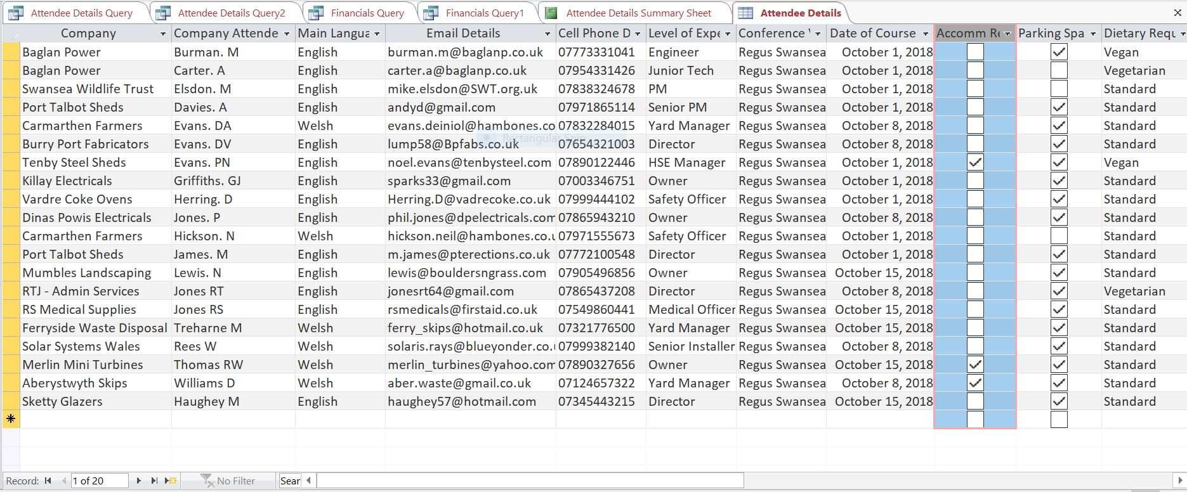

Financials Table Detail

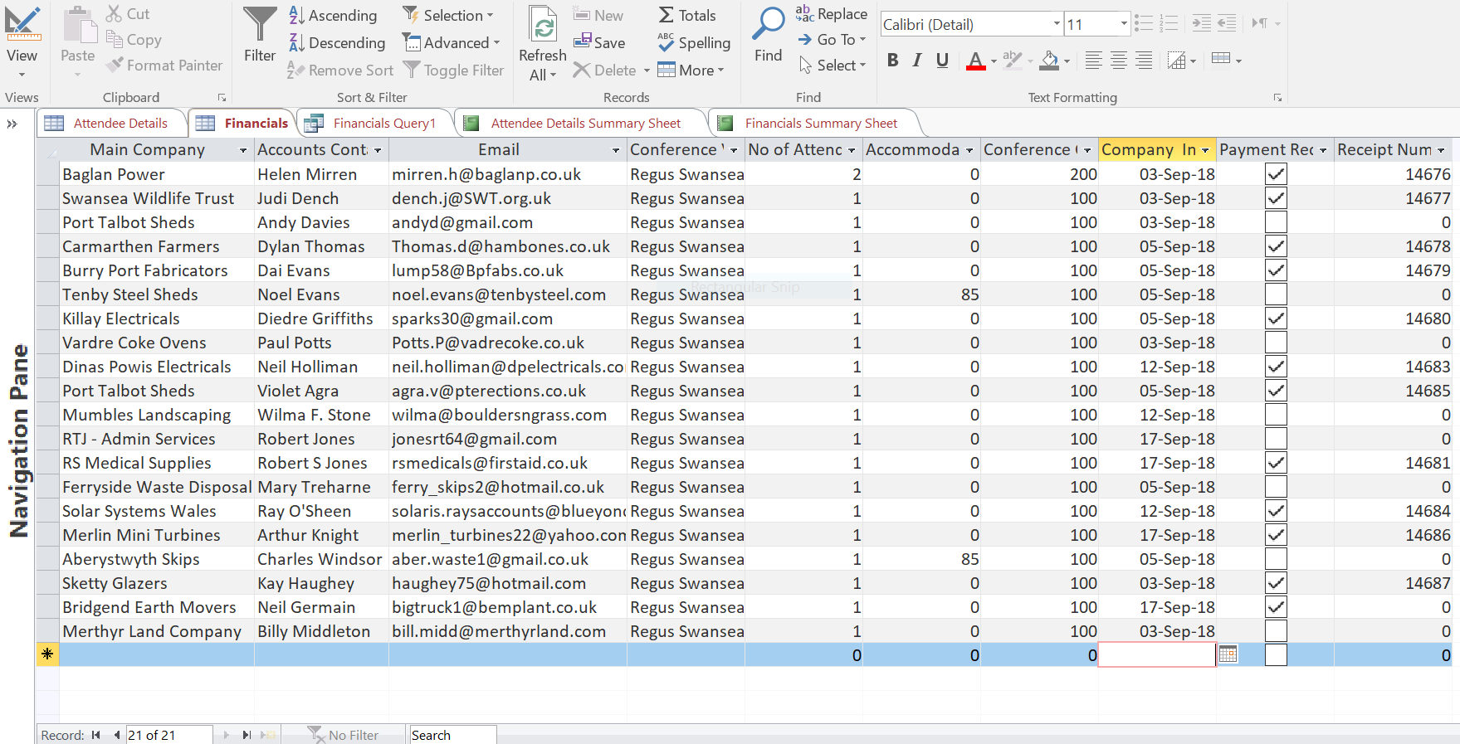

Attendee Form

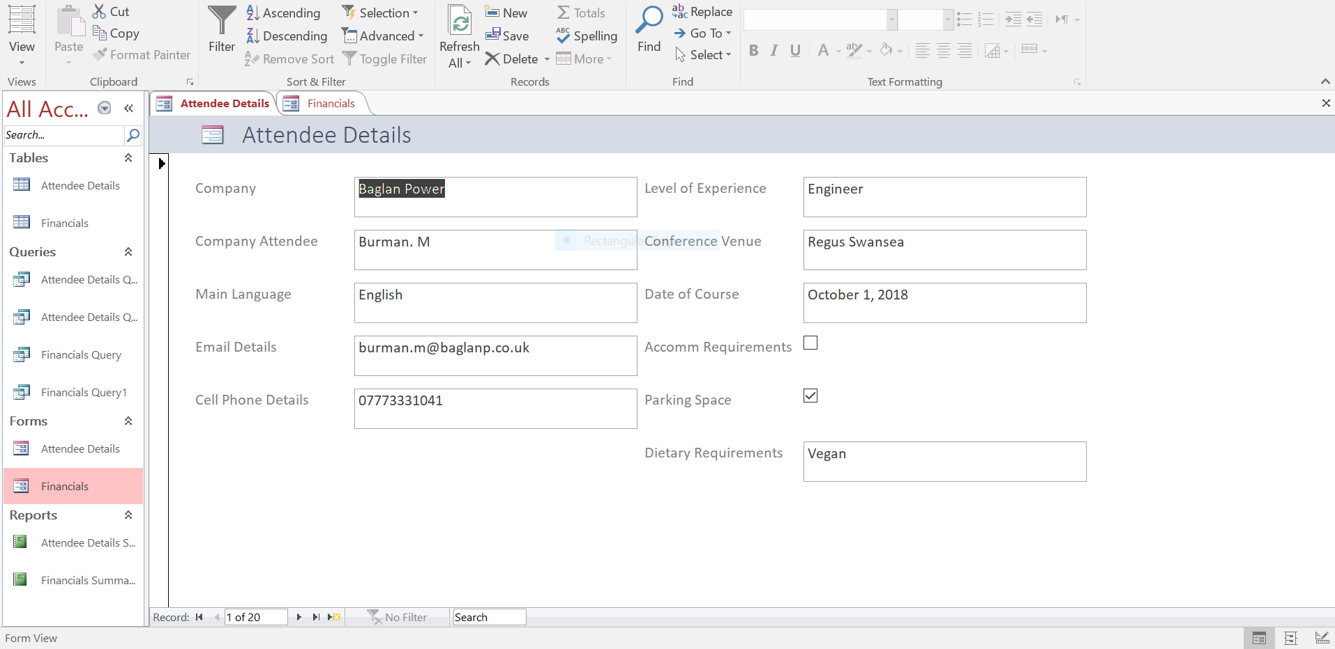

Financials Form

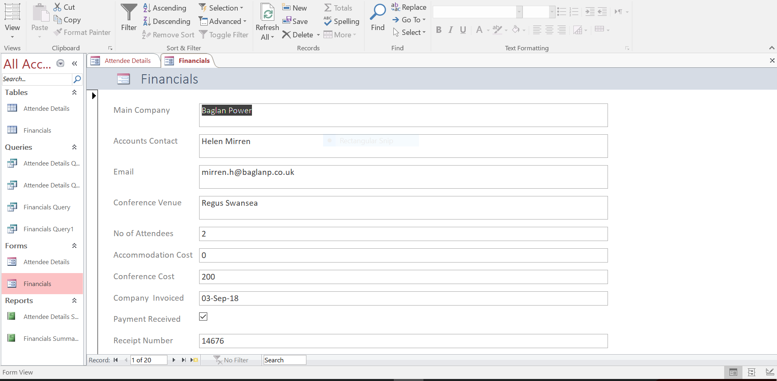

Attendee Query 1 – Company / Attendee / Experience Level / Date of Course

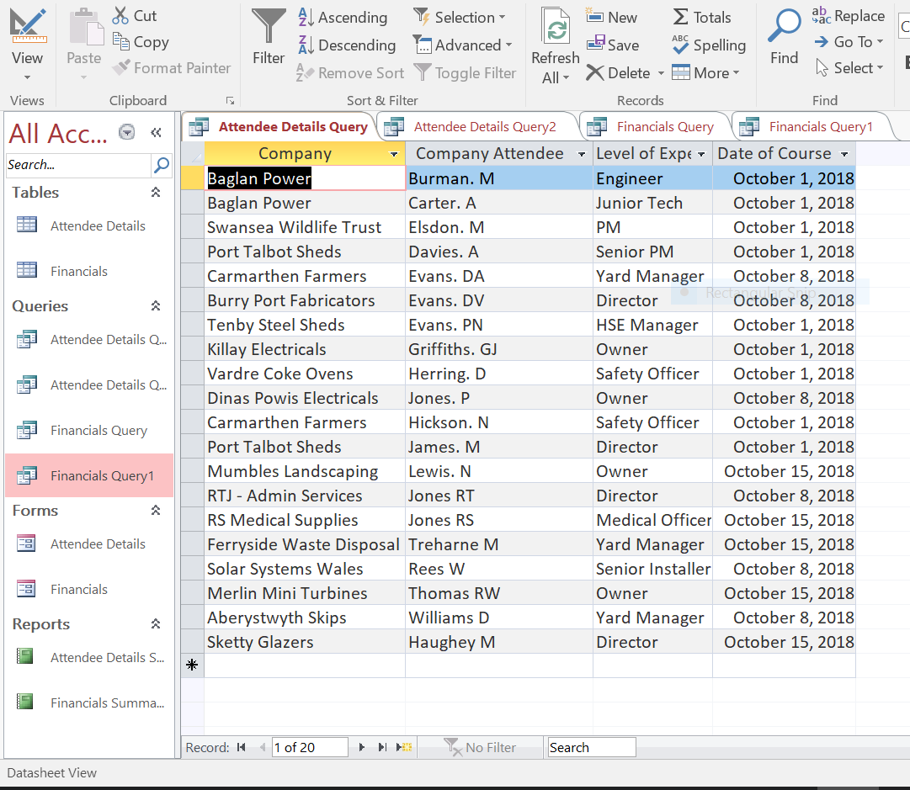

Attendee Query 2 – Attendee / Course Date / Dietary Requirements

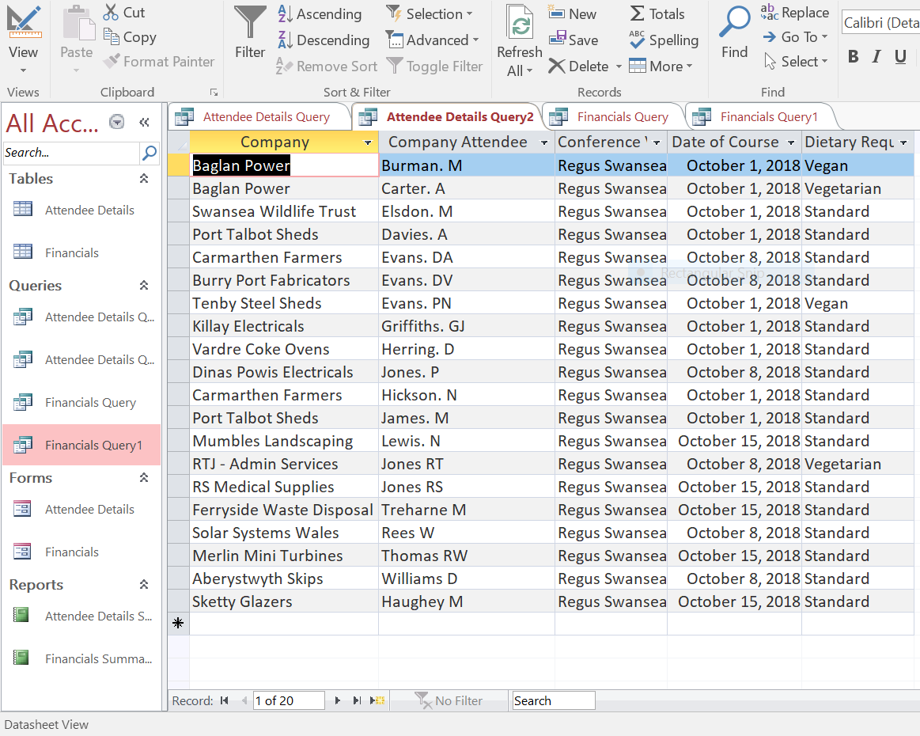

Financial Query 1 – Payment Details / Payments Received

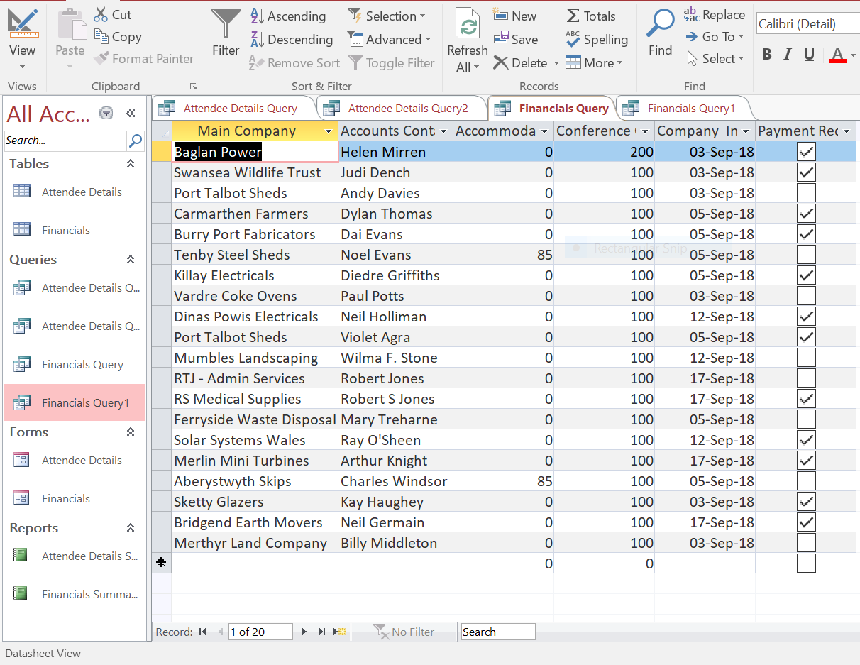

Financial Query 2- No. of Attendees / Payment Data

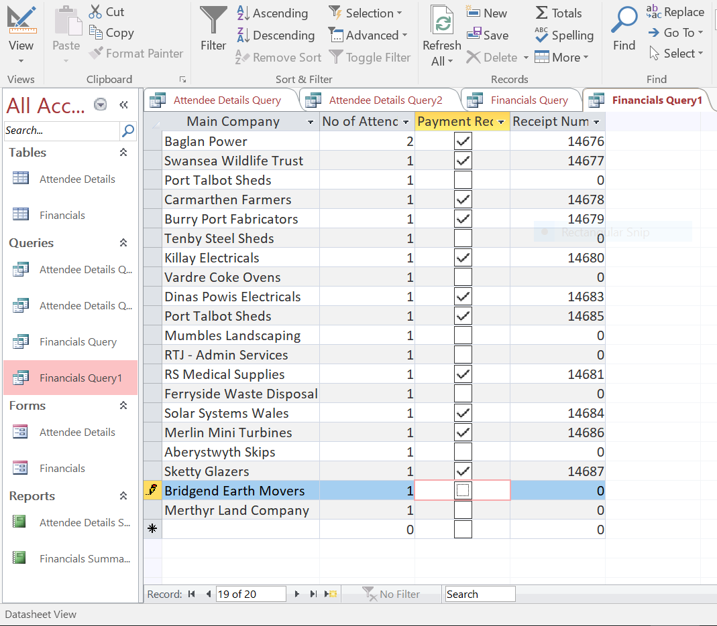

Attendee Report - (Note Snipping tool has cut the last 3 columns off the PNG due to size of laptop screen)

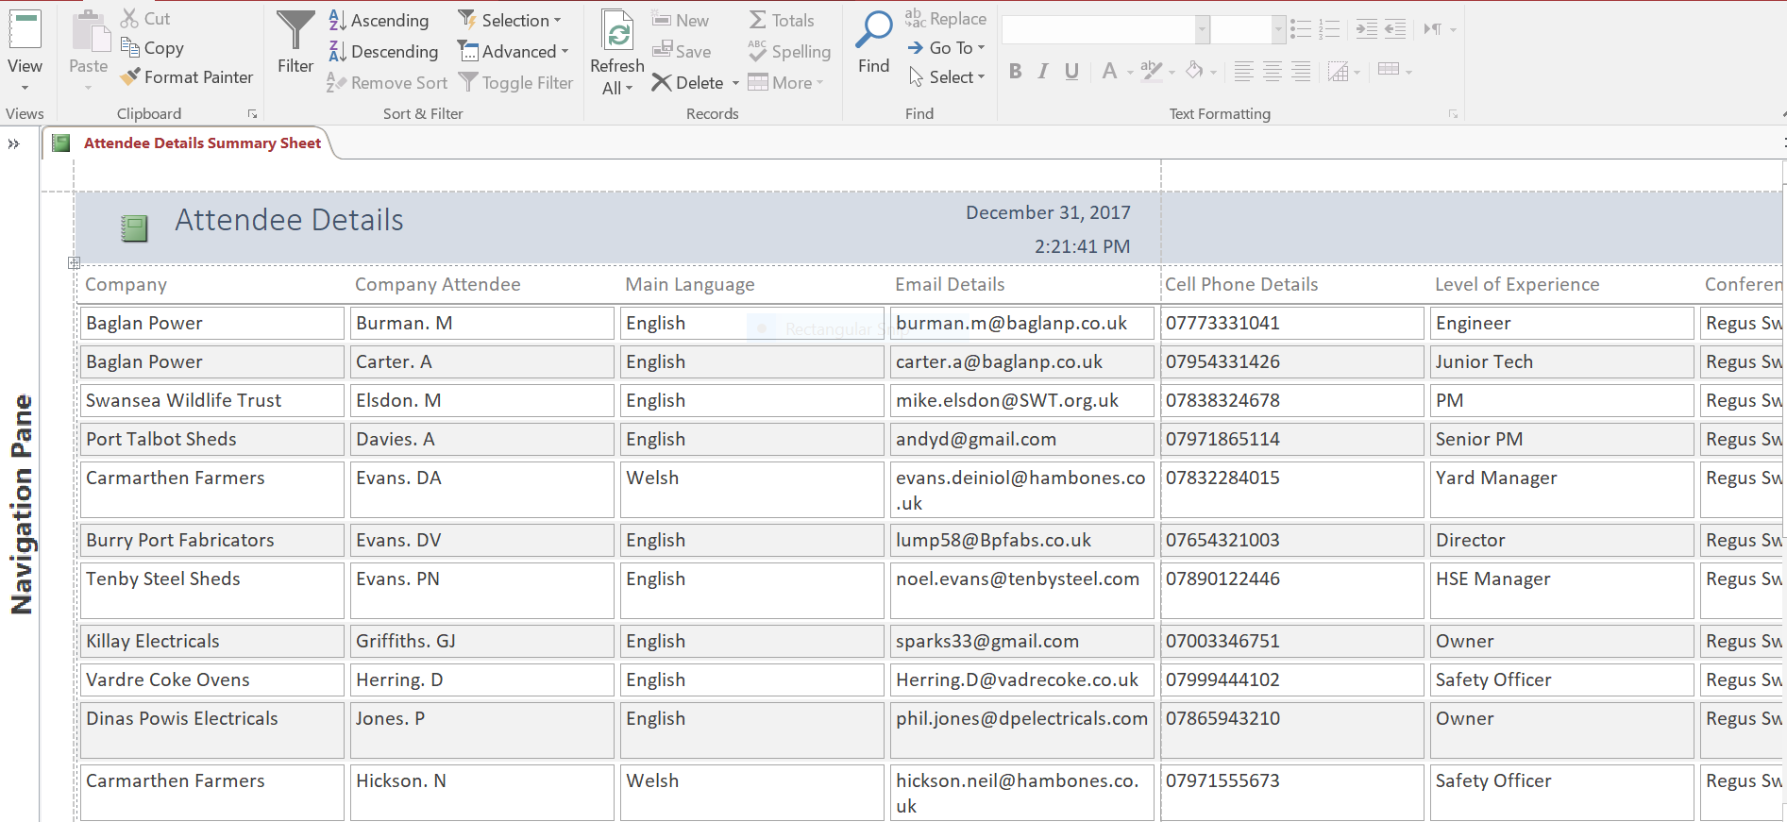

Financial Report – (Note Snipping tool has cut the last 4 columns off the PNG due to size of laptop screen)

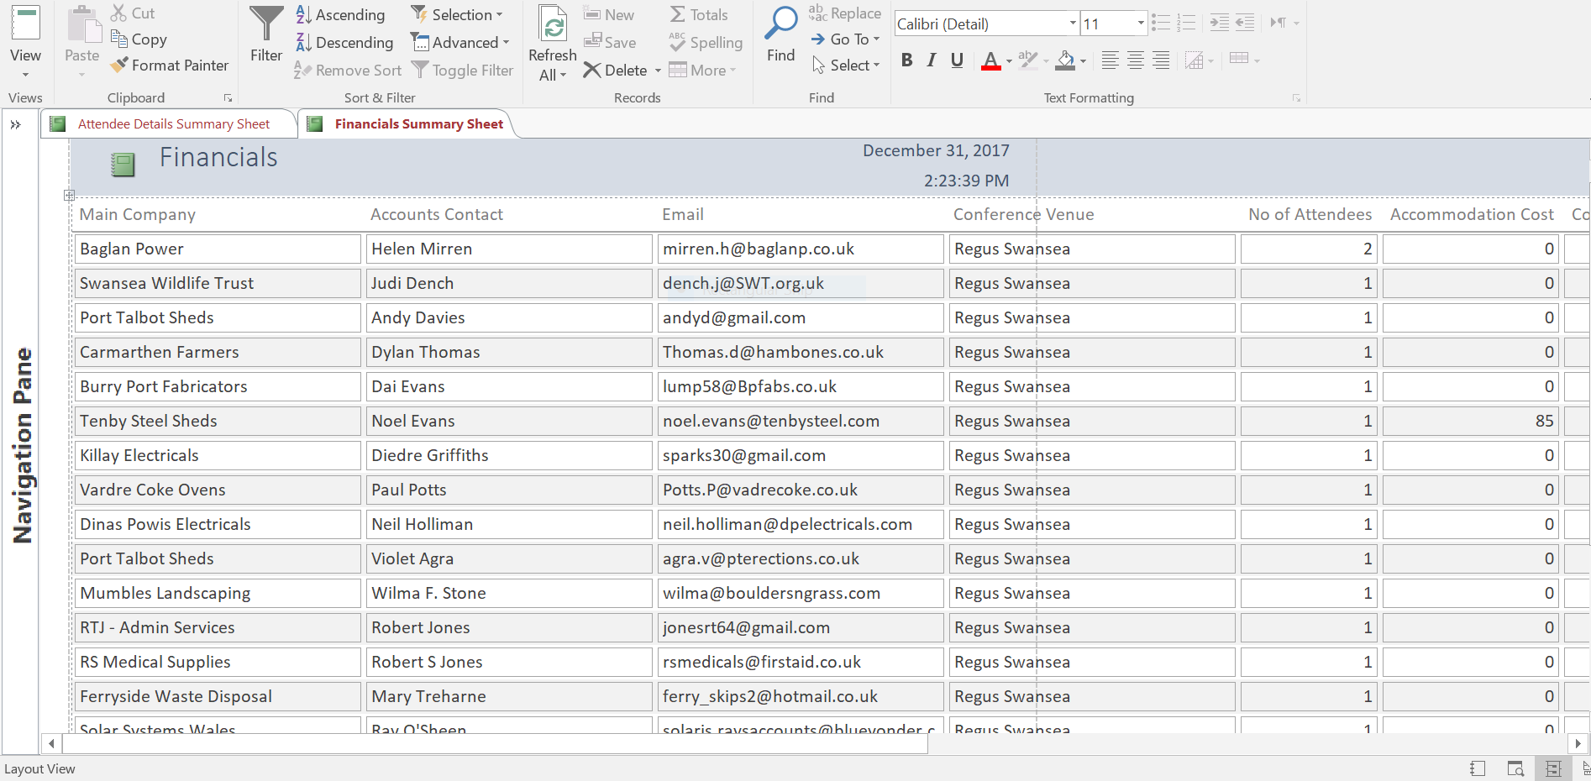

References:

Well-being of Future Generations (Wales) Act 2015
http://gov.wales/topics/people-and-communities/people/future-generations-act/?lang=en
[Accessed 08 Dec 2017]

Well-being of Future Generations (Wales) Act 2015
http://www.legislation.gov.uk/anaw/2015/2/contents/enacted [Accessed 08 Dec 2017]

Roles of the Business Analyst (Date unknown)
http://www.modernanalyst.com/TheProfession/Roles.aspx [Accessed 08 Dec 2017]

Brandenburg, L. (Oct 2010) What is a Business Analyst?
http://www.bridging-the-gap.com/what-is-a-business-analyst-role-anyway/
[Accessed 09 Dec 2017]

Pratt MK (7 Aug 2017) What is a business analyst and what do they do for software implementation projects?
https://www.cio.com/article/2436638/careers-staffing/project-management-what-do-business-analysts-actually-do-for-software-implementation-projects.html [Accessed 10 Dec 2017]

Benefits of a Database (Date unknown)
https://www.nibusinessinfo.co.uk/content/benefits-database-development
[Accessed 16 Dec 2017]

Raffo, D. (Date unknown) Hot data storage technology trends for 2017
http://searchstorage.techtarget.com/feature/Hot-data-storage-technology-trends-for-2017
[Accessed 8 Dec]

Musgrove, D (31 May 2011) White Rock Copper Works, Swansea
http://www.historyextra.com/visit/white-rock-copper-works-swansea [Accessed 12 Dec 2017]

Merril, T / Kitson, L (May 2017) The End of Coal Mining in South Wales: Lessons learned from industrial transformation
https://www.iisd.org/sites/default/files/publications/end-of-coal-mining-south-wales-lessons-learned.pdf [Accessed 14 Dec 2017]

British Accreditation Council (30 Aug 2017)
http://www.the-bac.org/ [Accessed 19 Dec 2017]

Apply for CPD Certification today. (No date)
https://cpduk.co.uk/become-accredited [Accessed 20 Dec 2017]

Meeting and Conference Venues in Swansea (No Date)
http://www.conferences-uk.org.uk/cities/swansea_conference_venues
[Accessed 22 Dec 2017]

