STUDENT NAME: Aneliya Karamanova
STUDENT ID NUMBER: 2235641
MODULE: ORGANISATIONAL CONSULTANCY
MODULE CODE: BMIH6005
LECTURER: Daniel Payne
Chosen Hotel: Park Hyatt Sydney
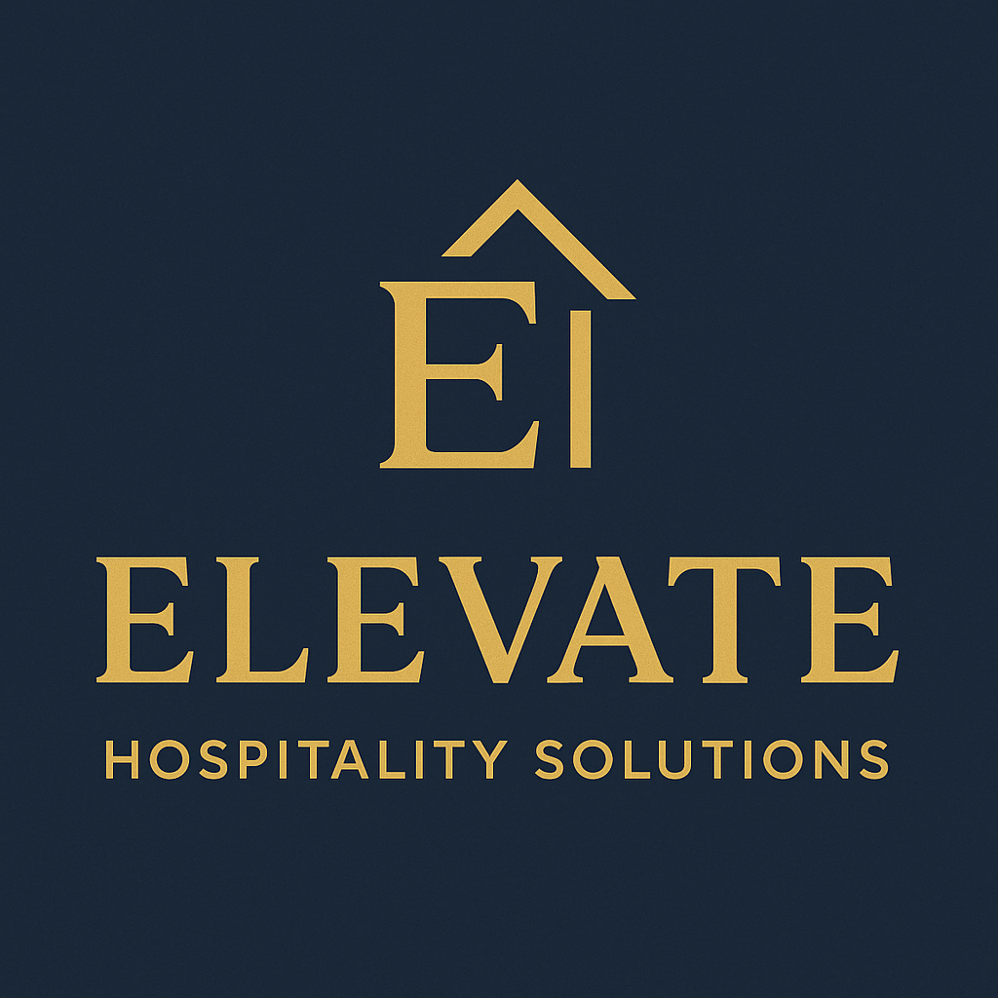
Consultancy Company Name: “Elevate Hospitality Solutions”

AI Declaration:
I confirm I have used of Grammarly for spelling correction. I confirm that I have not presented any AI generated text as my own work. I confirm I have copies of my drafts, notes and other resources I used before, and after the use of AI tools which I may be asked to provide in evidence.

Executive Summary
The consultancy report has stated that the Park Hyatt Sydney is facing immense issues in their service quality, employee morale along guest satisfaction. Located on the waterfront of Campbell's Cove in Sydney, Park Hyatt Sydney is a well-known five-star luxury hotel that offers panoramic views of the Sydney Harbour Bridge and Opera House. Despite its rich heritage, prestigious brand affiliation and strategic location, it faces huge issues in staff misconduct, poor sanitation issues and huge employee turnover. This is not just diminishing their overall competitiveness in the entire hospitality industry but is also leading to severe customer complaints and negative reviews on platforms like TripAdvisor.
Considering this issue, the report commenced by examining the operational landscape at Park Hyatt Sydney via stakeholder insights, client feedback and industry data. It found that the majority of the reviews found online were centred around widespread issues regarding their subpar cleanliness and delayed room turnovers. It has also been reported within the report that over 12% of the hotel inspections in Australia had flagged poor maintenance and hygiene, and Park Hyatt Sydney was not an exception to this. The staff-related issues have also come to the forefront, which has shown how the hospitality sector of Australia is facing a severe staff turnover rate, around 70% annually, and this hotel is also impacted by staff attrition, estimated to be around 51%. Such a turnover has not only weakened their service consistency levels but has also inflated training and recruitment costs. Many employees were also reported to feel demotivated and burned out, especially in front-of-house and housekeeping positions.
To strengthen the understanding of the external and internal factors affecting the hotel's operations, a STEEPLED framework (Social, Technological, Economic, Environmental, Political, Legal, Ethical, Demographic) has been analysed, followed by the SWOT and TOWS. The STEEPLED analysis highlighted that rising customer expectations post-pandemic related to digital or contactless services and hygiene, and all of these are exerting pressure upon the traditional service models. Park Hyatt has not just adopted innovative technologies like check-ins by mobile or automated concierge services that their rival companies have implemented to enhance their operations. Economically, it was reported that the hotel industry is anticipated to reach AUD 7.34 billion by the end of 2025, along with increasing wages and labour shortages that continue to squeeze the profits. The legal and ethical domains help in understanding the ongoing scrutiny of workplace conditions and outsourced labour. Over 50% of the female hospitality workers of South Australia have reported facing harassment, and this highly illustrates the urgent need to promote a supportive, safe, and conducive workplace culture for all employees so that everyone gets treated equally. However, the SWOT analysis has pinpointed both the strengths and vulnerabilities of the company, which has gained a wider understanding of what they must improve to address this issue and have a welcoming opportunity for all, be it guests or staff. Strengths included its globally trusted brand, prime location, celebrity entertainment and exclusive design features that have led to high room rates and enhanced brand loyalty among international travellers. Moreover, weaknesses like the rising cost of operations, limited digital transformation, low employee satisfaction and reliance on external contractors were included. It has also presented opportunities like rising demand for luxury sustainable tourism, along with the golden opportunity to implement AI-driven service enhancements. However, some threats include the highly competitive nature of the industry, along with more negative reviews that would diminish their reputation. The TOWS matrix was also used after this to convert this analysis into major strategic actions. Among the recommended strategies was to leverage their existing brand location and prestige (strengths) to be able to attract top-tier hospitality professionals by offering them competitive packages along with professional development programs. It was also thought that a targeted recruitment strategy might also reduce their dependence on short-term contractual workers, thus leading to better and consistent service levels. In fact, they might invest in smart technologies like automated cleaning systems, AI-integrated guest communication platforms, aiming to reduce operational pressure on staff while enhancing guest experience.
To mitigate the issues identified, we decided to recommend a few strategies. The first one was to adopt a situational leadership theory that would enable managers to tailor their leadership approach as per the situation and individual employee readiness. This would help the hotel to foster a supportive workplace setting and ensure both new and experienced employees get proper guidance and autonomy to perform effectively. They might also implement job enrichment strategies as per the Job Characteristics Model to address staff disengagement by increasing autonomy, variety, and feedback. Such practices have a proven history of motivating staff internally, along with enhancing their commitment to work towards producing high service standards. Finally, they might adopt Contingency Theory to support the development of adaptive management strategies tailored to evolving business situations like low-occupancy periods and peak tourist seasons. The measurable success indicators include reduced staff turnover, higher guest satisfaction ratings and enhanced adult results that would be used to evaluate the impact of these new strategies. All of these would collectively help the hotel to transform staff performance, high-quality service delivery and reinforce their reputation for excellence and luxury.

Table of Contents
Introduction 6
Background of the Hotel 6
Issues to be discussed 6
Overview of the Consultancy firm 7
Analytical Framework 7
Analysis 8
Issues identified by the Hotel 8
How is it impacting the hotel? 9
What are the causes? 10
STEEPLED Analysis 10
SWOT Analysis 14
TOWS Analysis 15
Recommendations and Change Management 17
Identifying the recommendations for the Hotel with Costs and Measures Included 17
Change Management Practices and Procedures included 21
Action Plan (SMART Analysis) 24
Conclusion 26
References 28

Introduction

Background of the Hotel
Park Hyatt Sydney is considered a luxury hotel which has been built on the grounds of Campbell's Cove. The hotel had a major transformation with a major refurbishment that saw three new rooftop suites added, among them the spacious 3,767-square-foot Sydney Suite (Hyatt, 2025). The hotel has 155 guestrooms and suites with panoramic views of the Sydney Opera House (Hyatt, 2025). The interior features Australian artisanry and The Rocks-inspired artworks. Locally sourced food can be enjoyed at The Dining Room or at The Living Room, where guests can unwind and take in the harbour views. Facilities include a rooftop heated pool, a five-room spa, and a fitness centre. Park Hyatt Sydney's strategic location in The Rocks positions it within walking distance from Sydney's dynamic business district and entertainment precincts. Its dedication to luxury and tailored service has featured in various celebrities, such as Lady Gaga and Nicole Kidman (The Rocks, 2025). Considering its combination of modern design and outstanding amenities, Park Hyatt Sydney remains a prominent figure for luxury hospitality in Australia.

Issues to be discussed.
It has been noted that staff behaviour and sanitation have become prominent issues for the hotel sector of Australia, which has been impacting client satisfaction and operational efficiency. It has been observed that around 98% of Australian accommodation customers rank a well-informed staff as their primary decision driver when deciding on spending. This highlights staff behaviour playing a prominent role in the client experience. However, the hotel sector in Australia is affected by serious labour problems, considering their turnover rates above 70% per year (Roosted, 2025). This tends to interfere with the consistency of service in employee training. Moreover, it has been observed that there are prominent instances of misconduct at workplaces, considering over 50% of female employees reporting harassment (Our Watch, 2025). However, it is difficult to have lofty standards of hygiene in consideration of staffing shortages and a high rate of turnover. It has been observed that over 12% of regular hotel inspections in Australia noted problems concerning the upkeep of physical infrastructure (World Health Organisation, 2025).

Overview of the Consultancy firm
Elevate Hospitality Solutions is a prominent consultancy services company with expertise in the hospitality and tourism industry. The organisation is committed to enabling hotels to excel in operational growth. The organisation has established itself as a dependable authority for providing innovative solutions that respond to the specific needs of high-end hospitality brands worldwide. The business caters to its cross-functional style by engaging in close collaboration with clients to learn about their fundamental issues. The consultancy's offerings cover a wide range of fields such as organisational restructuring and environmental design. Leveraging evidence-based recommendations, the business can ensure that clients obtain actionable insights towards meeting their strategic objectives. A prominent aspect of the company is its focus on sustainable solutions that equip hospitality organisations to meet changing market needs. With a global client base, Elevate Hospitality Solutions has been effective at turning operational inefficiencies into competitive strengths. The company's professional consultants remain aware of the current trends and technologies in the hospitality sector. This helps in allowing clients to be creative in a quickly changing world.

Analytical Framework
Several analytical frameworks will be used in this report to evaluate the issues confronting Park Hyatt Sydney. The STEEPLED analysis will be used in exploring the external environment affecting the hotel sector. Moreover, the SWOT analysis will determine the internal strengths and weaknesses of the hotel. This will help to provide a prominent picture of where it stands in the current strategic position. Moreover, the TOWS matrix will be used to create implementable strategies that capitalise on strengths and opportunities.

Analysis

Issues identified by the Hotel.
Park Hyatt Sydney has been confronted with significant issues regarding staff misconduct and sanitation, which have compromised its respected image. A major concern is the excessive rate of staff turnover. It has been observed that the Australian hospitality sector undergoes an average turnover rate of more than 15% (Econstor, 2022). This is significantly higher compared to other industries. This contributes to a workforce that is often made up of less skilled workers, causing service quality to be inconsistent.
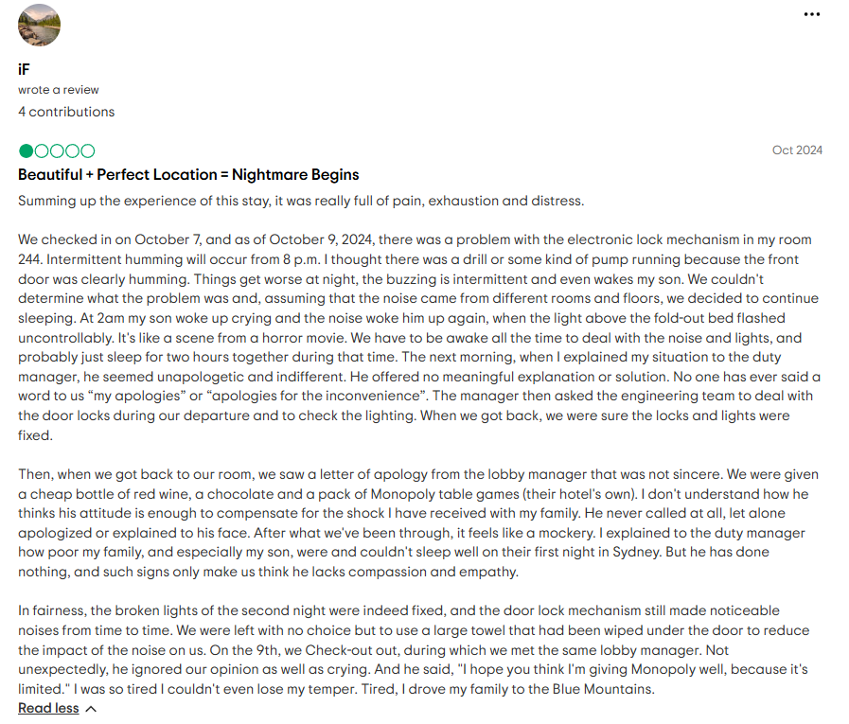
Figure 1: Customer Review
(Source: TripAdvisor, 2025)
Guest complaints identify a number of service failures. Examples include late room availability where one guest is told the wait would be 10-15 minutes, before waiting an hour. Housekeeping has also been an issue as there have been instances reported where rooms were left unclean until late afternoon, following early morning departures (Trip Advisor, 2025).
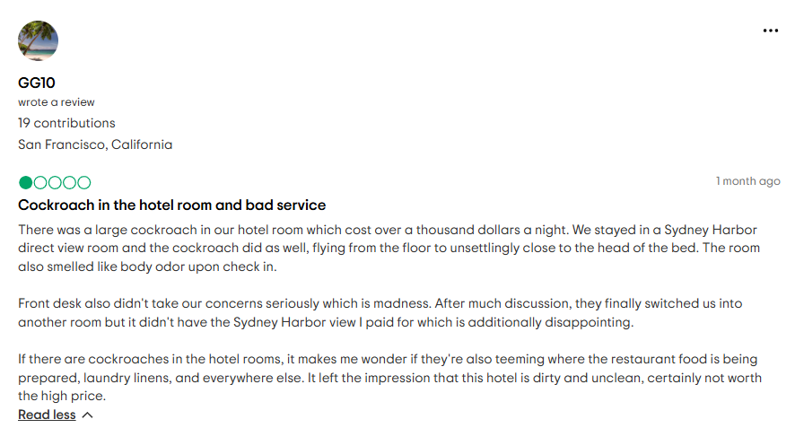
Figure 2: Customer Review
(Source: Trip Advisor, 2025)
Cleanliness has also been highlighted by incident reports of pest sightings, including cockroaches in guest rooms, with the response from management being seen as evasive (TripAdvisor, 2025). Internally, employee reviews also highlight difficult working conditions.

How is it impacting the hotel?
The issues of staff behaviour and hygiene at Park Hyatt Sydney have been major factors in the hotel's reputation and operational performance. The main issue is the staff turnover rate, which averages around 51% per year in the Australian hospitality industry-more than three times the industry standard (Emerald, 2022). This constant turnover results in an often inexperienced and disjointed workforce required to provide consistent service levels. Guest complaints articulate these difficulties. For example, a TripAdvisor reviewer witnessed a 10-minute wait at the check-in desk without recognition upon arrival, pointing out failures in fundamental customer service. Another attendee spoke of an incident where a requested humidifier took more than 90 minutes to be brought, only to discover it was faulty, demonstrating inefficiencies within its internal communication and resource management. Moreover, there have been complaints of rooms that have carpet stains and hair on the floor, with an apparent lapse in housekeeping standards.

What are the causes?
The root causes of the problems associated with staff behaviour and hygiene in Park Hyatt Sydney are a mix of internal and external issues. A major cause is poor management practices, such as inadequate communication and inadequate support for employees. This may cause frustration among employees and unprofessional behaviour. Furthermore, excessive workload demands and understaffing commonly lead to hurried-and-crush tasks and dismal cleanliness standards. The use of outsourced housekeeping services also adds to inconsistencies since the outside workers cannot be as accountable or well-trained as insiders (Zhang, 2021).

STEEPLED Analysis
Criteria | Description | Impact
Social | In 2023, total visitor arrivals in Australia reached 18.2 million, marking an 87.6% increase from 9.7 million in 2022 (HVS, 2024). | High
Social | The Australian hotel sector is adapting to evolving traveller preferences, with a notable increase in demand for eco-friendly accommodations and personalised experiences (Donald and Donald, 2024). | High
Social | Health and safety remain paramount, with guests expecting rigorous hygiene standards and transparent communication about cleanliness protocols (Hossain, 2023). | High
Social | Cultural diversity among travellers necessitates multilingual staff and culturally sensitive services to enhance guest satisfaction (Suwarto et al. 2024). | High
Technological | Hotels are increasingly adopting digital solutions, such as mobile check-ins and AI-driven customer service, to streamline operations and meet guest expectations (Khan, 2024). | Moderate
Technological | The integration of Internet of Things (IoT) devices allows guests to control room settings via smartphones, enhancing comfort and energy efficiency (Sabharwal and Jain, 2025). | Moderate
Technological | With the rise in digital transactions, robust cybersecurity measures are essential to protect guest data and maintain trust (Paul et al. 2023). | Moderate
Economic | Australia's hotel market is projected to reach 7.34 billion dollars in revenue by 2025, with a compound annual growth rate (CAGR) of 3.98% (Statista, 2025). | High
Economic | National occupancy rates sit at 71%, up 2% year-over-year, with revenue per available room (RevPAR) increasing by 3.8% to $171, indicating a positive trend in hotel performance (CBRE, 2025). | High
Economic | Despite these positive indicators, the hospitality sector faces challenges due to rising operating costs and labour shortages, impacting service quality and profitability (Kumar et al. 2024). | High
Environmental | There is a growing emphasis on sustainable practices within the hotel industry, including reducing energy consumption and waste (Prakash et al. 2023). | Low
Environmental | Climate change poses risks to hotel operations, with extreme weather events potentially disrupting travel plans and damaging infrastructure (Hsu and Sharma, 2023). | Low
Environmental | The demand for eco-tourism is increasing, with travellers seeking accommodations that prioritise environmental responsibility (Mishra and Kumar, 2024). | Low
Political | Government policies on visas, travel restrictions, and health guidelines directly affect hotel occupancy rates and operations (Seeyfi et al. 2023). | High
Political | Infrastructure investments, such as the AUD 5.3 billion Western Sydney Airport project, are expected to enhance accessibility and boost tourism (Infrastructure Pipeline, 2025). | High
Political | Support measures, including stimulus packages and grants, have been crucial in aiding the hospitality sector during economic downturns (Khalid et al. 2021). | High
Legal | Hotels must navigate various regulations, including health and safety standards, employment laws, and licensing requirements, to ensure compliance (Hu et al. 2021). | High
Legal | An increase in litigation risks, such as public liability claims, has led to higher insurance premiums for hotel operators (Padhy and Padhy, 2021). | High
Legal | Compliance with data protection laws is essential, especially with the rise in digital transactions and online bookings (Yallop et all. 2023). | High
Ethical | Ensuring fair labour practices, including equitable wages, and working conditions, is vital for employee satisfaction and retention (Fitri, 2024). | High
Ethical | Hotels are increasingly engaging with local communities and supporting local businesses to foster positive relationships and social responsibility (Goffi et al. 2022). | High
Ethical | Transparency in communication regarding policies, pricing, and services builds trust and loyalty among guests (Konuk, 2023). | High
Demographic | Australia is experiencing a surge in international arrivals, with total visitor arrivals reaching 18.2 million in 2023, marking an 87.6% increase from 2022 (ABS, 2025).
Demographic | The ageing population necessitates accommodations that offer accessible facilities and services tailored to older travellers (Cooper, 2022).
Demographic | Urbanisation trends are leading to higher demand for city-based accommodations, as more people move to urban areas (Xie et al. 2024).
Table 1: STEEPLED Analysis
Analysis:
The STEEPLED analysis also brings into focus the various external factors that critically affect Park Hyatt Sydney. Socially, changing guest expectations for bespoke and high-quality service means that any slip in staff conduct or standards of hygiene can critically tarnish the luxury reputation of the hotel. Technologically, most rivals are adopting innovations such as contactless check-ins and automated housekeeping. Economically, increasing labour costs and talent shortages within the hospitality industry constrain the hotel's capacity to attract and retain expert staff, directly affecting challenges in staff performance and cleanliness standards. Environmentally, the need for sustainable and clean practices adds more pressure on the hotel to have spotless and environmentally friendly conditions. Politically and legally, stricter health rules and labour legislation imply that the hotel has to stay on side, but the regulations can also be restrictive and impact staffing flexibility. Ethically, the demand for honest treatment of employees and open operations necessitates that the hotel project a supportive in-house culture. Demographically, the hotel caters to diverse types of guests, from global luxury travellers to the elderly with particular hygiene and comfort requirements, which heightens the need for uniformly ambitious standards. Using Herzberg's Two-Factor Theory could help to understand the source of staff behaviour problems. Under the theory, motivation is affected by hygiene factors and motivators (Rai et al. 2021). Therefore, ensuring effective staff training schemes can lift the levels of service and enforce compliance with hygiene standards. Furthermore, investing in routine maintenance could help businesses maintain the standards of cleanliness (Line, 2021). This is significantly relevant within the issues of higher staffing turnover and inconsistent training. Therefore, these systematic deficiencies contribute to the dynamics of hygiene and poor training of the frontline employees.

SWOT Analysis
Strengths | Weaknesses
Park Hyatt Sydney enjoys a prime location in the Rocks district, offering panoramic views of the Sydney Opera House and Harbour Bridge, which enhances its appeal and justifies premium pricing (Hyatt, 2025). | The hotel faces high operational costs due to its luxury positioning, which increases expenditures on labour, maintenance, and high-end amenities.
As part of the Hyatt Hotels Corporation, the hotel benefits from strong global brand recognition and loyalty, with the World of Hyatt loyalty program reaching over 35 million members globally as of 2023 (Hyatt, 2025). | Post-pandemic labour shortages have impacted service quality, with 47% of luxury hotels in Australia reporting difficulties in hiring and retaining trained staff in 2023 (Jobs and Skills, 2022).
In 2023, Park Hyatt Sydney achieved an average daily rate (ADR) exceeding AUD $1,100, placing it among the highest-earning luxury hotels in the country (Frasers, 2023). | With fewer guest rooms, a hotel has limited capacity, reducing its ability to scale during periods of high demand (NBER, 2020).
The hotel’s exclusive offerings help in consistently attracting potential customers (Mun et al. 2022).
Opportunities | Threats
Australia’s luxury tourism market is projected to grow at a CAGR of 7.6% from 2023 to 2028, presenting a chance for the hotel to expand its market share (Grand View Research, 2025). | Ongoing economic uncertainty, including inflation and rising interest rates, may reduce discretionary spending on luxury accommodations (Coibion et al. 2024).
There is increasing demand for sustainable hospitality, providing an opportunity for Park Hyatt Sydney to lead in eco-friendly certifications and practices. | The opening of new luxury competitors, such as Crown Sydney, intensifies market competition and could draw clientele away.
The expansion of digital services, such as mobile check-in and in-room smart technology, could enhance the guest experience and operational efficiency (Das, 2023). | The hotel’s waterfront location makes it vulnerable to climate-related risks such as flooding and storm surges, potentially disrupting operations.
Table 2: SWOT Analysis
Analysis:
The SWOT analysis provides key insights into how external and internal factors drive Park Hyatt Sydney's continuous problems of staff behaviour and cleanliness. Strengths like the hotel's high-end brand reputation and prime location appeal to upscale customers with lofty expectations, so any failure in service or hygiene levels is especially hurtful to its reputation. While the hotel provides upscale services and experiences, a highly trained and motivated staff can effectively only deliver them. Using Maslow's Hierarchy of Needs, it could be stated that for most staff, problems lie in unmet psychological and basic needs (Cui et al. 2021). This could include the factors such as insecurity of job and inefficient system of support. This has resulted in engagement of employees towards the decline in service standards that has negatively affected the satisfaction of guests and consistency in operations.

TOWS Analysis
TOWS Analysis |  | External Factors
 |  | Opportunities | Threats
Internal Factors | Strengths | Park Hyatt Sydney can leverage its premium brand image and iconic location to attract the growing market of luxury and eco-conscious travellers. | The hotel can differentiate itself from rising competitors like Crown Sydney by emphasising its bespoke services and unmatched waterfront views.
Internal Factors | Strengths | By using its high service standards and exclusive offerings, the hotel can lead in sustainability and digital guest experiences, enhancing guest satisfaction. | Strong global brand loyalty and high customer expectations can be used to justify premium pricing even during economic downturns, helping maintain profitability.
Internal Factors | Weaknesses | Park Hyatt Sydney should invest in staff training and well-being programs to address service quality issues while taking advantage of rising demand in luxury tourism. | To combat labour shortages and rising operational costs, the hotel should develop strategic partnerships with hospitality schools and streamline internal operations.
Internal Factors | Weaknesses | By adopting sustainable practices and smart room technologies, the hotel can modernise operations and reduce pressure on overworked staff. | By improving staff satisfaction and enforcing cleanliness protocols, the hotel can reduce guest complaints and defend its market position in an increasingly competitive environment.
Table 3: TOWS Analysis
Analysis:
The TOWS analysis provides a working model for Park Hyatt Sydney to react to its internal issues, specifically about employee behaviour and hygiene, by matching strengths and weaknesses with external opportunities and threats. The hotel's past reputation and location both offer obvious strengths, which can be matched strategically with opportunities like the increasing needs for luxury and eco-friendly travel. With its brand equity, the hotel is able to attract customers who appreciate lofty standards, while with investments in green practices and intelligent technologies, its operating efficiency can be enhanced and staff pressure alleviated. Through Theory X and Theory Y, how environmental analysis affects staff dynamics becomes more evident. Management acting with a Theory X frame of mind could result in controlling policies that decrease morale and service (Bushi, 2021). This approach tends to worsen the existing problems such as higher rates of turnover and inconsistency in the standards of hygiene. Through the shift of the mindset of Theory Y, Park Hyatt Sydney can foster empowerment to support autonomous decision-making.

Recommendations and Change Management
Root Cause Analysis:
Issue | Root Causes
Inconsistent Staff Behaviour | - Leadership styles do not adapt to varying staff readiness levels.  - Lack of tailored development plans and constructive feedback.  - High employee turnover and low morale reduce accountability and professionalism.
Poor Hygiene Standards | - Staff disengagement and inadequate training undermine cleaning consistency.  - Inefficient layout and suboptimal tools hinder effectiveness.  - Lack of standardised procedures across occupancy levels causes fluctuating cleanliness outcomes.
Table 4: Root Cause Analysis

Identifying the recommendations for the Hotel with Costs and Measures Included
Recommendation 1: Implementing strategies to enhance staff performance.
To solve the problems of inconsistent staff behaviour within Park Hyatt Sydney, the adoption of Situational Leadership Theory could be considered as a strategic measure. This theory states that there is no one best style of leadership, but effective leadership is reliant on employee readiness (Mulayana et al. 2022). Considering the situation of Park Hyatt, where there is both a pool of experienced professionals and newly hired workers, a situational leadership style is essential. Managers need to start by evaluating the motivation and performance level of individual employees (Forson et al. 2021). For instance, newly hired housekeeping staff might be missing some of the skills and confidence necessary to achieve the lofty standards of the hotel. Such employees would require a directive leadership style in which instructions are explicit. On the contrary, senior employees who feel secure in their place may need a delegative style that gives them the freedom to manage their tasks. By modifying their leadership style according to the development stage of each employee, managers are able to create a more caring work culture. Workers will be more likely to display professionalism and ambitious standards of cleanliness when they feel that their needs and capabilities are being valued. Through the personalised method over time, service inconsistencies can be minimised.
Recommendation 2: Redesigning the physical dynamics of the hotel.
To enhance both guests' impression of cleanliness, Park Hyatt Sydney can apply the Servicescape Model. This model focuses on the impact of the physical environment on customer behaviours in service environments (Chao et al. 2021). In a high-end hotel, where hygiene is paramount in ensuring guest satisfaction, planning the physical environment can respond directly to cleanliness issues. The services consist of two main environmental factors consisting of ambient conditions and spatial layout. By refining these components, a hotel can provide an environment that promotes efficient workflows as well as positive guest experiences (Das, 2023). For instance, making sure areas of service like housekeeping stations are well-lit can enhance staff effectiveness and decrease errors. In a similar vein, refreshing public areas with refined décor supports impressions of cleanliness and luxury. Moreover, meticulously designed service impacts employees' morale. Workers are likely to be proud of the job they do when working in a well-organised environment. Designing effective break rooms can encourage improved hygiene behaviour and employee well-being. By connecting operational requirements, Park Hyatt Sydney is able to reinforce its excellence and values. A well-designed service enhances the guest experience and helps in supporting employees in consistently providing prominent levels of service.
Recommendation 3: Fostering Employee Engagement within the hotel
To enhance employee behaviour, the hotel needs to implement the Job Characteristics Model. This model identifies fundamental job dimensions that lead to more motivated employees and performance (Zhao et al. 2024). When these aspects are properly integrated into the work of an employee, it results in a greater sense of internal motivation. This is essential for ensuring lofty standards of professionalism within a business environment (Tien et al. 2021). Within Park Hyatt, numerous jobs can become repetitive and lead to disengagement. By adding more variety to these roles, employees are going to feel more appreciated and committed to their jobs. Task assignment that enables the staff to observe firsthand the direct effect of their efforts on guest satisfaction can contribute to a greater sense of responsibility. Moreover, granting more autonomy is likely to be trusted. Ongoing constructive feedback from managers and instant reinforcement of accomplishments further encourage positive behaviour and ongoing improvement.
Recommendation 4: Developing Adaptive Strategies of Management
To effectively manage the dual challenges of staff behaviour and cleanliness, Park Hyatt Sydney should adopt Contingency Theory, which suggests that there is no universally optimal way to manage an organisation. Instead, effective management depends on aligning strategies with the specific internal and external conditions the business faces. In a dynamic hospitality environment, flexibility and situational responsiveness are essential. Park Hyatt Sydney exists in a dynamic environment in which guests need vary according to season. Through the use of Contingency Theory, the hotel is able to create adaptive strategies based on these changing variables. For instance, when there is high occupancy and pressure on personnel during peak tourist seasons, the hotel might adopt more formalised routines and standard cleaning checklists to guarantee consistency and minimise chances of service decline. In the slow periods, resources are shifted to the training of personnel, team building, and process review for better future performance. Contingency Theory promotes context-specific, evidence-based decision-making that empowers leaders to be able to navigate change and uncertainty with agility and effectiveness (Abedin, 2022). For Park Hyatt Sydney, this translates into proactively identifying when and how to adapt leadership approaches, resources, and workflow structures. By infusing flexibility into its operating culture, the hotel can more effectively cope with service quality, raise cleanliness standards, and solve staff behaviour problems in a responsive and sustainable manner.
Costs Associated and Success Measured:
Recommendations | Costs Associated | How the Impact Will Be Measured | How Success Will Be Determined
Situational Leadership Implementation | Costs include leadership training workshops, consultant fees, and manager coaching sessions (approx. AUD 20,000–30,000 annually). | Employee performance reviews, staff turnover rates, and guest service satisfaction surveys. | Success will be determined by improved staff retention, better staff ratings in guest feedback, and fewer service-related complaints.
Redesigning Servicescape | Redesigning and upgrading physical spaces, signage, ambient improvements, and maintenance (approx. AUD 50,000–75,000). | Guest satisfaction surveys related to ambience and cleanliness, and staff feedback on workplace functionality. | Success will be seen in higher guest cleanliness ratings, reduced negative comments about the physical environment, and increased staff productivity.
Job Enrichment | Costs include job redesign efforts, additional training programs, recognition systems, and cross-training staff (approx. AUD 25,000–40,000). | Staff engagement surveys, absenteeism rates, and quality assurance audits. | Success will be reflected in higher employee engagement scores, reduced absenteeism, and improved cleanliness and service audit results.
Contingency Strategy Development | Investment in dynamic workflow tools, flexible staffing systems, and periodic reviews (approx. AUD 15,000–25,000). | Operational performance metrics, adaptability during peak periods, and internal audits. | Success will be determined by consistent service levels across fluctuating demands, improved audit scores, and managerial feedback on flexibility.
Table 5: Cost-Success Matrix

Change Management Practices and Procedures included.
Recommendation 1: For effective application of Situational Leadership at Park Hyatt Sydney and solving staff behaviour issues, the hotel needs to acquire systematic change management practices emphasising clarity, engagement, and sustainability. An appropriate model for this action is Lewin's Change Management Model with three steps consisting of Unfreeze, Change, and Refreeze (Amina et al. 2022). During the Unfreeze phase, the company needs to prepare its management and employees for change by questioning current leadership norms and behaviours. This is followed by conveying the issues associated with inconsistent employee performance and how this impacts negatively on guest satisfaction and brand reputation. The leadership has to emphasise the need for change by using real-time feedback, performance statistics, and case studies to outline the explicit link between bad leadership, flexibility, and inconsistencies in services. Building awareness of such issues minimises resistance and generates a mutual understanding that there is a need for new leadership practices. In the Change phase, Situational Leadership is brought to the hotel through formal manager and supervisor training programs. These training programs will teach leaders to diagnose employees' development levels and use the right leadership style. Practical instruments like staff readiness tests, performance tracking templates, and one-on-one coaching sessions should also be offered. During this stage, two-way communication is critical in obtaining feedback, resolving concerns, and instilling the advantages of converging leadership styles to meet the needs of individual team members. This enhances a culture of support and learning over control and criticism. The Refreeze phase is important for integrating the new leadership style into the culture of the hotel. Managers can be held accountable for exercising situational awareness and flexibility in their leadership.
Recommendation 2: To successfully apply the redesign of Park Hyatt Sydney's physical environment based on the Servicescape Model, a formal change management process is necessary to minimise disruption and maximise staff and guests' engagement. For this purpose, the Transition Model is an efficient framework that addresses the psychological transition of people in organisational change, instead of the practicalities. The process starts with the Ending Phase, where staff are assisted to release current habits and comfort zones associated with the present physical space. Communication at this phase is important. Leadership has to properly articulate the reasons for the redesign and connect it with the chronic issues of cleanliness perception and workflow inefficiencies. The second phase is the Neutral Zone, where the old arrangement has been taken down, but the new one is not yet established. This tends to be the most difficult phase, where confusion and anxiety may occur. For the coordination of this, temporary signage, trial redesigns of particular areas and trial periods can be implemented. Training should be made available to staff on how to navigate and use the new spaces effectively, as well as ongoing feedback systems to tweak the changes. Having frontline staff evaluate out new layouts aids in creating ownership and real-world understanding of the Servicescape redesign (Nair et al. 2022). The final phase is the New Beginning, in which the revised environment is the new norm. By focusing on staff members' emotional transition along with physical adjustments, the hotel enhances the chances of success, enhances standards of cleanliness, and overall upgrades the guest experience.
Recommendation 3: To implement job enrichment at Park Hyatt Sydney and address staff disengagement and behavioural inconsistencies, Lewin’s Change Management Model provides a practical framework for managing this transformation effectively. In the Unfreeze stage, the organisation must prepare employees for a shift in how roles are structured. This begins with acknowledging the current issues and communicating the benefits of job enrichment. Leaders should create awareness among staff about how enriched roles can lead to increased engagement. Training is important in this stage to equip staff with the skills required to take on responsibilities. Leaders should also monitor reactions, collect feedback, and adjust job designs as needed to ensure the changes are practical and welcomed. In the Refreeze stage, these new job structures must be embedded into the hotel’s operations and culture.
Recommendation 4: In order to effectively apply adaptive management practice at Park Hyatt Sydney with Contingency Theory as a guide, the hotel will need to adopt a structured but adaptable change philosophy. Within the Unfreeze phase, Park Hyatt needs to initially prepare the organisation to challenge and break free from classic, standardised management methods no longer aligned with its dynamic hospitality setting. Leaders should communicate convincingly the need to move towards a more responsive, situational approach to management (Sarjito, 2023). Employees should be shown how uneven performance and subpar cleanliness results frequently arise from the mismatch between management practices and live operational requirements. This phase must be done through open communication via departmental briefings, team workshops, and case examples of when inflexibility caused failure in services. The aim is to minimise resistance by educating employees and managers that change is part of achieving efficiency and service excellence. Through the Change phase, the hotel will start creating and piloting adaptive management processes. This may involve the use of flexible staffing models, real-time decision support tools, or updated procedures for peak and off-peak seasons. Managers will be equipped to evaluate internal and external conditions and modify workflows, team tasks, and leadership styles in response. Pilot programs must be initiated in targeted departments to garner feedback and refine strategies prior to large-scale implementation. Open communication lines and feedback mechanisms have to be in place so that changes are made in light of frontline realities. During the Refreeze phase, the adaptive strategies learned are incorporated into the normal operating procedures of the hotel. This includes revising policy manuals, recasting managerial KPIs, and incorporating contingency-based decision-making into leadership development programs.

Action Plan (SMART Analysis)
No. | Problem Description | Solution to be Implemented | Desired Outcome | Time Scale for Completion | Expected Completion Date | Planned Budget (AUD)
1 | Inconsistent staff behaviour is impacting guest satisfaction and service quality | Implementation of Situational Leadership training for managers across all departments | More adaptive leadership, improved staff morale, reduced service complaints, and enhanced guest experience | 3 months (includes training, practice, and evaluation phases) | 31 August 2025 | $30,000
2 | Low perception of cleanliness and lack of environmental comfort among guests | Redesign and upgrade the hotel’s Servicescape, including lobby, restrooms, and back-of-house cleaning zones | Enhanced physical environment, improved hygiene standards, and increased guest satisfaction | 4 months (planning, renovation, and implementation) | 30 September 2025 | $75,000
3 | Staff disengagement and repetitive roles lead to demotivation and errors | Job enrichment through cross-training, expanded roles, and greater autonomy using the Job Characteristics Model | Higher employee engagement, lower absenteeism, and improved diligence in cleanliness and service | 3 months (phased role redesign, training, and integration) | 31 August 2025 | $35,000
4 | Inflexible management systems lead to operational inefficiencies in peak periods | Develop adaptive contingency strategies using real-time decision-making tools and flexible workflows. | Greater operational responsiveness, reduced service bottlenecks, and consistent quality delivery during busy periods | 2.5 months (system development, training, trial implementation) | 15 August 2025 | $20,000
Table 6: Action Plan

Conclusion
Therefore, the consultancy report of Park Hyatt Sydney has underscored that with its high-profile status and favourable location, the hotel has been facing serious issues, mostly focused on employee conduct and hygiene levels. These management problems directly affect client satisfaction, brand reputation, and, in turn, bottom-line performance. Fixing these issues calls for a multi-pronged approach that not only attacks near-term symptoms but redesigns root organisational processes and culture. The diagnosis of this report indicated that inconsistent staff behaviour, from poor communication to lack of professionalism, and inferior cleanliness, led to negative guest feedback, more complaints, and a drop in repeat customers. The STEEPLED and SWOT analyses further put these internal vulnerabilities in perspective within the wider external environment and found that technological innovation, changing customer needs, and competitive forces aggravate these challenges but also present chances for enhancement. The strategic assessment highlighted adaptive leadership and employee engagement as key drivers of transformation. The key recommendations suggested are aimed at developing a resilient and engaged workforce and an attractive and well-cared-for physical setting. Each recommendation is aligned with pertinent management theory and organised change management models like Lewin's Change Model and Bridges' Transition Model, and the process of implementation will be systematic, participative, and sustainable. Situational Leadership offers a direct solution to the fundamental problem of variable staff performance by empowering managers with the competencies to adapt their leadership style to meet individual employee needs and readiness. This responsive strategy promotes motivation and improved team integration, which is important for providing quality guest experiences. Moreover, the holistic solution suggested here accepts that addressing the problems of Park Hyatt Sydney will involve more than superficial repairs. It will entail developing a culture of adaptive leadership, staff empowerment, and ongoing improvement, complemented by an environment that matches the luxury positioning of the brand. Effective execution will set the hotel not only to reclaim lost ground in the marketplace but to establish new benchmarks of excellence in guest experience and operational excellence.

References
Abedin, B., 2022. Managing the tension between opposing effects of explainability of artificial intelligence: a contingency theory perspective. Internet Research, 32(2), pp.425-453.
ABS, 2025. Overseas Arrivals and Departures, Australia, March 2025. Available at: https://www.abs.gov.au/statistics/industry/tourism-and-transport/overseas-arrivals-and-departures-australia/latest-release (Accessed On: 17 May 2025)
Amina, A., Kassem, A. and Sleem, W., 2022. Applying Lewin's change management theory to improve the patient's discharge plan. Mansoura Nursing Journal, 9(2), pp.335-348.
Bushi, F., 2021. An overview of motivation theories: The impact of employee motivation on achieving organisational goals. Calitatea, 22(183), pp.8-12.
CBRE, 2025. Hotels Australia - Overview & Outlook 2025. Available at: https://www.cbre.com.au/insights/reports/hotels-australia-overview-outlook-2025 (Accessed On: 17 May 2025)
Chao, R.F., Fu, Y., and Liang, C.H., 2021. Influence of servicescape stimuli on word-of-mouth intentions: An integrated model to indigenous restaurants. International Journal of Hospitality Management, 96, p.102978.
Coibion, O., Georgarakos, D., Gorodnichenko, Y., Kenny, G. and Weber, M., 2024. The effect of macroeconomic uncertainty on household spending. American Economic Review, 114(3), pp.645-677.
Cooper, D., 2022. Exploring the Potential of E-Tourism in Enhancing Accessibility for Disabled and Elderly Travellers. Journal of Policy Options, 5(3), pp.24-29.
Cui, L., Wang, Y., Chen, W., Wen, W. and Han, M.S., 2021. Predicting determinants of consumers' purchase motivation for electric vehicles: An application of Maslow's hierarchy of needs model. Energy Policy, 151, p.112167.
Das, M.P., 2023. Technology and Guest experience innovations reshaping hotel management. International Journal for Multidimensional Research Perspectives, 1(3), pp.76-95.
Das, M.P., 2023. Technology and Guest experience innovations reshaping hotel management. International Journal for Multidimensional Research Perspectives, 1(3), pp.76-95.
Donald, M. and Donald, A., 2024. How Marketing and Design Can Enhance Customer Experience in Hospitality by Meeting Their Evolving Needs. In Marketing and Design in the Service Sector: Enhancing Customer Experience (pp. 175-186). Emerald Publishing Limited.
Econstar, 2022. Employee turnover: The hotel industry perspective. Available at: https://www.econstor.eu/bitstream/10419/272316/1/8-1-4.pdf (Accessed on: 17 May 2025)
Emerald, 2022. A review of antecedents of employee turnover. Available at: https://www.emerald.com/insight/content/doi/10.1108/ihr-09-2020-0050/full/html (Accessed On: 17 May 2025)
Fitri, S., 2024. Evaluation of compensation policies and their impact on employee retention in the food industry. Involvement International Journal of Business, 1(1), pp.43-59.
Forson, J.A., Ofosu-Dwamena, E., Opoku, R.A. and Adjavon, S.E., 2021. Employee motivation and job performance: a study of basic schoolteachers in Ghana. Future Business Journal, 7(1), p.30.
Frasers, 2023. Forging Trust Evolving Stronger - Frasers Hospitality Trust. Available at: https://fht.frasersproperty.com/misc/FHT_AR2023.pdf (Accessed on: 17 May 2025)
Goffi, G., Masiero, L. and Pencarelli, T., 2022. Corporate social responsibility and performance of firms operating in the tourism and hospitality industry. The TQM Journal, 34(6), pp.1626-1647.
Grand View Research, 2025. Australia Luxury Travel Market Size & Outlook, 2023-2030. Available at: https://www.grandviewresearch.com/horizon/outlook/luxury-travel-market/australia (Accessed On: 17 May 2025)
Hossain, M., 2023. The impact of hygiene practices in the management of restaurants and hotels.
Hsu, J.L. and Sharma, P., 2023. Disaster and risk management in outdoor recreation and tourism in the context of climate change. International Journal of Climate Change Strategies and Management, 15(5), pp.712-728.
Hu, X., Yan, H., Casey, T., and Wu, C.H., 2021. Creating a safe haven during the crisis: How organisations can achieve deep compliance with COVID-19 safety measures in the hospitality industry. International Journal of Hospitality Management, 92, p.102662.
HVS, 2024. Market Snapshot: Asia Pacific 2024 – HVS. Available at: https://www.hvs.com/article/10026-market-snapshot--asia-pacific-2024#:~:text=In%202023%2C%20total%20visitor%20arrivals,to%207.2%20million%20in%202023. (Accessed On: 17 May 2025)
Hyatt, 2025. 5 Star Hotel in The Rocks | Park Hyatt Sydney. Available at: https://www.hyatt.com/en-US/hotel/australia/park-hyatt-sydney/sydph (Accessed On: 17 May 2025)
Hyatt, 2025. 5 Star Hotel in The Rocks | Park Hyatt Sydney. Available at: https://www.hyatt.com/en-US/hotel/australia/park-hyatt-sydney/sydph (Accessed On: 17 May 2025)
Hyatt, 2025. Park Hyatt Sydney. Available at: https://www.hyatt.com/en-US/hotel/australia/park-hyatt-sydney/ (Accessed on: 17 May 2025)
Hyatt, 2025. World of Hyatt Loyalty Program. Available at: https://world.hyatt.com/content/gp/en/program-overview.html (Accessed on: 17 May 2025)
Infrastructure Pipeline, 2025. Western Sydney Airport. Available at: https://infrastructurepipeline.org/project/western-sydney-airport (Accessed On: 17 May 2025)
Jobs and Skills, 2022. Spotlight: Difficulty Recruiting Hospitality Workers. Available at: https://www.jobsandskills.gov.au/sites/default/files/2023-03/Recruitment%20difficulty%20for%20Hospitality%20Workers%20%28February%202023%29.pdf (Accessed On: 17 May 2025)
Khalid, U., Okafor, L.E. and Burzynska, K., 2021. Does the size of the tourism sector influence the economic policy response to the COVID-19 pandemic? Current Issues in Tourism, 24(19), pp.2801-2820.
Khan, H.A., 2024. Innovative Services, Processes and Product Design Crucial for Enhancing Customer Experience. In Marketing and Design in the Service Sector: Enhancing Customer Experience (pp. 63-81). Emerald Publishing Limited.
Konuk, F.A., 2023. Trustworthy brand signals, price fairness and organic food restaurant brand loyalty. Management Decision, 61(10), pp.3035-3052.
Kumar, S., Kapoor, B. and Shah, M.A., 2024. Contemporary Issues and Challenges Facing the Hospitality Industry. In The Framework for Resilient Industry: A Holistic Approach for Developing Economies (pp. 55-64). Emerald Publishing Limited.
Line, H.C.I.Y.B., 2021. The Value of Clean. ISSA.
Mishra, L.K. and Kumar, N., 2024. SUSTAINABLE TRAVEL AND THE RISE OF ECO-TOURISM: TRENDS, CHALLENGES, AND OPPORTUNITIES. Journal of Tourism & Hospitality (Los Angeles, Calif.).
Mulyana, A., Ridaryanthi, M., Faridah, S., Umarella, F.H. and Endri, E., 2022. Socio-emotional leadership style as implementation of situational leadership communication in the face of radical change. Management, 11(3), pp.150-161.
Mun, S.G., Park, E.O. and Woo, L., 2022. Strategic target customers of food and beverage offerings in full-service hotels: Outside-hotel customers. International Journal of Hospitality Management, 102, p.103159.
Nair, K.U., Kumar, D.S. and Purani, K., 2022. How well designed are your servicescape? Marketing Intelligence & Planning, 40(3), pp.388-407.
NBER, 2020. The Welfare Effects of Peer Entry in the Accommodation. Available at: https://www.nber.org/system/files/working_papers/w24361/w24361.pdf (Accessed on: 17 May 2025)
Our Watch, 2025. Sexual harassment response is a key issue in attracting talent. Available at: https://www.ourwatch.org.au/news/sexual-harassment-response-a-key-issue-in-attracting-and-retaining-staff-new-data-shows (Accessed On: 17 May 2025)
Padhy, A.K. and Padhy, A.K., 2021. Legal conundrums of space tourism. Acta Astronautica, 184, pp.269-273.
Paul, E., Callistus, O., Somtobe, O., Esther, T., Somto, K., Clement, O. and Ejimofor, I., 2023. Cybersecurity strategies for safeguarding customers’ data and preventing financial fraud in the United States financial sector. International Journal on Soft Computing, 14(3), pp.01-16.
Prakash, S., Sharma, V.P., Singh, R. and Vijayvargy, L., 2023. Adopting green and sustainable practices in the hotel industry operations analysis of critical performance indicators for improved environmental quality. Management of Environmental Quality: An International Journal, 34(4), pp.1057-1076.
Rai, R., Thekkekara, J.V. and Kanhare, R., 2021. Herzberg’s two-factor theory: A study on nurses’ motivation. RGUHS Journal of Allied Health Sciences, 1(1).
Roosted, 2025. Hospitality jobs have some of the highest turnover rates. Available at: https://www.roostedhr.com/hospitality-jobs-have-some-of-the-highest-turnover-rates (Accessed On: 17 May 2025)
Sabharwal, D. and Jain, V., 2025. Transforming Hospitality Through AI, Big Data, and Automation: The New Era of Service Innovation. In Addressing Contemporary Challenges in the B2B Hospitality Sector (pp. 309-336). IGI Global Scientific Publishing.
Sarjito, A., 2023. Integrating the concept of situational leadership and VUCA in formulating adaptive and responsive defence policies. Journal of Social Interactions and Humanities, 2(3), pp.221-238.
Seyfi, S., Hall, C.M. and Shabani, B., 2023. COVID-19 and international travel restrictions: the geopolitics of health and tourism. Tourism Geographies, 25(1), pp.357-373.
Statista, 2025. Hotels - Australia | Statista Market Forecast. Available at: https://www.statista.com/outlook/mmo/travel-tourism/hotels/australia (Accessed on: 17 May 2025)
Suwarto, T., Pforr, C. and Volgger, M., 2024. Front-desk workforce cultural diversity and its implications for service quality in the accommodation sector: a case from Australia. Tourism Review, 79(1), pp.234-249.
The Rocks, 2025. Park Hyatt Sydney. Available at: https://www.therocks.com/stay/park-hyatt-sydney (Accessed On: 17 May 2025)
Tien, N.H., Ngoc, N.M., and Anh, D.B.H., 2021. Current situation of high-quality human resources in FDI enterprises in Vietnam-solutions to attract and maintain. International Journal of Multidisciplinary Research and Growth Evaluation, 2(1), pp.31-38.
TripAdvisor, 2024. Reviews. Available at: https://www.tripadvisor.in/Hotel_Review-g255060-d256618-Reviews-Park_Hyatt_Sydney-Sydney_New_South_Wales.html#REVIEWS (Accessed On: 17 May 2025)
TripAdvisor, 2025. Park Hyatt Sydney. Available at: https://www.tripadvisor.in/Hotel_Review-g255060-d256618-Reviews-Park_Hyatt_Sydney-Sydney_New_South_Wales.html (Accessed On: 17 May 2025)
TripAdvisor, 2025. Reviews. Available at: https://www.tripadvisor.in/Hotel_Review-g255060-d256618-Reviews-Park_Hyatt_Sydney-Sydney_New_South_Wales.html#REVIEWS (Accessed On: 17 May 2025)
WHO, 2025. Health equity through action on the social determinants. Available at: https://apps.who.int/iris/bitstream/handle/10665/43943/9789241563703_eng.pdf (Accessed on: 17 May 2025)
Xie, Y., Dai, W., Xiang, S., Deng, H., Wang, Z., Li, Y., Wang, Z., Zhou, M. and Gao, M., 2024. Supply and demand of ecosystem services and their interaction with urbanisation: The case of Chengdu-Chongqing urban agglomeration. Urban Climate, 55, p.101978.
Yallop, A.C., Gică, O.A., Moisescu, O.I., Coroș, M.M. and Séraphin, H., 2023. The digital traveller: implications for data ethics and data governance in tourism and hospitality. Journal of Consumer Marketing, 40(2), pp.155-170.
Zhang, L., 2021. Contextualising precarious work: labour dispatch, boundary-drawing, and the politics of labour regulation in post-socialist China. Labour History, 62(5-6), pp.556-574.
Zhao, S., Ping, J., Zhu, H., Ji, W., Wang, Y. and Wang, Y., 2024. Job characteristics model-based study of the intrinsic motivations for primary care practitioners. Chinese General Practice Journal, 1(1), pp.3-10.

