BMSP7005D (Dissertation)
Evaluating the Sustainability of the Current Policing Model of the Royal St. Vincent and the Grenadines Police Force.

Submitted for the degree of MBA Sustainability Leadership
30th September 2024

Submitted by: 2114084

Acknowledgement
This dissertation would not have been possible without the help and support of a number of individuals. First and foremost, my grandmother “Buelah E. Shallow” and Aunt “Dionetta Shallow”, who have continuously supported me in all of my academic endeavours. Without their continued help and support this would never have been possible. Also, my two (2) sons Christoph G. Allen and Mozari G. Allen for being my motivation every step of this way. Mr. Glenn Behenna who guided me every step of the way through the completion of this dissertation and provided critical feedback on a periodic basis. Thank you all.

TABLE OF CONTENTS

CONTENTS | PAGE NO
Chapter I: Introduction | 5
Scope of study | 5-6
Contemporary challenges | 6-8
Chapter II: Literature Review | 9-17
Chapter III: Research Methodology | 18-23
Chapter IV: Findings | 24-42
Chapter V: Analysis Discussion | 43-52
Assessment of the current RSVGPF Policing Model | 52
Adaptability of RSVGPF Policing Model to contemporary Challenges | 52
Chapter VI: Conclusion and Recommendations
Conclusion | 53
Recommendation | 53-57
Suggestion for future research | 57
Appendices
Appendix I Permission letter and Response from SVGPF COP | 58
Appendix II- Chart Summary | 60
Appendix III- Survey Questionnaire | 61-62
Références | 63-76

Abstract
Sustainability in policing is crucial for ensuring resource conservation, operational efficiency, and organizational resilience. It necessary to critically assess the sustainability of policing models as law enforcement organizations over the years, has had to adapt to various complex challenges, evolving from social, technological and ecological changes. This dissertation evaluates the sustainability of the current model of policing within the Royal St. Vincent and the Grenadines Police Force (RSVGPF). The research uses a combination of quantitative measurements and qualitative feedback to provide a thorough understanding of the adaptability of RSVGPF to contemporary challenges.
A review of existing literature on sustainability and policing will create the theoretical basis of this research. Key concepts encompassing sustainability and related concepts such as policing practices, gender, climate change, pandemic preparedness, and cybercrime will be explored. Past research methodologies in sustainability will be observed to guide the design of this study. Data collections consisted of two (2) questionnaires which were administered online to twenty-five (25) police officers and ten (10) civilians. The questionnaires, tailored for each group, consisted of closed-ended and open-ended questions designed to elicit detailed responses on various aspects of sustainability.
Quantitative analysis involved descriptive statistics to summarize and present the data, while qualitative analysis used thematic analysis to identify recurrent themes from open-ended responses. Findings reveal the strengths and weaknesses of the current policing model, its adaptability to contemporary challenges, and experiences and perceptions from police officers and civilians regarding the effectiveness of current policing practices.
The study proposes evidence-based recommendations for enhancing the sustainability of the RSVGPF, aimed at improving sustainability. Despite limitations related to response bias, sample size, and time constraints, the research provides valuable insights into the sustainability of policing in St. Vincent and the Grenadines, contributing to the broader discourse on sustainable policing practices.

CHAPTER I -Introduction
Police officers around the world play the crucial role of maintaining law and order, ensuring public safety and upholding justice (Mohamed A & Mohamed, 2024). However, today policing has had to adapt to complex challenges, evolving from social, technological advancements, and ecological changes (Mohamed A & Mohamed, 2024). It has thus become necessary to critically assess the sustainability of policing practices. This dissertation will “Evaluate the sustainability of the current model of policing in the Royal St. Vincent and the Grenadines Police Force (RSVGPF).
The objectives of the research are to assess the current state of policing in the RSVGPF, in respect to global challenges and by doing the same it will identify the key strengths and weakness of current model of policing. The study will evaluate the RSVGPF’s practices and policies in relation to fostering Police-community relations, pandemic preparedness, climate change preparedness and cybercrime and technological integration. The information for the study will be collected from various stakeholders of the RSVGPF. In doing same, this dissertation seeks to identify best practice and offers recommendations for RSVGPF to increase the sustainability of the organization.
Scope of Study
To achieve its aim and objectives this research will examine the following challenges as it relates to the RSVGPF:
- Climate Change preparedness: How the RSVGPF prepares for and responds to environmental crisis.
- Resource Consumption and Pollution: Examine the RSVGPF practices in relation to resource use and environmental impact.
- Pandemic Preparedness: Examine the RSVGPF ability to adapt to crisis.
- Cyber-security and Technological Integration: evaluate how the RSVGP has integrated technology into its policing strategies and cybercrime.
- Community Policing: Examine efforts to build community trust and legitimacy by the RSVGPF.
- Transparency and Accountability: Examine practices related to transparency and accountability within the RSVGPF.
- Gender Integration: Examine gender dynamics and representation within the RSVGPF,

Today, the main responsibilities of policing remain the same, however, these duties are becoming more complex as the world now face challenges encompassing climate change and technological advancements, all of which are reshaping the nature of policing (Bayley, 2016). It is therefore, essential to critically assess the sustainability of RSVGPF’s policing model.
Sustainability
According to the Brunswick Commission sustainability is defined as the capacity to meet the needs of the current generation without compromising that ability of future generations to meet their own needs (Federal Office for Spatial Development ARE, 1987). Sustainability is relevant in organizations as it includes practices that endures overtime and create efficient and effective functioning organizations, while simultaneously minimizing negative environmental impact (Devi, 2024). Traditionally, sustainability in policing has been linked to effectiveness in regard to crime statistics and arrest rate (Ekici et al, 2022). However, this method does not provide information on other vital aspects of policing operations especially in the current global climate. The United Nations (UN) sustainable developmental goals outline that sustainable policing should aim to provide safe and secure workplace, ensure positive societal impact through policies and practices that promote healthy working environments (Workman-Stark, 2022).
Contemporary Challenges: A Multifaceted Landscape
Climate Change Resilience
The study will assess how the RSVGPF prepares for and responds to environmental crisis along with the RSVGPF practices in relation to resource use and environmental impact. Climate change involves both shifts in long-term averages and increased variation around them, with extreme events becoming more common (US Natl. Res. Counc. 2016 as cited in Dietz et al., 2020). Climate change has traditionally been considered an environmental issue however, it is now known to create implications that affects the entire society including policing (Matczak, & Bergh, 2023). As the climate changes, the ability of the police to respond to crisis from these events becomes vital. There is a need for greater collaborative efforts between the police and other vital bodies along with community awareness and evacuation plan. Police officers will be expected to engage with vulnerable citizens in order to ensure public safety and wellness (Mutongwizo, Blaustein, & Shearing, 2022). Therefore, the RSVGPF must adapt to respond to climatic and environmental challenges, not only immediate impacts but to create long-term resilience in the organization.
Resource consumption and Pollution: Furthermore, it is incumbent on every organization globally to implement the necessary changes to help reduce the impact of climate change. In taking climate action organizations are implementing more environmentally friendly and sustainable practices of doing policing work. These strategies entail a variety of actions, that can aid in the reduction of organizational CO2 emissions both directly and indirectly (Matczak and Bergh, 2003). Hence, the control of resource consumption and pollution mitigation is increasingly acknowledged as crucial in evaluating the sustainability of organizations.
Pandemic Preparedness and Response
The study will investigate the RSVGPF ability to adapt to crisis such as pandemics. A pandemic refers to an epidemic (outbreak of a disease that spreads quickly and affect many persons at the same time over a large geographical area) with a greater range and coverage such as continental or global (Laufs, J., & Waseem, Z., 2020). As a result of the Covid-19 pandemic it is clear that policing should be able to adapt to changes. Police officers are often directly or indirectly involved in the pandemic response and have thus a higher risk of getting infected. During Covid-19 pandemic police officer worldwide, including in St. Vincent and Grenadines were expected to manage and follow health protocols, and enforce these protocols while protecting themselves from the spread of the virus (Laufs, & Waseem, 2020). These responsibilities are added to existing duties police duties of maintaining law and order. Evaluating pandemic preparedness of the RSVGPF is vital part of creating a sustainable organization.
Cyber-security and Technological Integration
The study will examine how has the RSVGP integrates technology into its policing strategies and cybercrimes. Cybercrime refers to traditional crimes that are enhanced via the use of networked technologies. Cybercrime and cybersecurity have become one of the major social, political and economic challenges of today (Li, & Liu, 2021. The dependence of today's world on information is a fact, and it imposes more reliance on the existence of technological systems that cure them (Baltezarevic, 2004). Additionally, advancements in technology offers a way to enhance the RSVGPF’s investigations once effectively incorporated (Husson University online, 2023).
Community Policing (Building Trust and Legitimacy)
Community policing has been recognized as an effective approach for rebuilding trust between the public and the police (Crowley, 2022). According to Eck & Rosenbaum 1994 as cited in Denney & Jenkins 2013, there are no universally accepted definitions on what constitutes community policing. The primary goal of community policing is building partnerships within the community to support law enforcement efforts to reduce crime and the fear of crime (Evans, 2024). However, for community policing to be an effective policing strategy honesty and transparency is vital with communities (police1.com). Additionally, Peyton et al, (2019), found that a single pleasant, non-enforcement-related meeting raised the legitimacy of police officers and people's readiness to collaborate with them. Globally, occurrence between police and civilians both globally have strained the public’s trust in the police. The study will examine efforts to build community trust and legitimacy by the RSVGPF.
Transparency and Accountability

The research will examine practices related to transparency and accountability within the RSVGPF. Accountability refers to a 'higher authority' holding an individual or organization 'to account' for their acts and imposing sanctions (Usaid, 2020). On the other hand, transparency is considered as a requirement for accountability as it allows the 'principal' access to useful facts about their 'agenda (Hood, 2010). Transparency prevents government from operating inefficiently or oppressively (Birkinshaw, 2006). Transparency and accountability are key to building public trust in the police as it allows the pubic to understand and evaluate police actions (2023 The American Law Institute, n.d.). Transparency and accountability within the RSVGPF will allow the organization to change and adapt to society's changing requirements while preserving the greatest levels of integrity (D’Souza, 2022).
Gender Equality and Representation
The research seeks to examine gender representation and aspects within the RSVGPF to ensure a diverse organization. According to Cunningham & Ramshaw, 2019, policing has historically, been a male dominated occupation. Studies in other countries have found that officers face stereotypes that align with masculine norms and contradict feminine ideals. Officers are encouraged to exhibit male stereotypes and actions at all levels, including philosophy ((Archbold et al., 2010)). Thus, analysing gender in the RSVGPF is important because a diverse environment reflect the community at large and contributes to sustainability (Leach et al., 2016). The study will examine whether female police are sufficiently represented, recruitment, practices, career progression and experiences of officers as it relates to gender.
In concluding, the world as we know it, is constantly evolving which brings many global challenges. It is vital for the RSVGPF to adapt to these new challenges in order to effectively maintain law and order in St. Vincent and the Grenadines. The research provides a wide-ranging evaluation of the sustainability of the RSVGPF across key areas while simultaneously examining best practices and weaknesses. The ultimate objective of the study is to propose evidence-based recommendations to enhance the sustainability of the organization.

CHAPTER II-Literature Review
According to the Federal Office for Spatial Development ARE (1987) Sustainability refers to development that meets the needs of the present generation without compromising the ability of future generations to meet their own needs. Sustainability in policing is crucial for ensuring resource conservation, operational efficiency, and organizational resilience. Bittner (1974) noted that the police service, despite its widespread recognition, remains one of the "best known but least understood" public institutions. Policing involves the maintenance of order and the prevention and detection of crimes. Policing is vital to creating safe and liveable communities (Arisukwu et al., 2020). Each police action whether responding to crime scenes or removing dangerous weapons off the streets offers live saving assistance to civilians. However, the social and environmental cost of police activities are often overlooked. The daily activities of police officers consume energy while generating waste and pollution (Matczak & Bergh, 2023). Neyroud (2023) highlights the significance of sustainability in policing, drawing parallels between organizational excellence and sustainability, with a focus on evidence-based policing and the ethical dimensions of sustainability, operational efficiency and cost savings.

Furthermore, as the climate continues to change so does the challenge of maintaining public safety as officers will be expected to respond to various climate-induced challenges (Konyk, 2018). Criminologists have anticipated that climate change will have a number of effects that will result in compromised safety and security potentially arising from issues such as resource scarcity and environmental disasters, which are just two (2) of the difficulties that will confront police officers as their workload is expected to increase due to climate change. Agnew (2011) noted how social tensions caused by climate change have the ability to increase crime rates. Matczak & Bergh (2023) in their criminological analysis, has suggested that climate change and its effects will cause an increase in: beliefs and values that can inform criminal acts, societal strain, crime rates, social conflicts, along with a reduction in formal and informal social control, and social support. Moreover, weather conditions are considered variables that contribute to the successful commission of crime and escaping undetected, as well as to heightened aggression and loss of control (Ranson, 2014 as cited in Matzcak & Bergh, 2023). Climate change may produce resource scarcity and may nurture conditions that support corrupt diversion, illicit markets, profiteering, and food riots (South, 2010, p. 100 as cited in Matzcak and Bergh, 2023). Many organizations are at the point where they are seeing the importance of sustainability to their long-term strategies (Bonini & Gorner, n.d.). They have come to realize that embedding sustainability in organizations results in positive effects for their performance. These effects include value creation for stakeholders, improved financial performance, improved risk management and enhance creativity (Bonini & Gorner, n.d.). According to World Economic Forum (2022) sustainable organizations are more efficient, as implementing sustainability measures helps to reduce overhead costs and increase operating profits by up to sixty percent.

More than ninety percent of greenhouse gas emissions are caused by burning fossil fuels, as noted by Malley (2020). Sustainability methods lessen an organization's dependency on fossil fuel energy, and can help minimize carbon footprints (Sonoma Public Infrastructure, n.d.). According to Konyk (2018) by implementing sustainability police services can enhance overall performance, use fewer resources, and generate less waste and pollution.

There are a number of challenges that confronts police organizations worldwide, today and in the years to come. These challenges include:

The need for enhanced Technology and Science in crime fighting
As crime continues to evolve evidence-based approaches are crucial for policing to contribute effectively to Sustainable Development Goals (Addarly & Musgrove, 2001, p. 100 as cited in Fatih & Bekir, 2015). The advancement of technology presents opportunities for both criminals and law enforcement, necessitating continuous improvement in technologies and training practices within police forces (RTI International Police Executive Research Forum, 2016; Fatih & Bekir, 2015). The emergence of online crime, commonly referred to as cybercrime, has surged with the internet providing opportunities for new forms of criminal activity, some of which are carried out on an industrial scale. law enforcement agencies may need to seek out more highly developed software and technologies to overcome this application of technology by criminals which may be very sophisticated (World Economic Forum, 2023; Sarkar & Shukla, 2023). Globalization and the shift towards online services have led to a significant rise in cases of fraud and data theft, posing substantial challenges to law enforcement agencies (Shults, 2020). The article further highlighted that Online crime has become the most prevalent type of criminal activity, surpassing traditional forms of crime.

With regards to incorporating technology into crime fighting, the changing landscape of policing emphasizes the need for new tools and strategies to address evolving crime trend (Gelles, Mirkow, & Mariani., n.d.). For examples Some cities like Singapore are now using AI to help reduce their crime rate ((Deloitte. n.d.) Efforts to target repeated offenders through predictive intelligence and improved evidence processing can enhance law enforcement effectiveness (Shults, 2020; Columbia Southern university. n. d.). The continual improvement of technologies and tactics is essential to meet evolving challenges and public expectations in law enforcement (Dunham, Alpert, & McLean, 2021). Colvin and Goh (2005) emphasized the notion that the use of Information Technology is an important factor affecting the performance of police work. Wright (1978 as cited in Fatih & Bekir, 2015) commented that the aim of technology as used in law enforcement is to facilitate and provide efficiency in policing (p. 306). Custers (2012) enlightens us that law enforcement agencies should try to optimize the use of technology in criminal investigation and prosecution processes. Sustainability entails a shift towards a more data and technology-driven approach to crime fighting rather than relying on paper-based methods (Bachmann et al., 2022).

Cybercrime
Cybercrime refers to traditional crimes that are enhanced via the use of networked technologies (Dupont & Whelan, 2021). Cybercrime and cybersecurity are increasingly one of the major social, political and economic challenges today. Since the 1990s increased access to computer networks, the internet and digital platforms have altered every area of human behaviour and provided a continuous supply of new chances to commit illegal activities by profit-driven criminals and scammers seeking to take advantage of vulnerable financial transaction systems (Dupont, & Whelan, 2021; Wood & Feingold, 2024). Furthermore, misinformation tactics, false information, and rumours all contribute to the deterioration of the state's sovereignty. Non-peaceful usage of cyberspace has an impact upon the economic prosperity and well-being of all countries that rely on global information infrastructure. National interests tied to essential infrastructure have become exposed to cyber-attacks (Dupont, & Whelan, 2021). The dependence of today's world on information is a fact, and it imposes more reliance on many individuals on technological systems that cure them. Advancements in technology offers to enhance investigations once effectively incorporated. The dissertation will evaluate how has the RSVGPF integrated technology into its operations.
Police Officer’s Health and Wellbeing
Policing is one of the most stressful occupations as maintained by academic researchers, police practitioners, health-care professionals and psychologists (Purba & Demou, 2019; Biggam, Power, K & MacDonald, 1997). The occupation ranks in the top three (3) occupations in the Occupational Disease Intelligence Network (ODIN) system for Surveillance of Occupational Stress and Mental Health (Bano & Talib, 2017). A study conducted in India reveals that police personnel exhibit clear signs of high work-related stress, mainly cause by Inter Role Distance, Resource Inadequacy, and Role Stagnation (Bano & Talib, 2017). According to Myendeki (2008) stress is a by-product of police work. Police working environment has many occupational stressors and exposures that can lead to increased risk for mental health morbidities (Cooper, Davidson & Robinson, 1982 as cited in Purba & Demou, 2019). Police personnel are reported to have higher rates of substance abuse, divorce, suicide, cynicism, burnout, job dissatisfaction, heart diseases, stomach disorders, alcohol and drug use, lower morale and even more suicide attempts than members of other professions (Gilmartin, 2002; Tyagi and Lochan Dhar, 2014; Violanti et al, 2016 as cited in Bano & Talib, 2017). Furthermore, a study focusing on police mental health and wellbeing in 2017 by the National Police Wellbeing Services revealed that police officers reported higher incidence of work-related mental health problems than any other profession and by the end of 2020, officers’ wellbeing had deteriorated further, exacerbated by the pressures during the COVID-19 pandemic (Ard, L., n.d.). In addition, in some countries like the United States, factors such as negative public perception of the police, threats from the public and COVID-19 lockdowns have impacted officers, leading to increased anxiety (Grover et al., 2022).

Research has identified several factors contributing to police stress such as ineffective communication, harassment, role ambiguity, role overload, lack of organizational support, poor supervisor support, and a lack of training and promotional opportunities (James, 2021; Bano & Talib, 2017; Selokar et al., 2011). Research suggests the need for substantial reforms in police organizations, including job redesign and enrichment, especially for lower-ranking police officers (Bano & Talib, 2017).
Climate Change Preparedness
Matczak, & Bergh (2023) highlighted that although climate change is recognized as a critical societal challenge, it is often not integrated into police planning, strategies, and daily operations. Furthermore, policing, is influenced by factors such as social, cultural, political, economic, and ecological developments which are affected by climate change. Saint Vincent and the Grenadines is a small island in the Caribbean often referred to as third world countries. Like many small islands developing states, when compared to larger countries contribution to climate change activities may be considered miniscule (UNDP, 2021). However, these small islands are more vulnerable and may face greater impacts from climate change as they have a high exposure to hurricanes and extreme weathers (UNDP, 2021). Along with, modified eco-systems and rising sea levels all have the ability to affect coastal communities and disrupt everyday life of locals (UNDP, 2021). Currently researchers are unable to state the exact effects of climate change on police but it has been anticipated to cause compromised safety and security as a result of environmental shifts (Dietz et al,2020). Climate change presents an array of challenges for law enforcement ranging from extreme weather events to resource scarcity (South, 2010 as cited in Matczak & Bergh, 2023). As natural disasters increase, the ability of the police to respond to crisis from these events becomes vital. Many law enforcement agencies are beginning to adopt green policing practices to reduce their carbon footprint (Konyk, 2018; United Nations Climate Change, n.d.).

For police officers climate change also presents an increase in workload (Matczak and Bergh 2023). According to Agnew (2011) climate change is likely to increase social tensions, which can lead to higher crime rates due to social strife, weaken social control and eroded community support. Romualdo (2022) posits that climate change can significantly alter the frequency of crimes. Romualdo (2022) further stated that as environmental issues worsen, the role of public safety, particularly law enforcement, becomes increasingly vital, necessitating the evolution of environmental law enforcement. Additionally, hot weather can lead to an increase in stress levels and violent behaviours further leading to an increase in crime and police work (Lickiewicz et al., 2020; Ikegaya & Suganami, 2008). Moreover, corruption and exploitation for financial gain and civil unrest can all be facilitated by climate change (Matczak, & Bergh, 2023). Furthermore, the impact of weather on police officers’ mental and physical health is not fully understood, but the connection between heat and violence is well-documented. Applebaum et al., (2016) highlights that climate change presents risks to outdoor workers, including traffic police, who will need more protection against heat, pollutants, pathogens, wildfires, and violence. According to Matczak & Bergh (2023), Police officers face increased demands and stressors due to climate change, including exposure to extreme weather events and increased workload.

According to Howes et al (2017) despite years of scientific monitoring, global progress towards environmental sustainability remains elusive, with policy implementation failures playing a significant role. Currently, police planning strategies and daily work, lack climate change preparation. There is a need for integrating climate change considerations into risk analysis frameworks and recognizing that it poses a new array of challenges for law enforcement (McMurray, 2023). Integrating climate change considerations into risk analysis frameworks is crucial for effective police response and adaptation (Kythreotis et al., 2024). Whelan and Fink (2016) highlighted that Integration of sustainability into organizational strategy places organizations in a position where they are better able to manage risks that may arise from climate change and population demands.

The need for Gender Inclusive Policing
According to Rabe-Hemp (2018 as cited in Sebire, 2020) argues that many police forces remain as traditional, male-dominant hierarchical institutions One study noted that in England and Wales, although female officers comprised of 30.4% of the force, the progression of women to the highest ranks has declined. In Australia, there have been numerous investigations and reviews into gender-based violence and harassment in law enforcement organizations. Independent investigations into sex discrimination, sexual harassment, and predatory behaviour have been conducted within Victoria Police (VEOHRC, 2015) and South Australia Police (EOCSA, 2016), (Broderick et al., 2016 as cited in Sebire, 2020). Across these investigations, there are consistent findings that locate gender inequality within. Additionally, a study conducted in India found Gender inequality is observed in terms of total gender representations as women police personnel constitute only 10.5% of the police force in the country. Within the police services gender discrimination is observed at various levels, from overall representation to presence in the leadership roles (Sebire., 2020). The study highlighted that gender discrimination is evident in the police workforce as majority of respondents reported gender discrimination in terms of treatment, specific job assignments and career progression. Other challenges encountered by female officers include the “old boys’ club” culture, physical fitness requirements, and caring responsibilities (Sebire., 2020). Moreover, the dominant ways in which quality or success in policing is measured are also masculinized (James, 2021; Dick et al., 2013). Those measures often carry some of the problematic aspects of police culture (Dick et al., 2013). Furthermore, the reinforcing of masculinity in policing, both actual and perceived, continues to transcend modern policing practices for example fitness standard and grooming practices (Loftus, 2008; Lonsway, 2003). Police personnel face stereotypes that align with masculine norms and contradict feminine ideals. Officers are encouraged to exhibit male stereotypes and actions at all levels, including philosophy (Archbold et al., 2010).

Additionally, according to (Sebire, 2020) in policing despite positive action initiatives, barriers persist for female police officers in respect to recruitment, retention, and career progression. Addressing gender barriers in policing is crucial for achieving sustainable and equitable policing practices. Research into the work lives of female police has examined the notion of transformational leadership as aligned with the gendered traits of empathy, communication, relationality and inclusion (Sebire, 2020). This style of leadership is associated with creating a more ethical and quality of service culture (Dick et al, 2013). Moreover, Senior leadership teams should reflect the diverse communities they serve. Studies highlight that gender diversity in executive positions leads to greater effectiveness, productivity, and informed decision-making (Sieweke et al., 2023). Increased female representation at senior ranks contributes to stronger institutions and social peace. Other benefits of gender diversity in workplace includes enhanced creativity, stronger financial performance and employee retention (Ghosh, 2024). Moreover, treating police staff with equality and fairness translates to fair treatment of citizens, aligning with the UN’s sustainable development goal 16 (Seibre, 2020). According to Dick et al (2013) this style of leadership is associated with creating a more ethical and quality of service culture.
The need for Police Transparency and Accountability
Transparency and accountability are important aspect of police operations as they can help to build public trust. However, in most countries police officers continue to face substantial challenges in maintaining accountability and transparency (Griffiths & Clark, 2017 as cited in Bano & Talib 2017; Usaid, 2020). Police officer’s world wide suffers from negative public image and a lack of cooperation from the public (Bano & Talib, 2017). Police officers hold significant discretionary powers and are believed to be rude, brutal and deviant. (Epiphanio, 2020) found that public trust in the police can be diminished when officer use their discretionary powers, as it can be perceived as unfair by the public. Berkman (2022) also found that in the United States of America a lack of transparency negatively affects the perception of police officers in approximately 42% of people who participated in the study.
Walker (2007) highlighted that effective accountability procedures are essential if the police are to achieve their goals of lawfulness and legitimacy. Furthermore, the sustainable development goal Agenda 2030, requires service and human rights-oriented policing, a style of policing that focuses on protecting the vulnerable, and one committed to and practised within rule-of-law requirements and entrusted to a transparent, effective and accountable public institution (Zvekic & Sellar, 2019). Simultaneously, lawfulness and legitimacy, are essential if the police are to achieve their goals of reducing crime and disorder, enhancing the quality of neighbourhood life, and serve community needs (Walker, 2007). Nonetheless, the relationship between the police and citizens is key to understanding legitimacy as it relates to policing (Oliveira & Jackson, 2021). In general, police can be considered legitimate when the public believes they are acting in moral and ethical ways (Bureau of Justice Assistance, 1994). When police authority is viewed as legitimate, such widespread benefits thrive as the facilitation of voluntary cooperation and self-regulation (Tyler, 2008).
Recognizing and Implementing Community Policing
Traditional police operations have been found to be centralized, rigid, and focused on responding to calls for service (Kelling & Moore, 1998). Yet, crime remains a significant threat to individuals and community peace and security, which are essential preconditions for sustainable development (Antonio, 2019). Additionally, occurrence between police and civilians both globally have strained the public’s trust in the police (Mthombothi, 2023). Building trust requires sustained effort, but it is essential for police to identify and address the true concerns of the community and methods used to gain cooperation and support must be tailored to individual neighbourhoods (Schaap, 2019). Furthermore, when there is little or lack of cooperation between the community and the police, police efforts are hindered (Mthombothi, 2023). Hence, police alone cannot effectively solve public safety problems, and collaboration with other local agencies is crucial (Mthombothi, 2023). In community policing officers form alliances with the true stakeholders those affected by the problem to find a solution should be the goal of the police.
Additionally, United Nations Sustainable Development Goals 5 and 16 call for the elimination of violence and the establishment of strong and stable judicial institutions (United Nations, n.d). Community policing have been highlighted as and effective method in reducing crime (Nubani et al, 2023). Community-oriented policing stresses collaboration, community involvement, and problem-solving between police personnel and members of the public (Bradford, 2010). Moon (2017) argued that community policing contributes to the sustainability of communities, it maintains public safety and fosters sustainable development. Telep & Weisburd (2011) noted that direct police patrols reduce crime levels and boosts the public’s feeling of safety, while Peter Neyroud (2022) highlighted that community policing has shown effectiveness from its implementation as a post Covid strategy for renewing police legitimacy. Additionally, the COVID-19 pandemic has reshaped policing practices and highlighted the need for adaptive, community-focused approaches to public safety and health emergencies. Some jurisdictions also deployed community policing strategies to build trust and compliance with public health measures, recognizing the importance of community cooperation in controlling the spread of the virus ((Smylie et al, 2023; Aborisade & Adeleke, 2022).

According to Diamond & Mead Weiss (2009) it is critical that legislators realize the potential of community policing and prioritize its implementation. By implementing community policing policymakers and stakeholders should foster efforts to ensure sustainable practices within police force (Diamond & Mead Weiss, 2009).
Policing in Pandemics
The occurrence of a pandemic significantly modifies the environment in which police officers work. Keeping both the public and officers safe while maintaining public order is one of the utmost challenges during a pandemic. Since the police carries great responsibility in the effort to control the spread of COVID-19, effective management of the demands of the pandemic is crucial to protect police officers' functioning, well-being, and health. Additionally, Police officers are often directly or indirectly involved in the pandemic response and have thus a higher risk of getting infected (Laufs & Waseem, 2020). For example, On March 11, 2020, the World Health Organization (WHO) declared the coronavirus (COVID-19) outbreak a global pandemic (World Health Organization, n.d.). The police play a very important role in the fight against pandemics in the current situation (Ho & Li, 2024). The highly contagious status of the virus culminated in an unprecedented global response with governments adopting measures which law enforcement agencies had to implement (Ho & Li, 2024). These include strict health and social distancing protocols and protective gears to counter the virus spread (Bayley, 2020). (Frenkel et al., 2020) highlighted that during the pandemic police officers' duties increased to prioritize enforcing pandemic- related restrictions which included mask wearing and public gathering. In some countries there were closure of entry ports and public spaces and to ensure compliance and restrict movements police officers deployed sometimes alongside other nation security bodies to ensure public adherence to these policies (Aborisade, 2021). According to Laufs & Waseem 2020; Viedma & Abdalla (2022 as cited in Aborisade & Adeleke, 2022) the emergence and rapid spread of the Covid-19 virus subjected the global police system to the pressure of responding to and assisting in a public health crisis while enforcing new laws and bylaws (Ho & Li, 2024). Furthermore, in some countries many police officers died after contracting the Covid- 19 virus (Nix et al., 2021).
For many policing organizations these excess duties in addition to order maintenance led to strained in police -community relations, due to concerns over fairness and the legitimacy of enforcement actions (Tyler & Huo, 2002). Research highlighted that in some countries during the lock down phase of the pandemic, there were reports of extrajudicial and human rights violations (Gostin, et al., 2023; Shodunke, 2022). Additionally, in developing countries such as Nigeria, the preparedness of the police in responding to the health crisis was a substantial challenge due to the overarching problems which confronted the police like inadequate personnel, equipment, lack of regular training, and communication gadgets (Aborisade, 2021).
Furthermore, recent events have indicated the need to pay as much attention to the role of the police in emergencies caused by pandemics (epidemics) of infectious diseases, because it is noticeable that, in the previous period, either in practice or in scientific circles, not enough attention was paid to this segment of police work (Frenkel et al., 2021). The pandemic also fostered cooperation between police officers and health authorities which was crucial for sharing pandemic related information ((Sun et al., 2023)). According to (IFRC, 2022) the covid- 19 pandemic showed the effectiveness of preparedness in policing. Organizations that have resilient contingency plans and flexible leadership structures are better able to withstand these crises.
In conclusion, this literature review paves the way for comprehensive understanding of sustainable policing in the RSVGPF by examine diverse literature on contemporary global challenges such as Police community relations, police accountability and transparency, resource allocation, climate change, pollution, gender, pandemic preparedness, cybercrime and the benefits of incorporating technology in crime fighting. Additionally, this review sheds light on the complex nature of sustainable policing and by considering such complexity stakeholders can mold policing practices that endures and effectively serve its community.

CHAPTER III-Methodology
This research was undertaken to Evaluate the Sustainability of the Current Model of Policing in the Royal St. Vincent and the Grenadines Police Force. Sustainability refers to meeting the needs of the current generation without compromising the ability of future generations to meet their own needs (Federal Office for Spatial Development ARE (1987). Sustainability is vital in policing as it refers to the practices of resource conservation, efficiency, and resilience in all aspects of life (Holling, 1973, p. 14 as cited in Umberto Pisano, 2012). This chapter discusses the Research Methodology used in this research, along with the sampling technique “Stratified random sampling, data analysis and research ethics. Research methodology seeks to solve research problems (Denzin and Lincoln, 2011). Bryman (2012) posits that research methodology considers the logic behind methods that are used in a study with justification for choosing one method over another. The two (2) most prominent classifications of research methods are qualitative and quantitative despite the existence of others (Myers, 2009). The research methodology in research is often determined by the researcher and their expectation of desired results (Gray, 2009).
The research objectives
- Assess the current state of policing in the Royal St. Vincent and the Grenadines Police Force (RSVGPF).
- Identify the key strengths and weaknesses of the existing RSVGPF policing model.
- Examine the adaptability of the current model of policing in the RSVGPF to contemporary societal challenges.
- Explore the perceptions and experiences of both police and civilians regarding the effectiveness of the current policing model.
- Propose evident base recommendations for enhancing the sustainability of the policing model.
Research Design
Mix method design: This method has been found to give a better understanding of research problems and produce results with more depth (Cresswell, n.d.). This approach uses a combination of quantitative measurements and qualitative feedback to provide a thorough understanding of the research question (Dovetail Editorial Team, 2023). According to Myers (2009) qualitative research methodology are a product of social science which allow researchers to study social and cultural phenomena. It is preoccupied with analysing behaviours and opinions makes qualitative research possible. According to Bryman (2012) qualitative research design generate words and understanding of aspects of social life. The main benefit of this method is that it may provide a greater understanding of the research problem and of phenomena (Creswell and Plano Clark, 2007). This design allows researchers to examine persons perceptions and experiences on particular phenomenal which was important during the completion of this research.

Theoretical framework
A review of existing literature on sustainability and policing will inform the theoretical basis of this research. Key concepts encompassing sustainability and related concepts such as policing practices, gender, climate change, pandemic preparedness, and cybercrime will be explored. Past research methodologies in sustainability will be observed to guide the design of this study. A theoretical framework will be developed from the literature review. This framework will outline the key constructs and variables relevant to the evaluation of sustainability within the royal St. Vincent and the Grenadines Police Force. For example, Research by Matczak & Bergh, 2023 and Romualdo, 2022 explored the impact of climate change on policing and can provide data on successful sustainable practices within the area. Research by (Blaustein & Miccelli, 2024; Matczak & Bergh, 2023) shows that law enforcement will face climate related challenges which makes it necessary to implement adaptive strategies. Research have also found that sustainability reduces costs and can affect operating profits by up to sixty percent (Rafi, 2022 and Cote, 2021).

Data collection method
A survey method is used to gather information from groups of people by asking questions and can be conducted through various mediums telephone, face to face and online. The main goal is to collect data that is representative of the group under survey allowing for informed inferences (Bhat, 2024). A survey was administered to participants to gather perceptions and behavioural practices of police officers and civilians related to sustainability challenges in relation to the Royal St. Vincent and the Grenadines Police Force. The data will be collected to assist with qualitative and quantitative findings. Thereby providing a comprehensive understanding of how adaptable the RSVGPF is to current global challenges.
Online platform: A secure online tool called Google.Form was used for the distribution of the survey. An online survey structures questions that participants complete via the internet by filling in the form (Reja et al., 2003). The advantage of this method is that it provides accuracy, its quick and easy to analyse data, its is easy to secure participation as survey was sent via email and most persons have access to internet. Additionally, this method is easier for participant to give honest responses and be flexible with their responses.
The survey was sent to participants personal email with the link to the questions and clear instructions on how to access and complete it. According to Reja et al (2003), this method is less time-consuming, and, answers to open-ended questions in email and Web surveys are much richer than in other survey modes. The participants who did not respond within a particular time-frame were given a follow-up call or text message which was after one (1) or two (2) days. This was done to encourage them to answer the questionnaire. The majority of participant that was given a reminder call or text answered and submit their responses.
Structure
Two (2) different surveys were administered to participants. One (1) survey was tailored specifically for police officers in the RSVGPF, while the other was tailored for civilian members of the public. The survey tailored for police officers consists of twenty-three (23) questions categorized into sections encompassing police-community relations, police accountability and transparency, Gender, Climate change, Resource allocation, Pollution, Pandemic preparedness, Cybercrime and Technology. These areas address different environmental and social sustainability challenges. The survey tailored for the public comprised of fifteen (15) questions that sought to assess civilian experience and perception of RSVGPF practices relating to performance and operation, police-community relations and police accountability and transparency. The areas also addressed different environmental and social sustainability challenges. The structured that the questions are relevant to each group's perspective (Fink, 2013).

Content of survey questions
- Basic information: years of service and departmental experience
- Community Relations: access to sustainability and challenges posed by effective policing in the RSVGPF
- Police accountability and transparency: to assess accountability and transparency practices in the RSVGPF
- Gender: assessing how gender affects police officers in the RSVGPF
- Climate change: assessing climate change preparedness in the RSVGPF
- Resource allocation: assessing resource allocation in the RSVGPF
- Pollution: assessing pollution mitigation strategies in the RSVGPF
- Pandemic preparedness: assessing pandemic preparedness in the RSVGPF
- Cybercrime: assessing how equipped the RSVGPF is to deal with matters relating to cybercrime.
- Use of technology: assessing the use of technology in the RSVGPF
Survey type
- Closed-end questions: The survey included multiple choice questions to quantify responses on sustainability practices and perceptions in the Royal St. Vincent and the Grenadines Police Force. These questions usually generate responses that can be analysed (Rosala, 2024).

- Open-end questions: The survey consisted of questions that prompted respondents to give detailed explanations to questions on sustainability practices. These are found to encourage exploration of the research question (Rosala, 2024).
Sampling Strategy
King and Horrocks (2010) refer to sampling as a collection of some aspects of totality on basis for which inference about the totality is made. The use of sampling is to systematically select elements for distribution of survey and to choose the most appropriate elements, in this case the most appropriate elements were the police officers and civilians in St. Vincent and the Grenadines.
A stratified random sampling technique was used in order to ensure representation across police ranks, departments, and villages in St. Vincent. This technique of sampling involves the researcher dividing the target population into smaller strata based of shared characteristics (Sharma, 2017). A random sample from each stratum was then extracted in a number proportional to the stratum size (Sharma, 2017). The advantage of this sample is that it aids in the reduction of bias in the selection phase and helps to produce a sample that is highly representative of the target population. It allows the researcher to make generalizations from the sample chosen since the sample chosen is through probabilistic methods (Sharma, 2017).
Target group: This refers to a set of units which the survey data is use to make extrapolations, more specifically units which results of the study are meant to generalize. Twenty-five (25) police officers across various ranks and departments of the Royal St. Vincent and the Grenadines. Ten (10) civilians from ten (10) of fifteen (15) constituencies in St. Vincent and the Grenadines.
Geographic location: the constituencies civilians were chosen from: North Central Windward, South Windward, South Leeward, East St. George, West Saint George, Marriaqua, East Kingstown, Central Kingstown, West Kingstown and Northern Grenadines. This was done to ensure diversity in community representation.
Data Analysis:
According to Gretchen & Rallis (2003 as cited in Rutope, 2017) data analysis is the process of bringing order, structure and meaning to the mass collected. This research study focused on police officers and civilians’ perspectives regarding the sustainability of the current model of policing in the RSVGPF. Data was gathered through online surveys and documentations. Twenty-three (23) officers participated in the online surveys which contained twenty-four (24) questions including scale questions and open-ended responses. Twelve (12) civilians participated in online survey which contained fifteen (15) questions including scale questions and open-ended responses. The data was gathered and analysed, according to the thirty-nine (39) research questions. Survey results were arranged according to two (2) sections, section (1) for Police Officers of the RSVGPF and section (2) for civilians of St. Vincent and the Grenadines. Interview responses were saved on the platform “Google.Form”. Survey results were compared to determine similarities and discrepancies among the responses. Specific themes emerged from those responses.

Quantitative analysis: Descriptive statistics: Responses were categorized and calculated for mean, median, and mode to describe the responses. The data was also presented in charts to summarize the findings.

Qualitative analysis: Thematic analysis: the responses to open-ended questions were analysed using recurrent themes and patterns related to sustainability challenges (Braun & Clarke, 2006).

Ethical considerations
Research ethics govern the standards of conduct for scientific researchers. Ethical consideration protects participants of research, along with the researcher. The researcher demonstrates adherence to established ethical standards of a genuine research study (Word Health Organization, n.d).

Ethical approval: A letter requesting permission to administer the questionnaire to police officers of the Royal St. Vincent and the Grenadines Police Force was sent to the Commissioner to police prior to the administration of the questionnaire.

Privacy: This speaks to the belief that participants of research should control their data. Implementing privacy measures protects the participants' right to manage how they want to engage in the study (Tankala, 2023). The study-maintained respondents’ confidentiality, as no emails were saved with the responses and participants identifiable information was not asked, such as age and name. Additionally, only the researcher has access to the information (Resnik, 2018).

Informed consent: Participants were asked if they are willing to participate in study and those who agreed voluntarily submitted their email addresses to have the link to the survey sent to them (Resnik, 2018).

Limitations: This refers to constraints on the ability to generalize the result of the research (Price & Murnan, 2013).
Response bias: The responses to the question may be potentially biased, as some people may have answered favourably while others may not be aware of the actual policies in the RSVGPF. Individuals may have also answered the question because they wanted to cast a good light on the institution.
Generalizability: The sample size was small compared to the number of police officers in the RSVGPF. This was because many officers were reluctant to participate due to a lack of time and knowledge about the survey questions. Hence, the sample size chosen may not have been sufficient to give a true representation of the experiences and perception of members of the RSVGPF or the citizens of the country (Business Research Methodology, n.d.). Hence, the generalizability of the study may be limited. The researcher had to make numerous attempts to contact officers and remind them to participate in the study. However, a stratified random sampling technique was used to incorporate officers of all ranks, across all divisions, and with different years of service in order to create a diverse sample size and boost the generalizability of the study. This technique was also used to assist in reducing response bias from officers (Glasgow, 2005 as cited in ScienceDirect, n.d.).
Limited Geographical scope- the research did not incorporate samples from all constituencies in St. Vincent and the Grenadines. Also, within all constituencies in the country there are numerous villages and as such the responses captured my not be a true reflection of the population at large. Additionally, the study only consisted of participants in St. Vincent and the Grenadines.
Time: the deadline for submission of research, coupled with personal life, work, and participant participation, made it difficult to assess a wider sample size and may have restricted the scope of the study (Wordvice, 2013).
In conclusion, this methodology outlines a detailed and methodological approach to evaluating the sustainability of the current model of policing in the Royal St. Vincent and the Grenadines police force. It used an online questionnaire to gather both quantitative and qualitative data and gain an understanding of how adaptable the RSVGPF is to contemporary societal and global challenges.

CHAPTER IV-Findings
(Questionnaire with only RSVGPF police officers as respondents).
A total of twenty-three (23) police officers participated in the research.
Question 1. (See table 1. Appendix)
What department do you work, and how much years of service do you have? The participants of the survey covers a range of departmental experience of the RSVGPF: Criminal Investigations Department (CID), Financial Intelligence Unit, Tactical Unit, Port Elizabeth Police station, Special Branch, Cost Guard, Police Head-Quarters, Beat and Patrol, Questelles Police Station, Port security, Georgetown Police Station, Colonaire Police Station, Sexual Offences Unit, Special Services Unit, Public Relations and communications, Information Technology Department, Traffic Department, Mesopotamia Police Station, Layou Police Station, Rapid Response Unit, Criminal Records Office, Public Relations, Legal Research and Police Unit.
The years of service in the RSVGPF for the participants varies widely, from four (4) years to twenty-eight (28) years.

Question 2. (See table 2. Appendix
“What tactics does the RSVGPF employ to maintain law and order?” Twenty-two (22) participants responded to the question. One (1) participant did not respond to the question. Participants responded with a mixture of different answers to the question. However, all responses given falls under the following subheading: 21.73% of the participants stated that the RSVGPF uses Patrols (foot and mobile) as their tactic to maintain law and order in SVG, 17.39% of participant stated that the RSVGPF uses community outreach as a tactic, 13.04% stated that they use surveillance and intelligence, 13.04% stated that crime prevention initiatives are used as tactics, 13.04% stated that strategic deployment of officers used , 4.34% stated that training for officers is the tactic used to maintain law and order by the RSVGPF. 13.04% of participants responded with “nil” to the question.

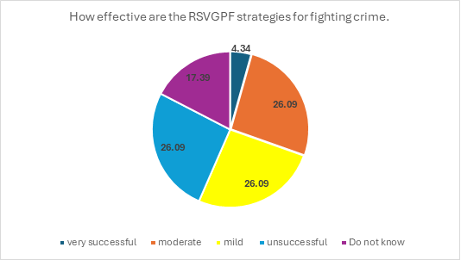
Figure. 1

The question in (Figure 1) was a follow-up question to question number two (2). Twenty-two (22) of the participants responded to the question. One (1) participant did not respond to the question. 26.09% of the participants stated that the tactics employed by the RSVGPF are unsuccessful, 26.09% stated that the tactics employed are moderately successful, 26.09% stated that the tactics used are mildly successful, 26.09% stated that they do not know whether the tactics are successful or not and 4.34% stated that the tactic employed are very successful.

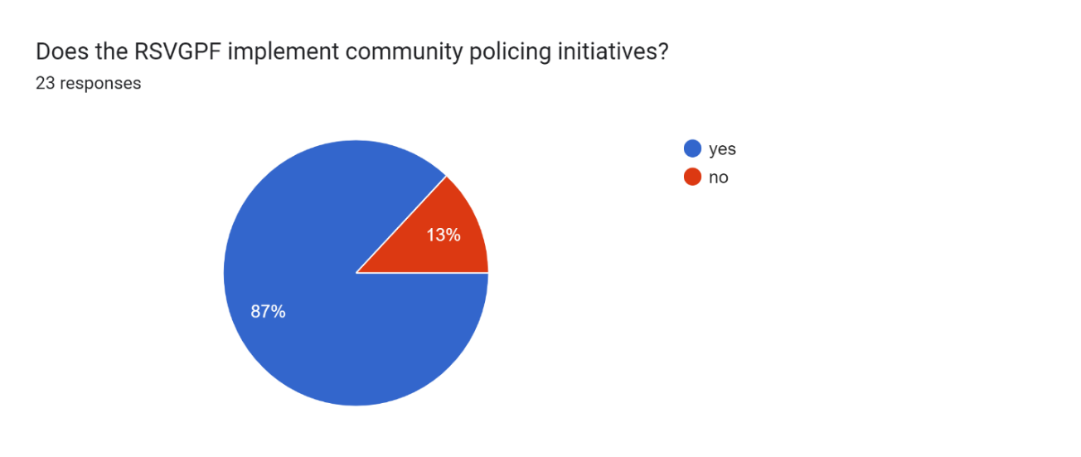
Figure 2.
All twenty-three participants (Figure 2) responded to the question. 87% of the participants stated “yes” that the RSVGPF engages in community policing while 13% of the participants stated “No” the RSVGPF does not implement community policing measures.

What problems exist in establishing trust and co-operation with community members?
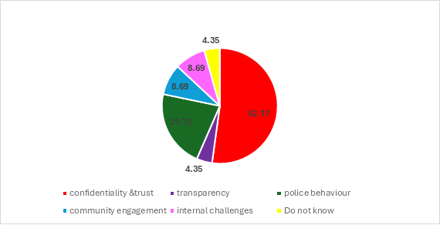
Figure 3.
All twenty-three (23) of the participants (Figure 3) responded to the question. 52% of the respondents stated that confidentiality and trust are the issues that hampers efforts to build trust and cooperate with the public, 21% of participants responded that police behaviour is the problem when it comes to building public trust, 8.69% of the respondents stated that community engagement is a problem, 8.9% stated internal challenges is the problem, 4.35% of the participants stated that transparency is a problem and 4.35% of the respondents stated that they do not know what problems exist in establishing trust and co-operation with community members.

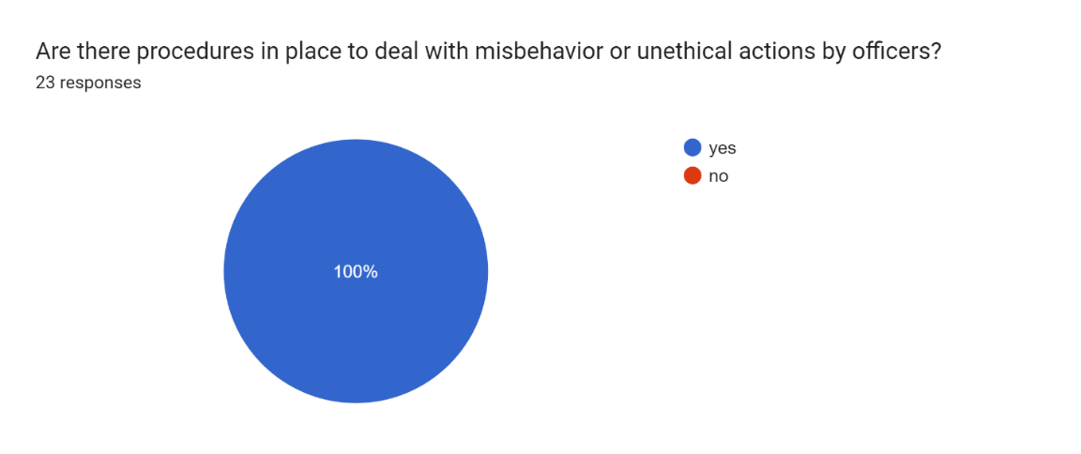
Figure 4.
All twenty-three (23) of the participants (Figure 4) responded to the question. 100% of participants stated “yes”, the RSVGPF have procedures in place to handle misbehaviour and unethical conduct by police officers.

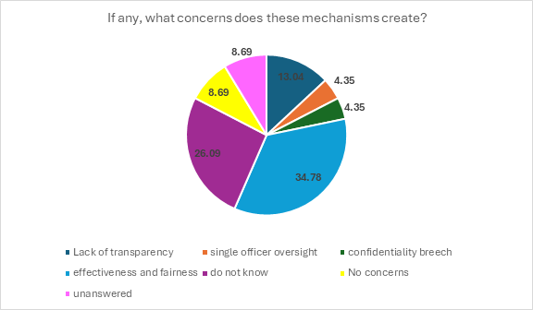
Figure 5.
Three (3) participants (Figure 5) did not respond to the question. 34.78% of the respondents sited that there are concerns with respect to effectiveness and Fairness, 26.09% are unsure about the impact o the mechanisms, 13.04% stated lack of transparency, 8.69% stated there are no concerns, 4.35% stated single officer oversight is a concern and 4.35% stated breech of confidentiality is a concern.

Figure 6.
All twenty-three (23) respondents (Figure 6) answered the question. 39.13% of the participants stated that the RSVGPF ensures transparency via Public Relations and complaint department which consist of and media releases, 26% of participants stated that “Do Not Know” how transparency is ensured in the RSVGPF, 13.04% of participants stated via Internet Policy, 8.7% of participants stated procedure sharing is used to maintain transparency, 4.35% of participants stated chain of command, 4.35% stated via documentation, 4.35% stated transparency is maintained through public Engagement.

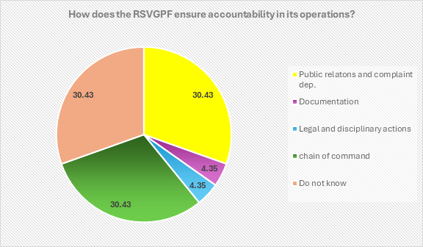
Figure 7.
All twenty-three (23) participants (Figure 7) answered the question. 30.43% they do not know, 30.43% chain of command, 30.43% public relations and complaint department, 4.35% Documentation and 4.35 Legal and disciplinary actions against officers.

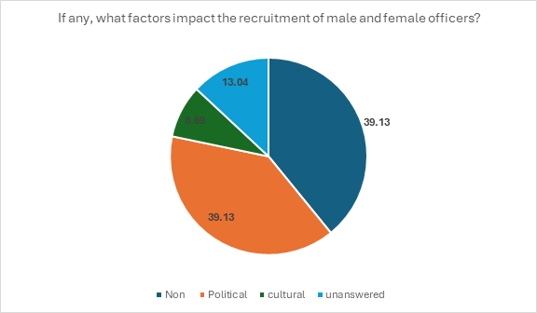
Figure 8.
Twenty (20) participants answered (Figure 8) the question. Three (3) participants did not respond to the question. 39.13% of participants stated political factors influence the recruitment of male and female, 39.13% of participants stated cultural factors, 13.04% of participants did not respond to the question and 8.69% stated no particular factor influence the recruitment of male and female officers.

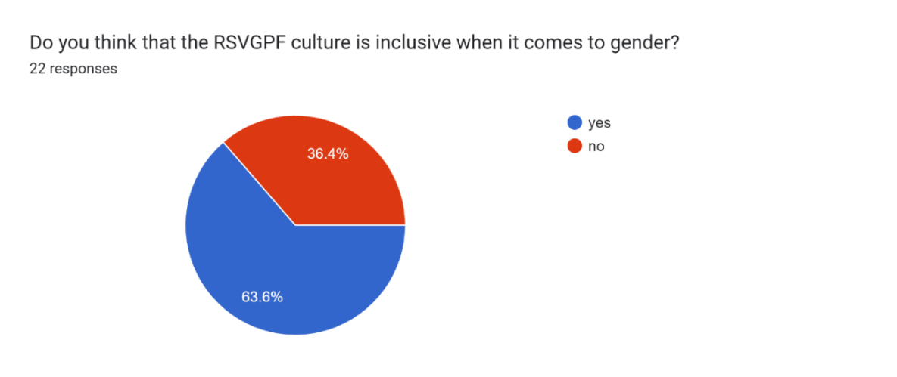
Figure 9.
Twenty-two (22) participants (Figure 9) responded to the question. One (1) participant did not respond to the question. 63.6% of the participants stated “yes” the RSVGPF culture is gender inclusive while 36.4% of the Participants stated no.

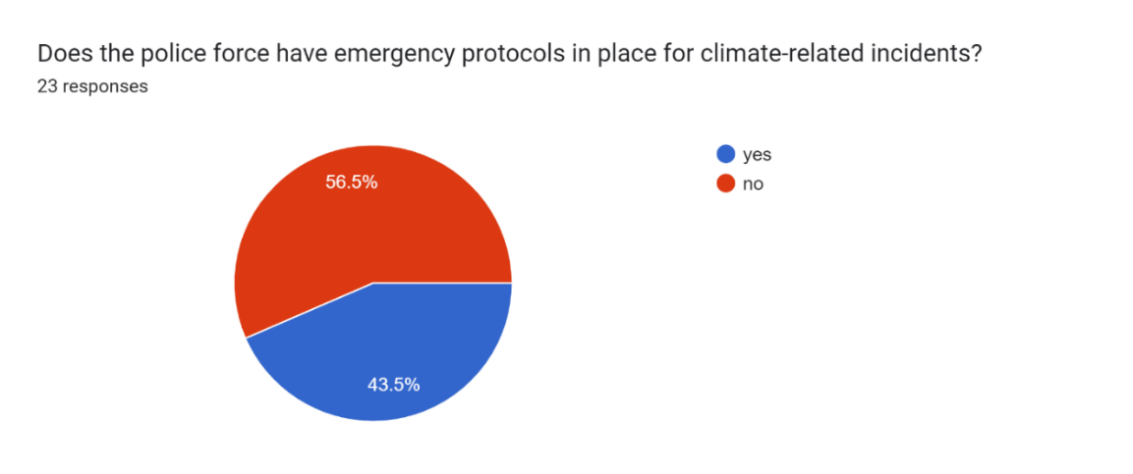
Figure 10.
All twenty-three (23) of the participants (Figure 10) responded to the question: 56.5% of respondents stated “no” the RSVGPF does not have protocols in place for climate related incidents while 43.5% stated “yes” the RSVGPF do have protocols in place for climate related incidents.

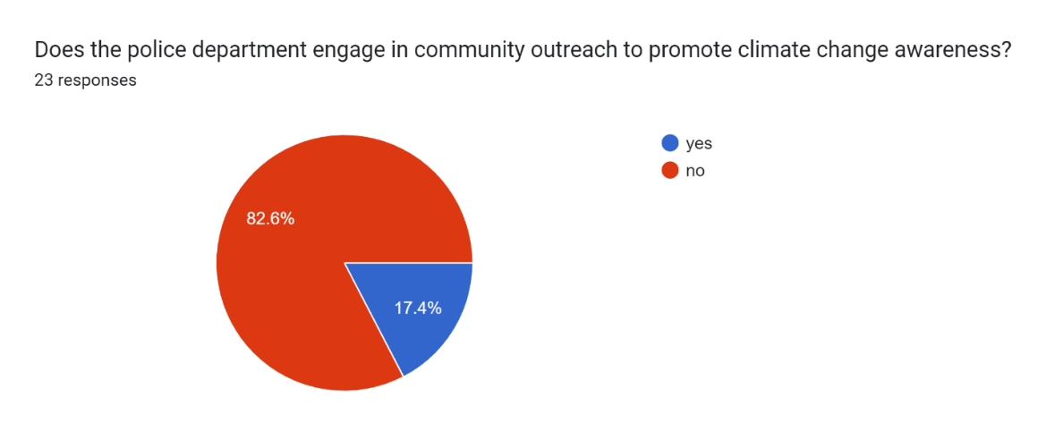
Figure 11.
All twenty-three (23) participants (Figure 11) answered the question. 82.6% stated no the police department does not engage in community outreach to promote climate change awareness and 17.4% stated yes it does.

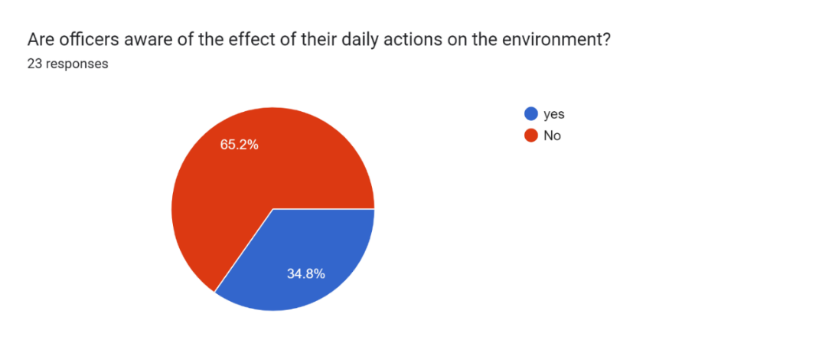
Figure 12.
All twenty-three (23) participants (Figure 12) answered the question the question. 65.2% stated no while 34.8% stated yes.

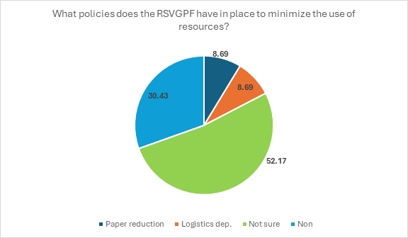
Figure 13.
All twenty-three (23) of the participants (Figure 13) responded to the question. 52.17% responded” they do not know” if there are policies in place to minimize the use of resources, 32.43% stated there are no polices in place, 8.69% stated there is a paper reduction policy and 8.69% mentioned the logistics department handles such policies.

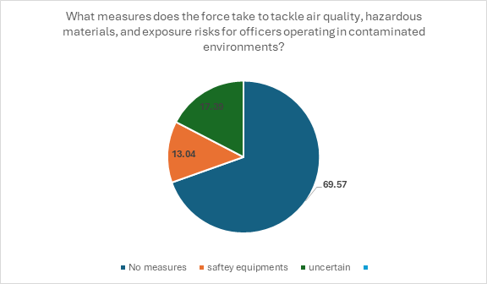
Figure 14.
All twenty-three (23) participants (Figure 14.) responded to the question. 69.57% responded that there are no measures in place, 17.39% stated they are uncertain whether there are any measures in place and 13.04% stated safety equipment as a measure.

Figure 15.
Twenty-two (2) participants responded (Figure 15) to the question. One (1) participant did not respond to the question. 43.49% of respondent stated enforcing environmental laws is how the force cooperates with local authorities, 30.44% stated “there is no cooperation between the two (2) entities”, 8.69% mentioned outreach efforts is a way in which the force cooperates with local agencies and 8.69% stated they do not know how cooperation is maintained between the two entities.
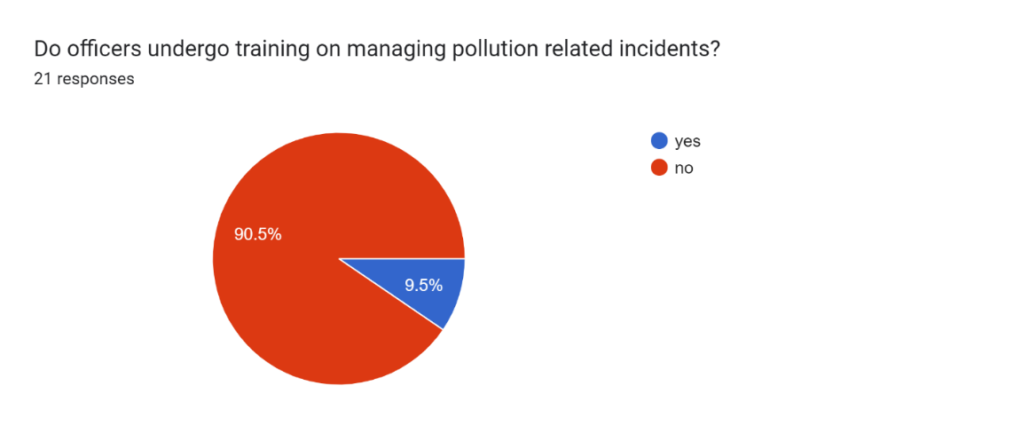
Figure 16.
Twenty-one (21) participants (Figure 16) answered the question while two (2) persons did not respond. 90.5% of participants responded with “no” officers do not undergo training on managing pollution related incidents while 9.5% responded with “yes” officers do undergo training on managing pollution related incidents.

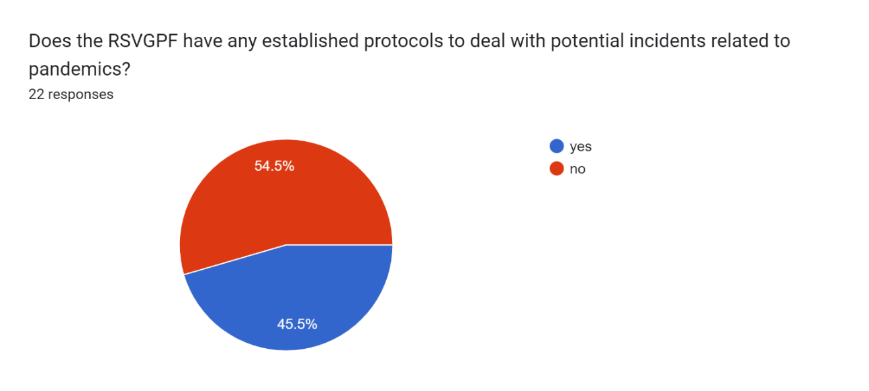
Figure 17.
Twenty-two (22) participants (Figure 17) responded to the question. One (1) participant did not respond to the question. 54.5% of respondent stated “no” the RSVGPF do not have any established protocols to deal with potential incidents related to pandemics while 45.5% stated “yes” the RSVGPF do have established protocols to deal with potential incidents related to pandemics.

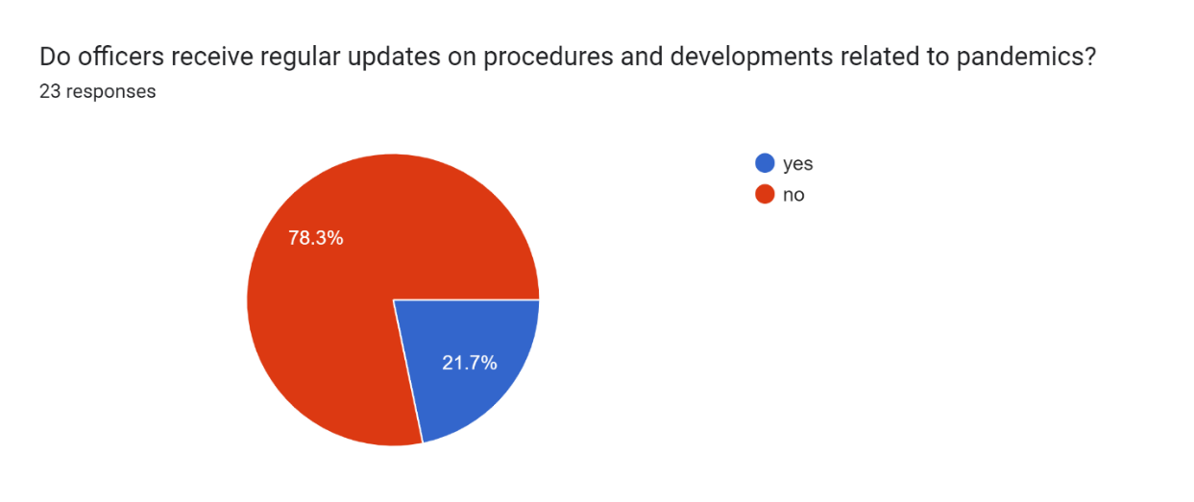
Figure 18.
All twenty-three (23) participants (Figure 18) answered the question. 78.3% of participant responded “no” officers do not receive regular updates on procedures and developments related to pandemics. 21.7% of participants responded “yes” officers do receive regular updates on pandemic related procedures and developments
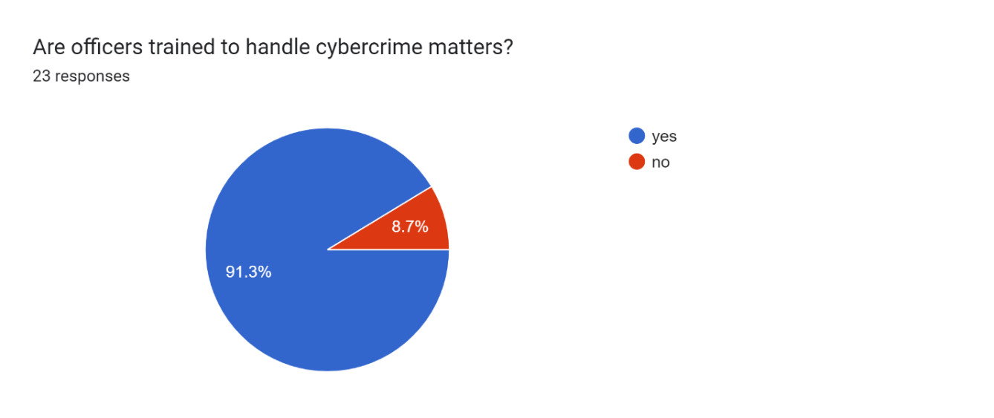
Figure 19.
All twenty-three (23) participants (Figure 19) responded to the question. 91.3% responded “yes” officers are trained to handle cybercrime related matters. 8.7% responded “no” officers are not trained to handle cybercrime related matters.

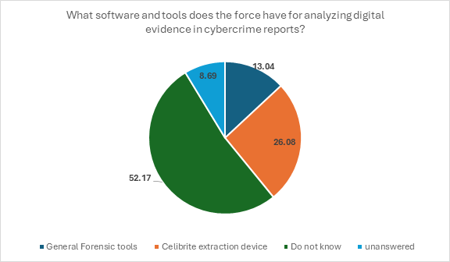
Figure 20.
Twenty-one (21) of the participants (Figure 20) answered the question. Two (2) participants did not answer the question. 52.17% of responded that they do not know what software tools the RSVGPF uses to analyse digital evidence in cybercrime reports, 26.08% responded that celibrite extraction device, 13.04% responded that the RSVGPF uses “general forensic tools” to analyse digital evidence in cybercrime reports.

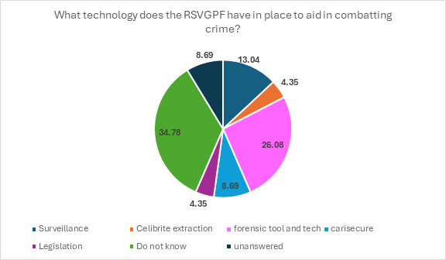
Figure 21.
Twenty (20) participants (Figure 21) responded to the question. Three (3) participants did not respond. 34.78% respondent stated they do not know what technology the RSVGPF have in place to aid in combatting crime, 26.08 mentioned the RSVGPF uses forensic tools and technology, 13.04% stated surveillance (camera), 8.69% stated Carisecure system, 4.35% stated Celibrite extraction and 4.35% stated legislations.

(Questionnaire with only civilian participants)

There was a total of twelve (12) respondents

Figure 22.

All twelve (12) participants (Figure 22) answered the question. 50% of participants stated they felt moderately safe in their community, 25% stated slightly safe, 8.3% stated fearful, 8.3% stated very safe and 8.3% stated extremely safe.

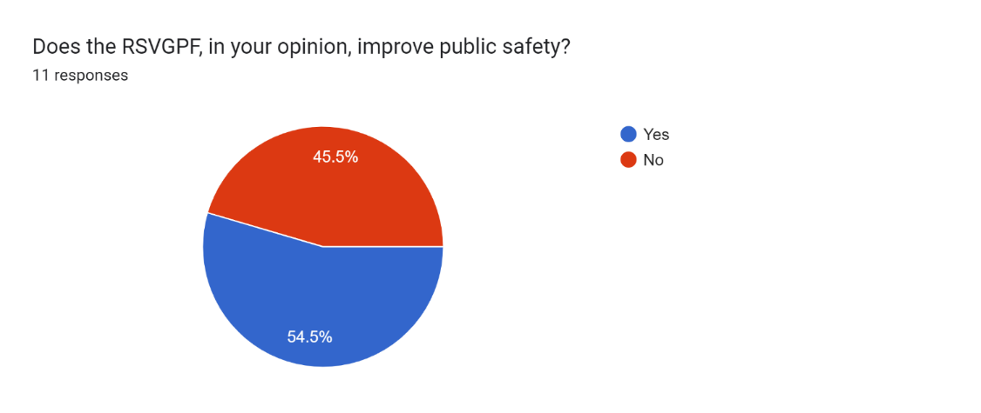

Figure 23.

Eleven (11) participants (Figure 23) answered the question. One (1) participant did not respond. 54.5% stated yes, the RSVGPF increase public safety, while 45.5% stated “no”, it does not.

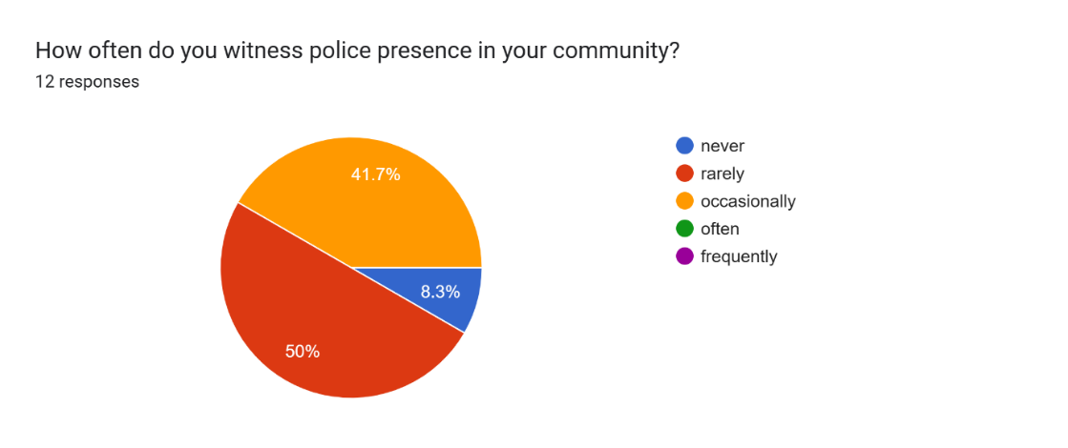
Figure 24.

All twelve (12) participants (Figure 24) responded to the question. 50% of respondents stated “rarely” do they witness police presence in their community, 41.7% stated occasionally, 8.3% stated “never “have they witnessed police presence in their community.

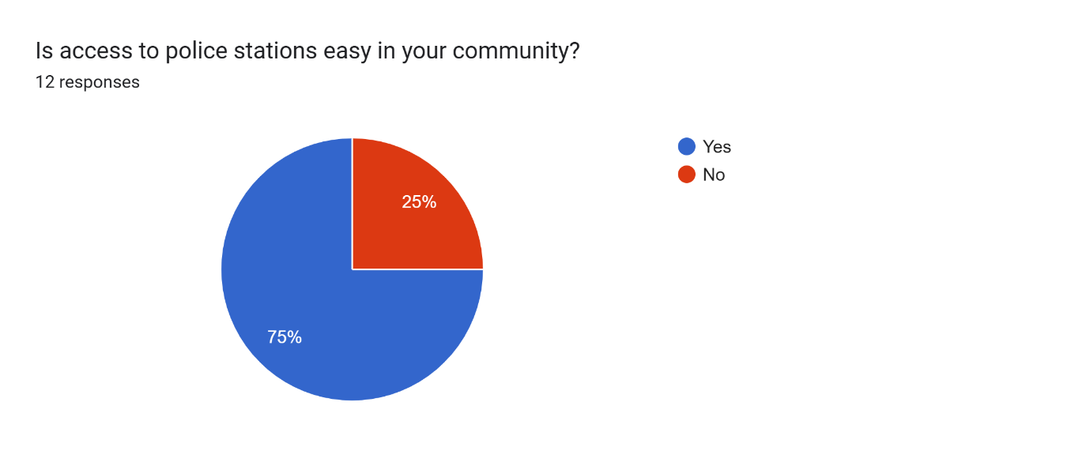
Figure 25.

All twelve (12) participants (Figure 25) responded to the question. 75% of respondents stated “yes” police station is easily accessible in their community, while 25% stated “no” it is not.

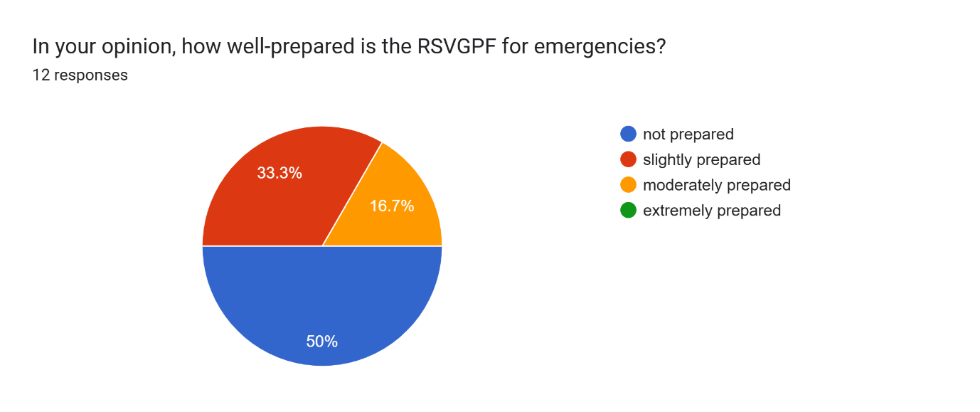
Figure 26.

All twelve (12) participants (Figure 26) responded to the question. 50% of respondents stated that the RSVGPF is not prepared for emergencies, 33.3% stated it is mildly prepared and 16.7% stated moderately prepared.

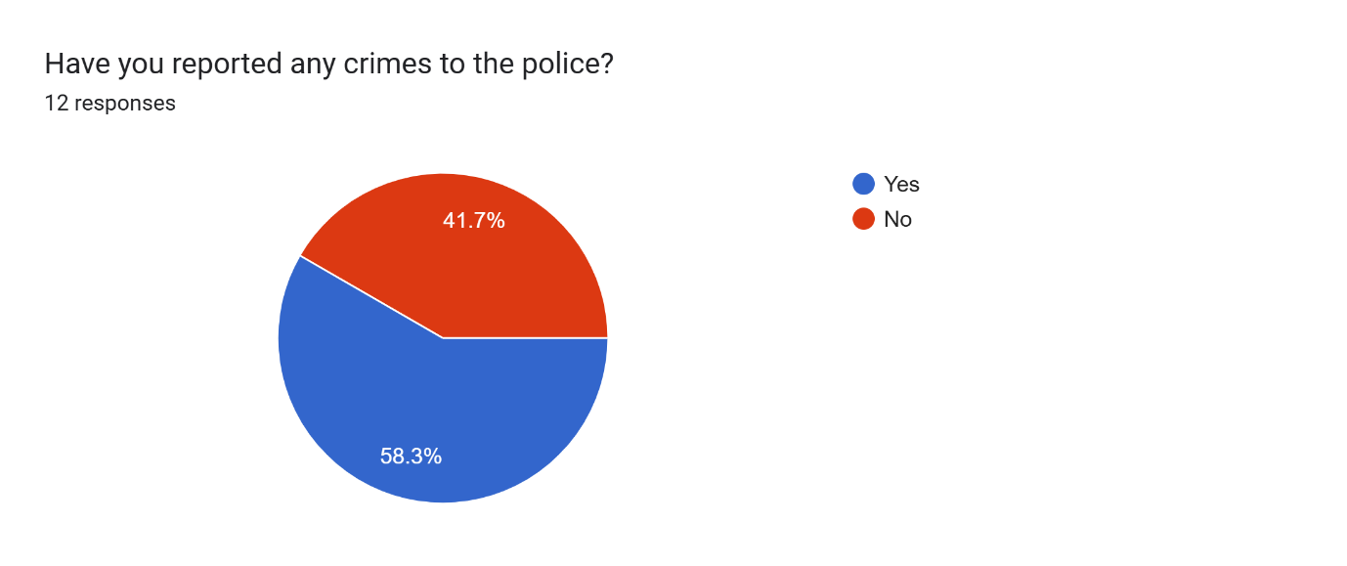
Figure 27.

All twelve participants (Figure 27) responded to the question. 58.3% of respondents stated “yes”, they have reported crime to the police. 41.7% of the respondents stated no they have not reported any crimes to the police.

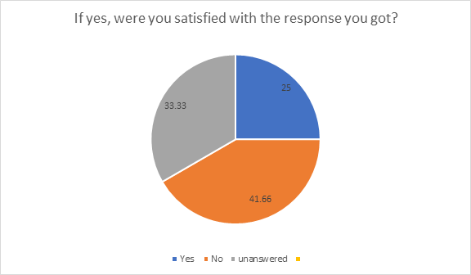
Figure 28.

This question (Figure 28) is in response to question 6. Seven (7) participants responded to this question. Five (5) respondents did not answer the question. 41.66% responded “no” they were not satisfied with the response they received, 25% stated “yes” they were satisfied.

Figure 29.
All twelve (12) participants (Figure 29) answered this question. 75% of respondents stated there are “no” community policing programs in their community, 16.7% stated “yes” and 8.3% stated that they are not sure if there are community policing programs in their community.

Figure 30.

Eleven (11) participants (Figure 30) responded to the question. One (1) participant did not respond. 41.66% of respondents stated interaction between the police and community is not effective, 33.33% of respondents stated slightly effective and 16.66% of respondents stated interactions between police and community residents are moderately effective.

Figure 31.

All twelve (12) participants (Figure 31) responded to the question. 74.9% stated no, the RSVGPF does not have sufficient resources to fight crime successfully, 8.3% stated “yes” the RSVGPF does have sufficient resources and 8.3% stated that there is a surplus of human resources but insufficient material resources and existing structure does not effectively utilize the human resources to maximize the benefits of the material resource.

Figure 32.

All twelve (12) participants (Figure 32) responded to the question. 100% of the respondents stated no RSVGPF is not a transparent organization.

Figure 33.

All twelve (12) participants (Figure 33.) responded to the question. 74.9% of respondents stated “no” officers are not held accountable for their actions. 25% stated “yes” officers are held accountable for their actions.

Figure 34.

Eleven (11) participants (Figure 34) responded to the question. One (1) participant did not respond to the question. 81.8% of respondents stated “yes” they should prioritize resource conversation. 18.2% of respondents stated “no” it should not.

Figure 35.

Elven (11) participants (Figure 35) responded to the question. One participant did not respond. 25% of respondent stated that they will suggest enhancing police visibility around the country, 25% stated that assessment should be conducted to decide where and what resources need to be allocated, 16.66% stated police need more equipment, 16.66% stated that they have no suggestion for resource distribution and 8.33% stated resource should be distributed to disaster preparedness.

Question 15.

The Participants for the research resided in ten (10) different constituencies through-out St. Vincent and the Grenadines, namely:
- North Central Windward
- South Windward
- South Leeward
- East St. George
- West Saint George
- Marriaqua
- East Kingstown
- Central Kingstown
- West Kingstown
- Northern Grenadines

NB: St. Vincent and the Grenadines has fifteen (15) constituencies

CHAPTER V-Analytical Discussion
The analysis of data collected from police officers and civilians in St. Vincent and the Grenadines on the sustainability of the current policing model of the RSVGPF highlight several concerns and potential for improvement. Below is a summary of sustainability issues in the organization and how addressing these issues can enhance the effectiveness of the current model of policing. The data was analyzed in two (2) parts according to respondent group, section one (1) Police officers and section two (2) civilians
Section one (1)
Question (1) The participants of the survey cover a range of departmental experience in the RSVGPF with years of service ranging from four (4) years to twenty-eight (28) years.
Question (2,3) Sought to gain knowledge of policing strategies and practices in the RSVGPF. Majority of officers stated that the RSVGPF uses patrols as its tactic to maintain law and order in SVG. Lesser responses given were outreach tactics, surveillance and intelligence, crime prevention initiatives, strategic deployment and officer training. 3. Majority of respondents believe the RSVGPF crime fighting strategy are mildly and moderately successful with 4.34% citing it as very successful.
Findings: There is a weak consensus on the effectiveness of the current crime fighting strategies employed to fight crime in the RSVGPF. However, there is a strong consensus that current strategies need to be improved. Additionally, there appears to be some misunderstanding or lapse in communication in respect of the effectiveness of these strategy. Furthermore, the impact of these strategies may warrant closer observation as to their use and objectives and there is need for improvement in the design, execution and communication of these crime fighting tactics. Ensuring stakeholders are well informed and transparency in strategic outcome may help to improve perception of officers who are unsure of the effectiveness of the crime fighting tactics. Additionally, future research can capture greater qualitative data from participants in order to pinpoint the areas need for improvement.

Question (4,5) Sought to gain data on community engagement. Majority of officers believe that the RSVGPF engages in community policing which may mean they have observed efforts of some aspects of community policing. A smaller percentage believes that the RSVGPF does not implement community policing measures which may mean no experience with such. 5. Majority of officers believe that confidentiality and trust are key problems that hampers police’ efforts to building trust and cooperation with the public which highlights the importance of trustworthiness and confidentiality. If civilians believes that police cannot be trusted with vital information, they will divulge sensitive information. Other barriers given were police behaviour, which may refer to unprofessionalism or unfavourable encounters with officer; lack of community engagement referring to little interaction and involvement with civilians in the decision-making; internal challenges which may refer to inadequate resources; police training or communication with the public, which can impact efforts to build community trust; Lack of transparency which can lead to mistrust and suspicion. Few officers stated “they do not know” which can highlight a lack of information or awareness by some officers.

Findings: There may be a communication gap with regard to community policing implementation. The latter may indicate inconsistencies in the understanding or application of “community policing” measures. An evaluation of the application of community policing measures may clarify discrepancy in the responses. This feedback may provide valuable insight on areas that need improvements.

Question (6,7,8,9). sought to gain data on Accountability, oversight and transparency in the RSVGPF. All officers agree that the RSVGPF has procedures in place to deal with misbehaviour and unethical actions by officers. Therefore, it appears that the organization prioritizes ethical conduct by officer and has established procedures for addressing misconduct. Furthermore, the responses show a level of transparency and accountability within the organization based on the existence of procedures that are visible, and such principles are critical to creating and maintaining public trust and ensuring professionalism by officers.

7. Officers provided diverse opinions for the efficiency of mechanism to address unethical behaviours by officers. Many officers viewed these mechanism as ineffective and unfair which highlights they do not accomplish their aim to address misconduct by the police or make fair decisions when such is believed to have occurred. The response also highlights that there is a lack of confidence in the procedure used for handling those investigations. A significant portion of officers stated that they “do not know” what concerns are created by the mechanism, while a small percentage did not respond to the question which may highlight officer’s uncertainty of the effects of the mechanisms which possibly reflect that either those officers are not familiar with the mechanisms and that they may need to be provided with more clarity about the outcome of those mechanisms. Other notable responses were: a lack of transparency when applying the mechanism which may mean a need for more clarity about the processes and outcomes of the mechanisms.Transparency is important for creating trust and can create scepticism when lacking; Single officer oversight”- which may mean lack of diversity in personnel presiding over matters; Confidentiality Breach- this may deter individual from voicing their concerns and undermine investigations as confidentially is a vital component for trust,

8. The respondents provided diverse responses on their awareness and understanding regarding of transparency in the RSVGPF. A significant proportion of officers stated that the RSVPF ensures transparency via “Public Relations and Media Releases” This department plays the major role in providing information to the pubic in relation to the police force. This means that there is a high awareness of the existence and functions of the public relations department. A significant percentage of officers stated that they “do not know” how the RSVGPF ensures transparency. This may highlight that there may be gaps in officers’ awareness and understanding of the organization’s transparency practices. This can also mean that better communication is needed with officers. Other notable responses were internet/ social media, public Engagement and procedure sharing, chain of command and documentation of action internally. However, the latter three (3) alone may not be sufficient to show transparency to the public unless made accessible to the them.

9. A significant proportion of officers stated that they “Do not know” how the RSVGPF ensures accountability. This may mean that there is a high level of uncertainty with regards to such methods and that there may be a lack of awareness and or understanding of whether such mechanism exist. This can also highlight a lack of communication and transparency regarding such mechanism. A significant proportion of officers stated chain of command, hence, recognizing it as an important internal mechanism for creating accountability. It is a structured in place dealing with oversight, which is essential for both addressing internal issues and managing police operations. A significant percentage of officers responded “Public Relations and Complaint Department”. This shows awareness of the role of that department in addressing public concerns and communicating information to the public. Other notable responses were documentation, and legal and disciplinary actions The latter measures provide formal consequences for unethical behaviour by officers and assist in upholding standards within the police force.

Findings: Despite having procedures in place to deal with officer’s misbehaviour and unethical actions many officers believe that the organization is not doing its job to address misconduct by police or make fair decisions when such is believed to have occurred. They believe that there is a lack of confidentially and transparency in the procedure used for handling investigations of such matters. Additionally, many officers believe that the RSVPF ensures transparency and accountability is maintained through a variety of different means the most prominent being via public relations departments and of chain of command. However, there still remain gaps in officers’ awareness regarding the existence of mechanism to ensures transparency and accountability in the organization.

Question (10,11) sought to gain data on gender inclusivity in the RSVGPF. A significant portion of officers believes that no factor influences the recruitment of male and female, which hints that the recruitment process for is unbiased in regards to gender or that some officers may not be aware of such complexities in the recruitment process. The same percentage of officers believe political factors is an influence to recruitment which can mean that recruitment is based on political affiliation or pressure and that such factors are seen to influence the diversity of the recruitment process, such can undermine the credibility of the recruitment process. A small percentage of officers did not respond to the question which may show uncertainty, while a smaller portion stated cultural factors which mean cultural stereotypes relating to gender may affect the recruitment of male and female candidates. Overall, gender equality in recruitment in the organization may be remedied by addressing cultural biases.

11. A significant proportion of officers believe that the RSVGPF culture is gender inclusive, which may highlight that the organization supports both gender equality and inclusivity. A notable portion of officers responded that the culture is not gender inclusivity, highlighting that there may be a gap in how and what officers perceived to be gender inclusivity and varying experiences.

Findings: The data pinpoints areas where the RSVGPF may need to improve in it quest to create gender inclusivity because their may still exist barriers to gender inclusivity. Overall, this can undermine the credibility of the recruitment process, gender equality in recruitment in the force can be remedied by addressing cultural biases.
Question (12, 13 14, 15, 16, 17, 18) sought to gain data on climate change preparedness and climate action in RSVGPF. A notable portion of officers stated the RSVGPF has established protocols for handling climate-related incidents, which may suggest that some officers have some levels of awareness of the existence of procedures for managing such emergencies. On the other hand, the majority of officers believe there are no protocols in place for managing climate-related incidents. This can highlight that majority officers are not aware of any existing protocol. Furthermore, the diversity in response may show a discrepancy in communication of these protocols and produce uncertainty about the existence of them.
13. Majority of officers do not believe that the RSVGPF engages in outreach activities to raise climate change awareness while a minority percentage do. This may indicate a strong observation or awareness gap regarding the RSVGPF’s involvement in climate change awareness efforts. It can also show where the RSVGPF could potentially improve its community engagement and outreach.
14. A small percentage of officers are aware of how their daily actions impact the environment while the majority is not. This can suggest that a small fraction of officers have some level of environmental awareness.
15. There is a high level of uncertainty about the existence of policies to minimize resource use which may suggest that information about resources minimization is not uniform throughout the organization. Additionally, that there may be some initiative in place aimed at reducing paper use, although all officers may not be aware.
16. The majority of officers do not believe tthe RSVGPF has measures to protect officers’ exposure to hazardous materials and those operating in contaminated environments. This can pose a major concern as officers operating in contaminated environments without adequate protection may be exposed to health risk. A notable percentage of officers responded that they are uncertain if such measures exist while a small percentage are aware of the existence of “Safety Equipment” to tackle such.
This uncertainty may highlight that officers have not received sufficient training, or are being communicated with on any existing equipment and procedures. 17. A significant proportion of officers stated that the RSVGPF cooperate with local agencies to control pollution through enforcement of law meaning taking against violation of environmental regulations in SVG. This may highlight that these officers have some awareness both of the existing laws to control pollution or ofsuccessful actions that have been taken against violations. The largest portion of officers stated that there is no cooperation between the police and local agencies to control pollution. While a smaller percentage stated that they do not know if there is any form of cooperation between the police and other entities. The latter may highlight that some officers may not be aware of any existing procedures to control pollution and that there may be a lack of communication regarding collaborative efforts with other local agencies. A small proportion of officers mentioned that the RSVGPF uses outreach efforts. However, while this is a positive effort, the limited number of responses may indicate that outreach efforts may not be widely recognized as a method of cooperation.
18. Do officers undergo training on managing pollution related incidents? A significant portion of officers stated they do not receive training on managing pollution related incidents while a small number of officers stated that thy do receive training on managing pollution related incidents.
Findings: There is positive effort by the RSVGPF to prepare officers for managing pollution related occurrences although awareness may not be widespread also officers may lack the necessary skills to respond to such incidents. Additionally, there may be a strong awareness gap regarding the RSVGPF’s involvement in climate change preparedness and awareness efforts. Furthermore, officers may have not received sufficient training, or are being communicated with on any existing procedures. officers should be informed and trained about such measures and equipment’s available. Ensuring that the police force has effective protocols in place is important for effective disaster preparedness response. Additionally, if there are protocols in place it is important to evaluate how well they are communicated to officers and to improve transparency as much as possible.
Question (19, 20) sought to gain data on pandemic preparedness in the RSVGPF 19. Majority of the officers responded that the RSVGPF does not have established protocols for dealing with pandemic-related incidents. On the other hand, a significant percentage of participants stated that the RSVGPF does have established protocols for managing pollution related incidents. This is a positive sign that suggests the RSVGPF may have taken some steps to prepared for pandemic related incidents. However, the diversity in the data may highlight that there is a lack of awareness and preparedness by some officers on the existence of such protocols and preparedness for such emergencies.
20. Majority of participants do not receive regular updates on procedures and/or developments related to pandemics. On the other hand, a lesser percentage stated that they do receive regular updates on pandemic related procedures and developments.
Findings: There appears to be some level of awareness and preparedness by officers however this practice may not be uniform throughout the organization.
Question (21, 22,23) sought to gain data on cybersecurity and technology in the RSVGPF. 21. The majority of participants believe officers are trained to handle cybercrime matters. This may highlight that officers are provided with the skills needed to address cybercrime related matters. On the other hand, a small proportion of participants are not trained to handle cybercrime matters.
22. More than half of the participants are not aware of the software and tools used for analysing digital evidence in cybercrime while a notable portion stated Cellebrite extraction device is used. Other responses were general forensic tool which can signify that these officers are aware that some devices are used but do not know the specific devices used. A small percentage of officers did not respond to the question. which could signify that some officers possess no knowledge of devices that are used for the analysis of digital evidence.
23. A significant proportion of officers stated that they do not know what technology is used in combatting crime in the RSVGPF. This may suggest a lack of communication or awareness about the tools and resources utilized in the organization. A notable percentage of officers stated forensic tools and technology are used. Other responses were surveillance technology including CCTV and body cameras, Cellebrite Extraction tool and legislations However, despite legislations being important technology also aids to support it use.
Findings: The data highlights an overall effectiveness of the RSVGPF’s ability in dealing with cybercrime and might imply that training and awareness are still needed for some officers in this area. Additionally, there is a lack of communication and awareness about the technology utilized in the organization to aid in combatting crime as the majority of officers do not know of the technology used.
Question (24) Sort to gain data on officer health and wellbeing in the RSVGPF. All officers believe that their health and wellbeing are neglected by the RSVGPF and that feeling appears to be unanimous throughout the organization.
Summary: Section one (1) analysis found several areas of concerns by officers of the RSVGPF: There appears to be a significant lack of communication about operation and policies within the RSVGPF leading to officers lack of awareness about vital matters. Additionally, existing policies may warrant closer investigation to pinpoint areas for improvement as they may be ineffective. Furthermore, there may exist material resource inadequacy in the organization which affects officers’ ability to perform effectively. There is a lack of proper transparency and accountability procedures and a need for increased gender inclusivity efforts. There is a lack of training and effective protocols geared towards climate preparedness and awareness, pandemic preparedness and the use of cybercrime and technology to combat crime. Lastly, police officers’ health and wellbeing appears to be of low priority in the organization.
Section two (2)
Question (1, 2) sought to obtain data on civilians’ perception of safety. 1. Civilians gave a set of diverse responses with the majority of participants not feeling entirely safe in their communities. This can mean that there is some/much room for improvement with regards to community safety. Also the difference in opinions may reflect diverse experiences and different community conditions. 2. The majority of respondents were positive about the presence of police which means that police create a positive impact. However, an almost equal proportion appears to not be swayed by police presence, which means that officer may not be as effective as they should. Hence, the RSVGPF may need to improve on the effectiveness of their presence.
Findings: There is much room for improvement with respect to increasing general public perception of safety and the effectiveness of police presence in communities.
Question (3, 4) sought to obtain data on visibility and accessibility of police by civillians.3. While a significant proportion of civilians occasionally see police presence in their community, the majority of them rarely or never see police in their community. This could mean that police presence is not prominent in all communities and that there may not be any form of active community policing in some communities. 4. Majority of civilians stated that the police station in their community is easily accessible, they may feel safer in their communities than the significantly less portion of civilians that stated police stations are not easily accessible, who may feel less safe in their communities.
Findings: Despite police stations been easily accessible to the majority of persons, police presence does not appear to be prominent in all communities. This may affect civilian perception of safety.

Question (5) sought to obtain data on climate preparedness of the RSVGPF .5. Half of the civilians stated that the RSVGPF is not prepared for climate related emergencies which may signify a lack of confidence in the organization in the event of such. A notable percentage stated mildly prepared, which can highlight some level of preparedness by the RSVGPF although it may not be sufficient to create a level of confidence. A lesser portion felt moderately prepared which may be a positive aspect however, this number is relatively low.
Findings: Majority of civilians believe some level of climate related emergency preparedness although it may not be sufficient to create a level of confidence in a high level of respondents, which may be a cause for concern.
Question (6, 7) sought to obtain data on civilian trust and confidence in police. 6. Majority of civilians have reported crime to the police while slightly less have not. This show that the majority of persons are willing to report criminal activities to the police, which may highlight that they trust the police to investigate matters. For those that have not reported crime this may show a lack of trust and confidence in the police ability to investigate matters.
7. More than half of the civilian were not satisfied with the response from the police after they reported a crime. While a significant portion did not respond to the question.
Findings: Majority of civilians are willing to report crime to the RSVGPF, signally existing confidence in their ability. However, there is still room for improvement as majority of civilians were not satisfied with the response they received after reporting crime, while notable portion do not report crime. As a result, the RSVGPF may need to improve in their investigative skills.
Question (8, 9) sought to obtain data on community policing in the RSVGPF. 8. Majority of civilians stated there are “no” community policing programs in their community, a smaller portion stated they are not sure if there are such programmes in their community. A lesser portion stated there is community policing in their communityhile a portion of civilians are not aware of such programmes in their communities.
9. A significant proportion of civilians believes interaction between them and the RSVGPF to be either non existent or poor. A smaller percentage stated that interaction between them is moderately effective; although this is a positive sign it is not unanimous with the majority of respondents.
Findings: Majority of civilians are not aware of the implementation of community policing in their communities. and there is much room for improvement with regards to interaction between police and majority of civilians as current communication is either poor or non existent.

Question (10, 11, 12) sought to obtain data on resource allocation of the RSVGPF. 10. Despite a small percentage of civilians believing that there are sufficient resources in the RSVGPF, the majority of respondents believe that the organization lacks sufficient material resources. This may affect civilians’ perception of police capabilities to fight crime.

11. Majority of civilians highlighted that using resources efficiently in the RSVGPF might be a significant concern. While the minority views that its not an area of concern. This may signify that there may be other concerns that the public believes should be prioritized.

12. A quarter of the respondents stated that enhancing police visibility should be prioritize when distributing resources this can mean the civilian may feel safter knowing that police are about. The same percentage of respondents stated that RSVGPF should conduct assessments before allocating resources, which highlights that some civilian a believe data driven approach to reource management may prove effective. Other notable responses where additional equipment are needed which points to resource inadequacy. Some officers had no suggestion which may highlight their uncertainty 8.33% of civilians stated resources should be allocated to disaster preparedness which may highlight, persons belief that police are not prepared but should be for disasters.
Findings: There may be resource inefficiency (material) in the RSVGPF which may be significant concern and should be prioritized along with enhancing police visibility. Furthermore, a data driven approach may be appropriate to resource allocation may be best.
Question (13,14) sought to obtain data on Accountability and transparency of the RSVGPF. 13. There is a unanimous agreement amongst civilians that the RSVGPF lacks transparency which may highlight a significant concern about the operation of the organization. 14. Majority of civilians believe that officers are not held accountable for their actions which may highlight a significant concern about the processes in place to hold officer accountable for misbehaviour. A smaller percentage of civilians believe that officers are held accountable which may mean that they had a positive encounter with such process. However, given that this opinion is not shared by the majority of respondents, this may be a cause for investigation.
Findings: Majority of civilians believe that officers are not held accountable for their actions and that the RSVGPF lacks transparency both of which highlights significant concerns and may require investigation to develop an amenable solution.

Question (14) background information. The Participants resided in ten (10) of fifteen constituencies through-out St. Vincent and the Grenadines.
Summary: Section two (2) analysis found several areas of concerns by civilians: There is significant need for improvement with respect to increasing public perception of safety and the effectiveness of police presence in communities. Secondly, there is a need for enhanced climate related preparedness efforts in the RSVGPF. There is also a significant lack of confidence and trust in the RSVGPF. Furthermore, there is a need for improved communication and interaction between police officers and civilians as current communication is either poor or non existent. There is resource inefficiency (material) in the RSVGPF which should be prioritized along with enhancing police visibility. Lastly, there is a significant lack of accountability by the RSVGPF and a lack of effective transparency mechanisms.
Overall, in relation to the current policing model of the RSVGPF and its adaptability to contemporary challenges the analysis highlights that the organization shows a commitment to evolving its policing model to better address contemporary challenges effectively, due to the following:
Strengths of the current RSVGPF policing model
- There is a strong existence of procedures to address misbehaviour and ethical misconduct (Usaid, 2020).
- There appears to be an engagement in community policing (Gill, et al, 2014).
- The existence of infrastructure to ensure transparency and accountability (Tyler, 2004).
- There are ongoing efforts to maintain gender inclusivity (Morash & Haar, 2012).
- The organization is increasing integrating technology into its crime fighting techniques (Koslicki, 2019).
At the same time, the current policing model shows several key weaknesses which affects its adaptability to contemporary challenges, such as:
- There is a significant lack of communication within the RSVGPF in respect to crime strategies, operational procedures, and resources (Kawalya-Tendo, 2024).
- There are concerns regarding transparency and accountability within the RSVGPF with respect to fairness and consistency in police disciplinary matters (Walker & Archbold, 2013).
- Despite the implementation of some community policing efforts, there is still need for greater consistency and strategy in implementing community policing (Modise, 2023).
- There appear to be a lack of material resources along with resource efficiency measures in the RSVGPF.
- Police officers may need additional training in areas such as cybercrime and Pandemic and climate change response (Halford & Youansamouth, 2022; Maskály et al., 2021; Alastal & Shaqfa, 2023; Strom, 2017; Mutongwizo et al., 2022).

CHAPTER VI-Conclusion and Recommendations
This dissertation evaluated the sustainability of the current policing model of the RSVGPF by using current practices of the RSVGPF, stakeholders feedback and existing literature which revealed several key findings. Some key strengths highlighted in the organization includes strong procedures to address misbehaviour and ethical misconduct, community policing engagement, the existence of infrastructure to ensure transparency and accountability and ongoing efforts to maintain gender inclusivity. However, some key concerns exist such as the lack of communication within the RSVGPF, resource inefficiency, the need to strengthen accountability and transparency processes, insufficient preparedness and training for climate change and pandemic emergencies and operational inefficiencies which are significant barriers to overall sustainability. Nonetheless, to enhance adaptability and sustainability there are recommended actions which can be taken to improve the RSVGPF policing model, as seen below.
Recommendations
Improving communication: The RSVGPF should improve communication and transparency of operational policies and processes with officers. Previous research highlights that many law enforcement organizations tend to suppress information due to their hierarchical and bureaucratic structures, leading to coordination challenges, distortion of information (Boorovec and Balgac 2017). Putnam & Krone (2006) argues that effective communication is crucial to organizational success, as it fosters vital relationships within the organization. Communication is key in aligning employees with an organization objective, when essential information is withheld it often brings suspicions. Kenney (n.d.) highlighted that sharing of information at all department levels can diminish such concerns. Effective communication helps to resolve personal conflict, provide clear guidance, convey accurate information and avoid confusion. Additionally, it helps reduce absenteeism by 41% with 24% less turnover, and 17% rise in productivity (How to Develop Effective Communication in Law Enforcement, 2021). Research conducted in Croatia found that internal communication is the strongest predictor of employee satisfaction (Borovec & Balgač, 2017). Thus, it helps officers to be better equipped in decisions making and understanding policies and directives from leadership (D’souza, 2022). Hence, the RSVGPF should develop structured communication systems as it enhances coordination, improve job satisfaction, and ultimately, achieve more effective policing.
Promote officer health and wellness: The RSVGPF should consider the adoption of policies and initiatives to promote overall health and well-ness for officers. Kerswell et al (2019) argues that officers are frequently faced with risks to their or others' physical safety as a result of dealing with everyday criminal behaviour, as well as risks associated with more uncommon or catastrophic situations such as natural disasters. According to Liakopoulou et al (2020) persistent exposure to 'violence, hostility, environmental stressors, and traumatic incidents' often results in poor physical and mental health among police officers. According to Clements et al (2020), officers frequently operate in high-pressure/stressful environments, which can lead to burnout, lower productivity, decrease in the quality of service provided, and severely affect officer’s physical health. Cole (2024) argues that improve access to wellness resources is critical as they can assist police in coping with stress and enhance mental health (Cole, 2024), while (Department of Justice) 2023 studies emphasizes that the prevalence of psychological work injuries presents acrucial need for focused therapies in law enforcement. A lack of effort to improve officers' health and wellness can have a negative influence on their morale. . Hence, it is imperative that the RSVGPF develop and implement robust wellness programs that enhance access to mental health resources, which will serve to enhance overall effectiveness of the workforce.

Strengthening Accountability and Transparency: The RSVGPF should update its internal disciplinary policies to enhance consistency and transparency in it’s application. As well as the establishment of an independent oversight body to ensure accountability in its practices (United Nations Office on Drugs and Crime, 2011). Evidence shows that incidents of police misconduct and inadequate accountability can significantly erode public trust, notable examples include the civil unrest in Harlem (1964), Watts (1965), Detroit (1967), and New York (1999), which underscores the critical impact of police behaviour on community relations. When law enforcement organizations fail to hold police accountable it weakens public trust and harms their credibility (Sunshine & Tyler, 2003). Police legitimacy is critical to successful crime prevention and control and when society regards police as unjust or unaccountable, their willingness to support and collaborate with them decreases, potentially leading to diminished adherence to the law and increased societal disputes (Tyler, 2008). D'Souza, (2022) argues that the perception that officers can behave with impunity erodes public’s faith in law enforcement . Hence, the RSVGPF should develop strong accountability mechanisms in conjunction with the establishment of a civilian oversight body, which is a procedure for providing input by individuals who are not sworn officers (Walker, 2001:5 as cited in D’Souza, 2022). According to Wang (2015) accountability structures make governments less corrupt, more efficient, more democratic, and more legitimate. These qualities are important virtues that bolster public trust (Tyler, 2004). These measures can aid in enhancing accountability and transparency within the organisation while assisting officers in building better public relations.
Enhance Community Policing Efforts: The RSVGPF should develop and implement community policing programs throughout the country. The establishment of these programs can assist in building better community relations and effectively aid in reducing crime. In addition to enhancing visibility and accessibility community policing creates the basis for developing trust and confidence between police and the people. It involves police officers becoming familiar with their communities. According to research, people are more cooperative to cops when they recognize them. For example, Cummings (2019 as cited in Manresa, 2023) discovered that a single, good, non-enforcement-related contact increased the legitimacy of officers and increased public willingness to assist them. A study in conducted in New Jersey, found that prior to the implementation of community policing in 2012, there was a high rate of crime in the city. But by 2020, violent crime had dropped by 52%. Community policing encourages accountability in officers by creating a foundation of transparency, interaction, and partnership with the communities they serve. Additionally, officers become more obliged to consider how their actions affect those they serve. The implementation of community policing may assist in: improving public opinion of the RSVGPF, reduce crime rates and promote a more cooperative society.
Enhance Sustainable Resource Management: The RSVGPF should undertake a comprehensive assessment to determine resource needs and how to best allocated resources. This should be done by using a data driven approach as it is more effective. Furthermore, the organization can explore cost saving and resource efficient measures when obtaining and using resources as they are more sustainable (Gatley, 2022). Sustainable resource management is vital for the organizations. This refers to managing resources in a way that will benefit current and future generations, including how resources are managed, made and used. By implementing sustainable resource management, the RSVGPF can improve its image, reduce energy cost, generate less waste, reduce spending and contribute to environmental sustainability (Gatley, 2022).
Promote Gender Inclusivity: An evaluation of the RSVGPF recruitment and promotion processes may aid in identifying and eliminating gender biases in the force which can help to foster a more gender inclusive culture. The composition and culture of a nation’s police force play an essential role in its ability to achieve sustainable development goals. Policing remains a male-dominated organization, and male-dominant hierarchical institutions (Rabe-Hemp 2018 as cited in Sebire, 2020). This means that men more than women continue to hold higher ranking police positions of authority. In England and Wales, women make up 30.4% of the force; however, their progression to the highest ranks has stagnated, with men significantly outnumbering women in senior positions (Clarke, 2024). In 2019, only (4) of (43) police forces in England and Wales are led by women (Daily Telegraph 2019 as cited in Sebire, 2020). Additionally, in the USA, women constitute less than 13% of total officers and has a much smaller proportion of leadership positions. Furthermore, studies indicate that women in policing face hostile environments, explicit and subtle harassment, sexism, skewed physical fitness assessments, double standards, and a lack of support and opportunity Sebire (2020). By prioritizing gender inclusivity, the RSVGPF can build a more equitable and effective police force that upholds the principles of justice and reflects the diverse society it serves. The United Nations goal #16, is to build strong and stable institutions (i.e., UN sustainable development goal 16 (Sebire, 2020). A diverse workforce, with female representation in all ranks, is a vital determinant for setting a police force’s culture. Additionally, women have been found to have proportionally fewer use-of force and citizen complaints, potentially saving departments from costly lawsuits. “Male officers’ cost more, with excessive use of force and complaints (Muhlhausen, 2019). An organization that is more reflective of society and is inclusive with its employees are more likely to be fair with its citizens which is more likely to create a peaceful society.
Strengthen Cybersecurity and technology: The RSVGPF should aim to improve its cybersecurity system and continually update officers on best practices through training. Cybercrime is a global concern that exists outside national boundaries. Because law enforcement is confined to national borders, criminals can easily take advantage of the vast opportunities in the digital world. Events like the ransomware attacks which occurred throughout the COVID-19 outbreak and targeted hospitals, governments, and other important institutions illustrate the serious dangers that cybercriminals represent (Jung & Doyle, 2021). Attacking vital institutions would allow criminals to increase both the amount of money they made and the harm they caused. To effectively investigate cybercrimes, officers needs specialized expertise and technologies like malware profiling, darknet tracing, and cryptocurrency analysis. Some law enforcement agencies lack these capabilities, that might leave loopholes that allow cybercriminal networks to avoid detection and carry out their illegal activities (Jung & Doyle, 2021). Strom (2017) argues that incorporating technology in policing can lead to a variety of beneficial outcomes, including improved procedures and creation of trust and legitimacy with communities. The RSVGPF can establish a proactive prevention culture in order to counter these challenges, which means investing in cybersecurity solutions as well as educating the public and offering training on the risks and reduction practices. Furthermore, regular updates on cybersecurity best practices and a focus on improving cyber hygiene can help prevent potential breaches and lessen the effect of cyber threats. By strengthening its cybersecurity, the RSVGPF can better protect its digital assets, respond to emerging threats, and contribute to the creation of a more secure online environment (SecureRedact, 2024).
Enhance pandemic preparedness and training: RSVGPF: Officers should be given frequent emergency preparedness training in the areas of cybercrime, climate change, and pandemics, as well as regular updates on any emerging threats (Laufs & Waseem, 2020). Additionally, officers should be supplied with the necessary instruments to use during emergencies. It is critical to safeguard officers while maintaining business continuity during pandemics. This will improve their ability to respond efficiently to emergencies. Frontline personnel, particularly police, are critical for controlling pandemics as they are responsible for imposing restrictions and safety procedures (IDFC, n.d). For example, the COVID-19 pandemic, coupled with statewide restrictions and economic woes, created considerable challenges for law enforcement (Nielson et al, 2022). Additionally, it is crucial for police to collaborates with public health specialists as this can ensure a more accurate emergency response. Along with developing contingency plans to address different scenarios; having plans assist in preventing random reactions and strengthens overall preparedness (Laufs & Waseem, 2020). By establishing these procedures, the RSVGPF can more effectively handle pandemics and prepare for future emergencies, ensure officer safety and law enforcement operations continuity.
Improve Climate Change Preparedness: Establishing and implementing guidelines to respond to climate-related incidents, as well as activities to raise environmental awareness among its officers. These guidelines should include strategies for natural disasters, resource scarcity, and environmental crime (Alexander, 2015). Along with emergency response protocols, collaborative protocols, and community engagement techniques (Mutongwizo et al, 2021). Weber (2024) argues that organizations should have contingency plans for emergencies which refers to alternate procedures and recovery plans to ensure that, in the event of a crisis, all the resources required to restore the system to normal operation with the fewest resources and fastest turnaround time are accessible. Furthermore, Officers should be trained to comprehend climate change and its implications for public safety and security (Agnew, 2011; Ranson, 2014 as cited in Konyk, 2018). As well as encouraged to adopt sustainable practices (Ahmad, 2014). The United Kingdom's policing decarbonization program and Police Scotland’s Environmental Strategy are two (2) examples of adapting policing models for reducing CO2 emissions and promoting sustainability (Thompson, 2021; Konyk, 2018). Hence, the RSVGPF can consider similar measures to enhance overall sustainability of its operations (Konyk, 2018; Matczak & Bergh, 2023).
Suggestion for future research
Based on current concerns that may serve to improve overall sustainability of the RSVGPF includes: An investigation into how public experiences and perceptions with the RSVGPF may influence overall effectiveness and sustainability; A comparative study with other law enforcement agencies in the Caribbean to identify best practices, An evaluation into how resource allocation may impact policing performance and outcome (crime rate, community perception, operation efficiency; An examination into the role of technology in modernizing policing practices and improving sustainability; A long term study to assess sustainability of the RSVGPF’s policing model overtime, looking at crime rate, community perception , resource usage along with vital aspects necessary to enhancing sustainability; An examination of how the organization handles crises (pandemics, natural disaster) focusing on building resilience of the organization and a research to evaluate the financial cost of implementing sustainability in the RSVGPF.

Appendix-I
10th July 2024
Mr. Enville Williams
Acting Commissioner of Police
RSVGPF
Kingstown
Dear Williams,
I am police constable 1078 Shallow, stationed at the Financial Intelligence Unit. I am currently conducting my final year research for MSc. in Sustainability Leadership with the University of Wales, Trinity St. David. My dissertation research topic is “Evaluating the Sustainability of the current model of policing in the RSVGPF.
In order to gather comprehensive insights, I have developed a questionnaire consisting of twenty-three (23) questions specifically tailored for officers of the RSVGPF. The aim of this questionnaire is to understand “how adaptable is the current model of policing to contemporary social and global challenges”.
Due to the nature of my research, I kindly request permission to administer this questionnaire to approximately thirty (30) relevant officers within the RSVGPF. I assure you that the information collected will be used solely for academic purposes and will be treated with the utmost confidentiality. Additionally, I am committed to adhering to all ethical guidelines and organizational protocols throughout the research process.
Thank you for considering my request. I look forward to your favourable response.
Yours sincerely,
Noriesiah T. Shallow

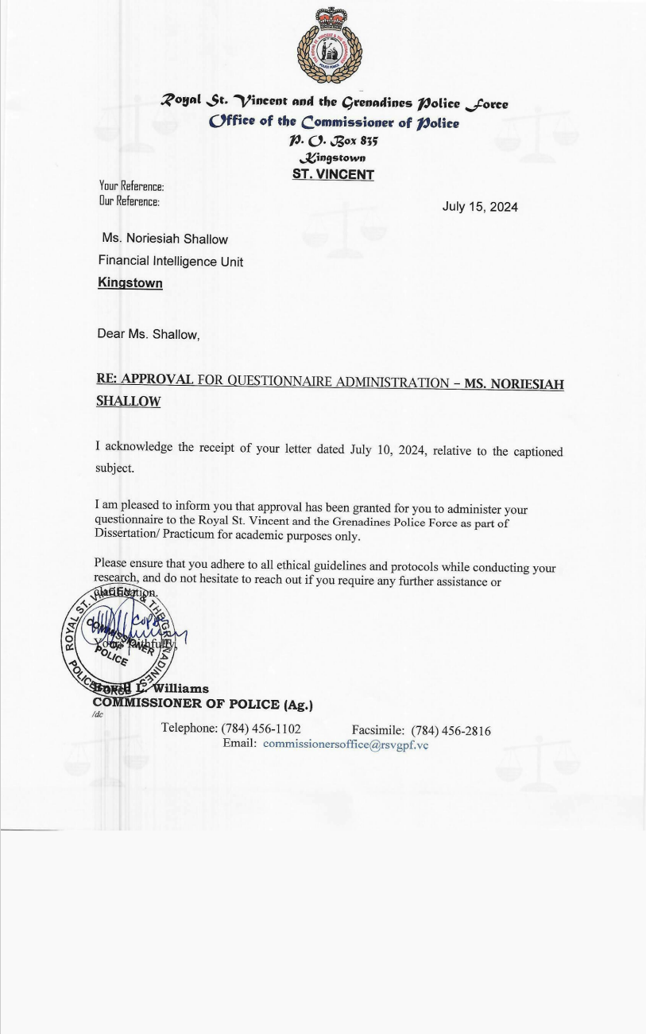
Appendix II- Chart Summary

Table 1.
Police Departments | No. of officers with work experience at the following stations
Criminal Investigations Département | 1
Port Elizabeth Police Station | 1
Financial Intelligence Unit | 4
Questelles Police Station | 3
Beat and Patrol | 5
Mesopotamia Police Station | 1
Police Headquarters | 3
Sexual Offenses Unit | 4
RRU | 1
Criminal Records Office | 2
Port Authourity | 2
Narcotics | 1
SSU | 1
Coast Guard | 1
Public Relation | 1
Legal Research and policy unit | 1
Information technology | 2
Central police station | 1
Georgetown police station | 1
Colonaire police station | 1
Layout police station | 1
Traffic department | 3

Table 2.
Strategies employed to fight crime | Nos of officers who responded to strategy
Community Policing | 4
Patrol – Mobile and foot | 10
Strategic deployment -high crime areas | 3
Police training | 1
Community programs – Radio, pan, meetings | 8
Intelligence gathering | 4
Statistical analysis | 1
Stop and search | 2
Gun amnesty | 1
CCTV cameras | 1
Eye witness testimony | 1
Police youth clubs | 2
Non- responsive | 2
Unanswered | 1

Appendix II- Survey Questions
Police Officers
Questions | Response options
- What departments have you worked in and how much years of service do you have?
- What tactics does the RSVGPF employ to maintain law and order?
- How successful do you think these tactics are at preventing crime and promoting community safety?
- Does the RSVGPF implement community policing initiatives? | Yes  No
- What problems are there in establishing trust and co-operation with community members?
- How does the RSVGPF ensure accountability in its operations?
- How does the RSVGPF ensure transparency in its operations?
- Are there procedures in place to deal with misbehaviour or unethical actions by officers? | Yes  No
- If any, what concerns does these mechanisms create?
- If any, what factors impact the recruitment of male and female officers?
- Do you think that the RSVGPF culture is inclusive when it comes to gender? | Yes  No
- Does the police force have emergency protocols in place for climate-related incidents? | Yes  No
- Does the police department engage in community outreach to promote climate change awareness? | Yes  No
- Are officers aware of the effect of their daily actions on the environment? | Yes  No
- What policies does the RSVGPF have in place to minimize the use of resources?
- What measures does the force take to tackle air quality, hazardous materials, and exposure risks for officers operating in contaminated environments?
- In what ways does the force cooperate with local agencies to control pollution?
- Do officers undergo training on managing pollution related incidents? | Yes  No
- Does the RSVGPF have any established protocols to deal with potential incidents related to pandemics? | Yes  No
- Do officers receive regular updates on procedures and developments related to pandemics? | Yes  No
- Are officers trained to handle cybercrime matters? | Yes  No
- What software and tools do the force have for analysing digital evidence in cybercrime reports?
- What technology do the RSVGPF have in place to aid in combatting crime?
Civilians
Questions | Response options
- How safe do you feel in your community? | Fearful  Slightly safe  Moderately safe  Very safe  Extremely safe
- Does the RSVGPF, in your opinion, improve public safety? | Yes  No
- How often do you witness police presence in your community? | Never  Rarely  Occasionally  Often  Frequently
- Is access to police stations easy in your community? | Yes  No
- In your opinion, how well-prepared is the RSVGPF for emergencies? | Not  Slightly  Moderately  Extremely
- Have you reported any crimes to the police? | Yes  No
- If yes, were you satisfied with the response you got?
- Does your area have any community policing programs? | Yes  No
- In your opinion, how effectively do the police interact with the residents of your community?
- Do you believe the RSVGPF has enough resources to fight crime successfully? | No  Yes
- Do you think that the RSVGPF is transparent organization? | Yes  No
- Do you think that police officers are held accountable for their actions. | Yes  No
- Do you believe that the RSVGPF's should prioritizes resource conservation in its operations? | Yes  No
- In terms of resource distribution, what suggestions would you make?
- What community are you from?

References
The American Law Institute. (2023). Principles of the law, policing. Principles of the Law Policing. https://www.policingprinciples.org/chapter-1/1-05-transparency-and-accountability/
Aborisade, R. A., & Adeleke, O. A. (2022, December 12). Pandemic policing and community engagement: Preparedness, legitimacy and public support during the COVID-19 crisis in Nigeria. Criminal Justice Review. https://www.ncbi.nlm.nih.gov/pmc/articles/PMC9748523/
Aborisade, R. A., & Ariyo, O. G. (2022, March). Policing the coronavirus pandemic: Nigeria police senior officers’ views on preparedness, response, legitimacy and post-COVID Policing. International Journal of Police Science & Management. https://www.ncbi.nlm.nih.gov/pmc/articles/PMC8863918/
Accountability. www.theadvocatesforhumanrights.org. (n.d.). https://www.theadvocatesforhumanrights.org/Res/ch_8_2.pdf
Agnew , R. (2011, September 6). Dire forecast: A theoretical model of the impact of climate change on crime. www.researchgate.net. https://www.researchgate.net/publication/258192079_Dire_forecast_A_theoretical_model_of_the_impact_of_climate_change_on_crime
Ahmad, S. (2014, November 16). Green Human Resource Management: Policies and Practices. www.tandfonline.com. https://www.tandfonline.com/doi/full/10.1080/23311975.2015.1030817
Alastal, A. I., & Shaqfa, A. H. (2023, March 14). Enhancing police officers’ cybercrime investigation skills using a checklist tool. SCIRP. https://www.scirp.org/journal/paperinformation?paperid=124124
Alexander, D. (2015, September 3). Disaster and emergency planning for preparedness, response, and recovery. Oxford Research Encyclopedia of Natural Hazard Science. https://doi.org/10.1093/acrefore/9780199389407.013.12
Alpert, G. P., & McLean, K. (2021). The more things change, the more they stay the same: The Queensland Police Service as a model for Sustainable Policing Reform. International Journal of Comparative and Applied Criminal Justice, 45(3), 345–355. https://doi.org/10.1080/01924036.2021.1899004
Antonio, D. E. (2019, December 30). Why peace and security are vital preconditions for sustainable development. UNDP. https://www.UNDP.org/jamaica/blog/why-peace-and-security-are-vital-preconditions-sustainable-development
Applebaum, K., Graham, J. P., Gray, G., & LaPuma, P. (2016, March). An overview of occupational risks from climate change. www.researchgate.net. https://www.researchgate.net/publication/292948814_An_Overview_of_Occupational_Risks_From_Climate_Change
Archbold, C., Stichman, A., & Hassell, K. (2010, January 23). comparing promotion aspirations of female and male police officers. www.researchgate.net. https://www.researchgate.net/publication/230814745_Comparing_Promotion_Aspirations_of_Female_and_Male_Police_Officers
Ard, L. (n.d.). Key Challenges Facing UK Police Forces in 2022 and Beyond. Blog.thrive.app. Retrieved June 13, 2024, from https://blog.thrive.app/key-challenges-facing-uk-police-forces#:~:text=%231%20Increasingly%20diverse%20communities%20present%20new%20challenges&text=From%20a%20shift%20in%20demographics
Arisukwu, O., Igbolekwu, C., Oye, J., Oyeyipo , E., Asamu, F., Rasak, B., & Oyekola, I. (2020, September 25). Community participation in crime prevention and control in rural Nigeria. www.sciencedirect.com. https://www.sciencedirect.com/science/article/pii/S2405844020318582
Azorin , J., & Cameron, R. (2010b). (PDF) the application of mixed methods in organisational research: A literature review. ejbrm-volume8-issue2. https://www.researchgate.net/publication/228933128_The_Application_of_Mixed_Methods_in_Organisational_Research_A_Literature_Review
Bachmann, N., Tripathi, S., Brunner, M., & Jodlbauer, H. (2022, February 22). The contribution of data-driven technologies in achieving the Sustainable Development Goals. MDPI. https://www.mdpi.com/2071-1050/14/5/2497
Baltezarevic, R. (2004, February). cybercrime as an essential impediment to international trade . www.researchgate.net. https://www.researchgate.net/publication/378498476_CYBERCRIME_AS_AN_ESSENTIAL_IMPEDIMENT_TO_INTERNATIONAL_TRADE
Bano, B., & Talib, P. (2017, June 28). Understanding police stress towards a secure and sustainable society. journals.sagepub.com. https://journals.sagepub.com/doi/10.1177/1461355717713999
Bayley, D. H. (2016, September 1). Volume 10, issue 3, September 2016. Oxford Academic. https://academic.oup.com/policing/issue/10/3
Bhat, A. (2024, April 17). Surveys: What they are, characteristics & examples. QuestionPro. https://www.questionpro.com/blog/surveys/
Biggam, F. H., Power, K. G., & MacDonald, R. R. (1997). Coping with the occupational stressors of police work: A study of Scottish officers. Stress Medicine, 13(2), 109–115. https://doi.org/10.1002/(SICI)1099-1700(199704)13:2<109::AID-SMI724>3.0.CO;2-H
Bittner, E. (1974). Florence Nightingale in pursuit of Willie Sutton: A theory of the police. In H. Jacob (Ed.), The potential for reform of criminal justice (pp. 17-44). Sage Publications.
Blaustein, J., Shearing, C., & Miccelli, M. (2024, June 9). Adaptive Policing for a climate crisis. www.tandfonline.com. https://www.tandfonline.com/doi/full/10.1080/10439463.2024.2362713
Bonini, S. and Gorner, S. (2011) The business of Sustainability: putting it into practice, Bing. Available at: https://www.bing.com/search?q=Bonini%2B%26%2BGorner&qs=n&form=QBRE&sp=-1&lq=1&pq=bonini%2B%26%2Bgorner&sc=2-15&sk=&cvid=6CC52B1B008E4D03A85AA3996A1AA931&ghsh=0&ghacc=0&ghpl= (Accessed: 13 June 2024).
Borovec, K., & Balgač, I. (2017, May 10). Contribution of internal communication in predicting job satisfaction among police officers. Kriminologija & socijalna integracija : časopis za kriminologiju, penologiju i poremećaje u ponašanju. https://hrcak.srce.hr/181157
Bradford, B. (2010, September). (PDF) Trust and confidence in the police: A conceptual review. www.researchgate.net. https://www.researchgate.net/publication/228242091_Trust_and_Confidence_in_the_Police_A_Conceptual_Review
Braun, V., & Clarke, V. (2006). (PDF) using thematic analysis in psychology. www.researchgate.net. https://www.researchgate.net/publication/235356393_Using_thematic_analysis_in_psychology
Bryman, A. (2016e). Social Research methods . ktpu.kpi.ua. https://ktpu.kpi.ua/wp-content/uploads/2014/02/social-research-methods-alan-bryman.pdf
Bureau of Justice Assistance. (1994b, August). Understanding community policing. www.ojp.gov. https://www.ojp.gov/pdffiles/commp.pdf
Business Research Methodology. (n.d.). Research limitations - research-methodology. Research. https://research-methodology.net/research-methods/research-limitations/
Caputo, T., & McIntyre, M. L. (2015, May 18). Addressing role and value in policing: Toward a sustainable policing framework. Policing: An International Journal of Police Strategies & Management. https://www.emerald.com/insight/content/doi/10.1108/PIJPSM-12-2014-0128/full/html
Careless, J. (2021b, December 1). Creating a positive impact: Effective community policing strategies. Police1. https://www.police1.com/community-policing/articles/creating-a-positive-impact-effective-community-policing-strategies-DztozvaIDseOpN44/
Clarke, D. (2024b, July 3). Police rank distribution England and Wales by gender 2023. Statista. https://www.statista.com/statistics/382525/share-of-police-officers-in-england-and-wales-gender-rank/
Clements, A. J., Sharples, A., & Kinman, G. (2020, January). (PDF) identifying well-being challenges and solutions in the ... www.researchgate.net. https://www.researchgate.net/publication/338514833_Identifying_well-being_challenges_and_solutions_in_the_police_service_A_World_Cafe_approach
Cloete, F. (2005) Towards a Monitoring and Evaluation System for Sustainable Development in South Africa, THEIACP.
Cole, D. (2024, March 10). The importance of prioritizing officer well-being; building safer communities and healthier workforces. LinkedIn. https://www.linkedin.com/pulse/importance-prioritizing-officer-well-being-building-safer-davin-cole-rn7ac
Columbia Southern university (no date) Current issues in law enforcement: What will departments face in 2022?, Current Issues in Law Enforcement: What Will Departments Face in 2022? | The Link. Available at: https://www.columbiasouthern.edu/blog/blog-articles/2022/february/current-issues-in-law-enforcement/ (Accessed: 14 June 2024).
Columbia Southern University. (2022, February 14). Current Issues in Law Enforcement: What Will Departments Face in 2022? Www.columbiasouthern.edu. https://www.columbiasouthern.edu/blog/blog-articles/2022/february/current-issues-in-law-enforcement/
Colvin, C. A., & Goh, A. (2005, February). Validation of the technology acceptance model for police. www.researchgate.net. https://www.researchgate.net/publication/222761017_Validation_of_the_technology_acceptance_model_for_police
Cote, C. (2021, April 13). Making the business case for Sustainability. Business Insights Blog. https://online.hbs.edu/blog/post/business-case-for-sustainability
Creswell, J., & Clark, V. (2007). Http://journals.sagepub.com/doi/abs/10.1177/0887302x07303626 | request PDF. journals.sagepub.com. https://journals.sagepub.com/doi/abs/10.1177/1094428108318066?journalCode=orma
Cresswell, J. W. (n.d.). Using mixed methods research. Emerald Publishing. https://www.emeraldgrouppublishing.com/how-to/research-methods/using-mixed-methods-research
Crowley, T. (2022). Community Policing: The Foundation of Trust between Police and Society . scholarworks.merrimack.edu. https://scholarworks.merrimack.edu/cgi/viewcontent.cgi?article=1046&context=crm_studentpub
Cunningham, E., & Ramshaw, P. (2017, August 27). Twenty-three women officers’ experiences of policing in England. journals.sagepub.com. https://journals.sagepub.com/doi/10.1177/1461355719868490
Cummings, M. (2019, September 16). Study finds community-oriented policing improves attitudes toward police. YaleNews. https://news.yale.edu/2019/09/16/study-finds-community-oriented-policing-improves-attitudes-toward-police
Custers, B. (2012, January 26). Technology in policing: Experiences, obstacles and police needs. Computer Law & Security Review. https://www.sciencedirect.com/science/article/abs/pii/S0267364911001853
Deloitte. (n.d.). Surveillance and predictive policing through AI. https://www.deloitte.com/za/en/Industries/government-public/perspectives/urban-future-with-a-purpose/surveillance-and-predictive-policing-through-ai.html
Denney, L., & Jenkins, S. (2013). What is community policing? The diversity of definitions and objectives. www.jstor.org. https://www.jstor.org/stable/pdf/resrep50185.7.pdf
Department of Justice . (2023, May). Report on best practices to advance officer wellness. www.justice.gov. https://www.justice.gov/d9/2023-05/Sec. 4(a) -Report on Best Practices to Advance Officer Wellness_FINAL.pdf
Denzin, N. K., & Lincoln , Y. S. (2011). The sage handbook of qualitative research. SAGE Publications Inc. https://us.sagepub.com/en-us/nam/the-sage-handbook-of-qualitative-research/book242504
Devi, A. B. (2024, January 3). Sustainable Project Management Practices: Environmental and social responsibility. London Premier Centre. https://www.lpcentre.com/articles/sustainable-project-management-practices-environmental-and-social-responsibility
Diamond, D., & Mead Weiss, D. (2009). Community policing: Looking to Tomorrow. U.S. Dept. of Justice, Office of Community Oriented Policing Services, Police Executive Research Forum.
Dick, P., Silvestri, M., & Westmarland, L. (2013, January). (PDF) research on women in policing: A look at the past, present and future. www.researchgate.net. https://www.researchgate.net/publication/230814746_Research_on_Women_in_Policing_A_Look_at_the_Past_Present_and_Future
Dietz, T., Shwom, R. L., & Whitley, C. T. (2020, July 30). Climate change and society. Annual Review of Sociology. https://www.annualreviews.org/content/journals/10.1146/annurev-soc-121919-054614
Dovetail Team. (2023, February 20). Mixed Methods Research Guide with examples. Mixed Methods Research Guide With Examples. https://dovetail.com/research/mixed-methods-research/
D’souza, A. (2022, October). Exploring the promise of police accountability. rucore.libraries.rutgers.edu. https://rucore.libraries.rutgers.edu/rutgers-lib/68027/PDF/1/play/
Dupont, B., & Whelan, C. (2021, March 27). (PDF) enhancing relationships between criminology and Cybersecurity. Enhancing relationships between criminology and cybersecurity. https://www.researchgate.net/publication/350440828_Enhancing_relationships_between_criminology_and_cybersecurity
Dunham, R. G., Alpert, G. P., & McLean, K. D. (2020, June). Critical Issues in Policing: Contemporary Readings, Eighth Edition. Waveland press - critical issues in policing - contemporary readings, Eighth Edition, . https://www.waveland.com/browse.php?t=292
Ekici, N., Akdogan, H., Kelly, R., & Gultekin, S. (2022, September 15). A meta-analysis of the impact of Community Policing on Crime Reduction: Journal of Community Safety and well-being. A meta-analysis of the impact of community policing on crime reduction | Journal of Community Safety and Well-Being. https://www.journalcswb.ca/index.php/cswb/article/view/244/736
Eliot Partnership. (2022, February 14). Top five benefits of sustainable business practices. eliotpartnership.com. https://eliotpartnership.com/news-insights/top-five-benefits-of-sustainable-business-practices/
Epiphanio, F. (2020, December). (PDF) police discretion and procedural justice. www.researchgate.net. https://www.researchgate.net/publication/348914047_POLICE_DISCRETION_AND_PROCEDURAL_JUSTICE
Evans, T. (2024, August 28). The benefits of community policing to police relationships. https://blog.zencity.io/resources/the-top-benefits-of-community-policing
Fatih, T., & Bekir, C. (2015, April). Police use of technology to fight against crime | semantic scholar. core.ac.uk. https://www.semanticscholar.org/paper/POLICE-USE-OF-TECHNOLOGY-TO-FIGHT-AGAINST-CRIME-Fatih-Bekir/b17a1c30bfd7e3ed51b860e8cb68c8c64eca88d0
Federal Office for Spatial Development ARE. (1987, March 20). 1987: Brundtland Report. Bundesamt fÃ¼r Raumentwicklung ARE. https://www.are.admin.ch/are/en/home/media/publications/sustainable-development/brundtland-report.html#:~:text=Sustainable%20development%20is%20defined%20as%20follows%3A%C2%ABSustainable%20development%20is
Fernandes, L., & Saldanha-da-Gama, F. (2008, October). Contingency Planning . www.researchgate.net. https://www.researchgate.net/publication/230807504_Contingency_planning_-_a_literature_review
Fink , A. G. (2005). Conducting research literature reviews: From the internet to paper: .: 9781412971898: Amazon.com: Books. www.amazon.com. https://www.amazon.com/Conducting-Research-Literature-Reviews-Internet/dp/1412971896
Frenkel , M. O., Giessing, L., Egger-Lampl , S., Hutter, V., Oudejans, R. R., Kleygrewe, L., Jaspaert, mma, & Plessner, H. (2020, October 19). The impact of the COVID-19 pandemic on European police officers: Stress, demands, and coping resources. Journal of Criminal Justice. https://www.sciencedirect.com/science/article/pii/S0047235220302506
Gatley, N. (2022, June 8). What is sustainable resource management and how do you achieve it? https://www.british-assessment.co.uk/what-is-sustainable-resource-management-and-how-do-you-achieve-it/
Gelles, M., Mirkow, A., & Mariani, J. (n.d.). The Future of Law Enforcement. www2.deloitte.com. https://www2.deloitte.com/content/dam/insights/us/articles/4973_Future-of-law-enforcement/DI_Future-of-law-enforcement.pdf
Ghosh, A. (2024, March 27). Unlocking success: The Power of Gender Diversity at Work. Mentoring Complete. https://www.mentoringcomplete.com/the-benefits-of-gender-diversity-in-the-workplace/
Gill , C., Weisburd, D., Telep, C. W., Vitter, Z., & Bennett, T. (2014). Community-oriented policing to reduce crime, disorder and ... www.researchgate.net. https://www.researchgate.net/profile/Trevor-Bennett/publication/272011608_Community-oriented_policing_to_reduce_crime_disorder_and_fear_and_increase_satisfaction_and_legitimacy_among_citizens_a_systematic_review/links/55ace73508aea9946727d2d7/Community-oriented-policing-to-reduce-crime-disorder-and-fear-and-increase-satisfaction-and-legitimacy-among-citizens-a-systematic-review.pdf
Global Policing Symposium: Challenges and Lessons Learned Summary Report (2020) THEIACP. Available at: https://www.theiacp.org/sites/default/files/Global Policing Symposium May 2020 Summary Report (1).pdf (Accessed: 13 June 2024).
Gostin, L. O., Friedman, E. A., Hossain, S., Mukherjee, J., Zia-Zarifi, S., & Clinton, C. (2023, January 14). Human rights and the COVID-19 pandemic: A retrospective and Prospective Analysis - The lancet. www.thelancet.com. https://www.thelancet.com/journals/lancet/article/PIIS0140-6736(22)01278-8/fulltext
Gray, D. E. (2009, January). Doing research in the Real World . www.researchgate.net. https://www.researchgate.net/publication/31764547_Doing_Research_in_the_Real_World_DE_Gray
Gretchen, & Rallis, S. F. (2003, January). Learning in the field: An introduction to qualitative research . www.researchgate.net. https://www.researchgate.net/publication/273313947_Learning_in_the_Field_An_Introduction_to_Qualitative_Research
Grover, S., Sahoo, S., Dua, D., Mehra, A., & Nehra, R. (2022). Psychological impact of covid-19 duties during lockdown on police personnel and their perception about the behavior of the people: An exploratory study from India. International journal of mental health and addiction. https://www.ncbi.nlm.nih.gov/pmc/articles/PMC7643718/
Halford, E., & Youansamouth, L. (2022, October). Emerging results on the impact of COVID-19 on police training in the United Kingdom. www.researchgate.net. https://www.researchgate.net/publication/364943477_Emerging_results_on_the_impact_of_COVID-19_on_police_training_in_the_United_Kingdom
Harvard Catalyst. (n.d.). Mixed methods research. Mixed Methods Research - Harvard Catalyst. https://catalyst.harvard.edu/community-engagement/mmr/
Ho, L. K., & Li, A. S. (2024, July 16). What has changed and why: the transformation and (de)legitimisation of post-COVID policing in Hong Kong and Taiwan. www.tandfonline.com. https://www.tandfonline.com/doi/full/10.1080/10439463.2024.2380730
How to develop effective communication in law enforcement. PowerDMS. (2021, November 8). https://www.powerdms.com/policy-learning-center/tips-for-effective-communication-in-law-enforcement
Howes, M., Wortley, L., Potts, R., Dedekorkut-Howes, A., Serrao-Neumann, S., Davidson, J., Smith, T., & Nunn, P. (2017). Environmental sustainability: A case of policy implementation failure? Sustainability, 9(2), 165. https://doi.org/10.3390/su9020165
Husson University online . (2023, September 28). The role of technology in criminal justice . Husson University. https://www.husson.edu/online/blog/2023/09/technology-in-the-criminal-justice-field
IDFC. (n.d.). THEIACP. Police Preparedness in Pandemic. https://www.theiacp.org/sites/default/files/IDFC%20Institute_Policing%20in%20Pandemics_28Apr2020-1.pdf
IFRC. (2022). World Disaster Report 2022. www.ifrc.org. https://www.ifrc.org/sites/default/files/2023-03/2022_IFRC-WDR_EN.0.pdf.pdf
Ikegaya, H., & Suganami, H. (2008, April). Correlation between climate and crime in Eastern Tokyo. www.researchgate.net. https://www.researchgate.net/publication/250196269_Correlation_between_Climate_and_Crime_in_Eastern_Tokyo
James , I. (2021). Workplace stress and coping in US virgin island police officers. scholarworks.waldenu.edu. https://scholarworks.waldenu.edu/cgi/viewcontent.cgi?article=11775&context=dissertations
Jung, W., & Doyle, S. (2021, November 12). Global Law Enforcement Agencies are working together to tackle cybercrime but more collaboration is needed. World Economic Forum. https://www.weforum.org/agenda/2021/11/police-agencies-must-partner-up-to-prevent-a-ransomware-crisis-heres-how/
Kawalya-Tendo, C. (2024, March). How strategic communication improves police-community relations. www.researchgate.net. https://www.researchgate.net/publication/379180002_How_Strategic_Communication_Improves_Police-Community_Relations
Keddie, A. (2022, October 28). Gender Equality Reform and police organizations: A social ... onlinelibrary.wiley.com. https://onlinelibrary.wiley.com/doi/full/10.1111/gwao.12918
Kelling, G., & Moore , M. (1998, November). The evolving strategy of policing - scholars at Harvard. scholar.harvard.edu. https://scholar.harvard.edu/files/markmoore/files/the_evolving_strategy_of_policing_1188.pdf
Kenney, J. (n.d.). Internal Police Communications. https://scholarlycommons.law.northwestern.edu/cgi/viewcontent.cgi?article=4410&context=jclc
Kerswell, N. L., Strodl, E., Johnson, L., & Konstantinou, E. (2019, January 7). Mental health outcomes following a large-scale potentially traumatic event involving police officers and civilian staff of the Queensland Police Service - Journal of Police and Criminal Psychology. SpringerLink. https://link.springer.com/article/10.1007/s11896-018-9310-0
King, N. A. (n.d.). A Policemans Journey. A policemans journey. https://thevincentian.com/a-policemans-journey-p13483-148.htm
Koslicki, I. (2019, May). (PDF) accountability or efficiency? body-worn cameras as replicative technology. www.researchgate.net. https://www.researchgate.net/publication/333613586_Accountability_or_Efficiency_Body-Worn_Cameras_as_Replicative_Technology
Konyk, J. (2018, August). Green Policing: Recommended Actions for an Environmental Sustainability Plan for the Vancouver Police Department. sustain.ubc.ca. https://sustain.ubc.ca/sites/default/files/2018-54%20Green%20Policing%20Recommended%20Actions%20for%20an%20Environmental%20Sustainability%20Plan%20at%20the%20VPD_Konyk.pdf
Kythreotis, A., Hannaford, M., Howarth , C., & Bosworth, G. (2024, February 17). Translating climate risk assessments into more effective adaptation decision-making: The importance of social and political aspects of place-based climate risk. Environmental Science & Policy. https://www.sciencedirect.com/science/article/pii/S146290112400039X
Laufs, J., & Waseem, Z. (2020, August 20). Policing in pandemics: A systematic review and best practices for police response to covid-19. International Journal of Disaster Risk Reduction. https://www.sciencedirect.com/science/article/pii/S2212420920313145
Leach, M., Mehta, L., & Prabhakaran, P. (2016, July 13). Gender Equality and Sustainable Development. www.unwomen.org. https://www.unwomen.org/sites/default/files/Headquarters/Attachments/Sections/Library/Publications/2016/DPS-Gender-equality-sustainable-development.pdf
Li, Y., & Liu , Q. (2021, November). [solved] a comprehensive review study of cyber-attacks and cyber security;... www.sciencedirect.com. https://www.sciencedirect.com/science/article/pii/S2352484721007289
Liakopoulou, D., Tigani, X., Varvogli, L., & Chrousos, G. (2020, January). Stress management and health promotion intervention program for police forces. www.researchgate.net. https://www.researchgate.net/publication/338751820_Stress_management_and_health_promotion_intervention_program_for_police_forces
Lickiewicz, J., Piotrowicz, K., Hughes, P. P., & Makara-Studzińska, M. (2020, December 7). Weather and aggressive behavior among patients in psychiatric hospitals-an exploratory study. International journal of environmental research and public health. https://www.ncbi.nlm.nih.gov/pmc/articles/PMC7730982/
Loftus, B. (2008, October). Dominant culture interrupted: Recognition, resentment ... www.researchgate.net. https://www.researchgate.net/publication/228223860_Dominant_Culture_Interrupted_Recognition_Resentment_and_the_Politics_of_Change_in_an_English_Police_Force
Lonsway, K. A. (2000, January). Hiring & retaining more women: The advantages to law enforcement agencies. www.researchgate.net. https://www.researchgate.net/publication/234761455_Hiring_Retaining_More_Women_The_Advantages_to_Law_Enforcement_Agencies
McMurray, S. (2023, October 12). Weathering risk - integrating climate security into policy frameworks: Jordan - Jordan. ReliefWeb. https://weatheringrisk.org/sites/default/files/document/Integrating_Climate_Security_into_Policy_Frameworks_Jordan_2.pdf
Muhlhausen, D. B. (2019, July). Women in policing: Breaking barriers and blazing a path. www.ojp.gov. https://www.ojp.gov/pdffiles1/nij/252963.pdf
Malley, P. (2020, October 22). The benefits of corporate sustainability. Cleaning & Maintenance Management. https://cmmonline.com/articles/benefits-of-corporate-sustainability
Manresa, G. (2023, August 25). 5 reasons why community policing is effective. The Lesniak Institute for American Leadership. https://www.lesniakinstitute.org/5-reasons-why-community-policing-is-effective/
Martin, M. E. (2006). Restoring Justice Through Community Policing. Criminal Justice Policy Review, 17(3), 314–329. https://doi.org/10.1177/0887403405284736
MacDonald , J. (2020, October). The effectiveness of community policing in reducing urban violence. citeseerx.ist.psu.edu. https://www.researchgate.net/publication/238342190_The_Effectiveness_of_Community_Policing_in_Reducing_Urban_Violence
Maskály , J., Ivković, S. K., & Neyroud, P. (2021, April 28). Policing the COVID-19 Pandemic: Exploratory Study of the Types of Organizational Changes and Police Activities Across the Globe. journals.sagepub.com. https://journals.sagepub.com/doi/10.1177/10575677211012807
Matczak, A., & Bergh, S. I. (2023, September 25). A review of the (potential) implications of climate change for Policing Practice Worldwide. OUP Academic. https://academic.oup.com/policing/article/doi/10.1093/police/paad062/7282125
Mthombothi , S. I. (2023, March). The roles that the community can play to fight crime in their ... www.ijhssi.org. https://www.ijhssi.org/papers/vol12(3)/M12036374.pdf
McGill. (n.d.). What is Sustainability. McGill University. https://www.mcgill.ca/sustainability/files/sustainability/what-is-sustainability.pdf
Modise, M. J. (2023, July). (PDF) community policing strategies include community patrols, Neighborhood Watch and Community Policing. www.researchgate.net. https://www.researchgate.net/publication/376260707_Community_Policing_Strategies_Include_Community_Patrols_Neighborhood_Watch_and_Community_Policing
Mohamed Abdi, A.-N. (2024, March 12). Full article: Impact of police effectiveness on public trust ... www.tandfonline.com. https://www.tandfonline.com/doi/full/10.1080/23311886.2024.2327137
Moon, H., Choi, H., Lee, J., & Lee, K. (2017). Attitudes in Korea toward introducing smart policing technologies: Differences between the general public and police officers. Sustainability, 9(10), 1921. https://doi.org/10.3390/su9101921
Morash, M., & Haarr, R. (2012, January). Doing, Redoing, and Undoing Gender: Variation in Gender Identities of Women Working as Police Officers. www.researchgate.net. https://www.researchgate.net/publication/241647809_Doing_Redoing_and_Undoing_Gender_Variation_in_Gender_Identities_of_Women_Working_as_Police_Officers
Mutongwizo, T., Blaustein, J., & Shearing, C. (2022, May 11). Resilience policing and climate change: Adaptive responses to hydrological emergencies. www.researchgate.net. file:///C:/Users/n.shallow/Downloads/Resilience_policing_and_climate_change_Adaptive_re%20(1).pdf
Myendeki, A. N. (2008, April). Job stress, burnout and coping strategies of South African police officers. http://vital.seals.ac.za/. http://vital.seals.ac.za:8080/vital/access/manager/PdfViewer/vital:11859/SOURCEPDF?viewPdfInternal=1
Myers, M. D. (2008, November). Qualitative Research in Business & Management | Request PDF. www.researchgate.net. https://www.researchgate.net/publication/236144326_Qualitative_Research_in_Business_Management
Nix, J., Ivanov, S., & Pickett, J. T. (2021, August). What does the public want police to do during pandemics? A national experiment. Criminology & public policy. https://www.ncbi.nlm.nih.gov/pmc/articles/PMC8013863/
Nielson, K. R., Zhang, Y., & Ingram, J. R. (2022). The impact of covid-19 on police officer activities. Journal of criminal justice. https://www.ncbi.nlm.nih.gov/pmc/articles/PMC9549130/
Neyroud, P. (2022, August 17). Policing “landscapes” for the rule of law and public protection: The State of evidence on organisational policies, structures, and Human Resources - Cambridge Journal of Evidence-based policing. SpringerLink. https://link.springer.com/article/10.1007/s41887-022-00081-y
Nubani, L., Fierke-Gmazel, H., Madill, H., & Biasi, A. D. (2023, February 2). Community engagement in crime reduction strategies: A tale of three cities: Published in Journal of Participatory Research Methods. Journal of Participatory Research Methods. https://jprm.scholasticahq.com/article/57526-community-engagement-in-crime-reduction-strategies-a-tale-of-three-cities
Oliveira, T. R., & Jackson, J. (2021, September). Scielo. www.scielo.br. https://www.scielo.br/j/ts/a/kqLkpx7LkQHrzkYSLT9v8FP/?format=pdf&lang=en
Owen-Burge, C. (2022, June 16). Why sustainability is crucial for corporate strategy. Climate Champions. https://climatechampions.unfccc.int/why-sustainability-is-crucial-for-corporate-strategy/?gclid=EAIaIQobChMIgpGbqOue_AIVmMKGCh2e_Q3-EAAYASAAEgKNlfD_BwE
Peyton, K., Sierra-Arévalo, M., & Rand, D. (2019, August 12). A field experiment on community policing and ... www.pnas.org. https://www.pnas.org/doi/10.1073/pnas.1910157116
Phythian, R., Birdsall, N., & Boulton, L. (2022, March 2). Developments in UK police wellbeing: A review of blue light ... https://journals.sagepub.com/doi/full/10.1177/0032258X211073003
Pisano, U. (2012, September). Resilience and Sustainable Development:. ESDN_Reports. https://www.esdn.eu/fileadmin/ESDN_Reports/2012-September-Resilience_and_Sustainable_Development.pdf
Price, J. H., & Murnan, J. (2013, February 22). Research limitations and the necessity of reporting them . https://www.researchgate.net/publication/274050161_Research_Limitations_and_the_Necessity_of_Reporting_Them
Purba, A., & Demou, E. (2019, October 15). The relationship between organisational stressors and mental wellbeing within police officers: A systematic review - BMC public health. BioMed Central. https://bmcpublichealth.biomedcentral.com/articles/10.1186/s12889-019-7609-0
Putnam, L. (2007b, January). Organizational Communication. www.researchgate.net. https://www.researchgate.net/publication/364850148_Organizational_Communication
Reiss, A. (2020, January 5). Police organization in the Twentieth Century. Police Organization in the Twentieth Century. https://openlab.bmcc.cuny.edu/crj-201-policing-professor-ostrowe/wp-content/uploads/sites/326/2020/03/Police-Organization-Article-1.pdf
Reja, U., Manfreda, K., Hlebec, V., & Vehovar, V. (2003). Open-ended vs. Close-ended Questions in Web Questionnaires. https://begrijpelijkeformulieren.org/sites/begrijpelijkeformulieren/files/Reja_e.a._Open-ended_vs._Close-ended_Questions_in_Web.pdf
Report on best practices to advance officer wellness. www.justice.gov. (2023, May). https://www.justice.gov/d9/2023-05/Sec. 4(a) -Report on Best Practices to Advance Officer Wellness_FINAL.pdf
Rafi, T. (2022, June 9). Why sustainability is crucial for corporate strategy. World Economic Forum. https://www.weforum.org/agenda/2022/06/why-sustainability-is-crucial-for-corporate-strategy/#:~:text=Sustainability%20reduces%20costs%20and%20can%20affect%20operating%20profits,27%25%20higher%20profitability%20and%20a%2022%25%20greater%20productivity.
Resnik, D. B. (2018, January). (PDF) the ethics of research with human subjects. www.researchgate.net. https://www.researchgate.net/publication/322334566_The_Ethics_of_Research_with_Human_Subjects
Romualdo, A., & Robles, A. C. (2023). The Future of Green Policing: A Delphi-based forecast of Sustainability ndicators for Law Enforcers. Global Sustainability Research, 2(3), 52–59. https://doi.org/10.56556/gssr.v2i3.556
Rosala, M. (2024, February 5). Open-ended vs. closed questions in User Research. Nielsen Norman Group. https://www.nngroup.com/articles/open-ended-questions/
Rutope, J. (2017). Reportage of artisanal mining and environmental issues in Zimbabwe by The Sunday News and The Standard from 2017 to 2018. cris.library.msu.ac.zw. https://cris.library.msu.ac.zw/bitstream/11408/3633/1/Dissertation%20Final%20draft.pdf
RTI International Police Executive Research Forum. (2016, May). Research on the impact of technology on policing strategy ... Research on the Impact of Technology on Policing Strategy in the 21st Century. https://www.ojp.gov/pdffiles1/nij/grants/251140.pdf
‌ Sagepub. What is policing. (n.d.). https://www.sagepub.com/sites/default/files/upm-binaries/19049_01_Rowe_Ch_01.pdf
Sarkar, G., & Shukla, S. K. (2023, October 11). Behavioral Analysis of Cybercrime: Paving the way for effective policing strategies. Journal of Economic Criminology. https://www.sciencedirect.com/science/article/pii/S2949791423000349
Schaap, D. (2019, January 29). Full article: Police Trust-building strategies. A socio-institutional, comparative approach. www.tandfonline.com. https://www.tandfonline.com/doi/full/10.1080/10439463.2020.1726345
Scharnick, C.A. (2008) A SUSTAINABLE GOVERNANCE MODEL FOR METROPOLITAN POLICING IN SOUTH AFRICA, In partial fulfillment of the requirements for the degree of Master of Public Administration at the University of Stellenbosch. Available at: https://scholar.sun.ac.za/server/api/core/bitstreams/f881fcf0-c7df-45b1-8cdc-d32dd4935f39/content.
ScienceDirect. (n.d.). Stratified random sample. Stratified Random Sample - an overview | ScienceDirect Topics. https://www.sciencedirect.com/topics/mathematics/stratified-random-sample
Scottish Police Authority. (n.d.). Police Scotland Environmental Strategy 2012. https://www.spa.police.uk/spa-media/k40frogo/rep-b-20210319-item-7-appendix-a-environmental-strategy.pdf?cv=1
Sebire, J. (2020, February 25). Why Gender Equality in Policing is Important for Achieving United Nations Sustainable Development Goals 5 and 16. International Journal for Crime, Justice and Social Democracy. https://www.crimejusticejournal.com/article/view/1452
SecureRedact. (2024, July 7). The role of technology in modern law enforcement. SecureRedact. https://www.secureredact.ai/articles/role-of-technology-in-modern-law-enforcement
Sieweke, J., Bostandzic, D., & Smolinski, S.-M. (2023, May 29). The influence of top management team gender diversity on firm performance during stable periods and economic crises: An instrumental variable analysis. The Leadership Quarterly. https://www.sciencedirect.com/science/article/pii/S1048984323000292
Selokar, D., Nimbarte, S., Ahana, S., Gaidhane, A., & Wagh, V. (2011). Occupational stress among police personnel of Wardha City, India. The Australasian medical journal. https://www.ncbi.nlm.nih.gov/pmc/articles/PMC3562957/
Sharma, G. (2020, August 10). Pros & cons of different sampling methods. CloudResearch. https://www.cloudresearch.com/resources/guides/sampling/pros-cons-of-different-sampling-methods
Shodunke, A. O. (2022, June 7). Enforcement of covid-19 pandemic lockdown orders in Nigeria: Evidence of public (non)compliance and police illegalities. International Journal of Disaster Risk Reduction. https://www.sciencedirect.com/science/article/pii/S2212420922003016
Shults, J. (2020) What are the biggest challenges impacting policing in America?, Police1. Available at: https://www.police1.com/chiefs-sheriffs/articles/what-are-the-biggest-challenges-impacting-policing-in-america-40yihBU84Le24mou/ (Accessed: 14 June 2024).
Smylie, C., Duxbury, L., & Bennell, C. (2023, June 16). Community policing during the pandemic. carleton.ca. https://carleton.ca/policeresearchlab/wp-content/uploads/Community-policing-during-the-pandemic.pdf
Somona Public Infrastructure. (n.d.). Benefits of sustainability. County Of Sonoma. https://sonomacounty.ca.gov/administrative-support-and-fiscal-services/sonoma-public-infrastructure-(formerly-gs)/divisions/energy-and-sustainability/benefits-of-sustainability
Strom , K. (2017, September). Research on the impact of technology on policing strategy in the 21st Century: Final report | request pdf. https://www.researchgate.net/publication/319711044_Research_on_the_impact_of_technology_on_policing_strategy_in_the_21st_century_Final_report
Sudama et al. (2021) BRIDGING SUST BRIDGING SUSTAINABILITY AND POLICING T Y AND POLICING TO BALINESE O BALINESE ORMAS CONFLIC AS CONFLICT: AN IN T: AN INTEGRATIVE CONCEPTU TIVE CONCEPTUAL FRAMEWORK. Available at: https://scholarhub.ui.ac.id/cgi/viewcontent.cgi?article=1182&context=irhs (Accessed: 13.06.2024).
Sun, I. Y., Wu, Y., Shen, S., Kutnjak Ivkovich, S., Maskaly, J., & Neyroud, P. (2023, February 20). Police officers’ preferences for enforcing COVID-19 regulatory violations: The impact of organizational support, psychological conditions, and public compliance. Crime and Delinquency. https://www.ncbi.nlm.nih.gov/pmc/articles/PMC9944427/
Sunshine, J., & Tyler, T. R. (2003, September). The role of procedural justice in shaping public support for policing | request PDF. www.researchgate.net. https://www.researchgate.net/publication/51993079_The_Role_of_Procedural_Justice_in_Shaping_Public_Support_for_Policing \
Tankala, S. (2023, October 10). Maintaining the privacy and security of Research Participants’ Data. Nielsen Norman Group. https://www.nngroup.com/articles/privacy-and-security/
Taylor Griffiths, C., & Clark, P. (2017). Building police legitimacy in a high demand environment: The case of Yukon, Canada. Policing: An International Journal, 40(3), 560–573. https://doi.org/10.1108/pijpsm-06-2016-0088
Telep, C. W., & Weisburd, D. L. (2012, December). (PDF) what is known about the effectiveness of police practices in reducing crime and disorder?. www.researchgate.net. https://www.researchgate.net/publication/258180233_What_is_Known_About_the_Effectiveness_of_Police_Practices_in_Reducing_Crime_and_Disorder
Terrafiniti. (2021, May 24). Sustainability issues | Sustainability trends. https://www.terrafiniti.com/sustainability-issues/
Thompson , T. (2021, November 3). Related news. Police Professional. https://policeprofessional.com/news/de-carbonisation-programme-launched-for-policing/
Tyler, T. R. (2008). Why do people help the police fight crime in their ... scholarship.law.columbia.edu. https://scholarship.law.columbia.edu/cgi/viewcontent.cgi?article=1388&context=faculty_scholarship
Tyler, T. (2004, May). Enhancing police legitimacy . www.researchgate.net. https://journals.sagepub.com/doi/abs/10.1177/0002716203262627
Tyler, T. R., & Huo, Y. J. (2002). Trust in the law: Encouraging public cooperation with the police and courts. Russell Sage Foundation.
ToolSense. (2022, October 18). Why all businesses should embrace sustainability. IMD business school for management and leadership courses. https://www.imd.org/research-knowledge/articles/why-all-businesses-should-embrace-sustainability/
UNDP. (2021, December 17). Small island developing states are on the frontlines of climate change – here’s why. UNDP Climate Promise. https://climatepromise.UNDP.org/news-and-stories/small-island-developing-states-are-frontlines-climate-change-heres-why
United Nations Climate Change. (n.d.). Zero Carbon Police Force | United Arab Emirates. Unfccc.int. https://unfccc.int/climate-action/momentum-for-change/climate-neutral-now/zero-carbon-police-force
United Nations. (n.d.). Peace, justice and strong institutions - united nations sustainable development. https://www.un.org/sustainabledevelopment/peace-justice/
United Nations Office on Drugs and Crime. (2011). Handbook on police accountability, oversight and integrity. www.unodc.org. https://www.unodc.org/pdf/criminal_justice/Handbook_on_police_Accountability_Oversight_and_Integrity.pdf
Usaid. (2020, August). The effectiveness of police accountability mechanisms and ... www.usaid.gov. https://www.usaid.gov/sites/default/files/2022-05/Police_Accountability_Mechanisms_8.5.2020.pdf
Walker, S. (2007, May). Police accountability: Current issues and research needs. www.ojp.gov. https://www.ojp.gov/pdffiles1/nij/grants/218583.pdf
Walker, S., & Archbold, C. (2013, December). (PDF) The New World of Police Accountability. www.researchgate.net. https://www.researchgate.net/publication/259592586_The_New_World_of_Police_Accountability
Wang, K. (2015, January 21). How to make sense of government accountability. World Bank Blogs. https://blogs.worldbank.org/en/governance/how-make-sense-government-accountability
Weber , J. (2024, July 16). Law enforcement’s role in responding to disasters: American Military University (AMU). AMU. https://www.amu.apus.edu/area-of-study/emergency-and-disaster-management/resources/law-enforcements-role-in-responding-to-disasters/
Whelan, T., & Fink, C. (2016, October 21). The Comprehensive Business Case for Sustainability. Harvard Business Review. https://hbr.org/2016/10/the-comprehensive-business-case-for-sustainability
World Health Organization. (n.d.). Coronavirus disease (covid-19) pandemic. https://www.who.int/europe/emergencies/situations/covid-19
World Economic Forum. (2022, June 9). Why sustainability is crucial for corporate strategy. https://www.weforum.org/agenda/2022/06/why-sustainability-is-crucial-for-corporate-strategy/#:~:text=Sustainability%20reduces%20costs%20and%20can%20affect%20operating%20profits,27%25%20higher%20profitability%20and%20a%2022%25%20greater%20productivity.
Willard, B. (2019, February 28). Five reasons why mother nature is a key stakeholder. Sustainabilityadvantage.com. https://sustainabilityadvantage.com/2019/02/28/5-reasons-why-mother-nature-is-a-key-stakeholder/
Wood, J., & Feingold, S. (2024, April 10). “pig-butchering” scams on the rise as technology amplifies financial fraud, Interpol warns. World Economic Forum. https://www.weforum.org/agenda/2024/04/interpol-financial-fraud-scams-cybercrime/
Wordvice HJ (2013) Wordvice provides high-quality English proofreading and editing services.We have helped thousands of researchers. (2023, July 13). Limitations of the study - how to write & examples. Wordvice. https://blog.wordvice.com/how-to-present-study-limitations-and-alternatives/
Workman-Stark, A. (2022b, September 12). Rethinking police reform: From defunding to promoting sustainability. The Conversation. https://theconversation.com/rethinking-police-reform-from-defunding-to-promoting-sustainability-172120#:~:text=Repositioning%20police%20sustainability%20as%20creating%20public%20value%20while,on%20top%20of%20police%20actions%20that%20benefit%20communities.
world Economic Forum . (2023, October 31). Cybercrime and violent crime are converging - this is why. World Economic Forum. https://www.weforum.org/agenda/2023/10/cybercrime-violent-crime/
World Health Organization. (n.d.). Ensuring ethical standards and procedures for research with human beings. https://www.who.int/activities/ensuring-ethical-standards-and-procedures-for-research-with-human-beings
Yuksel, Y. (2016, February 10). Communication and police organizations : The case of Compstat. Academia.edu.
Yuksel, Y. (2016, February 10). Understanding the role of culture and communication in planned organizational change the case of Compstat in police organizations. Academia.edu. https://www.academia.edu/21767910/Understanding_the_Role_of_Culture_and_Communication_in_Planned_Organizational_Change_The_Case_of_Compstat_in_Police_Organizations
Zvekic, U., & Sellar, J. (2019, March 12). Policing for Sustainable Development Goals. Global Initiative. https://globalinitiative.net/analysis/policing-for-sustainable-development-goals/

