

Research Report
Student Name: Lucy Msyk
Student Number: 2223875
Lecturer Name: Mike Seal
LCHS4002_BIRM
Digital Skills and Research Methods.

1. Introduction

For this report information and data have been collected by doing group work with peer students at UWTSD to answer and analyse the chosen question which is,
which digital tool is mainly used by students at UWTSD?
This question was chosen out of interest in finding out which digital tool students benefitted from using the most to help with their learning and studies.
Each digital tool is important for research, studies, and assignments, but during this research we think we will find out which is the most used digital tool used by students at UWTSD.
Young (2004) Said "PowerPoint is one of the most common technologies used amongst teachers and also the most criticized software programs used by Teachers" (p. 29).
During this report a presentation was prepared and presented with all the information found by doing research, A questionnaire survey was also created using Ms forms asking a mixture of closed, rank and Likert scale questions, written consent was then gained from students at UWTSD for 5 minutes of their time to complete the survey.
Once the results were collected the data was then put into charts to analyse our findings.
(Montes, 2022) Quoted “Digital education has boomed in recent years, and with so many advantages for modern learners, it's not hard to see why”.
(Deloitte United Kingdom, n.d.) “We need to equip young people with the tech skills to solve the problems that are important to them.”.
Here are some benefits of using digital tools-

- Define data.
- Communication.
- Collaboration space.
- Flexibility.
- Consistency.
- Personalized learning.
- Self-directed study.
- Recorded lectures.
- Written language skills.
- Keep on top of progress.
- 24-hour resources.

2. Research design
Our research question is, Which Digital Tool Is Mostly Used by Students at UWTSD? This question was chosen because students and peer colleagues got together to create a survey using MS forms and were interested in finding out which digital tool students use the most to help with student life at UWTSD. Each digital tool is important for research, studies, and assignments but the aim is to find out which digital tool is mainly used. To gather this information, we created a survey using a variety of closed questions, rank order questions and Likert scale questions, students within the UWTSD campus were then asked for 5 minutes of their time to fill in the questionnaire.
Questions we asked,
•Do you consent to take part in this survey voluntarily? Yes/No
•Do you use WhatsApp more than any other digital tool? Yes/No
•Do you use one drive more than any other digital tool? Yes/No
•There is no digital tool that I use more frequently than others? Strongly Disagree/Disagree/Agree/Strongly Agree.
•Rank these applications in order accordingly to how frequently you use them on OneDrive? Ms teams/OneDrive/Ms word/WhatsApp/ Moodle.
•I use a range of different tools to collaborate.? Strongly Disagree/Disagree/Agree/Strongly Agree.
Barrett et al. (2016, p7) Said “Ethics helps us decide what we should do and why”.
Within the questionnaire survey we ensured data collected was protected by following the UK-GDPR policy, all participants signed written consent and were made aware any information gathered will not be shared and will be destroyed once data has been analysed, all students who participated in the survey was given the option to withdraw consent if they wished to do so and also had the option to be anonymous by not filling in the optional name box at the start of this survey.
Saunders et al (2019) outlines a series of key ethical principles that any researcher needs to be aware of, the first six principles apply to working with the participants.
Respect for others
Avoidance of harm
Privacy of those taking part
Voluntary nature of participation and right to withdraw.
Integrity, fairness, and open-mindedness of the researcher
Informed consent of those taking part.
(Morandini, Thum-Thysen and Vandeplas, 2020) Digitalisation presents great opportunities for economic growth and improvements in working conditions. At the same time, it brings challenges such as new skill requirements – with potentially important distributional implications in the absence of commensurate policy action. To facilitate the digital transition and reap its benefits, people will need a broad set of skills. The analysis in this paper suggests that both cognitive (numeracy, literacy and digital) and non-cognitive skills exhibit a strong and robust positive correlation with labour productivity. While cognitive skills remain very important, there are signs that non-cognitive skills are rapidly increasing in importance. In a world in which the task content of jobs is progressively de-routinised and changing faster than ever, adaptability, communication and collaboration skills, critical thinking, creativity, entrepreneurship, and readiness to learn become all the more important.

3. Results

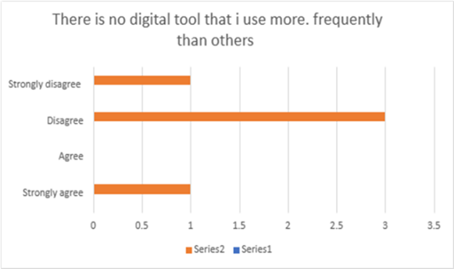
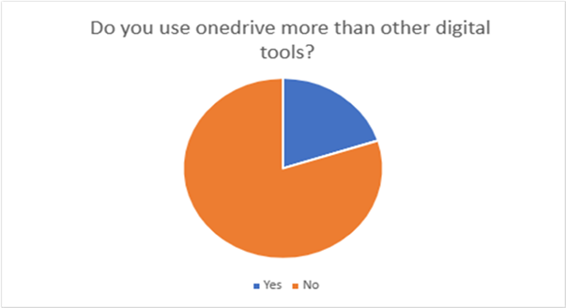
Figure 1 Figure 2
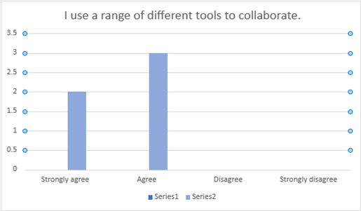
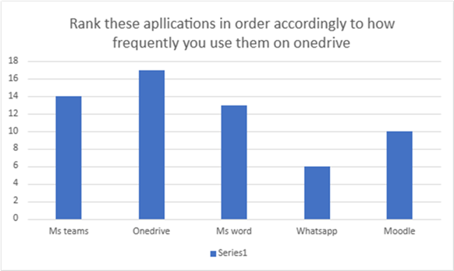

Figure 3 Figure 4

Figure 3 Figure 4

Notetaking

Figure 5

4. Discussion

Using the questionnaire survey created I have been able no analysis data and Information collected and put the information into charts which show the below results,
Figure 1 shows that only 1% of people asked to take part in this survey do not use OneDrive more than any other digital tool. The main benefit of using OneDrive is it is accessible from mobile devices, uses cloud storage and is available to use it anywhere whilst also securing and protecting your data. (Microsoft Customers Stories, n.d.) “We wanted a single, easy-to-use file sharing solution that integrated with the everyday tools people already have on their desktops. OneDrive was the answer.”
Figure 2 shows that the majority of students asked disagree that there is no digital tool that they use more frequently than others. (www.watermarkinsights.com, n.d.) When you login to a digital solution, you enter a shared workspace where multiple participants can contribute to a common process or project. All work is captured in a purpose-built system that can also guide participants through the process.
Figure 3 When asked to rank these applications in order according to how frequently students use them on OneDrive, MS teams, OneDrive, Ms word, WhatsApp, and Moodle, OneDrive was ranked the most used. (Explore the eLearning world with us, 2020) Moodle is a platform for online learning that enables you to create online courses, add assignments, and keep an eye on your students’ progress. It also allows you to communicate with the students and encourage communication between them in forums and discussions.
Figure 4 Shows students either strongly agreed or agreed when asked if students use a range of different tools to collaborate.Sørensen(2018) Said That He "found that students are conservative in their choices of digitals, with preference for Mainstream commercial tools that they already familiar with."
Figure 5 The majority of students who were asked this question agreed that yes, they do use WhatsApp more than other digital tool. (Bing, n.d.) “With private messaging and calling, you can be yourself, speak freely and feel close to the most important people in your life no matter where they are”.
The overall results of this report show that OneDrive although it is very popular amongst students who participated in this survey is not the most used digital tool in fact the survey showed no digital tools were used more than any other digital tool, The survey shows students at UWTSD use a collaboration of digital tools and tend not to stick to one in particular tool. (Hernandez and May 25, n.d.) The researchers found OneDrive to be the most popular cloud storage service overall, with 51 percent of businesses using it and another 10 percent planning to deploy within the next two years. When creating this survey, I was sure Moodle would be the most used digital tool for students at UWTSD, the reason I had this opinion is because as a student myself at UWTSD I can see how much Moodle is used and relied upon by myself and other students to use on a week to week basis, I personally use Moodle for looking through modules, submitting assignments. Keeping track with lessons, presentations, useful links, reading lists and for research and guidance on subjects we are learning. I use WhatsApp more for social communication with friends and family rather than a learning tool and OneDrive more as a storage space, Ms teams for online classes, group support chats, MS word for use for typing assignments.
Each digital tool is still as important as any other digital tool with each offering a variety of different benefits for students at the UWTSD Birmingham campus.
If a larger survey was created asking more participants to cooperate and maybe asking different questions such as multiple choice and students own options then we may find the answer but this research did not find one digital tool was used more then any other digital tool it just shows that a variety of digital tools are used to collaborate for possibly different reasons

5. Conclusion

This report has been written based on the facts and information imputed by students who gave written consent and chose to participate in this survey at Birmingham UWTSD campus. In conclusion to this report using the data collected via a Microsoft forms questionnaire survey, the answer to our question which was? which digital tool is mostly used by students at UWTSD is, There is no digital tool used the most amongst students who participated in this survey at the UWTSD Birmingham campus. Students asked use a variety of digital tools to collaborate. students gave both verbal and written consent to take part in this survey. With the knowledge that all information and any personal details given will be destroyed when data has been analysed and recorded, participants were given their rights to withdraw their consent if they changed their mind for whatever reason, we respected their privacy and valued their input and thank them all for the cooperation and time used to take part.
A range of rank order questions, closed questions and Likert scale questions were asked on this survey questionnaire, the questions asked were as followed.
•Do you consent to take part in this survey voluntarily? Yes/No
•Do you use WhatsApp more than any other digital tool? Yes/No
•Do you use one drive more than any other digital tool? Yes/No
•There is no digital tool that I use more frequently than others? Strongly Disagree/Disagree/Agree/Strongly Agree.
•Rank these applications in order accordingly to how frequently you use them on OneDrive? Ms teams/OneDrive/Ms word/WhatsApp/ Moodle.
•I use a range of different tools to collaborate.? Strongly Disagree/Disagree/Agree/Strongly Agree.
Students use a range of digital tools depending on what they need for example.
WhatsApp for communication
OneDrive for storage
Moodle for week-week lessons, guidance and assignment briefs and submitting assignments.
Ms teams for online lessons, support, communication
Ms word for typing assignments and documents.
Six key ethical principles outlined by Saunders et al (2019) were followed during this survey.
Respect for others
Avoidance of harm
Privacy of those taking part
Voluntary nature of participation and right to withdraw.
Integrity, fairness, and open-mindedness of the researcher
Informed consent of those taking part.
6. REFERENCES

- Barrett, D. et al. (2016) Public Health Ethics: Cases Spanning the Globe. 1st ed. Cham: Springer International Publishing. doi:10.1007/978-3-319-23847-0.
- Bing. (n.d.). WhatsApp. [online] Available at: https://www.bing.com/search?q=whataspp&form=SWAUA2 [Accessed 30 Mar. 2023].

- Customers Stories. (n.d.). Nestlé serves up anywhere access for a global team. [online] Available at: https://customers.microsoft.com/en-us/story/766083-nestle-consumer-goods-m365.

- Deloitte United Kingdom. (n.d.). My life through tech and what it’s taught me. [online] Available at: https://www2.deloitte.com/uk/en/pages/consulting/articles/my-life-through-tech-gareth-stockdale.html?gclid=EAIaIQobChMItZCkra-F_gIVguDtCh0nRQ6DEAAYASAAEgIJsvD_BwE [Accessed 31 Mar. 2023].

- Explore the eLearning world with us. (2020). The 15-Minute Guide for Teachers on Moodle. [online] Available at: https://www.ispringsolutions.com/blog/getting-started-with-moodle#:~:text=Moodle%20is%20a%20platform%20for.

- Hernandez, B.W.A. and May 25, 2018 (n.d.). Study: More Orgs Favor OneDrive over Other Cloud Storage -. [online] Redmond Channel Partner. Available at: https://rcpmag.com/articles/2018/05/25/spiceworks-onedrive-vs-other-cloud-storage.aspx?m=1#:~:text=The%20researchers%20found%20OneDrive%20to [Accessed 30 Mar. 2023].

- Montes, E. (2022). The Advantages of Digital Education. [online] D2L. Available at: https://www.d2l.com/en-eu/blog/advantages-of-digital-education/. [ Accessed On 15th February 2023]

- Morandini, M.-C., Thum-Thysen, A. and Vandeplas, A. (2020). Facing the Digital Transformation: Are Digital Skills Enough? European Economy - Economic Briefs. [online] Available at: https://ideas.repec.org/p/euf/ecobri/054.html [Accessed 31 Mar. 2023].

- Saunders, M.N.K., Lewis, P. and Thornhill, A. (2019) Research methods for business students. 8th edition. Harlow: Pearson. From https://www.researchgate.net/profile/Mark-Saunders-10/publication/330760964_Research_Methods_for_Business_Students_Chapter_4_Understanding_research_philosophy_and_approaches_to_theory_development/links/5c53056f299bf12be3f0e2cf/Research-Methods-for-Business-Students-Chapter-4-Understanding-research-philosophy-and-approaches-to-theory-development.pdf

- Sørensen, M. T. (2018). The students’ choice of technology: A pragmatic and outcome-focused approach. In D. Kergel, B. Heidkamp, P.K. Telléus, T. Rachwal & S. Nowakowski (Eds), The digital turn in higher education (pp.161-174). Springer. https://doi.org/10.1007/978-3-658-19925-8_12, ( Accessed on 7th Feb 2023)

- www.watermarkinsights.com. (n.d.). Top 5 Reasons to Use Digital Tools for Key Campus Processes. [online] Available at: https://www.watermarkinsights.com/resources/blog/top-5-reasons-to-use-digital-tools-for-key-campus-processes.

- Young, J. R. (2004, November 12). When good technology means bad teaching. The Chronicle of Higher Education, 51(12), A31. (Accessed on 7th Feb 2023)

7. APPENDIX

This is a blank copy of our questionnaire survey showing the questions which we asked participants in order to collect and analysis the date to use in this report.


