Developing my personal Welsh language skills

Throughout the PGCE course I have strived to improve my personal Welsh language literacy because I am not overly confident in my own ability to speak Welsh. I think that it is my professional responsibility to progress in my Welsh literacy so that I can contribute to the Welsh Government’s vision of developing bilingual learners. I have collated evidence here which I believe illustrates my commitment to improving my personal Welsh language skills.
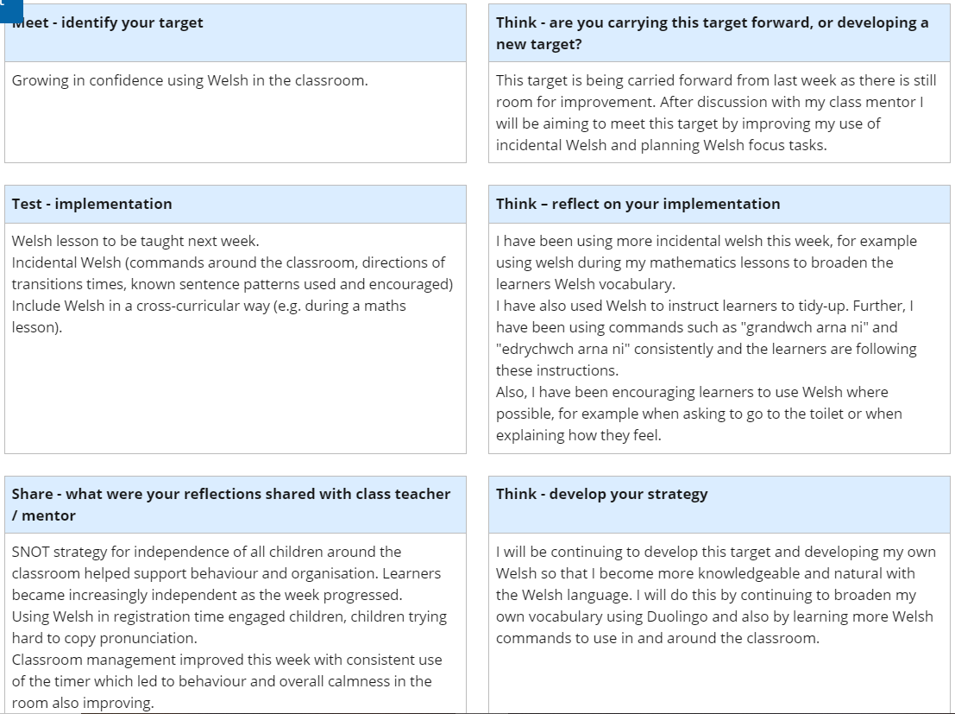
Example 1. This is a screenshot from one of my weekly reflections with my class mentor in foundation phase during PTE1. We agreed that I needed to focus on growing in confidence using Welsh in the classroom by developing my personal Welsh literacy and using as much Welsh as I was able. Having this as a weekly target really made me focus upon how I could improve and what impact it had on the learners. One of the things which I developed was learners developing their emotional literacy by expressing their feelings in Welsh during registration time. Learners grew more confident asking and answering ‘sut wyt ti?’ as time progressed and using as many Welsh words as they could such as ‘pam?’ and ‘achos’.

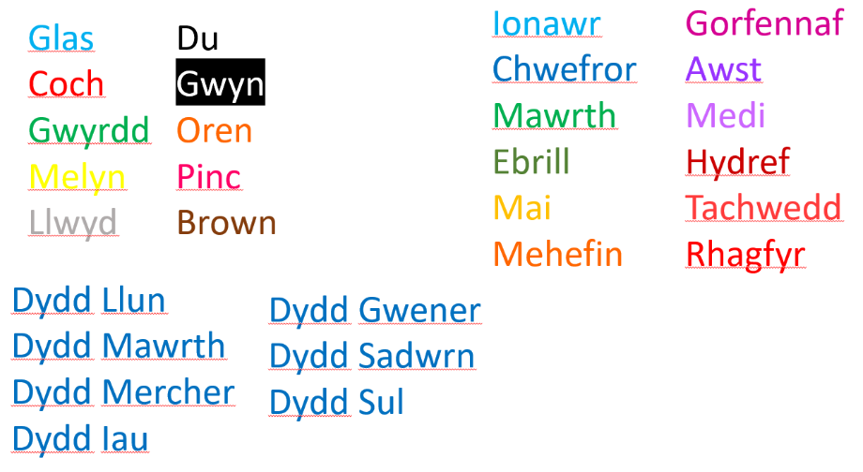
Example 2. Prior to the start of the course I knew that I had forgotten basic Welsh vocabulary which I would need to use in the classroom. To brush up on my vocabulary I made revision pages on my laptop and asked my family to test me until I was confident that I had drilled it into myself.

Example 3. To improve in my own Welsh language literacy, I regularly use the app Duolingo. While using this app I have become more confident using Welsh in the classroom, but also in my day-to-day life. I have learnt a lot of new vocabulary, practised my pronunciation and developed more competency using different sentence patterns. I will continue to use this app to improve my Welsh literacy and consider other programmes to develop for professional and personal reasons.

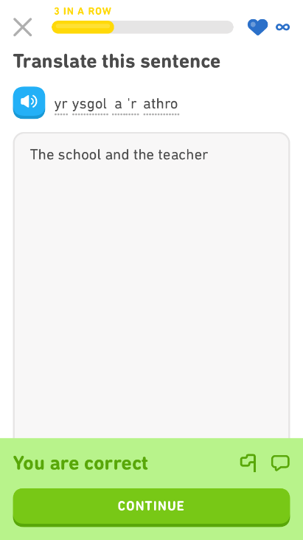

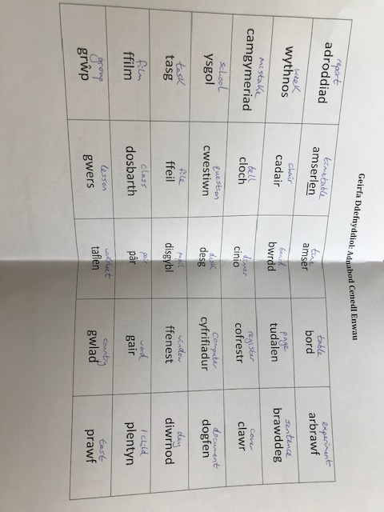
Example 4. I have attended all Cymraeg i Bawb sessions whilst in university. I have endeavoured to engage with the content to improve, while utilising this opportunity to practise pronunciation and mutations alongside my peers. I have transferred ideas learnt in these classes to the classroom, for example ‘un, dau, tri, edrychwch arna ni’ to embed Welsh into the culture of my lessons.
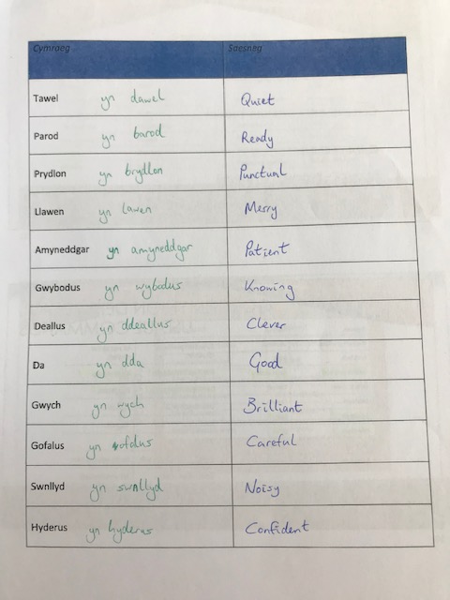

Example 5. These extracts from my learning journal are comments from my class mentor during PTE1 regarding my use of Welsh during the lessons. I strived to incorporate Welsh as far as possible and in doing so felt more confident as the placement progressed.
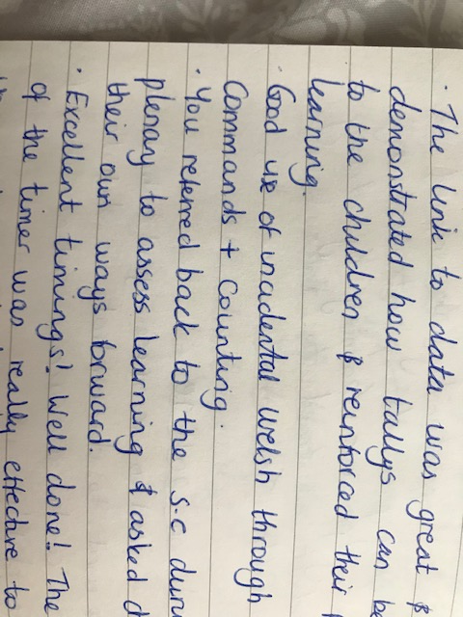
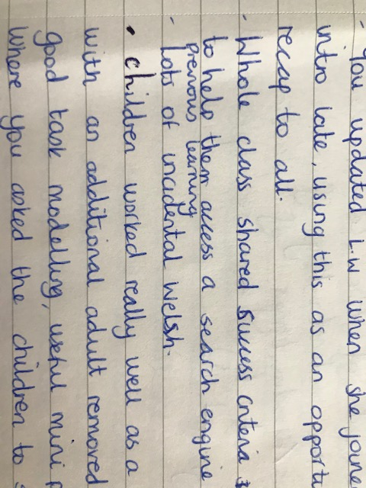

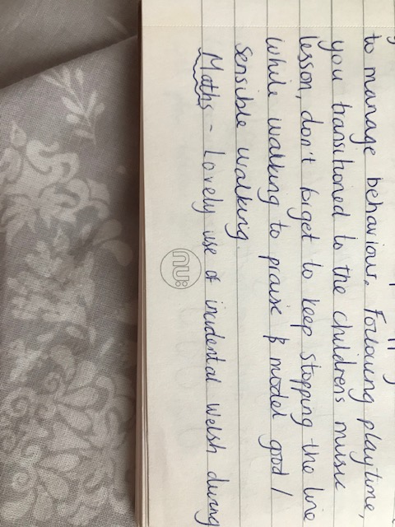

Example 6. This is an extract from my observation during PTE1. As you can see, my lead network mentor set me a target of continuing to develop different Welsh phrases and patterns in the classroom. As we were unable to complete PTE2, I have been unable to try and test out more Welsh during my lessons, I have continued to engage with Duolingo and revise content from Cymraeg i Bawb to ensure that I can continue to progress with my use of Welsh during my NQT year.


