Data Warehousing

Name: Jaylan Lee
Student Number: 2220768
Module Code: ACCA6026
Module Title: Data Warehousing & Data Mining
Lecturer Name: Md Abrar Jahin Almazi Bipon
Assignment Title: Data Warehousing

ABSTRACT
The NHS has to manage a vast quantity of data in its day-to-day operations, such as patient data, Clinical Activity data, demographics and administrative processes. The important data is managed in an online transaction processing system (OLTP) that operates in real-time transactions. This system is stopping them from making effective strategic decisions because it lacks the necessary storage for analysis.
The aim of this project is to build a Data warehouse architecture that allows the NHS to be more efficient so it can manage its resources better, control its spending better and improve its overall standard of care.

1.1 OLTP vs. Data Warehouse
The NHS already operates a class of systems that support and oversee transaction-oriented applications, usually for data entry, retrieval, and transaction processing, known as online transaction processing (OLTP). [1] The term "transaction" is defined in terms of business or commercial transactions in addition to computer or database transactions. [1] OLTP databases are made to handle transactions in real time. [2]
In contrast, A data warehouse is a sizable data repository that facilitates decision-making by storing and integrating data from multiple sources in an organised way. [3] Data warehousing is the process of gathering information into a data warehouse. [3] The data collection will be unique to the company as a whole, not specific to any user group. Unlike OLTP, which deals with information in real time, a data warehouse is utilised for decision-making rather than day-to-day tasks and transaction processing. [4]
The main benefit of a data warehouse for the NHS is its focus on data modelling and analysis for decision-makers. [4] Since a data warehouse focuses on data modelling and analysis for decision-makers, it will usually offer a clear, succinct perspective on a given topic. [4] such as sales or patients. rather than the continuous activities of the international organisation. This is accomplished by removing information that is not relevant to the situation and adding all information required for users to comprehend what is happening. [4]

1.2 Data Warehouse Architecture & ETL
The NHS has to extract information from a variety of different internal sources such as workforce data, patient information, clinical and many more. A three-phase procedure called extract, transform, and load (ETL) will be used to integrate these data. [5]
The Data Warehouse architecture's essential component is the ETL procedure. It seeks to make the data accessible and suitable for the intended purpose by standardising the processing of the original data. [6]
In the first phase, external data is extracted from a variety of source systems. [6]
In order to guarantee data quality, the data is transformed. [7] This process entails data cleansing, which includes finding and fixing mistakes, inconsistencies, and missing values. [7]Deduplication, normalisation, and integration of different data formats are frequently necessary when combining data from multiple sources to produce a cohesive perspective. [7]
The last stage of ETL is loading. Data is imported into the target data warehouse scheme after being transformed into a particular data warehouse format. [6] which will function as a central repository for data, data marts, or other analytical databases for reporting and querying. [7]
The ETL process is designed to maintain data quality and integrity throughout the migration, employing robust validation and error-handling mechanisms. [8] It will not disrupt normal operations [8]

Figure 1 shows the ETL Process [6]
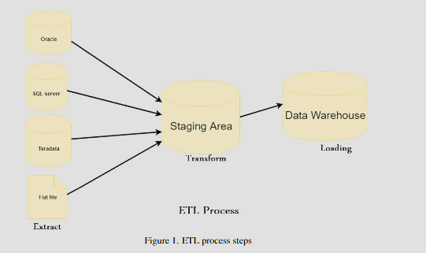

1.3 Data Marts for Management Decision-Making
A Data Mart is a subset of a larger information store that may be disseminated to meet business needs and is typically focused on a particular goal or key data subject. [9] Data Marts are analytical record stores created to concentrate on certain business operations for a community inside an organisation. Subsets of data in a data warehouse are used to create data marts. [9]
For the Chief Executive, Data Marts can support the use of Key Performance Indicators, which help the Chief Executive to assess how well the NHS is accomplishing its goals and objectives. [10] These metrics are essential in the healthcare sector for evaluating the standard of patient care and pinpointing areas in need of development [10]
The Medical Director is crucial to providing clinical leadership, expert guidance, staff management, and departmental staff reconciliation. [11] This helps to promote improvements within the NHS. [11]Because they combine clinical expertise with administrative skills to help steer the hospital-based unit toward high performance and dependability [12] Data Marts can help provide the Medical Director with data such as pharmaceutical, medical test, and demographic data.
Finance Director in the NHS is responsible for Capital structure, annual operating and capital budget, financial policies, and strategies [13] The financial data mart will assist the Finance Director in decision-making by consolidating data from several operational systems into a central repository, with the capability to efficiently hold and retrieve financial data. [14] For the NHS, some of this financial data can be Cost per patient, spending percentage, and budget effectiveness. [14]

1.4 OLTP Normalisation vs. Data Warehouse Dimensional Modelling
In the NHS, Real-time transactional data handling is the responsibility of OLTP systems. [15] Every action that takes place in the hospital's daily operations is documented by these systems. [15] The patient registration system keeps track of their personal information, including name, age, insurance, and medical history. [15]The OLTP system updates the hospital's calendar, logs the time slot, and verifies availability when a patient makes or changes an appointment with a physician. Patients are registered, billed, and scheduled using OLTP systems. [15] The vast volumes of this data will be organised into tables and their connections will be determined; this is also known as normalisation. [16]
In contrast, Data Warehouse Dimensional categories that provide the data a descriptive meaning are called dimensions, such as time, patient, and location. Each dimension can be allocated a variety of attributes (for example, patient name, type of treatment, and Bed location) and may include hierarchies such as year, month, and day. Fact tables, which include the performance's typically numerical numbers, measurements like waiting times, patient admissions or patient discharged, dimension tables typically hold descriptive text. When combined, they contain effective analysis by connecting quantitative and descriptive data.

Figure 2 shows the NHS Star Schema
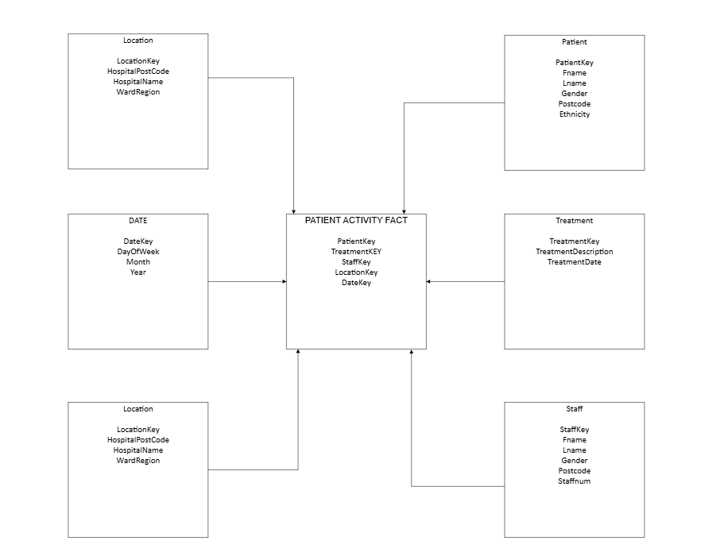

TASK 2

2.1 Source System Identification

There are a few systems, both internal and external to NHS England, that will feed data into the data warehouse. The internal system consists of clinical activity data, electronic patient records, operational data, financial management systems, workforce data, financial data and quality & performance data. [15] [17]

2.2 Star Schema Design

Figure 3 shows the NHS internal source

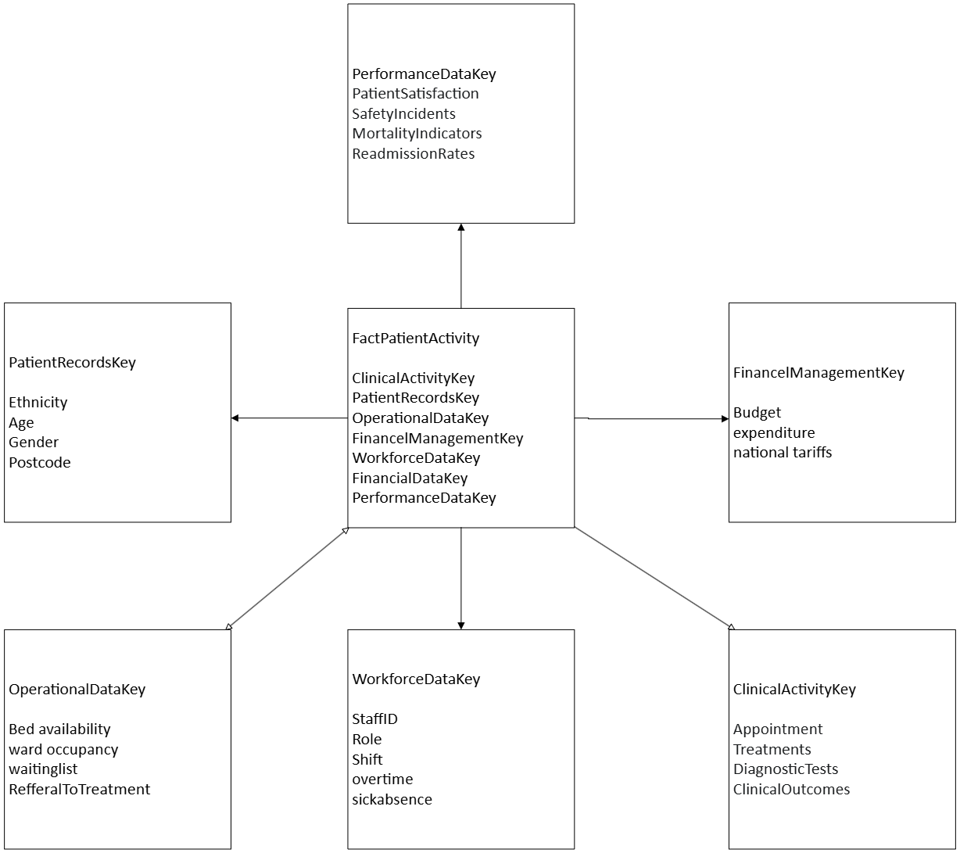

Internal Source | Attributes | Description
 | FactPatientActivity
ClinicalActivityKey | Appointment, Treatments, DiagnosticTests, ClinicalOutcomes | Patient care
OperationalDataKey | Bed availability, WardOccupancy  WaitingList, RefferalToTreatment | NHS operations and management
FinancelManagementKey | Budget, expenditure, national tariffs | How the NHS manage finances
WorkforceDataKey | StaffID, RoleShift, OverTime  SickAbsence | NHS workers' day-to-day activities
FinancialDataKey | Budget, expenditure, national tariffs | NHS costs of operation
PerformanceDataKey | PatientSatisfaction, SafetyIncidents  MortalityIndicators, ReadmissionRates | How well the NHS is performing

2.3 Data Marts and Schema
The data mart for finance will use the budget data and the expenditure data. The fact table will contain the Cost of treatment, budgets, national tariff income, and expenditure.
In the operational data mart, data will be used to track patients who come in and out of the hospital and how resources are allocated to them. This will be shown in the fact table as ward occupancy, bed availability, referral-to-treatment (RTT.
The Clinical Activity data mart will focus on patient healthcare and safety. Appointments, clinical outcomes, theatre utilisation, treatments and diagnoses will be in the fact table.

Figure 4 shows the Finance Fact table

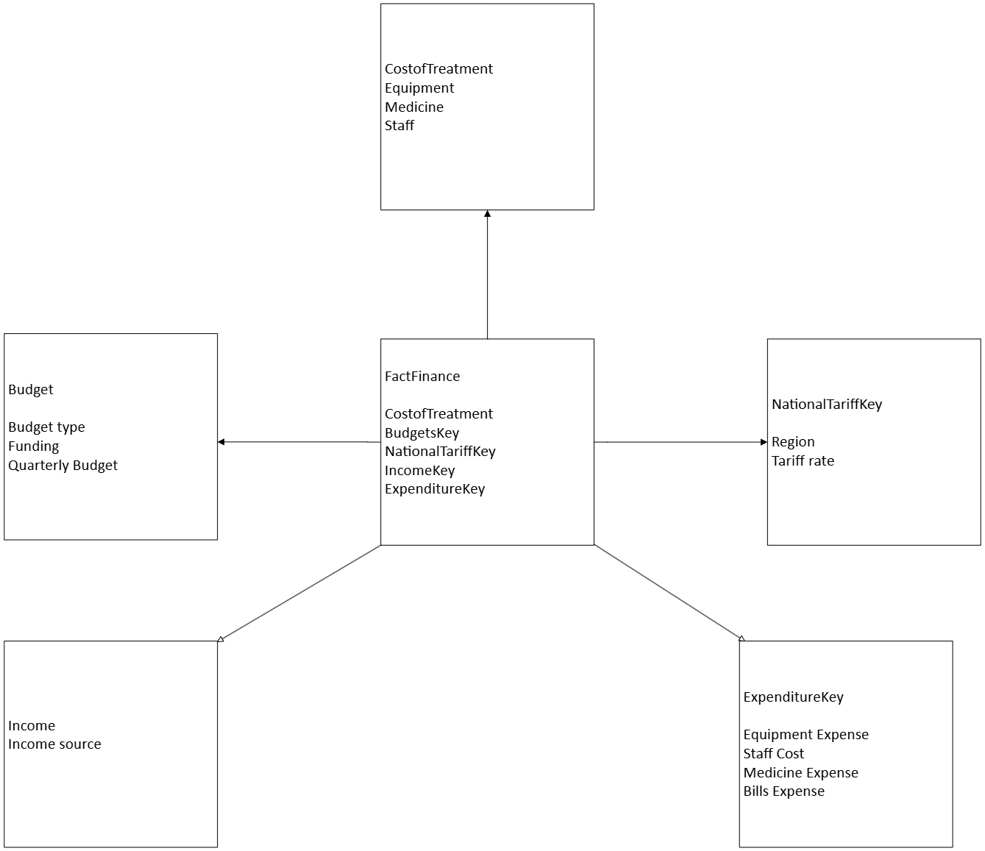

References

[1] | ,. E. M. G. S. P. Dr. Sandeep Srivastava, E-Commerce, SBPD Publications, 2023.
[2] | H. Hu, Q. Zheng, X. Zou, L. Qin, C. Zhang and W. Zhang, “A Cost-Effective and Decompression-Transparent Compressor for OLTP-Oriented Databases,” in 2025 IEEE 41st International Conference on Data Engineering (ICDE), 2025.
[3] | M. D. Nambiar Athira, “An Overview of Data Warehouse and Data Lake in Modern Enterprise Data Management,” Big Data and Cognitive Computing, vol. 6, no. 4, p. 132, 2022.
[4] | M. Soni, Database Management System, Poorav Publications, 2024.
[5] | A. Dhaouadi, K. Bousselmi, M. M. Gammoudi, S. Monnet and S. Hammoudi, “Data Warehousing Process Modeling from Classical Approaches to New Trends: Main Features and Comparisons,” Data, vol. 7, no. 8, p. 113, 2022.
[6] | S. Q. E. H. A. M. S. Abd Al-Rahman, “Design and implementation of the web (extract, transform, load) process in data warehouse application,” IAES International Journal of Artificial Intelligence, vol. 12, no. 2, 2023.
[7] | G. F. G. F. Walha Afef, “Data integration from traditional to big data: main features and comparisons of ETL approaches,” Springer Nature B.V., vol. 80, no. 19, 2024.
[8] | S. H. S. K. S. S. P. Mohith Surya Kiran Kasula, “Utilizing ETL Processes to Enhance Healthcare Education: Migrating MIMIC-IV to OpenEMR,” 2024.
[9] | A. K. V. K, Business Intelligence Demystified: Understand and Clear All Your Doubts and Misconceptions About BI (English Edition), BPB Publications.
[10] | D. M. M. Salama, Clarity in Healthcare Quality: CHQ Handbook, Mazenz.com, 2023.
[11] | I. A. M. Khamis Al-Alawy, “Review: Medical directors – Is there a need for reform?,” Sage Journals, 2024.
[12] | F. M. N. Lynch, “Acute Nephrology Nurse Managers and Medical Directors: The Roles and Relationships to Produce Quality in the Unit,” Nephrology Nursing Journal, vol. 51, no. 3, 2024.
[13] | A. S. Gutterman, Board of Directors: The Finance Committee, University of California, Berkeley, 2023.
[14] | A. F. L. E. G. V. Susiana Sunjaya, “Development of Financial Data Mart for Nonprofit Organization,” Jurnal Teknik Informatika dan Sistem Informasi, vol. 10, no. 2, pp. 200-214, 2024.
[15] | M. A. Q. Y. Y. F. M. M. P. M. J. Amara Atif, Decoding Data: A Complete Guide to Business Intelligence, UTS ePRESS, 2026.
[16] | T. R. Kedeisha Bryan, Cracking the Data Engineering Interview: Land your dream job with the help of resume-building tips, over 100 mock questions, and a unique portfolio, Packt Publishing Ltd, 2023.
[17] | P. S. E. Ozieranski and S. Mulinari, “Pharmaceutical industry payments to NHS trusts in England: A four-year analysis of the Disclosure UK database,” PLoS One, vol. 18, no. 11, 2023.
[18] | M. O. Chonchanok Wongaphai, “Enhancing Financial Service Systems Through OLAP and OLTP Integration,” in 2025 10th International Conference on Business and Industrial Research (ICBIR), 2025.

