L6- BA Computer Games Design | Critical Review | ADFM6001 |Reel Promo| Gabriella N. Smith 1901111 |2 Pages | 16th May 2022

Personal Showreel
The show-reel is unlisted so anyone with the link or QR code have access to my show-reel.
If I make an online brand after University, I would be able to make this video public as I would only upload project related videos to my channel.
(Research in Bibliography)

Showreel URL: https://youtu.be/q3dqCxUWobs

Business Card
The business card is 91 x 60 mm.
(Research in Bibliography)
Front of the business card:
The front of my business card has my name, role, contact details, linked in URL and a QR code linking to my Show-Reel.


Back of the Business Card:
The back of the business card is just the same background on the front of the card so that it’s not blank.

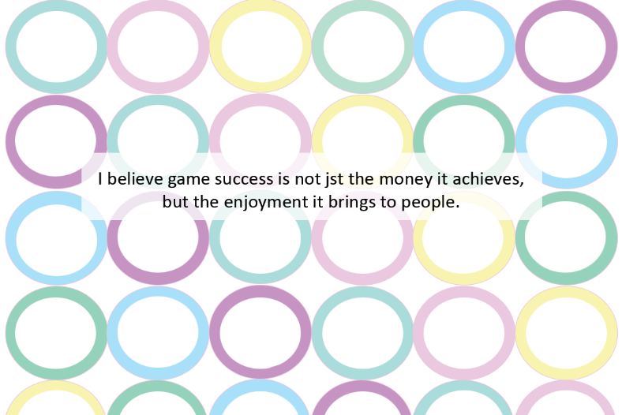

Bibliography
Show-Reel
Alpha, “3D Art- Demo Reel 2019”, YOUTUBE, 4 March 2019, [Online]. Available: https://www.youtube.com/watch?v=arigK3xM7Us [Accessed: 10/05/2022].
Eman AlShehabi, “Matte Painting/ concept art showreel 2018”, YOUTUBE, 7 Oct 2018, [Online]. Available: https://www.youtube.com/watch?v=IyS0X_2ZpGE [Accessed: 10/05/2022].
Sean, “Game Environment and Prop Artist- Showreel 2018”, YOUTUBE, 25 April 2018, [Online]. Available: https://www.youtube.com/watch?v=3lfYmp3xUkE [Accessed: 10/05/2022].
Ruth Heneghan, “Ruth Heneghan Showreel”, YOUTUBE, 14 May 2018, [Online]. Available: https://www.youtube.com/watch?v=Nv2UbPP7Bp4 [Accessed: 10/05/2022].
Business Card
Northeast Ink, “Game Developer Business Card”, PINTEREST, [Online]. Available: https://www.pinterest.co.uk/pin/153263193547189516/ [Accessed: 10/05/2022].
Unknown, “23+ Gaming Business Cards”, CREATIVE VIVID, [Online]. Available: https://www.creativevivid.com/design/cards/gaming-business-card/ [Accessed: 10/05/2022].

