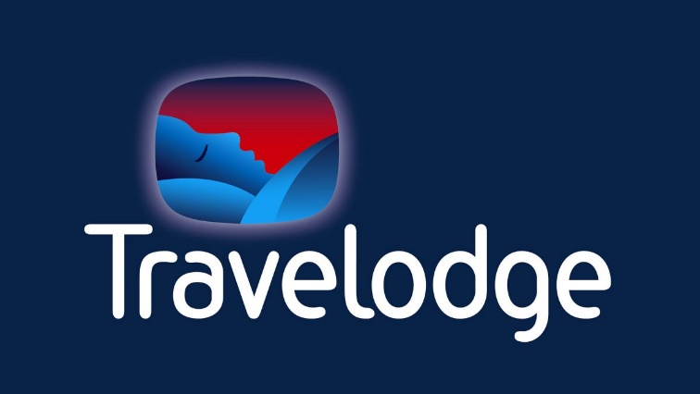

The marketing plan is written for Travelodge

Student Name: CRISTINA ILIUTA

Student ID number: 2212526

Marketing Essentials BMIH4005

Lecturer: LUCIANA SUARDI

Introduction
Travelodge is a private company that operates in hotels and hospitality across the United Kingdom, Spain and Ireland. The brand is referred to as the largest independent hotel in the United Kingdom, with more than 570 limited services hotels operating across the country. The core emphasis of the marketing plan is to increase its customer base and attract new customers. With the marketing plan, different tools and frameworks will be adopted that would be helpful in evaluating the environment the brand is operating. Moreover, situational analysis alongside SWOT and PESTLE analysis will also be done.
Situation Analysis

Company: SWOT analysis (Microanalysis)
Strengths | Weaknesses
- Strong brand image  - Offers affordable prices  - Specific programs for premium customers (Aroul et al., 2022  - Extensive presence across the United Kingdom | - Limited range of products and services  - Customers complain that hotels are boring and plain looking  - Does not live up to customers' expectations
Opportunities | Threats
- Focus on green and ecotourism (Vico 2018)  - Increase in global expansion  - Attract a new customer base | - Intense competition (George 2021)  - Limited international presence  - Lowering demand for hotel services due to security issues

Customers: Segmentation and Targeting/ Customer profiles'
Segmentation of the market is referred to as the grouping of customers that have similar kinds of needs and demands (Bigo, Raj and Situmeang 2021). The market segment of Travelodge is categorised into four types that include business travellers, leisure travellers, group meetings and others.
Segmentation: the brand segments the target market demographically and, with that, segments the market as per the income level of the consumers.
Targeting: the primary target market for the hotel brand are business class and corporate people.
Positioning: Travelodge positioned itself as a brand that focuses on providing high-quality service and hospitality to customers.

Competitors: Porter's five forces
The threat of new entrants (Low) | - Already existing players increase challenges  - Massive capital requirement  - Difficult to achieve economy of scale
Power of suppliers (Low) | - Easy availability of the resources and suppliers  - Unique items are not required (Jones and Comfort, 2022)
Power of buyer (high) | - Several options are available for the consumers  - Availability of low-cost hotels and motels (Lu and Tabari 2019)  - Low switching cost
The threat of substitute (High) | - Budget-friendly options (Nain 2018)  - Other players offering similar services
Competition in the industry (High) | - Many brands have been operating for a long time (Yang et al., 2022)  - Lower product differentiation cost  - Already built network of loyal customers

Collaborators: Demonstrate an awareness of your organisation's B2B Relationships, Partnerships, and Franchises.
- Travelodge focuses on providing quality services at a budget-friendly price,
- The focus is on building a strong relationship with its customers.

Climate: PESTLE (Macro analysis)
Political factors | - Favourable environment to do business  - Government support  - Low tax for the hospitality industry (Maclean et al., 2018)
Economic factors | - Increase in GDP  - Stable economic condition
Social factors | - Increase in travelling  - Looking for budget-friendly options
Technological factors | - Use of advanced technology such as artificial intelligence  - Focus on innovative services (Eid and Agag 2020).
Legal factors | - Implementation of different laws for protecting employees and consumers
Environmental factors | - Focus on green and ecotourism  - Ensuring sustainability (Ouyang, Wei and Chi, 2019)

Objectives
SMART target:
The primary aim of the marketing plan is to increase the existing customer base and attract new customers for the brand. This will be done with the effective use of digital and social media tools.
Following are the core objectives that will be accomplished through the marketing plan.
- To increase customer base by 10% till the end of 2023.
- To enlarge customer engagement by 15% by mid-2023.
- To expand global presence by 5% within the next 2 years.

Strategy

The value proposition for Travelodge is the services they provide at affordable price ranges. The emphasis is on providing quality services at a reasonable price range. This is helpful in attracting customers and increasing its market share. For mapping out the position of the brand within the market place adopting the Bowman strategy clock would be an effective tool. This is considered an easy and comprehensive tool which is effective in providing options for positioning within the market depending on the perceived value and price. Taking into consideration Travelodge, the brand falls under the dimension of low price. This indicates that the brand focuses on offering low prices, but with that, it is also made sure that quality should be maintained or else it would lead to low sales. Along with this, low offering prices would be helpful in attracting more customers, but at the same time, it is essential that the brand should focus on maintaining quality in order to ensure retention of customers.

Tactics
Marketing mix:
Product
The primary product of Travelodge is the accommodation and restaurant services it provides to the customers. Along with this, different features are also provided, some of which include internet facilities, meeting and conferencing rooms alongside the video conferencing facilities.
Place (Distribution)
Within the hotel industry, third parties are involved, such as travel agents and airlines, provide ease to the customers in terms of booking. Similarly, for Travelodge, both direct and indirect distributors are involved. Through the direct process, booking can be made from the official website of the company; along with this, on-call services are also available. Moreover, in terms of indirect distributors, travel agents are generally connected.
Price
Pricing strategy is considered crucial for any business in order to ensure success (Thabit and Raewf 2018). In comparison to the other major players in the market, Travelodge offers its customers a low-price strategy. With that, rooms can be booked at a much cheaper rate if reservations are made earlier. With low prices, it also makes sure that the quality of service should be maintained and that a luxurious experience should be provided.
Promotion
Effective promotion strategies play important in attracting customers for the brand (Anjani, Irham and Waluyati, 2018). Travelodge, over the years, has successfully adopted different promotional strategies, which are helpful in attracting the target audience and maintaining its position in the market. To accomplish the set objectives, it is necessary that Travelodge should focus on investing more in adopting new trends and technologies for developing marketing strategies. Along with this, it is also essential that focus should be given to using digital marketing, with that implementation of the RACE model would be effective in the accomplishment of the set objectives.

Action
-Gannt chart of marketing activities:
In order to ensure that all the activities should be done as per the set schedule, it is essential that focus should be given to effective monitoring, and with that, emphasis needs to be given to an adequate delegation of the tasks. Furthermore, the following action plan will be adopted, referring to the marketing plan for Travelodge.
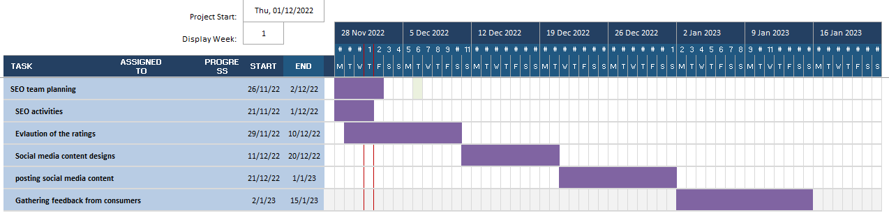

Effective use of social media is considered beneficial in connecting and engaging potential customers with the business (Li, Larimo. and Leonidou 2021). With the help of a strong social media strategy alongside the ability to create engaging content, it would be beneficial for marketers to increase customer engagement. Effective social engagement would be helpful for businesses in building trust and authority with the target audience.
Control
The Unique selling point of a company is helpful in defining the unique position of the business within the marketplace it is operating (Mohd Satar, Dastane and Ma’arif 2019). Moreover, a strong USP of a business is helpful in articulating specific benefits which cannot be offered by the other competitors. In the case of Travelodge, the low cost offered by the company is the USP, as the other brands are offering similar services but at a much higher rate. Offering quality services in a budget-friendly manner is helpful for the company in attracting potential customers and, with that maintaining a strong customer base. Promoting the USP with effective marketing would be helpful for the company in accomplishing the set objectives.
Conclusion
Travelodge is working effectively in managing its customers with the help of effective marketing strategies. With the current marketing plan, the core emphasis is on increasing the customer base by attracting new customers. In order to do so, it is suggested that focus needs to be given to using digital and social media marketing strategies.

References
.Maclean, M., Harvey, C., Suddaby, R. and O’Gorman, K., 2018. Political ideology and the discursive construction of the multinational hotel industry. Human Relations, 71(6), pp.766-795.
Anjani, H.D., Irham, I. and Waluyati, L.R., 2018. Relationship of 7P marketing mix and consumers' loyalty in traditional markets. Agro Ekonomi, 29(2), pp.261-273.
Aroul, R.R., Hodari, D., Bianchi, G. and Martignoni, G., 2022. The impact of brand affiliation on asset values: the case of UK hotels. Journal of Property Research, pp.1-31.
Bigo, C., Raj, A. and Situmeang, R.R., 2021. Segmentation, Targeting, Positioning (STP), Communication and Price Strategies on Consumer Purchasing Decisions at PT. Alfa Scorpii Medan. Jurnal Mantik, 4(4), pp.2370-2375.
Eid, R. and Agag, G., 2020. Determinants of innovative behaviour in the hotel industry: a cross-cultural study. International Journal of Hospitality Management, 91, p.102642.
George, R., 2021. The Tourism and Hospitality Marketing Environment. In Marketing Tourism and Hospitality (pp. 183-219).
Jones, P. and Comfort, D., 2022. Modern Slavery Statements and Service Industry Supply Chains: A Commentary on the Leading Hotel and Retail Companies in the UK. Operations and Supply Chain Management, 15(3), pp.386-394.
Li, F., Larimo, J. and Leonidou, L.C., 2021. Social media marketing strategy: definition, conceptualisation, taxonomy, validation, and future agenda. Journal of the Academy of Marketing Science, 49(1), pp.51-70.
Lu, L. and Tabari, S., 2019. Impact of Airbnb on customers' behaviour in the UK hotel industry. Tourism Analysis, 24(1), pp.13-26.
Mohd Satar, N.S., Dastane, D.O. and Ma’arif, M.Y., 2019. Customer value proposition for E-Commerce: A case study approach. International Journal of Advanced Computer Science and Applications (IJACSA), 10(2), pp.454-458.
Nain, A., 2018. A study on major challenges faced by the hotel industry globally. International Journal of Creative Research Thoughts, 6(1), pp.561-571.
Ouyang, Z., Wei, W. and Chi, C.G., 2019. Environment management in the hotel industry: does institutional environment matter?. International Journal of Hospitality Management, 77, pp.353-364.
Thabit, T. and Raewf, M., 2018. The evaluation of marketing mix elements: A case study. International Journal of Social Sciences & Educational Studies, 4(4).
Vico, RP, 2018. International Tourism: modern trends, models and processes. Sociedade e Território, 30(1), pp.68-93.
Yang, Y., Nieto García, M., Viglia, G. and Nicolau, J.L., 2022. Competitors or complements: a meta-analysis of the effect of Airbnb on hotel performance. Journal of Travel Research, 61(7), pp.1508-1527.

Appendices


