Synthesize a solution to a potential real life scenario
By Donna Wright

Abstract
This report has been complied to provide a bring your own device solution for the consultancy company Hyper-fort. It looks at the various solutions available and provides insight into the technologies which can be deployed.

Contents
Introduction 4
Related Work 4
Problem Formulation 5
Implementation 6
Conclusion, recommendation and future work 8
References and further reading 9

Introduction
The demand for companies to facilitate the concept of BYOD (bring your own device) or BYOT (bring your own technology) for their staff and customers is steadily increasing. These concepts attract positives and negatives for a company, ranging from cost saving to privacy issues.
The concept of BYOD is to allow individuals to use their own devices and technology in order to access and interact with elements of your company’s infrastructure. For example, employees accessing your network using their personal laptop or accessing work email on their personal mobiles.
The purpose of this paper is to look at the feasibility of putting this concept into action within the company Hyper-fort.

Related Work
With the use of personal mobile devices becoming more common there is a greater expectation by individuals to be able to conduct business on their own device. The National Cyber Security Centre (NCSC) provides some good guidance for companies considering adopting this approach for their business on their website [1]. This guidance outlines the potential risks and considerations a company may face when looking to implement this concept. These include:
- Responsibilities as a data controller opposed to the device owner
- Effective policies
- Information sharing capabilities
- Potential technical controls
- Device support
- Ownership models

There are a mixture of advantages and disadvantages with implementing a BYOD solution. Security specialists such as Gina Matteucci [2] have conducted research into the pros and cons of BYOD and have provided guidance to assist in the decision making process as to whether it is the right choice for a business.
From her research Gina outlined several advantages and risks associated with BYOD. For example, utilising a BYOD solution will mean the company’s technology costs will be reduced as there is no requirement for them to purchase devices, the technology used will usually be the latest as individuals will upgrade their devices regularly and availability and access to information will be greatly improved as individuals will usually have their own device to hand. In addition to the user experience will be improved as they can use a device they have selected and are comfortable with.
Some of the risks Gina noted were lack of end-user support and legal costs. The largest risk however was the security concerns this solution attracted. For example, the ability to monitor devices is affected when they are not managed by the company. This will affect a company’s ability to address issues such as viruses or attacks on the device. Reduced protection on a device may mean that there are certain actions the individual cannot undertake, for example accessing sensitive information. Parr, Brown, Gee and Loveless [3] provide some guidance on the legal side of BYOD. This includes requirements to register devices, have password protection enabled on devices and that an ability to remotely wipe devices if required. These types of requirements should make up any policies associated with the solution and agreed to by individuals.
It is clear that the introduction of a BYOD solution can result in an increase in productivity as it raises the availability of the services.
As Cisco point out in their guidance [4] there is also an inherent risk a company runs when allowing an unmanaged device to access their network. One solution that Cisco provides to counter this risk is an Identity Service Engine (ISE) [5]. This solution facilitates different levels of access into a network depending on intent. For example, a different level of access will be afforded to a permanent employee than to a contractor. This approach can be beneficial if the company is looking to implement a network based approach.
It is strongly recommended that technical controls to secure, manage and support your BYOD solution are implemented. These include Mobile Device Management (MDM) and Virtual Private Networks (VPN).
A MDM facilitates the administration of mobile devices. There are numerous MDM solutions available on the market and it is advised that adequate research is done into potential choices. There is no correct answer on selecting a service to fit the BYOD solution a company checks. Many will offer similar services but it is unlikely that you will identify one that meets all your needs. This is something that Andrew A at the NCSC recognises:
“Each MDM product we’ve come across tends to focus more on some platforms and use cases than others — Apple iOS rather than Android, or fully managed rather than bring your own device (BYOD). We’re yet to come across a single MDM product that does well with all platforms and use cases.” [6]
The inclusion of a VPN in a BYOD solution will allow a secure mechanism for connecting devices to a network. This adds a layer of security to a connection and can help to mitigate against potentially poorly configured connections. The NCSC [7] provide some guidance on VPNs including underlying technology.

Problem Formulation
The consultancy company Hyper-fort currently delivers its IT services using cloud services and approximately 95% of their network is wireless. In addition the company has a vast social media and online presence.
Following increased pressure from staff and clients the company is now looking to explore the feasibility of implementing a BYOD solution.
It is assumed that there are 4 types of users. These are:
- On prem – these are the individuals on site accessing the network and services via a cabled connection.
- Remote workers – these are individuals accessing the network and services using a company issued device.
- Staff own device – these are members of staff connecting to services using their own devices.
- Guest own device – these are guests known to the company connecting to services using their own devices.
The following proposed solution will look to address the requirements of the business, staff members and clients whilst ensuring data is secure and the companies intellectual properties are protected.
It is advised that a policy is created outlining the responsibilities regarding the devices. This should include any inherent risks. This policy will be signed and agreed to by both the owner of the device and a representative from the business.

Implementation
As stated in the previous section there is assumed to be 4 user types. I have looked at each of these user types below providing detail on the proposed technical solution.
On prem
Devices connecting on premises will be wired to the network. They will connect via switches to a firewall pair (paired for resilience). A combination of access control lists and firewall rules will determine the level of access a user will be given. These devices will remain in an office which is controlled by RFID cards.
Remote workers
These will be standard Windows 10 devices that are procured and owned by the company and will be assigned to staff. Each device will be encrypted as standard to protect against loss of data. It is advised that Microsoft Bitlocker full disk encryption (FDE) is enabled upon each laptop host with local TPM acting as cryptographic chain of trust root.
These devices will connect via a VPN client such as Palo Alto. The VPN Client will have a set policies allowing or denying traffic. This will be used in conjunction with active directory to determine the levels of access individuals are given. Connection to the VPN client will require authentication from a recognised device.
Staff own device and guest own device
Individuals wishing to use their own device to connect to the services will have either a Windows or Apple device which will be managed through Mobile Device Management solutions enabling secure corporate applications. This will allow secure conditional access.
A combination of device management solutions will be used to control device security and availability with a focus on enabling the work force, protecting corporate information and nurturing effective collaboration while enforcing compliance and identity management. The use of multiple mobile device management platforms allows flexibility, scale and diversity for development.
Integration with Microsoft Intune Mobile Device Management (MDM) [8] and VMware Airwatch Workspace One (Airwatch) [9] will provide compliance, security, control and management over single devices accessing corporate services. Airwatch WorkSpace One will be used primarily for MacOS deployments due the enhanced management around this platform including automated out of the box (OOTB) deployment and configuration.
Collaboration and corporate tools will be made available to devices on premises or mobile when using the Palo Alto VPN. Microsoft Intune and Airwatch enforcement controls will ensure conditional granted access through approved routes is available and application protection polices protecting and encrypting data from loss on devices.
MDM process will track and enforce device compliance, location, roles, health, permissions and users with the ability to control, report and manage devices.
Palo Alto will also be available to measure, review and secure corporate services and ensure network routes used are trusted and known.
SSH will be enabled on all switches and Telnet disabled. All unnecessary ports will be locked down and switches will be password protected.
The server room should be separate from the rest of the company and accessible via RFID card by select staff.
Below is a screenshot of a simulation of the proposed network. This has been attached for reference
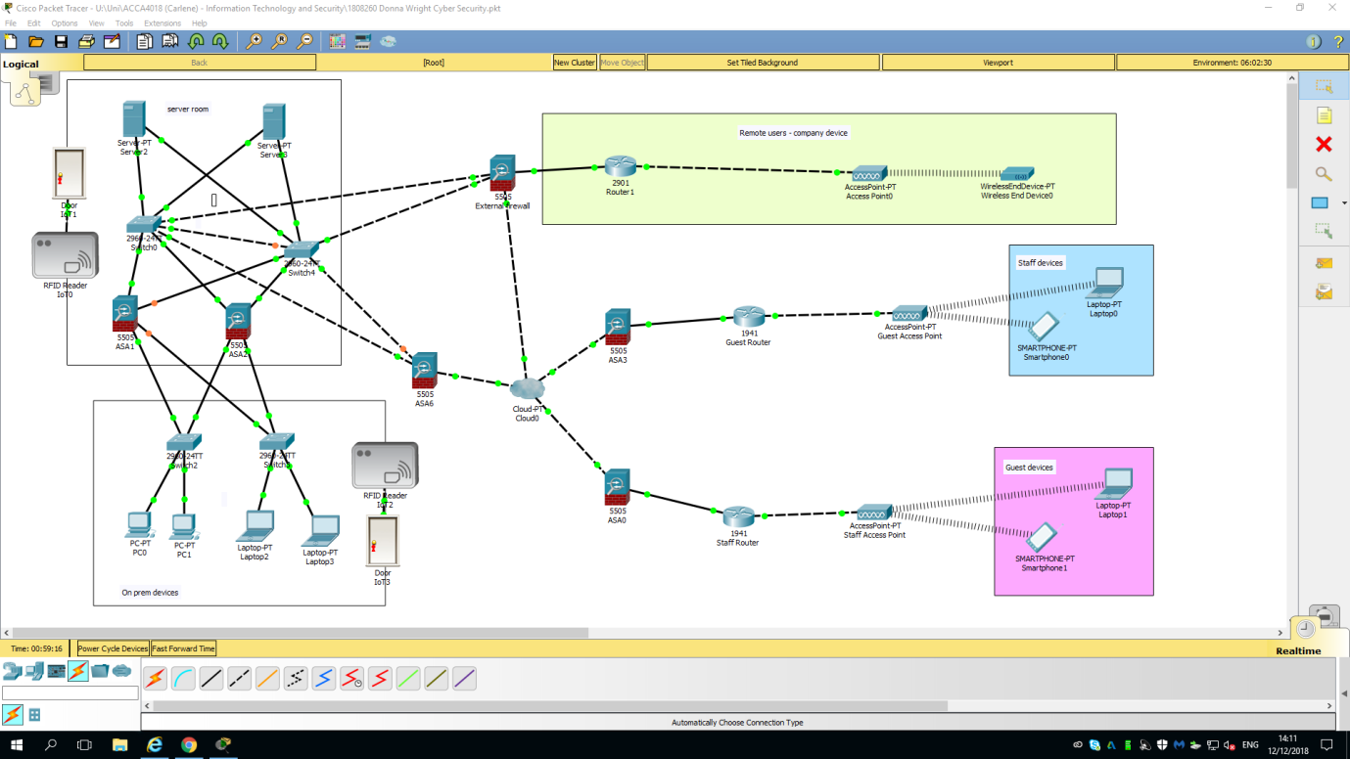
A policy concerning the use of own device will be in place and users will sign up to it before access is granted. This policy must address the following provisions:
- It is the users responsibility to ensure their device receives updates in a timely manner
- The company is not liable for the maintenance and/or repair of users device
- The user is responsible for any damages and resulting repairs to the device
- The user accepts the risk that their device may be remotely wiped in the event of an incident
- The user accepts that their device may be remotely wiped in the event that the device is lost, stolen or fails
- The user accepts that some inbuilt functionality will be disabled, for example Siri and Alexa
- The user accepts that automatic back-ups outside of those approved by the company must be disabled
- The user accepts that their device is liable to be seized in the event of a security incident
- The user accepts that there may be a requirement for technical specialists to inspect their device
- The user accepts they may be prohibited from taking their device abroad without prior consultation with the security team to provide advice and guidence
- The user understands that they are held fully responsible for the security of the device

An example connection by a user has been depicted below:

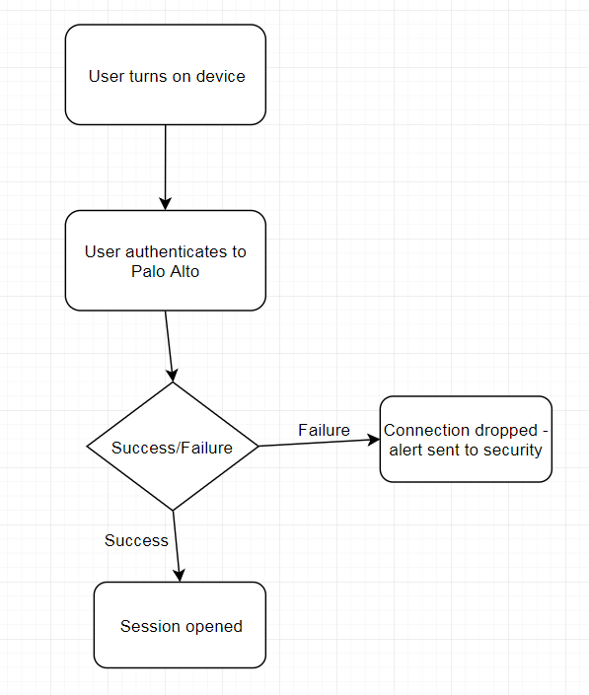

Conclusion
For corporate issued devices there is the option of wired on prem devices or remote access via Palo Alto. This will potentially give access to the entirety of the network dependent on the individual’s access requirements. These devices remain the property of Hyper-fort with users accepting responsibility for elements such as the security of the device whilst in their possession.
For devices owned by individuals a combination of VPN and a MDM solution will be used to manage the access securely. The VPN will be Palo Alto allowing a single pain of glass for monitoring and logging of activity. The MDM solutions selected are Airwatch and Intune for the reasons outlined in the implementation. Users will sign up to policies outlining their responsibilities and agreements and removing the company’s liability regarding the device.

Recommendation and future work
It is recommended that should this solution be put in place a regular review of access is undertaken with regular access cleansing. This will involve an audit check of access to ensure it is still required.
As this is an ever changing area it is advised that continuous improvement is conducted in the form of research to ensure the tooling used is the best fit.
Regular review of the solution is required to ensure it is still meeting the needs of the business, staff members and clients.
Hyper-fort are advised to regularly review any associated policies in line with procedural or legal changes.

References and further reading

[1] | NCSC, “BYOD: Executive summary,” [Online]. Available: https://www.ncsc.gov.uk/guidance/byod-executive-summary. [Accessed 08 January 2019].
[2] | G. Matteucci, “MSI,” 28 August 2018. [Online]. Available: https://www.msidata.com/pros-and-cons-of-byod-in-mobile-field-workforce/. [Accessed 15 January 2019].
[3] | Parr, Brown, Gee & Loveless, “THE LEGAL SIDE OF BRING YOUR OWN DEVICE (BYOD),” [Online]. Available: https://parrbrown.com/the-legal-side-of-bring-your-own-device-byod/. [Accessed 15 January 2019].
[4] | Cisco, “Bring your own device (BYOD),” [Online]. Available: https://www.cisco.com/c/en/us/solutions/byod-smart-solution/overview.html. [Accessed 08 January 2019].
[5] | Cisco. [Online]. Available: https://www.cisco.com/c/dam/en/us/products/collateral/security/identity-services-engine/at_a_glance_c45-654884.pdf. [Accessed 08 January 2019].
[6] | A. A, “NCSC IT: MDM products - which one is best?,” 08 March 2017. [Online]. Available: https://www.ncsc.gov.uk/blog-post/ncsc-it-mdm-products-which-one-best-1. [Accessed 08 January 2019].
[7] | NCSC, “End User Devices: VPNs,” [Online]. Available: https://www.ncsc.gov.uk/guidance/end-user-devices-vpns-1. [Accessed 08 January 2019].
[8] | “Microsoft,” [Online]. Available: https://www.microsoft.com/en-gb/cloud-platform/microsoft-intune. [Accessed 10 January 2019].
[9] | “VM Ware,” [Online]. Available: https://www.air-watch.com/why-workspace-one-airwatch/. [Accessed 10 January 2019].
[10] | NCSC, “BYOD,” [Online]. Available: https://www.ncsc.gov.uk/content/files/NCSC%20Bring%20Your%20Own%20Device.pdf. [Accessed 088 January 2019].
[11] | T. Kaneshige, “CIO,” 04 February 2014. [Online]. Available: https://www.cio.com/article/2379003/mobile-device-management/attack-of-the-byod-killing-mdm-software.html. [Accessed 08 January 2019].
[12] | S. Emery, “Factors for Consideration when Developing a Bring Your Own Device (BYOD),” July 2012. [Online]. Available: http://www.assistivetechnology.vcu.edu/wp-content/uploads/sites/1864/2013/09/Emery2012.pdf. [Accessed 08 January 2019].
[13] | Trend Micro, “Implementing BYOD plans. Are you letting malware in?,” 2012. [Online]. Available: http://www.trendmicro.tw/cloud-content/us/pdfs/business/reports/rpt_implementing_byod_plans.pdf. [Accessed 09 January 2019].
[14] | R. Simmons, “SANS,” December 2017. [Online]. Available: https://www.sans.org/reading-room/whitepapers/mobile/byod-security-implementation-small-organizations-38230. [Accessed 08 January 2019].
[15] | B. Morrow, “BYOD security challenges: control and protect your most sensitive data,” Network Security, vol. 2012, no. 12, December 2012.
[16] | B. Tokuyoshi, “The security implications of BYOD,” Network Security, vol. 2013, no. 4, April 2013.

