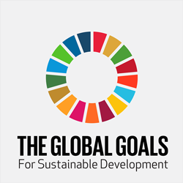  10 YEAR RISK ON GLOBAL SUSTAINABILITY DEVELOPMENT  Assignment 2 | Sara John-Davies (1910200)  Business Management

Contents
Introduction 2
Global Risks Report 3
Sustainable Development Goals 4
Goal 11 - Sustainable cities and communities 5
Goal 13 – Climate Action 8
How are countries doing with the Sustainable Development Goals? 9
Barriers into meeting the Sustainable Development Goals 10
Recommendations 11
Conclusion 12
References 13

Introduction

This report will be exploring a lot of aspects to do with sustainable economics. ‘Sustainability means meeting our own needs with compromising the ability of future generations to meet their own needs. Also, within natural resources we also need social and economic resources.’ (Alberta, 2021) A sustainable economy is one that is resilient and provides a good quality of life for everyone. ‘It stays within the limits of the planet and helps keep global warming within the well below 2°C threshold.’ (Godinot, 2022) The two main global risks which this report will be focusing on will be Climate change and also Net zero. ‘Climate change is the long-term shift in average weather patterns across the world. Since the mid-1800’s, humans have contributed to the release of carbon dioxide and other greenhouse gases into the air. This causes global temperatures to rise, resulting in long-term changes to the climate’. (Office, 2022) ‘Net Zero is, the amount of greenhouse gases for example this would be gases such as carbon dioxide that are in the atmosphere is no longer more than what is taken out’ (Newsom, 2019 ) Net zero is also being able to achieve an overall balance between emissions produced and emissions taken out of the atmosphere. (Commentary, 2019) This report will also be looking at the effects and barriers which the Sustainable Development Goals and Global Risks Report face or have faced throughout the years.
This report will also be looking into what is the risk outlook for the next 10 years and what impact will this be having on the global efforts on sustainable development.

Global Risks Report

The global risk report series tracks global risks perceptions among risk experts and world leaders in business, government, and civil society. The global risk report is published each year. The report is spread across five different categories and explores:
- Economic
- Environmental
- Geopolitical
- Societal
- Technological
Climate Change and Net Zero
According to the Global Risks Report. During the 2021 United Nations Climate Change Report (COP26) they managed to be successful in getting 197 countries to align on the Glasgow Climate Pact, and also many other landmark pledges. But unfortunately, all of the agreements which the 197 countries signed up too and committed to are expected to miss the 1.5°C goal established in the 2016 Paris Climate Agreement and increase the risks from a disorderly climate transition. (Forum, 2022) Climate Change continues to be perceived as the gravest threats to humanity.
Outcomes of COP26. The main outcomes of the COP26 meeting and agreements were:
- The country India has pledged to reach net zero emissions by 2070.
- 46 countries pledged to transition from coal to clean power by 2040.
- 104 countries pledged to a 30% cut in methane emissions by 2030. Methane accounts for 30% of historical global warming.
- 141 countries that account for 91% if the world’s forests pledged to end deforestation by 2030. (Forum, 2022)

Sustainable Development Goals
‘The United Nations Sustainable Development Goals (SDGs) are targets for global development adopted in September 2015, set to be achieved by 2030. All countries of the world have agreed to work towards achieving these goals.’ The sustainable development goals are: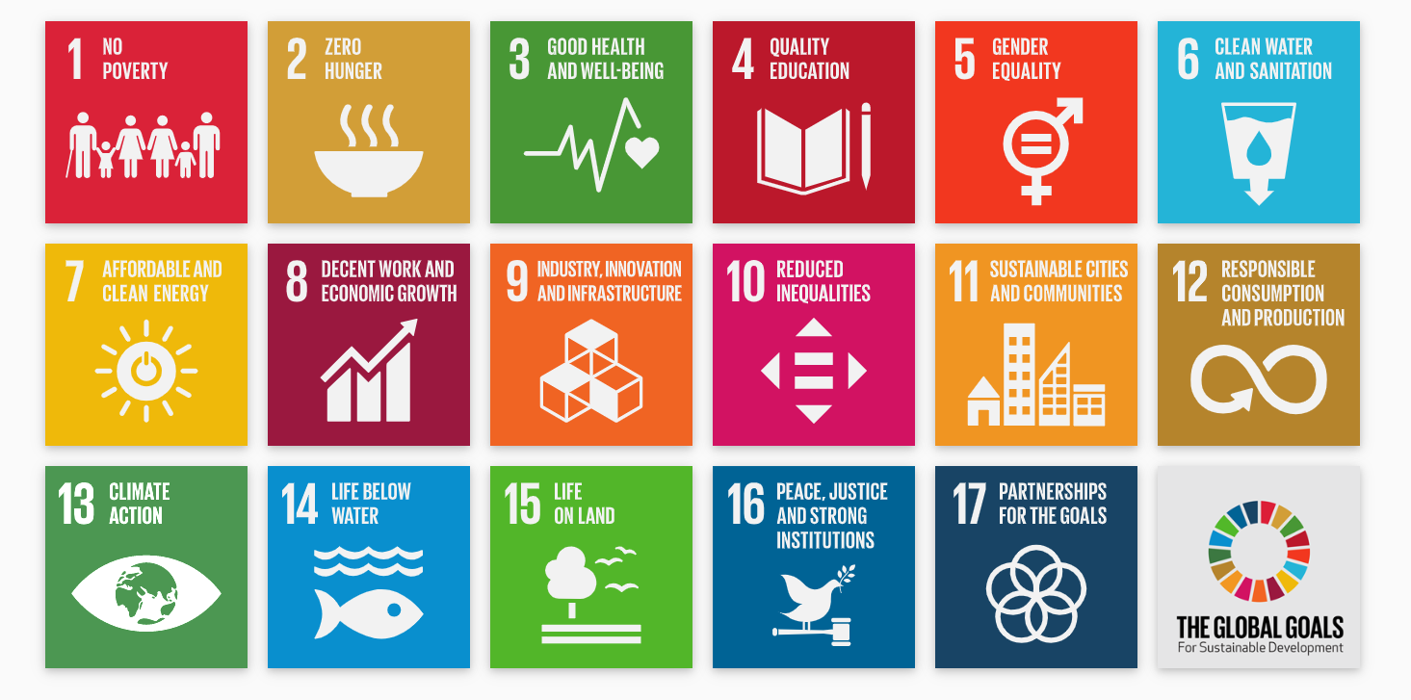
As you can see there is a wide variety of goals which are Global goals which need to be achieved by 2030. All of the Global goals were launched in 2018. (Goals S. D., 2018) The goals which are going to be focused on in this report is going to be:
- Climate action
- Sustainable cities and communities

Goal 11 - Sustainable cities and communities
The United Nations has defined 10 targets and 15 indicators for the eleventh sustainable development goal. These targets and indicators are put in place by the United Nations to be able to track the worlds aims and targets to see if these are going to be met or not.
Some of the targets which the United Nations have put in place for the eleventh goal are:
- Target 1 - Safe and affordable housing
  - The aim within target one is by the year 2030, granting access for everyone to adequate, safe and affordable housing and basic services
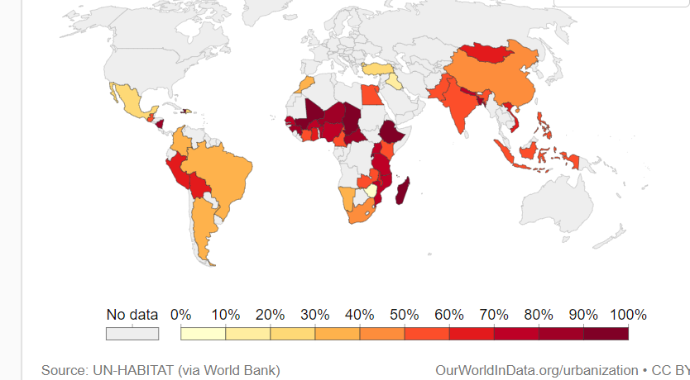

This map shows the share of the urban population living in the slums in the 1990’s.

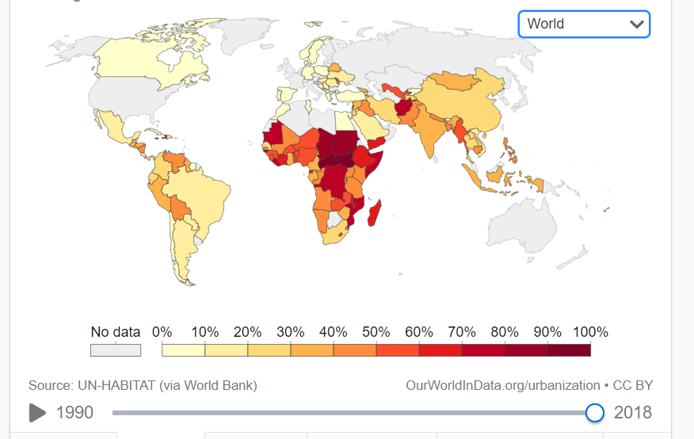

This map shows the share of the urban population living in the slums in the year 2018.

(Goals S. D., 2018)
The difference between these two maps is that there in a very higher population of the world who are now living in the slums. This would be due to inflation of bills, mass unemployment and an ever-growing population wanting to move to the cities, but they are unable to find housing which they will be able to comfortably live in and to be able to be financially stable.
- Target 2 - Affordable and sustainable transport systems
  - By 2030 provide access to safe, affordable accessible and sustainable transport systems for all. (Goals S. D., 2018)
- Target 3 – Inclusive and sustainable urbanization
  - By 2030, enhance inclusive and sustainable urbanization and capacity for participatory integrated and sustainable human settlement planning and management in all countries’ (Goals S. D., 2018)
- Target 4 – Protect the world’s cultural and natural heritage
  - Strengthen efforts to protect and safeguard the world’s cultural and natural heritage (Goals S. D., 2018)
- Target 5 – Reduce the adverse effects of natural disasters
  - In order for the goal to be met by 2030 then there needs to be a significant reduce in the number of deaths and the number of people affected and sustainability decrease the direct economic losses relative to global gross domestic product. (Goals S. D., 2018)
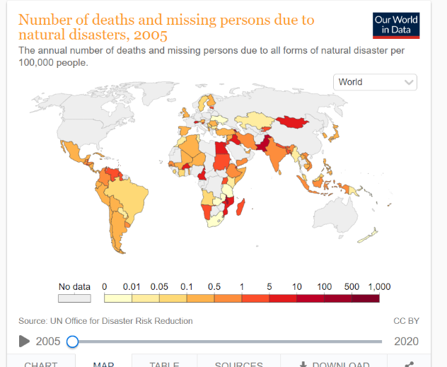

The map shows the number of deaths and missing persons due to natural disasters in 2005.

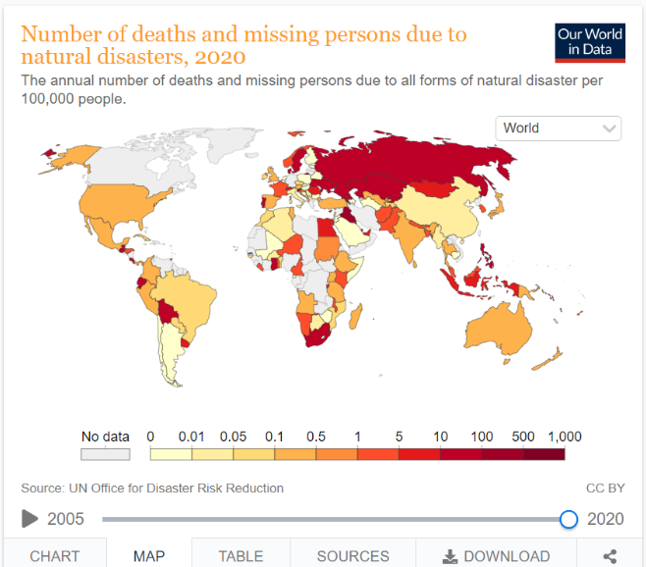

The map shows the number of deaths and missing persons due to natural disasters in 2020.

(Goals S. D., 2018)

When looking at the difference between these maps in 2005 there wasn’t a very high percentage of the darker colours which means less people had died/gone missing in 2005. But, in 2020 this was not the case there was a lot more of the map coloured and preferably in the darker red colour which means 1,000 per 100,000 people.
- Target 6 – Reduce the environmental impacts of cities
  - By 2030, reduce the adverse per capita environmental impact of cities, including by paying special attention to air quality and municipal and other waste management. (Goals S. D., 2018)
- Target 7 – Provide access to safe and inclusive green and public spaces.
  - By 2030 provide universal access to safe, inclusive, and accessible, green, and public spaces, in particular for women and children older persons and persons with disabilities. (Goals S. D., 2018)
By looking at all of the sustainable goals which the United Nations put in place when they put the 2030 deadline in place it is clear that, sustainable cities and communities are very important to everyone, you would think that in the year 2022 that these would already be in place for everyone, but unfortunately this is not the case. With the coloured maps which are shown the Sustainable cities and communities’ things are only getting worse for countries.

Goal 13 – Climate Action
The second sustainability goal which this report will be looking into is, climate action. The United Nations explains that: ‘Affordable, scalable solutions are now available to enable countries to leapfrog to cleaner, more resilient economies. The pace of change is quickening as more people are turning to renewable energy and a range of other measures that will reduce emissions and increase adaptation efforts.’ (Goals S. D., 2022)
There is also a lot of targets to go with within this goal.
- Target 1 – Implement then UN framework convention on Climate Change.
  - One of the main targets within target 1 is that the Green Climate Find mobilisation of $100 billion. The meaning of this is to be able to commit to this to be able to build a framework convention for Climate change. Also, unlike a lot of the other Sustainable Development Goals this target requires $100 billion annually by 2020 from all sources. (Goals S. D., 2022)
- Target 2 – Promote mechanisms to raise capacity for planning and management.
  - The purpose of this target is to be able to promote mechanisms to raise the capacity for effective climate change related planning and management in least developed countries, this is the goal by 2030.
By looking into these targets within this goal it is obvious that everyone needs to work together and work fast and with a large sum of $100Billion annually to be to beat climate change.

How are countries doing with the Sustainable Development Goals?

There are 193 countries who are United Nations members. The top five of these countries are
- Finland with a score of 85.90%
- Sweden with a score of 85.61%
- Denmark with a score of 84.86%
- Germany with a score of 82.48%
- Belgium with a score of 82.19%
All of the above countries are well on their way to being able to meet the Sustainable Development Goals in 2030 if not before which is great news. (Report, 2022)
The United Kingdom are currently place seventeen on the ranking table with a score of 79.97% so this isn’t a terrible score, and they are on their way to reaching the end goal by 2030 if not sooner. (Report, 2022)
Out of 193 countries which are United Nations members only 165 countries have made any progress with this, the country which is number 165 on the ranking tables is Central African Republic with a score of 38.27%. (Report, 2022)

Barriers into meeting the Sustainable Development Goals

As with everything there is always going to be boundaries with the Sustainable Development Goals one of the most common barriers which comes with the Sustainable Development Goals and also with the Global Risks report would be Coronavirus.
Coronavirus, or as many people will know it COVID-19 this is an infectious disease which is caused by SARS-CoV-2 virus. Most people who get infected with the virus will experience mild or moderate respiratory illness, but as with everything with life people of a certain age or if they already have other health conditions then this may affect them differently. But anyone can get sick with COVID-19 and become seriously ill or potentially die of this illness at any age. (Organisation, 2022)
COVID-19 has caused a massive disruption to people’s lives and livelihoods whilst the progress to achieve the Sustainable Development Goals have been slow even before the pandemic hit. So, when the pandemic stuck it meant that there was highs and lows with all of the Sustainability Development Goals. Obviously with the world in lockdowns it meant that the economic slowdown in 2020 managed to slow down the climate crisis a little. ((DESA), 2021)
COVID-19 global pandemic really did help the environment with lockdowns there are so many reports out there to say that the COVID-19 pandemic helped toward cleaner air and less pollution in general. In China their emissions fell by 25% in February 2021 this is in comparison with the February figures in 2019. But not only while the world was on lockdown now the pandemic is coming to an end in 2022, people are still finding ways to reduce their emissions for example, pre COVID-19 lockdown it meant that people would fly, drive or take public transport to meetings sometimes across the world to then stay in a hotel this could be just for an hours’ worth of meetings but now, people are now choosing to not do this they are now opting to take their conference calls from their permanent workplace or their home office this way they are then able to make a Zoom or Microsoft Teams call with people we are all across the world. This will massively help to reduce the carbon footprint. (Lee, 2020)

Recommendations

The recommendations which the writer would suggest for Climate Change would be:
- For all businesses to have an unlimited subscription to online video conferencing to stop them need to go to planes or travel far and wide around the world to be able to attend a meeting. If there was unlimited subscription to online video it would be amazing to be able to reduce the carbon footprint and emissions.

- Cycle to work scheme for a business to be able to offer this to their staff it would mean that if an employer was to sign up to this scheme it would mean that businesses would then be able to offer their employees up to 40% off of a bike for them to cycle to work using.

- Electric vehicles, this is a recommendation which is aimed off of the tradesman working life. A lot of trades men do have vans, and sometimes they will all have their own individual vans but if they took the change from petrol or diesel vans to full electric or even hybrid vans it would mean that they will be able to reduce the amount of carbon emissions and the business carbon footprint.

- Work from home, this is something which was enforced during the COVID-19 pandemic but if a business was to be continued through the business and forever more this would stop people needed to leave their houses and would definitely be able to reduce the carbon emissions and carbon footprint.

Conclusion

To conclude the main purpose of this report was to be able to highlight the main points in the Global Risks Report and also the main highlights and targets through out Sustainable Development Goals. The main topic which this report focused on was Climate change, or as it is stated in the Sustainable Development Goals its target 13 – Climate Action.
Obviously, everyone all of the world can have a different view on Climate change/action but one of the main reasons which really turned the corner with this was the COVID-19 global pandemic as the world stopped so all of the emissions reduced massively. The writer feels that if everyone was to adapt to their recommendations which they recommended then they would be able to continue flattening the curve on climate change/action and the world will be a much better and healthier place.

References
(DESA), U. N. (2021, July 6). Sustainable development report shows devastating impact of COVID, ahead of ‘critical’ new phase. Retrieved from Welcome to the United Nations: https://www.un.org/africarenewal/news/sustainable-development-report-shows-devastating-impact-covid-ahead-%E2%80%98critical%E2%80%99-new-phase
Alberta, U. o. (2021). What is sustainability? Alberta: University of Alberta.
Commentary. (2019, April 30). What is net zero? Retrieved from The London School of Economics and Political Science : https://www.lse.ac.uk/granthaminstitute/news/what-is-net-zero/
Forum, W. E. (2022). The Global Risks Report 2022. World Economic Forum.
Goals, S. D. (2018). Measuring progress towards the Sustainable Development Goals. Retrieved from Sustainable Development Tracker: https://sdg-tracker.org/
Goals, S. D. (2022). Take urgent action to combat climate change and its impacts. Retrieved from Sustainability Development Goals: https://sdg-tracker.org/climate-change
Godinot, S. (2022). Sustainable Economies. Retrieved from WWF: https://www.wwf.eu/what_we_do/sustainable_economies/
Lee, B. O. (2020, April 9). COVID-19: 3 Lessons for Climate Change. Retrieved from UNDP: https://www.my.undp.org/content/malaysia/en/home/stories/covid-19--3-lessons-for-climate-change.html?utm_source=EN&utm_medium=GSR&utm_content=US_UNDP_PaidSearch_Brand_English&utm_campaign=CENTRAL&c_src=CENTRAL&c_src2=GSR&gclid=EAIaIQobChMIuIC20avD9wIVzuvt
Newsom, R. (2019 , June 12). Greenpeace. Retrieved from What is 'net zero' and how can we get there?: https://www.greenpeace.org.uk/news/explained-theresa-mays-net-zero-plan-wtf-is-it-will-it-be-any-good/?source=GA&subsource=GOFRNAOAGA034J&gclid=EAIaIQobChMIxpf1k4nB9wIVg49oCR0wxQbUEAAYAiAAEgLMNvD_BwE
Office, M. (2022). What is climate change? Retrieved from Met Office: https://www.metoffice.gov.uk/weather/climate-change/what-is-climate-change
Organisation, W. H. (2022). World Health Organisation . Retrieved from Coronavirus disease (COVID-19): https://www.who.int/health-topics/coronavirus#tab=tab_1
Report, S. D. (2022). Ranking. Retrieved from Sustainable Development Report: https://dashboards.sdgindex.org/rankings
Zurich. (2022, January 11). The Global Risks Report . Retrieved from Zurich : https://www.zurich.com/en/knowledge/topics/global-risks/the-global-risks-report-2022#:~:text=The%20World%20Economic%20Forum%20Global,societal%2C%20environmental%20and%20technological%20tensions.

