
Classroom Management
SJIE6005

Laura Lynch
1707998
This resource is designed for all students within the early year setting, to promote positive behaviour in and outside of the classroom. The aim is to fill your bucket over the week, with ten straws to then receive a prize. The straws are earned by the individual and given by the classroom teacher or learning support assistant (LSA), for good, positive behaviour. The idea of this is to encourage positive behaviour in and outside the classroom, with the intention that others will follow in their footsteps. For example, Moyles, (1994) believes children learn from adults and children around them, so if they see positive behaviour from others and children being rewarded for something good, it is likely they will repeat the positive behaviour and attitudes they see. Porter, (2001). Skinner, (1948) also suggests this in his theory. Skinner developed operant conditioning, he believes when children are rewarded or punished for behaviours, they will learn what is expected of them and repeat the positive behaviours they have been rewarded for. (Simplypsycology.org).
Psychologist Brunner (1972) agrees with Moyles, children do learn and repeat from those around them. Grigg, (2013). He feels that children’s play is a rehearsal of actions that are going on in their life. (study.com). Neglect for example, can have a huge impact on a child’s mental health. (nhs.uk). Having basic needs not met preventing them from developing social skills needed to develop healthy relationships with other students and teachers, shown by Maslow, (1943) Hierarchy of Needs, which is a theory of human motivation. (simplypsychology.org). If neglect is all the child has experienced, then they would not know or be capable of interacting or sharing with others, as Moyles, (1994) states above children learn from those around them. Meaning early years is the first opportunity to discover if a child has been neglected and teach them basic skills such as sharing, kindness and respect and the importance of building friendships. All things this resource is designed to help promote.
Classroom management theorist Kohn, (1997), believes child development is a process which starts from birth. (wikkibooks.org). No child is born with the ability to walk and talk and make sense of the world around them. It is a process of developing skills as Piaget, (1936) cognitive theory shows, the process of taking in information, that encourages growth. Learning such skills like kindness and respect, which this resource is aimed to promote and will prep them for different stages of their life. Piaget’s theory being a learning approach, takes age into account, the learning approach helps develop the way an individual processes information which they will acquire knowledge through memory and perception.
It is important to remember that each student and their needs are different and not all children will learn the same way. Jorden, (1989). Children learn by seeing, hearing, exploring, curiosity, experimenting and by asking questions, covering the three inputs of learning as stated by Jorden, (1998). He believes that the brain works in a variety of ways, also shown in Piaget’s cognitive theory. Before information is stored into the long-term memory it would have to go through a process, first the working memory where the information is processed and interoperated before then being stored into the long-term memory. Piaget, (1936). (study.com).
This resource if used as described in the instructions below, will cover the three inputs of learning as described by Jorden. For example, a discussion of what this resource is between you and the students, will cover auditory. Creating a display of the students buckets with their names and a list of positive things that they may earn a straw for, covers visual. As seeing the display will also be a constant reminder of what behaviour is expected of them in the classroom. Kinaesthetic is learning by doing, so getting the students involved in not only creating the display or their own designed buckets, but also the list of what positive behaviours will see them earn a straw, is giving the students a task of doing. Showing this resource to be beneficial to students learning in more ways than one and creating opportunities to lifelong learning.
Fill your bucket, will help the development of new skills, as pointed out by Moyles, children learn from those around them, so this is developing children’s social skills by interacting and forming friendships. A straw in their bucket along with praise could be given to students for sharing or teamwork for example. This shows that through perception this resource is beneficial, also for developing Emotional intelligence, by promoting the management of feelings through their behaviour. Feelings of happiness for receiving a straw in their bucket or even a feeling of jealousy or sadness for not receiving one, or having a straw removed for unwanted classroom behaviour. Fontana, (1994) page 27;
‘behaviour that is rewarded tends to be repeated and to become associated in the individual’s mind with pleasure and positive emotions, while behaviour that goes unrewarded tends to become associated with negative emotions, and to be avoided.’
This resource could be used as rewards or punishment, which is something Skinner suggests being beneficial to learning throughout his theory. Operant condition is a method of learning developed by Skinner, (1948). His theory shows that through being rewarding or punished, it creates opportunities to learn what is expected of them. Being kind to others like sharing or helpfulness would earn the student a straw, meaning the student would be more likely to repeat the behaviour, same works for being unkind and removing the straw from their bucket. The student will learn that having a straw removed for such things, is unwanted behaviour and learn not to do it. As shown above with the learning process described by Piaget. Such feelings would also help the individual progress of cognitive skills, by increasing self-awareness. Identifying what behaviours for example would earn them that straw and give them confidence in repeating good behaviours. Showing that this resource supports ‘The Four Purposes of the Curriculum in Wales’ who aims for healthy and confident students, who are ambitious and capable to learn. (gov.wales)
The prize is set by the teacher and must be age related, it can be of their choice or even a multi choice, so the students have options, such as lucky dip? Or choice of stickers to choose from? Others may prefer to keep the prize as extra praise or classroom related, like promoting the students into job roles, such as teacher’s helper or in charge of reading materials for the following week. Robertson, (1996) suggests this will Make them feel important by giving them responsibility. Developing the cognitive process described by Piaget and having the ability to take ownership for their behaviour. Fontana, (1994) also feels students take ownership and responsibility for their own behaviours when students are presented with opportunities to have an input in their learning. This shows that getting the students to come up with their own ideas of classroom behaviours to earn them a straw would be more beneficial than the teacher writing a list and telling the class, what they are. Once this stage of the resource is completed and displayed in the classroom for students to see (please refer to instructions below) the teacher can always refer to them as their ideas, by pointing to the display and going over them when anyone in the classroom needs reminding.
It is important to have enough prizes or job roles created ready for the end of the week for this resource to be beneficial, to create positive behaviour. McPhillimy, (1996) believes in different awards for different individuals, he believes creating opportunities for the students preferred activities would increase the chance of that student repeating their positive behaviour. Whilst Skinner, (1948) agrees that rewards can be anything from extra praise, a smile or a prize would encourage a positive reinforcement, it is important to remember not all students will benefit from the same thing, as shown above by Jorden. Also, not all students may benefit from this resource!
The Education Inclusion Policy and Strategy aims to include all students, to do this they believe in giving all students access to the same services which would create the same opportunities by promoting achievement. (pembsinclusionservice.wales). If for example, an autistic student was in a mainstream classroom, things would need to be adapted in the rewards to this resource. Autistic children are unable to relate in the same way as other children, Wilkinson, (2014) states autism prevents the ability of understanding feelings and not having the ability to recognise others, feelings or emotions, such as happiness and sadness. Meaning simple things like a smile as given praise, could cause exclusion which is the opposite of what this resource is designed for. Adjusting rewards for individuals as McPhilimy suggests would be the answer to promote inclusion for all. Fitting in with the aims from ‘The Education Inclusion Policy and Strategy’ However Kohn, (1997) disagrees with Skinner and his theory on operant conditioning, Kohn feels that learning is a reward in itself and students should not be rewarded or punished to do something that is a natural process of developing and also for something which is expected of them. (alfieKohn.org).
However, Piaget’s theory shows that learning is a process so therefore children of young age, who this resource is designed for would need to learn what behaviours are good and what is not acceptable. His cognitive process shows how the brain works and how things are processed in the working memory before being stored into the long-term memory, showing that not all children would know what is expected of them, as shown above. Children who have experienced neglect wouldn’t know that kindness and relationships with peers is a natural process of growing and developing and needed to grow further. (study.com) Also highlighted by Maslow above in his motivational theory. Skinners method of rewards such as this resource for early years is a way of encouraging good behaviours whilst promoting the development of new skills, in a way that Piaget shows to be beneficial to store these new skills and behaviours in the long term memory, meaning they move forward in life knowing what behaviours are expected of them. Fontana, (1994) page 64 also believes that behaviours are learnt, he states;
‘The majority of human behaviours are learnt, Thus if these behaviours are unacceptable for some reason, we can help the person producing them and to learn something more appropriate in their place.’
‘Education Inclusion Policy and Strategy’ promotes inclusion for all as one of their aims, promoting achievement and opportunities. (gov.uk). This resource promotes achievement by clear guidance of what is expected of them in and outside the classroom by discussing what things could see them earn a straw in their bucket, as shown in the resource instructions below. Giving students a sense of direction to achieve targets, Students are encouraged to set their own targets of gaining straws with a little steer in the right direction form the teacher.
This gives the students the opportunity to have an input on what behaviours or even rules are expected in school. Fontana, (1994) believe that giving students an opportunity to have an input in their learning will create the students to take ownership and responsibility for their own behaviours. This resource is designed for the students to come up with their own ideas of positive behaviours to see them earn a straw in their bucket, which Fontana suggests. Kohn, (1997) highlights this throughout his theory and feels that classrooms should all be student centred learning, giving students control for their own learning and responsibilities. He believes teachers should only act as facilitators whilst children have the control. (AlfiKohn.org).
Providing good pupil outcomes is a role of mainstream school, a key focus is on academics, however not limited to just this as shown in the Inclusion Strategy Policy, (2013) progress of social and emotional skills are just as important. Using this resource in early years supports the aim of mainstream school and helps to develop students with social and emotional skills, by encouraging them to engage with feelings and understand them, creating opportunities to interact with others forming relationships with peers and teachers. Also developing skills to manage and express emotions through experience. As mentioned above straws could be given for teamwork or being helpful to others, encouraging repeat behaviours as previously mentioned by Porter.
Whilst it is clear throughout that there are mixed opinions on if rewards are beneficial and should be given for such things that are expected in an education setting, like behaviours and respect shown by Kohn. (AlfieKohn.org). It is important to remember and take into consideration that learning is a process, described by Piaget cognitive theory (simplypsycology.org) and the age this resource is designed for. This resource is designed to encourage good behaviours and learn what is expected of them within a setting. Using this resource for early years not only encourages good behaviours it also helps the student’s individual growth as Maslow has shown above, children need relationships with peers and teachers to progress with further learning. (simplypsycology.org).
Not everyone comes from the same background, unfortunately as previously stated some students may be neglected. (nhs.uk). Developing relationships with others would not be as natural to them as it would for others, so they would need to be taught how. This shows that this resource is beneficial to early years and supports the Education Inclusion Strategy Policy, (2013) by developing social and emotional skills and inclusion. As this resource is designed for the students to create as a classroom and prizes can be adapted to benefit each student by changing it to suit individual needs , shows it is a beneficial resource for inclusion of all students, which promotes achievements and creates opportunities. (pembsinclusionservice.wales). Opportunities such as classroom promotions of different job roles, giving the students responsibility, making them feel important. Robertson, (1966).

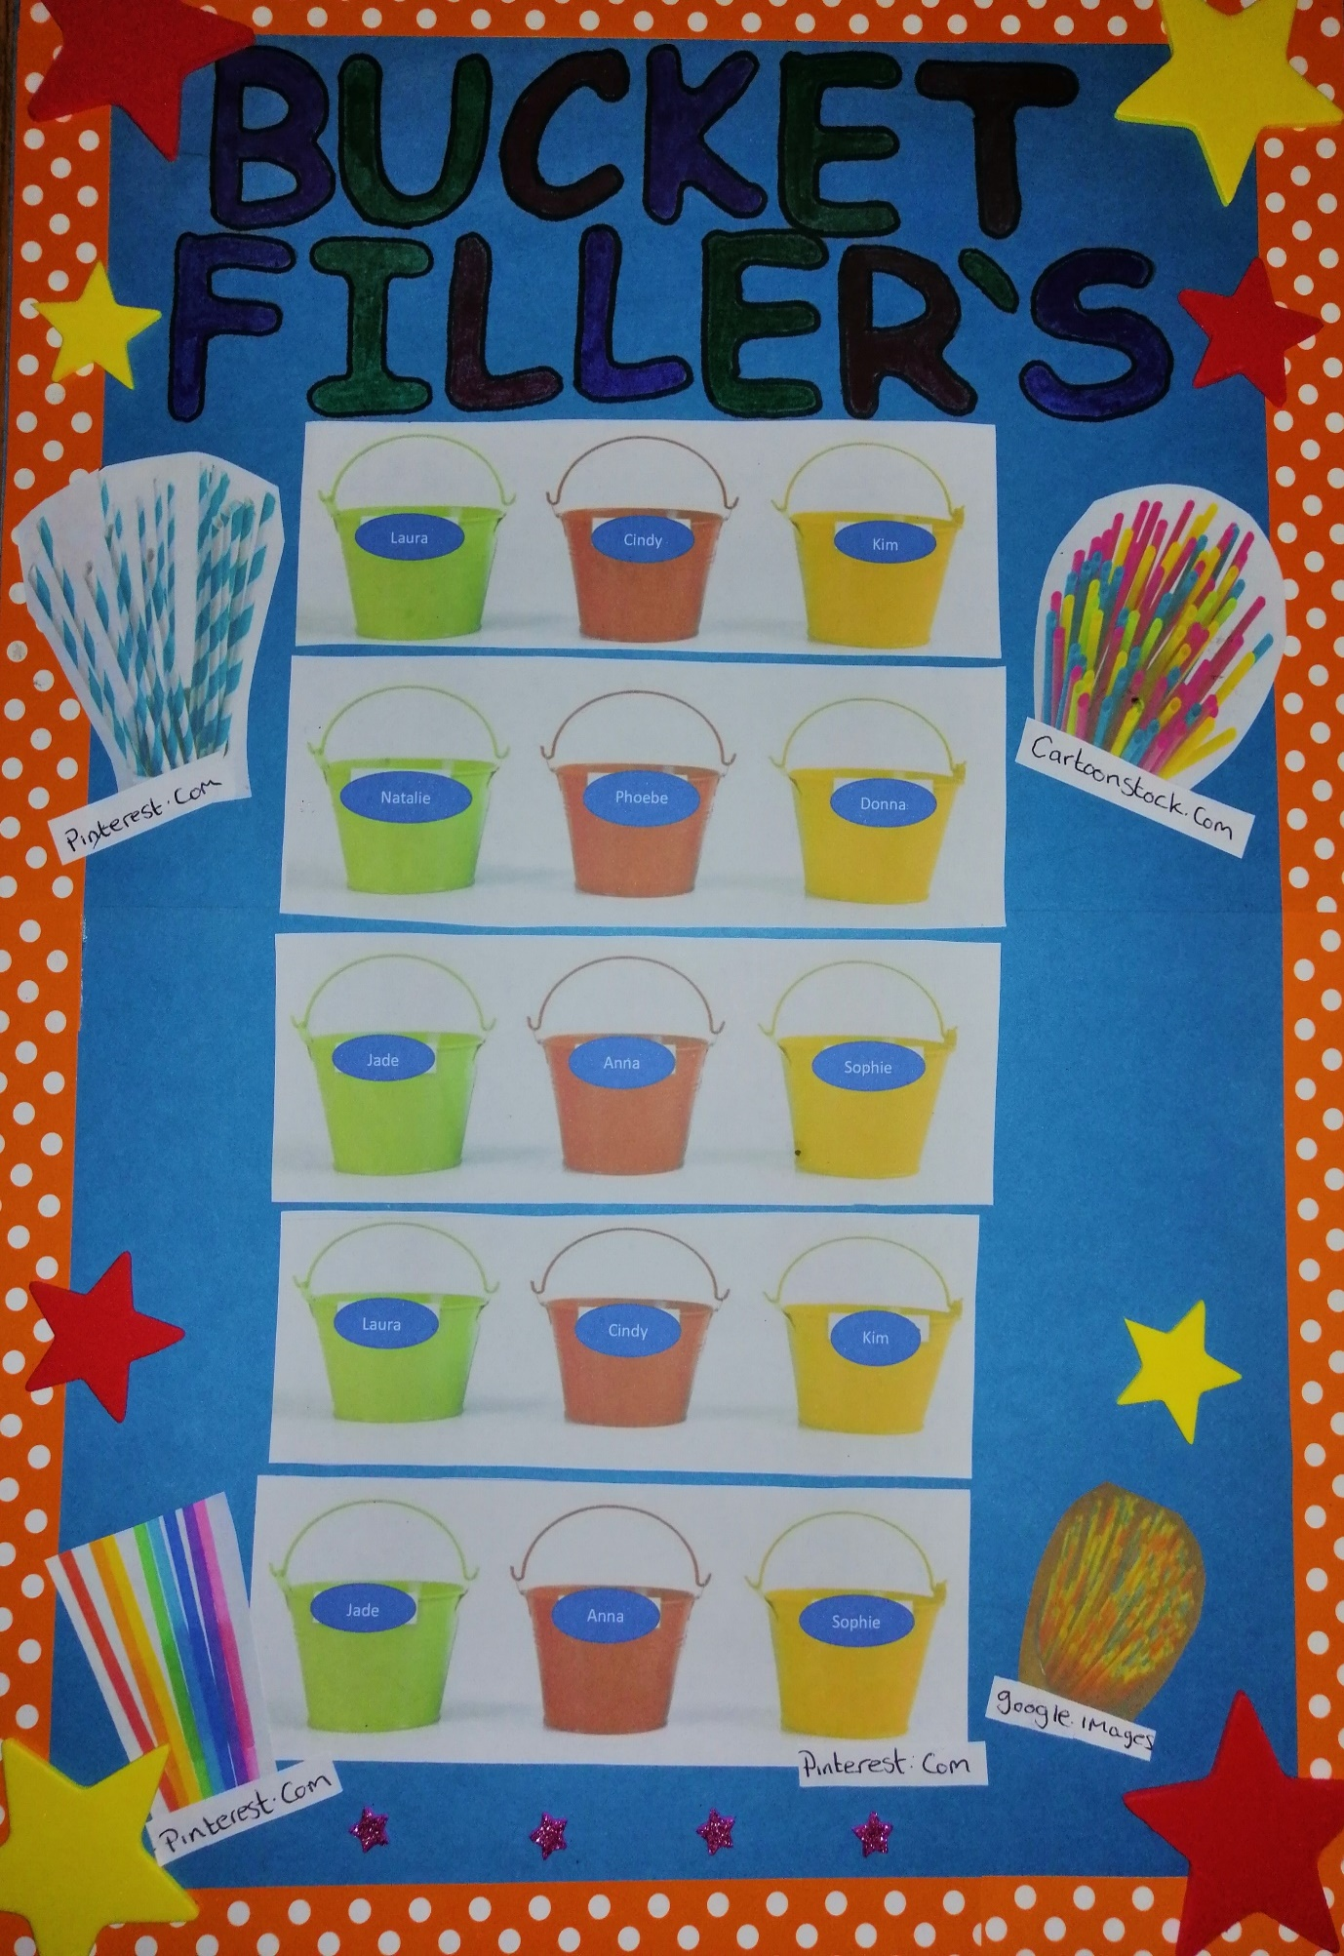
FILL YOUR BUCKET INSTRUCTIONS

Materials you will need;
- Buckets (enough for each student).
- Pot of straws (enough to cover 10 for each bucket).
- Name tags (Or enough resources for students to make their own).

Instructions
- An introduction to the students of what ‘Fill Your Bucket’ is.
- A discussion with the students on how it works and how you can earn straws for your bucket, also discuss that straws may be taken away for unwanted behaviour.
- Get the students involved by asking them what they think may earn a straw in their bucket. Gentle encouragement on this may be needed, so you may want to start them off with a few suggestions and let the students go from there. Write their ideas down for them to see, also encourage them to include what things may see them lose a straw! Talking about their ideas bringing them into what is expected in class and school. Highlight that their ideas are in fact school rules, for example, School A is a rights respecting school and friendly and kindness as well as other things, are super important and included in the school behaviour policy.
- Get the students involved by creating or decorating their name tags for their bucket. Print off the student’s ideas and get them to recall their ideas of things to earn a straw and things that they might lose a straw for. You could display them in a decorated area by the buckets. This will be easier to refer to when giving or taking away a straw. For example, well done Cindy that was good sharing, remember students? We wrote sharing down on the board, that’s why it is here with the list of things to fill your bucket.

References
Fontana, D. (1994) MANAGING CLASSROOM BEHAVIOURS, Leicester, The British Psychological Society.
Grigg, R. (2013) Becoming an Outstanding Primary School Teacher, New York, Routledge.
Jordan, D.R. (1989) Overcoming Dyslexia in Children, Adolescents and Adults, Austin, PRO-ED.
McPhilillimy, B. (1996) Controlling Your Class, A Teacher’s Guide to Managing Classroom Behaviour, Great Britain, Bookcraft Ltd.
Moyles, J. (1994) Classroom Management, Bright ideas for Early Years, Warwickshire, Scholastic Publication Ltd.
Moyles, J.R. (1994) Organizing for Learning in the Primary Classroom, A Balanced Approach to Classroom Management, Buckingham, Open University Press.
Porter, L. (2000) BEHAVIOUR IN SCHOOLS Theory and Practice for Teachers, Buckingham and Philadelphia, Open university Press.
Robertson, J (1996) EFFECTIVE CLASSROOM CONTROL Understanding teacher – student relationships, Great Britain, The Bath Press.
Alfie Kohn
It’s not about behaviour 05-09-2018
https://www.alfiekohn.org/article/behaviour/
accessed 27-06-20
Alfie Kohn
Classroom management – Wikibooks.org
https://en.wikibooks.org/wiki/Classroom_Management_Theorists_and_Theories/Alfie_Kohn
Accessed 06-06-20
B.F Skinner
Operant conditioning – Simply Psychology
https://www.simplypsychology.org/operant-conditioning.html
Accessed 27-06-20
Jean Piaget's Theory of Cognitive Development | Simply Psychology (2018)
Simplypsychology.org
https://www.simplypsychology.org/piaget.html
Accessed 10-07-20
Personal and Social Educational Framework
Learning.gov.wales(2018)
http://learning.gov.wales/docs/learningwales/publications/130425-personal-and-social-education-framework-en.pdf
Accessed 09-06-20
Neglect
NSPCC
https://www.nspcc.org.uk/what-is-child-abuse/types-of-abuse/neglect
Accessed 20-07-20
Pembrokeshire Inclusion Service
https://pembsinclusionservice.wales
Accessed 28-06-20
Simply Psychology
https://www.Simplypsychology.org/maslow.html
Accessed 14-07-20
The Four Purposes of the Curriculum in Wales
https://hwb.gov.wales/curriculum-for-wales/introduction#:~:text=%20Introduction%20to%20Curriculum%20for%20Wales%20guidance%20,requires%20schools%20to%20design%20their%20own...%20More%20
Accessed 17-07-20

