COMMUNITY ENGAGEMENT
ASSESSMENT 1

LCBB4002
LECTURER: RULA ALOUSI
STUDENT: DENISA-ANDREEA MATEI
Table of Contents
Introduction 3
Best practice of the organization related to community engagement 3
Best practice of the organization related to stakeholder participation 5
Conclusion and recommendation 8
References 9

Introduction
Community engagement refers to a process to work collaboratively affiliated with special interests, geographic proximity, or similar situations that affects well-being. Community building, direct service, economic development, community education are some of the examples of community engagement. The present study will discuss the community engagement of Unilever. It is one of the largest companies of consumer goods in the UK and the headquarters of the company are in London. The company serves its product throughout the world. Nearly 155,000 employees are associated with the company. The present study will also include the stakeholder participation with respect to the company.

Best practice of the organization related to community engagement
Arrangement of additional facilities
Arrangement of additional facilities for the employees with respect to Unilever is one of the best practices related to community engagement. The engagement can be considered on the ground of economic development (Brunton et al. 2017, p.14). Unilever is a company whose contribution level in the economy is high. From that context, it can be said that the company has contributed to the economic growth. At the same time, it has contributed to economic development as well. The employees work in the company for earning money. Most of the time, it is seen that employees are not happy with the behavior of the company. However, this is not true for Unilever. This is due to the fact that along with salary, some additional benefits are provided to the employees which are helpful for the family members of the employees (Hollebeek et al. 2017). For example, the scholarship benefits and facility of health insurance can be mentioned. These are the reasons for which the employees are dedicated to work for the company. However, the company did not increase the number of employees in the last few years. If these facilities could be provided to some more people, Unilever could be considered more engaged in the community. The fare wages provided by the company can also be mentioned in that context. It is helpful for the employees to raise the standard of living. The importance of inclusion, as well as human rights, can also be addressed in this respect.
Engaged in research
Engaged in research can be considered as a community engagement with respect to Unilever. The mission of the business enterprise to provide quality of products to the customers. Therefore the company is focused on the way it can provide more quality products to the customers. The company can take the feedback of the customers and in the present times, the company has created business pages on various kinds of social networking sites. These are helpful to understand the perception of the consumers towards the product of Unilever. Research is a very important tool that helps in dealing with current challenges (Kumar and Kumar, 2020, p. 101949). In past times, the number of people who were associated with research work in respect of Unilever was much less. However, in present times, the number of people who are engaged in research work has increased to a great extent. The increased number of pages in various kinds of social networking sites can be considered as one of the most significant reasons.
Environmental protection as well as community development
Environmental protection, as well as community development, need to be mentioned in the context of best practices of the organization related to community engagement. The company includes the main corporate citizenship body which helps in dealing with various kinds of environmental issues. Community development is helpful in the process of sustainable development as well. Consumer awareness is also an important factor that needs to be mentioned in that context (Brunton et al. 2017, p.14). The environmental policy of Unilever can be mentioned in that context. According to the policy, the company will not adopt any way which is not suitable for the environment. In that context, it is important to mention that more people were engaged with the company after adopting this particular policy. It has improved the image of the company to the customers.
Sustainable living brands
The incorporation of sustainable living brands can be mentioned on the ground of best practices of community engagement. It can be properly understood from the following figure.
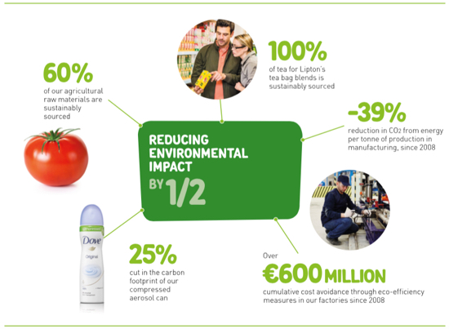
Figure 1: Incorporation of sustainable living brands with respect to Unilever
(Source:environmentalleader, 2021)
Based on the above figure, it can be said that a large community is associated with Unilever. A large raw materials of agriculture are sourced sustainably from the company. The reduction of carbon footprint is also an important thing that can be mentioned in this context. Eco delivery measurement is another factor that can also be addressed in that context. Under the considerations of all these facts, it can be said that the company had to engage more people for covering all these activities. In that context, it is important to mention that the company did not have to face any kind of problem to incorporate more people under community engagement (Pratt et al. 2020, p.44).
In order to develop community engagement, Unilever follows several strategies. It includes transparent communication, stakeholder engagement as well as marketing. Maintenance of transparency and playing the responsibility are some of the reasons for which the company is able to get sufficient help from the Government of the country. The company is currently engaged with NGOs and it has connections with the World Economic Forum. Engagement with the organization is helpful for the company to deal with financial problems (Di Napoli et al. 2019, p. 551). The relationship with the stakeholders can also be mentioned in that context. The significance of the Partner with Purpose program can be considered on the ground of developing community engagement.

Best practice of the organization related to stakeholder participation
Identification of stakeholders
A stakeholder is of two types and these are internal stakeholders as well as an external stakeholder. Internal stakeholder includes employees, BOD (Board of directors ), executives as well as subject matter experts among others. External stakeholders are consumers, suppliers, the local community, creditors as well as Government (Chilisa et al. 2017, p.327). External stakeholders are those who are not associated with the company directly but their actions can have an influence on Unilever. On the other hand, internal stakeholders are those who have a direct connection with the company and they have much influence over the action of the company. Both are important with respect to the business process of Unilever. The stakeholders are very much important for a company and it can be well understood from the following figure.
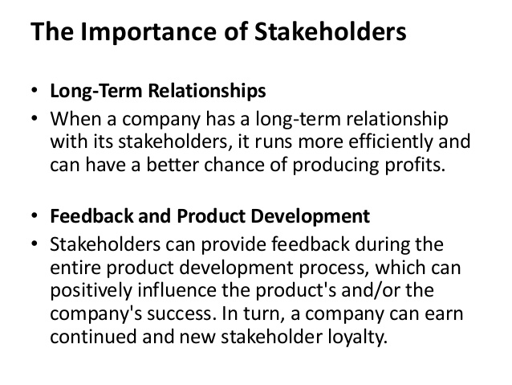
Figure 2: Importance of stakeholder engagement
(Source:Sonawane, 2021)
Elaboration of stakeholder participation
- Both types of stakeholders are engaged under the best practice of the organization. Employees are the most important internal employees with respect to the business enterprise. Most of the employees are committed to the work and it can be said under the best practice of the organization. The stakeholder engagement has developed after registering under trade association memberships. In that context, it is important to mention that the number of developmental activities has increased much after registering in this association (Poncian, 2019, p.79). The collaboration with Cosmetic Toiletry and Perfumery Association can be mentioned in that context.
- Customers are the most important stakeholders of the company and therefore the company follows the strategies which are helpful to maintain the long-run relationship with the customers(Hollebeek et al. 2017). Due to the price of the commodity, all types of people are the customers of Unilever and it is an important factor that can be mentioned on the ground of organizational best practices. The company is very much focused on customer satisfaction. The business enterprise follows a quarterly basis checking and therefore in recent times, the company has incorporated modern technology in this process. This is applicable for both domestic as well as international countries. Unilevel thinks that feedback from customers is helpful to understand the exact wants of the customers (De Weger et al. 2018, p.285). It is also helpful for the company to remain ahead on the edge of the competition. The importance of sustainability goal achievement can be mentioned in this regard. The reduction of carbon emission is a factor that helps in the process of achieving sustainability goals. Unilever has arranged many campaigns in this particular respect.
- The present pandemic situation has changed the life of the people and business procedure has also got interrupted. In order to overcome the problems, different kinds of volunteer activities have been raised. The help of the NHS is important to mention. The significance of financial help can also be addressed in this regard. From that context, the contribution of Unilever can be mentioned. In the process of dealing with a variety of problems related to the outbreak of COVID 19, many people have been associated in respect of Unilever(uprisevsi.co.uk, 2021). Financial help in this tough time is also an important factor that is done under the best practice of the company. Apart from that, help related to transport is also a factor that was done under the best practice of stakeholder participation.
- Suppliers are very important stakeholders of Unilever. The company has a moderate amount of suppliers and most of them do not delay to supply the products. Considering the present times it can be said that Unilever was able to supply commodities in a proper way and from that context, the efficiency of suppliers can be mentioned. It is very important to maintain the equilibrium condition in the market. Sometimes the company faces an unexpected rise in demand. In that case, a store of inventory may not be sufficient to mitigate the demand. From that context also the contribution of suppliers can be mentioned.
- Peer companies are also important stakeholders that help in implementing best practices with respect to the company. In order to conduct CSR activities, Unilever takes help from peer companies. Apart from that, the importance of peer companies can be understood during taking business strategies (Dostilio, 2017). As the peer companies and the main companies have similar interests, Unilever does not feel any kind of problem while taking strategies for business or other purposes.
- BOD executives are some of the other stakeholders who also play a role in implementing best practices. Their role can be mentioned on the ground of employee engagement. It is helpful in the process of reduction of employee turnover rate (Evans et al. 2017, 48). The BOD, as well as the executive of Unilever, regularly holds meetings and in these meetings, the problems related to the business are solved.

Conclusion and recommendation
Conclusion
Based on the above discussion it can be concluded that Community engagement helped Unilever to build a good image. At present, there are various types of stakeholders associated with the business enterprises and their participation is very much important for the best practices with respect to the organization. The community engagement of the company includes various kinds of CSR activities. Implementation of environmental policy, as well as the incorporation of sustainable development, are some of the important factors that help in the process of community development. The employees of Unilever are happy with the additional facilities provided by the company and in this way the company is associated with activities of economic development.
Recommendation
- Unilever is facing the problem related to the maintenance of the community. It has become more difficult under the increased number of people in a particular community(De Weger et al. 2018, p.285). This is the matter which should be focused on by the company. Without figuring out a proper solution, it is not important to add more people to the community.
- Due to an increase in stakeholders, Unilever faces problems related to making decisions. It becomes very much problematic when decision is need to take within a short span of time. In order to overcome the problem, Unilever should prioritize its stakeholders according to the importance. Both internal and stakeholders need to incorporate under this process.

References
Brunton, G., Thomas, J., O’Mara-Eves, A., Jamal, F., Oliver, S., and Kavanagh, J. (2017). Narratives of community engagement: a systematic review-derived conceptual framework for public health interventions. BMC Public Health, 17(1), 1-15.
Chilisa, B., Major, T. E., and Khudu-Petersen, K. (2017). Community engagement with a postcolonial, African-based relational paradigm. Qualitative Research, 17(3), 326-339.
De Weger, E., Van Vooren, N., Luijkx, K. G., Baan, C. A., and Drewes, H. W. (2018). Achieving successful community engagement: a rapid realist review. BMC health services research, 18(1), 285.
Di Napoli, I., Dolce, P., and Arcidiacono, C. (2019). Community trust: A social indicator related to community engagement. Social Indicators Research, 145(2), 551-579.
Dostilio, L. D. (Ed.). (2017). The community engagement professional in higher education: A competency model for an emerging field. Stylus Publishing, LLC.
environmentalleader, 2021. Unilever ‘Sustainable Brands’ Grew 30% Faster Than Other Brands in 2015. [online] Environment + Energy Leader. Available at: <https://www.environmentalleader.com/2016/05/unilever-sustainable-brands-grew-30-faster-than-other-brands-in-2015/> [Accessed 30 April 2021].
Evans, E., Funes, M., Hong, H., Reuter, K., Ahmed, S., Calhoun, K., ... and Wallerstein, N. (2018). Defining and measuring community engagement and community-engaged research: Clinical and translational science institutional practices. Progress in community health partnerships: research, education, and action, 12(2), 145-156.
Hollebeek, L. D., Juric, B., and Tang, W. (2017). Virtual brand community engagement practices: a refined typology and model. Journal of Services Marketing.
Kumar, J., and Kumar, V. (2020). Drivers of brand community engagement. Journal of Retailing and Consumer Services, 54, 101949.
Poncian, J. (2019). When government commitment meets community proactiveness: governing gas and community engagement in Tanzania. Energy Research and Social Science, 52, 78-90.
Pratt, B., Cheah, P. Y., and Marsh, V. (2020). Solidarity and community engagement in global health research. The American Journal of Bioethics, 20(5), 43-56.
Sonawane, R., 2021. Stakeholders In Business. [online] Slideshare.net. Available at: <https://www.slideshare.net/messageforu/stakeholders-in-business-16038680> [Accessed 30 April 2021].
uprisevsi.co.uk, 2021. Roles for Volunteers | NHS Volunteer Responders. [online] NHS Volunteer Responders. Available at: <https://nhsvolunteerresponders.org.uk/i-want-to-volunteer/volunteer-roles?utm_source=google&amp;utm_medium=paid-search&amp;utm_campaign=nhsvr&amp;gclid=Cj0KCQjwvYSEBhDjARIsAJMn0lhgAxDRtFMHqlDG6eGK8x2cEPnq4X_bMJ7SWEh5oUy5fHPfSNYBG5gaAg-wEALw_wcB> [Accessed 30 April 2021].

