
Student name: Abdulai Kamara
Student ID: 2328050
Module name: Changemakers: Building Your Personal Brand for Sustainable Employment
Module code: BMHP5015
Lecturer name: Caroline Salami
Submission Date: 19th December 2025
Component 2: Assignment (Report)
Time: 14:00 (2PM)

Table of Contents
1. Introduction 3
2. Analysis of the Employability Skills Required 3
2.1 Job description and person specification 3
2.2 Core employability skills for performance 3
2.3 Frameworks and professional values 4
3. Evaluation of Current Skills 5
3.1 Skills audit snapshot 5
3.2 SWOT analysis 6
3.3 Reflection on feedback and experience 6
4. Building a Personal Brand and Professional Identity 6
4.1 Values and alignment 6
4.2 Professional visibility 7
4.3 Unique selling point 8
4.4 Networks 8
5. Action Plan and Timeline 8
6. Conclusion 10
References 11

Introduction

The selected job title is the Healthcare Support Worker in an NHS trust adult inpatient ward. The stand reflects the interest in being engaged into direct care, collaboration, and competence building of clinical practise in a formal hospital environment. The post supports registered nurses and allied professionals to deliver safe daily care to adults with acute and long-term conditions. Interest in this role reflects a focus on practical support, direct contact with patients and families, and opportunities for structured development. A typical vacancy lists personal care, vital sign observations, food and fluid support, record keeping, safe moving and handling, simple equipment cleaning, and contribution toward housekeeping. Shift working across days, nights, weekends, and bank holidays is standard (Weller et al., 2024). This report outlines the role of employability demands, compares these with the current skill profile, sets out a concise personal brand and visibility plan, and provides a staged action plan with milestones and evidence. The aim is a credible, value-led route into a Healthcare Support Worker post with realistic steps that build confidence and competence.

2. Analysis of the Employability Skills Required

2.1 Job description and person specification
The Healthcare Support Worker assists with personal hygiene, toileting, dressing, mobility, hydration and nutrition, and comfort checks. Routine observations include pulse, respiration, temperature, blood pressure, oxygen saturation, and pain scores as directed by registered staff (Atinga et al., 2024). The worker documents care and observations on paper or electronic records, prepares bed areas, supports infection prevention, and reports concerns promptly. Essential criteria commonly include basic literacy and numeracy, good spoken and written communication, capacity for shift work, and an understanding of confidentiality and dignity. Desirable criteria include the Care Certificate, experience in a caring role, and confidence with electronic patient records (Tortosa-Alted et al., 2021). The person’s specification stresses compassion, reliability, attention to dealing with teamwork, and willingness to learn. This aligns with thew 6 CSs of nursing values, care, compassion, competence, communication ,courage and commitment.
Figure 1. Job advertisement for NHS Health Support Worker.
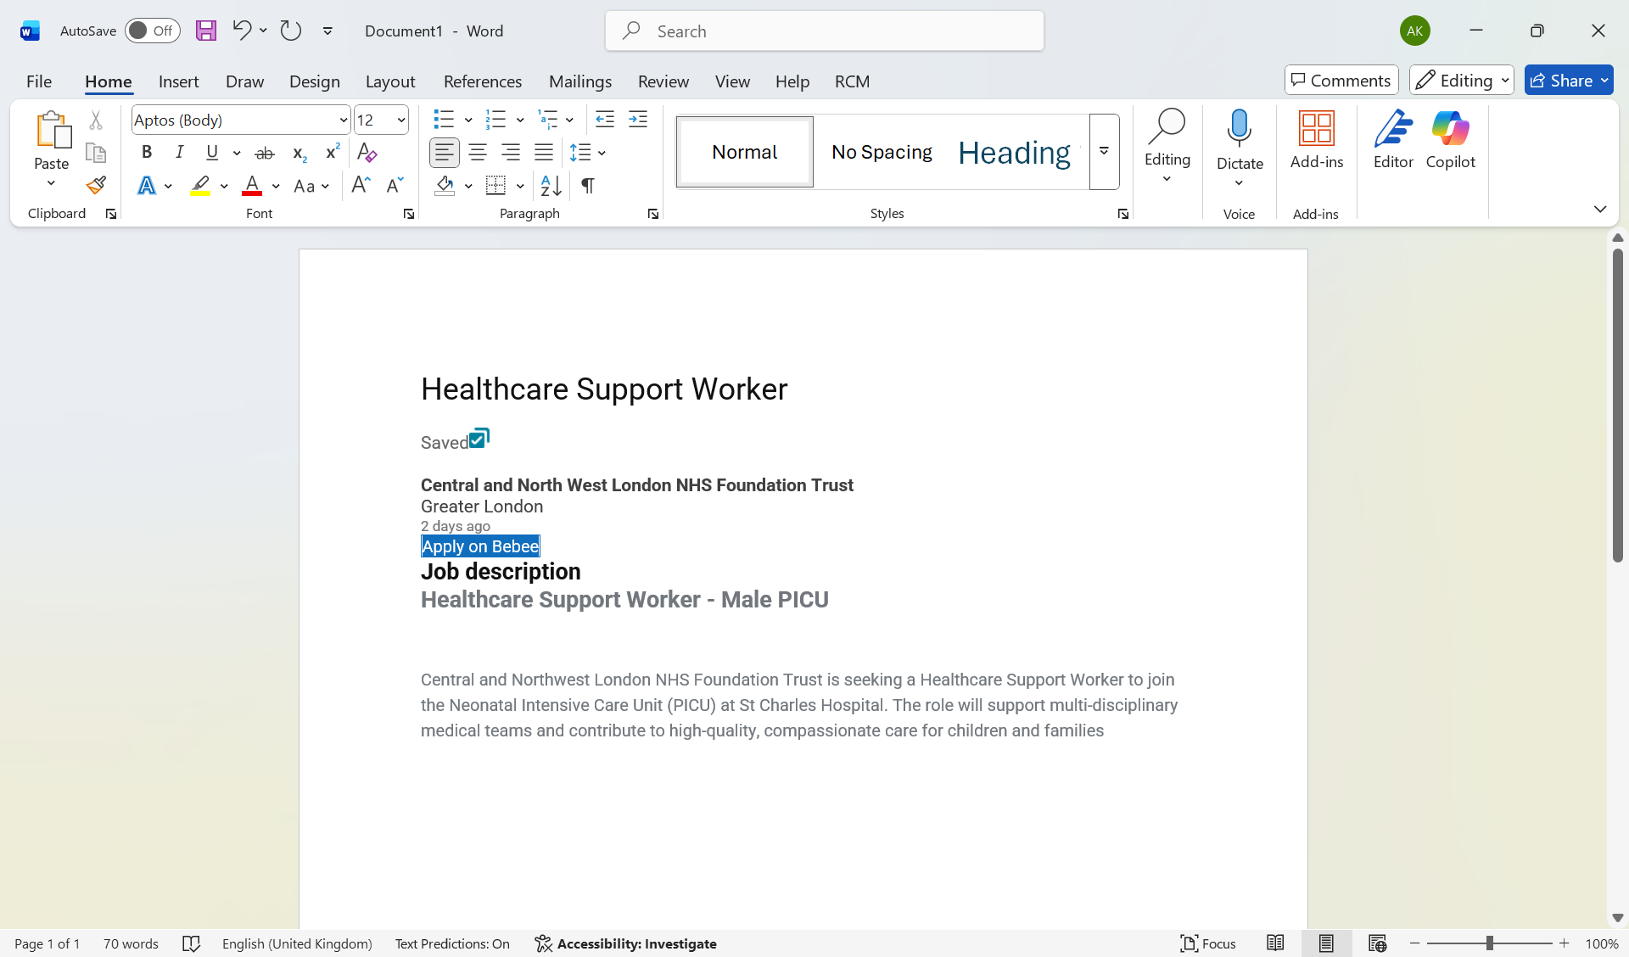

2.2 Core employability skills for performance
- Communication: Communication means giving and receiving information in clear, respectful, and accurate ways, including speaking, listening, and record keeping. It matters because safe care depends on shared understanding of needs and risks. For example, during a fall risk review, the support worker explains the plan in plain language, confirms understanding, and documents actions so the nurse can adjust supervision promptly (Dacre Pool and Sewell, 2007).
- Empathy: Empathy is the ability to notice feelings and see the situation from the patient’s view, then respond with kindness. It is important since dignity and trust are developed when distress is identified and early. As an illustration, a patient denies morning care following a restless night. The employee provides the subsequent wash, switches off the lights, and comes back with hot water, decreasing the agitation and maintaining the choice (Shi, et al., 2022).
- Teamwork: Teamwork refers to coordinated effort with identified roles and supportive behaviors that facilitate the entire ward. The reason is that priorities are variable with a shift and no role can fulfil all needs. As an illustration, during the lunch round, a colleague will be involved in feeding, another one will be involved in updating intake charts, and a third one will be involved in clearing hazards to avoid choking risks and keep the documentation up to date.
- Problem solving: Problem solving involves identifying a problem and finding alternatives and making a secure, practical course. It is relevant since unforeseen issues are encountered on a daily basis in hectic environments. For example, a pressure cushion is missing at transfer. The worker pauses the move, calls stores, uses a spare from the equipment bay, and records the request, preventing skin damage while maintaining momentum (Delardes et al., 2020).
- Time management: Time management is planning tasks around clinical risk and patient comfort, then delivering them efficiently. It matters because delays can harm comfort and safety. For example, at the start of a busy evening, the worker builds a simple schedule that fronts medication support and toileting and hydration, groups nearby tasks, and leaves buffer time for observations, which reduces missed care (Dacre-Pool, 2020).

2.3 Frameworks and professional values
Core caring values emphasises care, compassion, competence, communication, courage, and commitment (NHS, 2024). These values guide judgement in routine and urgent situations. The STAR approach helps to show skills in action.
- Situation: A patient becomes breathless after a short walk.
- Task: Ensure safety and escalate if needed.
- Action: Sit the person down, offer reassurance, check saturation as directed, and inform the nurse.
- Result: Symptoms settle and the patient remains safe while further review takes place. Learning models such as simple reflection and deliberate practice support growth from each shift (NHS, 2019).
Together, the duties, values, and models point to a dependable colleague who notices risk early, communicates clearly, and learns quickly.

3. Evaluation of Current Skills

3.1 Skills audit snapshot
Skill | Current level (1–5) | Evidence of capability | Development need
Communication | 4 | Clear speech in patient interactions, accurate notes from placement reviews, adapts language to anxiety or confusion | Practice concise handovers, refine written summaries, build confidence in difficult conversations, refusal of care (Francy Tatiana et al., 2020)
Empathy and dignity | 5 | Positive feedback on kind manners, offers choice and privacy during personal care, checks understanding | Maintain standards during late-shift pressure, develop habits to prevent compassion fatigue
Teamwork | 4 | Works to plan within ward routines, supports colleagues at mealtimes and turns, follows boundaries and seeks help early | Increase contribution during peak activity, practice leading a small task group when delegated
Problem solving | 3 | Notices missing equipment and finds alternatives, escalates concerns appropriately, uses checklists (Mulfiyanti and Satriana, 2022) | Build a structured approach to options and risks, rehearse responses to common scenarios such as falls and agitation
Time management | 3 | Uses checklists to plan rounds, groups tasks by location to reduce delays, keeps workspace tidy | Improve prioritisation across overlapping tasks, protect buffer time for observations and documentation

3.2 SWOT analysis
- Strengths: Calm manners under pressure, clear spoken and written communication, and steady teamwork that supports safe delivery of routine and urgent tasks. Reliable attendance and punctuality build trust on shift. Adherence to boundaries and timely reporting safeguard patients and co-workers. And readiness to learn and accept feedback enhances day to day performance (Ghosh, et al., 2021).
- Weaknesses: The lack of experience in the hospital electronic record systems and device workflow slows down and lowers confidence in busy times. On late shifts stamina might also drop and this increases chances of missing details. The allocation between demands in the face of competition cannot be done inconsistently without a plan that is ready at the start of the shift.
- Opportunities: Local staff bank roles, skills laboratories, simulation sessions, and short accredited courses can build clinical fluency and digital confidence within months. Mentoring within words and peer learning groups can speed up safe practice. Trust open days and careers events increase visibility and access to vacancies (Min, et al., 2021).
- Threats: Strong competition for entry roles may delay offers. Placement capacity constraints can limit supervised hours. Fatigue risk without strong recovery habits can harm judgement. Sudden changes to service pressure or Rota patterns can disrupt learning plans. Financial limits on training budgets may slow formal upskilling. Weather disruptions can also affect shift availability.

Figure 2 Work values for a Creer in Health and Social Care
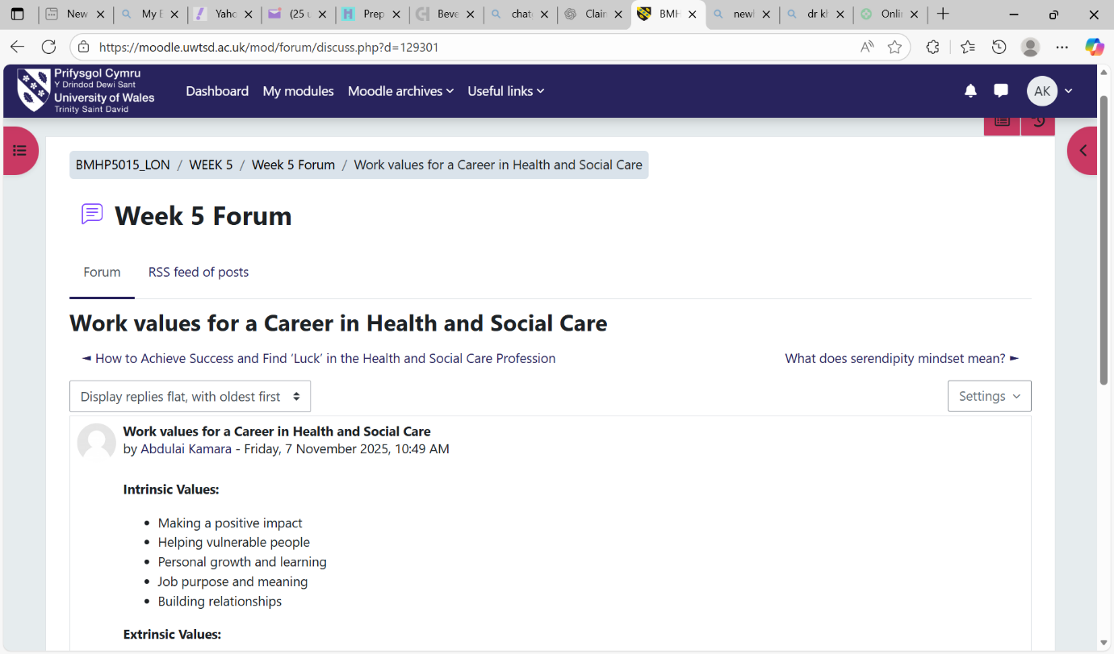

3.3 Reflection on feedback and experience
Supervisor feedback highlights patience during personal care and thoughtful support at mealtimes. Early voluntary shifts showed slow pacing due to fear of error. After coaching and rehearsal, task flow improved while safety remained central. As highlighted by Gibbs reflective cycle shows learning. Description. Supported a person with reduced mobility to wash and dress. Feelings. Initial worry and self-doubt reduced confidence. Evaluation. Preparation, clear steps, and steady tone produced a safe, dignified outcome. Analysis (Ivziku et al., 2021). Anxiety reduced once actions were planned and explained in simple language. Conclusion. Preparation and calm communication improve pace and safety. Action. Rehearse steps, prepare equipment early, and seek feedback after each shift.

4. Building a Personal Brand and Professional Identity

4.1 Values and alignment
Core values are respect, compassion, and fairness for the role of Healthcare Support Worker. These ideals influence everyday decisions that have an impact on experience and safety. These include the use of preferred names, taking breaks, and taking care of privacy when washing and getting dressed (Köse et al., 2025).

4.2 Professional visibility
The resume starts by showing a clear profile based on the following safe bedside care, correct observations, and reliable collaboration. The entries of experience indicate the actions and the outcomes in brief lines (Francy Tatiana et al., 2020).
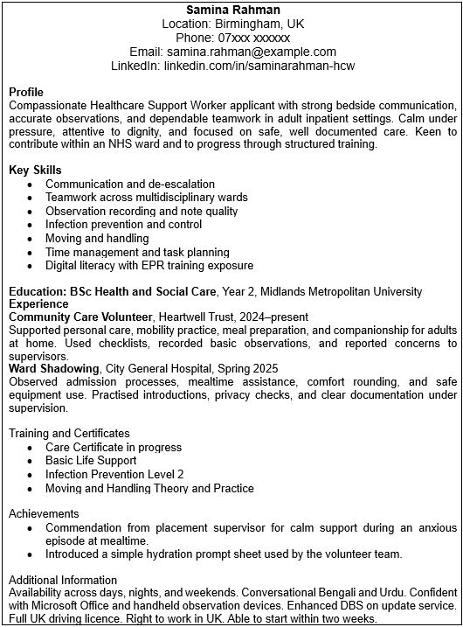

4.3 Unique selling point
The nature of the profile is indicated by a peaceful demeanour in the busiest times and meticulous record keeping that facilitates decision making. Examples of evidence points are comments on the part of a supervisor regarding consistent work during the meal rounding and observation charts that are well neat and meet the local standards (Kolb, 2015). The habit of equipping oneself with equipment prior to every task minimises the delays and unnecessary errors.

4.4 Networks
Performance increases visibility via working networks. Such actions as going through local trust pages, joining student groups and support workers, attending open days, and participating in online skills sessions can also be useful (Mulfiyanti and Satriana, 2022). A weekly habit of engaging in one discussion or arranging one short guidance call builds contact and confidence.
Figure 3. Networking in Health and Social Care
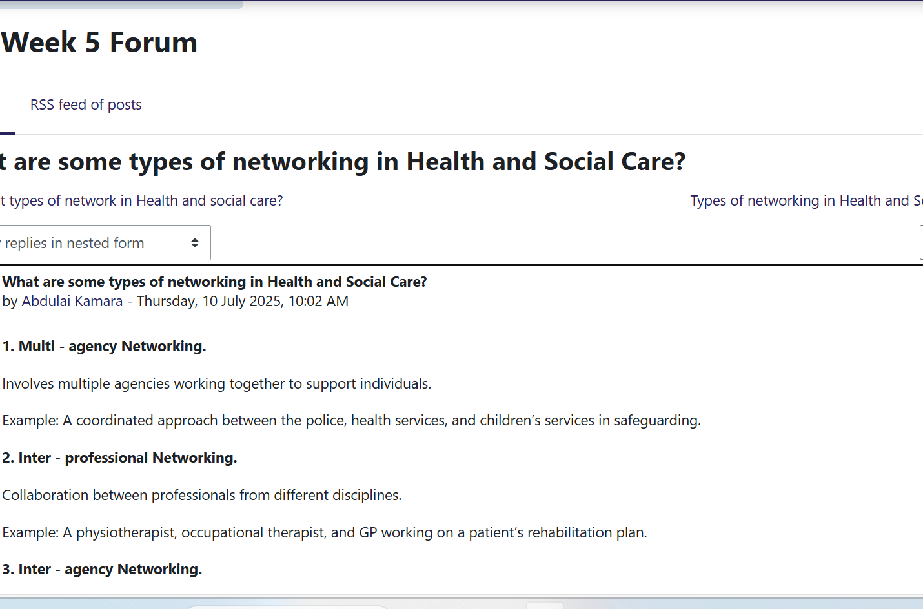

5. Action Plan and Timeline
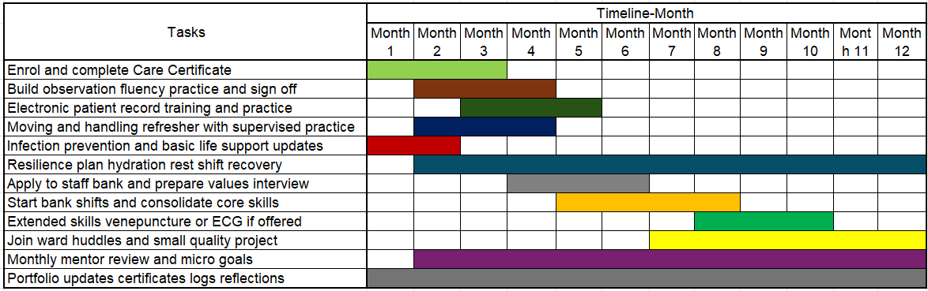
Goal | Steps and milestones | Resources or support | Evidence of progress | Target date
Gain the Care Certificate | Enroll, complete all units, arrange workplace sign off | Course access, mentor time | Certificate and signed workbook | Month 3
Build observation fluency | Weekly skills lab, supervised ward sessions, timed practice runs (Francy Tatiana et al., 2020) | Skills lab slots, clinical coach | Accuracy logs within target range | Month 4
Improve electronic records | Complete EPR training, practice notes, use templates, seek feedback | Training account, ward access | Sample entries approved by mentor | Month 5
Strengthening moving and handling | Refresher course and supervised practice with equipment | Manual handling trainer | Competency sign off (Dacre-Pool, 2020) | Month 4
Enhance resilience | Set rest plan, hydration routine, short debrief after shifts | Peer buddy and mentor | Fatigue diary shows improvement | Month 6
Secure bank shifts | Apply to trust staff bank, prepare for values interview, complete induction (Min, et al., 2021) | Application support and ID checks | Offer letter and rostered shifts | Month 6
Developing extended skills | Attend venepuncture or ECG course if offered | Training budget and release | Competency record and mentor note | Month 10
Contribute to quality | Join ward huddles, propose a small improvement to hydration chart process | Support from ward sister (Shi, et al., 2022) | Note of change and brief impact summary | Month 12

Risk and contingency: Placement or bank capacity may limit early hours. If access is delayed, community shifts will increase while skills labs continue to maintain momentum. Funding delays may slow training access. If budgets are not yet confirmed, free provider modules and open learning will fill the gap until enrolment is possible (NHS, 2024). Illness or caring duties may interrupt progress. If this occurs, milestones will be reset, and the plan will resume with a reduced weekly load to protect wellbeing.
Self-efficacy note: Confidence will develop through graded exposure, repeated practice, and regular feedback. Small wins will be recorded after each shift to reinforce progress and shape the next steps (Weller et al., 2024).

6. Conclusion
The effective functioning of any adult inpatient ward is founded on the five capabilities, which are interdependent. Communication will help in proper exchanges with patients and colleagues, effective handovers, and correct notes that will be utilised in making safe decisions during the shift. Empathy assists in protecting dignity, reducing suffering and building trust especially in intimate care or when the anxiety is high. Shared work and prioritising work are also arranged by teamwork so that the right person can receive assistance at the right time. Problem solving is used to resolve unexpected situations which might include the lack of equipment to the beginning of the deterioration and make informed and safe decisions and ramps up at an efficient speed. Rounds, documentation and rest breaks are considered time management to reduce delays and care omissions. The current profile shows empathetic, communicative, and teamwork. The modern long shift will focus on the individual development of the regular clinical activities, guaranteed electronic recording, and normal rhythm. The action plan will correlate the skills with milestones. The practice of organised handover improves communication. The short debriefs and reflective journals assure protection against empathy. The teamwork process becomes even more intensive with the aspects of bank transfers and mentor feedback. Problem solving can be enhanced with the aid of simulation and scenario practice. The time management involves follow-up by straightforward schedules in which there are buffer periods. All these are realistic preparation to save, human practice and readiness to a substantive post.

References
Atinga, R.A., Gmaligan, M.N., Ayawine, A. and Yambah, J.K. (2024). ‘It’s the Patient That Suffers from Poor communication’: Analysing Communication Gaps and Associated Consequences in Handover Events from Nurses’ Experiences. SSM - Qualitative Research in Health, [online] 6(100482). doi:https://doi.org/10.1016/j.ssmqr.2024.100482.
Dacre Pool, L. and Sewell, P. (2007). The key to employability: developing a practical model of graduate employability. Education & Training, [online] 49(4), pp.277–289. doi:https://doi.org/10.1108/00400910710754435.
Dacre-Pool, L. (2020). Revisiting the CareerEDGE model of graduate employability. Journal of the National Institute for Career Education and Counselling, [online] 44(1), pp.51–56. doi:https://knowledge.lancashire.ac.uk/id/eprint/33178/10/33178%20NICEC%20CareerEDGE%20article%20April%202020%20%28FINAL%29.pdf.
Delardes, B., McLeod, L., Chakraborty, S. and Bowles, K.-A. (2020). What is the effect of electronic clinical handovers on patient outcomes? A systematic review. Health Informatics Journal, 26(4), p.146045822090516. doi:https://doi.org/10.1177/1460458220905162.
Francy Tatiana, Cruz, C., Esteban, J. and Gaitan, H. (2020). Effective communication in health care: a systematic review. ResearchGate. [online] doi:https://doi.org/10.13140/RG.2.2.27782.73280.
Ghosh, S., Ramamoorthy, L. and Pottakat, B. (2021). Impact of structured clinical handover protocol on communication and patient satisfaction. Journal of Patient Experience, 8(1), pp.1–6. doi:https://doi.org/10.1177/2374373521997733.
Ivziku, D., Ferramosca, F.M.P., Filomeno, L., Gualandi, R., De Maria, M. and Tartaglini, D. (2021). Defining nursing workload predictors: A pilot study. Journal of Nursing Management, 30(2), pp.473–481. doi:https://doi.org/10.1111/jonm.13523.
Kolb, D. (2015). Experiential learning: Experience as the source of learning and development. 2nd ed. Upper Saddle River, New Jersey: Pearson Education, Inc.
Köse Tosunöz, İ. and Aydınlı, A. (2025). Nurses’ perceptions of the effectiveness of handover practices, influencing factors and perceived barriers: A descriptive cross-sectional study of medical and surgical nurses. Collegian. [online] doi:https://doi.org/10.1016/j.colegn.2025.06.002.
Min, A., Hong, H.C. and Kim, Y.M. (2021). Work schedule characteristics and occupational fatigue/recovery among rotating‐shift nurses: A cross‐sectional study. Journal of Nursing Management, 30(2). doi:https://doi.org/10.1111/jonm.13511.
Mulfiyanti, D. and Satriana, A. (2022). The Correlation between the Use of the SBAR Effective Communication Method and the Handover Implementation of Nurses on Patient Safety. International Journal of Public Health Excellence (IJPHE), 2(1), pp.376–380. doi:https://doi.org/10.55299/ijphe.v2i1.275.
NHS (2019). The NHS Patient Safety Strategy Safer culture, safer systems, safer patients NHS England and NHS Improvement. [online] Available at: https://www.england.nhs.uk/wp-content/uploads/2020/08/190708_Patient_Safety_Strategy_for_website_v4.pdf?utm.
NHS (2024). Quality strategy. [online] England.nhs.uk. Available at: https://www.england.nhs.uk/long-read/quality-strategy-december-2024/?utm.
Shi, F., Li, Y. and Zhao, Y. (2022). How do nurses manage their work under time pressure? Occurrence of implicit rationing of nursing care in the intensive care unit: A qualitative study. Intensive and Critical Care Nursing, 75(1), p.103367. doi:https://doi.org/10.1016/j.iccn.2022.103367.
Tortosa-Alted, R., Reverté-Villarroya, S., Martínez-Segura, E., López-Pablo, C. and Berenguer-Poblet, M. (2021). Emergency handover of critical patients. A systematic review. International Emergency Nursing, 56(1), p.100997. doi:https://doi.org/10.1016/j.ienj.2021.100997.
Weller, J.M., Mahajan, R., Williams, K.F. and Webster, C.S. (2024). Teamwork matters: Team situation awareness to build high-performing healthcare teams, a narrative review. British Journal of Anaesthesia, 132(4), pp.771–778. doi:https://doi.org/10.1016/j.bja.2023.12.035.

